# User guide for web application “Student Attendance Management”.

The "Student Attendance Management" web application allows the Instructor to access his/her class information. Follwing features are supported:

- The application provides the instructor a page for entering the student information after successful login.

- The instructor can find students with the 5 fewest and 5 most absences.

- lets the instructor enter, review, update and delete the attendance of the students of the class.

- The instructor can log out at any time. and if instructor logs out, the application takes the user to the login screen.

## Screenshots

1. The index page is the login page.Here the instructor logs in with his provided login-in details. For trial running the following credentials can be used.

User ID – admin

Password- admin

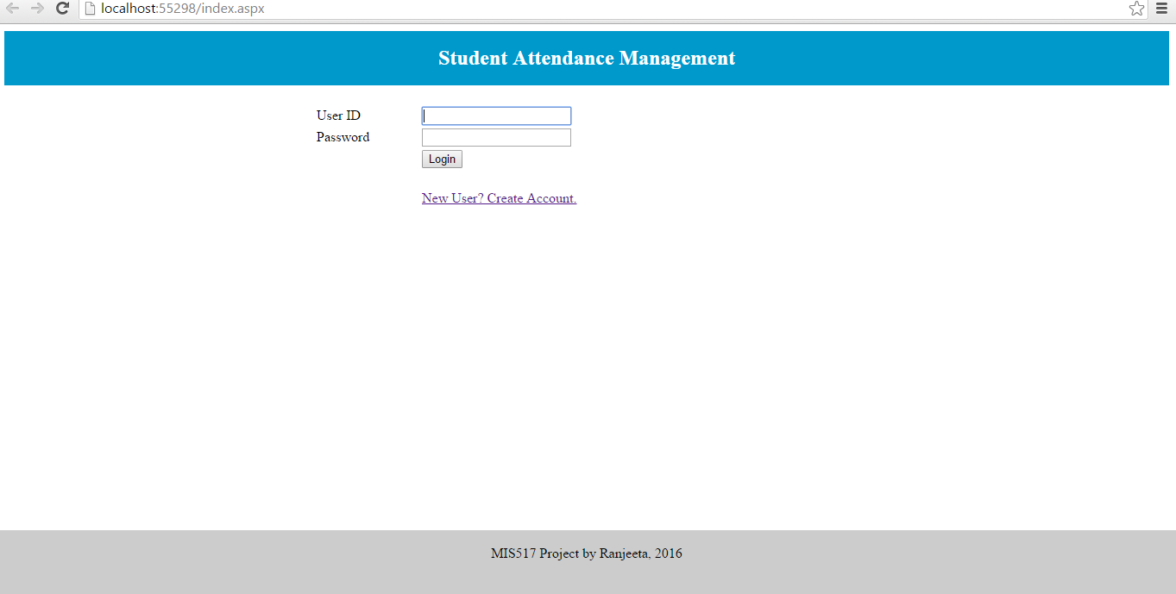

1. Successful login takes the user to the Welcome Page which provides the option to “View Student Attendance” and “View Student Information”.

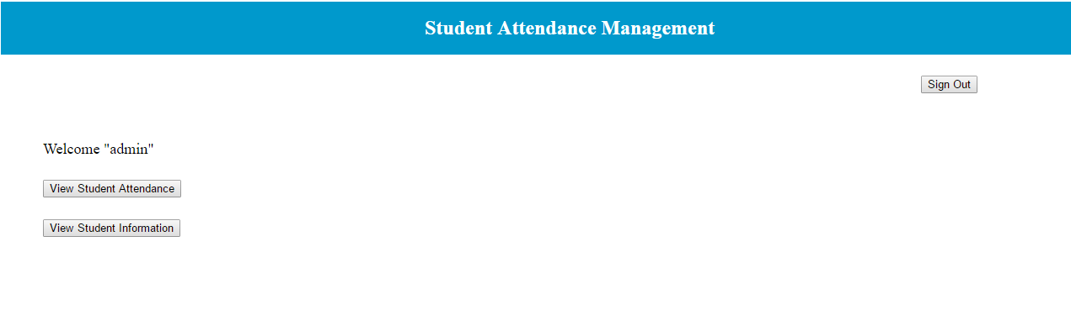

1. The “View Student Attendance” shows the entire attendance for the course of the enrolled student. Allows the user to enter new attendance or edit existing one. Also allows to user to view 5 fewest absences and 5 most absences.

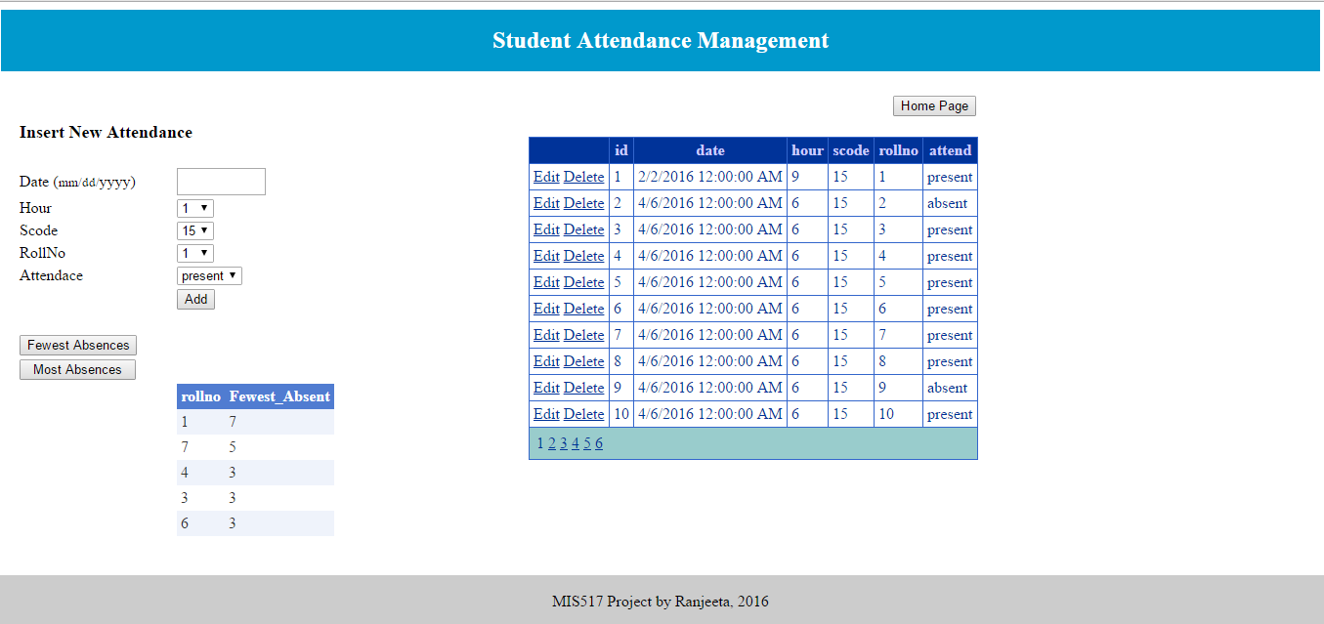

1. The “View Student information” page displays the information of all students enrolled for the course. Allows to enter a new student as well.

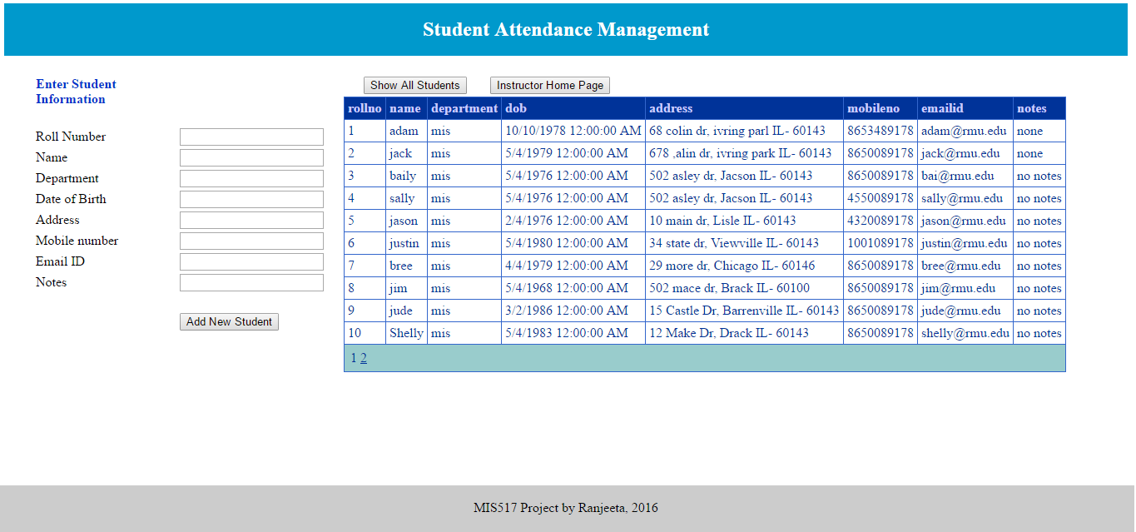

1. The Login screen provides a hyperlink “New User? Create Account”. Clicking on that takes the user to a page where he/she can create a new login.

