Step 1- Home page

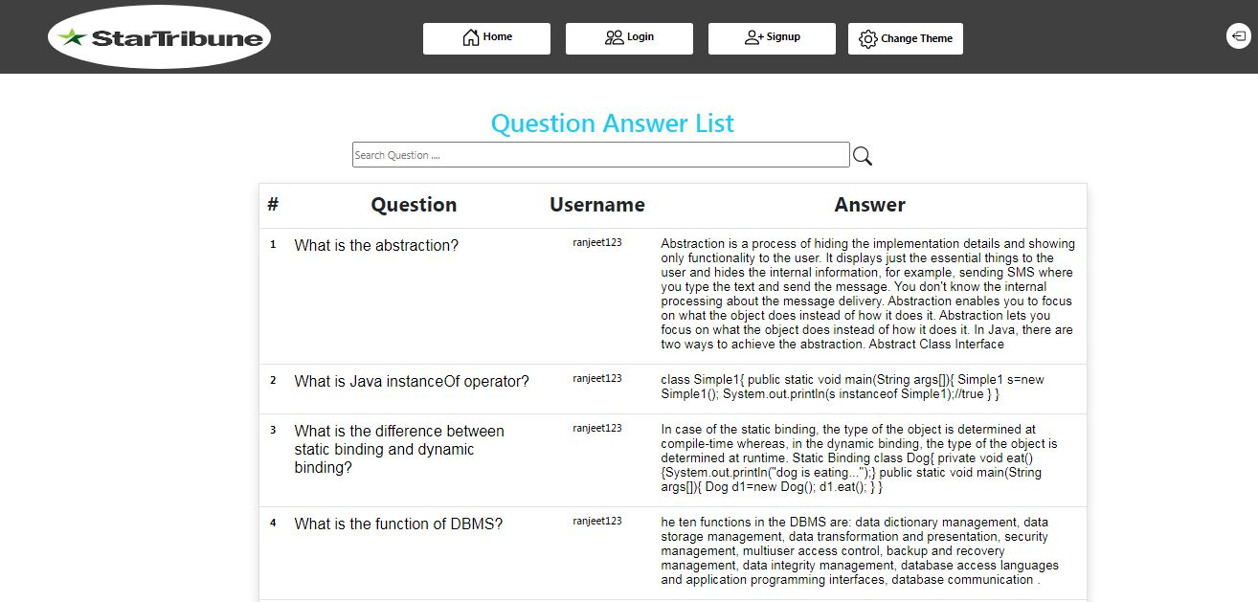

Step 2- Login page

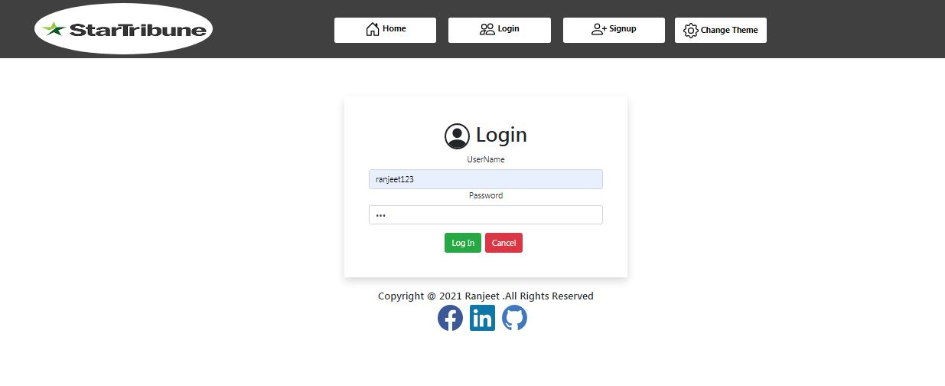

Step 3- after login success

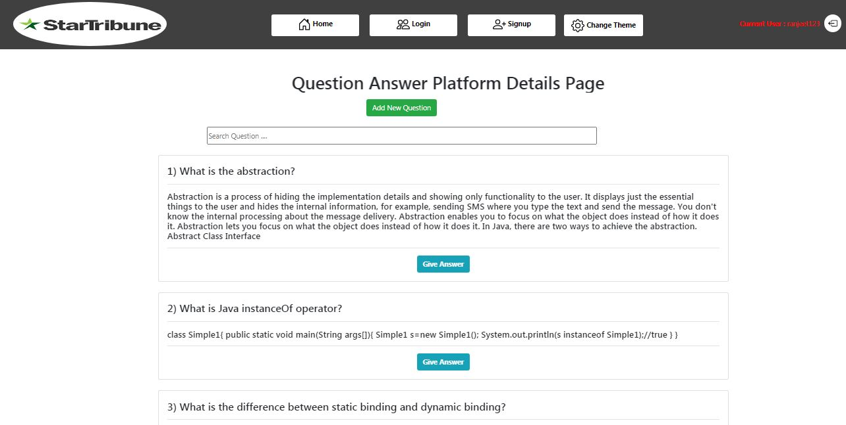

Step 4- click on give answer button then user can add own answer from the current question.

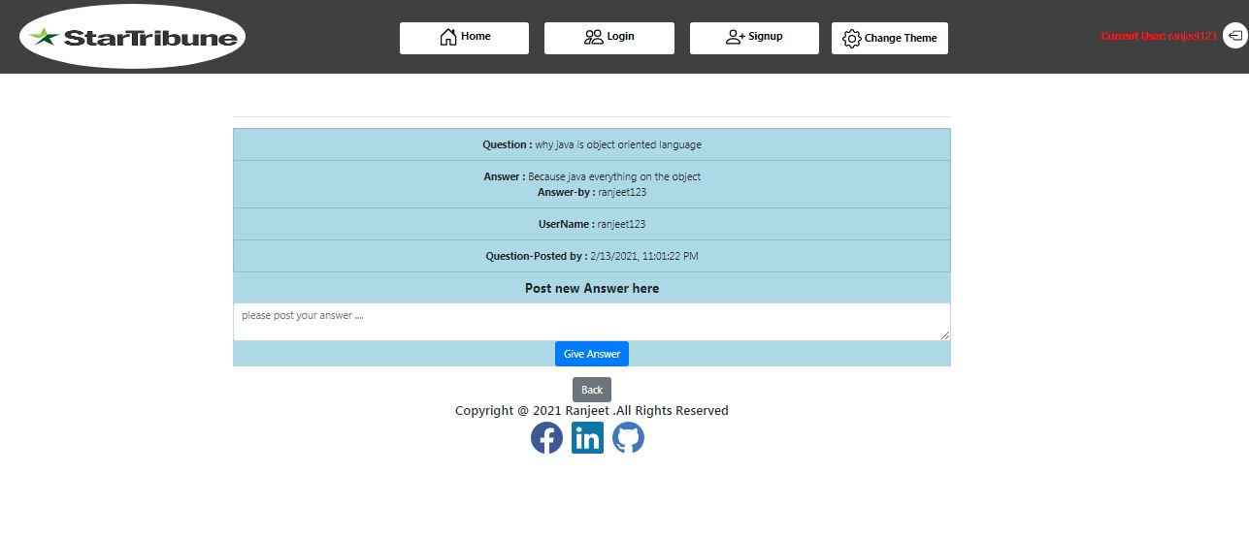

Step 5- User click add question button then above window will be open .

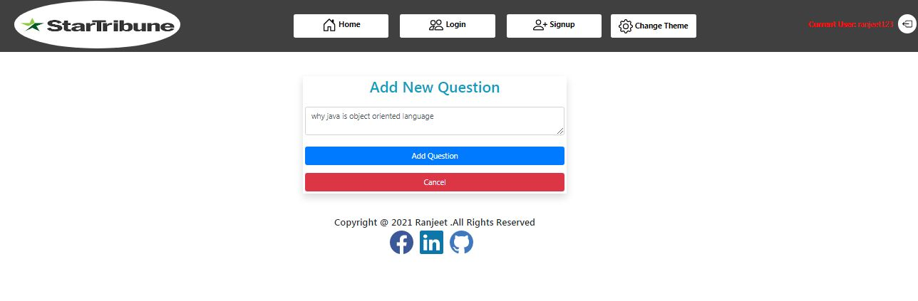

Step 6 –after create a new question then above question list will be shown.



Step -7 after adding new question then home screen will display the new question from top of the list.

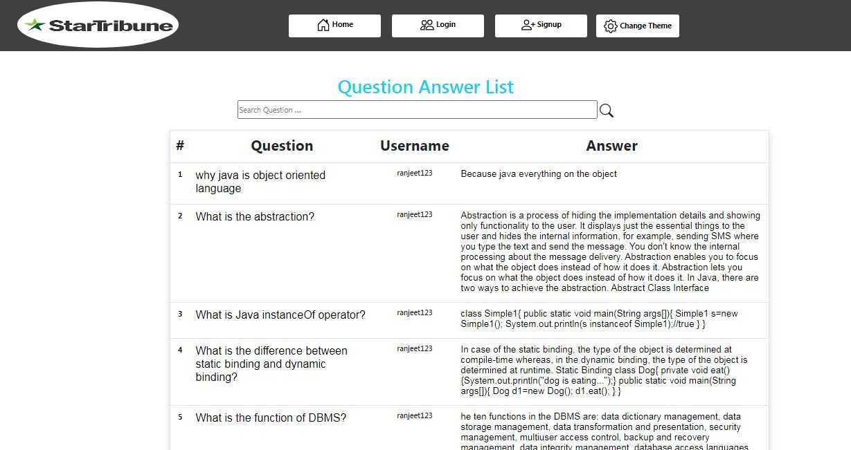

Step8- To enable the dark mode .click on change theme button

