**ONLINE BOOK SELLING (99Books)**

**A Project Report**

***Submitted by:***

**ANJALI SHIVHARE (OUI117BCS004)**

**RANJEET VISHWAKARMA (OUI117BCS015)**

**SOURAV MALVIYA (OUI117BCS023)**

***in partial fulfilment for the award of the degree***

***of***

**BACHELOR OF TECHNOLOGY**

**IN**

**COMPUTER SCIENCE AND ENGINEERING**

**at**



**Oriental University, Indore**

**DECLARATION**

I hereby declare that the project entitled **“Online Book Selling (99Books)”** submitted for the B. Tech. (CSE) the degree is my original work and the project has not formed the basis for the award of any other degree, diploma, fellowship or any other similar titles.

Anjali Shivhare

Ranjeet Vishwakarma

Sourav Malviya

**Signature of the Student**

**Place:** Indore

**Date:** 23/06/2021

**CERTIFICATE**

This is to certify that the project titled **“Online Book Selling (99Books)”** is the bonafide work carried out by ***Anjali Shivhare, Ranjeet Vishwakarma and Sourav Malviya,*** the student of B.Tech (CSE) of Oriental University Indore, during the academic year 2020-21, in partial fulfilment of the requirements for the award of the degree of Bachelor of Technology (Computer Science and Engineering) and that the project has not formed the basis for the award previously of any other degree, diploma, fellowship or any other similar title.

Dr Dinesh Jain

**Signature of the Guide**

**Place:** Indore

**Date:** 23/06/2021

**ACKNOWLEDGEMENT**

We want to express our deep sense of gratitude to our project guide **Dr Dinesh Jain Sir** who guided us throughout the project development and keeping us motivated. Also special thanks to **Dr Tanmay Kasbe Sir** who helped us in various aspects of the project development and documentation and make it possible and presentable.

We would also like to express our thanks to all our supportive Computer Science Department faculty members who have been a constant source of encouragement for the successful completion of the project. We would like to express our greatest appreciation to all individuals who have helped and supported us throughout the project.

A special acknowledgement goes to teammates who helped in completing the project by giving their valuable time, exchanging interesting ideas and sharing their experience.

This project has been a source to learn and bring our theoretical knowledge to the real-life world. So, we would acknowledge their help and guidance for this project. Also, it is a bridge between theoretical and practical learning and with this thinking, we worked on the project and made it successful due to the timely support and efforts of all who helped us.

In the end, we want to thank our friends who displayed appreciation for our work and motivate us to continue our work.

Ranjeet Vishwakarma

Anjali Shivhare

Sourav Malviya

**ABSTRACT**

**“99Books”** is a web application that acts as a central database containing various books in stock along with their title, author and cost. This web project is developed using HTML, CSS, JavaScript, Angular 1.0 and Bootstrap at the Front end, NodeJS at the Server end and MongoDB as a Database.

A user visiting the website can see a wide range of books arranged in respective categories. The user may select the desired book and view its price. If a user wants to purchase a book he can simply click on the buy option and the user is then redirected to the billing page where he/she can make payment directly with PayPal or Credit Card and purchase the books and can receive to billing address mentioned by the user at the time of registration or can change billing address at payment or billing page.

**“99Books”** is an open-source web project as it is developed using open sources NodeJS, and MongoDB database. This web application provides a huge database of different books present over the internet where a person can search interested books and purchase them through different payment options where the user can send a purchase order to a merchant online.

User can register themselves in the index webpage through the registration link and can sell or purchase books through the user home webpage where they can find different options as per their privilege. User can add their books for sale through the Sell Books link and can also purchase through the Books link by selecting different categories.

Furthermore, for a student to buy a book from any store is normally takes a lot of time and a lot of processes, Unavailability of some books when we arrive at the store leads us repeatedly visiting a particular store in other to get the book. Hence, this project became important for a web-based bookselling portal to provide fast service and save time.

The objective is to develop a fully functional online bookselling website to allow users to sell and buy books and obtain full utilization of books. To further make the system complete an enquiry system is put into place to determine if a buyer or seller wants to interact with the admin and confirming the book to be purchased or uploaded or have any query related to selling and buying.

The name of our project is **"99Books"**. Which is a book-selling portal of both old and new books. We provide a facility to the user which can be a student or any person who requires any book or want to sell any books.

**List of Figures**

1. Flow Chart……………………………………………………………………………………… 4
2. Data Flow Diagram Level-0……………………………………………………………………. 5
3. Data Flow Diagram Level-1 Admin………………………………………………………….… 6
4. Data Flow Diagram Level-1 User……………………………………………………………… 7
5. Entity Relationship Diagram…………………………………………………………………… 8
6. Home page…………………………………………………………………………………….. 13
7. Category page…………………………………………………………………………………. 13
8. About page……………………………………………………………………………………. 14
9. Contact us page……………………………………………………………………………….. 14
10. Register page………………………………………………………………………………….. 15
11. Login Page…………………………………………………………………………………….. 15
12. Add Category page……………………………………………………………………………. 16
13. Add Product page……………………………………………………………………………... 16
14. Users list………………………………………………………………………………………. 17
15. Books list……………………………………………………………………………………… 17
16. Our Team……………………………………………………………………………………… 18
17. Product Page…………………………………………………………………………………... 18
18. Admin panel Order page……………………………………………………………………… 19
19. Checkout page (Make payment) ……………………………………………………………... 19
20. Category page in mobile devices……………………………………………………………... 20
21. Register page in mobile devices……………………………………………………………… 20
22. Login page in mobile devices………………………………………………………………… 20
23. Footer in mobile devices……………………………………………………………………… 20
24. Admin home page in mobile devices…………………………………………………………. 20
25. Checkout page in mobile devices…………………………………………………………….. 20

**List of Database Collection Figures**

1. Database all collections……………………………………………………………………….. 21
2. Database category collection………………………………………………………………….. 21
3. Database orders collection……………………………………………………………………. 22
4. Database product collection…………………………………………………………………... 22

**Table of Contents**

Declaration……………………………………………………………………………………………… i Certificate………………………………………………………………………………………………. ii Acknowledgement.......………………………………………………………………………………… iii Abstract………………………………………………………………………………………………... iv List of Figures...………………………………………………………………………………………… v List of Collection……………………………………………………………………………………….. v **Chapter 1. Introduction**……………………………………………………………………………….. 1 1.1. Problem Definition………………………………………………………………………………… 1 1.2. Project Overview/Specification……………………………………………………………………. 2 1.3.1. Hardware Specification…………………………………………………………………………... 3 1.3.2. Software Specification…………………………………………………………………………… 3 **Chapter 2. System Analysis and Design**……………………………………………………………… 4 2.1.1. Flowchart………………………………………………………………………………………… 4 2.1.2. Data Flow Diagram………………………………………………………………………………. 5 2.1.3. Entity Relationships Diagram……………………………………………………………………. 8 2.2. Design and Test Steps / Criteria……………………………………………………………………. 9 2.3. Testing Process…………………………………………………………………………………… 11 **Chapter 3. Result / Outputs**………………………………………………………………………….. 13 **Chapter 4. Conclusions / Recommendations**……………………………………………………… 23 **Chapter 5. References**………………………………………………………………………………... 24 **Chapter 6. Appendices**……………………………………………………………………………….. 25

**Chapter 1. Introduction**

Our project “99books” website is the platform where customer can buy as well as sell books from the comfort of their home. Through our platform customer can browse through the catalogue and select the books of interest and we made the searching easier category wise. The selected books may be collected in a shopping cart which can be presented as an order at the time of checkout and payment can be made for the same through the available payment method and the book is made shipped to the customer's address within the specified time limit.

The following are the objectives that are fulfilled by creating an online shop for selling books online.

* To provide a wider market to the seller.
* To remove monopoly and provide better products to the customers
* To make products easily available to the customers.

**1.1 Problem Definition**

The process of buying books from a small scale business requires that the customers must move with cash in which may be dangerous to their life.

Furthermore, for a student to buy a book from any store is normally takes a lot of time and a lot of processes, Unavailability of some books when we arrive at the store leads us repeatedly visiting a particular store to get the book. Hence, this project became important for a web-based bookselling portal to provide fast service and save time.

The existing system is still a manual process therefore problems arises are:-

* Time-consuming
* Labour requirement more
* Lack of coordination
* The store has a limited area for the user to reach
* Assuming the current situation of COVID-19, no one want to go outside for any kind of work or selling or purchasing

With technologies, trends have shifted towards online purchasing but still, it has the following issues:-

* Not user friendly
* Navigation problems
* high cost of maintenance of their online portal due to old technology used in the development

Apart from this some books which are not useful for someone as they used them earlier but now that books become unwanted or unusable but these books can be useful for someone else who want to buy that book but unable to buy it as it's the cost is high, in this situation we are providing a platform for both of these type of peoples as the one who has unusable books, they can sale them and on the other hand, the person who wants to buy that book can directly buy from our website at low cost for it's reselling is definitely at a lower cost than actual new books and they don't need to wander to get their desired book.

**1.2 Project Overview/Specification**

The system will be a website where the users will come on and buy and sell their respective books on the site. The system uses numerous technologies like HTML, CSS, bootstrap, JavaScript, JQuery, NodeJs, ExpressJS, MongoDB to bring the whole project together.

We use MongoDB as a database so it can store a large amount of data.

The users of the website can see all the categories and availability of books available for sale and can directly contact us if he/she have any doubt or query.

For buying or selling a book a user must be registered on the website first then he/she can log in via the same details provided during registration. After registration, he/she is allowed to buying or selling books. The buyers can directly buy a book and the payment will be online with secure payment mode and the user will get the book at his door without going anywhere outside of his home to take the book. The user can buy new books as well as old books also at the cheapest cost.

Hence, another part of this project belongs to the users who want to sell their old books to be reused by other persons at a cheap cost. Here, a user can sell his books just by giving books details and images in a simple form even he/she can directly contact us by filling a contact-us form if he/she has any doubts or they can mail us at the given mail id on website.

The books uploaded by users(resellers) can be authenticated by Admin and if the admin found it well then he/she will allow it to available in public for all on the website. It's an amazing thing that a user can sell his old books easily without any worries and lot's of long processes, just by clicking on some buttons.

As we have mentioned about the person "Admin" he is the owner of the website or the person who have all rights to maintain this site. There is a different panel for all admins named Admin panel where admins can register once and can handle the whole website.

The admin can perform the following actions:

* They can authenticate a user or can block the user.
* They can add a new category, a subcategory of books or new books.
* They can allow a user to sell his old books after checking all details.
* They can view or handle all the data of the website and also can change the data if required.

So, It was the detailed overview and specification of our project. We have some future aspects for this project as in this project:

* we can add other payments mode also as Paytm, phone pay etc.
* The user will get a verification link after sign up for self-authentication so that the fake or unauthorized persons can't register on the website.

**1.3.1 Hardware Specification**

Any electronic device which supports internet connectivity and has any browser and search engine. The devices are like computers, laptop, mobile, tablet etc.

For the Developer, there is a requirement for any computer or laptop which have a minimum of 4GB ram and required space for the supporting software used in the development of this project. The supporting software's are, any IDE(vscode recommended) or notepad, NodeJs, MongoDB.

**1.3.2 Software Specification**

Any browser which has an updated version and supports JavaScript. We recommend the Chrome browser. For the Developer, there will be a requirement of some software, tools and modules. Which are mentioned below-

The software are-

* NodeJs
* MongoDB database

The modules are-

* express
* ejs (Embedded Javascript)
* mongoose
* express-fileupload
* express-session

**Chapter 2. System Analysis and Design**

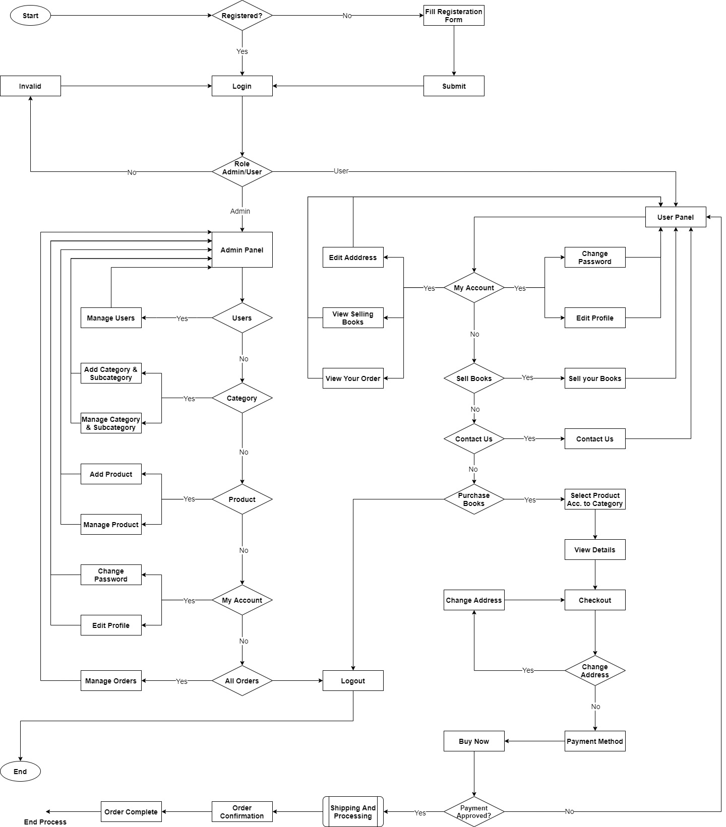**2.1.1 Flowchart**

Fig. 1 – Flow Chart

**2.1.2 Data Flow Diagram**

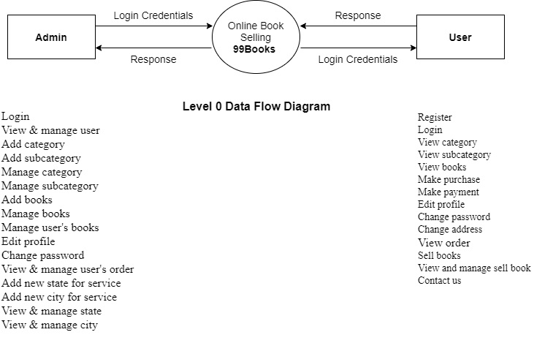

Fig. 2 – DFD Level-0

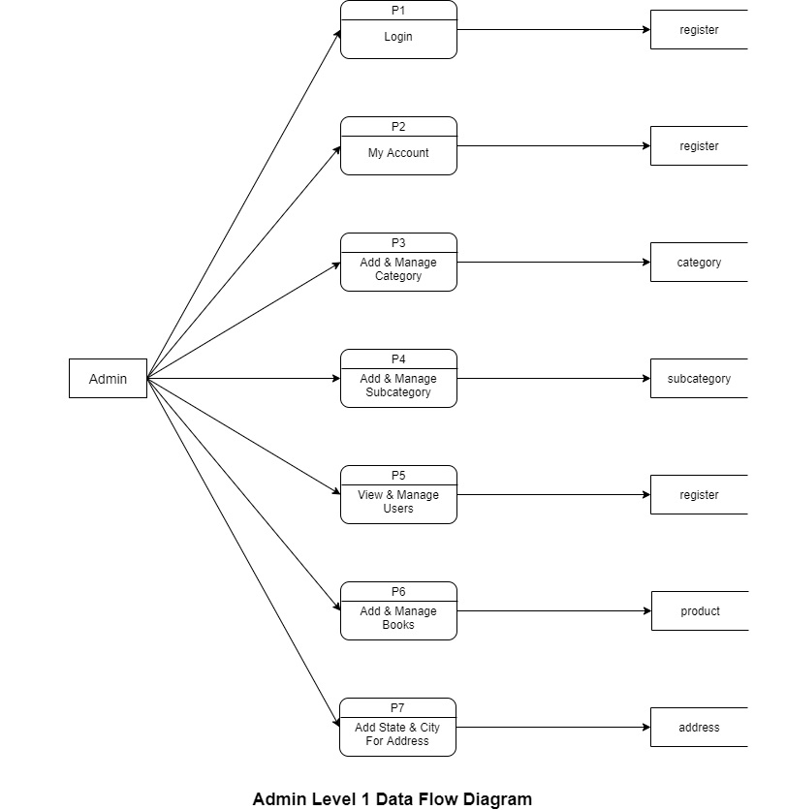Fig. 3 – Level 1 Admin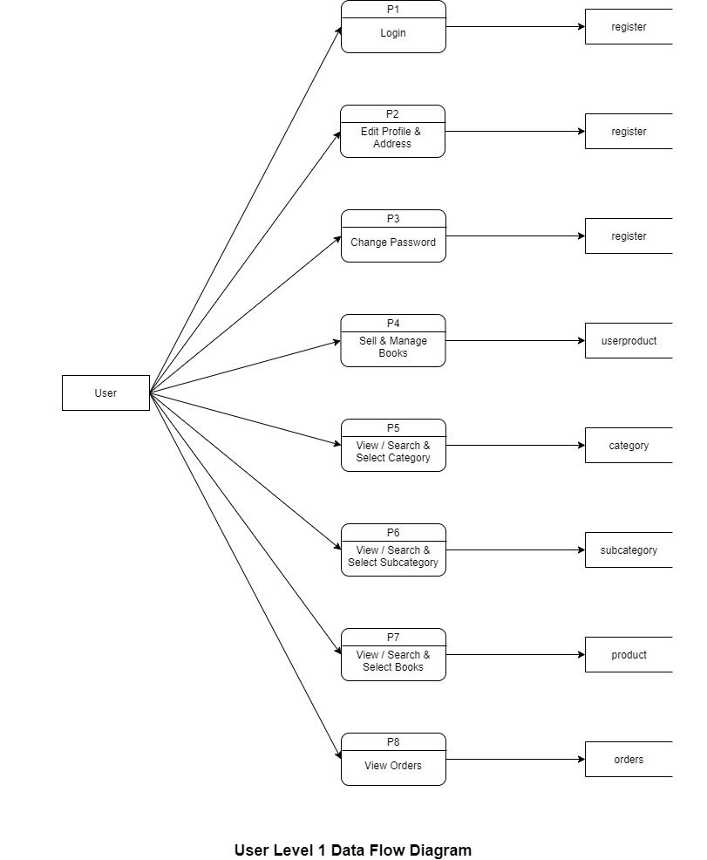

Fig. 4 – Level 1 User

**2.1.3 Entity Relationships Diagram**

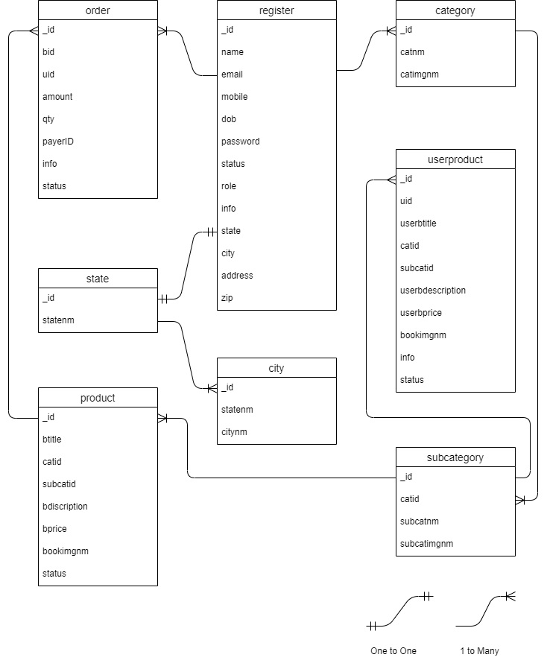

Fig. 5 – Entity Relationship Diagram

**2.2 Design and Test Steps / Criteria**

**2.2.1 Functionality Testing:-**

Test for – all the links in web pages, database connection, forms used for submitting or getting information from the user in the web pages, etc.

Check out all the links:

* Test the outgoing links from all the pages to the specific domain under test.
* Test all internal links.
* Test links jumping on the same page.
* Test links are used to send emails to admin or other users from web pages.
* Test to see if there are any orphan pages
* Finally, link checking includes, check for broken links in all the above-mentioned links.

Test forms on all pages:

Forms are an integral part of any website. Forms are used for receiving information from users and to interact with them. So what should be checked in these forms?

* First, check all the validations on each field.
* Check for default values in the fields.
* Wrong inputs in the forms to the fields in the forms.

Database Testing:

Data consistency is also very important in a web application. Check for data integrity and errors while you edit, delete, modify the forms or do any DB related functionality.

Check if all the database queries are executed correctly, data is retrieved and also updated correctly.

**2.2.2 Interface Testing**

In web testing, the server-side interface should be tested. This can be done by verifying that the communication is done properly. The compatibility of the server with software, hardware, network, and the database should be tested.

The main interfaces are:

* Web server and application server interface
* Application server and Database server interface.

Check if all the interactions between these servers are executed and errors are handled properly. If the database or web server returns an error message for any query by the application server then the application server should catch and display these error messages appropriately to the users.

**2.2.3 Compatibility Testing**

The compatibility of your website is a very important testing aspect. See which compatibility test to be executed:

* Browser compatibility
* Mobile browsing

Browser Compatibility:

Some applications are very dependent on browsers. Different browsers have different configurations and settings that your web page should be compatible with.

Your website coding should be cross-browser platform compatible. If you are using java scripts or AJAX calls for UI functionality, performing security checks or validations then give more stress on browser compatibility testing of your web application.

Test web applications on different browsers like Firefox, Chrome, Breve browsers.

Mobile Browsing:

We are in the new technology era. So in the future Mobile browsing will rock. Test your web pages on mobile browsers. Compatibility issues may be there on mobile devices as well.

**2.2.4 Security Testing**

The following are some of the test cases for web security testing:

* Test by pasting the internal URL directly into the browser address bar without login. Internal pages should not open.
* If you are logged in using a username and password and browsing internal pages, then try changing URL options directly. I.e. If you are checking some publisher site statistics with publisher site ID= 123. Try directly changing the URL site ID parameter to a different site ID that is not related to the logged-in user. Access should be denied for this user to view other people’s stats.
* Try some invalid inputs in input fields like login username, password, input text boxes, etc. Check the system’s reaction to all invalid inputs

**2.3 Testing Process**

**Test Cases**

Home Page

* The home page is the first page that appears to the user on the website.
* Some test cases are generated as under

Step 1: Click on Home – It is a link to the home page of the site

* Status – Fail
* Remark – Look whether a link is provided to the home click

Step 2: Click on Register – It is a link to the Register page

* Status – Pass
* Remark – None

Step 3: Click on Login – It is a link to the Register page

* Status – Pass
* Remark – None

Register Page

* The register page provides authentication to the user.
* The user is allowed to fill a registration form giving some information.
* Then the user is allowed to log in after successful register.
* Some test cases are generated as under:

Step 1: Enter a sign in id - Takes input in the register for the mail id and it accepts a similar one or duplicates one for the registered id.

* Status – Fail
* Remark – Check id from the database.

Step 2: Enter password - Takes input for the password and displays password entered in encrypted form.

* Status – Pass
* Remark – None

Step 3: Enter Name – Take the input for the name.

* Status – Pass
* Remark – None

Step 4: Enter Mobile number - Take the input for the mobile number.

* Status – Pass
* Remark – None

Step 5: Enter Email – Take the input for the email.

* Status – Pass
* Remark – None

Step 6: Click on the Register Button – If all fields are correct, the site will be directed to the login page.

* Status – Pass
* Remark – None

Login Page

* The sign-in is the page that the user authenticates himself for the website and use various resources and facilities.
* On the sign-in page, the user has to provide the username and password.
* If he/she provides a valid detail, he/she is successfully logged in to the site.
* Some test cases are generated as under:

Step 1: Enter your user name or email id – Takes input for the user’s login id.

* Status – Pass
* Remark – None

Step 2: Enter your password – Takes input for the password

* Status – Fail
* Remark – Incorrect password has been entered, check for the capslock or wrong entry.

Step 3: Click on Sign in button – The site is directed to the user home page

* Status – Pass
* Remark – None

**Chapter 3: Result / Outputs**

Some Screenshots of the website on large devices and small devices are below:

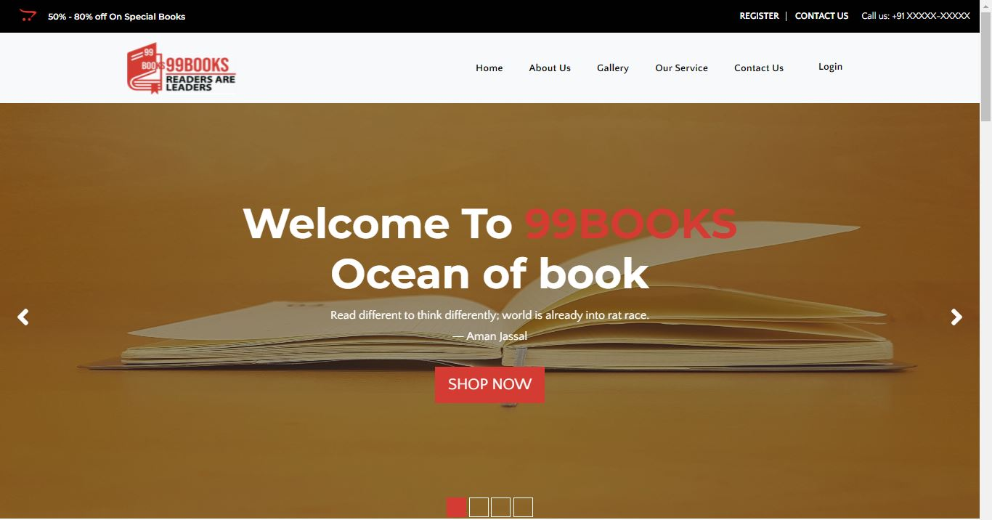

Fig. 6 – Home Page

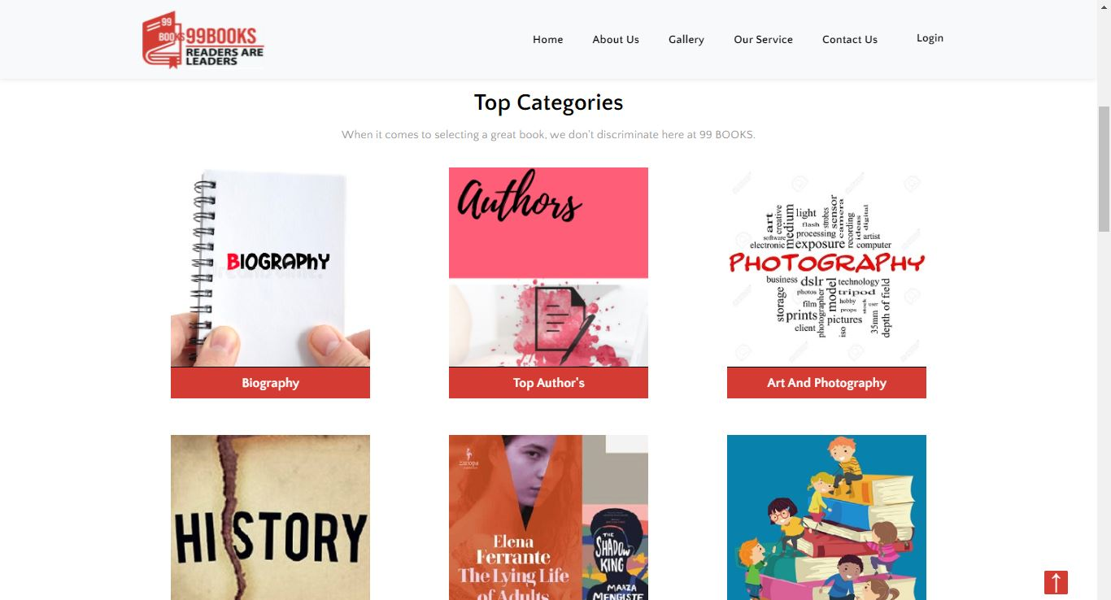

Fig. 7 – Category Page



Fig. 8 – About Us Page

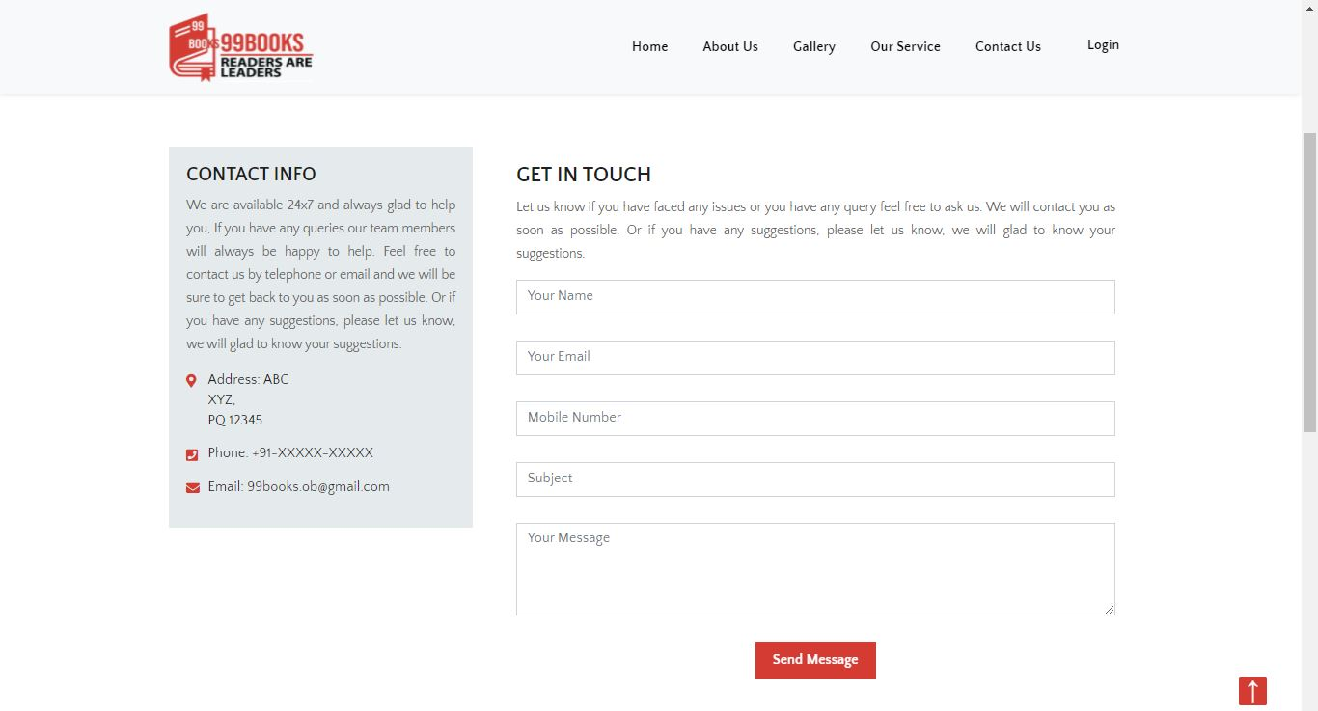

Fig. 9 – Contact Us Page

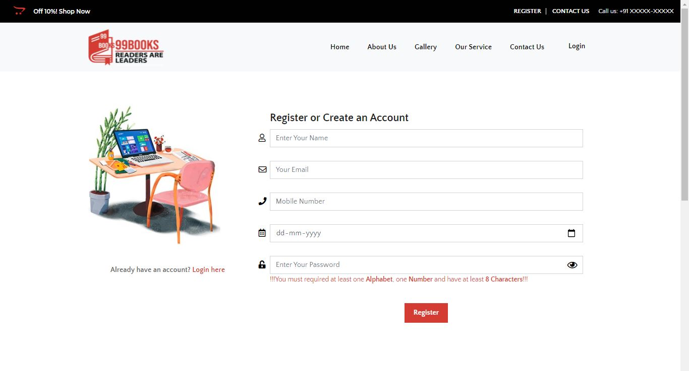

Fig. 10 – Register Page

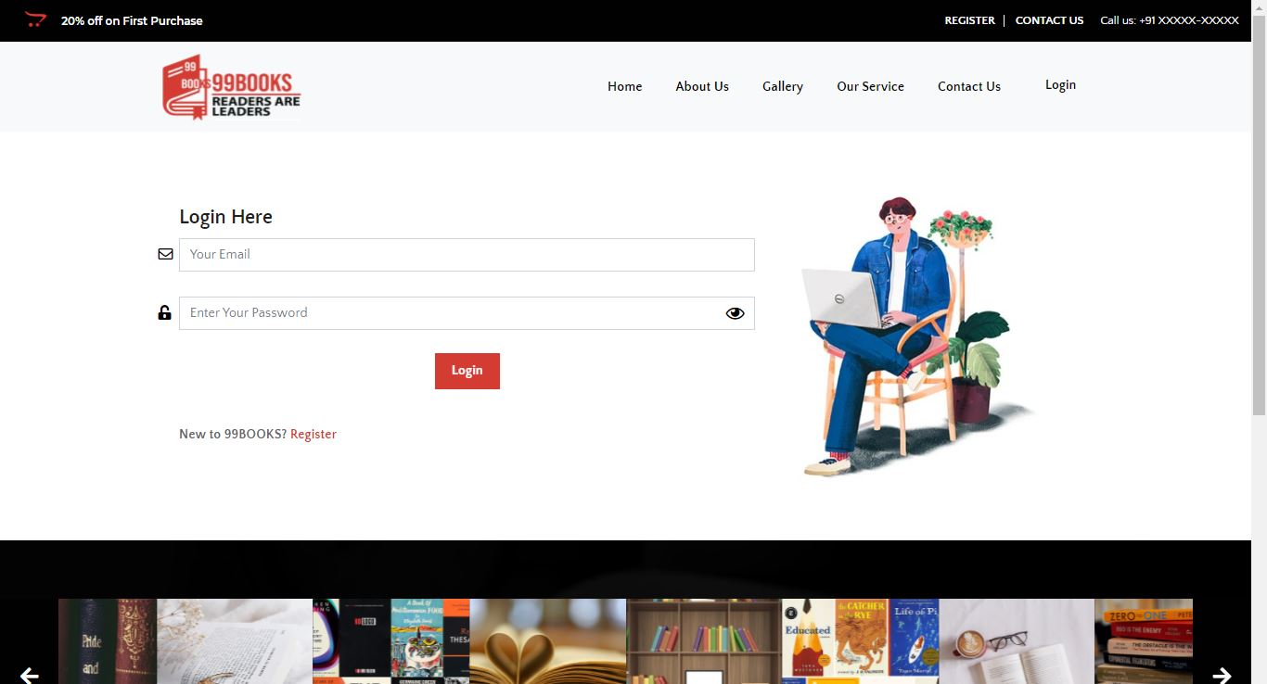

Fig. 11 – Login Page

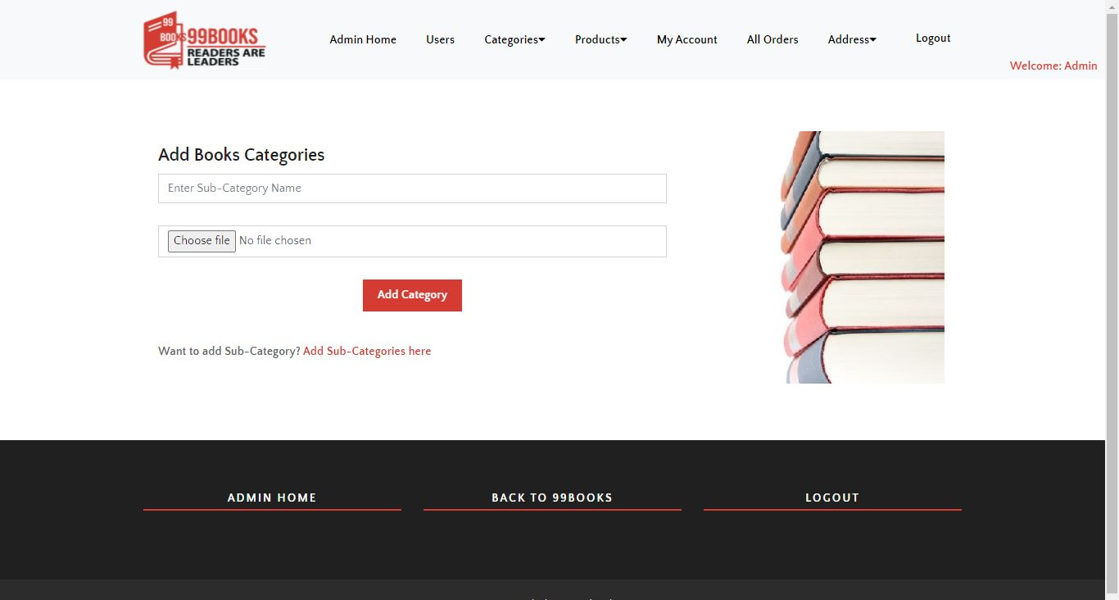

Fig. 12 – Admin Add Books Category Page

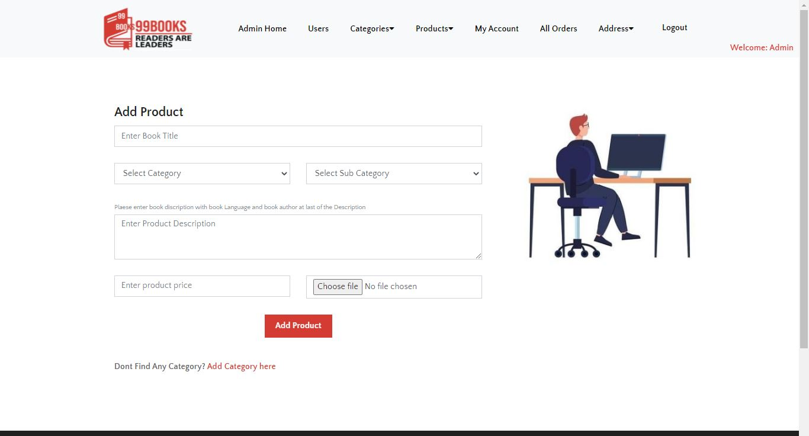

Fig. 13 – Admin Add Product Page

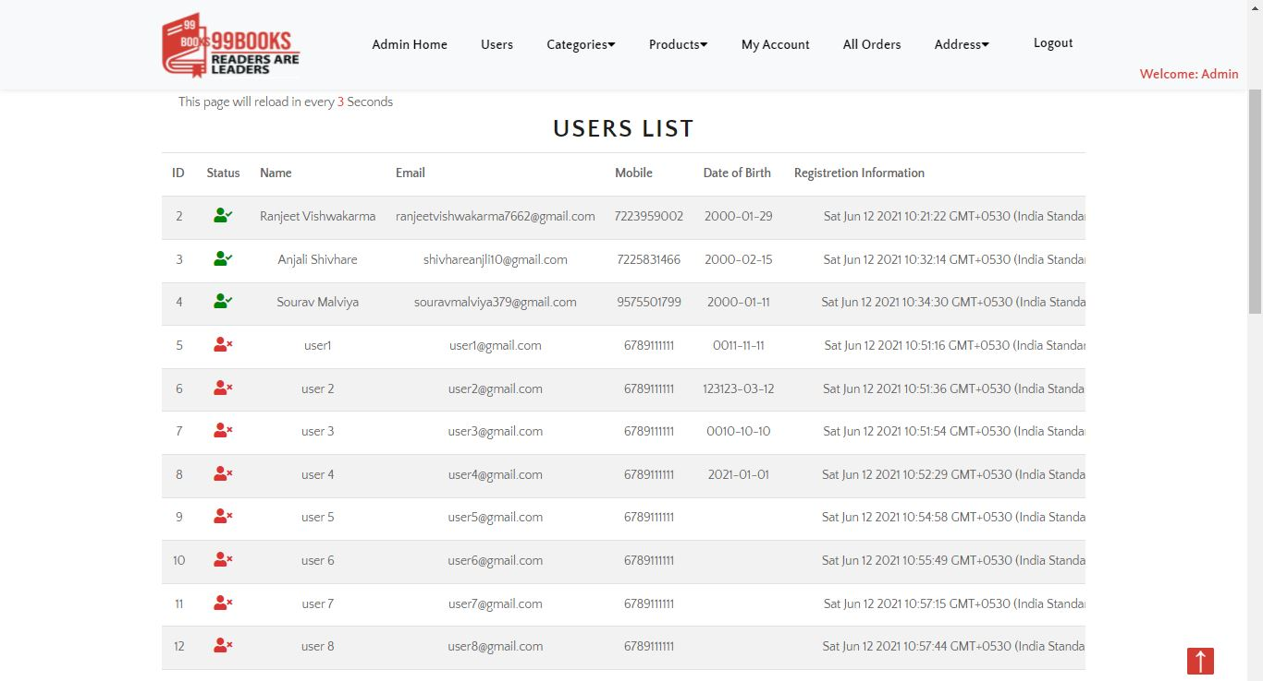

Fig. 14 – Admin Users List Page

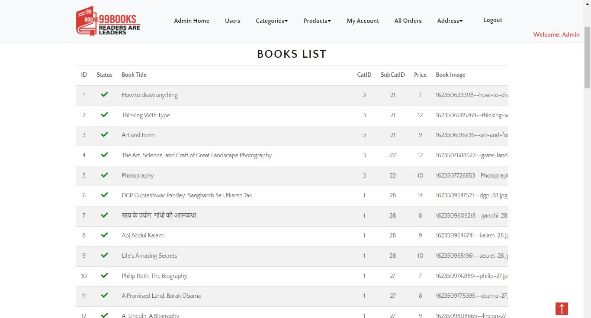

Fig. 15 – Admin Books List Page

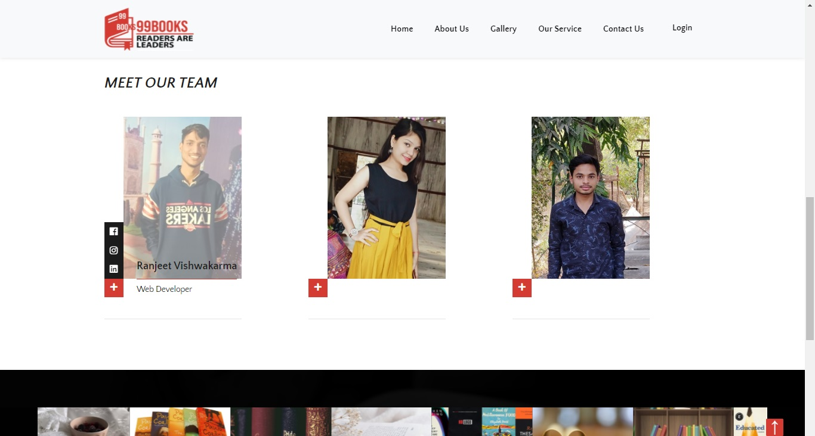

Fig. 16 – Our Team

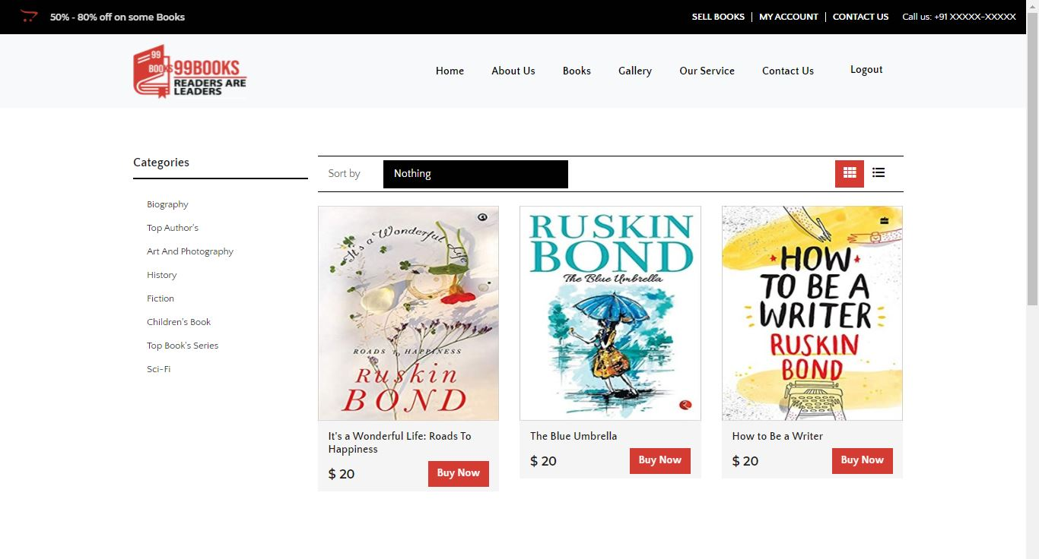

Fig. 17 – Product Page

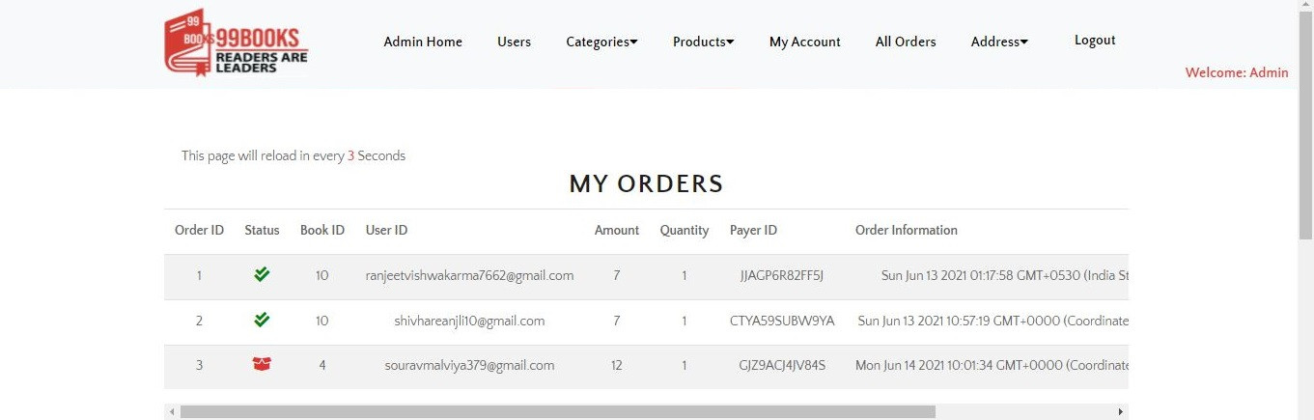

Fig. 18 – Admin My Order Page

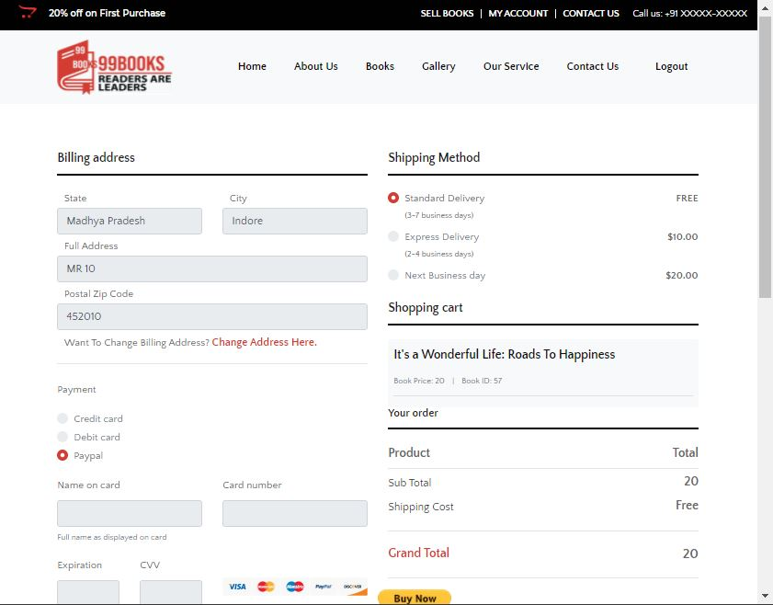

Fig. 19 – Checkout Page



Fig. 20 – Category page in mobile

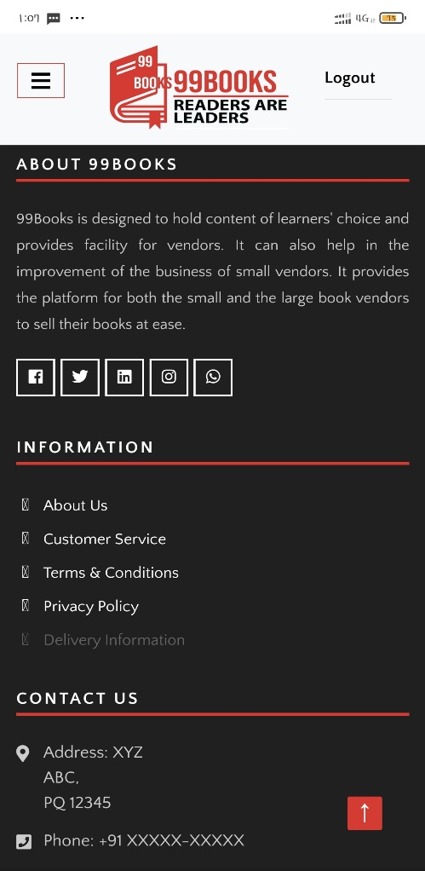

Fig. 23 – Footer in mobile

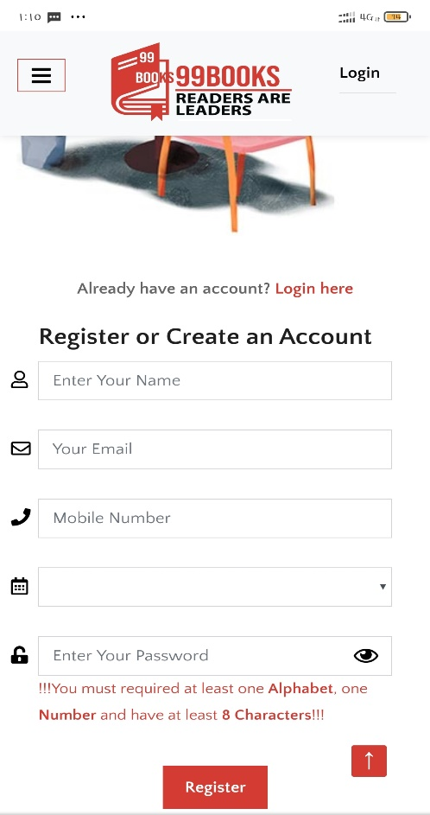

Fig. 21 – Register page in mobile

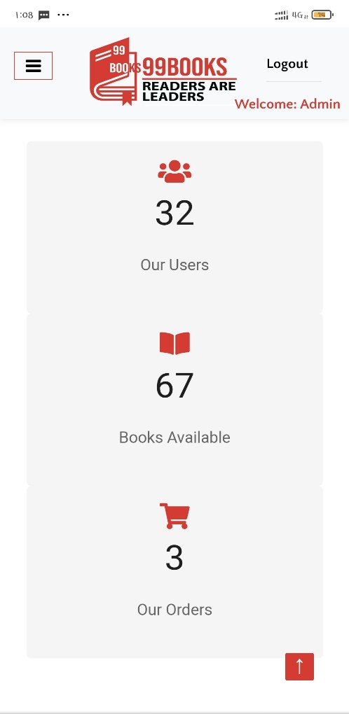

Fig. 24 – Admin Home in mobile

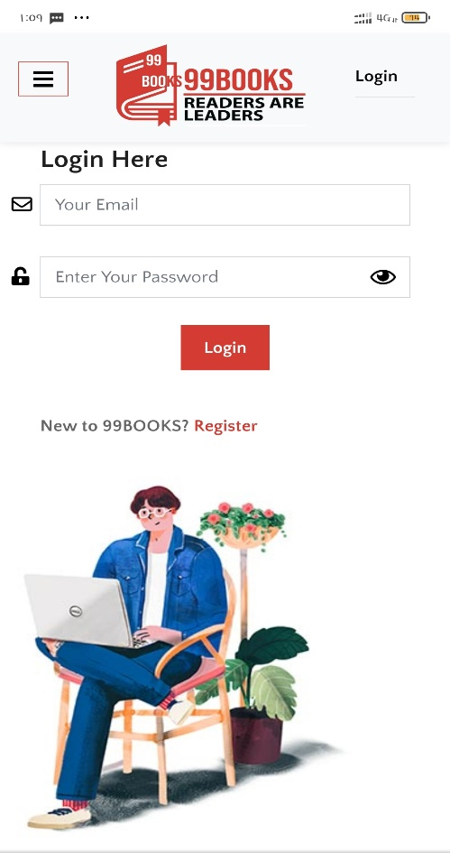

Fig. 22 – Login page in mobile

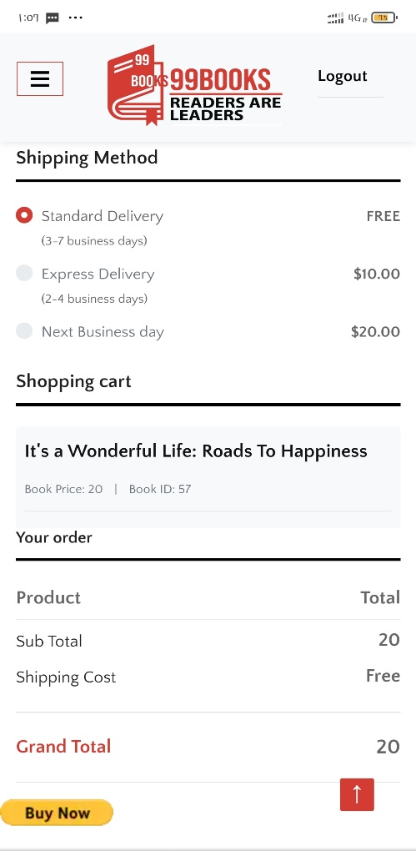

Fig. 25 – Checkout page in mobile

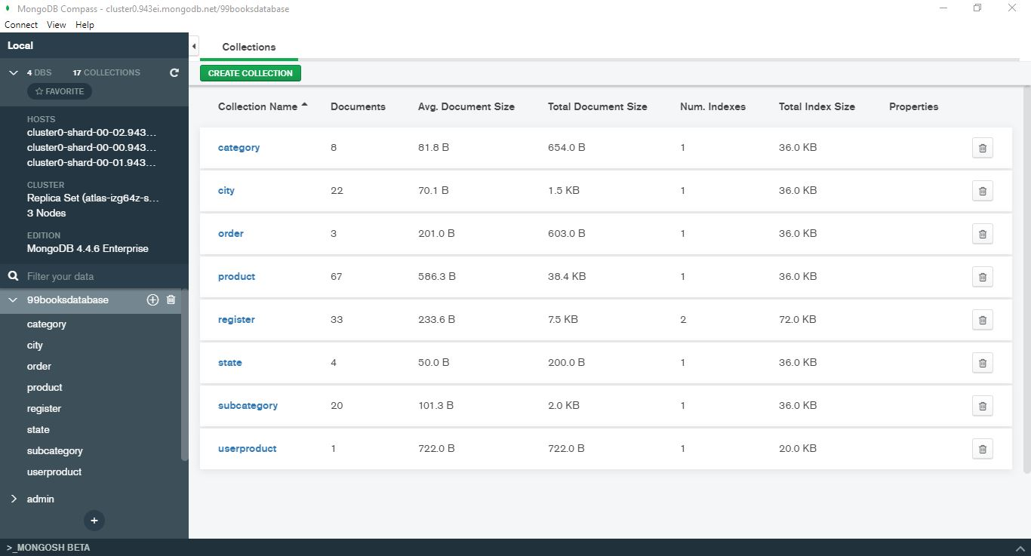

Fig. 26 – Database all collections name

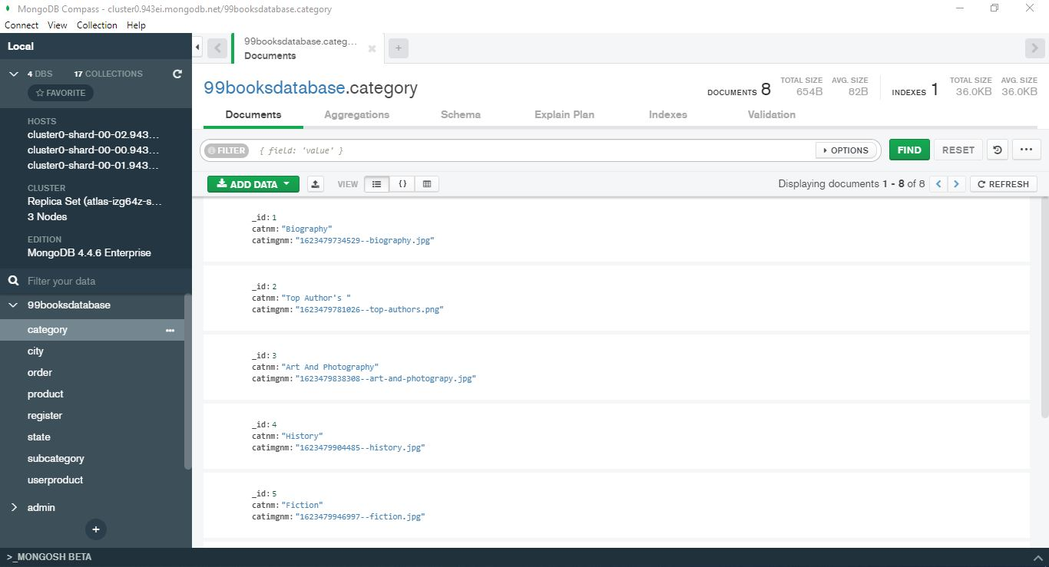

Fig. 27 – Database category collection

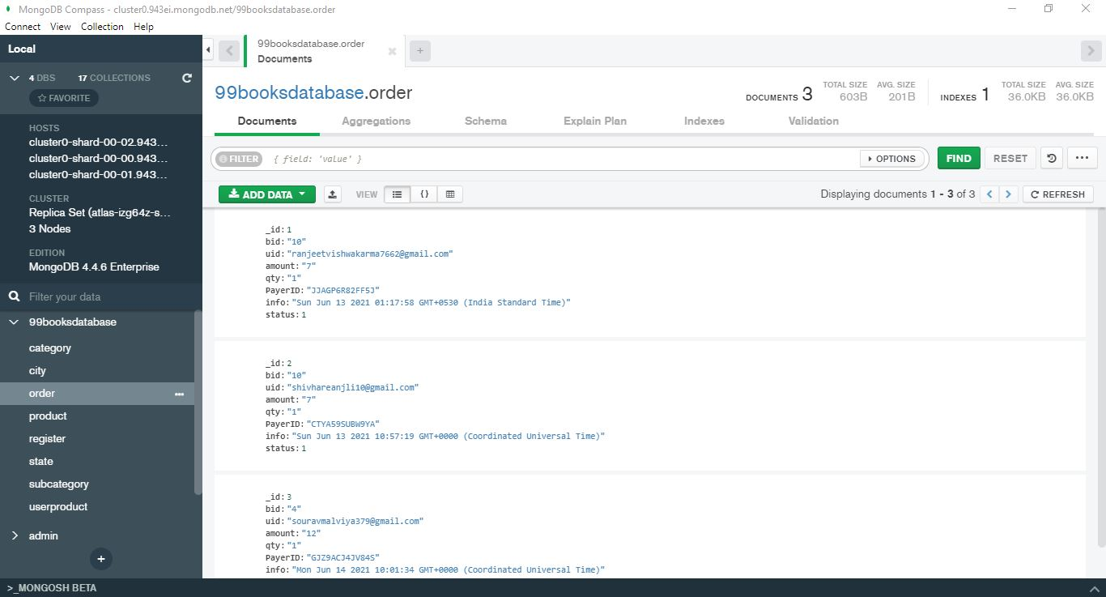

Fig. 28 – Database order collection

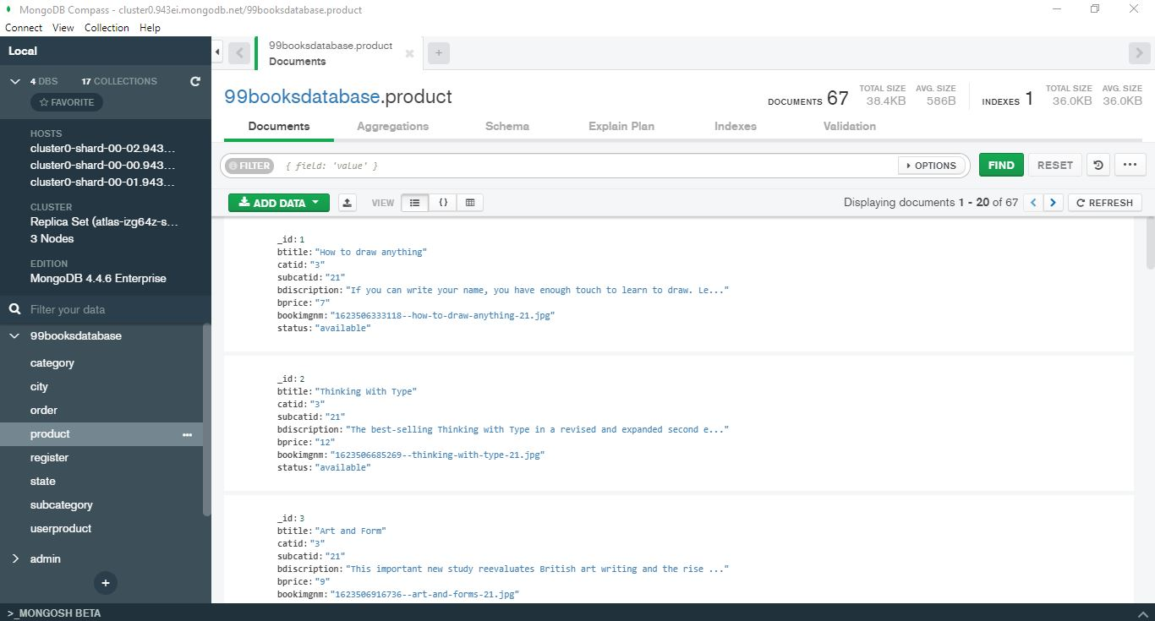

Fig. 29 – Database product collection

**Chapter 4. Conclusions / Recommendations**

The Book Selling system is designed in such a way that modifications can be done easily. The following conclusions may be deducted from the development of the project :

* It provides a friendly graphical user interface.
* It gives appropriate access to the authorized users depending on their permissions.
* The system has adequate scope for future modifications if it is necessary.
* We designed different panels for admin and user so that they find it easy to handle responsibilities.
* Admin is capable of blocking and verifying the user.
* Admin can manage category and products.
* The user is also capable of selling any type of books.
* But the admin has all the power to verify the user's product of selling so that it makes the website more effective and valuable.
* So that necessary changes can be performed regarding the orders and available products.
* As per the current scenario, the customer can directly order books without adding them to the cart.

Finally, the system is implemented and tested according to test cases.

**Future Recommendations:**

* Artificial Intelligence(AI) implementation can be done in future to learn about user’s interests. So that recommendation of user’s interest related books can be given when a user visits the website next time.
* The development of this project surely prompts many new areas of investigations. This project has wide scope to implement in any eCommerce website.
* A good shopping cart design may be accompanied by user-friendly shopping cart application logic.
* More payment methods may be added depending upon the customer’s comfort.
* More books category may be added depending upon the customer’s requirements.
* Also, more language of books can be added depending upon the customer’s requirements.

**Chapter 5. References**

1. Node Js JavaScript runtime built, <https://nodejs.org/en/>
2. Template integration, <https://www.free-css.com/free-css-templates/page246/thewayshop>
3. For any query, <https://stackoverflow.com/>
4. Additional Information, <https://www.w3schools.com/>
5. Icons used in website, <https://fontawesome.com/v4.7/icons/>
6. HTML related basic information, <https://html.com/>
7. Provide an online platform for storage of source code and give accessibility for hosting web application with ‘Herokuapp’, <https://github.com/>
8. Provide an online platform for hosting on www, <https://www.heroku.com/>
9. Payment integration for developer perspective, <https://www.sandbox.paypal.com/>
10. Database for storing data, <https://www.mongodb.com/>
11. Help in adding source code on Git-Hub, <https://git-scm.com/doc>
12. ERD, Abraham Silberchatz, Henry F. Korth, S. Sudarsham, “Database System Concept”, 4th Edition, The McGraw-Hill Companies, NY, USA, 2002, page 212-222
13. DFD, Award, Elias M. Award, “System Analysis and Design”, 2nd Edition, Richard D. Irwin, Inc, 2000, Page 145-160
14. ERD, DFD, Flowchart Diagrams make, <https://app.diagrams.net/>
15. Abstract Description, <https://www.slideshare.net/gennieyoffe/online-shopping-report6-month-project?qid=a07cee76-4efd-4787-822e-b8ed8f9ddcc8&v=&b=&from_search=2>
16. References description, <https://www.slideshare.net/luckymoni76/c111230?qid=6fca8c26-dba4-48a7-8eab-b308e5c12d14&v=&b=&from_search=2>
17. Testing, <https://www.softwaretestinghelp.com/web-application-testing/>
18. For CSS, <https://www.tutorialspoint.com/css/index.htm>
19. For JavaScript, <https://www.javatpoint.com/javascript-tutorial>

**Chapter 6. Appendices**

This is a project report on Online Books Selling Portal "99Books". During the making/development of this project, we explored new ideas and functionality.

This project is the output of our planning, schedule, programming skill and hard work and this report reflects our steps taken at various levels of programming skill, planning and schedule.

We have learnt a lot during this project and liked the improvement in our skills and deep concept related to these kinds of projects.

Our project is Online Books Selling Portal "99Books". This is a web-based application that helps people to find, buy and sell new and old books with different functionalities on the internet. It is useful in the way that it makes an easier way to buy and sell new as well as old books online.

In this application, we have 2 modules. The first module includes the user's module and the second one is the admin module.

The customer has to register for any enquiry related to selling the books but for any other queries, he/she can contact without registration. The unregistered person can only access the home page and some other page that can attract the person to register for this application. The registered user can view all details of books and he/she can buy the books of his choice and need or the registered user can also sell the books which are not useful for his/her but can be useful for others.

The admin module contains the access of admin on the application. The admin can modify or update many things in the application. He can add, delete, update any information regarding the books or users.

Email (Ranjeet Vishwakarma): [ranjeetvishwakarma7662@gmail.com](mailto:ranjeetvishwakarma7662@gmail.com) Contact: +91 7223959002

Email (Anjali Shivhare): [shivhareanjali10@gmail.com](mailto:shivhareanjali10@gmail.com) Contact: +91 7225831466

Email (Sourav Malviya): [souravmalviya379@gmail.com](mailto:souravmalviya379@gmail.com) Contact: +91 9575501799

Website Link: <https://books99ob.herokuapp.com/>

**\*\*\*\*\*\*\*\*\*\*\*\*\*\*\*\*End of Report\*\*\*\*\*\*\*\*\*\*\*\*\*\*\*\***