**Sales Insights Data Analysis Project**

* AIMS grid (project management tool)

1. Purpose
2. Stakeholders
3. End result
4. Success criteria

* **OLTP or Online Transaction Processing** is a type of data processing that consists of executing a number of transactions occurring concurrently—online banking, shopping, order entry, or sending text messages, for example.
* **Extract, transform, and load (ETL)** is the process of combining data from multiple sources into a large, central repository called a data warehouse. ETL uses a set of business rules to clean and organize raw data and prepare it for storage, data analytics, and machine learning (ML).
* **Online analytical processing (OLAP)** is software technology you can use to analyze business data from different points of view. Organizations collect and store data from multiple data sources, such as websites, applications, smart meters, and internal systems.
* A **star schema** is a multi-dimensional data model used to organize data in a database so that it is easy to understand and analyze. Star schemas can be applied to data warehouses, databases, data marts, and other tools. The star schema design is optimized for querying large data sets. 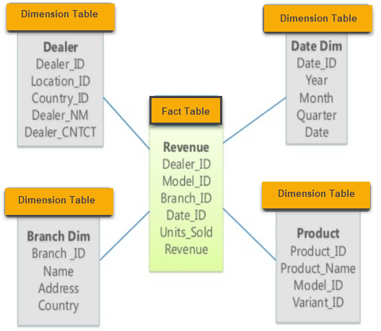

1. Have db
2. Load db in mysql server
3. Connect the mysql db to power bi
4. Load the data [ETL]
5. Transform data