**GRAPHS:**

**Winter:**

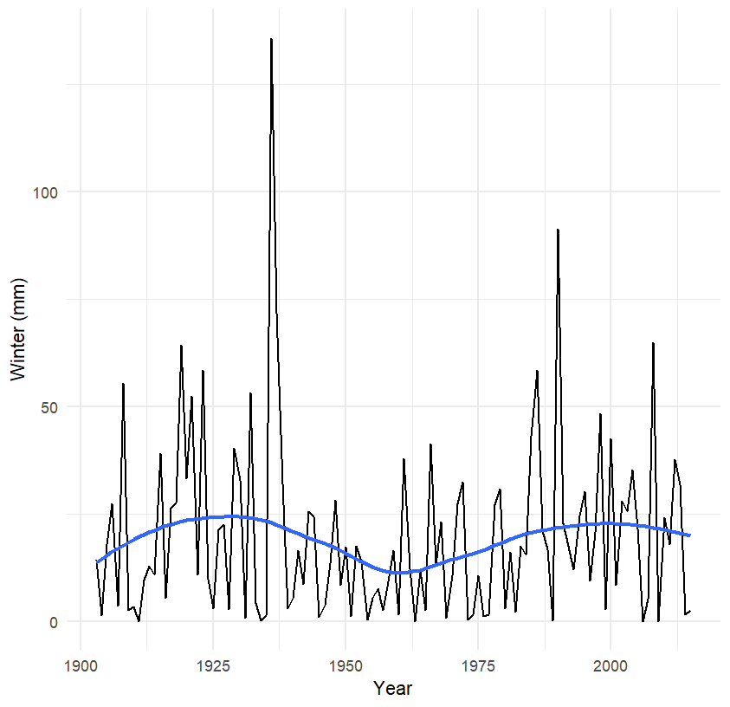

**Pre-Monsoon:**

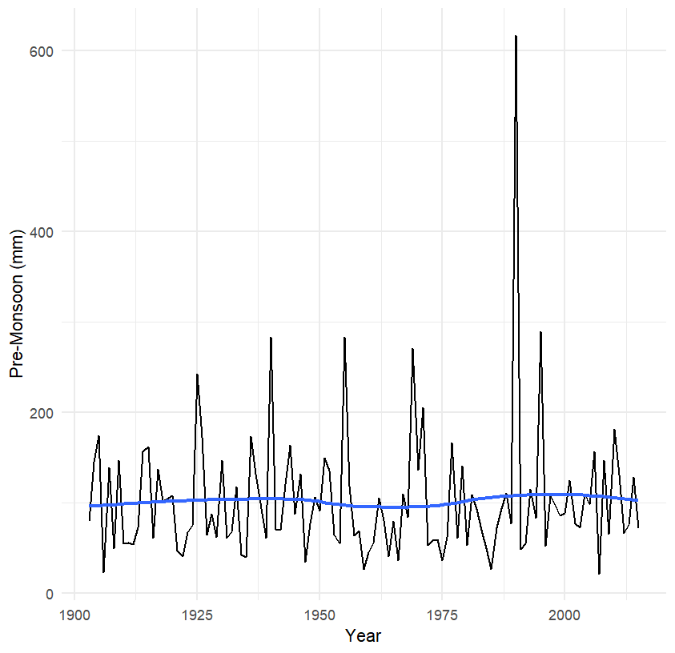

**Post-Monsoon:**

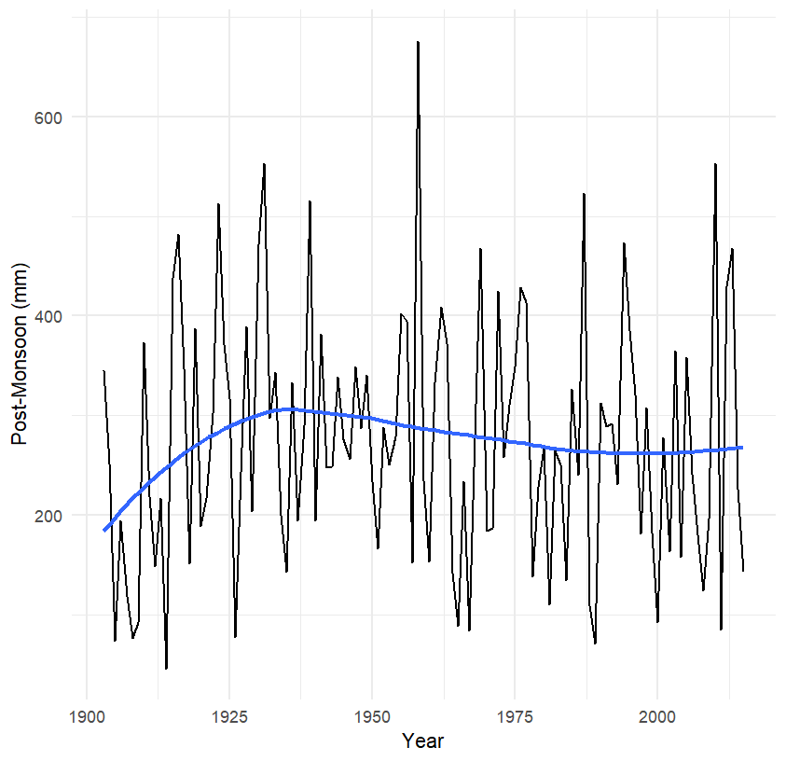

**Monsoon:**

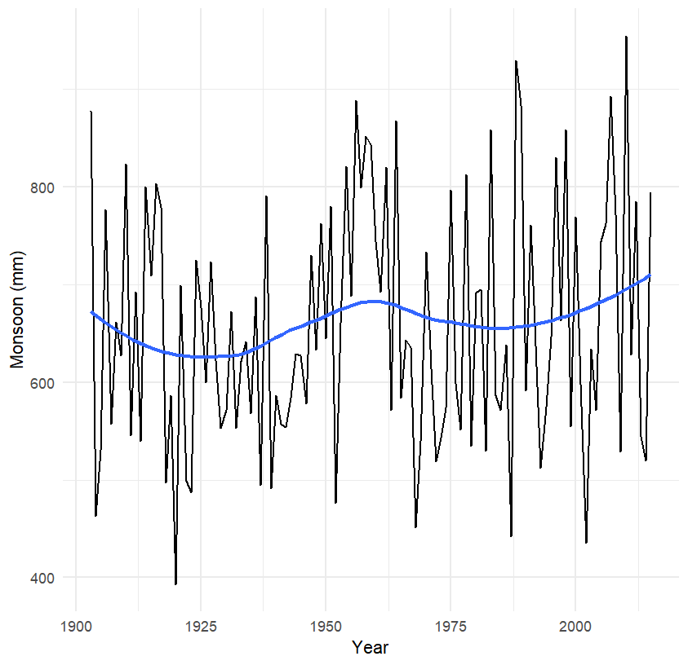

**Annual:**

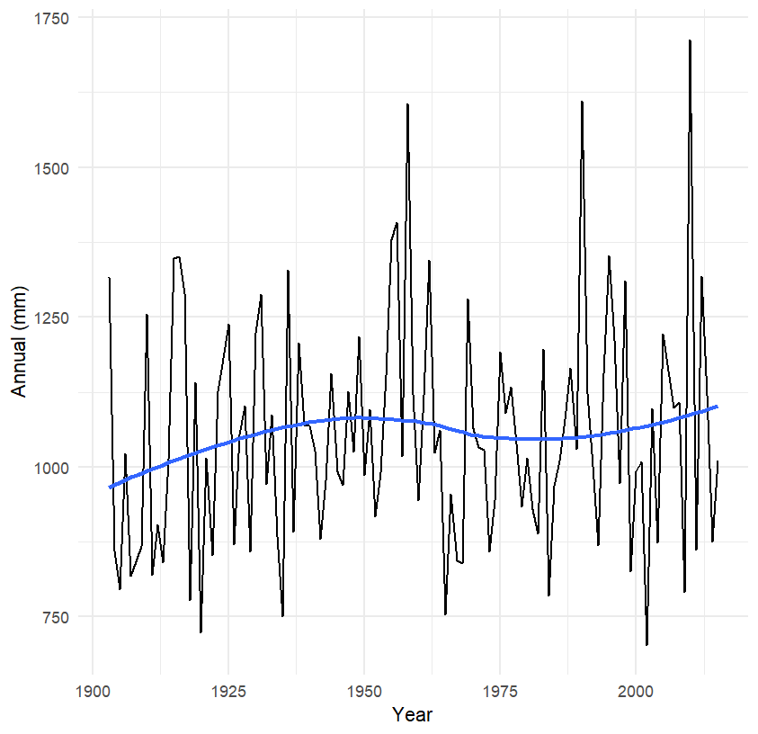

**Predicted rainfall in Winter season**

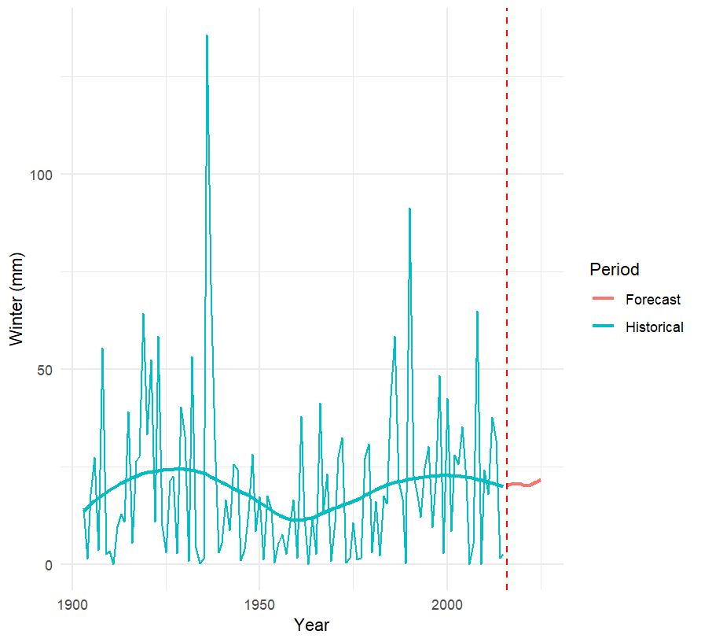

**Predicted rainfall in Pre-Monsoon season**

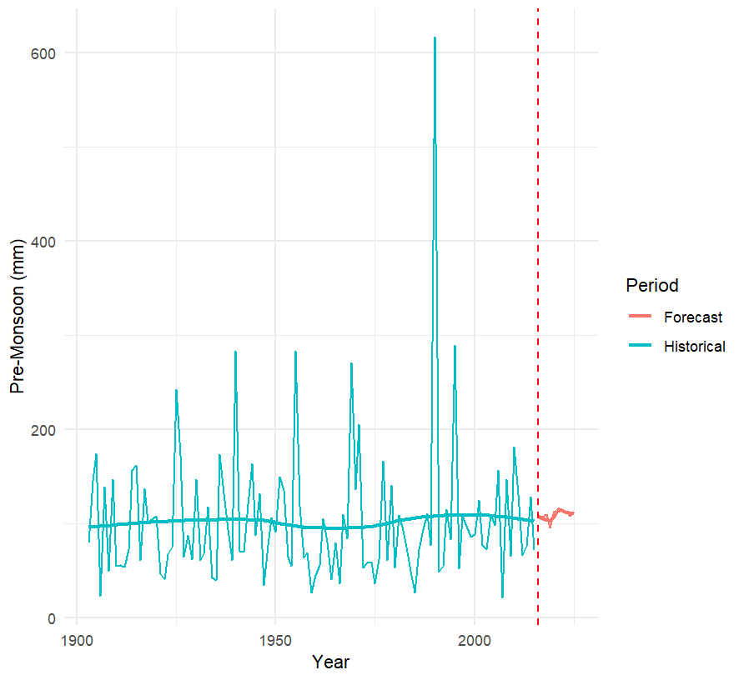

**Predicted Rainfall of Monsoon season**

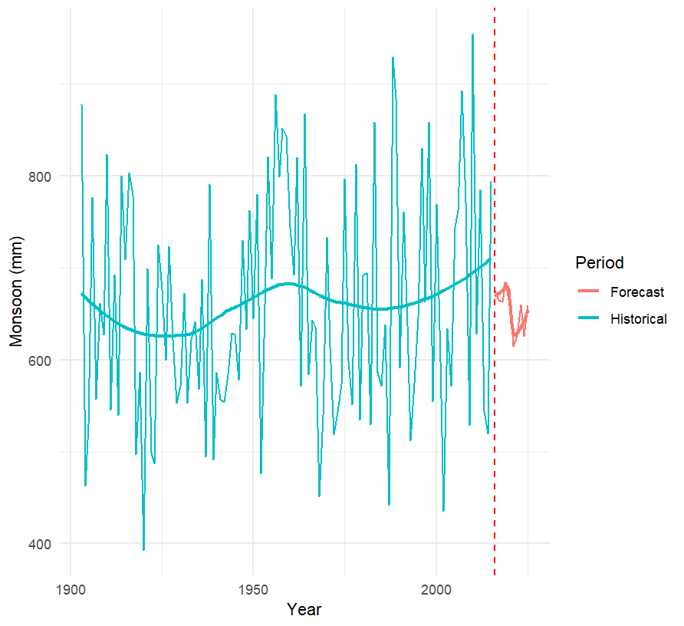

**4.4 Predicted Rainfall of Post-Monsoon season**



**Predicted Annual Rainfall**

