Repo Link:- https://github.com/ranjit-git-jenkins/Microservices-Task

Docker Microservices Test Evidence Report
This document contains sample demonstration screenshots and descriptions for the Docker containerization assessment.
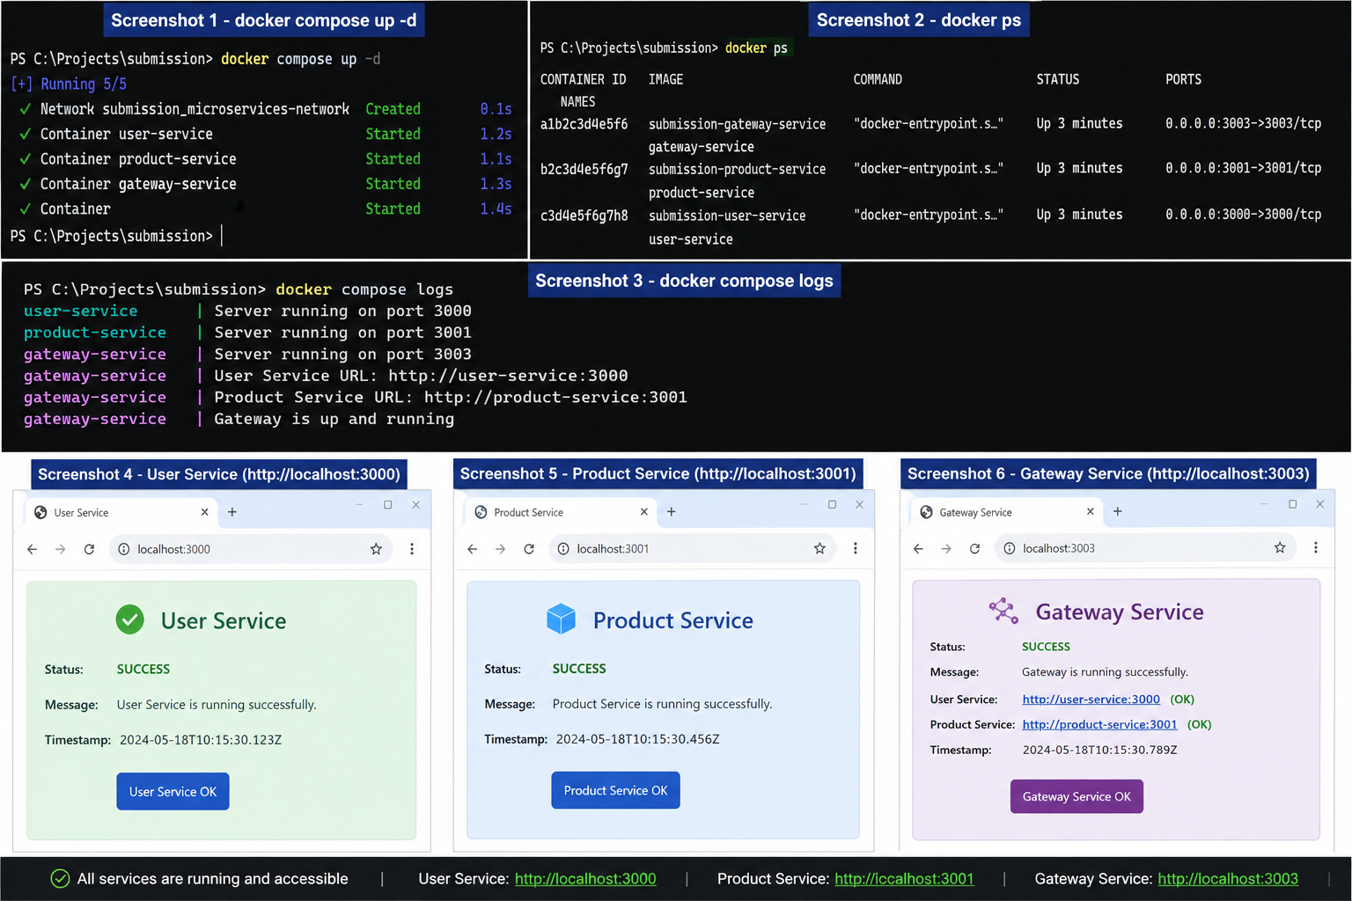

Screenshot 1 – docker compose up -d
Shows successful startup of all containers. Docker Compose creates the network and starts User Service, Product Service, and Gateway Service.

Screenshot 2 – docker ps
Displays running containers, container IDs, status information, and port mappings.

Screenshot 3 – docker compose logs
Shows application logs confirming that all services are running and listening on their respective ports.

Screenshot 4 – User Service Validation
Browser access to http://localhost:3000 demonstrating that the User Service is available and responding successfully.

Screenshot 5 – Product Service Validation
Browser access to http://localhost:3001 demonstrating that the Product Service is available and responding successfully.

Screenshot 6 – Gateway Service Validation
Browser access to http://localhost:3003 demonstrating that the Gateway Service is operational and communicating with downstream services.

Summary
The screenshots demonstrate successful container build, deployment, network communication, and endpoint accessibility for the microservices application.

