# CHAPTER 5: TESTING

Testing is done at the end of software development lifecycle. Its main purpose is to check if actual results have been produced from the designed software. It helps in finding out where the error lies, how the system is performing and supposed to perform. It can be done manually or also through some automated tools.

For my project, I have used black box testing and white box testing.

## **Black box testing:**

Black box testing is the process of testing a software where functionality of the application is checked rather than the internal code structure. The detail structure and paths of is not checked in this part of testing. Just input and output is focused on this type of testing.

## **Unit testing:**

Unit testing is a part of white box testing where test is done and it impacts directly upon your application. Its main aim is to prevent as many bugs from introduced. Unit testing is mainly done by developers themselves.

|  |  |
| --- | --- |
| Test no.1 | 1 |
| Purpose of the test | To check whether login function is working properly or not by providing username and password |
| Test data | User(ramesh@gmail.com)  Admin (Hari) |
| Test name | Login test (user and admin) |
| Expected Result | Login test needs to be success and gets user directed to homepage and admin to dashboard. |
| Actual result | User gets successfully logged in to home page and admin gets successfully logged in to dashboard. |
| Test Status | success |

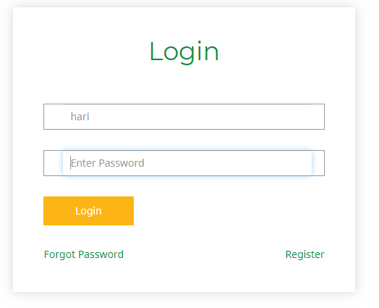

Fig: Black Box testing for admin login

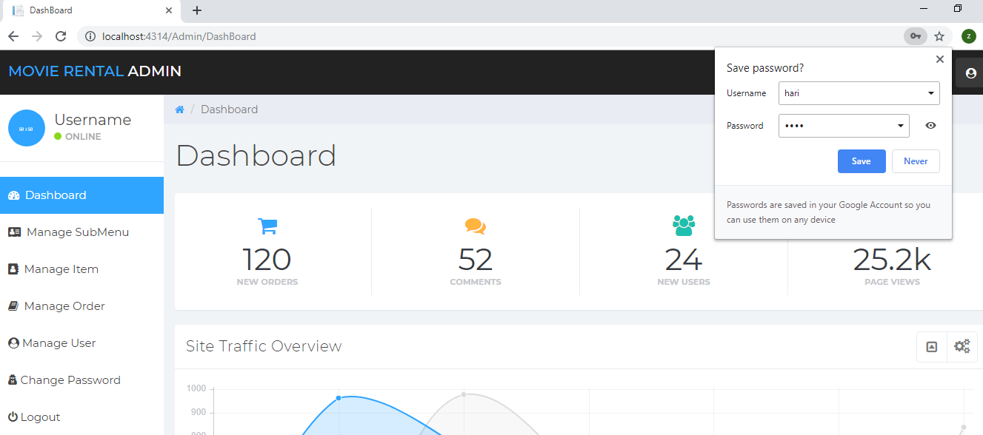

Fig: redirected to admin dashboard after login

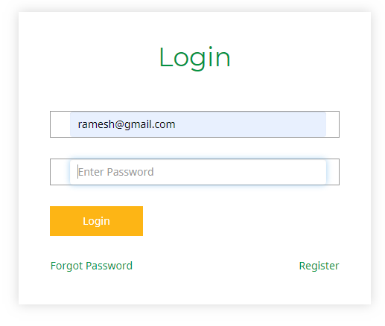

Fig: Black box testing for user login

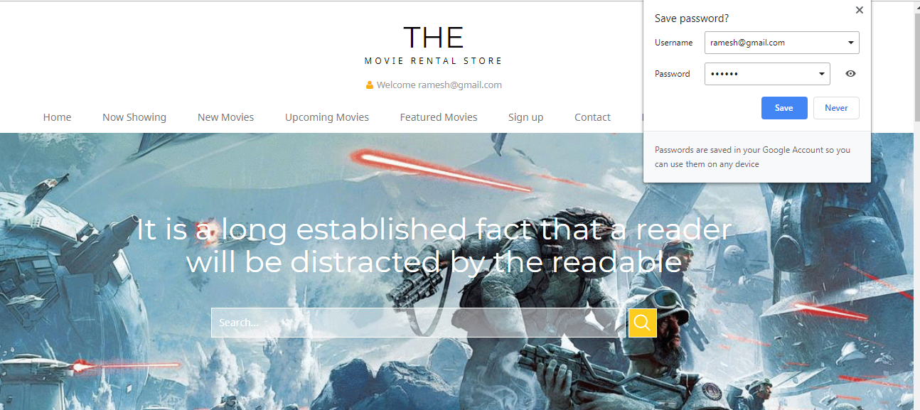

Fig: user gets redirected to homepage after login

|  |  |
| --- | --- |
| Test no.1 | 2 |
| Purpose of the test | To check whether registration function is working properly or not by providing required information fields |
| Test data | shyam@gmail.com |
| Test name | Registration test |
| Expected Result | User needs to gets registered successfully |
| Actual result | User gets registered successfully |
| Test Status | success |

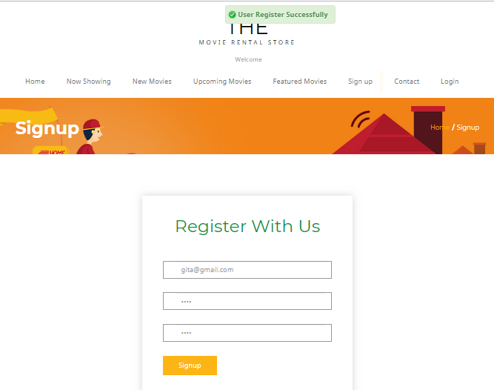

Fig: Black box testing for user registration

|  |  |
| --- | --- |
| Test no.1 | 3 |
| Purpose of the test | To check whether movie gets managed in the system |
| Test data | Spiderman |
| Test name | Movie manage test |
| Expected Result | Movie needs to be added, edited or deleted in the system |
| Actual result | Movie added, deleted successful |
| Test Status | success |

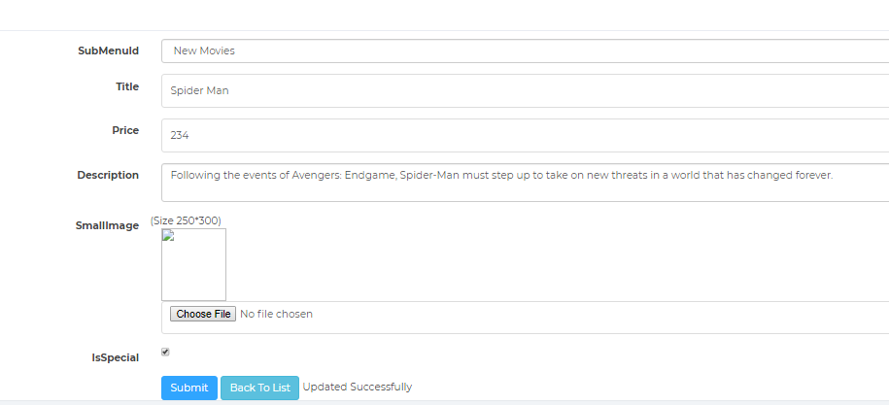

Fig: Black box testing for managing movie (Update)

|  |  |
| --- | --- |
| Test no.1 | 4 |
| Purpose of the test | To check whether movie gets rented successfully |
| Test data | Spiderman |
| Test name | Rent movie test |
| Expected Result | Movie gets rented and is shown on the cart items |
| Actual result | Movie rented successfully |
| Test Status | success |

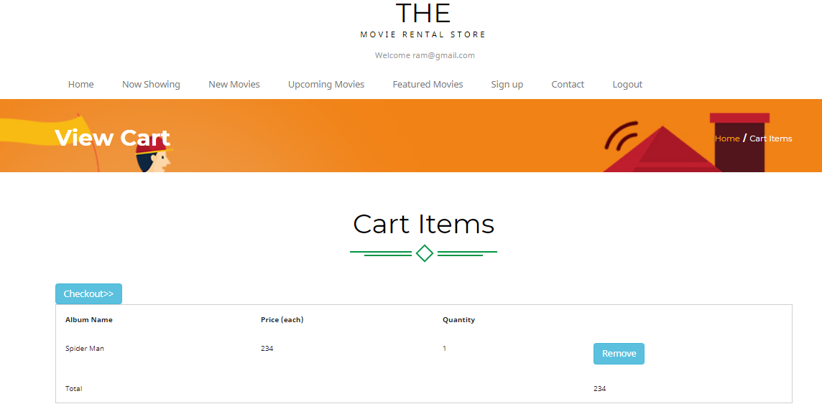

Fig: Black box testing for renting a movie

|  |  |
| --- | --- |
| Test no.1 | 5 |
| Purpose of the test | To check if password changing function is working or not |
| Test data | Hari(admin) |
| Test name | Change password test |
| Expected Result | Password changed successfully |
| Actual result | Password change successful |
| Test Status | successful |

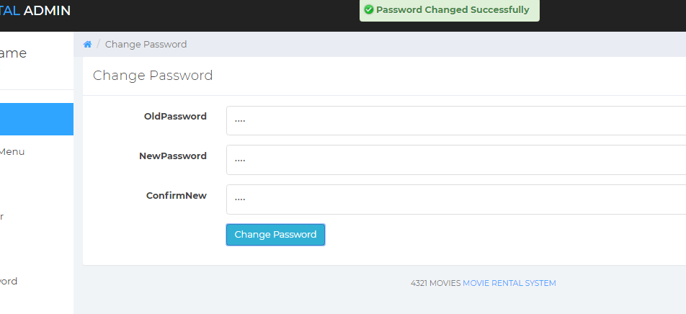

Fig: Black box testing for changing password

|  |  |
| --- | --- |
| Test no.1 | 6 |
| Purpose of the test | To check whether user can manage rented movie |
| Test data | Order 6 (Suraj) |
| Test name | manage rented movie |
| Expected Result | Admin can confirm or delete movie |
| Actual result | Confirm or delete successful |
| Test Status | success |

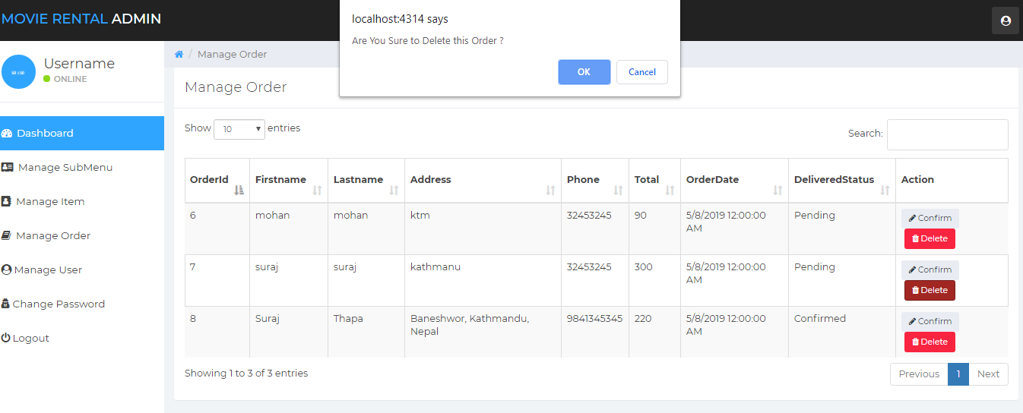

Fig: Black box testing for managing rented movie

|  |  |
| --- | --- |
| Test no.1 | 7 |
| Purpose of the test | To check whether provided address for delivery information gets submitted or not |
| Test data | Address for order |
| Test name | Order test |
| Expected Result | User orders is displayed successfully |
| Actual result | Ordered done successful |
| Test Status | success |

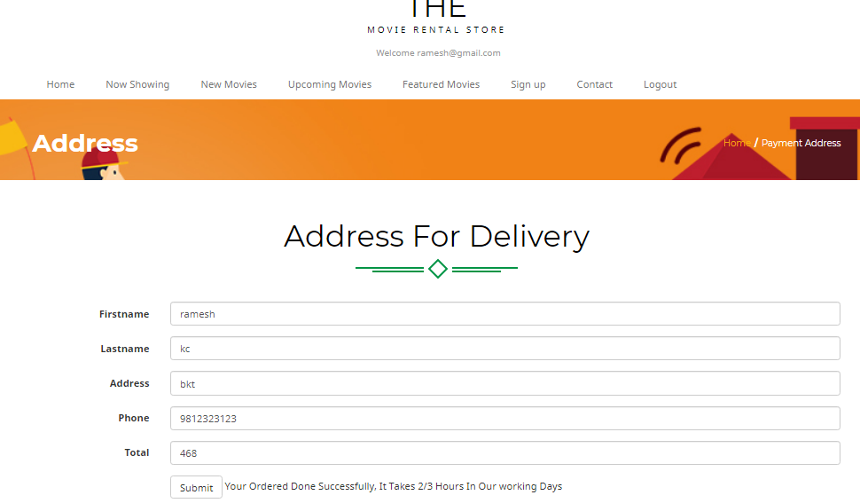

Fig: Black box testing for successful ordering

|  |  |
| --- | --- |
| Test no.1 | 8 |
| Purpose of the test | To check if when user clicks on the movie icon overview of the movie is shown or not |
| Test data | Spiderman |
| Test name | Quick overview test |
| Expected Result | Movie quick overview needs to be shown |
| Actual result | Over view successful |
| Test Status | success |

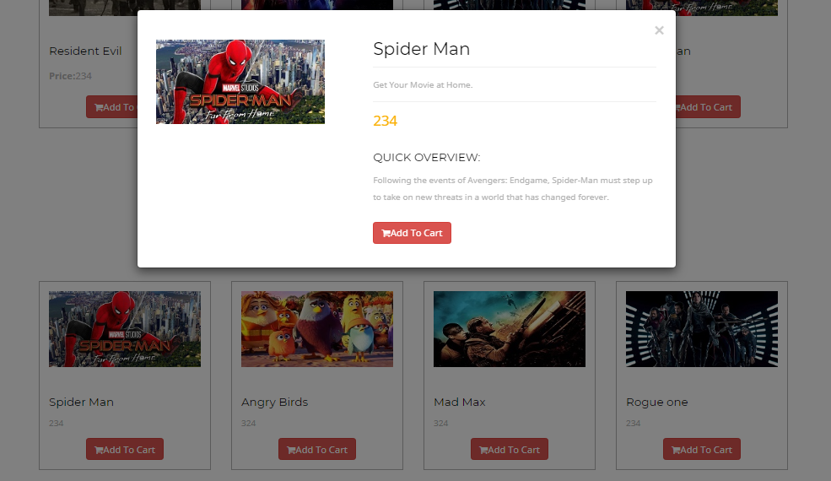

Fig: Black box testing for overview of movie

|  |  |
| --- | --- |
| Test no.1 | 9 |
| Purpose of the test | To check if admin gets to manage user |
| Test data | aa@gmail.com |
| Test name | User control test |
| Expected Result | User gets deleted successfully |
| Actual result | User deleted successful |
| Test Status | success |

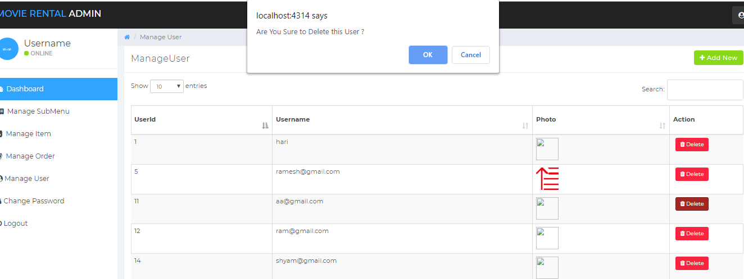

Fig: Black box testing for user control

|  |  |
| --- | --- |
| Test no.1 | 10 |
| Purpose of the test | To check if when user clicks on view more button on the home page, it needs to show list of movies |
| Test data | View more |
| Test name | View more test |
| Expected Result | Page should be directed to list of movies after clicking view more button |
| Actual result | List of movies page load successful |
| Test Status | success |

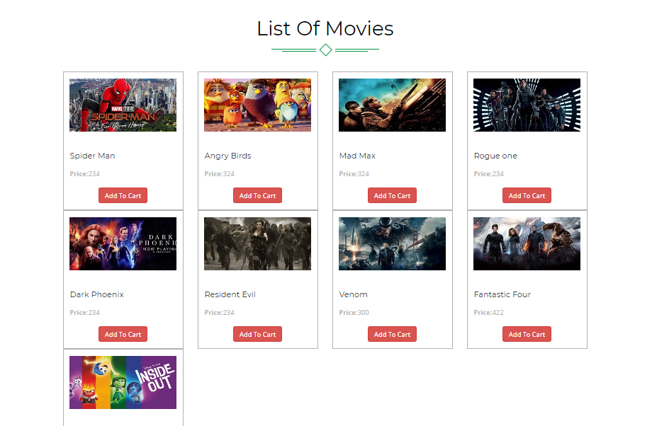

Fig: Black box testing for view more test