

Tenant Creation Automation Guide

**Version 1.0**

**Features covered**

**TMS**

* Company creation.
* Role assignment and filling registry value.
* Password reset.

**SIM**

* Client Configuration.
* Filling accesses for MDM.
* Adding and uploading reference master data.
* Creating field global payment term and assigning views to it.
* Making necessary changes for Purchasing views under Manage View.
* Making Payment term non- mandatory.
* Activating and deactivating fields/views.
* Adding all facilities for client.
* Again, selecting access for payment under view-access for MDM

**eProc**

* Changing user specified password.
* Filling values of System Tenant configuration.

**eInvoice**

* Filling values of System Tenant configuration.

**eCatalog**

* Filling values of System Tenant configuration.

**CMD**

* Filling values of System Tenant configuration.
* Activating/Uploading files for master data Components.

**Steps to be followed for Automated Tenant Creation**

# Configuration files

Navigate to input >> Tenant Creation folder under project folder to view below excel files.

* newCompanyData : to fill the data for new company.
* registryValues : to fill registry values for allocated products.
* masterValues : to fill the DB names, columns and details for SIM.
* rolesForAdminUser : to specify the roles to be allocated for client admin.
* simConfigurationData : to specify data related to sim.
* systemTenantConfigurationValuesWithEntity : to specify all the product wise system tenant configuration values in respective product’s sheets.
* masterDataCmd : to specify the CMD data to activate/upload

Follow below guidelines while filling data in above excel files:

* Inspect and copy values from Browser Console and paste it in respective cell.
* Any data left blank will be omitted from filling respective value during execution.

**Note:** Any modifications in locator excel will lead to automation failure as script won’t be able to locate UI elements.

# For newCompanyData excel

* Data for checkboxes like SaaS Company should be filled with values true/false.





* The fields Unique key and value are to be comma separated (e.g. key1, key2 and value1, value2)
* Also, company admin and client identifier should not be missed.

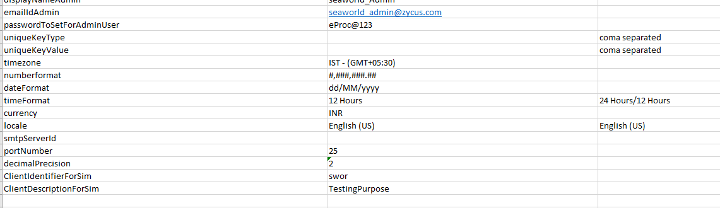

# For registryValue excel

* The Product name must be same as displayed in UI and is case sensitive

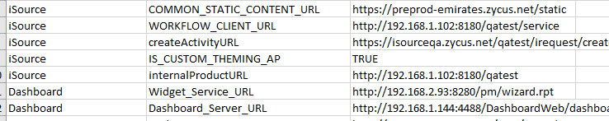

# For masterValues Excel sheet

* Client-identifier must not be appended against table name (e.g. given below)

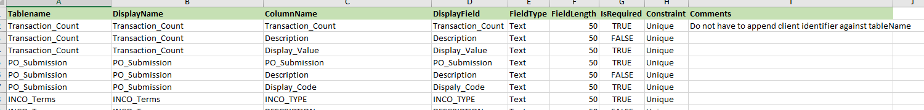

# For rolesForAdminUser Excel sheet

* All the roles added will be selected

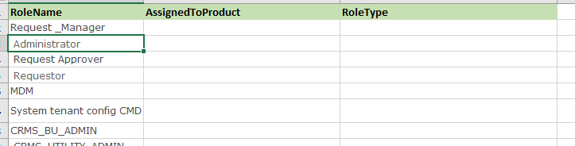

* For roles with same name, you can differentiate by specifying either its **product** (Assigned to), or **Role type**, or **BOTH**, as displayed in UI (must be case sensitive). Anything left blank will be omitted from comparison of matching exact role.

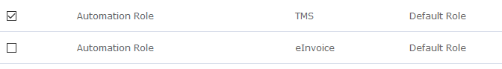

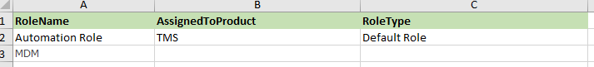

# For simConfigurationData Excel sheet

* The views to be selected are to be marked ‘true’
* For the folder containing the files for reference master files to upload, mention the file path in the format:

D:\\FolderName\\

Or

**Ending with double slash**

D:\\Full\\Path\\Separated\\By\\DoubleSlash\\

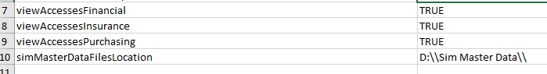

# For the above folder containing master data files

* File names should be:

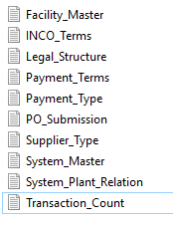

* If file name will differ, it will not be uploaded hence tending to failure of execution.
  + System_Plant_Relation should not be changed to System Facility Relation.
  + Client Identifier must not be appended in file name.
* File must be provided post manual verification of the internal format and correct data for uploading as verification of data is out of scope for Automation.

# For systemTenantConfigurationValuesWithEntity excel sheet

* Radio button of ‘YES/NO’ type is to specify with value as yes/no in excel sheet.
* Any field left blank will not be selected.

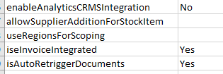

* All product wise data should be filled in respective product sheet (shown in below pointer)
* No of integration entity of a product should match the values provided in that products’ entity sheet (e.g. below figure)





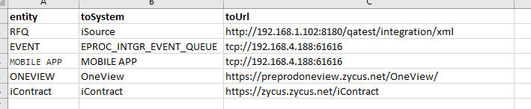

*[****eproc_entity sheet****]*

# For masterDataCmd excel sheet

* The fields to upload/activate are to be marked ‘yes’
* The kind of activation is mentioned in the comments i.e for ‘activate all’ type, all the values present in that master will be activated and for ‘via upload’ the uploading will be done by uploading zip files. For ‘consider next sheet if Yes’ the levels are to be mentioned in the respective sheet.

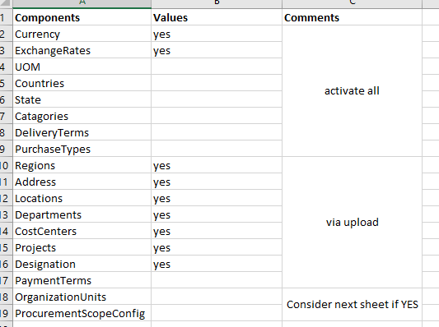



# For CMD activation of data (activate all type)

* The master data to be activated are to be marked yes only.

# For Uploading (via upload type)

* Folder named ‘AutoItFiles’ should be unzipped and should be placed on D drive (D:\AutoItFiles)
* This folder will contain all the zip files that are to be uploaded into cmd master data
* There will be other exe files present which should not be deleted or tampered as it is responsible for uploading the respective file of CMD to upload. Any modification will cause failure while uploading.

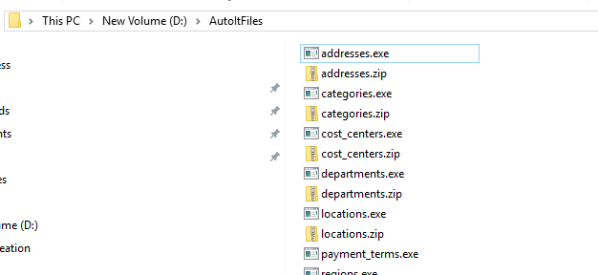

# For OU levels and Procurement scope

* Levels should be mentioned like below

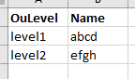

* Procurement scope should be mentioned like below

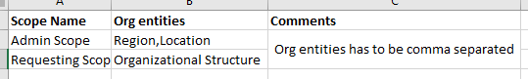

# For URLs and set up

* Kindly refer to config.properties and put below values:
  + URL
  + TMS_URL
  + TMS_URL_COMPANY_LISTING
  + SIM_URL
  + SIM_URL_ADMIN
  + EINVOICE_URL
  + RESET_PASSWORD_LINK
  + AdminUsername
  + AdminPassword

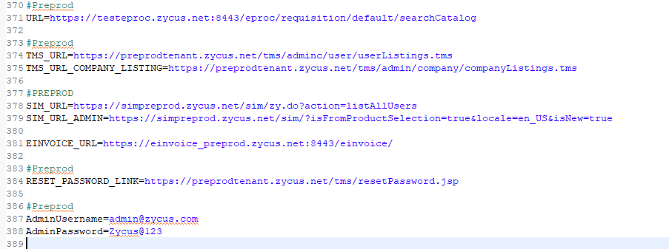

# To Run utility

* Run the ‘run1.bat’ file
* Browser will be launched showing the complete steps of execution and should not be manually intervened as it may lead to failure of any step.

