**CURRENT PROBLEMS**

We are facing covid19 as a big trouble and many problems have occurred because of it. They are-

1. Labours moving towards their home by walking 1500-2000 kms. They are moving because-

* They don’t have work to do in cities.
* Even if they are getting food they are going because they are tired and have lost hope for a brighter future.
* They don’t have anything to eat.
* They thing if others are going, they should also go.

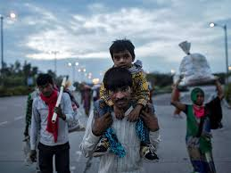

They have lack of awareness that they might get infected, they are putting in risk their lives, their families, their village people.

1. Lack of doctors. The number of patients are increasing day by day and it is getting difficult for the doctors to manage huge number of patients.
2. Lack of beds and other facilities.
3. Shops have started opening, which is a problem because in lockdown only India reached up to 1 lack then what will happen now. We still don’t have any special medicine prepared.
4. Low level and middle level workers are scared if they don’t get salaries, how will they feed their family.

*After discussing with lot of business houses, employees and labours, I have come to this conclusion that there are people who need help and there are people ready to help. A company owner said that this is not the year for making profits, this is the year to fulfil your social responsibility. Earn as much that you and your employees don’t die hungry.*

**SOLUTIONS TO BE TAKEN BY PREDULIVE**

*Every small step can help*

**Zero cost solutions-**

1. We can encourage people to be more helpful, kind and compassioned towards the needy.

We can do this by sharing the stories of the people, who are becoming the real heroes right now.

For example – my maid told me that yesterday two 8-9-year-old children came to her door and asked her to help, they said they are hungry, their mom doesn’t have a saree to wear. She said she gave them food and 2 sarees for her mom, she was so happy to help. She doesn’t earn much, approximately 3000 to 4000 a month but she didn’t think twice before helping them. She is a real hero and there are many more like her.

Her story inspired me and will inspire many. So if we post such stories with their picture, people will get inspired, we will have more followers and this kind of work is what people want to see.

This can be our campaign #**tohumanity.**

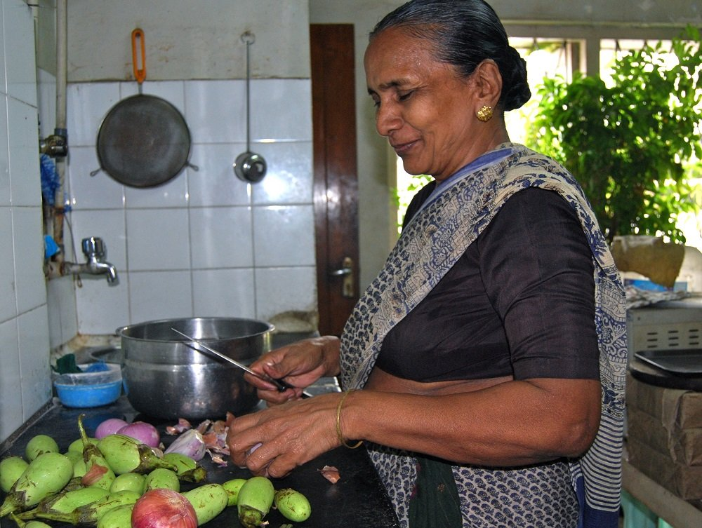

1. We will organise a online art competition, where anyone can participate, the theme will be the current situation, the participation conditions are-

* **They need to google pay 50 rupees**
* **They need to follow our page**

Then we will post their work on our page, the most liked picture will get a price of 1000 rupees. We will also mention that this money will go to the needy people.



This will help us in getting more active online presence, this will showcase our small efforts and will also help us in making our all other initiatives successful.

With the money we can do the following-

* We can buy material of mask making, give it to poor lady and tell her to make mask and sell in her locality.
* We can also provide books or food to poor children.

1. Connect the people of every house in your locality and ask them to make 2-3 extra rotis or if they have extra food to put it in a packet outside their house before 10:00 a.m. and then one of your person will collect the food and give it to the police officer and he will provide it to the poor, hungry people. This is being followed in Surat, Gujrat.

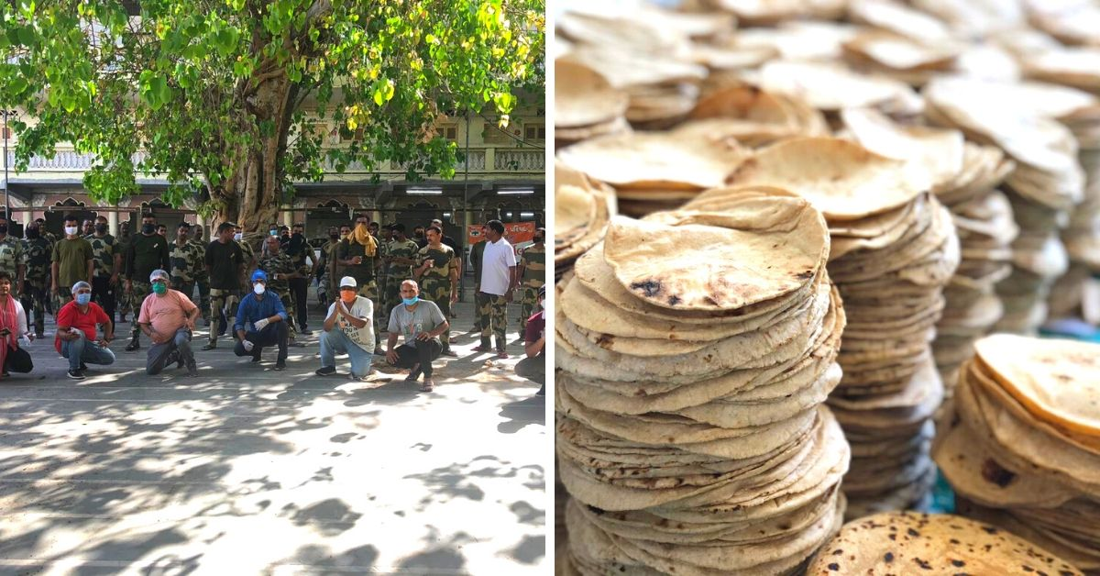

[5 Extra Rotis In Surat Homes Is Feeding Thousands of Hungry Migrants](https://www.thebetterindia.com/226205/gujarat-surat-coronavirus-migrant-workers-roti-seva-food-bank-hunger-hero-gop94/)

This will help you create a good name of your NGO in your society and also will connect you with more helpers, you might need in future.

**COST INCURRING SOLLUTION**

As you know there are less bed available for quarantined people and we will need a huge number of bed in future as you might have heard about the situation of Mumbai and the case where a Bombay Stock Exchange member have to wait for 3 days to even get a bed.

So, the plan is to provide cardboard to the people who have been quarantined and ask them to make bed with the easiest technique. This will help to get cheap beds which are biodegradable. I have attached a link in the mail, which will provide more information.

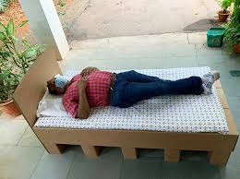

This will help you to connect with the government and will provide a good image of the organisation.