# How to migrate on premises VM to AWS.

1) Download aws cli for windows and install aws cli

2) Get access key from aws account to configure aws cli ($ aws configure)

3) Test your access using ( aws ec2 describe-regions) # fine if region listed

4) Create role name should be vmimport with relevent permission.

5) Export the virtual machine

6) Create bucket and upload image inside S3 bucket.

7) Import the virtual machine

8) Access the virtual machine

9) test.

## create role name vi trust.policy.json

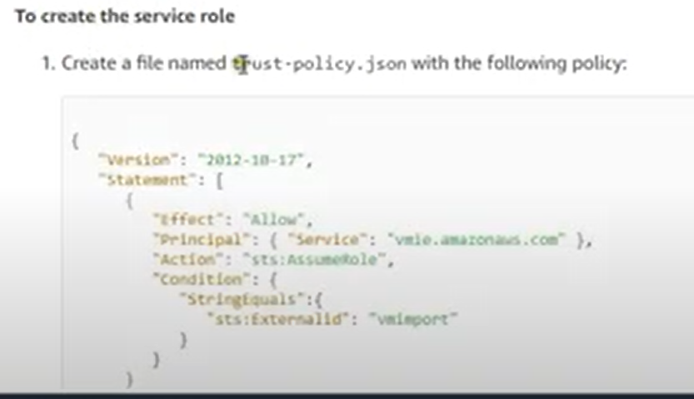

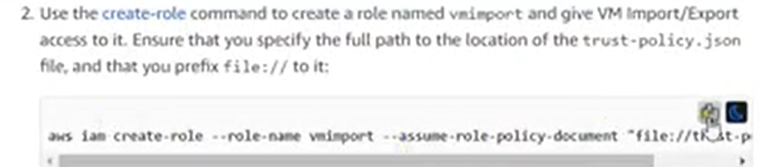



Now role created

Now export virtual machine as below. But vm should be stopped before export.

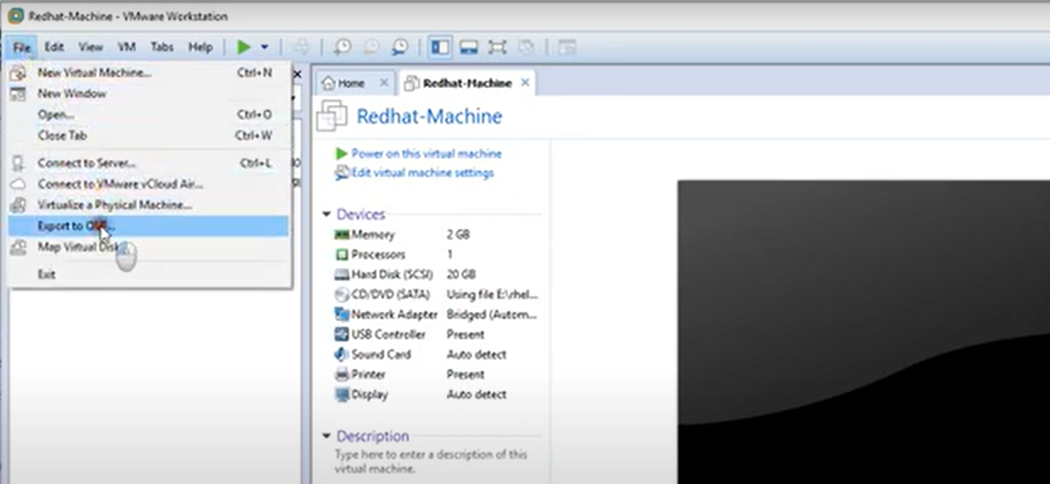

Exported vm on disktop as below pic.

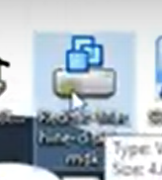

Now bucket will create on AWS, and upload exported image in this bucket. (it will take time to upload).

Now will Import the virtual machine as below.

First make this file.

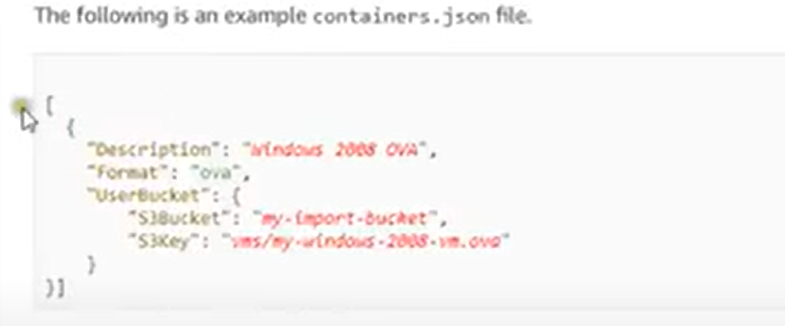

Now edited this file as below (S3Bucket – bucket name, S3Key- image name)

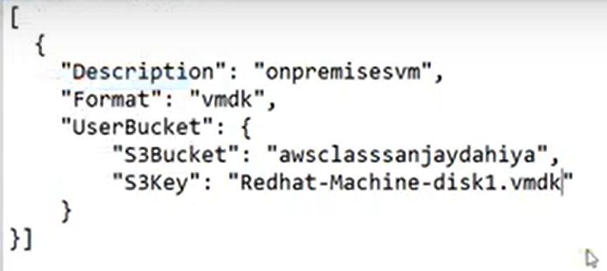



Goto Role and attache this policy before import image. As below.

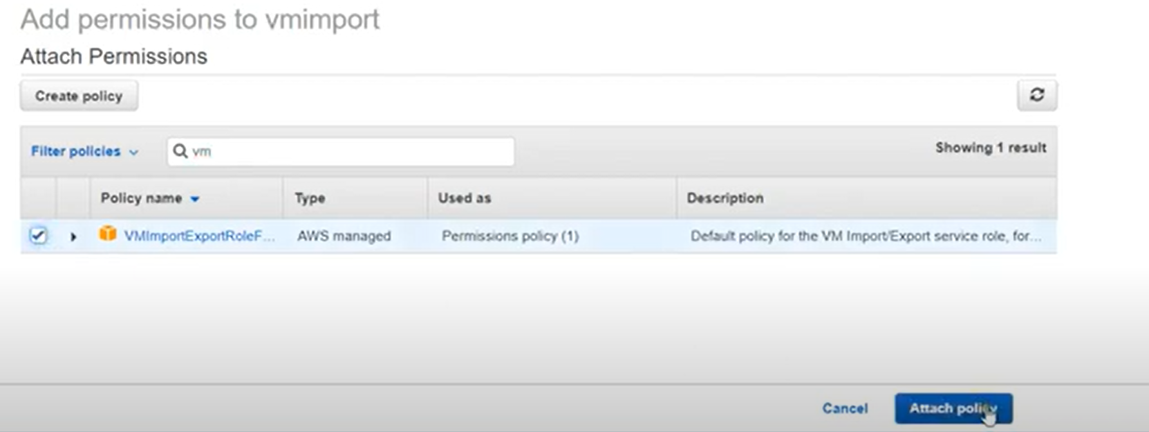



To check image imported or not using below command. It will take time.



Now image imported in AWS as below.

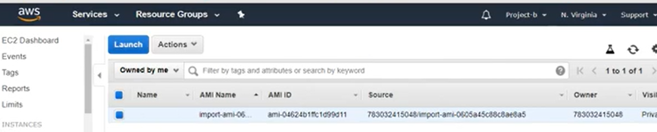

Now finally create ec2 instance using this image and connect using putty. Working fine. (migration done)