print("Sequence of numbers :- ")

print(seq(20,50))

print("Mean of numbers :- ")

print(mean(20:60))

print("Sum of numbers :- ")

print(sum(51:91))

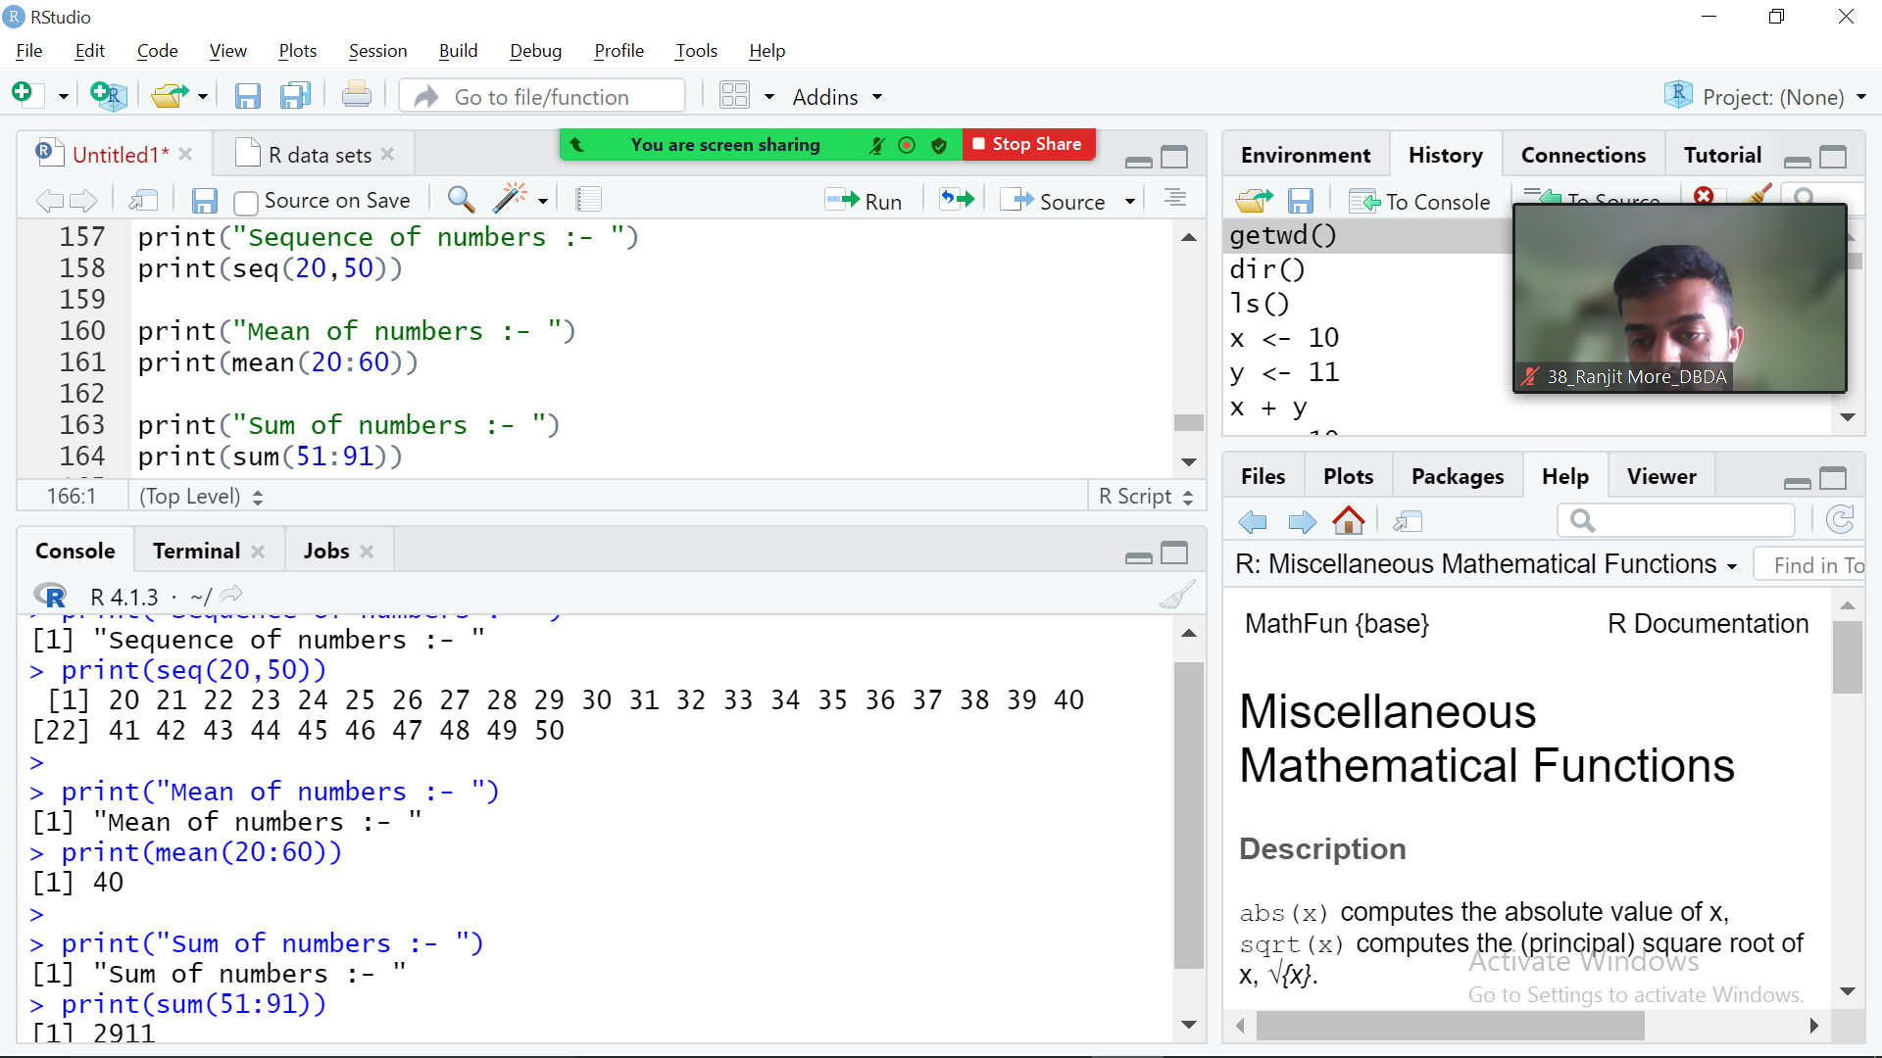

for (n in 1:100){

if ((n %% 3 == 0) & (n %% 5 == 0)){

print("FizzBuzz")}

else if (n %% 3 == 0){

print("Fizz")}

else if (n %% 5 == 0){

print("Buzz")

}

}

}

}

}

