IAS

0.1v

Design Document - IAS

**Document Control :**

|  |  |  |  |  |  |  |  |  |
| --- | --- | --- | --- | --- | --- | --- | --- | --- |
| **Project Revision History** | | | | | | | | |
|  |  |  | |  |  |  |  |  |
| **Date** | **Version** | **Author** | **Brief Description of Changes** | | | | **Approver Signature** | |
| 11-11-2022 | 0.1v | Group 05 | Initial Draft | | | |  | |
|  |  |  |  | | | |  | |
|  |  |  |  | | | |  | |

1. Introduction 5

1.1. Intended Audience 5

1.2. Acronyms/Abbreviations 5

1.3. Project Purpose 5

1.4. Key Project Objectives 5

1.5. Project Scope and Limitation 6

1.5.1. In Scope 6

1.5.2. Out of scope 6

1.6. Functional Overview 6

1.7. Assumptions, Dependencies & Constraints 6

1.8. Risks 6

2. Design Overview 7

2.1. Design Objectives 7

2.1.1. Recommended Architecture 7

2.2. Architectural Strategies 7

2.2.1. Design Alternative 7

2.2.2. Reuse of Existing Common Services/Utilities 7

2.2.3. Creation of New Common Services/Utilities 7

2.2.4. User Interface Paradigms 8

2.2.5. System Interface Paradigms 8

2.2.6. Error Detection / Exceptional Handling 8

2.2.7. Memory Management 8

2.2.8. Performance 8

2.2.9. Security 8

2.2.10. Concurrency and Synchronization 8

2.2.11. Housekeeping and Maintenance 8

3. System Architecture 9

3.1. System Architecture Diagram. (Not Necessary) 9

3.2. System Use-Cases 10

3.3. Subsystem Architecture 11

3.4. System Interfaces 11

3.4.1. Internal Interfaces 11

3.4.2. External Interfaces 11

4. Detailed System Design 11

4.1. Key Entities 12

4.2. Detailed-Level Database Design 12

34.2.1. Data Mapping Information 12

4.2.2. Data Conversion 13

4.3. Archival and retention requirements 13

4.4. Disaster and Failure Recovery 13

4.5. Business Process workflow 13

4.6. Business Process Modeling and Management (as applicable) 13

4.7. Business Logic 13

4.8. Variables 13

4.9. Activity / Class Diagrams (as applicable) 14

4.10. Data Migration 14

4.10.1. Architectural Representation 14

4.10.2. Architectural Goals and Constraints 14

4.10.3. Logical View 14

4.10.4. Architecturally Significant Design Packages 14

4.10.5. Data model 14

4.10.6. Deployment View 14

5. Environment Description 14

5.1. Time Zone Support 14

5.2. Language Support 14

5.3. User Desktop Requirements 15

5.4. Server-Side Requirements 15

5.4.1. Deployment Considerations 15

5.4.2. Application Server Disk Space 15

5.4.3. Database Server Disk Space 15

5.4.4. Integration Requirements 15

5.4.5. Jobs 15

5.4.6. Network 15

5.4.7. Others 15

5.5. Configuration 15

5.5.1. Operating System 16

5.5.2. Database 16

5.5.3. Network 16

5.5.4. Desktop 16

6. References 16

7. Appendix 16

# 

# Introduction

Inventory Analysis system has become important factor in modern business field. The application contains general organization profile, sales details, Purchase details and the remaining stock that are presented in the organization. The study findings enable the definition of the project problem statement, its objectives, scopes and advantages of the inventory management system. Each new stock is created and entitled with the ID, name, description and the quantity of that stock and it can also be updated any time when required. Here the login page is created in order to protect the management of the stock of organization in order to prevent it from the threads and misuse of the inventory.

## Intended Audience

This document could be shared or viewed across all the following members CG employees, BU SME's. internal SME's.

This is a technical document, and the terms should be understood by all of them.

|  |  |
| --- | --- |
| CG Employee |  |
| Internal SME |  |

## Acronyms/Abbreviations

|  |  |
| --- | --- |
| IAS | Inventory Analysis Software |
| CRUD | Create, Read, Update, Delete |
|  |  |
|  |  |

## Project Purpose

The purpose of this project is to present a detailed description of the Inventory Analysis Software using C and various operations to create, read, update and delete. It will explain the purpose and features of the software, the interfaces of the software, what the software will do. This document is intended for both the end users and the developers of the software.

## Key Project Objectives

* To develop an application that deals with the day to -

day requirement of any production organization

* To develop the easy management of the inventory
* To handle the inventory details like product details, sales details, and balance stock details.
* To provide competitive advantage to the organization.
* To provide details information about the stock balance.

## Project Scope and Limitation

The scope of Inventory analysis is to manage the stock of the company. it provides proper details of the products what kind of raw material, what are the sizes we require and etc. to the purchasing department.

Limitation of this software is the inventories are counted weekly or monthly and then compared with counts from the previous period can only generate data at or after the point of counting. This results in a lack of detail in the information about how inventory moves over the short term. Businesses moving large amounts of inventory may want to have a finer level of detail than periodic inventory allows.

### In Scope

This project helps to provide proper information about stocks, that saves the unnecessary expenses on stocks. This is a console-based application which helps to manage the stock pf products. According to the info provided by the user. Inventory analysis helps to improve the productivity of the machines and manpower.

### Out of scope

The scope of Inventory analysis is to manage the stock of the company. it provides proper details of the products what kind of raw material, what are the sizes we require and etc. to the purchasing department. Inventory analysis helps to improve the productivity of the machines and manpower. Inventory analysis helps to improve the profits of the company. it helps to provide proper information about stocks, that saves the unnecessary expenses on stocks.

## Functional Overview

Inventory management software enables us to increase productivity and efficiency by implementing automated daily manual tasks. This will assist you to maximize the growth of your business. With inventory management software installed, you can set a limit for re-ordering so that stock when drops it gets automatically re-ordered. The software makes the process of inventory management a lot easier which saves money and time both. It assists to automate the business processes and guides to make smarter decisions.

## Assumptions, Dependencies & Constraints

The following assumptions have been made in regards to the development of inventory analysis software:

* C source can be compiled on the machines.
* Users with administrator access should be careful in deleting or modifying any information knowingly or unknowingly which will lead the inconsistency of database.
* The files will be loaded in memory, and all CRUD operations will happen in memory, and the data will be committed to files.

## Risks

The source code needs to be implemented in such a way that it is portable to any machine that can compile and run C programs.

# Design Overview

Operating Environment for the Inventory analysis software is as follows:

* Client/server system.
* Operating System: Any UNIX Based OS
* Compiler: GCC or similar to compile source code written in C programming language.

## Design Objectives

The following are design objectives of inventory analysis software:

* To ensure a continuous supply of materials and stock so that production should not suffer at the time of customers demand.
* To avoid both overstocking and under-stocking of inventory.
* To maintain the availability of materials whenever and wherever required in enough quantity.
* To minimize loss through deterioration, pilferage, wastages, and damages.
* To supply the required material continuously.
* To maintain a systematic record of inventory.

### Recommended Architecture

[In this section, a document the Recommended System Architecture]

NA

## Architectural Strategies

* Create Product: This allows the user to create a product along with relevant fields to the store.
* Read Product : This allows the user to read the product details that has been purchased by them.
* Display all products :The function displays all the products and their related fields to the users.
* Update Product : It update the contents of a selected product.
* Delete Product : It deletes the product that is not needed by checking the expiry dates and damages.

### Design Alternative

The project uses a database to establish a connection between the user and admin for accessing and storing the data.

### Reuse of Existing Common Services/Utilities

This project does not reuse any new common services or alternatives.

### Creation of New Common Services/Utilities

The project does not create or use any creation or any new common services or utilities.

### User Interface Paradigms

* + CLI: The application uses Command Line Interface to accept console commands by users and perform the needful functions.
  + Desktop or a Linux machine with internet connection.

### System Interface Paradigms

* 64bit Machine capable of running UNIX based operating system.
* Linux Kernel version – 4.4.0-1904]-Microsoft.
* Bash shell – x86_64 GNU/Linux.

### Error Detection / Exceptional Handling

* Error detection in all phases of client connection to the server will be provided.
* Four levels of debug log messages will be included like FATA, INFO, WARNING & DEBUG.
* Appropriate error messages for file handling will also be included.

### Memory Management

We store the user data and product data in files.

### Performance

The Application is developed to run on UNIX based systems. As long as the machine can run the operating system along with the necessary dependencies without any flaws there are no additional requirements.

### Security

The security requirements deal with the primary security. The software should be handled only by the administrator and authorized users. The Inventory analysis contains a set of basic functions for creating, adding, deleting and updating new products.

### Concurrency and Synchronization

NA

### Housekeeping and Maintenance

* It supports production.
* Minimizing Work load
* Reduces the risk of loss.
* Better service to customer.

# System Architecture

In this inventory analysis software first it shows the register /login page after login it will show a menu page in this it shows Add product, Add sale, get the sale report , get the product report and exit. If you press 1, it will display it’s sub menu and in this it shows add a product, update product , display product, delete product and back to main menu. When you click 2 add a sale it shows make sale, display and back to previous menu. When you press 3 ,it gets the sale report i.e. all transaction records till now and for 4 it gets the product report i.e. all available stock of organization.

## System Architecture Diagram. (Not Necessary)

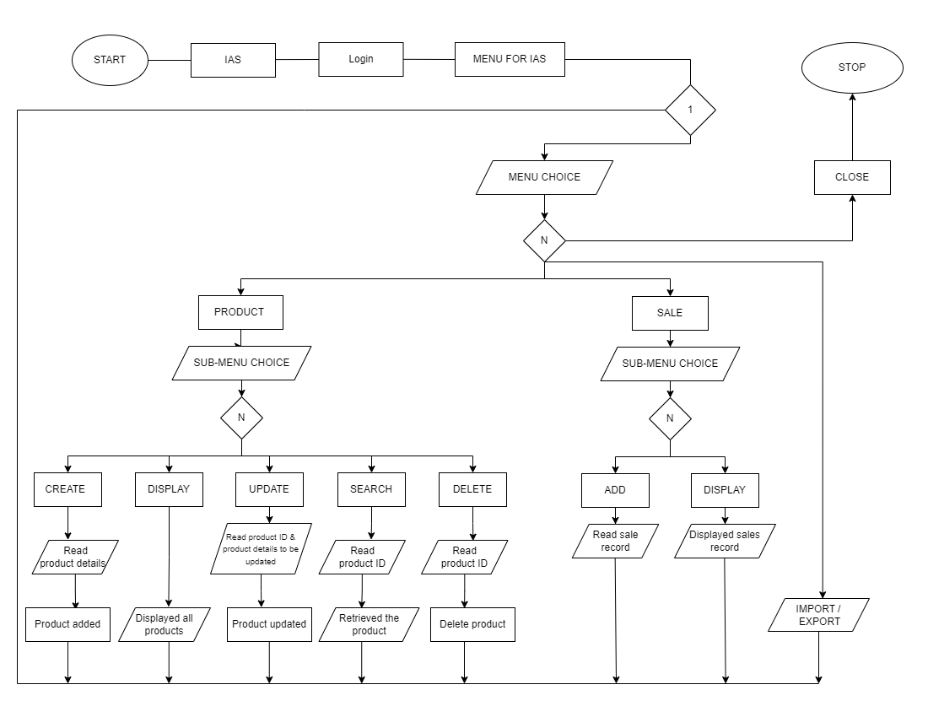

## System Use-Cases

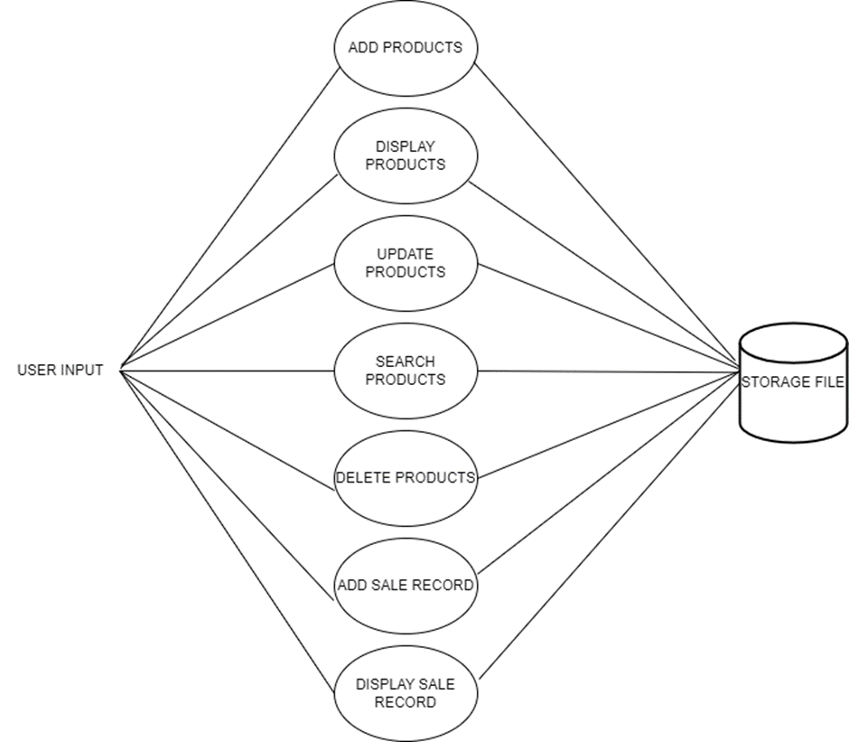

## Subsystem Architecture

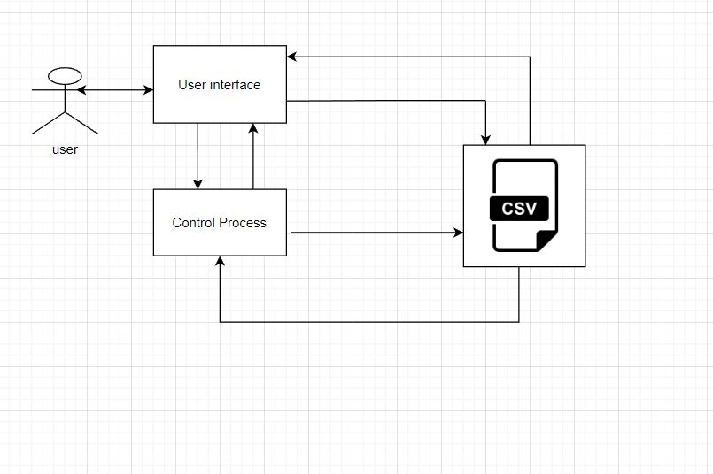

## System Interfaces

NA

### Internal Interfaces

NA

### External Interfaces

The external interface comprises interfaces through which the users interact with the system.

* Desktop or Linux Machine
* Internet
* Software where the application is activated.

# Detailed System Design

NA

## Key Entities

The key entities associated with the system are:

Admin

* It can add a product and add a sale.
* Able to update the entry.
* It give sales report and product details
* Able to add, modify and delete the stock entry.

Inventory

* Able to check the stock available.
* Able to check the balance payment.
* Able to view the remaining sales stock.

## Detailed-Level Database Design

**4.2.1.1. Level 0 Diagram**

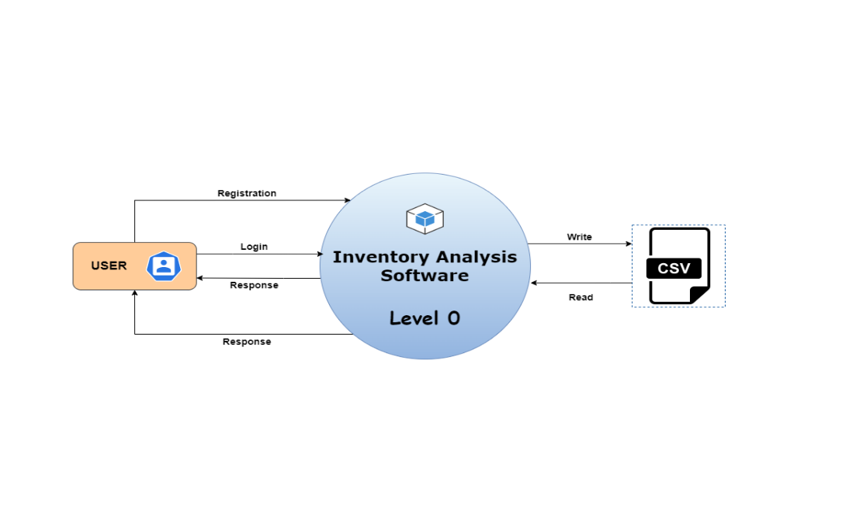

**4.2.1.2. Level 1 Diagram**

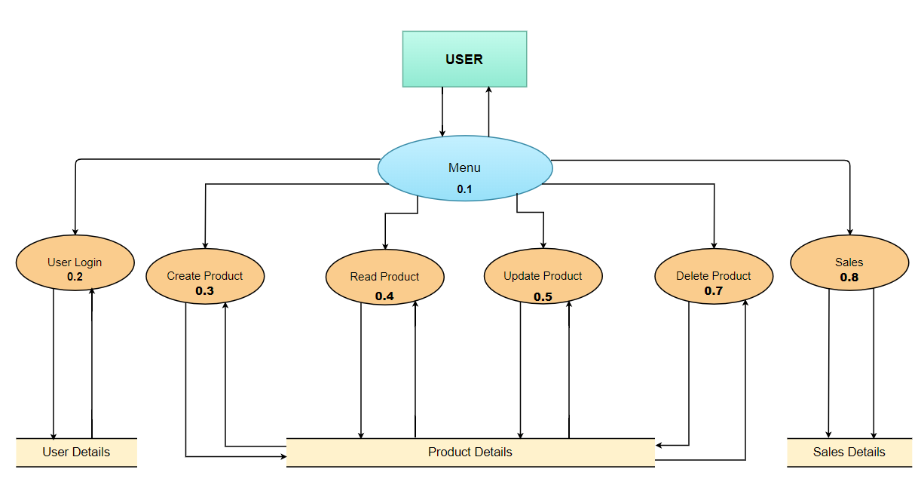

### Data Mapping Information

An inventory map is an actual map of a given inventory. Larger businesses have a map of the inventory and managers rely on it to locate items within. The map includes the location of the item, the size of it in case the items have different sizes or shapes and the price of the item.

### Data Conversion

NA

## Archival and retention requirements

NA

## Disaster and Failure Recovery

NA

## Business Process workflow

[Document the Business Process Workflow in this section here.]

NA

## Business Process Modeling and Management (as applicable)

[Document the Business Process Modeling and management details in this section]

NA

## Business Logic

NA

## Variables

NA

## Activity / Class Diagrams (as applicable)

[Document the details related to Activity / Class Diagrams in this section.]

NA

## Data Migration

Data is migrated between the user and the customer.

### Architectural Representation

NA

### Architectural Goals and Constraints

NA

### Logical View

NA

### Architecturally Significant Design Packages

NA

### Data model

**Legacy system data model**

**Proposed system data model**

**Interface data model**

### Deployment View

NA

# Environment Description

[The complete details of the System Environment has to be documented in this section including the details of all requirements, time zones etc.

## Time Zone Support

It will support the time zone as per Indian Standard Time (IST) in (GMT +5:30) and UST standard.

## Language Support

C language and compilation using gcc. The Linux commands to do that task we can specify the commands.

## User Desktop Requirements

User desktop requires a Linux environment, Operating system of Linux Debian or Ubuntu 20.04.5 LTS (GNU/Linux 4.4.0-19041-Microsoft x86_64) kernel version and reliable internet connectivity

## Server-Side Requirements

In server side,

● Disk space – Minimum 150GB

● Uninterrupted connectivity 24x7

● Monitor long running jobs, to reduce the server load.

### Deployment Considerations

Deployment considerations are,

● 500Mhz Processor

● 4GB RAM

● Network connectivity

### Application Server Disk Space

Disk space – Minimum 150GB

### Database Server Disk Space

NA

### Integration Requirements

The PWD Displays the current working directory on the server for the logged in user.

### Jobs

NA

### Network

### The network connects the system for the purpose of file searching therefore stable Internet connectivity is required.

### Others

NA

## Configuration

NA

### Operating System

* Operating system – Unix.
* RAM - 8GB.
* Processor - i3/i5/i7

### Database

NA

### Network

NA

### Desktop

Unix like environment is required.

# References

* [www.w3schools.com](http://www.w3schools.com)
* <https://www.lovelycoding.org/inventory-management-system-project/>
* System Requirements Specification Document.
* Project Proposal Document.

# Appendix

https://drive.google.com/drive/folders/1gLSsHl_5GDsaE-G6-D8Eih3ya9ZVLIB-?usp=sharing

**Change Log**

|  |  |  |  |  |  |
| --- | --- | --- | --- | --- | --- |
| **QMS Template Version Control (Maintained by QA)** | | | | | |
|  |  |  |  |  |  |
| **Date** | **Version** | **Author** | | **Description** | |
| 28-May-2015 | 1.0 | QA Team | | Initial Version | |
|  |  |  | |  | |
|  |  |  | |  | |
|  |  |  | |  | |