**Table of Contents**

[**1. Git**](http://www.vogella.com/tutorials/Git/article.html#git)

[**1.1. What is a version control system?**](http://www.vogella.com/tutorials/Git/article.html#versioncontrolssystems)

[**1.2. Localized and centralized version control systems**](http://www.vogella.com/tutorials/Git/article.html#cvcs_definition)

[**1.3. What is a distributed version control system?**](http://www.vogella.com/tutorials/Git/article.html#dvcs_definition)

[**1.4. What is Git?**](http://www.vogella.com/tutorials/Git/article.html#git_definition)

[**2. Tools**](http://www.vogella.com/tutorials/Git/article.html#gitdefintion_tools)

[**2.1. The Git command line tools**](http://www.vogella.com/tutorials/Git/article.html#gitdefintion_tools1)

[**2.2. Separating parameters and file arguments in Git commands**](http://www.vogella.com/tutorials/Git/article.html#gitdefintion_doublehyphens)

[**2.3. Graphical tools for Git**](http://www.vogella.com/tutorials/Git/article.html#gitdefintion_tools2)

[**3. Important terminology in Git**](http://www.vogella.com/tutorials/Git/article.html#git)

[**3.1. Cloning, creating and deleting a Git repository**](http://www.vogella.com/tutorials/Git/article.html#gitdefintion_localrepositories)

[**3.2. Bare repositories and non-bare repositories**](http://www.vogella.com/tutorials/Git/article.html#gitdefintion_bare)

[**3.3. Working tree**](http://www.vogella.com/tutorials/Git/article.html#workingtree)

[**3.4. Local operations**](http://www.vogella.com/tutorials/Git/article.html#gitdefintion_localoperations)

[**3.5. Synchronization with remote repositories**](http://www.vogella.com/tutorials/Git/article.html#gitdefintion_remoterepositories)

[**3.6. The concept of branches**](http://www.vogella.com/tutorials/Git/article.html#gitdefintion_branching)

[**4. The process of adding to a Git repository via staging and committing**](http://www.vogella.com/tutorials/Git/article.html#git)

[**4.1. Adding changes to a Git repository**](http://www.vogella.com/tutorials/Git/article.html#git_addtorepository)

[**4.2. Adding to the staging area**](http://www.vogella.com/tutorials/Git/article.html#git_stagingprocess)

[**4.3. Committing to the repository**](http://www.vogella.com/tutorials/Git/article.html#git_commitprocess)

[**4.4. Committing changes**](http://www.vogella.com/tutorials/Git/article.html#commits)

[**5. The details of the commit objects**](http://www.vogella.com/tutorials/Git/article.html#git)

[**5.1. Commit object (commit)**](http://www.vogella.com/tutorials/Git/article.html#commit_object)

[**5.2. Technical details of a commit object**](http://www.vogella.com/tutorials/Git/article.html#commit_objects)

[**5.3. Hash and abbreviated commit hash**](http://www.vogella.com/tutorials/Git/article.html#commits_sha_checksum)

[**6. Summary of Git terminology**](http://www.vogella.com/tutorials/Git/article.html#gitterminology_section)

[**6.1. Reference table with important Git terminology**](http://www.vogella.com/tutorials/Git/article.html#gitterminology)

[**6.2. File states in the working tree**](http://www.vogella.com/tutorials/Git/article.html#gitterminology_filelifecycle)

[**7. Commit references**](http://www.vogella.com/tutorials/Git/article.html#commitreference)

[**7.1. Predecessor commits, parents and commit references**](http://www.vogella.com/tutorials/Git/article.html#commitreference_whatis)

[**7.2. Branch references and the HEAD reference**](http://www.vogella.com/tutorials/Git/article.html#commitreference_branchheadreferences)

[**7.3. Parent and ancestor commits**](http://www.vogella.com/tutorials/Git/article.html#commitreference_parentancestor)

[**7.4. Using caret and tilde for commit references**](http://www.vogella.com/tutorials/Git/article.html#commitreference_carettilde)

[**7.5. Commit ranges with the double dot operator**](http://www.vogella.com/tutorials/Git/article.html#commitreference_ranges_doubledot)

[**7.6. Commit ranges with the triple dot operator**](http://www.vogella.com/tutorials/Git/article.html#commitreference_ranges_tripledot)

[**8. Installation**](http://www.vogella.com/tutorials/Git/article.html#installation)

[**8.1. Ubuntu, Debian and derived systems**](http://www.vogella.com/tutorials/Git/article.html#installation_ubuntu)

[**8.2. Fedora, Red Hat and derived systems**](http://www.vogella.com/tutorials/Git/article.html#installation_fedora)

[**8.3. Other Linux systems**](http://www.vogella.com/tutorials/Git/article.html#installation_linux)

[**8.4. Windows**](http://www.vogella.com/tutorials/Git/article.html#installation_windows)

[**8.5. Mac OS**](http://www.vogella.com/tutorials/Git/article.html#installation_mac)

[**9. Different levels of Git configuration**](http://www.vogella.com/tutorials/Git/article.html#setup)

[**9.1. Git configuration levels**](http://www.vogella.com/tutorials/Git/article.html#setup_configurationlevels)

[**9.2. Git system-wide configuration**](http://www.vogella.com/tutorials/Git/article.html#setup_systemwideconfiguration)

[**9.3. Git user configuration**](http://www.vogella.com/tutorials/Git/article.html#setup_userconfiguration)

[**9.4. Repository specific configuration**](http://www.vogella.com/tutorials/Git/article.html#setup_configuration)

[**10. Performing the Git configuration**](http://www.vogella.com/tutorials/Git/article.html#setup)

[**10.1. User configuration**](http://www.vogella.com/tutorials/Git/article.html#setup_user)

[**10.2. Exercise: User configuration**](http://www.vogella.com/tutorials/Git/article.html#setup_userexercise)

[**10.3. Push configuration**](http://www.vogella.com/tutorials/Git/article.html#setup_pushconfiguration)

[**10.4. Avoid merge commits for pulling**](http://www.vogella.com/tutorials/Git/article.html#setup_rebase)

[**10.5. Color Highlighting**](http://www.vogella.com/tutorials/Git/article.html#setup_highlighting)

[**10.6. Setting the default editor**](http://www.vogella.com/tutorials/Git/article.html#setup_editor)

[**10.7. Setting the default merge tool**](http://www.vogella.com/tutorials/Git/article.html#setup_mergetool)

[**10.8. More settings**](http://www.vogella.com/tutorials/Git/article.html#setup_allsetttings)

[**10.9. Query Git settings**](http://www.vogella.com/tutorials/Git/article.html#setup_seesettings)

[**11. Configure files and directories to ignore**](http://www.vogella.com/tutorials/Git/article.html#d338416e1240)

[**11.1. Ignoring files and directories with a .gitignore file**](http://www.vogella.com/tutorials/Git/article.html#d338416e1243)

[**11.2. Global (cross-repository) .gitignore settings**](http://www.vogella.com/tutorials/Git/article.html#d338416e1308)

[**11.3. Local per-repository ignore rules**](http://www.vogella.com/tutorials/Git/article.html#d338416e1329)

[**12. Git and empty directories**](http://www.vogella.com/tutorials/Git/article.html#ignorekeep_gitkeep)

[**12.1. Default behaviour of Git for empty directories**](http://www.vogella.com/tutorials/Git/article.html#ignorekeep_gitkeep1)

[**12.2. Tracking empty directories**](http://www.vogella.com/tutorials/Git/article.html#ignorekeep_gitkeep2)

[**13. Create repository**](http://www.vogella.com/tutorials/Git/article.html#firstgit)

[**13.1. Target of this chapter**](http://www.vogella.com/tutorials/Git/article.html#firstgit_createrepotarget)

[**13.2. Create a directory**](http://www.vogella.com/tutorials/Git/article.html#firstgit_directory)

[**13.3. Create a new Git repository**](http://www.vogella.com/tutorials/Git/article.html#firstgit_repository_creation)

[**14. Getting started with Git**](http://www.vogella.com/tutorials/Git/article.html#firstgit_addfiles)

[**14.1. Target of this chapter**](http://www.vogella.com/tutorials/Git/article.html#firstgit_addingfilestarget)

[**14.2. Create new content**](http://www.vogella.com/tutorials/Git/article.html#firstgit_content)

[**14.3. See the current status of your repository**](http://www.vogella.com/tutorials/Git/article.html#firstgit_repostatus)

[**14.4. Add files to the staging area**](http://www.vogella.com/tutorials/Git/article.html#firstgit_repoadd)

[**14.5. Change files that are staged**](http://www.vogella.com/tutorials/Git/article.html#firstgit_changefiles)

[**14.6. Commit staged changes to the repository**](http://www.vogella.com/tutorials/Git/article.html#firstgit_repocommit)

[**15. Looking at the result**](http://www.vogella.com/tutorials/Git/article.html#firstgitresult)

[**15.1. Viewing the Git commit history**](http://www.vogella.com/tutorials/Git/article.html#firstgitresult_results)

[**15.2. Directory structure**](http://www.vogella.com/tutorials/Git/article.html#firstgitresult_directory)

[**16. Remove files and adjust the last commit**](http://www.vogella.com/tutorials/Git/article.html#adjustgit)

[**16.1. Remove files**](http://www.vogella.com/tutorials/Git/article.html#firstgit_deletefile)

[**16.2. Revert changes in files in the working tree**](http://www.vogella.com/tutorials/Git/article.html#firstgit_checkout)

[**16.3. Correct the last commit with git amend**](http://www.vogella.com/tutorials/Git/article.html#firstgit_amend)

[**17. Ignoring certain files and directories**](http://www.vogella.com/tutorials/Git/article.html#adjustgitignore)

[**17.1. Ignore files and directories with the .gitignore file**](http://www.vogella.com/tutorials/Git/article.html#usegitignore)

[**17.2. Stop tracking files based on the .gitignore file**](http://www.vogella.com/tutorials/Git/article.html#untrack)

[**17.3. Commit the .gitignore file**](http://www.vogella.com/tutorials/Git/article.html#commitgitignore)

[**18. Remote repositories**](http://www.vogella.com/tutorials/Git/article.html#remotes)

[**18.1. What are remotes?**](http://www.vogella.com/tutorials/Git/article.html#remotes_definition)

[**18.2. Bare repositories**](http://www.vogella.com/tutorials/Git/article.html#bareremotes_definition)

[**18.3. Convert a Git repository to a bare repository**](http://www.vogella.com/tutorials/Git/article.html#bareremotes_convert)

[**19. Cloning repositories and the remote called "origin"**](http://www.vogella.com/tutorials/Git/article.html#gitclone)

[**19.1. Cloning a repository**](http://www.vogella.com/tutorials/Git/article.html#remotes_cloneoperation)

[**19.2. The remote called "origin"**](http://www.vogella.com/tutorials/Git/article.html#remotes_clone_origin)

[**19.3. Exercise: Cloning to create a bare Git repository**](http://www.vogella.com/tutorials/Git/article.html#remotes_setupexercise)

[**20. Adding and listing existing remotes**](http://www.vogella.com/tutorials/Git/article.html#remotes)

[**20.1. Adding a remote repository**](http://www.vogella.com/tutorials/Git/article.html#remotes_remoteadd)

[**20.2. Synchronizing with remote repositories**](http://www.vogella.com/tutorials/Git/article.html#remotes_remote_synchronize)

[**20.3. Show the existing remotes**](http://www.vogella.com/tutorials/Git/article.html#remotes_showremote)

[**21. The push and pull commands**](http://www.vogella.com/tutorials/Git/article.html#cloneremotes)

[**21.1. Push changes to another repository**](http://www.vogella.com/tutorials/Git/article.html#cloneremotes_push)

[**21.2. Pull changes**](http://www.vogella.com/tutorials/Git/article.html#cloneremotes_pull)

[**21.3. Exercise: Clone your bare repository**](http://www.vogella.com/tutorials/Git/article.html#exercise_cloneremotes_clone)

[**21.4. Exercise: Using the push command**](http://www.vogella.com/tutorials/Git/article.html#exercise_cloneremotes_push)

[**21.5. Exercise: Using the pull command**](http://www.vogella.com/tutorials/Git/article.html#exercise_cloneremotes_pull)

[**22. Working with remote repositories**](http://www.vogella.com/tutorials/Git/article.html#remote)

[**22.1. Cloning remote repositories**](http://www.vogella.com/tutorials/Git/article.html#remote_clone)

[**22.2. Add more remote repositories**](http://www.vogella.com/tutorials/Git/article.html#remote_add)

[**22.3. Rename remote repositories**](http://www.vogella.com/tutorials/Git/article.html#remote_rename)

[**22.4. Remote operations via HTTP**](http://www.vogella.com/tutorials/Git/article.html#remote_httpprotocol)

[**22.5. Using a proxy**](http://www.vogella.com/tutorials/Git/article.html#remote_httpproxy)

[**23. What are branches?**](http://www.vogella.com/tutorials/Git/article.html#gitbranch_def)

[**24. Commands to working with branches**](http://www.vogella.com/tutorials/Git/article.html#gitbranch)

[**24.1. List available branches**](http://www.vogella.com/tutorials/Git/article.html#gitbranch_listbranches)

[**24.2. Create new branch**](http://www.vogella.com/tutorials/Git/article.html#gitbranch_createnewbranch)

[**24.3. Checkout branch**](http://www.vogella.com/tutorials/Git/article.html#gitbranch_checkout)

[**24.4. Rename a branch**](http://www.vogella.com/tutorials/Git/article.html#git_rename_branch)

[**24.5. Delete a branch**](http://www.vogella.com/tutorials/Git/article.html#gitdeletebrach)

[**24.6. Push changes of a branch to a remote repository**](http://www.vogella.com/tutorials/Git/article.html#gitpushbranch)

[**25. Differences between branches**](http://www.vogella.com/tutorials/Git/article.html#gitdiffbranches)

[**26. Tags in Git**](http://www.vogella.com/tutorials/Git/article.html#tags)

[**26.1. What are tags?**](http://www.vogella.com/tutorials/Git/article.html#tagging)

[**26.2. Lightweight and annotated tags**](http://www.vogella.com/tutorials/Git/article.html#tagging_lightweight_annotated)

[**26.3. Naming conventions for tags**](http://www.vogella.com/tutorials/Git/article.html#tagging_namingconventions)

[**27. Working with tags**](http://www.vogella.com/tutorials/Git/article.html#tagging)

[**27.1. List tags**](http://www.vogella.com/tutorials/Git/article.html#tagging_list)

[**27.2. Search by pattern for a tag**](http://www.vogella.com/tutorials/Git/article.html#tag_searchbypattern)

[**27.3. Creating lightweight tags**](http://www.vogella.com/tutorials/Git/article.html#tagging_createlightweight)

[**27.4. Creating annotated tags**](http://www.vogella.com/tutorials/Git/article.html#tagging_createannoted)

[**27.5. Creating signed tags**](http://www.vogella.com/tutorials/Git/article.html#tagging_signedtags)

[**27.6. Checkout tags**](http://www.vogella.com/tutorials/Git/article.html#tagging_checkout)

[**27.7. Push tags**](http://www.vogella.com/tutorials/Git/article.html#tagging_pushtags)

[**27.8. Delete tags**](http://www.vogella.com/tutorials/Git/article.html#tagging_delete)

[**28. Listing changed files before a commit**](http://www.vogella.com/tutorials/Git/article.html#analyzechanges)

[**28.1. Listing changed files**](http://www.vogella.com/tutorials/Git/article.html#gitstatus)

[**28.2. Example: Using git status**](http://www.vogella.com/tutorials/Git/article.html#gitstatus_example)

[**29. Reviewing the changes in the files before a commit**](http://www.vogella.com/tutorials/Git/article.html#analyzechanges)

[**29.1. See the differences in the working tree since the last commit**](http://www.vogella.com/tutorials/Git/article.html#gitdiff_changesdiff)

[**29.2. Example: Using "git diff" to see the file changes in the working tree**](http://www.vogella.com/tutorials/Git/article.html#analyzechanges_gitdiffworkingtree)

[**29.3. See differences between staging area and last commit**](http://www.vogella.com/tutorials/Git/article.html#gitdiff_index)

[**30. Analyzing the commit history with git log**](http://www.vogella.com/tutorials/Git/article.html#analyzechanges)

[**30.1. Using git log**](http://www.vogella.com/tutorials/Git/article.html#analyzechanges_log)

[**30.2. Helpful parameters for git log**](http://www.vogella.com/tutorials/Git/article.html#git_log_options)

[**30.3. View the change history of a file**](http://www.vogella.com/tutorials/Git/article.html#analyzechangesg_changesinafile)

[**30.4. Configuring output format**](http://www.vogella.com/tutorials/Git/article.html#analyzechanges_output)

[**30.5. Filtering based on the commit message via regular expressions**](http://www.vogella.com/tutorials/Git/article.html#analyzechanges_grep)

[**30.6. Filtering the log output based on author or committer**](http://www.vogella.com/tutorials/Git/article.html#analyzechanges_user)

[**31. Viewing changes with git diff and git show**](http://www.vogella.com/tutorials/Git/article.html#gitdiffchapter)

[**31.1. See the differences introduced by a commit**](http://www.vogella.com/tutorials/Git/article.html#analyzechanges_showcommitchanges)

[**31.2. See the difference between two commits**](http://www.vogella.com/tutorials/Git/article.html#gitdiff_comparetwocommits)

[**31.3. See the files changed by a commit**](http://www.vogella.com/tutorials/Git/article.html#analyzechanges_file)

[**32. Analyzing line changes with git blame**](http://www.vogella.com/tutorials/Git/article.html#git_blame_def)

[**33. Example: git blame**](http://www.vogella.com/tutorials/Git/article.html#git_blame_example)

[**34. Commit history of a repository or certain files**](http://www.vogella.com/tutorials/Git/article.html#gitk)

[**35. git shortlog for release announcements**](http://www.vogella.com/tutorials/Git/article.html#gitshortlog)

[**36. Stashing committed changes with git stash**](http://www.vogella.com/tutorials/Git/article.html#stash)

[**36.1. Stashing changes in Git**](http://www.vogella.com/tutorials/Git/article.html#stash_usage)

[**36.2. Using the Git stash command**](http://www.vogella.com/tutorials/Git/article.html#stash_example1)

[**37. Remove untracked files with git clean**](http://www.vogella.com/tutorials/Git/article.html#gitclean)

[**37.1. Removing untracked files**](http://www.vogella.com/tutorials/Git/article.html#gitclean_command)

[**37.2. Example: Using git clean**](http://www.vogella.com/tutorials/Git/article.html#gitclean_example)

[**38. Revert uncommitted changes in tracked files**](http://www.vogella.com/tutorials/Git/article.html#undochanges)

[**38.1. Use cases**](http://www.vogella.com/tutorials/Git/article.html#undochanges_usecase)

[**38.2. Remove staged changes from the staging area**](http://www.vogella.com/tutorials/Git/article.html#undochanges_reset)

[**38.3. Remove changes in the working tree**](http://www.vogella.com/tutorials/Git/article.html#undochanges_checkout)

[**38.4. Remove changes in the working tree and the staging area**](http://www.vogella.com/tutorials/Git/article.html#undochanges_directorydeletion)

[**38.5. Remove staging area based on last commit change**](http://www.vogella.com/tutorials/Git/article.html#undochanges_indexexisting)

[**39. Use cases for git reset**](http://www.vogella.com/tutorials/Git/article.html#resetcommitsdef)

[**39.1. Moving the HEAD and branch pointer**](http://www.vogella.com/tutorials/Git/article.html#resetcommit_move)

[**39.2. Not moving the HEAD pointer with git reset**](http://www.vogella.com/tutorials/Git/article.html#resetcommit_path)

[**40. Resetting changes with git reset**](http://www.vogella.com/tutorials/Git/article.html#resetcommits)

[**40.1. Finding commits that are no longer visible on a branch**](http://www.vogella.com/tutorials/Git/article.html#findingresetedcommits)

[**40.2. Deleting changes in the working tree and staging area for tracked files**](http://www.vogella.com/tutorials/Git/article.html#cleanworkingdir)

[**40.3. Using git reset to squash commits**](http://www.vogella.com/tutorials/Git/article.html#resettosquash)

[**41. Retrieving files from the history**](http://www.vogella.com/tutorials/Git/article.html#retrievefiles)

[**41.1. View file in different revision**](http://www.vogella.com/tutorials/Git/article.html#retrievefiles_show)

[**41.2. Restore a deleted file in a Git repo**](http://www.vogella.com/tutorials/Git/article.html#retrievefiles_fromcommit)

[**41.3. See which commit deleted a file**](http://www.vogella.com/tutorials/Git/article.html#retrievefiles_finddeletedfile)

[**42. Revert commits**](http://www.vogella.com/tutorials/Git/article.html#revertcommit)

[**42.1. Reverting a commit**](http://www.vogella.com/tutorials/Git/article.html#undochanges_revertcommit1)

[**42.2. Example: Reverting a commit**](http://www.vogella.com/tutorials/Git/article.html#undochanges_revertcommit2)

[**43. Resetting the working tree based on a commit**](http://www.vogella.com/tutorials/Git/article.html#undochanges_checkoutcommits)

[**43.1. Checkout based on commits and working tree**](http://www.vogella.com/tutorials/Git/article.html#undochanges_checkoutcommits1)

[**43.2. Example: Checkout a commit**](http://www.vogella.com/tutorials/Git/article.html#undochanges_checkoutcommits2)

[**44. Recovering lost commits**](http://www.vogella.com/tutorials/Git/article.html#gitreflog)

[**44.1. Detached HEAD**](http://www.vogella.com/tutorials/Git/article.html#detachedheadmode)

[**44.2. git reflog**](http://www.vogella.com/tutorials/Git/article.html#gitreflog_definition)

[**44.3. Example**](http://www.vogella.com/tutorials/Git/article.html#gitreflog_example)

[**45. Remote and local tracking branches**](http://www.vogella.com/tutorials/Git/article.html#gitremotebranch)

[**45.1. Remote tracking branches**](http://www.vogella.com/tutorials/Git/article.html#gitremotebranch_overview)

[**45.2. Delete a remote-tracking branch in your local repository**](http://www.vogella.com/tutorials/Git/article.html#gitremotebranch_delete)

[**45.3. Delete a branch in a remote repository**](http://www.vogella.com/tutorials/Git/article.html#gitremotebranch_deleteremote)

[**45.4. Tracking branches**](http://www.vogella.com/tutorials/Git/article.html#git_trackingbranches)

[**45.5. Setting up tracking branches**](http://www.vogella.com/tutorials/Git/article.html#git_setting_uptrackingbranches)

[**45.6. See the branch information for a remote repository**](http://www.vogella.com/tutorials/Git/article.html#gitremotebranch_seetrackingbranch)

[**46. Updating your remote-tracking branches with git fetch**](http://www.vogella.com/tutorials/Git/article.html#gitfetch)

[**46.1. Fetch**](http://www.vogella.com/tutorials/Git/article.html#gitfetch_intro)

[**46.2. Fetch from all remote repositories**](http://www.vogella.com/tutorials/Git/article.html#gitfetch_updateremotes)

[**46.3. Compare remote-tracking branch with local branch**](http://www.vogella.com/tutorials/Git/article.html#gitfetch_compare)

[**46.4. Rebase your local branch onto the remote-tracking branch**](http://www.vogella.com/tutorials/Git/article.html#gitfetch_rebase)

[**46.5. Fetch compared with pull**](http://www.vogella.com/tutorials/Git/article.html#gitremotebranch_fetchpull)

[**47. Merging**](http://www.vogella.com/tutorials/Git/article.html#gitmerge_definition)

[**48. Merging branches**](http://www.vogella.com/tutorials/Git/article.html#combinechanges)

[**48.1. Fast-forward merge**](http://www.vogella.com/tutorials/Git/article.html#gitmerge_fastforward)

[**48.2. Merge commit**](http://www.vogella.com/tutorials/Git/article.html#gitmerge_mergecommit)

[**48.3. Merge strategies - Octopus, Subtree, Ours**](http://www.vogella.com/tutorials/Git/article.html#gitmerge_octopus)

[**49. Commands to merge two branches**](http://www.vogella.com/tutorials/Git/article.html#gitmergecommand_branches)

[**49.1. The git merge command**](http://www.vogella.com/tutorials/Git/article.html#gitmergecommand_branches)

[**49.2. Specifying merge strategies**](http://www.vogella.com/tutorials/Git/article.html#gitmerge_mergeoptionsstrategies)

[**49.3. Specifying parameters for the default merge strategy**](http://www.vogella.com/tutorials/Git/article.html#gitmerge_mergeoptions)

[**49.4. Enforcing the creation of a merge commit**](http://www.vogella.com/tutorials/Git/article.html#gitmerge_forcemergecommit)

[**50. Rebasing branches**](http://www.vogella.com/tutorials/Git/article.html#rebase)

[**50.1. Rebasing branches**](http://www.vogella.com/tutorials/Git/article.html#rebase_branches)

[**50.2. Good practice for rebase**](http://www.vogella.com/tutorials/Git/article.html#rebase_bestpractice)

[**51. Example for a rebase**](http://www.vogella.com/tutorials/Git/article.html#rebase_example)

[**52. Example: Interactive rebase**](http://www.vogella.com/tutorials/Git/article.html#interactiverebase_example)

[**53. Applying a single commit**](http://www.vogella.com/tutorials/Git/article.html#cherrypick_definition)

[**54. Example: Using cherry-pick**](http://www.vogella.com/tutorials/Git/article.html#cherrypick_example)

[**55. Solving merge conflicts**](http://www.vogella.com/tutorials/Git/article.html#mergeconflict)

[**55.1. What is a conflict during a merge operation?**](http://www.vogella.com/tutorials/Git/article.html#mergeconflict_definition)

[**55.2. Keep a version of a file during a merge conflict**](http://www.vogella.com/tutorials/Git/article.html#mergeconflict_theirs)

[**56. Exercise: Solving a conflict during a merge operation**](http://www.vogella.com/tutorials/Git/article.html#mergeconflict)

[**56.1. Create a conflict**](http://www.vogella.com/tutorials/Git/article.html#mergeconflict_examplecreate)

[**56.2. Review the conflict in the file**](http://www.vogella.com/tutorials/Git/article.html#mergeconflict_examplesee)

[**56.3. Solve a conflict in a file**](http://www.vogella.com/tutorials/Git/article.html#mergeconflict_examplesolve)

[**57. Solving rebase conflicts**](http://www.vogella.com/tutorials/Git/article.html#rebaseconflict)

[**57.1. What is a conflict during a rebase operation?**](http://www.vogella.com/tutorials/Git/article.html#rebaseconflict_definition)

[**57.2. Handling a conflict during a rebase operation**](http://www.vogella.com/tutorials/Git/article.html#rebaseconflict_solving)

[**57.3. Aborting a rebase operation**](http://www.vogella.com/tutorials/Git/article.html#rebaseconflict_abort)

[**57.4. Picking theirs or ours for conflicting file**](http://www.vogella.com/tutorials/Git/article.html#rebaseconflict_theirs)

[**58. Define alias**](http://www.vogella.com/tutorials/Git/article.html#alias)

[**58.1. Using an alias**](http://www.vogella.com/tutorials/Git/article.html#alias_definition)

[**58.2. Alias examples**](http://www.vogella.com/tutorials/Git/article.html#alias_example)

[**59. Submodules - repositories inside other Git repositories**](http://www.vogella.com/tutorials/Git/article.html#submodules)

[**59.1. What are submodules?**](http://www.vogella.com/tutorials/Git/article.html#submodules_definition)

[**59.2. Adding a submodule to a Git repository**](http://www.vogella.com/tutorials/Git/article.html#submodules_adding)

[**60. Working with submodules**](http://www.vogella.com/tutorials/Git/article.html#submodules)

[**60.1. Updating submodules**](http://www.vogella.com/tutorials/Git/article.html#submodules_cloning)

[**60.2. Tracking branches with submodules**](http://www.vogella.com/tutorials/Git/article.html#submodules_trackbranch)

[**60.3. Tracking commits**](http://www.vogella.com/tutorials/Git/article.html#submodules_track)

[**61. Error search with git bisect**](http://www.vogella.com/tutorials/Git/article.html#bisect)

[**61.1. Using git bisect**](http://www.vogella.com/tutorials/Git/article.html#bisect_definition)

[**61.2. git bisect example**](http://www.vogella.com/tutorials/Git/article.html#bisect_cloning)

[**62. Rewriting commit history with git filter-branch**](http://www.vogella.com/tutorials/Git/article.html#filterbranch)

[**62.1. Using git filter-branch**](http://www.vogella.com/tutorials/Git/article.html#filterbranch_definition)

[**62.2. filter-branch example**](http://www.vogella.com/tutorials/Git/article.html#filterbranch_example)

[**63. What is a patch file?**](http://www.vogella.com/tutorials/Git/article.html#gitpatch)

[**64. Example: Creating patches**](http://www.vogella.com/tutorials/Git/article.html#gitpatch_create)

[**64.1. Create and apply patches**](http://www.vogella.com/tutorials/Git/article.html#gitpatch_createandapply)

[**64.2. Create a patch for a selected commit**](http://www.vogella.com/tutorials/Git/article.html#gitpatch_createforcommit)

[**65. Git commit and other hooks**](http://www.vogella.com/tutorials/Git/article.html#gitcommithooks)

[**65.1. Usage of Git hooks**](http://www.vogella.com/tutorials/Git/article.html#gitcommithooks_intro)

[**65.2. Client and server side commit hooks**](http://www.vogella.com/tutorials/Git/article.html#gitcommithooks_clientserver)

[**65.3. Restrictions**](http://www.vogella.com/tutorials/Git/article.html#gitcommithooks_restrictions)

[**66. Handling line endings on different platforms**](http://www.vogella.com/tutorials/Git/article.html#line_feedendings)

[**66.1. Line endings of the different platforms**](http://www.vogella.com/tutorials/Git/article.html#line_feedendings_platform)

[**66.2. Configuring line ending settings as developer**](http://www.vogella.com/tutorials/Git/article.html#line_feedendings_convert)

[**66.3. Configuring line ending settings per repository**](http://www.vogella.com/tutorials/Git/article.html#line_feedendings_gitattributes)

[**67. Migrating from SVN**](http://www.vogella.com/tutorials/Git/article.html#svn_migration)

[**68. Frequently asked questions**](http://www.vogella.com/tutorials/Git/article.html#gitfaq)

[**68.1. Can Git handle symlinks?**](http://www.vogella.com/tutorials/Git/article.html#gitfaq_symlinks)

[**69. Git series**](http://www.vogella.com/tutorials/Git/article.html#gitseries)

[**70. Get the Book**](http://www.vogella.com/tutorials/Git/article.html#kindleedition)

[**71. About this website**](http://www.vogella.com/tutorials/Git/article.html#supportandlicense)

[**72. Links and Literature**](http://www.vogella.com/tutorials/Git/article.html#resources)

[GET THE BOOK](http://www.vogella.com/books/git.html)](http://www.vogella.com/books/git.html)

**1. Git**

**1.1. What is a version control system?**

A version control system (VCS) allows you to track the history of a collection of files. It supports creating different versions of this collection. Each version captures a snapshot of the files at a certain point in time and the VCS allows you to switch between these versions. These versions are stored in a specific place, typically called a *repository*.

You may, for example, revert the collection of files to a state from 2 days ago. Or you may switch between versions of your files for experimental features.

The process of creating different versions (snapshots) in the repository is depicted in the following graphic. Please note that this picture fits primarily to Git. Other version control systems like *Concurrent Versions System* (CVS) don't create snapshots but store file deltas.

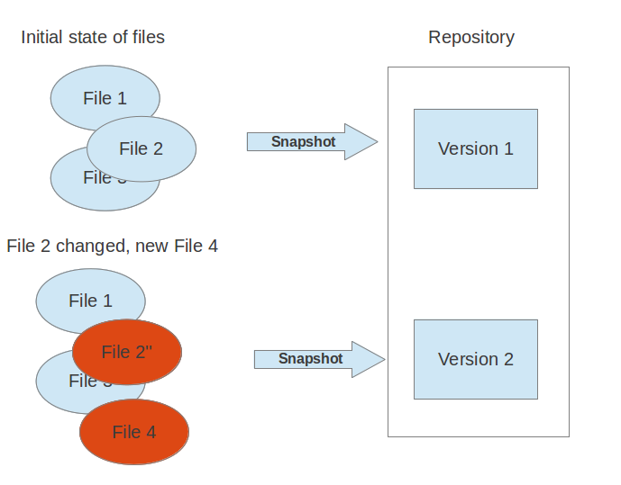

VCS are typically used to track changes in *source code* for a programming language or other text files, like HTML code or configuration files. But a typical version control system can put any type of file under version control, e.g., you may use a VCS to track the different versions of your company logo.

**1.2. Localized and centralized version control systems**

A localized version control system keeps local copies of the files. This approach can be as simple as creating a manual copy of the relevant files. A centralized version control system provides a server software component which stores and manages the different versions of the files and let developer copy (checkout) a certain version onto their individual computer.

Both approaches have the drawback that they have only one single point of failure, e.g., in localized version control systems the individual computer and in a centralized version control systems the server machine. Both system makes it also harder to work in parallel on different features.

**1.3. What is a distributed version control system?**

In a distributed version control system each user has a complete local copy of a repository on his individual computer. The user can copy an existing repository. This copying process is typically called *cloning* and the resulting repository can be referred to as a *clone*.

Every clone contains the full history of the collection of files and a cloned repository has the same functionality as the original repository.

Every repository can exchange versions of the files with other repositories by transporting these changes. This is typically done via a repository running on a server which is, unlike the local machine of a developer, always online. Typically there is a central server for keeping a repository but each cloned repository is a full copy of this repository. The decision which of the copies is considered to be the central server repository is pure convention and not tied to the capabilities of the distributed version control system itself.

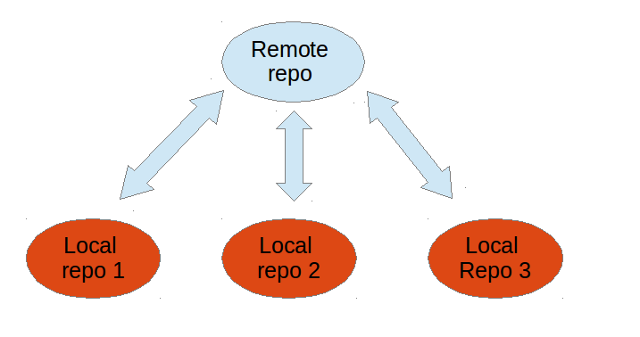

**1.4. What is Git?**

*Git* is currently the most popular implementation of a distributed version control system.

Git originates from the Linux kernel development and was founded in 2005 by Linus Torvalds. Nowadays it is used by many popular open source projects, e.g., the Android or the Eclipse developer teams, as well as many commercial organizations.

The core of Git was originally written in the programming language *C*, but Git has also been re-implemented in other languages, e.g., Java, Ruby and Python.

**2. Tools**

**2.1. The Git command line tools**

The original tooling for Git is based on the command line, i.e., the Git development team provides only tooling for the command line. Most of the following examples are based on the Git command line tooling which offers all capabilities of Git.

**2.2. Separating parameters and file arguments in Git commands**

The double hyphens (--) in Git separates out any references or other options from a path (usually file names). For example HEAD has a special meaning in Git. Using double hyphens llows you to distinguish between looking at a file called HEAD from a Git commit reference called HEAD.

In case Git can determine the correct parameters and options automatically the double hyphens can be avoided.

*# seeing the git log for the HEAD file*

git log --HEAD

*# seeing the git log for the HEAD reference*

git log HEAD --

*# if there is no HEAD file you can use HEAD as commit reference*

git log HEAD

**2.3. Graphical tools for Git**

You can also use graphical tools see [**GUI Clients**](http://git-scm.com/downloads/guis) at the official git website for an overview.

For example the [**Eclipse IDE**](https://www.eclipse.org/downloads/) provides excellent support for working with Git repositories.

To learn more about the Git integration into Eclipse see the [**Eclipse Git online tutorial**](http://www.vogella.com/EclipseGit/articles.html) or the [**Eclipse IDE book**](http://www.vogella.com/books/eclipseide.html).

**3. Important terminology in Git**

**3.1. Cloning, creating and deleting a Git repository**

The process of copying an existing Git repository is called cloning. After cloning a repository the user has the complete repository with its history on his local machine. Of course, Git also supports the creation of new repositories.

If you want to delete a Git repository, you can simply delete the folder which contains the repository.

**3.2. Bare repositories and non-bare repositories**

If you clone a Git repository, by default, Git assumes that you want to work in this repository as a user. Git also supports the creation of repositories targeting the usage on a server.

* bare repositories are supposed to be used on a server for sharing changes coming from different developers. Such repositories do not allow the user to modify locally files and to create new versions for the repository based on these modifications.
* non-bare repositories target the user. They allow you to create new changes through modification of files and to create new versions in the repository. This is the default type which is created if you do not specify any parameter during the clone operation.

A local non-bare Git repository is typically called *local repository*.

**3.3. Working tree**

A local repository provides at least one collection of files which originate from a certain version of the repository. This collection of files is called the *working tree*. It corresponds to a checkout of one version of the repository with potential changes done by the user.

The user can change the files in the *working tree* by modifying existing files and by creating and removing files. Afterwards he can add these changes to the repository.

**3.4. Local operations**

Once the user has his local repository, he can perform modify files in his working tree and perform version control operations. For example he can create new versions for the files in his Git repository, revert the files to another version stored in the repository, etc.

**3.5. Synchronization with remote repositories**

Git allows the user to synchronize the local repository with other (remote) repositories.

Users with sufficient authorization can send new version in their local repository to to remote repositories via the *push* operation. They can also integrate changes from other repositories into their local repository via the *fetch* and *pull* operation.

**3.6. The concept of branches**

Git supports *branching* which means that you can work on different versions of your collection of files. A branch separates these different versions and allows the user to switch between these versions to work on them.

For example, if you want to develop a new feature, you can create a branch and make the changes in this branch without affecting the state of your files in another branch.

Branches in Git are local to the repository. A branch created in a local repository, which was cloned from another repository, does not need to have a counterpart in the remote repository. Local branches can be compared with other local branches and with *remote-tracking branches*. A remote-tracking branch proxies the state of a branch in another remote repository.

Git supports the combination of changes from different branches. This allows the developer, for example, to work independently on a branch called *production* for bugfixes and another branch called *feature_123* for implementing a new feature. The developer can use Git commands to combine the changes at a later point in time.

For example, the Linux kernel community used to share code corrections (patches) via mailing lists to combine changes coming from different developers. Git is a system which allows developers to automate such a process.

**4. The process of adding to a Git repository via staging and committing**

**4.1. Adding changes to a Git repository**

If you modify your *working tree* (see [**Section 3.3, “Working tree”**](http://www.vogella.com/tutorials/Git/article.html#workingtree)) you need to perform two steps to persist these changes in your local repository. You

* add selected changes to the something called the *staging area* and
* afterwards you commit the changes stored in the *staging area* to the repository

This process is depicted in the following graphic.

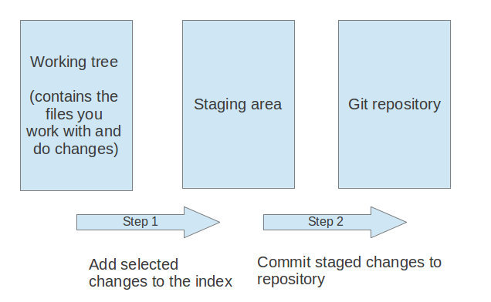

**4.2. Adding to the staging area**

You need to mark changes in the working tree to be relevant for Git. This process is called *staging* or *to add changes to the staging area*.

You add changes in the working tree to the staging area with the git add command. This command stores a snapshot of the specified files in the staging area.

The git add command allows you to incrementally modify files, stage them, modify and stage them again until you are satisfied with your changes.

Older versions of Git used the term *index* instead of staging area. Staging area is nowadays the preferred term by the Git community. Both terms mean the same thing.

**4.3. Committing to the repository**

After adding the selected files to the staging area, you can *commit* these files to add them permanently to the Git repository.*Committing* creates a new persistent snapshot (called *commit* or *commit object*) of the staging area in the Git repository. A commit object, like all objects in Git, is immutable.

The *staging area* keeps track of the snapshots of the files until the staged changes are committed.

For committing the staged changes you use the git commit command.

**4.4. Committing changes**

If you commit changes to your Git repository, you create a new *commit object* in the Git repository. See [**Section 5.1, “Commit object (commit)”**](http://www.vogella.com/tutorials/Git/article.html#commit_object) for information about the commit object.

**5. The details of the commit objects**

**5.1. Commit object (commit)**

Conceptually a commit object (short:commit) represents a version of all files tracked in the repository at the time the commit was created. Commits know their parent(s) and this way capture the version history of the repository.

**5.2. Technical details of a commit object**

This commit object is addressable via a hash (*SHA-1 checksum*). This hash is calculated based on the content of the files, the content of the directories, the complete history of up to the new commit, the committer, the commit message, and several other factors.

This means that Git is safe, you cannot manipulate a file or the commit message in the Git repository without Git noticing that corresponding hash does not fit anymore to the content.

The *commit object* points to the individual files in this commit via a *tree* object. The files are stored in the Git repository as *blob* objects and might be packed by Git for better performance and more compact storage. Blobs are addressed via their SHA-1 hash.

Packing involves storing changes as deltas, compression and storage of many objects in a single *pack file*. *Pack files*are accompanied by one or multiple index files which speedup access to individual objects stored in these packs.

A commit object is depicted in the following picture.

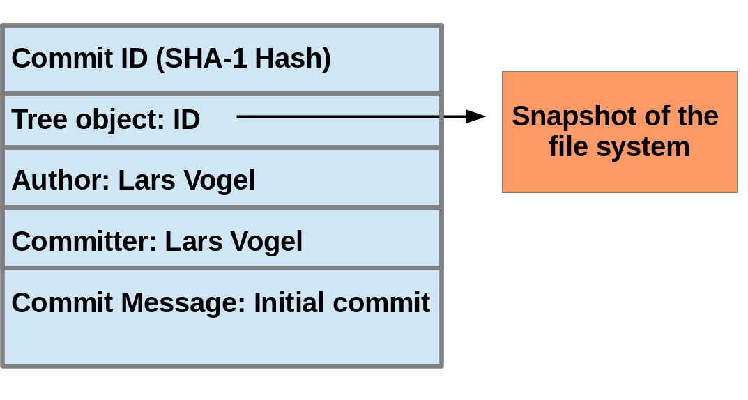

The above picture is simplified. Tree objects point to other tree objects and file blobs. Objects which didn't change between commits are reused by multiple commits.

**5.3. Hash and abbreviated commit hash**

A Git commit object is identified by its hash (SHA-1 checksum). SHA-1 produces a 160-bit (20-byte) hash value. A SHA-1 hash value is typically rendered as a hexadecimal number, 40 digits long.

In a typical Git repository you need fewer characters to uniquely identify a commit object. As a minimum you need 4 characters and in a typical Git repository 5 or 6 are sufficient. This short form is called the abbreviated commit hash or abbreviated hash. Sometimes it is also called the shortened SHA-1 or abbreviated SHA-1.

Several commands, e.g., the git log command can be instructed to use the shortened SHA-1 for their output.

**6. Summary of Git terminology**

**6.1. Reference table with important Git terminology**

The following table provides a summary of important *Git* terminology.

**Table 1. Important Git terminology**

| **Term** | **Definition** |
| --- | --- |
| Branch | A *branch* is a named pointer to a commit. Selecting a branch in Git terminology is called *to checkout a branch*. If you are working in a certain branch, the creation of a new commit advances this pointer to the newly created commit.  Each commit knows their parents (predecessors). Successors are retrieved by traversing the commit graph starting from branches or other refs, symbolic references (for example: HEAD) or explicit commit objects. This way a branch defines its own line of descendants in the overall version graph formed by all commits in the repository.  You can create a new branch from an existing one and change the code independently from other branches. One of the branches is the default (typically named *master*). The default branch is the one for which a local branch is automatically created when cloning the repository. |
| Commit | When you commit your changes into a repository this creates a new *commit object* in the Git repository. This*commit object* uniquely identifies a new revision of the content of the repository.  This revision can be retrieved later, for example, if you want to see the source code of an older version. Each commit object contains the author and the committer, thus making it possible to identify who did the change. The author and committer might be different people. The author did the change and the committer applied the change to the Git repository. This is common for contributions to open source projects. |
| HEAD | *HEAD* is a symbolic reference most often pointing to the currently checked out branch.  Sometimes the *HEAD* points directly to a commit object, this is called *detached HEAD mode*. In that state creation of a commit will not move any branch.  If you switch branches, the *HEAD* pointer points to the branch pointer which in turn points to a commit. If you checkout a specific commit, the *HEAD* points to this commit directly. |
| Index | *Index* is an alternative term for the *staging area*. |
| Repository | A *repository* contains the history, the different versions over time and all different branches and tags. In Git each copy of the repository is a complete repository. If the repository is not a bare repository, it allows you to checkout revisions into your working tree and to capture changes by creating new commits. Bare repositories are only changed by transporting changes from other repositories.  This book uses the term *repository* to talk about a non-bare repository. If it talks about a bare repository, this is explicitly mentioned. |
| Revision | Represents a version of the source code. Git implements revisions as *commit objects* (or short *commits*). These are identified by an SHA-1 hash. |
| Staging area | The *staging area* is the place to store changes in the working tree before the commit. The *staging area* contains a snapshot of the changes in the working tree (changed or new files) relevant to create the next commit and stores their mode (file type, executable bit). |
| Tag | A *tag* points to a commit which uniquely identifies a version of the Git repository. With a tag, you can have a named point to which you can always revert to. You can revert to any point in a Git repository, but tags make it easier. The benefit of tags is to mark the repository for a specific reason, e.g., with a release.  Branches and tags are named pointers, the difference is that branches move when a new commit is created while tags always point to the same commit. Tags can have a timestamp and a message associated with them. |
| URL | A URL in Git determines the location of the repository. Git distinguishes between *fetchurl* for getting new data from other repositories and *pushurl* for pushing data to another repository. |
| Working tree | The *working tree* contains the set of working files for the repository. You can modify the content and commit the changes as new commits to the repository. |

**6.2. File states in the working tree**

A file in the working tree of a Git repository can have different states. These states are the following:

* untracked: the file is not tracked by the Git repository. This means that the file never staged nor committed.
* tracked: committed and not staged
* staged: staged to be included in the next commit
* dirty / modified: the file has changed but the change is not staged

**7. Commit references**

**7.1. Predecessor commits, parents and commit references**

Each commit has zero or more direct predecessor commits. The first commit has zero parents, merge commits have two or more parents, most commits have one parent.

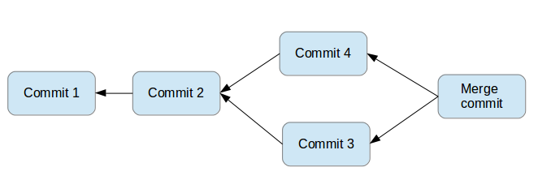

In Git you typically need to address certain commits. For example you want to tell Git to show you all changes which were done in the last three commits. Or you want to see the differences introduced between two different branches.

Git allows addressing commits via *commit reference* for this purpose.

A commit reference can be a *simple reference* (simple ref), in this case it points directly to a commit. This is the case for a commit hash or a tag. A commit reference can also be *symbolic reference* (symbolic ref, symref). In this case it points to another reference (either simple or symbolic). For example HEAD is a symbolic ref for a branch, if it points to a branch. HEAD points to the branch pointer and the branch pointer points to a commit.

**7.2. Branch references and the HEAD reference**

A branch points to a specific commit. You can use the branch name as reference to the corresponding commit. You can also use HEAD to reference the corresponding commit.

**7.3. Parent and ancestor commits**

You can use ^ (caret) and ~ (tilde) to reference predecessor commit objects from other references. You can also combine the ^ and ~ operators. See [**Section 7.4, “Using caret and tilde for commit references”**](http://www.vogella.com/tutorials/Git/article.html#commitreference_carettilde) for their usage.

The Git terminology is *parent* for ^ and *ancestor* for ~.

**7.4. Using caret and tilde for commit references**

[reference]~1 describes the first predecessor of the commit object accessed via [reference]. [reference]~2 is the first predecessor of the first predecessor of the [reference] commit. [reference]~3 is the first predecessor of the first predecessor of the first predecessor of the [reference] commit, etc.

[reference]~ is an abbreviation for [reference]~1.

For example, you can use the *HEAD~1* or *HEAD~* reference to access the first parent of the commit to which the *HEAD* pointer currently points.

[reference]^1 also describes the first predecessor of the commit object accessed via [reference].

For example HEAD^^^ is the same as HEAD~~~ and is the same as HEAD~3.

The difference is that [reference]^2 describes the second parent of a commit. A merge commit typically has two predecessors. HEAD^3 means ‘the third parent of a merge’ and in most cases this won’t exist (merges are generally between two commits, though more is possible).

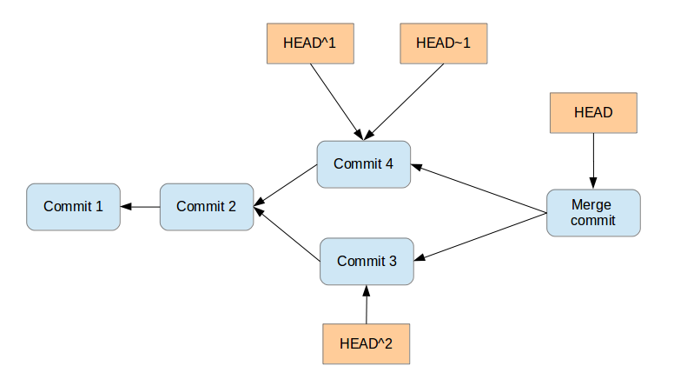

[reference]^ is an abbreviation for [reference]^1.

**7.5. Commit ranges with the double dot operator**

You can also specify ranges of commits. This is useful for certain Git commands, for example, for seeing the changes between a series of commits.

The double dot operator allows you to select all commits which are reachable from a commit c2 but not from commit c1. The syntax for this is "c1..c2". A commit A is reachable from another commit B if A is a direct or indirect parent of B.

**Tip**

Think of c1..c2 as *all commits as of c1 (not including c1) until commit c2.*

For example, you can ask Git to show all commits which happened between HEAD and HEAD~4.

git log HEAD~4..HEAD

This also works for branches. To list all commits which are in the "master" branch but not in the "testing" branch, use the following command.

git log testing..master

You can also list all commits which are in the "testing" but not in the "master" branch.

git log master..testing

**7.6. Commit ranges with the triple dot operator**

The triple dot operator allows you to select all commits which are reachable either from commit c1 or commit c2 but not from both of them.

This is useful to show all commits in two branches which have not yet been combined.

*# show all commits which*

*# can be reached by master or testing*

*# but not both*

git log master...testing

**8. Installation**

**8.1. Ubuntu, Debian and derived systems**

On Ubuntu and similar systems you can install the Git command line tool via the following command:

sudo apt-get install git

**8.2. Fedora, Red Hat and derived systems**

On Fedora, Red Hat and similar systems you can install the Git command line tool via the following command:

dnf install git

**8.3. Other Linux systems**

To install Git on other Linux distributions please check the documentation of your distribution. The following listing contains the commands for the most popular ones.

*# Arch Linux*

sudo pacman -S git

*# Gentoo*

sudo emerge -av git

*# SUSE*

sudo zypper install git

**8.4. Windows**

A Windows version of Git can be found on the [**Git download page**](http://git-scm.com/downloads). This website provides native installers for each operating system. The homepage of the Windows Git project is [**git for window**](https://git-for-windows.github.io/).

**8.5. Mac OS**

The easiest way to install Git on a Mac is via the [**Git download page**](http://git-scm.com/downloads) and to download and run the installer for Mac OS X.

Git is also installed by default with the Apple Developer Tools on Mac OS X.

**9. Different levels of Git configuration**

**9.1. Git configuration levels**

The git config command allows you to configure your Git settings. These settings can be system wide, user or repository specific.

A more specific setting overwrites values in the previous level, i.e., a setting the repository overrides the user setting and a user setting overrides a system wide setting.

**9.2. Git system-wide configuration**

You can provide a system wide configuration for your Git settings. A system wide configuration is not very common, most settings are user specific or repository specific as described in the next chapters.

On a Unix based system Git uses the */etc/gitconfig* file for this system-wide configuration. To set this up, ensure you have sufficient rights, i.e. root rights, in your OS and use the *--system* option for the git config command.

**9.3. Git user configuration**

Git allows you to store user settings in the *.gitconfig* file located in the user home directory. This is also called the *global* Git configuration.

For example Git stores the committer and author of a change in each commit. This and additional information can be stored in the Git user settings.

In each Git repository you can also configure the settings for this repository. User configuration is done if you include the *--global*option in the git config command.

**9.4. Repository specific configuration**

You can also store repository specific settings in the *.git/config* file of a repository. Use the *--local* or use no flag at all. If neither the *--system* not the *--global* parameter is used, the setting is specific for the current Git repository.

**10. Performing the Git configuration**

**10.1. User configuration**

You have to configure at least your user and email address to be able to commit to a Git repository because this information is stored in each commit.

**10.2. Exercise: User configuration**

Configure your user and email for Git via the following command.

*# configure the user which will be used by Git*

*# this should be not an acronym but your full name*

git config --global user.name "Firstname Lastname"

*# configure the email address*

git config --global user.email "your.email@example.org"

**10.3. Push configuration**

If your are using Git in a version below 2.0 you should also execute the following command.

*# set default so that only the current branch is pushed*

git config --global push.default simple

This configures Git so that the git push command pushes only the active branch (in case it is connected to a remote branch, i.e., configured as remote-tracking branches) to your Git remote repository. As of Git version 2.0 this is the default and therefore it is good practice to configure this behavior.

You learn about the push command in [**Section 21.1, “Push changes to another repository”**](http://www.vogella.com/tutorials/Git/article.html#cloneremotes_push).

**10.4. Avoid merge commits for pulling**

If you pull in changes from a remote repository, Git by default creates merge commits if you pull in divergent changes. This may not be desired and you can avoid this via the following setting.

*# set default so that you avoid unnecessary commits*

git config --global branch.autosetuprebase always

**Note**

This setting depends on the individual workflow. Some teams prefer to create merge commits, but the author of this book likes to avoid them.

**10.5. Color Highlighting**

The following commands enables color highlighting for Git in the console.

git config --global color.ui auto

**10.6. Setting the default editor**

By default Git uses the system default editor which is taken from the *VISUAL* or *EDITOR* environment variables if set. You can configure a different one via the following setting.

*# setup vim as default editor for Git (Linux)*

git config --global core.editor vim

**10.7. Setting the default merge tool**

File conflicts might occur in Git during an operation which combines different versions of the same files. In this case the user can directly edit the file to resolve the conflict.

Git allows also to configure a merge tool for solving these conflicts. You have to use third party visual merge tools like tortoisemerge, p4merge, kdiff3 etc. A Google search for these tools help you to install them on your platform. Keep in mind that such tools are not required, you can always edit the files directly in a text editor.

Once you have installed them you can set your selected tool as default merge tool with the following command.

*# setup kdiff3 as default merge tool (Linux)*

git config --global merge.tool kdiff3

*# to install it under Ubuntu use*

sudo apt-get install kdiff3

**10.8. More settings**

All possible Git settings are described under the following link: [**git-config manual page**](https://www.kernel.org/pub/software/scm/git/docs/git-config.html)

**10.9. Query Git settings**

To query your Git settings, execute the following command:

git config --list

If you want to query the global settings you can use the following command.

git config --global --list

**11. Configure files and directories to ignore**

**11.1. Ignoring files and directories with a .gitignore file**

Git can be configured to ignore certain files and directories for repository operations. This is configured via one or several*.gitignore* files. Typically, this file is located at the root of your Git repository but it can also be located in sub-directories. In the second case the defined rules are only valid for the sub-directory and below.

You can use certain wildcards in this file. *\** matches several characters. More patterns are possible and described under the following URL: [**gitignore manpage**](https://www.kernel.org/pub/software/scm/git/docs/gitignore.html)

For example, the following *.gitignore* file tells Git to ignore the *bin* and *target* directories and all files ending with a ~.

*# ignore all bin directories*

*# matches "bin" in any subfolder*

bin/

*# ignore all target directories*

target/

*# ignore all files ending with ~*

*~

You can create the *.gitignore* file in the root directory of the working tree to make it specific for the Git repository.

**Tip**

The *.gitignore* file tells Git to ignore the specified files in Git commands. You can still add ignored files to the*staging area* of the Git repository by using the --force parameter, i.e. with the git add --force [paths]command.

This is useful if you want to add, for example, auto-generated binaries, but you need to have a fine control about the version which is added and want to exclude them from the normal workflow.

It is good practice to commit the local *.gitignore* file into the Git repository so that everyone who clones this repository has it.

**11.2. Global (cross-repository) .gitignore settings**

You can also setup a global *.gitignore* file valid for all Git repositories via the core.excludesfile setting. The setup of this setting is demonstrated in the following code snippet.

*# Create a ~/.gitignore in your user directory*

**cd** ~/

**touch** .gitignore

*# Exclude bin and .metadata directories*

**echo** "bin" >> .gitignore

**echo** ".metadata" >> .gitignore

**echo** "*~" >> .gitignore

**echo** "target/" >> .gitignore

*# for Mac*

**echo** ".DS_Store" >> .gitignore

**echo** "._*" >> .gitignore

*# Configure Git to use this file*

*# as global .gitignore*

git config --global core.excludesfile ~/.gitignore

The global *.gitignore* file is only locally available.

**11.3. Local per-repository ignore rules**

You can also create local per-repository rules by editing the *.git/info/exclude* file in your repository. These rules are not committed with the repository so they are not shared with others.

This allows you to exclude, for example, locally generated files.

**12. Git and empty directories**

**12.1. Default behaviour of Git for empty directories**

Git ignores empty directories, i.e., it does not put them under version control.

**12.2. Tracking empty directories**

If you want to track an empty directory in your Git repository, it is a good practice to put a file called *.gitignore* in the directory. As the directory now contains a file, Git includes it into its version control mechanism.

**Note**

The file could be called anything. Others sources recommend to call the file *.gitkeep*. One problem with this approach is that *.gitkeep* is unlikely to be ignored by build systems, resulting in the *.gitkeep* file being copied to the output repository.

**13. Create repository**

**13.1. Target of this chapter**

In this chapter you create a local Git repository. The comments (marked with #) before the commands explain the specific actions.

Open a command shell for the operations.

**13.2. Create a directory**

The following commands create an empty directory which is used later in this exercise to contain the working tree and the Git repository.

*# switch to home*

**cd**

*# create a directory and switch into it*

**mkdir** repo01

**cd** repo01

*# create a new directory*

**mkdir** datafiles

**13.3. Create a new Git repository**

The following explanation is based on a non-bare repository. See [**Section 6.1, “Reference table with important Git terminology”**](http://www.vogella.com/tutorials/Git/article.html#gitterminology)for the difference between a bare repository and a non-bare repository with a *working tree*.

Every Git repository is stored in the *.git* folder of the directory in which the Git repository has been created. This directory contains the complete history of the repository. The *.git/config* file contains the configuration for the repository.

The following command creates a Git repository in the current directory.

*# you should still be in the repo01 directory*

**cd** ~/repo01

*# initialize the Git repository*

*# for the current directory*

git init

All files inside the repository folder excluding the *.git* folder are the *working tree* for a Git repository.

**14. Getting started with Git**

**14.1. Target of this chapter**

In this chapter you create several files and place them under version control.

**14.2. Create new content**

Use the following commands to create several new files.

*# switch to your Git repository*

**cd** ~/repo01

*# create an empty file in a new directory*

**touch** datafiles/data.txt

*# create a few files with content*

**ls** > test01

**echo** "bar" > test02

**echo** "foo" > test03

**14.3. See the current status of your repository**

The git status command shows the working tree status, i.e. which files have changed, which are staged and which are not part of the staging area. It also shows which files have conflicts and gives an indication what the user can do with these changes, e.g., add them to the staging area or remove them, etc.

Run it via the following command.

git status

The output looks similar to the following listing.

On branch master

Initial commit

Untracked files:

(use "git add <file>..." to include in what will be committed)

datafiles/

test01

test02

test03

nothing added to commit but untracked files present (use "git add" to track)

**14.4. Add files to the staging area**

Before committing changes to a Git repository you need to mark the changes that should be committed. This is done by adding the new and changed files to the staging area. This creates a snapshot of the affected files.

*# add all files to the index of the Git repository*

git add .

Afterwards run the git status command again to see the current status.

On branch master

Initial commit

Changes to be committed:

(use "git rm --cached <file>..." to unstage)

new file: datafiles/data.txt

new file: test01

new file: test02

new file: test03

**14.5. Change files that are staged**

In case you change one of the staged files before committing, you need to add it again to the staging area to commit the new changes. This is because Git creates a snapshot of these staged files. All new changes must again be staged.

*# append a string to the test03 file*

**echo** "foo2" >> test03

*# see the result*

git status

Validate that the new changes are not yet staged.

On branch master

Initial commit

Changes to be committed:

(use "git rm --cached <file>..." to unstage)

new file: datafiles/data.txt

new file: test01

new file: test02

new file: test03

Changes not staged **for** commit:

(use "git add <file>..." to update what will be committed)

(use "git checkout -- <file>..." to discard changes in working directory)

modified: test03

Add the new changes to the staging area.

*# add all files to the index of the Git repository*

git add .

Use the git status command again to see that all changes are staged.

On branch master

Initial commit

Changes to be committed:

(use "git rm --cached <file>..." to unstage)

new file: datafiles/data.txt

new file: test01

new file: test02

new file: test03

**14.6. Commit staged changes to the repository**

After adding the files to the Git staging area, you can commit them to the Git repository. This creates a new commit object with the staged changes in the Git repository and the HEAD reference points to the new commit. The *-m* parameter allows you to specify the commit message. If you leave this parameter out, your default editor is started and you can enter the message in the editor.

*# commit your file to the local repository*

git commit -m "Initial commit"

**15. Looking at the result**

**15.1. Viewing the Git commit history**

The Git operations you performed have created a local Git repository in the *.git* folder and added all files to this repository via one commit. Run the git log command (See [**Section 30.1, “Using git log”**](http://www.vogella.com/tutorials/Git/article.html#analyzechanges_log) for details).

*# show the Git log for the change*

git log

You see an output similar to the following.

commit 30605803fcbd507df36a3108945e02908c823828

Author: Lars Vogel <Lars.Vogel@vogella.com>

Date: Mon Dec 1 10:43:42 2014 +0100

Initial commit

**15.2. Directory structure**

Your directory contains the Git repository as well as the Git working tree for your files. This directory structure is depicted in the following screenshot.

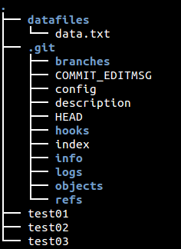

**16. Remove files and adjust the last commit**

**16.1. Remove files**

If you delete a file you use the git add . command to add the deletion of a file to the staging area. This is supported as of Git version 2.0.

*# remove the "test03" file*

**rm** test03

*# add and commit the removal*

git add .

*# if you use Git version < 2.0 use: git add -A .*

git commit -m "Removes the test03 file"

Alternatively you can use the git rm command to delete the file from your working tree and record the deletion of the file in the staging area.

**16.2. Revert changes in files in the working tree**

Use the git checkout command to reset a tracked file (a file that was once staged or committed) to its latest staged or commit state. The command removes the changes of the file in the working tree. This command cannot be applied to files which are not yet staged or committed.

**echo** "useless data" >> test02

**echo** "another unwanted file" >> unwantedfile.txt

*# see the status*

git status

*# remove unwanted changes from the working tree*

*# CAREFUL this deletes the local changes in the tracked file*

git checkout test02

*# unwantedstaged.txt is not tracked by Git simply delete it*

**rm** unwantedfile.txt

If you use git status command to see that there are no changes left in the working directory.

On branch master

nothing to commit, working directory clean

**Warning**

Use this command carefully. The git checkout command deletes the unstaged and uncommitted changes of tracked files in the working tree and it is not possible to restore this deletion via Git.

**16.3. Correct the last commit with git amend**

The git commit --amend command makes it possible to replace the last commit. This allows you to change the last commit including the commit message.

**Note**

The amended commit is still available until a clean-up job removes it. See [**Section 44.2, “git reflog”**](http://www.vogella.com/tutorials/Git/article.html#gitreflog_definition) for details.

Assume the last commit message was incorrect as it contained a typo. The following command corrects this via the --amendparameter.

*# assuming you have something to commit*

git commit -m "message with a tpyo here"

*# amend the last commit*

git commit --amend -m "More changes - now correct"

You should use the git --amend command only for commits which have not been pushed to a public branch of another Git repository. The git --amend command creates a new commit ID and people may have based their work already on the existing commit. In this case they would need to migrate their work based on the new commit.

**17. Ignoring certain files and directories**

**17.1. Ignore files and directories with the .gitignore file**

Git allows you to define pattern for files which should not be tracked by the Git repository. Create the following *.gitignore* file in the root of your Git directory to ignore the specified directory and file.

**cd** ~/repo01

**touch** .gitignore

**echo** ".metadata/" >> .gitignore

**echo** "doNotTrackFile.txt" >> .gitignore

**Tip**

The above command creates the file via the command line. A more common approach is to use your favorite text editor to create the file. This editor must save the file as plain text, e.g., gedit under Ubuntu or Notepad under Windows.

The resulting file looks like the following listing.

.metadata/

doNotTrackFile.txt

**17.2. Stop tracking files based on the .gitignore file**

Files that are tracked by Git are not automatically removed if you add them to a *.gitignore* file. Git never ignores files which are already tracked, so changes in the *.gitignore* file only affect new files. If you want to ignore files which are already tracked you need to explicitly remove them.

The following command demonstrates how to remove the *.metadata* directory and the *doNotTrackFile.txt* file from being tracked. This is example code, as you did not commit the corresponding files in your example, the command will not work in your Git repository.

*# remove directory .metadata from git repo*

git rm -r --cached .metadata

*# remove file test.txt from repo*

git rm --cached doNotTrackFile.txt

Adding a file to the *.gitignore* file does not remove the file from the repository history. If the file should also be removed from the history, have a look at git filter-branch which allows you to rewrite the commit history. See [**Section 62.1, “Using git filter-branch”**](http://www.vogella.com/tutorials/Git/article.html#filterbranch_definition) for details.

**17.3. Commit the .gitignore file**

It is good practice to commit the *.gitignore* file into the Git repository. Use the following commands for this.

*# add the .gitignore file to the staging area*

git add .gitignore

*# commit the change*

git commit -m "Adds .gitignore file"

**18. Remote repositories**

**18.1. What are remotes?**

*Remotes* are URLs in a Git repository to other remote repositories that are hosted on the Internet, locally or on the network.

Such remotes can be used to synchronize the changes of several Git repositories. A local Git repository can be connected to multiple remote repositories and you can synchronize your local repository with them via Git operations.

**Note**

Think of *remotes* as shorter bookmarks for repositories. You can always connect to a remote repository if you know its URL and if you have access to it. Without *remotes* the user would have to type the URL for each and every command which communicates with another repository.

It is possible that users connect their individual repositories directly, but a typically Git workflow involves one or more remote repositories which are used to synchronize the individual repository. Typically the remote repository which is used for synchronization is located on a server which is always available.

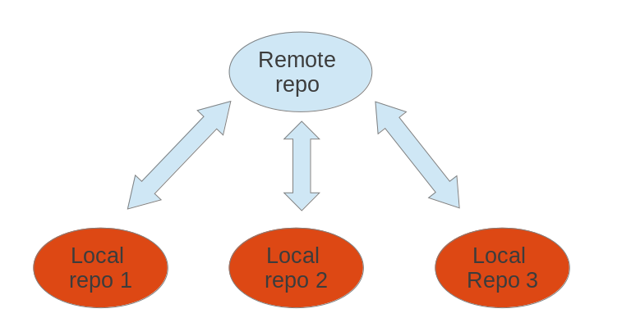

**Tip**

A remote repository can also be hosted in the local file system.

**18.2. Bare repositories**

A remote repository on a server typically does not require a *working tree*. A Git repository without a *working tree* is called a *bare repository*. You can create such a repository with the *--bare* option. The command to create a new empty bare remote repository is displayed below.

*# create a bare repository*

git init --bare

By convention the name of a bare repository should end with the *.git* extension.

To create a bare Git repository in the Internet you would, for example, connect to your server via the SSH protocol or you use some Git hosting platform, e.g., GitHub.com.

**18.3. Convert a Git repository to a bare repository**

Converting a normal Git repository to a bare repository is not directly support by Git.

You can convert it manually by moving the content of the *.git* folder into the root of the repository and by removing all others files from the working tree. Afterwards you need to update the Git repository configuration with the git config core.bare truecommand.

As this is officially not supported, you should prefer cloning a repository with the *--bare* option.

**19. Cloning repositories and the remote called "origin"**

**19.1. Cloning a repository**

The git clone command copies an existing Git repository. This copy is a working Git repository with the complete history of the cloned repository. It can be used completely isolated from the original repository.

**19.2. The remote called "origin"**

If you clone a repository, Git implicitly creates a *remote* named *origin* by default. The *origin* *remote* links back to the cloned repository.

If you create a Git repository from scratch with the git init command, the *origin* remote is not created automatically.

**19.3. Exercise: Cloning to create a bare Git repository**

In this section you create a bare Git repository. In order to simplify the following examples, the Git repository is hosted locally in the filesystem and not on a server in the Internet.

Execute the following commands to create a bare repository based on your existing Git repository.

*# switch to the first repository*

**cd** ~/repo01

*# create a new bare repository by cloning the first one*

git clone --bare . ../remote-repository.git

*# check the content of the git repo, it is similar*

*# to the .git directory in repo01*

*# files might be packed in the bare repository*

**ls** ~/remote-repository.git

**Tip**

If you receive a warning similar to the following: push.default is unset; its implicit value is changing in Git 2.0 from 'matching' to 'simple', see [**Section 10.3, “Push configuration”**](http://www.vogella.com/tutorials/Git/article.html#setup_pushconfiguration) for the missing configuration.

**20. Adding and listing existing remotes**

**20.1. Adding a remote repository**

You add as many *remotes* to your repository as desired. For this you use the git remote add command.

You created a new Git repository from scratch earlier. Use the following command to add a remote to your new bare repository using the *origin* name.

*# add ../remote-repository.git with the name origin*

git remote add origin ../remote-repository.git

**20.2. Synchronizing with remote repositories**

You can synchronize your local Git repository with remote repositories. These commands are covered in detail in later sections but the following command demonstrates how you can send changes to your remote repository.

*# do some changes*

**echo** "I added a remote repo" > test02

*# commit*

git commit -a -m "This is a test for the new remote origin"

*# to push use the command:*

*# git push [target]*

*# default for [target] is origin*

git push origin

**20.3. Show the existing remotes**

To see the existing definitions of the remote repositories, use the following command.

*# show the details of the remote repo called origin*

git remote show origin

To see the details of the *remotes*, e.g., the URL use the following command.

*# show the existing defined remotes*

git remote

*# show details about the remotes*

git remote -v

**21. The push and pull commands**

**21.1. Push changes to another repository**

The git push command allows you to send data to other repositories. By default it sends data from your current branch to the same branch of the remote repository.

By default you can only push to bare repositories (repositories without working tree). Also you can only push a change to a remote repository which results in a fast-forward merge. See [**Section 48.1, “Fast-forward merge”**](http://www.vogella.com/tutorials/Git/article.html#gitmerge_fastforward) to learn about fast-forward merges.

See [**Section 24.6, “Push changes of a branch to a remote repository”**](http://www.vogella.com/tutorials/Git/article.html#gitpushbranch) for details on pushing branches or the [**Git push manpage**](https://www.kernel.org/pub/software/scm/git/docs/git-push.html)for general information.

**21.2. Pull changes**

The git pull command allows you to get the latest changes from another repository for the current branch.

The git pull command is actually a shortcut for git fetch followed by the git merge or the git rebase command depending on your configuration. In [**Section 10.4, “Avoid merge commits for pulling”**](http://www.vogella.com/tutorials/Git/article.html#setup_rebase) you configured your Git repository so thatgit pull is a fetch followed by a rebase. See [**Section 46.1, “Fetch”**](http://www.vogella.com/tutorials/Git/article.html#gitfetch_intro) for more information about the fetch command.

**21.3. Exercise: Clone your bare repository**

In this exercise you create a Git repository based on the bare repository you created in [**Section 19.3, “Exercise: Cloning to create a bare Git repository”**](http://www.vogella.com/tutorials/Git/article.html#remotes_setupexercise).

Clone a repository and checkout a working tree in a new directory via the following commands.

*# switch to home*

**cd** ~

*# make new directory*

**mkdir** repo02

*# switch to new directory*

**cd** ~/repo02

*# clone*

git clone ../remote-repository.git .

**21.4. Exercise: Using the push command**

Make some changes in your local repository and push them from your first repository to the remote repository via the following commands.

*# make some changes in the first repository*

**cd** ~/repo01

*# make some changes in the file*

**echo** "Hello, hello. Turn your radio on" > test01

**echo** "Bye, bye. Turn your radio off" > test02

*# commit the changes, -a will commit changes for modified files*

*# but will not add automatically new files*

git commit -a -m "Some changes"

*# push the changes*

git push ../remote-repository.git

**21.5. Exercise: Using the pull command**

To test the git pull in your example Git repositories, switch to your second repository, pull in the recent changes from the remote repository, make some changes, push them to your remote repository via the following commands.

*# switch to second directory*

**cd** ~/repo02

*# pull in the latest changes of your remote repository*

git pull

*# make changes*

**echo** "A change" > test01

*# commit the changes*

git commit -a -m "A change"

*# push changes to remote repository*

*# origin is automatically created as we cloned original from this repository*

git push origin

You can pull in the changes in your first example repository with the following commands.

*# switch to the first repository and pull in the changes*

**cd** ~/repo01

git pull ../remote-repository.git/

*# check the changes*

git status

**22. Working with remote repositories**

**22.1. Cloning remote repositories**

Git supports several transport protocols to connect to other Git repositories; the native protocol for Git is also called git.

The following command clones an existing repository using the Git protocol. The Git protocol uses the port 9148 which might be blocked by firewalls.

*# switch to a new directory*

**mkdir** ~/online

**cd** ~/online

*# clone online repository*

git clone git://github.com/vogella/gitbook.git

If you have SSH access to a Git repository, you can also use the ssh protocol. The name preceding @ is the user name used for the SSH connection.

*# clone online repository*

git clone **ssh**://git@github.com/vogella/gitbook.git

*# older syntax*

git clone git@github.com:vogella/gitbook.git

Alternatively you could clone the same repository via the http protocol.

*# the following will clone via HTTP*

git clone http://github.com/vogella/gitbook.git

**22.2. Add more remote repositories**

As discussed earlier cloning repository creates a *remote* called origin pointing to the remote repository which you cloned from. You can push changes to this repository via git push as Git uses *origin* as default. Of course, pushing to a remote repository requires write access to this repository.

You can add more *remotes* via the git remote add [name] [URL_to_Git_repo] command. For example, if you cloned the repository from above via the Git protocol, you could add a new remote with the name *github_http* for the http protocol via the following command.

*# add the HTTPS protocol*

git remote add github_http https://vogella@github.com/vogella/gitbook.git

**22.3. Rename remote repositories**

To rename an existing remote repository use the git remote rename command. This is demonstrated by the following listing.

*# rename the existing remote repository from*

*# github_http to github_testing*

git remote rename github_http github_testing

**22.4. Remote operations via HTTP**

It is possible to use the HTTP protocol to clone Git repositories. This is especially helpful if your firewall blocks everything except HTTP or HTTPS.

git clone http://git.eclipse.org/gitroot/platform/eclipse.platform.ui.git

For secured SSL encrypted communication you should use the SSH or HTTPS protocol in order to guarantee security.

**22.5. Using a proxy**

Git also provides support for HTTP access via a proxy server. The following Git command could, for example, clone a repository via HTTP and a proxy. You can either set the proxy variable in general for all applications or set it only for Git.

The following listing configures the proxy via environment variables.

*# Linux and Mac*

**export** http_proxy=http://proxy:8080

**export** https_proxy=https://proxy:8443

*# Windows*

**set** http_proxy http://proxy:8080

**set** https_proxy http://proxy:8080

git clone http://git.eclipse.org/gitroot/platform/eclipse.platform.ui.git

The following listing configures the proxy via Git config settings.

*# set proxy for git globally*

git config --global http.proxy http://proxy:8080

*# to check the proxy settings*

git config --get http.proxy

*# just in case you need to you can also revoke the proxy settings*

git config --global --**unset** http.proxy

**Tip**

Git is able to store different proxy configurations for different domains, see *core.gitProxy* in [**Git config manpage**](http://git-scm.com/docs/git-config).

**23. What are branches?**

Git allows you to create *branches*, i.e. named pointers to commits. You can work on different branches independently from each other. The default branch is most often called *master*.

A branch pointer in Git is 41 bytes large, 40 bytes of characters and an additional new line character. Therefore, the creating of branches in Git is very fast and cheap in terms of resource consumption. Git encourages the usage of branches on a regular basis.

If you decide to work on a branch, you *checkout* this branch. This means that Git populates the *working tree* with the version of the files from the commit to which the branch points and moves the *HEAD* pointer to the new branch.

As explained in [**Section 6.1, “Reference table with important Git terminology”**](http://www.vogella.com/tutorials/Git/article.html#gitterminology) *HEAD* is a symbolic reference usually pointing to the branch which is currently checked out.

**24. Commands to working with branches**

**24.1. List available branches**

The git branch command lists all local branches. The currently active branch is marked with *.

*# lists available branches*

git branch

If you want to see all branches (including remote-tracking branches), use the *-a* for the git branch command. See [**Section 45.1, “Remote tracking branches”**](http://www.vogella.com/tutorials/Git/article.html#gitremotebranch_overview) for information about remote-tracking branches.

*# lists all branches including the remote branches*

git branch -a

The *-v* option lists more information about the branches.

In order to list branches in a remote repository use the git branch -r command as demonstrated in the following example.

*# lists branches in the remote repositories*

git branch -r

**24.2. Create new branch**

You can create a new branch via the git branch [newname] command. This command allows to specify the starting point (commit id, tag, remote or local branch). If not specified the commit to which the HEAD reference points is used to create the branch.

*# syntax: git branch <name> <hash>*

*# <hash> in the above is optional*

git branch testing

**24.3. Checkout branch**

To start working in a branch you have to *checkout* the branch. If you *checkout* a branch, the HEAD pointer moves to the last commit in this branch and the files in the working tree are set to the state of this commit.

The following commands demonstrate how you switch to the branch called *testing*, perform some changes in this branch and switch back to the branch called *master*.

*# switch to your new branch*

git checkout testing

*# do some changes*

**echo** "Cool new feature in this branch" > test01

git commit -a -m "new feature"

*# switch to the master branch*

git checkout master

*# check that the content of*

*# the test01 file is the old one*

**cat** test01

To create a branch and to switch to it at the same time you can use the git checkout command with the *-b* parameter.

*# create branch and switch to it*

git checkout -b bugreport12

*# creates a new branch based on the master branch*

*# without the last commit*

git checkout -b mybranch master~1

**24.4. Rename a branch**

Renaming a branch can be done with the following command.

*# rename branch*

git branch -m [old_name] [new_name]

**24.5. Delete a branch**

To delete a branch which is not needed anymore, you can use the following command. You may get an error message that there are uncommited changes if you did the previous examples step by step. Use force delete (uppercase *-D*) to delete it anyway.

*# delete branch testing*

git branch -d testing

*# force delete testing*

git branch -D testing

*# check if branch has been deleted*

git branch

**24.6. Push changes of a branch to a remote repository**

You can push the changes in the current active branch to a remote repository by specifying the target branch. This creates the target branch in the remote repository if it does not yet exist.

*# push current branch to a branch called "testing" to remote repository*

git push origin testing

*# switch to the testing branch*

git checkout testing

*# some changes*

**echo** "News for you" > test01

git commit -a -m "new feature in branch"

*# push all including branch*

git push

This way you can decide which branches you want to push to other repositories and which should be local branches. You learn more about branches and remote repositories in [**Section 45.1, “Remote tracking branches”**](http://www.vogella.com/tutorials/Git/article.html#gitremotebranch_overview).

**25. Differences between branches**

To see the difference between two branches you can use the following command.

*# shows the differences between*

*# current head of master and your_branch*

git diff master your_branch

You can also use commit ranges as described in [**Section 7.5, “Commit ranges with the double dot operator”**](http://www.vogella.com/tutorials/Git/article.html#commitreference_ranges_doubledot) and [**Section 7.6, “Commit ranges with the triple dot operator”**](http://www.vogella.com/tutorials/Git/article.html#commitreference_ranges_tripledot). For example, if you compare a branch called *your_branch* with the *master* branch the following command shows the changes in *your_branch* and *master* since these branches diverged.

*# shows the differences in your*

*# branch based on the common*

*# ancestor for both branches*

git diff master...your_branch

See [**Section 31, “Viewing changes with git diff and git show”**](http://www.vogella.com/tutorials/Git/article.html#gitdiffchapter) for more examples of the git diff command.

**26. Tags in Git**

**26.1. What are tags?**

Git has the option to *tag* a commit in the repository history so that you find it easier at a later point in time. Most commonly, this is used to tag a certain version which has been released.

If you tag a commit, you create an annotated or lightweight tag.

**26.2. Lightweight and annotated tags**

Git supports two different types of tags, lightweight and annotated tags.

A *lightweight tag* is a pointer to a commit, without any additional information about the tag. An *annotated tag* contains additional information about the tag, e.g., the name and email of the person who created the tag, a tagging message and the date of the tagging. *Annotated tags* can also be signed and verified with *GNU Privacy Guard (GPG)*.

**26.3. Naming conventions for tags**

Tags are frequently used to tag the state of a release of the Git repository. In this case they are typically called *release tags*.

Convention is that release tags are labeled based on the [major].[minor].[patch] naming scheme, for example "1.0.0". Several projects also use the "v" prefix.

The idea is that the *patch* version is incremented if (only) backwards compatible bug fixes are introduced, the *minor* version is incremented if new, backwards compatible functionality is introduced to the public API and the *major* version is incremented if any backwards incompatible changes are introduced to the public API.

For the detailed discussion on naming conventions please see the following URL: [**Semantic versioning**](http://semver.org/).

**27. Working with tags**

**27.1. List tags**

You can list the available tags via the following command:

git tag

**27.2. Search by pattern for a tag**

You can use the *-l* parameter in the git tag command to search for a pattern in the tag.

git tag -l <pattern>

**27.3. Creating lightweight tags**

To create a lightweight tag don't use the *-m*, *-a* or *-s* option.

The term *build* describes the conversion of your source code into another state, e.g., converting Java sources to an executable *JAR*file. Lightweight tags in Git are often used to identify the input for a build. Frequently this does not require additional information other than a build identifier or the timestamp.

*# create lightweight tag*

git tag 1.7.1

*# see the tag*

git show 1.7.1

**27.4. Creating annotated tags**

You can create a new annotated tag via the git tag -a command. An annotated tag can also be created using the *-m* parameter, which is used to specify the description of the tag. The following command tags the current active HEAD.

*# create tag*

git tag 1.6.1 -m 'Release 1.6.1'

*# show the tag*

git show 1.6.1

You can also create tags for a certain commit id.

git tag 1.5.1 -m 'version 1.5' [commit id]

**27.5. Creating signed tags**

You can use the option *-s* to create a signed tag. These tags are signed with *GNU Privacy Guard (GPG)* and can also be verified with GPG. For details on this please see the following URL: [**Git tag manpage**](https://www.kernel.org/pub/software/scm/git/docs/git-tag.html).

**27.6. Checkout tags**

If you want to use the code associated with the tag, use:

git checkout <tag_name>

**Warning**

If you checkout a tag, you are in the *detached head mode* and commits created in this mode are harder to find after you checkout a branch again. See [**Section 44.1, “Detached HEAD”**](http://www.vogella.com/tutorials/Git/article.html#detachedheadmode) for details.

**27.7. Push tags**

By default the git push command does not transfer tags to remote repositories. You explicitly have to push the tag with the following command.

*# push a tag or branch called tagname*

git push origin [tagname]

*# to explicitly push a tag and not a branch*

git push origin tag <tagname>

*# push all tags*

git push --tags

**27.8. Delete tags**

You can delete tags with the *-d* parameter. This deletes the tag from your local repository. By default Git does not push tag deletions to a remote repository, you have to trigger that explicitly.

The following commands demonstrate how to push a tag deletion.

*# delete tag locally*

git tag -d 1.7.0

*# delete tag in remote repository*

*# called origin*

git push origin :refs/tags/1.7.0

**28. Listing changed files before a commit**

**28.1. Listing changed files**

The git status command shows the status of the working tree, i.e., which files have changed, which are staged and which are not part of the staging area. It also shows which files have merge conflicts and gives an indication what the user can do with these changes, e.g., add them to the staging area or remove them, etc.

**28.2. Example: Using git status**

The following commands create some changes in your Git repository.

*# make some changes*

*# assumes that the test01*

*# as well as test02 files exist*

*# and have been committed in the past*

**echo** "This is a new change to the file" > test01

**echo** "and this is another new change" > test02

*# create a new file*

**ls** > newfileanalyzis.txt

The git status command shows the current status of your repository and suggests possible actions which the user can perform.

*# see the current status of your repository*

*# (which files are changed / new / deleted)*

git status

The output of the command looks like the following listing.

*# On branch master*

*# Your branch is ahead of 'origin/master' by 1 commit.*

*# (use "git push" to publish your local commits)*

*#*

*# Changes not staged for commit:*

*# (use "git add <file>..." to update what will be committed)*

*# (use "git checkout -- <file>..." to discard changes in working directory)*

*#*

*# modified: test01*

*# modified: test02*

*#*

*# Untracked files:*

*# (use "git add <file>..." to include in what will be committed)*

*#*

*# newfileanalyzis.txt*

no changes added to commit (use "git add" and/or "git commit -a")

**29. Reviewing the changes in the files before a commit**

**29.1. See the differences in the working tree since the last commit**

The git diff command allows seeing the changes in the working tree compared to the last commit.

**29.2. Example: Using "git diff" to see the file changes in the working tree**

In order to test this, make some changes to a file and check what the git diff command shows to you. Afterwards commit the changes to the repository.

*# make some changes to the file*

**echo** "This is a change" > test01

**echo** "and this is another change" > test02

*# check the changes via the diff command*

git diff

*# optional you can also specify a path to filter the displayed changes*

*# path can be a file or directory*

git diff [path]

**29.3. See differences between staging area and last commit**

To see which changes you have staged, i.e., you are going to commit with the next commit, use the following command.

*# make some changes to the file*

git diff --cached

**30. Analyzing the commit history with git log**

**30.1. Using git log**

The git log command shows the history of your repository in the current branch, i.e., the list of commits.

*# show the history of commits in the current branch*

git log

**30.2. Helpful parameters for git log**

The *--oneline* parameter fits the output of the git log command in one line.

If you use the *--abbrev-commit* parameter, the git log command uses shorter versions of the SHA-1 identifier for a commit object but keeps the SHA-1 unique. This parameter uses 7 characters by default, but you can specify other numbers, e.g., --abbrev-commit --abbrev=4.

The *graph* parameter draws a text-based graphical representation of the branches and the merge history of the Git repository.

*# uses shortend but unique SHA-1 values*

*# for the commit objects*

git log --abbrev-commit

*# show the history of commits in one line*

*# with a shortened version of the commit id*

*# --online is a shorthand for "--pretty=oneline --abbrev-commit"*

git log --oneline

*# show the history as graph including branches*

git log --graph --oneline

For more options on the git log command see the [**Git log manpage**](https://www.kernel.org/pub/software/scm/git/docs/git-log.html).

**30.3. View the change history of a file**

To see changes in a file you can use the *-p* option in the git log command.

*# git log filename shows the commits for this file*

git log [file path]

*# Use -p to see the diffs of each commit*

git log -p filename

*# --follow shows the entire history*

*# including renames*

git log --follow -p file

**30.4. Configuring output format**

You can use the *--pretty*parameter to configure the output.

*# command must be issued in one line, do not enter the line break*

git log --pretty=format:'%Cred%h%Creset %d%Creset %s %Cgreen(%cr)

%C(bold blue)<%an>%Creset' --abbrev-commit

This command creates the output.

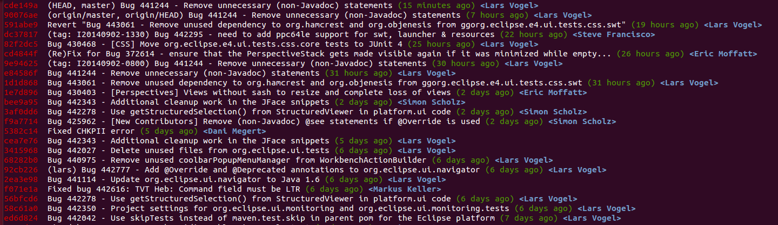

You can define an alias for such a long command. See [**Section 58.1, “Using an alias”**](http://www.vogella.com/tutorials/Git/article.html#alias_definition) for information how to define an alias.

**30.5. Filtering based on the commit message via regular expressions**

You can filter the output of the git log command to commits whose commit message, , or reflog entry, respectively, matches the specified regular expression pattern with the --grep=<pattern> and --grep-reflog=<pattern> option.

For example the following command instructs the log command to list all commits which contain the word "workspace" in their commit message.

*# oneline parameter included for better readability*

git log --oneline --grep="workspace"

There is also the --invert-grep=<pattern> option. When this option is used, git log lists the commits that don't match the specified pattern.

**30.6. Filtering the log output based on author or committer**

You can use the --author=<pattern> or --committer=<pattern> to filter the log output by author or committer. You do not need to use the full name, if a substring matches, the commit is included in the log output.

The following command lists all commits with an author name containing the word "lvogel".

git log --author=lvogel

See also [**Section 35, “git shortlog for release announcements”**](http://www.vogella.com/tutorials/Git/article.html#gitshortlog).

**31. Viewing changes with git diff and git show**

**31.1. See the differences introduced by a commit**

To see the changes introduced by a commit use the following command.

git show <commit_id>

**31.2. See the difference between two commits**

To see the differences introduced between two commits you use the git diff command specifying the commits. For example, the following command shows the differences introduced in the last commit.

*# directly between two commits*

git diff HEAD~1 HEAD

*# using commit ranges*

git diff HEAD~1..HEAD

**31.3. See the files changed by a commit**

To see the files which have been changed in a commit use the git diff-tree command. The *name-only*tells the command to show only the names of the files.

git diff-tree --name-only -r <commit_id>

**32. Analyzing line changes with git blame**

The git blame command allows you to see which commit and author modified a file on a per line base.

That is very useful to identify the person or the commit which introduced a change.

**33. Example: git blame**

The following code snippet demonstrates the usage of the git blame command.

*# git blame shows the author and commit per*

*# line of a file*

git blame [filename]

*# the -L option allows limiting the selection*

*# for example by line number*

*# only show line 1 and 2 in git blame*

git blame -L 1,2 [filename]

The git blame command can also ignore whitespace changes with the *-w* parameter.

**34. Commit history of a repository or certain files**

[**Gitk**](http://git-scm.com/docs/gitk) can be used to visualize the history of a repository of certain files.

In some cases simply using git blame is not sufficient in order to see all details of certain changes. Therefore you can for exmaple navigate to the filelocation in the target git repository and use the gitk [filename] command to see all commits of a file in a clear UI.

In this screenshot we can see all commits of the *ShowViewHandler.java* by using the gitk ShowViewHandler.java command:

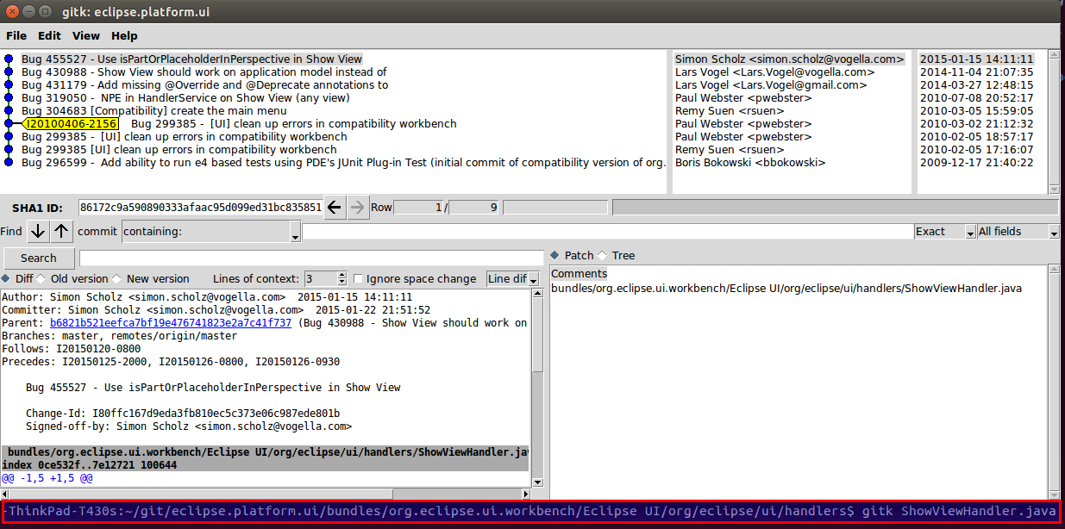

On linux you can easily install gitk by using the sudo apt-get install gitk command in a terminal.

See [**http://git-scm.com/docs/gitk**](http://git-scm.com/docs/gitk) for further information.

**35. git shortlog for release announcements**

The git shortlog command summarizes the git log output, it groups all commits by author and includes the first line of the commit message.

The *-s* option suppresses the commit message and provides a commit count. The *-n* option sorts the output based on the number of commits by author.

*# gives a summary of the changes by author*

git shortlog

*# compressed summary*

*# -s summary, provides a commit count summary only*

*# -n sorted by number instead of name of the author*

git shortlog -sn

This command also allows you to see the commits done by a certain author or committer.

*# see the commits by the author "Lars Vogel"*

git shortlog --author="Lars Vogel"

*# see the commits by the author "Lars Vogel"*

*# restricted by the last years*

git shortlog --author="Lars Vogel" --since=2years

*# see the number of commits by the author "Lars Vogel"*

git shortlog -s --author="Lars Vogel" --since=2years

**36. Stashing committed changes with git stash**

**36.1. Stashing changes in Git**

**36.1.1. The git stash command**

Git provides the git stash command which allows you to record the current state of the working directory and the staging area and to revert to the last committed revision.

This allows you to pull in the latest changes or to develop an urgent fix. Afterwards you can restore the stashed changes, which will reapply the changes to the current version of the source code.

**36.1.2. When to use git stash**

In general using the stash command should be the exception in using Git. Typically, you would create new branches for new features and switch between branches. You can also commit frequently in your local Git repository and use interactive rebase to combine these commits later before pushing them to another Git repository.

Even if you prefer not to use branches, you can avoid using the git stash command. In this case you commit the changes you want to put aside and amend the commit with the next commit. If you use the approach of creating a commit, you typically put a marker in the commit message to mark it as a draft, e.g., "[DRAFT] implement feature x".

**36.2. Using the Git stash command**

**36.2.1. Example: Using the git stash command**

The following commands will save a stash and reapply them after some changes.

*# create a stash with uncommitted changes*

git stash

*# do changes to the source, e.g., by pulling*

*# new changes from a remote repo*

*# afterwards, re-apply the stashed changes*

*# and delete the stash from the list of stashes*

git stash pop

It is also possible to keep a list of stashes.

*# create a stash with uncommitted changes*

git stash save

*# see the list of available stashes*

git stash list

*# result might be something like:*

stash@{0}: WIP on master: 273e4a0 Resize issue in Dialog

stash@{1}: WIP on master: 273e4b0 Silly typo in Classname

stash@{2}: WIP on master: 273e4c0 Silly typo in Javadoc

*# you can use the ID to apply a stash*

git stash apply stash@{0}

*# or apply the latest stash and delete it afterwards*

git stash pop

*# you can also remove a stashed change*

*# without applying it*

git stash drop stash@{0}

*# or delete all stashes*

git stash clear

**36.2.2. Create a branch from a stash**

You can also create a branch for your stash if you want to continue to work on the stashed changes in a branch. This can be done with the following command.

*# create a new branch from your stack and*

*# switch to it*

git stash branch newbranchforstash

**37. Remove untracked files with git clean**

**37.1. Removing untracked files**

If you have untracked files in your working tree which you want to remove, you can use the git clean command.

**Warning**

Be careful with this command. All untracked files are removed if you run this command. You will not be able to restore them, as they are not part of your Git repository.

**37.2. Example: Using git clean**

The following commands demonstrate the usage of the git clean command.

*# create a new file with content*

**echo** "this is trash to be deleted" > test04

*# make a dry-run to see what would happen*

*# -n is the same as --dry-run*

git clean -n

*# delete, -f is required if*

*# variable clean.requireForce is not set to false*

git clean -f

*# use -d flag to delete new directories*

*# use -x to delete hidden files, e.g., ".example"*

git clean -fdx

**38. Revert uncommitted changes in tracked files**

**38.1. Use cases**

If you have a tracked file in Git, you can always recreate the file content based on the staging area or based on a previous commit. You can also remove staged changes from the staging area to avoid that these changes are included in the next commit. This chapter explain you how you can do this.

**38.2. Remove staged changes from the staging area**

You can use the git reset [paths] command to remove staged changes from the staging area. This means that git reset [paths] is the opposite of git add [paths]. It avoids that the changes are included in the next commit. The changes are still available in the working tree, e.g., you will not lose your changes and can stage and commit them at a later point.

In the following example you create a new file and change an existing file. Both changes are staged.

*# do changes*

**touch** unwantedstaged.txt

**echo** "more.." >> test02

// add changes to staging area

git add unwantedstaged.txt

git add test02

*# see the status*

git status

The output of git status command should look similar to the following.

On branch master

Changes to be committed:

(use "git reset HEAD <file>..." to unstage)

modified: test02

new file: unwantedstaged.txt

Remove the changes from the staging area with the following command.

*# remove test02 from the staging area*

git reset test02

*# remove unwantedstaged.txt from the staging area*

git reset unwantedstaged.txt

Use the git status command to see the result.

On branch master

Changes not staged **for** commit:

(use "git add <file>..." to update what will be committed)

(use "git checkout -- <file>..." to discard changes in working directory)

modified: test02

Untracked files:

(use "git add <file>..." to include in what will be committed)

unwantedstaged.txt

no changes added to commit (use "git add" and/or "git commit -a")

The git reset behaves differently depending on the options you provide. To learn more about the git reset command see[**Section 39, “Use cases for git reset”**](http://www.vogella.com/tutorials/Git/article.html#resetcommitsdef).

**38.3. Remove changes in the working tree**

**Warning**

Be careful with the following command. It allows you to override the changes in files in your working tree. You will not be able to restore these changes.

Changes in the working tree which are not staged can be undone with git checkout command. This command resets the file in the working tree to the latest staged version. If there are no staged changes, the latest committed version is used for the restore operation.

*# delete a file*

**rm** test01

*# revert the deletion*

git checkout -- test01

*# note git checkout test01 also works but using*

*# two - ensures that Git understands that test01*

*# is a path and not a parameter*

*# change a file*

**echo** "override" > test01

*# restore the file*

git checkout -- test01

For example, you can restore the content of a directory called *data* with the following command.

git checkout -- data

**38.4. Remove changes in the working tree and the staging area**

If you want to undo a staged but uncommitted change, you use the git checkout [commit-pointer] [paths] command. This version of the command resets the working tree and the staged area.

The following demonstrates the usage of this to restore a delete directory.

*# create a demo directory*

**mkdir** checkoutheaddemo

**touch** checkoutheaddemo/myfile

git add .

git commit -m "Adds new directory"

*# now delete the directory and add the change to*

*# the staging area*

**rm** -rf checkoutheaddemo

*# Use git add . -A for Git version < 2.0*

git add .

*# restore the working tree and reset the staging area*

git checkout HEAD -- your_dir_to_restore

The additional commit pointer parameter instructs the git checkout command to reset the working tree and to also remove the staged changes.

**38.5. Remove staging area based on last commit change**

When you have added the changes of a file to the staging area, you can also revert the changes in the staging area base on the last commit.

*# some nonsense change*

**echo** "change which should be removed later" > test01

*# add the file to the staging area*

git add test01

*# restores the file based on HEAD in the staging area*

git reset HEAD test01

**39. Use cases for git reset**

**39.1. Moving the HEAD and branch pointer**

Sometimes you want to change the commmit your branch pointer is pointing to. The git reset command allows you to manually set the current HEAD pointer (and its associated branch) to a specified commit. This is for example useful to undo a particular change or to build up a different commit history.

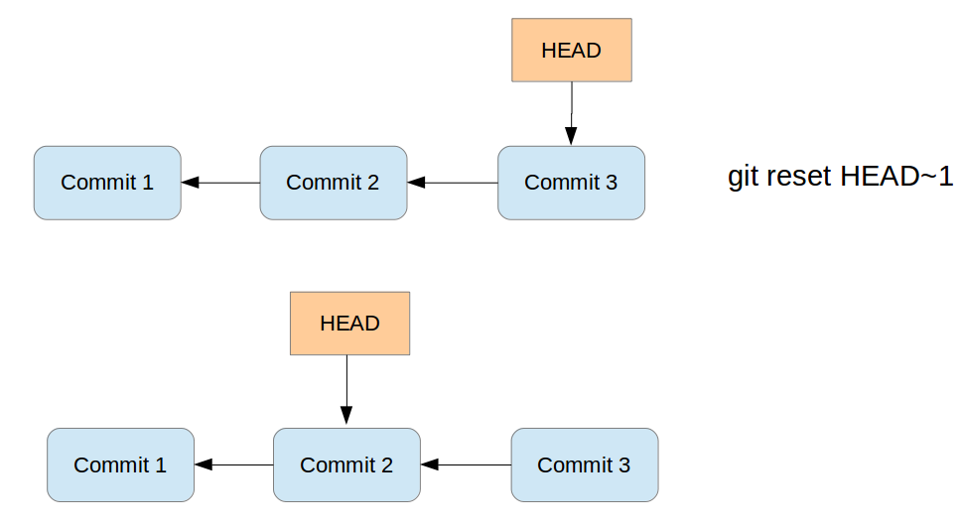

All commits which were originally pointed to by the HEAD pointer and the commit pointed to by HEAD after the reset, are *reseted*, e.g., not directly visible anymore from the current HEAD and branch pointer.

Via parameters you can decide what you happen to the changes in the working tree and changes which were included in the commits between the original commit and the commit now referred to by the HEAD pointer. As a reminder, the working tree contains the files and the staging area contains the changes which are marked to be included in the next commit. Depending on the specified parameters the git reset command performs the following:

1. If you specify the *--soft* parameter, the git reset command moves the HEAD pointer. Changes in the working tree will be left unchanged and all changes which were commited included in commits which are reseted are staged.
2. If you specify the *--mixed* parameter (the default), the git reset command moves the HEAD pointer and resets the staging area to the new HEAD. Any file change between the original commit and the one you reset to shows up as modifications (or untracked files) in your working tree. Use this option to remove commits but keep all the work you have done. You can do additional changes, stage changes and commit again. This way you can build up a different commit history.
3. If you specify the *--hard* parameter, the git reset command moves the HEAD pointer and resets the staging area and the working tree to the new HEAD. This effectively removes the changes you have done between the original commit and the one you reset to.

Via parameters you can define if the staging area and the working tree is updated. These parameters are listed in the following table.

**Table 2. git reset options**

| **Reset** | **Branch pointer** | **Working tree** | **Staging area** |
| --- | --- | --- | --- |
| soft | Yes | No | No |
| mixed (default) | Yes | No | Yes |
| hard | Yes | Yes | Yes |

The git reset command does not remove untracked files. Use the git clean command for this.

**39.2. Not moving the HEAD pointer with git reset**

If you specify a path via the git reset [path] command , Git does not move the HEAD pointer. It updates the staging area or also the working tree depending on your specified option.

**40. Resetting changes with git reset**

**40.1. Finding commits that are no longer visible on a branch**

If you reset the branch pointer of a branch to a certain commit, the git log commands does not show the commits which exist after this branch pointer. For example assume you have two commits A-> B, where B is the commit after A. You if you reset your branch pointer to A, the git log command does not include B anymore.

Commits like B can still be found via the git reflog command. See [**Section 44, “Recovering lost commits”**](http://www.vogella.com/tutorials/Git/article.html#gitreflog).

**40.2. Deleting changes in the working tree and staging area for tracked files**

The git reset --hard command makes the working tree exactly match HEAD.

*# removes staged and working tree changes*

*# of committed files*

git reset --hard

**Warning**

If you have tracked files with modifications, you lose these changes with the above command.

**Note**

The reset command does not delete untracked files. If you want to delete them also see [**Section 37.1, “Removing untracked files”**](http://www.vogella.com/tutorials/Git/article.html#gitclean_command).

**40.3. Using git reset to squash commits**

As a soft reset does not remove your change to your files and index, you can use the git reset --soft command to squash several commits into one commit.

As the staging area is not changed with a soft reset, you keep it in the desired state for your new commit. This means that all the file changes from the commits which were reseted are still part of the staging area.

*# squashes the last two commits*

git reset --soft HEAD~1 && git commit -m "new commit message"

The interactive rebase adds more flexibility to squashing commits and allows to use the existing commit messages. See [**???**](http://www.vogella.com/tutorials/Git/article.html) for details.

**41. Retrieving files from the history**

**41.1. View file in different revision**

The git show command allows to see and retrieve files from branches, commits and tags. It allows seeing the status of these files in the selected branch, commit or tag without checking them out into your working tree.

By default, this command addresses a file from the root of the repository, not the current directory. If you want the current directory then you have to use the ./ specifier. For example to address the *pom.xml* file the current directory use: *./pom.xml*

The following commands demonstrate that. You can also make a copy of the file.

*# [reference] can be a branch, tag, HEAD or commit ID*

*# [file_path] is the file name including path*

git show [reference]:[file_path]

*# to make a copy to copiedfile.txt*

git show [reference]:[file_path] > copiedfile.txt

*# assume you have two pom.xml files. One in the root of the Git*

*# repository and one in the current working directory*

*# address the pom.xml in the git root folder*

git show HEAD:pom.xml

*# address the pom in the current directory*

git show HEAD:./pom.xml

**41.2. Restore a deleted file in a Git repo**

You can checkout a file from the commit. To find the commit which deleted the file you can use the git log or the git ref-listcommand as demonstrated by the following command.

*# see history of file*

git log -- <file_path>

*# checkout file based on predecessors the last commit which affect it*

*# this was the commit which delete the file*

git checkout [commit] ^ -- <file_path>

*# alternatively use git rev-list*

git rev-list -n 1 HEAD -- <file_path>

*# afterwards, the same checkout based on the predecessors*

git checkout [commit] ^ -- <file_path>

**41.3. See which commit deleted a file**

The git log command allows you to determine which commit deleted a file. You can use the *--* option in git log to see the commit history for a file, even if you have deleted the file.

*# see the changes of a file, works even*

*# if the file was deleted*

git log -- [file_path]

*# limit the output of Git log to the*

*# last commit, i.e. the commit which delete the file*

*# -1 to see only the last commit*

*# use 2 to see the last 2 commits etc*

git log -1 -- [file_path]

*# include stat parameter to see*

*# some statics, e.g., how many files were*

*# deleted*

git log -1 --stat -- [file_path]

**42. Revert commits**

**42.1. Reverting a commit**

You can revert commits via the git revert command. This command reverts the changes of a commit.

Such commits are useful to document that a change was withdrawn.

**42.2. Example: Reverting a commit**

The following command demonstrates the usage of the git revert command.

*# revert a commit*

git revert commit_id

**43. Resetting the working tree based on a commit**

**43.1. Checkout based on commits and working tree**

You can check out older revisions of your file system via the git checkout command followed by the commit ID. This command will reset your complete *working tree* to the status described by this commit.

The commit ID is shown if you enter the git log command.

The following command shows the log.

*# displays the commit history of the repository*

*# which contains the commit ID, author, message etc.*

git log

The following listing shows an example output of a Git log command.

commit 046474a52e0ba1f1435ad285eae0d8ef19d529bf

Author: Lars Vogel <Lars.Vogel@gmail.com>

Date: Wed Jun 5 12:13:04 2013 +0200

Bug 409373 - Updates version number of e4 tools

Repairs the build

commit 2645d7eef0e24195fc407137200fe7e1795ecf49

Author: Lars Vogel <Lars.Vogel@gmail.com>

Date: Wed Jun 5 12:00:53 2013 +0200

Bug 409373 - Updates version number of e4 CSS spy features

**43.2. Example: Checkout a commit**

To checkout a specific commit you can use the following command.

*# checkout the older revision via*

git checkout [commit_id]

*# based on the example output this could be*

git checkout 046474a52e0ba1f1435ad285eae0d8ef19d529bf

*# or you can use the abbreviated version*

git checkout 046474a5

**Warning**

If you checkout a commit, you are in the *detached head mode* and commits in this mode are harder to find after you checkout another branch. Before committing it is good practice to create a new branch to leave the*detached head mode*. See [**Section 44.1, “Detached HEAD”**](http://www.vogella.com/tutorials/Git/article.html#detachedheadmode) for details.

**44. Recovering lost commits**

**44.1. Detached HEAD**

If you checkout a commit or a tag, you are in the so-called *detached HEAD mode*. If you commit changes in this mode, you have no branch which points to this commit. After you checkout a branch you cannot see the commit you did in detached head mode in thegit log command.

To find such commits you can use the git reflog command.

**44.2. git reflog**

Reflog is a mechanism to record the movements of the *HEAD* and the branches references.

The Git reflog command gives a history of the complete changes of the *HEAD* reference.

git reflog

*# <output>*

*# ... snip ...*

1f1a73a HEAD@{2}: commit: More chaanges - typo in the commit message

45ca204 HEAD@{3}: commit: These are new changes

cf616d4 HEAD@{4}: commit (initial): Initial commit

The git reflog command also list commits which you have removed.

**Tip**

There are multiple reflogs: one per branch and one for HEAD. For branches use the git reflog [branch]command and for HEAD use the git reflog or the git reflog HEAD command.

**44.3. Example**

The following example shows how you can use git reflog to reset the current local branch to a commit which isn't reachable from the current branch anymore.

*# assume the ID for the second commit is*

*# 45ca2045be3aeda054c5418ec3c4ce63b5f269f7*

*# resets the head for your tree to the second commit*

git reset --hard 45ca2045be3aeda054c5418ec3c4ce63b5f269f7

*# see the log*

git log

*# output shows the history until the 45ca2045be commit*

*# see all the history including the deletion*

git reflog

*# <output>*

cf616d4 HEAD@{1}: reset: moving to 45ca2045be3aeda054c5418ec3c4ce63b5f269f7

*# ... snip ...*

1f1a73a HEAD@{2}: commit: More chaanges - typo in the commit message

45ca204 HEAD@{3}: commit: These are new changes

cf616d4 HEAD@{4}: commit (initial): Initial commit

git reset --hard 1f1a73a

**45. Remote and local tracking branches**

**45.1. Remote tracking branches**

Your local Git repository contains references to the state of the branches on the remote repositories to which it is connected. These local references are called *remote-tracking branches*.

You can see your remote-tracking branches with the following command.

*# list all remote branches*

git branch -r

To update remote-tracking branches without changing local branches you use the git fetch command which is covered in[**Section 46, “Updating your remote-tracking branches with git fetch”**](http://www.vogella.com/tutorials/Git/article.html#gitfetch).

**45.2. Delete a remote-tracking branch in your local repository**

It is also safe to delete a remote branch in your local Git repository. You can use the following command for that.

*# delete remote branch from origin*

git branch -d -r origin/[remote_branch]

The next time you run the git fetch command the remote branch is recreated.

**45.3. Delete a branch in a remote repository**

To delete the branch in a remote repository use the following command.

*# delete branch in a remote repository*

git push [remote] :branch

Alternatively you can also use the following command.

*# delete branch in a remote repository*

git push [remote] --delete :[branch]

For example if you want to delete the branch called *testbranch* in the remote repository called *origin* you can use the following command.

git push origin :testbranch

**Note**

Note you can also specify the remote repository's URL. So the following command also works.

git push **ssh**://[URL_to_repo] :testbranch

**45.4. Tracking branches**

*Branches* can track another branch. This is called *to have an upstream branch* and such branches can be referred to as *tracking branches*.

*Tracking branches* allow you to use the git pull and git push command directly without specifying the branch and repository.

If you clone a Git repository, your local *master* branch is created as a *tracking branch* for the *master* branch of the *origin* repository (short: *origin/master*) by Git.

**45.5. Setting up tracking branches**

You create new *tracking branches* by specifying the *remote branch* during the creation of a branch. The following example demonstrates that.

*# setup a tracking branch called newbrach*

*# which tracks origin/newbranch*

git checkout -b newbranch origin/newbranch

Instead of using the git checkout command you can also use the git branch command.

*# origin/master used as example, but can be replaced*

*# create branch based on remote branch*

git branch [new_branch] origin/master

*# use --track,*

*# default when the start point is a remote-tracking branch*

git branch --track [new_branch] origin/master

The --no-track allows you to specify that you do not want to track a branch. You can explicitly add a tracking branch with the git branch -u command later.

*# instruct Git to create a branch which does*

*# not track another branch*

git branch --no-track [new_branch_notrack] origin/master

*# update this branch to track the origin/master branch*

git branch -u origin/master [new_branch_notrack]

**45.6. See the branch information for a remote repository**

To see the tracking branches for a remote repository (short: remote) you can use the following command.

*# show all remote and tracking branches for origin*

git remote show origin

An example output of this might look as follows.

* remote origin

Fetch URL: ssh://test@git.eclipse.org/gitroot/e4/org.eclipse.e4.tools.git

Push URL: ssh://test@git.eclipse.org/gitroot/e4/org.eclipse.e4.tools.git

HEAD branch: master

Remote branches:

integration tracked

interm_rc2 tracked

master tracked

smcela/HandlerAddonUpdates tracked

Local branches configured for 'git pull':

integration rebases onto remote integration

master rebases onto remote master

testing rebases onto remote master

Local refs configured for 'git push':

integration pushes to integration (up to date)

master pushes to master (up to date)

**46. Updating your remote-tracking branches with git fetch**

**46.1. Fetch**

The git fetch command updates your remote-tracking branches, i.e., it updates the local copy of branches stored in a remote repository. The following command updates the remote-tracking branches from the repository called *origin*.

git fetch origin

The fetch command only updates the *remote-tracking branches* and none of the local branches and it does not change the working tree of the Git repository. Therefore, you can run the git fetch command at any point in time.

After reviewing the changes in the remote tracking branch you can merge the changes into your local branches or rebase your local branches onto the remote-tracking branch.

Alternatively you can also use the git cherry-pick commit_id command to take over only selected commits.

See [**Section 53, “Applying a single commit”**](http://www.vogella.com/tutorials/Git/article.html#cherrypick_definition) for information about cherry-pick. See [**Section 47, “Merging”**](http://www.vogella.com/tutorials/Git/article.html#gitmerge_definition) for the merge operation and [**Section 50.1, “Rebasing branches”**](http://www.vogella.com/tutorials/Git/article.html#rebase_branches) for the rebase command.

**46.2. Fetch from all remote repositories**

The git fetch command updates only the remote-tracking branches for one remote repository. In case you want to update the remote-tracking branches of all your remote repositories you can use the following command.

*# simplification of the fetch command*

*# this runs git fetch for every remote repository*

git remote update

*# the same but remove all stale branches which*

*# are not in the remote anymore*

git remote update --prune

**46.3. Compare remote-tracking branch with local branch**

The following code shows a few options how you can compare your branches.

*# show the log entries between the last local commit and the*

*# remote branch*

git log HEAD..origin/master

*# show the diff for each patch*

git log -p HEAD..origin/master

*# show a single diff*

git diff HEAD...origin/master

*# instead of using HEAD you can also*

*# specify the branches directly*

git diff master origin/master

The above commands show the changes introduced in HEAD compared to origin. If you want to see the changes in origin compared to HEAD, you can switch the arguments or use the *-R* parameter.

**46.4. Rebase your local branch onto the remote-tracking branch**

You can rebase your current local branch onto a remote-tracking branch. The following commands demonstrate that.

*# assume you want to rebase master based on the latest fetch*

*# therefore check it out*

git checkout master

*# update your remote-tracking branch*

git fetch

*# rebase your master onto origin/master*

git rebase origin/master

**Tip**

More information on the rebase command can be found in [**Section 50.1, “Rebasing branches”**](http://www.vogella.com/tutorials/Git/article.html#rebase_branches).

**46.5. Fetch compared with pull**

The git pull command performs a git fetch and git merge (or git rebase based on your Git settings). The git fetchdoes not perform any operations on your local branches. You can always run the fetch command and review the incoming changes.

**47. Merging**

Git allows you to combine the changes which were created on two different branches. One way to achieve this is *merging*, which is described in this chapter. Other ways are using rebase or cherry-pick.

**48. Merging branches**

**48.1. Fast-forward merge**

If the commits which are merged are direct successors of the *HEAD* pointer of the current branch, Git simplifies things by performing a so-called *fast forward merge*. This *fast forward merge* simply moves the *HEAD* pointer of the current branch to the tip of the branch which is being merged. You can also merge based on a tag or a commit.

This process is depicted in the following diagram. The first picture assumes that master is checked out and that you want to merge the changes of the branch labeled "branch 1" into your "master" branch. Each commit points to its predecessor (parent).

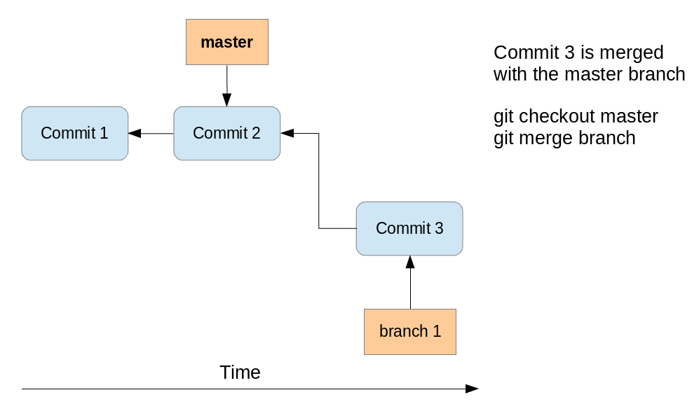

After the fast-forward merge the *HEAD* points to the master branch pointing to "Commit 3". The "branch 1" branch points to the same commit.

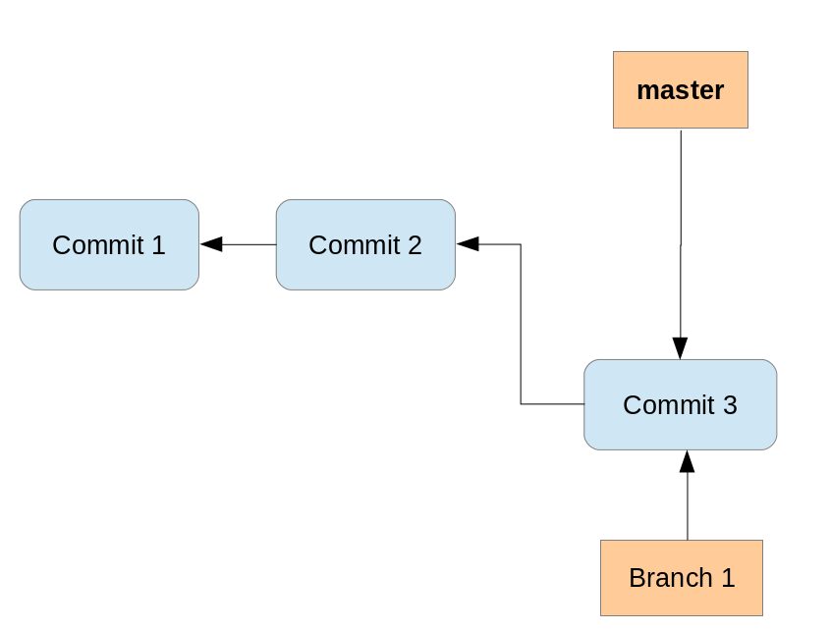

**48.2. Merge commit**

If commits are merged which are not direct predecessors of the current branch, Git performs a so-called *three-way-merge* between the latest commits of the two branches, based on the most recent common predecessor of both.

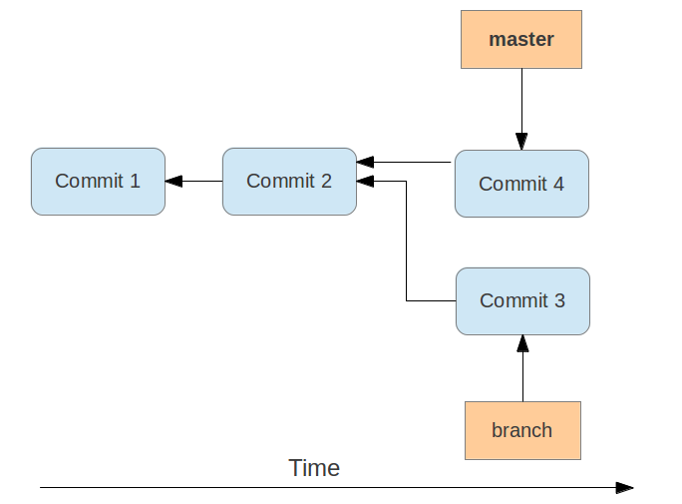

As a result a so-called *merge commit* is created on the current branch which combines the respective changes from the two branches being merged. This commit points to both of its predecessors.

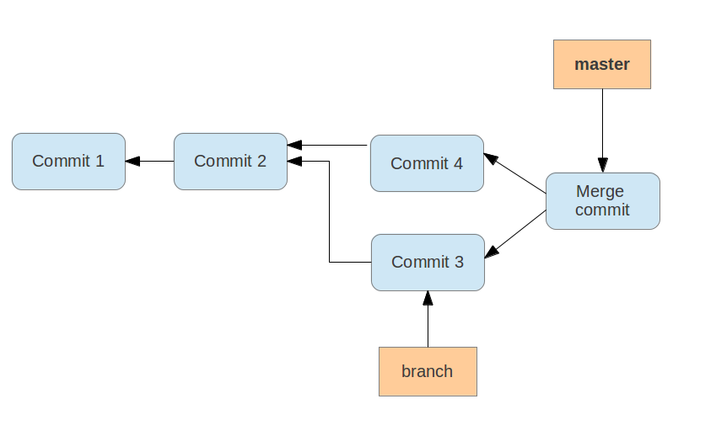

**Note**

If multiple common predecessors exist, Git uses recursion to create a virtual common predecessor. For this Git creates a merged tree of the common ancestors and uses that as the reference for the 3-way merge. This is called the *recursive merge* strategy and is the default merge strategy.

**48.3. Merge strategies - Octopus, Subtree, Ours**

If a fast-forward merge is not possible, Git uses a merge strategy. The default strategy called *recursive merge* strategy was described in [**Section 48.2, “Merge commit”**](http://www.vogella.com/tutorials/Git/article.html#gitmerge_mergecommit).

The Git command line tooling also supports the *octopus merge* strategy for merges of multiple references. With this operation it can merge multiple branches at once.

The *subtree* option is useful when you want to merge in another project into a sub-directory of your current project. It is rarely used and you should prefer the usage of Git submodules. See [**Section 59.1, “What are submodules?”**](http://www.vogella.com/tutorials/Git/article.html#submodules_definition) for more information.

The *ours* strategy merges a branch without looking at the changes introduced in this branch. This keeps the history of the merged branch but ignores the changes introduced in this branch.

You typically use the *ours* merge strategy to document in the Git repository that you have integrated a branch and decided to ignore all changes from this branch.

**49. Commands to merge two branches**

**49.1. The git merge command**

The git merge command performs a merge. You can merge changes from one branch to the current active one via the following command.

*# syntax: git merge <branch-name>*

*# merges into your currently checked out branch*

git merge testing

**49.2. Specifying merge strategies**

The *-s* parameter allows you to specify other merge strategies. This is demonstrated with the following command.

For example, you can specify the *ours* strategy in which the result of the merge is always that of the current branch head, effectively ignoring all changes from all other branches. This is demonstrated with the following command.

*# merge branch "obsolete" ignoring all*

*# changes in the branch*

git merge -s ours obsolete

**Warning**

Be careful if you use the *ours* merge strategy, it ignores everything from the branch which is merged.

The usage of the octopus merge strategy is triggered if you specify more than one reference to merge.

*# merge the branch1 and the branch2 using*

*# changes in the branch*

git merge branch1 branch2</code>

**49.3. Specifying parameters for the default merge strategy**

The recursive merge strategy (default) allows you to specify flags with the *-X* parameter. For example you can specify here the *ours*option. This option forces conflicting changes to be auto-resolved by favoring the local version. Changes from the other branch that do not conflict with our local version are reflected to the merge result. For a binary file, the entire contents are taken from the local version.

**Warning**

The *ours* option for the *recursive* merge strategy should not be confused with the *ours* merge strategy.

A similar option to *ours* is the *theirs* option. This option prefers the version from the branch which is merged.

Both options are demonstrated in the following example code.

*# merge changes preferring our version*

git merge -s recursive -X ours [branch_to_merge]

*# merge changes preferring the version from*

*# the branch to merge*

git merge -s recursive -X theirs [branch_to_merge]

Another useful option is the *ignore-space-change* parameter which ignores whitespace changes.

For more information about the merge strategies and options see [**Git merge manpage**](https://www.kernel.org/pub/software/scm/git/docs/git-merge.html).

**49.4. Enforcing the creation of a merge commit**

If you prefer to have merge commits even for situations in which Git could perform a fast-forward merge you can use the git merge --no-ff command.

The *--no-ff* parameter can make sense if you want to record in the history at which time you merged from a maintenance branch to the master branch.

When pulling from a remote repository, prefer doing a rebase to a merge. This will help to keep the history easier to read. A merge commit can be helpful to document that functionality was developed in parallel.

**50. Rebasing branches**

**50.1. Rebasing branches**

You can use Git to rebase one branch on another one. As described, the merge command combines the changes of two branches. If you rebase a branch called A onto another, the git command takes the changes introduced by the commits of branch A and applies them based on the HEAD of the other branch. This way the changes in the other branch are also available in branch A.

The process is displayed in the following picture. We want to rebase the branch called branch_1 onto master.

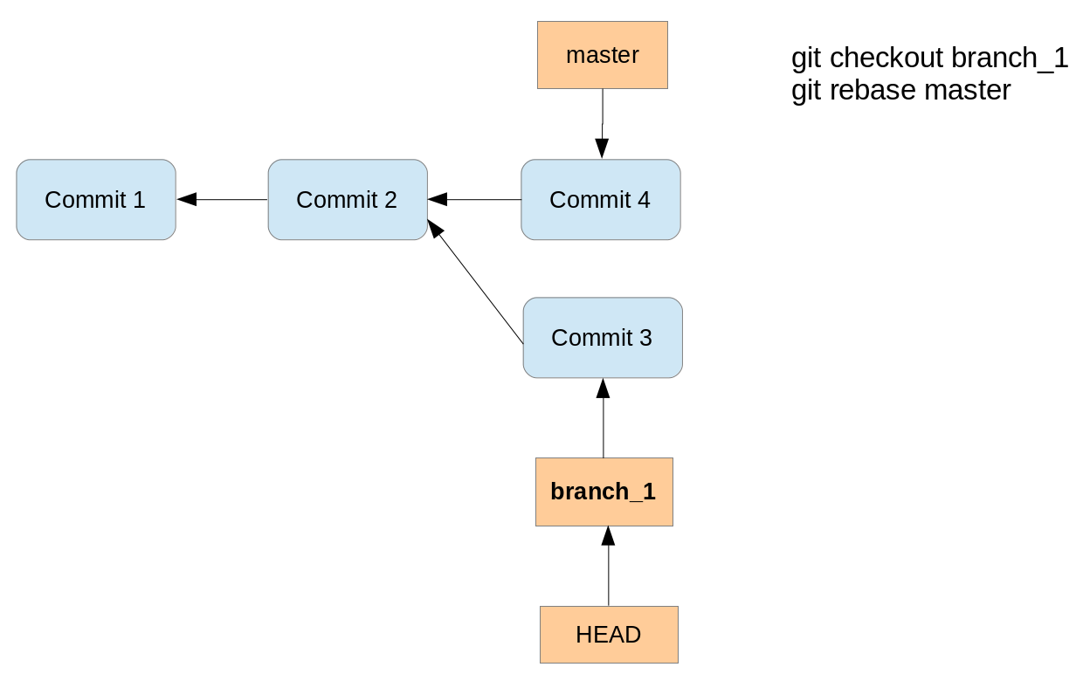

Running the rebase command creates a new commit with the changes of the branch on top of the master branch.

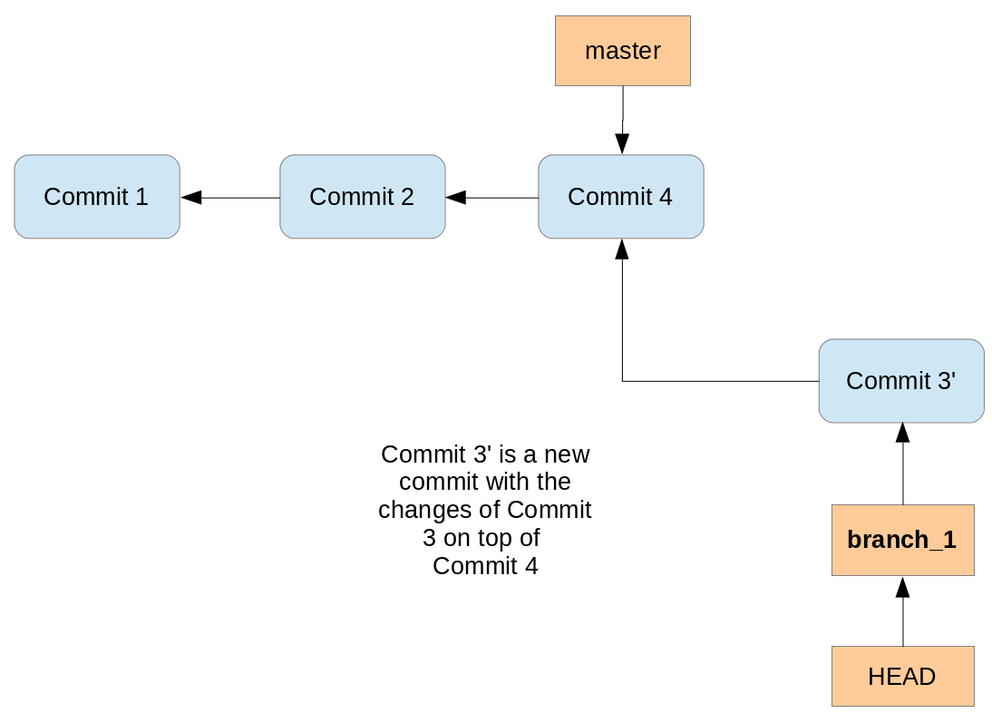

Performing a rebase does not create a merge commit. The final result for the source code is the same as with merge but the commit history is cleaner; the history appears to be linear.

Rebase can be used to forward-port a feature branch in the local Git repository onto the changes of the master branch. This ensures that your feature is close to the tip of the upstream branch until it is finally published.

If you rewrite more than one commit by rebasing, you may have to solve conflicts per commit. In this case the merge operations might be simpler to be performed because you only have to solve merge conflicts once.

Also, if your policy requires that all commits result in correct software you have to test all the rewritten commits since they are "rewritten" by the rebase algorithm. Since merge/rebase/cherry-pick are purely text-based and do not understand the semantics of these texts they can end up with logically incorrect results. Hence, it might be more efficient to merge a long feature branch into upstream instead of rebasing it since you only have to review and test the merge commit.

**Note**

You can use the rebase command to change your Git repository history commits. This is called *interactive*rebase, see [**???**](http://www.vogella.com/tutorials/Git/article.html) for information about this feature.

**50.2. Good practice for rebase**

You should avoid using the Git rebase operation for changes which have been published in other Git repositories. The Git rebase operation creates new commit objects, this may confuse other developers using the existing commit objects.

Assume that a user has a local feature branch and wants to push it to a branch on the remote repository. However, the branch has evolved and therefore pushing is not possible. Now it is good practice to fetch the latest state of the branch from the remote repository. Afterwards you rebase the local feature branch onto the remote tracking branch. This avoids an unnecessary merge commit. This rebasing of a local feature branch is also useful to incorporate the latest changes from remote into the local development, even if the user does not want to push right away.

**Tip**

Rebasing and amending commits is safe as long as you do not push any of the changes involved in the rebase. For example, when you cloned a repository and worked in this local repository. Rebasing is a great way to keep the history clean before contributing back your modifications.

**Warning**

In case you want to rewrite history for changes you have shared with others you need to use the *-f*parameter in your git push command and subsequently your colleagues have to use fetch -f to fetch the rewritten commits.

*# using forced push*

git push -f

**51. Example for a rebase**

The following demonstrates how to perform a rebase operation.

*# create new branch*

git checkout -b rebasetest

*# create a new file and put it under revision control*

**touch** rebase1.txt

git add . && git commit -m "work in branch"

*# do changes in master*

git checkout master

*# make some changes and commit into testing*

**echo** "rebase this to rebasetest later" > rebasefile.txt

git add rebasefile.txt

git commit -m "create new file"

*# rebase the rebasetest onto master*

git checkout rebasetest

git rebase master

*# now you can fast forward your branch onto master*

git checkout master

git merge rebasetest

**52. Example: Interactive rebase**

The following commands create several commits which will be used for the interactive rebase.

*# create a new file*

**touch** rebase.txt

*# add it to git*

git add . && git commit -m "add rebase.txt to staging area"

*# do some silly changes and commit*

**echo** "content" >> rebase.txt

git add . && git commit -m "add content"

**echo** " more content" >> rebase.txt

git add . && git commit -m "just testing"

**echo** " more content" >> rebase.txt

git add . && git commit -m "woops"

**echo** " more content" >> rebase.txt

git add . && git commit -m "yes"

**echo** " more content" >> rebase.txt

git add . && git commit -m "add more content"

**echo** " more content" >> rebase.txt

git add . && git commit -m "creation of important configuration file"

*# check the git log message*

git log

We want to combine the last seven commits. You can do this interactively via the following command.

git rebase -i HEAD~7

This command opens your editor of choice and lets you configure the rebase operation by defining which commits to *pick*, *squash* or*fixup*.

The following listing shows an example of the selection, we pick the last commit, squash 5 commits and fix the sixth commit. The listing uses the long format of the commands (for example *fixup* instead of the short form *f*) for better readability.

pick 7c6472e rebase.txt added to index

fixup 4f73e68 added content

fixup bc9ec3f just testing

fixup 701cbb5 ups

fixup 910f38b yes

fixup 31d447d added more content

squash e08d5c3 creation of important configuration file

# Rebase 06e7464..e08d5c3 onto 06e7464

#

# Commands:

# p, pick = use commit

# r, reword = use commit, but edit the commit message

# e, edit = use commit, but stop for amending

# s, squash = use commit, but meld into previous commit

# f, fixup = like "squash", but discard this commit's log message

# x, exec = run command (the rest of the line) using shell

#

# These lines can be re-ordered; they are executed from top to bottom.

#

# If you remove a line here THAT COMMIT WILL BE LOST.

# However, if you remove everything, the rebase will be aborted.

**53. Applying a single commit**

The git cherry-pick command allows you to select the patch which was introduced with an individual commit and apply this patch on another branch. The patch is captured as a new commit on the other branch.

This way you can select individual changes from one branch and transfer them to another branch.

**Note**

The new commit does not point back to its original commit so do not use cherry-pick blindly since you may end up with several copies of the same change. Most often cherry-pick is either used locally (to emulate an interactive rebase) or to port individual bug fixes done on a development branch into maintenance branches.

**54. Example: Using cherry-pick**

In the following example you create a new branch and commit two changes.

*# create new branch*

git checkout -b picktest

*# create some data and commit*

**touch** pickfile.txt

git add pickfile.txt

git commit -m "adds new file"

*# create second commit*

**echo** "changes to file" > pickfile.txt

git commit -a -m "changes in file"

You can check the commit history, for example, with the git log --oneline command.

*# see change commit history*

git log --oneline

*# results in the following output*

2fc2e55 changes in file

ebb46b7 adds new file

[MORE COMMITS]

330b6a3 initial commit

The following command selects the first commit based on the commit ID and applies its changes to the master branch. This creates a new commit on the master branch.

git checkout master

git cherry-pick ebb46b7

The cherry-pick command can be used to change the order of commits. git cherry-pick also accepts commit ranges for example in the following command.

git checkout master

*# pick the last two commits*

git cherry-pick picktest~1..picktest~2

**Tip**

See [**Section 7.5, “Commit ranges with the double dot operator”**](http://www.vogella.com/tutorials/Git/article.html#commitreference_ranges_doubledot) for more information about commit ranges.

If things go wrong or you change your mind, you can always reset to the previous state using the following command.

git cherry-pick --abort

**55. Solving merge conflicts**

**55.1. What is a conflict during a merge operation?**

A conflict during a merge operation occurs if two commits from different branches have modified the same content and Git cannot automatically determine how both changes should be combined when merging these branches.

This happens for example if the same line in a file has been replaced by two different commits.

If a conflict occurs, Git marks the conflict in the file and the programmer has to resolve the conflict manually.

After resolving it, he adds the file to the staging area and commits the change. These steps are required to finish the merge operation.

**55.2. Keep a version of a file during a merge conflict**

Sometimes if a conflict occurs the developer does not want to solve the conflict. He decides that he wants to keep the original version or the new version of the file.

For this, there is the *--theirs* and the *--ours* options on the git checkout command. The first option keeps the version of the file that you merged in, and the second option keeps the version before the merge operation was started.

git checkout --ours foo/bar.java

git add foo/bar.java

git checkout --theirs foo/bar.java

git add foo/bar.java

**56. Exercise: Solving a conflict during a merge operation**

**56.1. Create a conflict**

In the following example you create a conflict during a merge operation.

The following steps create a merge conflict. It assumes that *repo1* and *repo2* have the same *origin* repository defined.

*# switch to the first directory*

**cd** ~/repo01

*# make changes*

**echo** "Change in the first repository" > mergeconflict.txt

*# stage and commit*

git add . && git commit -a -m "Will create conflict 1"

*# switch to the second directory*

**cd** ~/repo02

*# make changes*

**touch** mergeconflict.txt

**echo** "Change in the second repository" > mergeconflict.txt

*# stage and commit*

git add . && git commit -a -m "Will create conflict 2"

*# push to the master repository*

git push

*# switch to the first directory*

**cd** ~/repo01

*# now try to push from the first directory*

*# try to push --> assuming that the same remote repository is used,*

*# you get an error message*

git push

As this push would not result in a non-fast-format merge, you receive an error message similar to the following listing.

! [rejected] master -> master (fetch first)

error: failed to push some refs to '../remote-repository.git/'

hint: Updates were rejected because the remote contains work that you **do**

hint: not have locally. This is usually caused by another repository pushing

hint: to the same ref. You may want to first integrate the remote changes

hint: (e.g., 'git pull ...') before pushing again.

hint: See the 'Note about fast-forwards' in 'git push --help' **for** details.

To solve this, you need to integrate the remote changes into your local repository. In the following listing the git fetch command gets the changes from the remote repository. The git merge command tries to integrate it into your local repository.

*# get the changes via a fetch*

git fetch origin

*# now merge origin/master into the local master*

*# this creates a merge conflict in your*

*# local repository*

git merge origin/master

This creates the conflict and a message similar to the following.

Auto-merging mergeconflict.txt

CONFLICT (add/add): Merge conflict in mergeconflict.txt

Automatic merge failed; fix conflicts and then commit the result.

The resulting conflict is displayed in [**Section 56.2, “Review the conflict in the file”**](http://www.vogella.com/tutorials/Git/article.html#mergeconflict_examplesee) and solved in [**Section 56.3, “Solve a conflict in a file”**](http://www.vogella.com/tutorials/Git/article.html#mergeconflict_examplesolve)

**Tip**

If you use the git pull command it performs the "fetch and merge" or the "fetch and rebase" command together in one step. Whether merge or rebase is used depends on your Git configuration for the branch. See[**Section 10.4, “Avoid merge commits for pulling”**](http://www.vogella.com/tutorials/Git/article.html#setup_rebase) for the global configuration.

**56.2. Review the conflict in the file**

Git marks the conflicts in the affected files. In the example from [**Section 56.1, “Create a conflict”**](http://www.vogella.com/tutorials/Git/article.html#mergeconflict_examplecreate) one file has a conflict and the file looks like the following listing.

<<<<<<< HEAD

Change in the first repository

=======

Change in the second repository

>>>>>>> b29196692f5ebfd10d8a9ca1911c8b08127c85f8

The text above the ======= signs is the conflicting change from your current branch and the text below is the conflicting change from the branch that you are merging in.

**56.3. Solve a conflict in a file**

In this example you resolve the conflict which was created in [**Section 56.1, “Create a conflict”**](http://www.vogella.com/tutorials/Git/article.html#mergeconflict_examplecreate) and apply the change to the Git repository.

To solve the merge conflict you edit the file manually. The following listing shows a possible result.

Change in the first and second repository

Afterwards add the affected file to the staging area and commit the result. This creates the merge commit. You can also push the integrated changes now to the remote repository.

# add the modified file

git add .

# creates the merge commit

git commit -m "Merge changes"

# push the changes to the remote repository

git push

Instead of using the *-m* option in the above example you can also use the git commit command without this option. In this case the command opens your default editor with the default commit message about the merged conflicts. It is good practice to use this message.

**Tip**

Alternatively, you could use the git mergetool command. git mergetool starts a configurable merge tool that displays the changes in a split screen. Some operating systems may come with a suitable merge tool already installed or configured for Git.

**57. Solving rebase conflicts**

**57.1. What is a conflict during a rebase operation?**

During a rebase operaton, several commits are applied onto a certain commit. If you rebase a branch onto another branch, this commit is the last common ancestor of the two branches.

For each commit which is applied it is possible that a conflict occurs.

**57.2. Handling a conflict during a rebase operation**

If a conflict occurs during a rebase operation, the rebase operation stops and the developer needs to resolve the conflict. After he has solved the conflicts, the developer instructs Git to continue with the rebase operation.

A conflict during a rebase operation is solved similarly to the way a conflict during a merge operation is solved. The developer edits the conflicts and adds the files to the Git index. Afterwards he continues the rebase operation with the following command.

*# rebase conflict is fixed, continue with the rebase operation*

git rebase --**continue**

To see the files which have a rebase conflict use the following command.

*# lists the files which have a conflict*

git diff --name-only --diff-filter=U

You solve such a conflict similar to the description in [**Section 56.3, “Solve a conflict in a file”**](http://www.vogella.com/tutorials/Git/article.html#mergeconflict_examplesolve).

You can also skip the commit which creates the conflict.

*# skip commit which creates the conflict*

git rebase --skip

**57.3. Aborting a rebase operation**

You can also abort a rebase operation with the following command.

*# abort rebase and recreate the situation before the rebase*

git rebase --abort

**57.4. Picking theirs or ours for conflicting file**

If a file is in conflict you can instruct Git to take the version from the new commit of the version of commit onto which the new changes are applied. This is sometimes easier than to solve all conflicts manually. For this you can use the git checkout with the *--theirs*or *--ours* flag. During the conflict *--ours* points to the file in the commit onto which the new commit is placed, i.g., using this skips the new changes for this file.

Therefore to ignore the changes in a commit for a file use the following command.

git checkout --ours foo/bar.java

git add foo/bar.java

To take the version of the new commit use the following command.

git checkout --theirs foo/bar.java

git add foo/bar.java

**58. Define alias**

**58.1. Using an alias**

An *alias* in Git allows you to create a short form of one or several existing Git commands. For example, you can define an alias which is a short form of your own favorite commands or you can combine several commands with an alias.

**58.2. Alias examples**

The following defines an *alias* to see the staged changes with the new git staged command.

git config --global alias.staged 'diff --cached'

Or you can define an *alias* for a detailed git log command. The following command defines the git ll *alias*.

git config --global alias.ll 'log --graph --oneline --decorate --all'

You can also run external commands. In this case you start the *alias* definition with a ! character. For example, the following defines the git ac command which combines git add . -A and git commit commands.

*# define alias*

git config --global alias.act '!git add . -A && git commit'

*# to use it*

git act -m "message"

**Warning**

In the past *msysGit* for Windows had problems with an *alias* beginning with !, but it has been reported that this now works with *msysGit*, too .

**59. Submodules - repositories inside other Git repositories**

**59.1. What are submodules?**

Git allows you to include other Git repositories into a Git repository. This is useful in case you want to include a certain library in another repository or in case you want to aggregate certain Git repositories.

Git calls these included Git repositories *submodules*. Git allows you to commit, pull and push to these repositories independently.

**59.2. Adding a submodule to a Git repository**

You add a submodule to a Git repository via the git submodule add command. The git submodule init command creates the local configuration file for the submodules if this configuration does not exist.

*# add a submodule to your Git repo*

git submodule add [URL to Git repo]

*# initialize submodule configuration*

git submodule init

**60. Working with submodules**

**60.1. Updating submodules**

To pull in changes into a Git repository including the changes in submodules, you can use the *--recurse-submodules* parameter in the git pull command.

*# pull in the changes from main repo and submodules*

git pull --recurse-submodules

Use the git submodule update command to set the submodules to the commit specified by the main repository.

*# setting the submodules to the commit defined by master*

git submodule update

**Warning**

The fact that submodules track commits and not branches frequently leads to confusion. That is why Git 1.8.2 added the option to also track branches. Read the following sections to learn more about this.

**60.2. Tracking branches with submodules**

Since its 1.8.2 release the Git system allows tracking a branch in a submodule. To track branches you specify the branch with the *-b*parameter during the submodule add command.

This allows you use to use *--remote* parameter in the git submodule update command.

*# add submodule to track master branch*

git submodule add -b master [URL to Git repo]

*# update your submodule*

*# --remote will also fetch and ensure that*

*# the latest commit from the branch is used*

git submodule update --remote

*# to avoid fetching use*

git submodule update --remote --no-fetch

**60.3. Tracking commits**

Without any additional parameter, submodules are tracked by commit, i.e., the main Git repository remembers a certain commit of the submodule.

The git submodule update command sets the Git repository of the submodule to that particular commit. The submodule repository tracks its own content which is nested into the main repository. This main repository refers to a commit of the nested submodule repository.

**Warning**

This means that if you pull in new changes into the submodules, you need to create a new commit in your main repository in order to track the updates of the nested submodules.

If you update your submodule and want to use this update in your main repository, you need to commit this change in your main repository. The git submodule update command sets the submodule to the commit referred to in the main repository.

The following example shows how to update a submodule to its latest commit in its master branch.

*# update submodule in the master branch*

*# skip this if you use --recurse-submodules*

*# and have the master branch checked out*

**cd** [submodule directory]

git checkout master

git pull

*# commit the change in main repo*

*# to use the latest commit in master of the submodule*

**cd** ..

git add [submodule directory]

git commit -m "move submodule to latest commit in master"

*# share your changes*

git push

Another developer can get the update by pulling in the changes and running the submodules update command.

*# another developer wants to get the changes*

git pull

*# this updates the submodule to the latest*

*# commit in master as set in the last example*

git submodule update

**Warning**

With this setup you are tracking commits, so if the master branch in the submodule moves on, you are still pointing to the existing commit. You need to repeat this procedure every time you want to use new changes of the submodules. See [**Section 60.2, “Tracking branches with submodules”**](http://www.vogella.com/tutorials/Git/article.html#submodules_trackbranch) for tracking branches.

**61. Error search with git bisect**

**61.1. Using git bisect**

The git bisect command allows you to run a binary search through the commit history to identify the commit which introduced an issue. You specify a range of commits and a script that the bisect command uses to identify whether a commit is good or bad.

This script must return 0 if the condition is fulfilled and non-zero if the condition is not fulfilled.

**61.2. git bisect example**

Create a new Git repository, create the *text1.txt* file and commit it to the repository. Do a few more changes, remove the file and again do a few more changes.

We use a simple shell script which checks the existence of a file. Ensure that this file is executable.

*#!/bin/bash*

FILE=$1

**if** [ -f $FILE ];

**then**

**exit** 0;

**else**

**exit** 1;

**fi**

Afterwards use the git bisect command to find the bad commit. First you use the *git bisect start* command to define a commit known to be bad (showing the problem) and a commit known to be good (not showing the problem).

*# define that bisect should check*

*# the last 5 commits*

git bisect start HEAD HEAD~5

Afterwards run the bisect command using the shell script.

*# assumes that the check script*

*# is a directory above the current*

git bisect run ../check.sh test1.txt

**Tip**

The above commands serve as an example. The existence of a file can be easier verified with the git bisect command: git bisect run test -f test1.txt

**62. Rewriting commit history with git filter-branch**

**62.1. Using git filter-branch**

The git filter-branch command allows you to rewrite the Git commit history for selected branches and to apply custom filters on each revision. This creates different hashes for all modified commits. This implies that you get new IDs for all commits based on any rewritten commit.

The command allows you to filter for several values, e.g., the author, the message, etc. For details please see the following link:

[**git-filter-branch(1) Manual Page**](http://www.kernel.org/pub/software/scm/git/docs/git-filter-branch.html)

**Warning**

Using the filter-branch command is dangerous as it changes the Git repository. It changes the commit IDs and reacting on such a change requires explicit action from the developer, e.g., trying to rebase the stale local branch onto the corresponding rewritten remote-tracking branch.

A practical case for using git filter-branch is where you have added a file which contains a password or a huge binary file to the Git repository, and you want to remove this file from the history. To completely remove the file you need to run the filter-branchcommand on all branches.

**62.2. filter-branch example**

The following listing shows an example on how to replace the email address from one author of all the commits via the git filter-branch command.

git filter-branch -f \

--env-filter 'if [ "$GIT_AUTHOR_NAME" = "Lars Vogel" ]; then \

GIT_AUTHOR_EMAIL="lars.vogel@gmail.com"; fi' HEAD)

**63. What is a patch file?**

A *patch* is a text file that contains changes to the source code. A patch created with the git format-patch command includes meta-information about the commit (committer, date, commit message, etc) and also contains the changes introduced in binary data in the commit, for example, an image.

This file can be sent to someone else and this developer can use this file to apply the changes to his local repository. The metadata is preserved.

Alternatively you could create a diff file with the git diff command, but this diff file does not contain the metadata information.

**64. Example: Creating patches**

**64.1. Create and apply patches**

The following example creates a branch, changes several files and creates a commit recording these changes.

*# create a new branch*

git branch mybranch

*# use this new branch*

git checkout mybranch

*# make some changes*

**touch** test05

*# change some content in an existing file*

**echo** "new content for test01" >test01

*# commit this to the branch*

git add .

git commit -m "first commit in the branch"

The next example creates a patch for these changes.

*# creates a patch --> git format-patch master*

git format-patch origin/master

*# this creates the file:*

*# patch 0001-First-commit-in-the-branch.patch*

To apply this patch to your master branch in a different clone of the repository, switch to it and use the git apply command.

*# switch to the master branch*

git checkout master

*# apply the patch*

git apply 0001-First-commit-in-the-branch.patch

Afterwards you can commit the changes introduced by the patches and delete the patch file.

*# patch is applied to master*

*# change can be committed*

git add .

git commit -m "apply patch"

*# delete the patch file*

**rm** 0001-First-commit-in-the-branch.patch

**Tip**

Use the git am command to apply and commit the changes in a single step. To apply and commit all patch files in the directory use, for example, the git am *.patch command. You specify the order in which the patches are applied by specifying them on the command line.

**64.2. Create a patch for a selected commit**

You can specify the commit ID and the number of patches which should be created. For example, to create a patch for selected commits based on the HEAD pointer you can use the following commands.

*# create patch for the last commit based on HEAD*

git format-patch -1 HEAD

*# create a patch series for the last three commits*

*# based on head*

git format-patch -3 HEAD

**65. Git commit and other hooks**

**65.1. Usage of Git hooks**

Git provides commit hooks, e.g., programs which can be executed at a pre-defined point during the work with the repository. For example, you can ensure that the commit message has a certain format or trigger an action after a push to the server.

These programs are usually scripts and can be written in any language, e.g., as shell scripts or in Perl, Python etc. You can also implement a hook, for example, in C and use the resulting executables. Git calls the scripts based on a naming convention.

**65.2. Client and server side commit hooks**

Git provides hooks for the client and for the server side. On the server side you can use the *pre-receive* and *post-receive* script to check the input or to trigger actions after the commit. The usage of a server commit hook requires that you have access to the server. Hosting providers like GitHub or Bitbucket do not offer this access.

If you create a new Git repository, Git creates example scripts in the *.git/hooks* directory. The example scripts end with *.sample*. To activate them make them executable and remove the *.sample* from the filename.

The hooks are documented under the following URL: [**Git hooks manual page**](https://www.kernel.org/pub/software/scm/git/docs/githooks.html).

**65.3. Restrictions**

Not all Git server implementations support server side commit hooks. For example Gerrit (a Git server which also provides the ability to do code review) does not support hooks in this form. Also Github and Bitbucket do not support server hooks at the time of this writing.

Local hooks in the local repository can be removed by the developer.

**66. Handling line endings on different platforms**

**66.1. Line endings of the different platforms**

Every time a developer presses return on the keyboard an invisible character called a line ending is inserted. Unfortunately, different operating systems handle line endings differently.

Linux and Mac use different line endings than Windows. Windows uses a carriage-return and a linefeed character (CRLF), while Linux and Mac only uses a linefeed character (LF). This becomes a problem if developers use different operating system to commit changes to a Git repository.

To avoid commits because of line ending differences in your Git repository you should configure all clients to write the same line ending to the Git repository.

**66.2. Configuring line ending settings as developer**

On Windows systems you can tell Git to convert line endings during a checkout to CRLF and to convert them back to LF during commit. Use the following setting for this.

*# configure Git on Windows to properly handle line endings*

git config --global core.autocrlf true

On Linux and Mac you can tell Git to convert CRLF to LF with the following setting.

*# configure Git on Linux and Mac to properly handle line endings*

git config --global core.autocrlf input

**66.3. Configuring line ending settings per repository**

You can also configure the line ending handling per repository by adding a special *.gitattributes* file to the root folder of your Git repository. If this file is committed to the repository, it overrides the core.autocrlf setting of the individual developer.

In this file you can configure Git to auto detect the line endings.

**Note**

Not all graphical Git tools support the *.gitattributes* file, for example the Eclipse IDE does currently not support it. See [**Eclipse Bug report**](https://bugs.eclipse.org/bugs/show_bug.cgi?id=342372).

**67. Migrating from SVN**

To convert Subversion projects to Git you can use a RubyGem called *svn2git* which relies on git svn internally and handles most of the trouble.

To install it (on Ubuntu) simply type:

sudo apt-get install git-svn ruby rubygems

sudo gem install svn2git

Let's say you have a repository called http://svn.example.com/repo with the default layout (trunk, branches, tags) and already prepared a local git repository where you want to put everything, then navigate to your git directory and use the following commands:

svn2git http://svn.example.com/repo --verbose

svn2git --rebase

The parameter *--verbose* adds detailed output to the commandline so you can see what is going on including potential errors. The second svn2git --rebase command aligns your new git repository with the svn import. You are now ready to push to the web and get forked! If your svn layout deviates from the standard or other problems occur, seek svn2git --help for documentation on additional parameters.

**68. Frequently asked questions**

**68.1. Can Git handle symlinks?**

The usage of symlinks requires that the operating system used by the developers supports them.

Git as version control system can handle symlinks.

If the symlink points to a file, then Git stores the path information it is symlinking to, and the file type. This is similar to a symlink to a directory; Git does not store the contents under the symlinked directory.

**69. Git series**

This tutorial is part of a series about the Git version control system. See the other tutorials for more information.

* [**Introduction to Git**](http://www.vogella.com/tutorials/Git/article.html)
* [**Using Github**](http://www.vogella.com/tutorials/GitHub/article.html)
* [**Hosting Git repositories at Bitbucket or on your own server**](http://www.vogella.com/tutorials/GitHosting/article.html)
* [**Typical workflows with Git**](http://www.vogella.com/tutorials/GitWorkflows/article.html)
* [**EGit - Teamprovider for Eclipse**](http://www.vogella.com/tutorials/EclipseGit/article.html)

**70. Get the Book**

This tutorial is part of a book available as [**paper print**](http://www.vogella.com/books/git.html) and electronic form for your [**Kindle**](http://www.vogella.com/books/git.html).