SonarQube

Downoad sonar qube community version from below llink

[Clean Code | Developer First | Sonar (sonarsource.com)](https://www.sonarsource.com/products/sonarqube/downloads/)

Unzip the downloaded file in sonarqube folder

Open bin folder and go to preferred options here I am choosing windows-x86-64 as m using windows

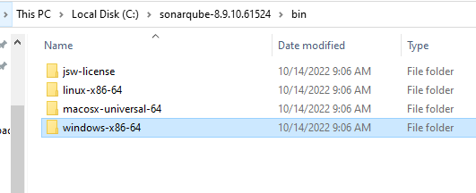

Copy this path “C:\sonarqube-8.9.10.61524\bin\windows-x86-64”

And open Terminal to go t this directory

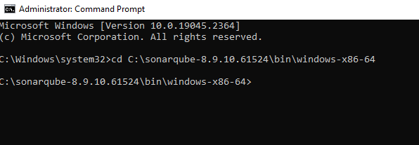

Execute command “startsonar”

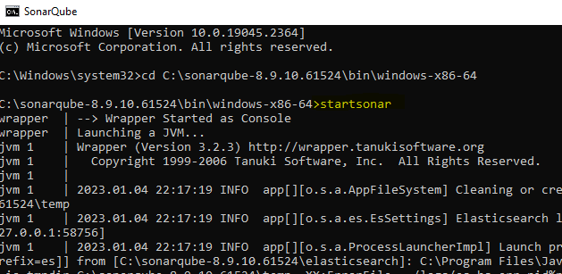

If it give error that java virtua machine could not be created like below

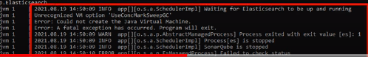

Then follow below steps

Go to jdk version folder

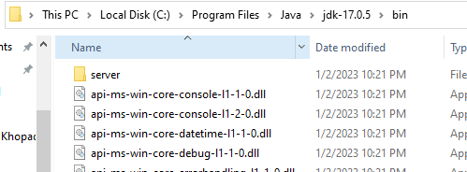

Copy bin folder path “C:\Program Files\Java\jdk-17.0.5\bin”

Go to sonarqube folder and open wrapper.config file from given path “C:\sonarqube-8.9.10.61524\conf”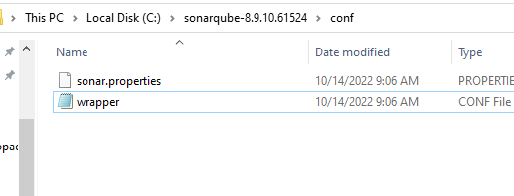”

In this config file remove java from wrapper.java.command and paste the jdk bin path

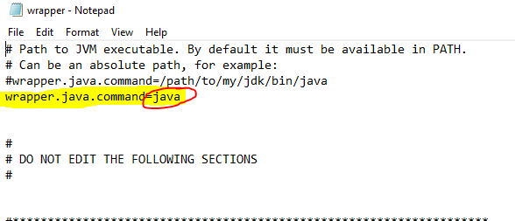

Replace java with “C:\Program Files\Java\jdk-17.0.5\bin” nd save the file

Agin the “sonarsart” command in terminal from “C:\sonarqube-8.9.10.61524\bin\windows-x86-64” directory

Now in terminal at last you can see process is up and sonar is up log it means snarqube I read to use now

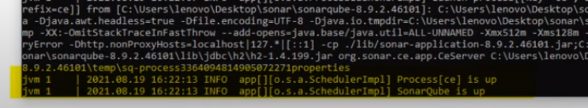

In brower open the below URL to access sonarqube

<http://localhost:9000>

Log in page will be came up login using admin user with password admin and then you change the user and password

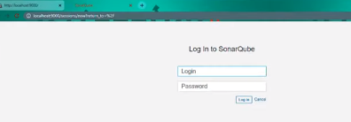

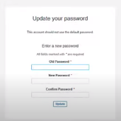

Now your ready to use sonarqube

