# Deconstructors

Basically, what a Constructor would do is it will create a new object of a given type with given parameters (but opting out the default constructor as it has no parameters).

So what the Deconstructor would do is it will deconstruct the object back into its original parts. To be specific, you have the control of specifying how would you like the object to be deconstructed.

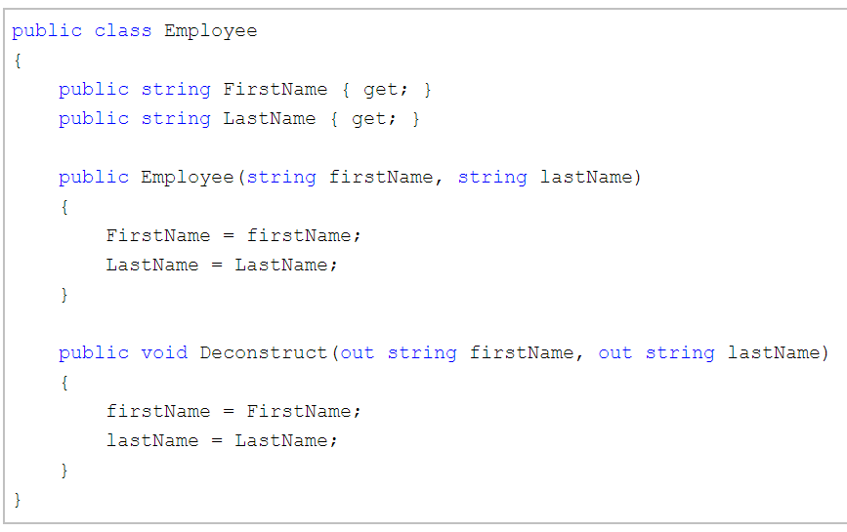

The only thing we need to have is, we should have a **public void**method named **Deconstruct** and**one or more** property that we want the object to be deconstructed into, should be specified as **out** parameters.

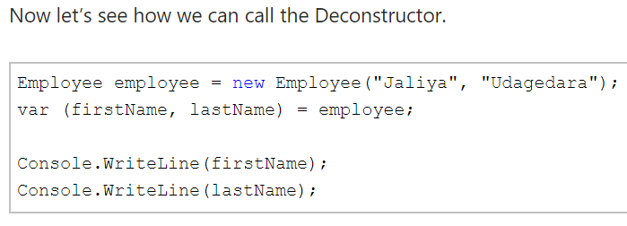

And the nice thing is, you can have multiple Deconstructors with different parameters (that’s basically method overloading).

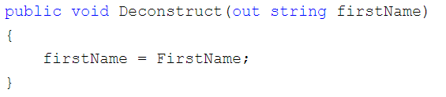



* - - - -

OTHERS

