https://developer.mozilla.org/en-US/docs/Web/JavaScript/Reference/Operators/Destructuring_assignment  
  
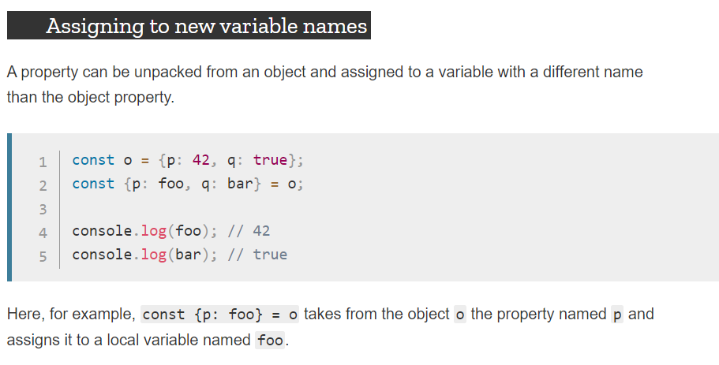

http://www-lia.deis.unibo.it/materiale/JS/developer.mozilla.org/en-US/docs/Web/JavaScript/Reference/Operators/Destructuring_assignment.html



   

