BEFORE C# 7.x (< 7.x)

OUT parameter usage is as below

bool lblnLightView = false;

if (string.IsNullOrEmpty(lstrSPFArgument14) == false)

{

bool.TryParse(lstrSPFArgument14,out lblnLightView);

}

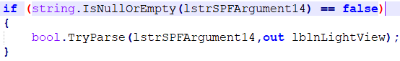

WHEN OUT parameter is used

The Out parameter is used when a method returns multiple values.

OUT parameter in detail

When a parameter passes with the Out keyword/parameter in the method, then that method works with the same variable value that is passed in the method call. If variable value changes, the method parameter value also changes.

* - - - - - - -

NEW CHANGES IN C# 7.x ( >7.x )

1. Out parameter can pass without its declaration and initialization.
2. Out parameter can use var type in the method parameter list.
3. It is not obligatory that Out parameter name should be same in both, function definition and call.

POINT 1: Out parameter can pass without its declaration and initialization.

In-line declaration of Out parameter

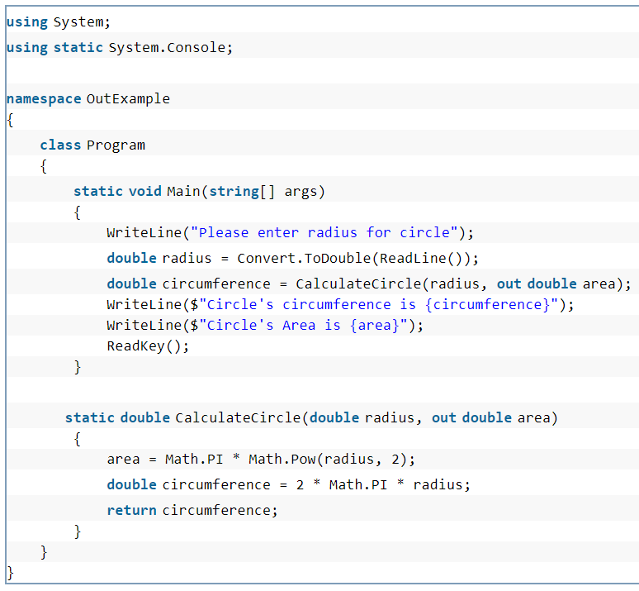

POINT 2: Out parameter can use var type in the method parameter list.

# Implicit Type Out Parameter

