Entire System Diagram
This document describes the complete system: browser, authentication, chat UI, the Astro SSR front-end, the Bun HTTP API, the action engine, events, LLM provider, XState workflow machines, the in-memory execution queue, and Brevo transactional email.

Status legend
Line style | Meaning
Solid | Implemented today
Dashed | Planned or not implemented
Immediate send_email delivery is implemented through a Bun HTTP API, a server-side XState root machine, an in-memory FIFO queue, and a Brevo actor. The chat client keeps the clarification and confirmation conversation, then enqueues a confirmed action. Scheduling has a placeholder root-machine state only. Persistent records, retries, background workers, and server-side authentication remain planned.
In development, the Astro front-end proxies relative /api requests to the Bun API. The Astro production server does not include that proxy automatically; production needs a reverse proxy or equivalent same-origin routing.

1. System context
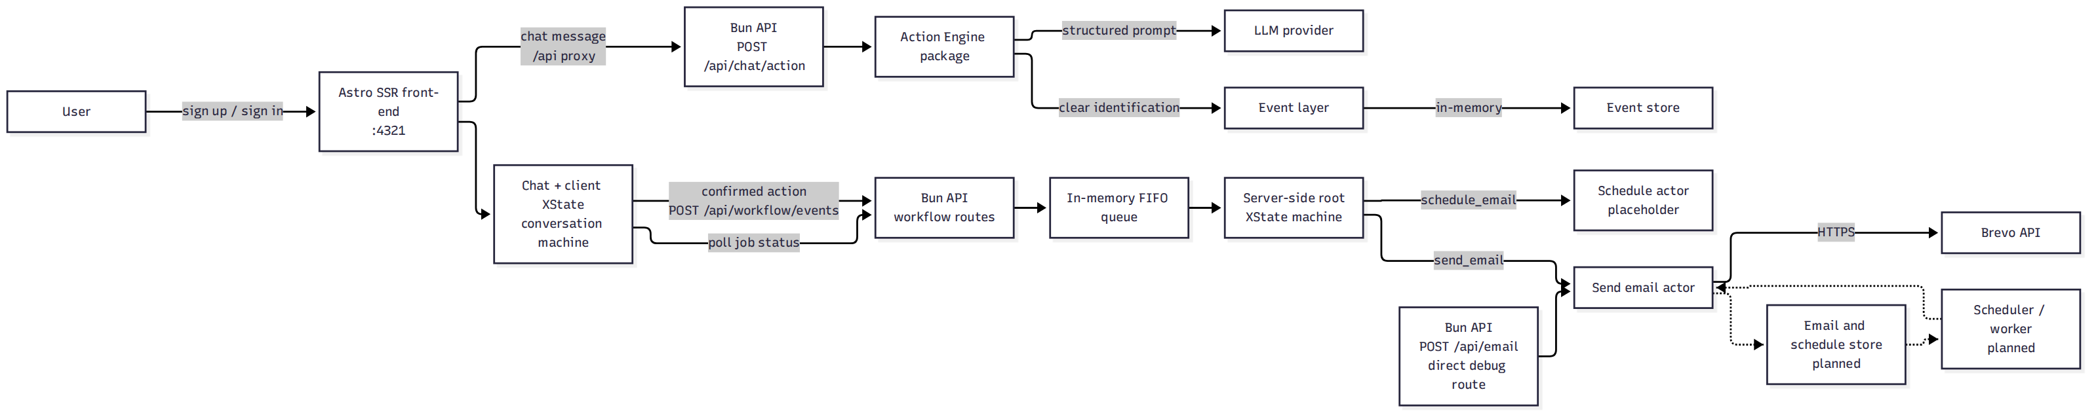

Event-to-Brevo workflow mapping
Event | Emitted when | Execution
chat.action.identified | An action is identified as clear | None; identification only
workflow.action.requested | User confirms a complete action | Queued for the server root machine
The raw identification event is not an execution command. Execution requires a confirmed, complete action. schedule_email events are accepted by the queue but fail in the placeholder actor.

2. Component architecture
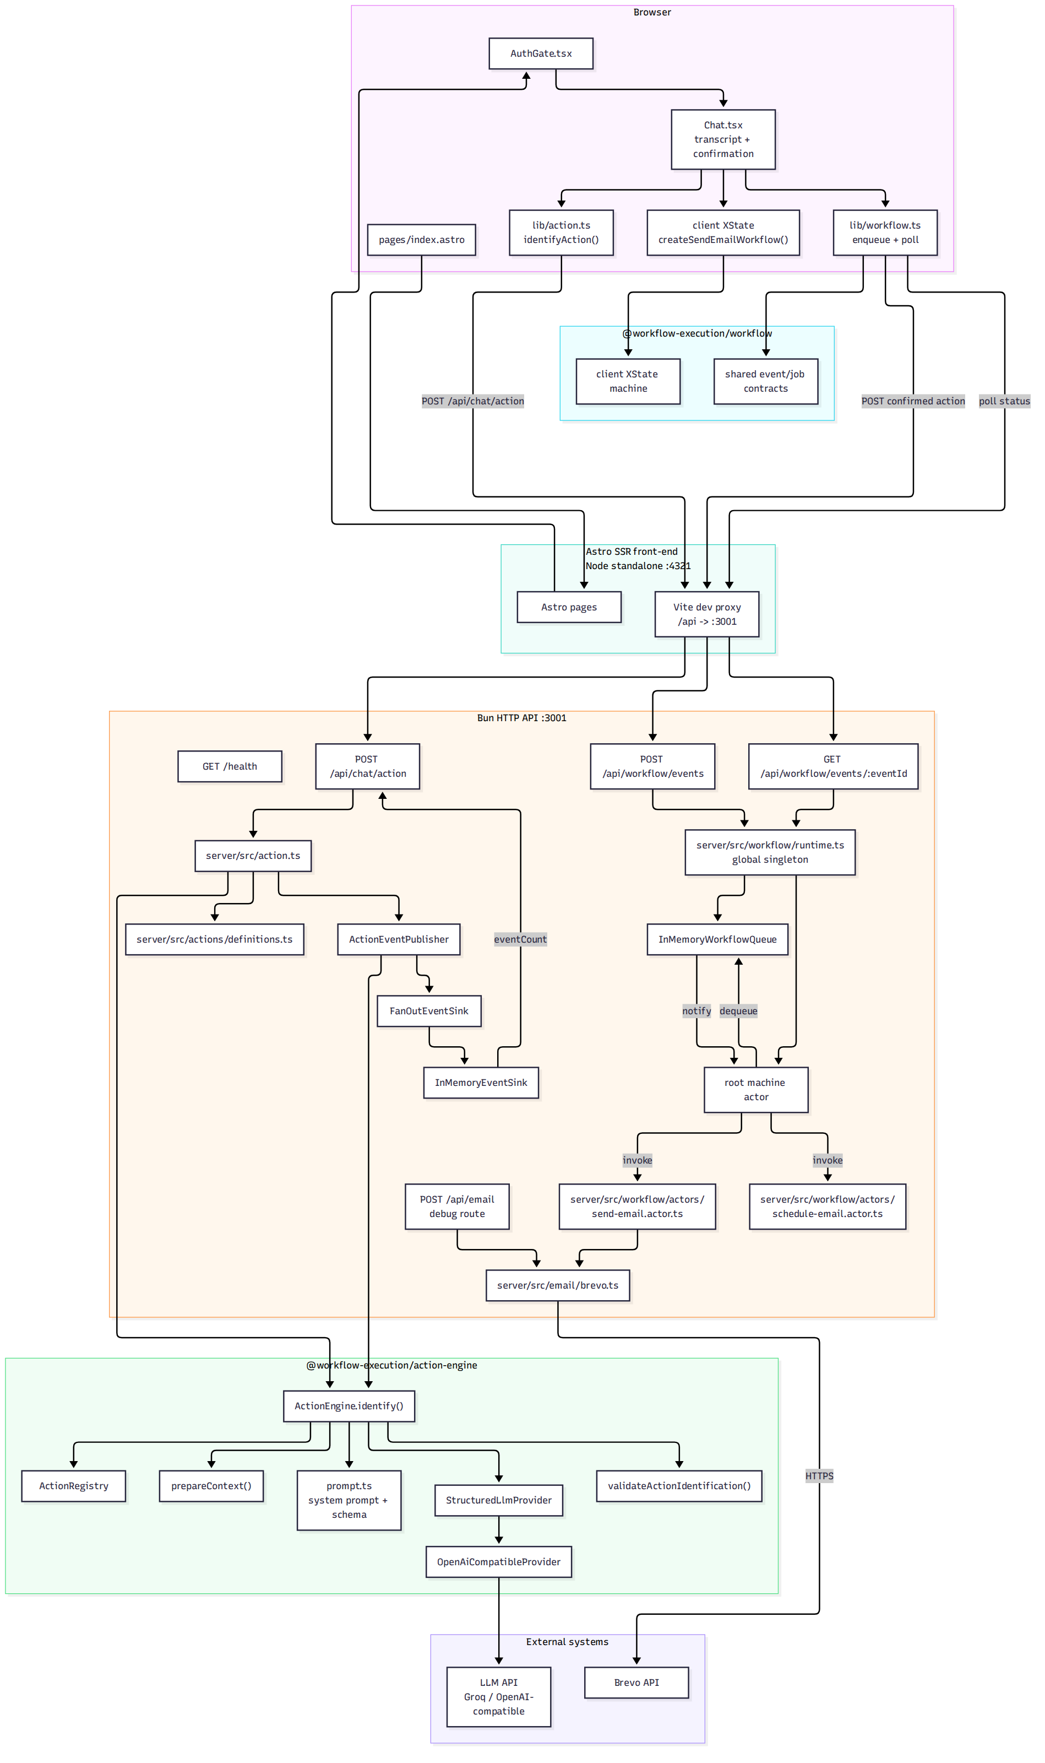

3. Identification and clarification flow
Clear send_email results continue into the client conversation machine in section 4. Clear schedule_email results stop at the action card.
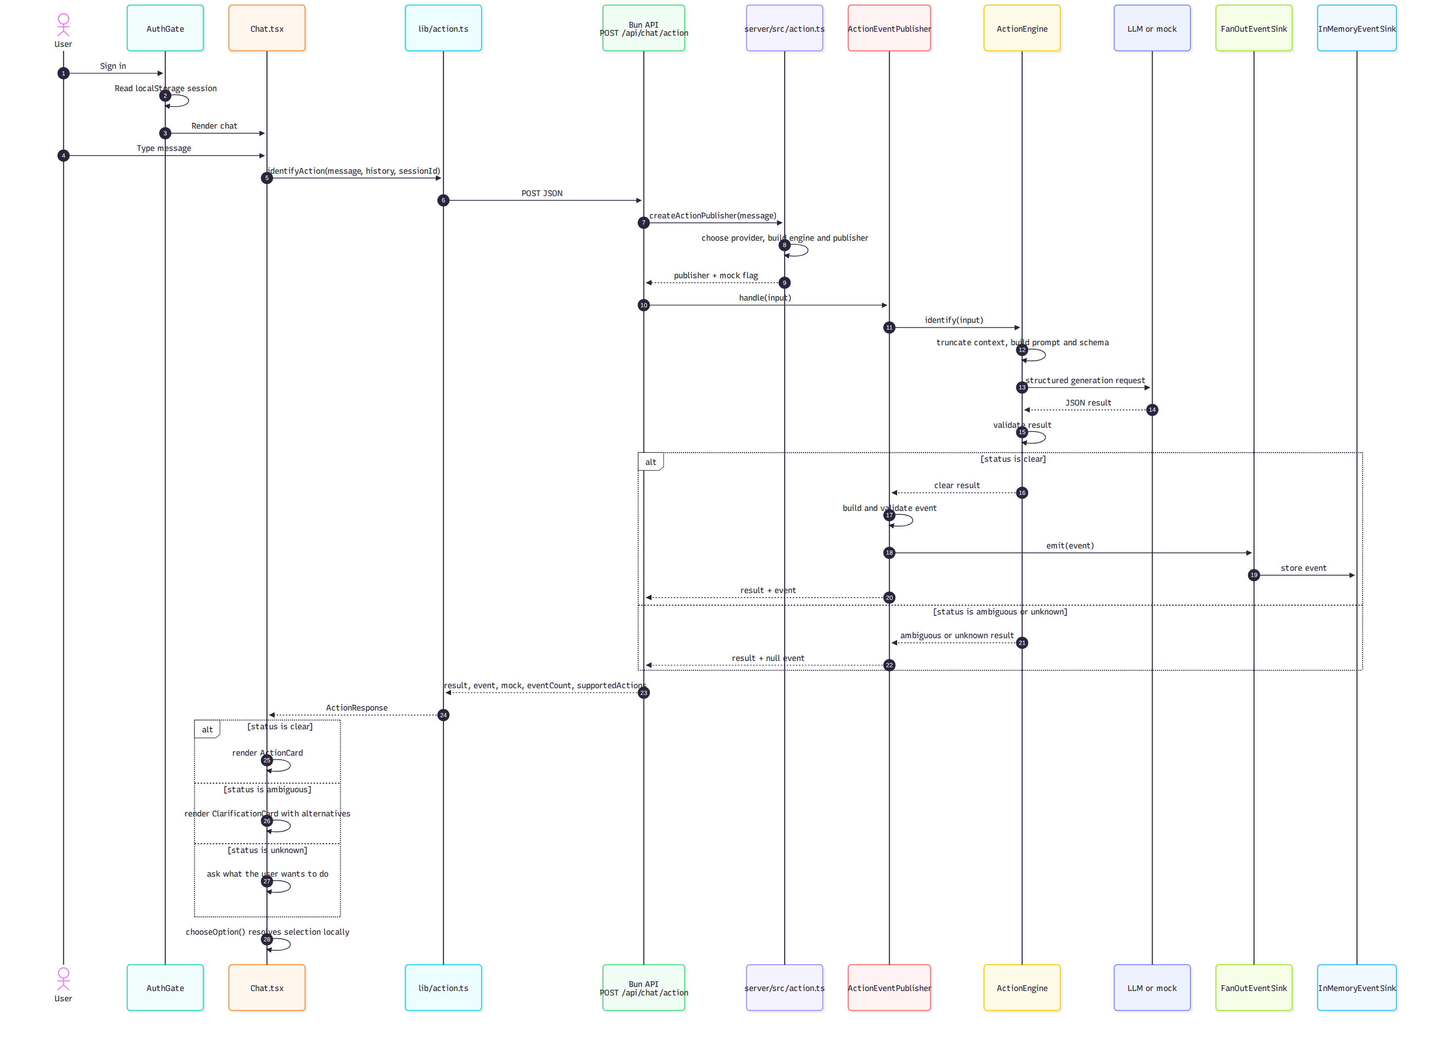

4. send_email flow (implemented)
Chat.tsx owns the client conversation state and the enqueue/poll effects. The server root machine owns execution after the confirmed event is queued.
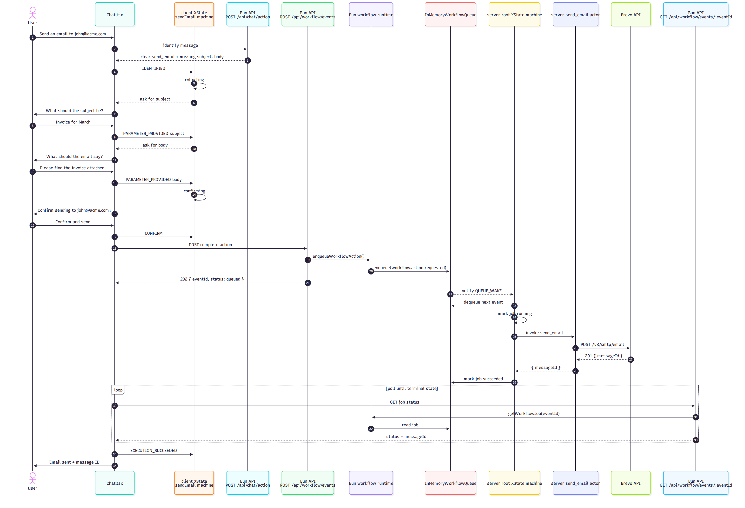
If the actor fails, the root machine records status: failed and the error. Chat sends EXECUTION_FAILED to the client machine.

5. Server root workflow machine (implemented)
The root machine lives in server/src/workflow/root-machine.ts. It is started only by server/src/workflow/runtime.ts inside the Bun API process.
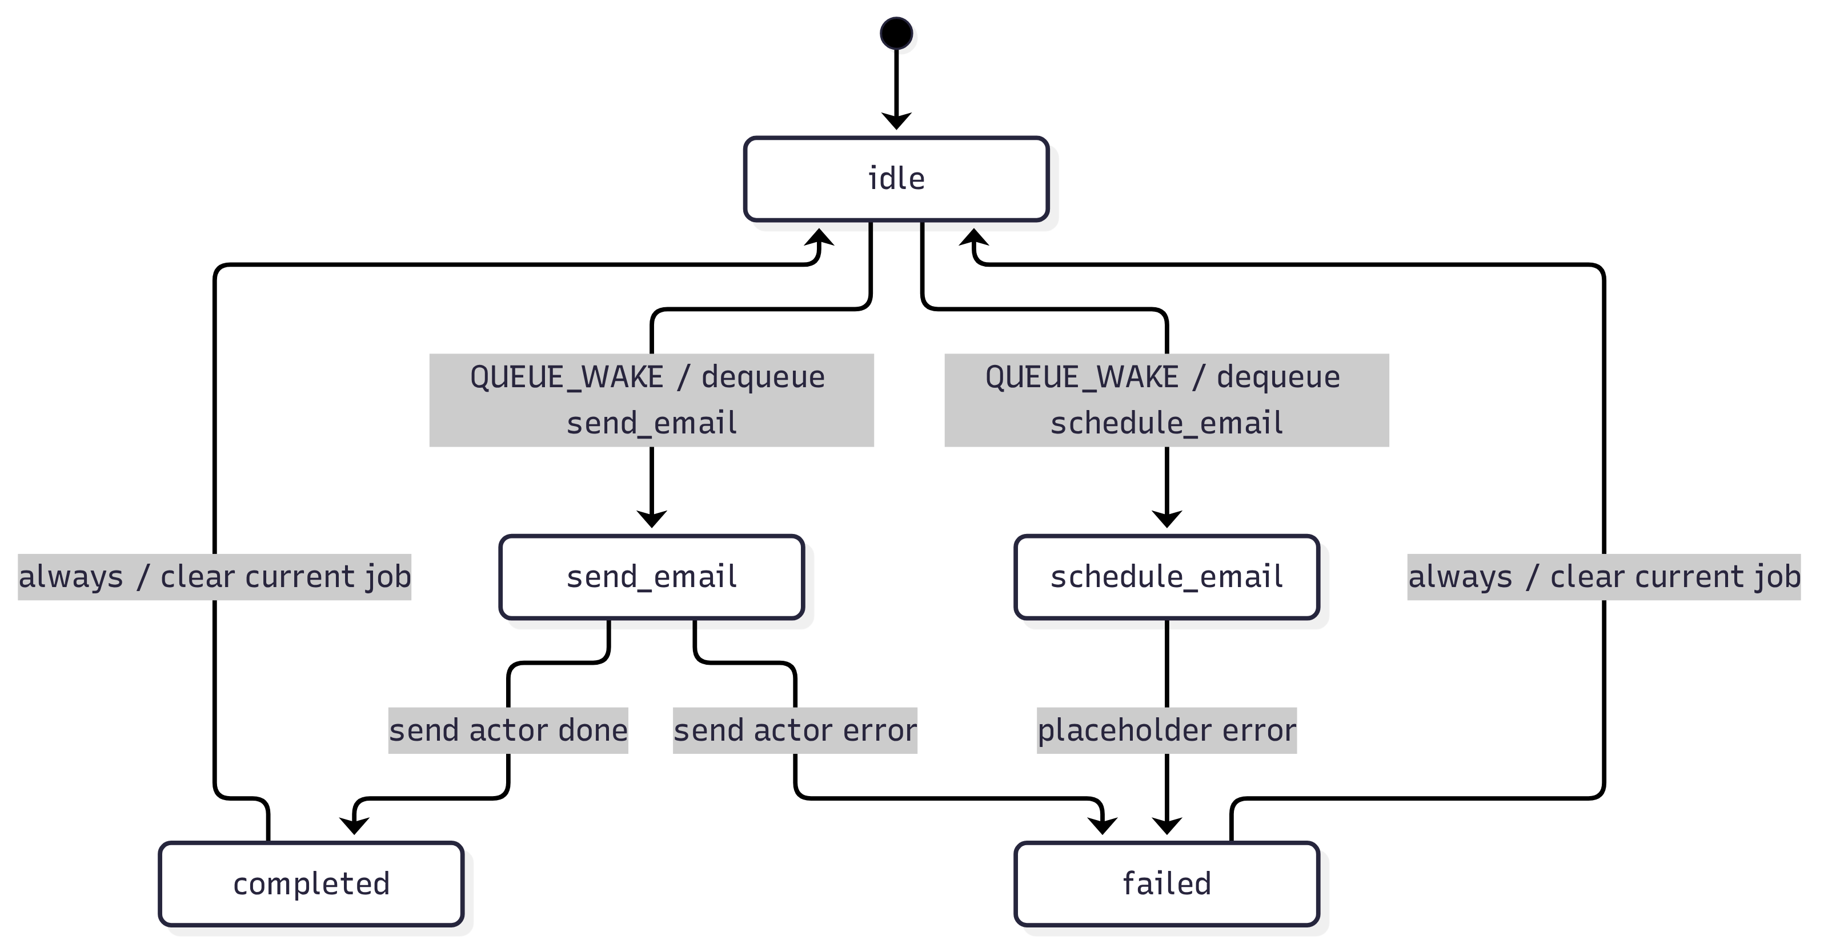
The queue listener wakes the machine whenever a job is enqueued. The machine processes one job at a time and raises another wake-up after completion.

6. Client send-email conversation machine (implemented)
The client machine lives in workflow/src/core/create-email-workflow.ts. Chat.tsx sends events into it and performs the enqueue/poll effects after CONFIRM.
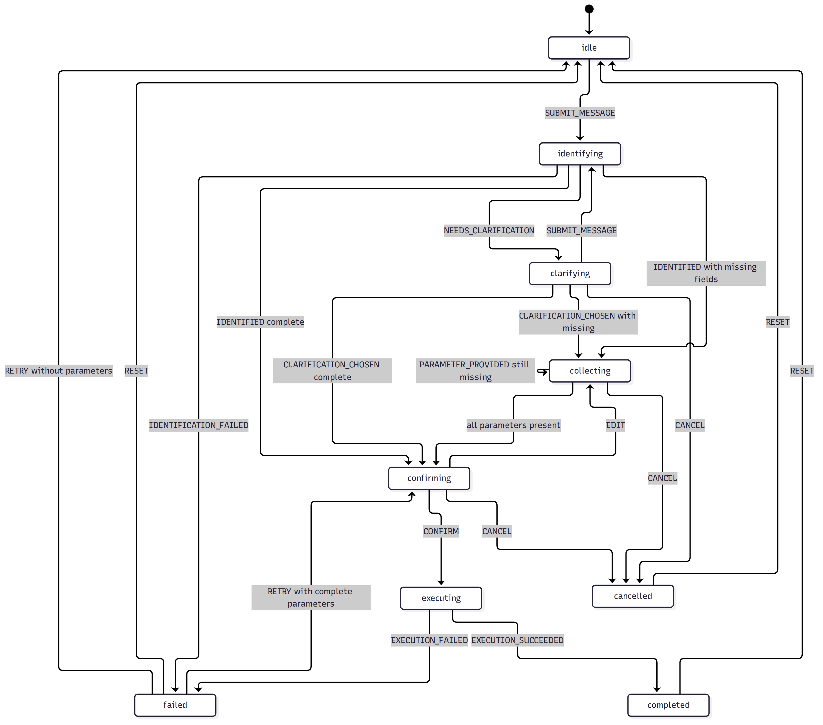
The machine is pure and framework-free. The React layer calls the workflow API; the client machine does not perform I/O.

7. schedule_email placeholder flow
schedule_email is identified by the catalog, but Chat does not collect or confirm it. The workflow API accepts a complete event for exercising the root machine, where the placeholder actor fails the job.
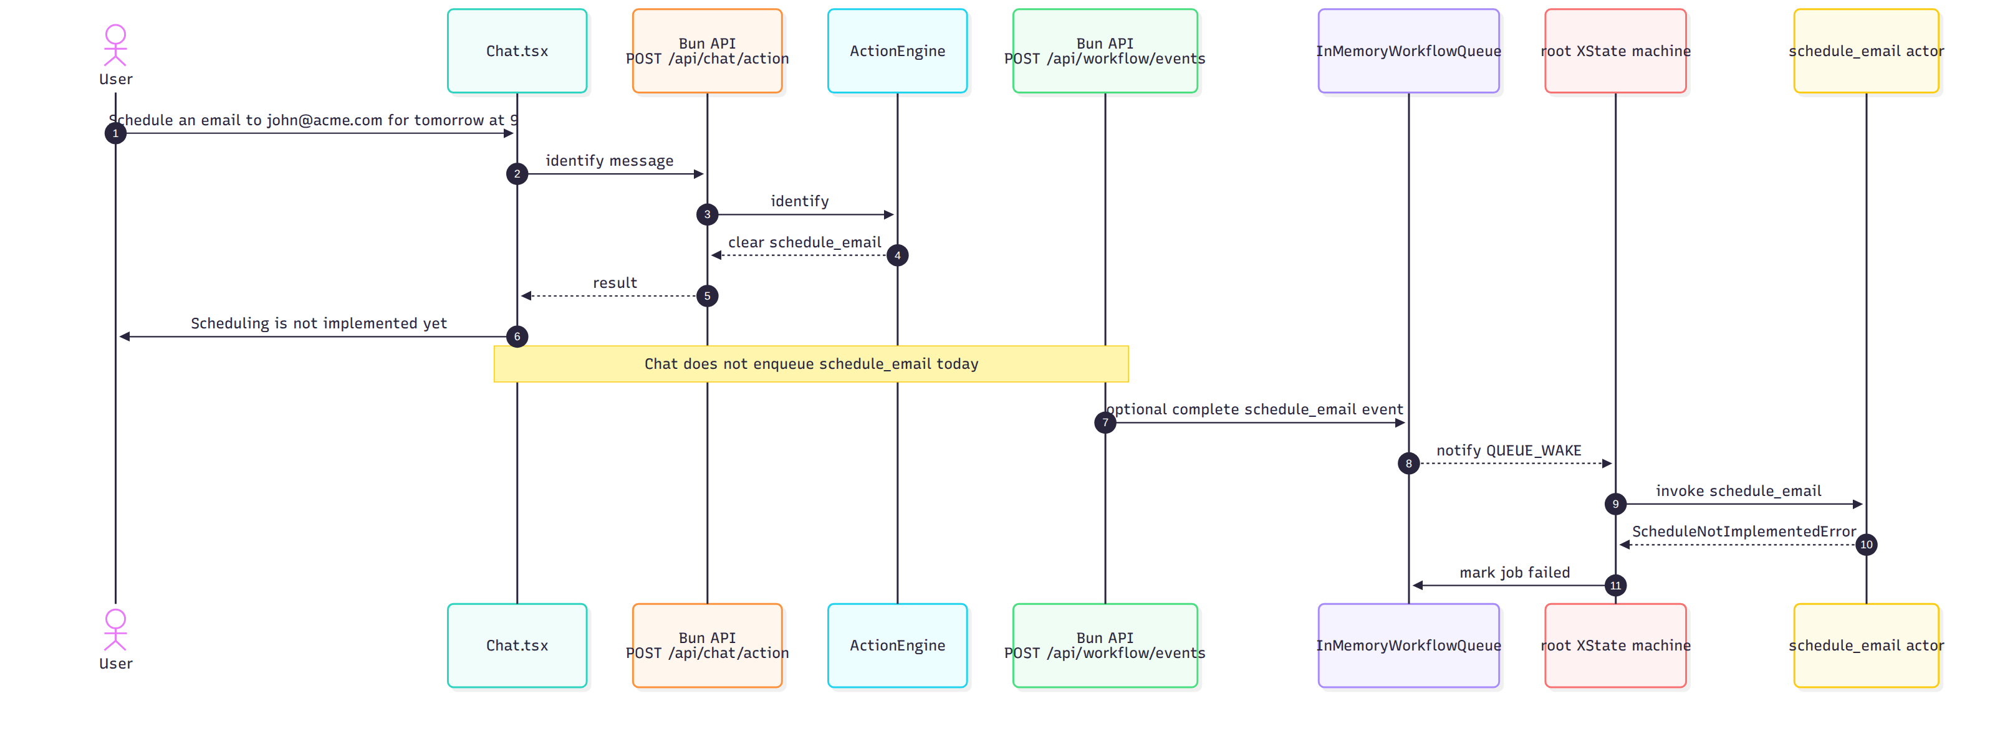
There is no schedule store, worker, or real scheduled delivery yet.

8. Event pipeline
Identification events and execution events are separate.
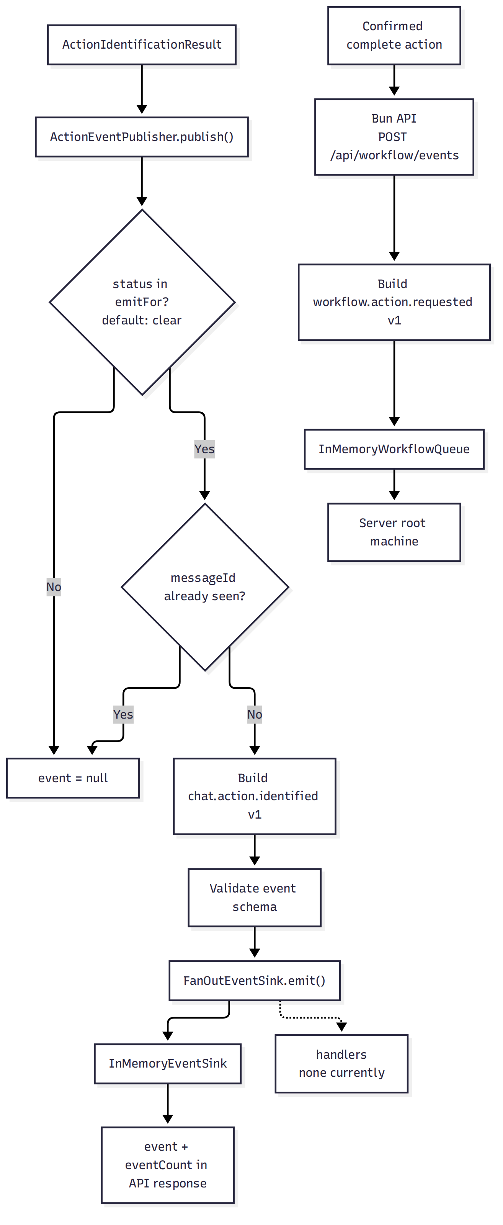

9. Authentication and session flow
Authentication is client-only and stored in localStorage.
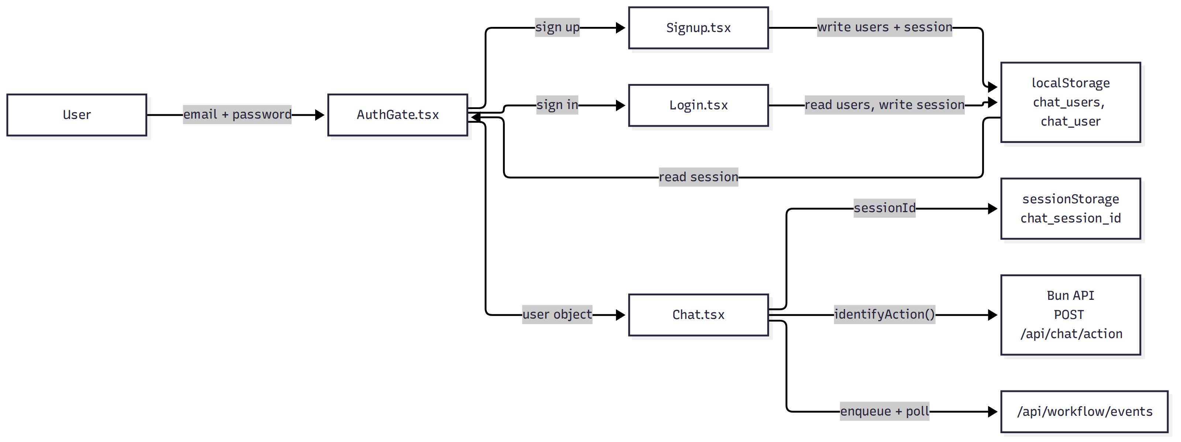
Security note: there is no server-side authentication, password hashing, or session validation. Anyone with browser access can read or modify the stored user data.

10. Runtime topology
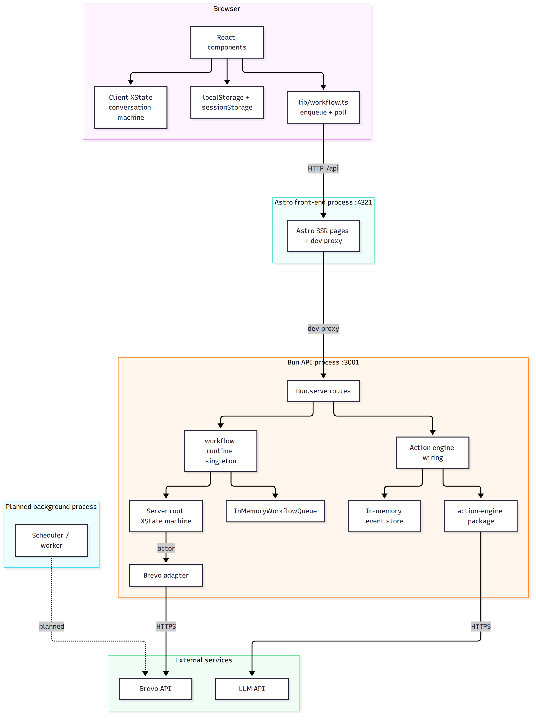

11. Data stores
Store | Location | Persistence | Current use
chat_users | Browser localStorage | Browser-local | Sign-up accounts
chat_user | Browser localStorage | Browser-local | Signed-in user
chat_session_id | Browser sessionStorage | Tab-local | Chat session ID
Action events | InMemoryEventSink in the Bun process | Process memory | Event count and inspection
Pending action | Browser memory (client XState) | Lost on refresh | Implemented send_email conversation
Workflow jobs | InMemoryWorkflowQueue in the Bun process | Process memory | Queue, status, result, errors
Email / schedule records | Not implemented | None | Brevo message ID is returned but not stored
Sequence enrollments | Not implemented | None | Future extension; Brevo has no public sequence API

12. Implementation status
Area | Status
Chat UI and suggestions | Implemented
Client-only authentication | Implemented
Bun HTTP server and route table | Implemented
Vite /api development proxy | Implemented
POST /api/chat/action | Implemented (Bun API)
send_email catalog entry | Implemented
schedule_email catalog entry | Implemented
Mock classifier | Implemented
LLM provider | Implemented
Action validation | Implemented
Clarification for ambiguous/unknown | Implemented
Event publishing | Implemented
In-memory event storage | Implemented
Local option resolution | Implemented
Client XState send_email conversation | Implemented
Missing-parameter collection | Implemented in the client machine
Explicit confirmation | Implemented in the client machine
POST /api/workflow/events | Implemented (Bun API)
GET /api/workflow/events/:eventId | Implemented (Bun API)
GET /health | Implemented (Bun API)
In-memory workflow queue | Implemented
Server-side root XState machine | Implemented
send_email actor and Brevo sending | Implemented
schedule_email root state | Placeholder; always fails
Execution event (workflow.action.requested) | Implemented
Job status polling in Chat | Implemented
Direct POST /api/email debug route | Implemented (Bun API)
Persistent workflow jobs | Not implemented
Retry / cancellation | Not implemented
Scheduled email delivery | Not implemented
Email / schedule storage | Not implemented
Background scheduler | Not implemented
Sequence execution | Not implemented
Server-side authentication | Not implemented

13. Endpoint inventory
All endpoints are served by the Bun API on HOST:PORT (default 127.0.0.1:3001). In development, Astro proxies /api to it.
Endpoint | Status | Purpose
GET /health | Implemented | Bun API health check
POST /api/chat/action | Implemented | Identify an action from a chat message
POST /api/chat/action/resolve | Removed | Previously resolved a selected option
POST /api/workflow/events | Implemented | Validate and enqueue a confirmed action
GET /api/workflow/events/:eventId | Implemented | Read workflow job status and result
POST /api/email | Implemented | Direct debug send through Brevo, bypassing the queue
POST /api/email/schedule | Planned | Real scheduled delivery
GET /api/events | Not present | Event inspection used to be exposed

14. Related documents
- ARCHITECTURE.md
- ACTION_ENGINE_DIAGRAM.md
- SETUP.md

