Email Orchestrator Architecture
Schedule-time orchestration + main/retry queue execution flow
TypeScript | PostgreSQL | Redis / BullMQ | Worker | Brevo
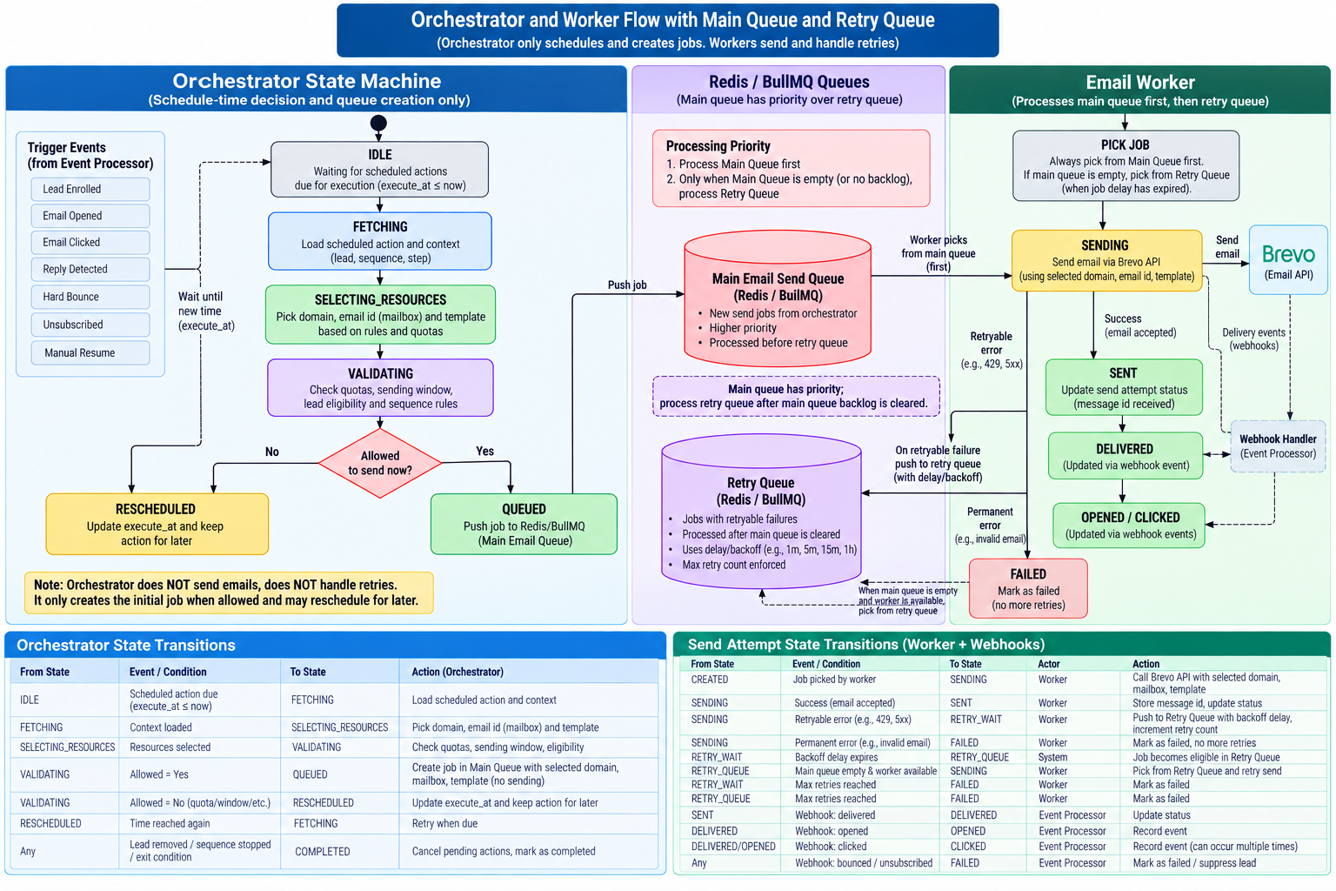
Figure 1. Orchestrator and worker flow with main and retry queues.

1. Core Responsibility Split
Orchestrator: decides what should happen at schedule time. It loads the scheduled action, selects the domain, mailbox, and template, validates quotas and sending rules, and creates a job in the main queue. It does not call Brevo.
Worker: picks queued jobs, sends through Brevo, handles transient send failures, and places retryable failures into the retry queue. The worker does not choose a new business sequence.
Brevo: external email delivery provider. Delivery and engagement events return through the webhook path.

2. End-to-End Flow
Step | Component / State | Responsibility
1 | Scheduled action becomes due | The orchestrator notices an action where execute_at <= now.
2 | Fetch context | Load the lead, dataset, sequence, step, and any related configuration from PostgreSQL.
3 | Select resources | Choose an eligible domain, sending mailbox/email ID, and template.
4 | Validate | Check lead eligibility, sending window, global/domain/mailbox/dataset limits, and other rules.
5 | Queue | If allowed, create a queue payload and push it into the Main Email Send Queue.
6 | Worker | Worker always checks the Main Queue first and picks a normal send job.
7 | Send via Brevo | Worker calls Brevo with the selected domain/mailbox/template information.
8 | Retry if needed | Retryable failures go to the Retry Queue with backoff. Permanent failures are marked failed.
9 | Process retry queue | After the main queue has no backlog, the worker processes eligible retry jobs.
10 | Receive events | Brevo webhooks update send/event state through the webhook/event processor path.

3. Orchestrator State Machine
IDLE -> FETCHING -> SELECTING_RESOURCES -> VALIDATING -> QUEUED -> WAITING_FOR_WORKER
Alternative path: VALIDATING -> RESCHEDULED when the action cannot be queued now because the send window, quota, or another scheduling constraint is not available. The same scheduled action is kept for a later execute_at time.
From | Event / Condition | To | Orchestrator Action
IDLE | Scheduled action due | FETCHING | Load scheduled action and context
FETCHING | Context loaded | SELECTING_RESOURCES | Prepare eligible domain, mailbox, template
SELECTING_RESOURCES | Resources selected | VALIDATING | Proceed to validation
VALIDATING | Allowed = Yes | QUEUED | Create job in Main Queue
VALIDATING | Allowed = No | RESCHEDULED | Update execute_at and keep the action
RESCHEDULED | Time reached again | FETCHING | Re-evaluate the action
QUEUED | Job pushed | WAITING_FOR_WORKER | Orchestrator handoff ends

4. Resource Selection Done by the Orchestrator
- Select domain: consider active/healthy domains allowed for the dataset or sequence and remove domains that have no capacity.
- Select mailbox/email ID: choose an eligible mailbox on the selected domain, respecting mailbox caps and sending windows. Round-robin is a reasonable starting policy.
- Select template: resolve the template from the current sequence step, including an A/B variant when configured.
- Prepare personalization data: retain the identifiers needed to render the email later or provide the worker enough context to fetch it safely.
- Validate all constraints before queueing: global cap, domain cap, mailbox cap, dataset cap, hourly cap, daily cap, sending window, and lead eligibility.

5. Main Queue Payload
{
sendAttemptId: string;
leadId: string;
datasetId: string;
sequenceId: string;
stepId: string;
templateId: string;
domainId: string;
mailboxId: string;
scheduledAt: string;
priority: "normal" | "high";
}

6. Main Queue and Retry Queue
Main Queue has priority. Workers should always attempt to clear normal/new email work before consuming retry work. Retry jobs become eligible after their backoff time expires, but they should not starve new work.
Queue | Contains | Processing Priority
Main Email Send Queue | New jobs created by the orchestrator | Highest priority
Retry Queue | Jobs that failed transiently and are waiting for backoff | Processed after the main queue has no backlog
Recommended worker loop: 1) fetch from Main Queue; 2) if empty, fetch an eligible job from Retry Queue; 3) on retryable failure, increase retry count and schedule backoff; 4) on permanent failure or max retries, mark the send attempt failed.

7. Worker / Retry State Transitions
From | Event / Condition | To | Action
SENDING | 429 / 5xx / timeout | RETRY_WAIT | Compute backoff; preserve same sendAttemptId and idempotency key
RETRY_WAIT | Backoff expired + Main Queue empty | RETRY_QUEUE | Make retry eligible
RETRY_QUEUE | Worker picks retry | SENDING | Attempt send again
SENDING | Permanent error | FAILED | Mark failed; do not retry
SENDING | Max retries reached | FAILED | Mark failed

8. Brevo Webhook Event Path
- Brevo sends an event to the webhook endpoint after delivery/engagement activity.
- Webhook API validates the request and stores the raw provider event.
- Event Processor reads the event, finds the related send attempt, and records the event.
- The event processor may update lead/sequence state and create or cancel future scheduled actions according to your workflow rules.

9. Responsibility Boundary
Component | Should Do | Should Not Do
Orchestrator | Schedule-time selection, validation, queue creation | Call Brevo; send emails; process send retries
Main Queue | Hold normal send jobs | Make business decisions
Retry Queue | Hold retryable failed jobs during backoff | Compete ahead of normal work
Worker | Pick job, send via Brevo, retry transient failures | Choose lead sequence transitions
Brevo | Deliver email and emit provider events | Know your internal orchestration rules
Webhook / Event Processor | Persist and interpret provider events | Act as the outbound sending worker
PostgreSQL | Source of truth for state and audit history | Be used as the high-throughput job queue

10. Recommended TypeScript Structure
- orchestrator/scheduler.ts: finds due scheduled actions and drives the orchestrator state machine.
- orchestrator/resource-selector.ts: domain, mailbox, and template selection.
- orchestrator/quota-validator.ts: global/domain/mailbox/dataset/hourly/daily validation.
- queues/email-main.queue.ts and queues/email-retry.queue.ts: BullMQ queue definitions.
- workers/email.worker.ts: main-first queue consumption, Brevo send, retry handling.
- webhooks/brevo.webhook.ts: lightweight event receiver.
- workers/event-processor.worker.ts: translate provider events into durable application state changes.
Key invariant: the orchestrator prepares a complete send job and stops after queueing it; the worker owns the actual send and retry mechanics.

