Design and Implementation of a Secure Campus Network
A Brief Report

Prepared for: Samuel Okegbile [CIS-192]
Prepared by: Ranjit Gautam
Date: 2024-11-29
Table of Contents
- Introduction
- Network Design Overview
- Topology and IP Addressing Plan
- Core Layer Configuration
- Distribution Layer Configuration & VLAN Setup for Access Layer Configuration

- Security Implementations
- Redundancy and Failover Mechanisms
- Testing and Analysis
- Conclusion and Recommendations

1. Introduction
Purpose of the Network Design
The campus network is designed to be reliable, secure, and future-proof. With the increasing need for smooth connectivity, data security, and uninterrupted services, this network will effectively support educational and administrative operations.
Key goals:
- Scalability: Built to handle more users, devices, and services as the campus grows.
- Security: Protects sensitive data with robust defenses like VLANs, firewalls, and access controls.
- Redundancy: Ensures constant availability with backup systems and failover mechanisms.
This design ensures smooth operations, protects critical resources, and prepares the campus for future demands.

2. Network Design Overview
The campus network is organized to efficiently connect multiple departments and user groups, ensuring seamless communication and resource sharing across the organization. The layout comprises four primary departments:
- Administration:
- IT Department:
- Library:
- Classrooms
Three-Layer Network Model
The campus network follows a hierarchical three-layer model to ensure scalability, security, and performance.

- Core Layer
- Role: Serves as the network's backbone, ensuring fast and reliable communication between distribution layers. Two core switches were used.
- Key Features:
  - High-speed multilayer switches for efficient data transmission.
  - Dynamic routing protocols like EIGRP or OSPF to manage data flow.
  - Redundant links for reliability using EtherChannel.

- Distribution Layer
- Role: Connects the core layer to the access layer, managing data flow and implementing security policies. Four switches were used for this layer. which has also been tusk with other switch.
- Key Features:

  - Multilayer switches (e.g., Cisco 3560-24PS) at the Distribution Layer for inter-VLAN routing.
  - VLANs for logical segmentation of traffic.
  - Redundant links using EtherChannel to ensure failover support.
  - GigabitEthernet uplinks for core-to-distribution connections.

- Access Layer
- Role: Provides end devices (e.g., PCs, printers) with network access. Where eight switches were used. They have more connection with distribution switch as they are tusk with two different department.
- Key Features:
  - Layer 2 switches are configured with VLANs to segment traffic.
  - Port security to prevent unauthorized connections.
  - ACLs (Access Control Lists) to restrict and filter traffic.

Diagram of the Network Topology
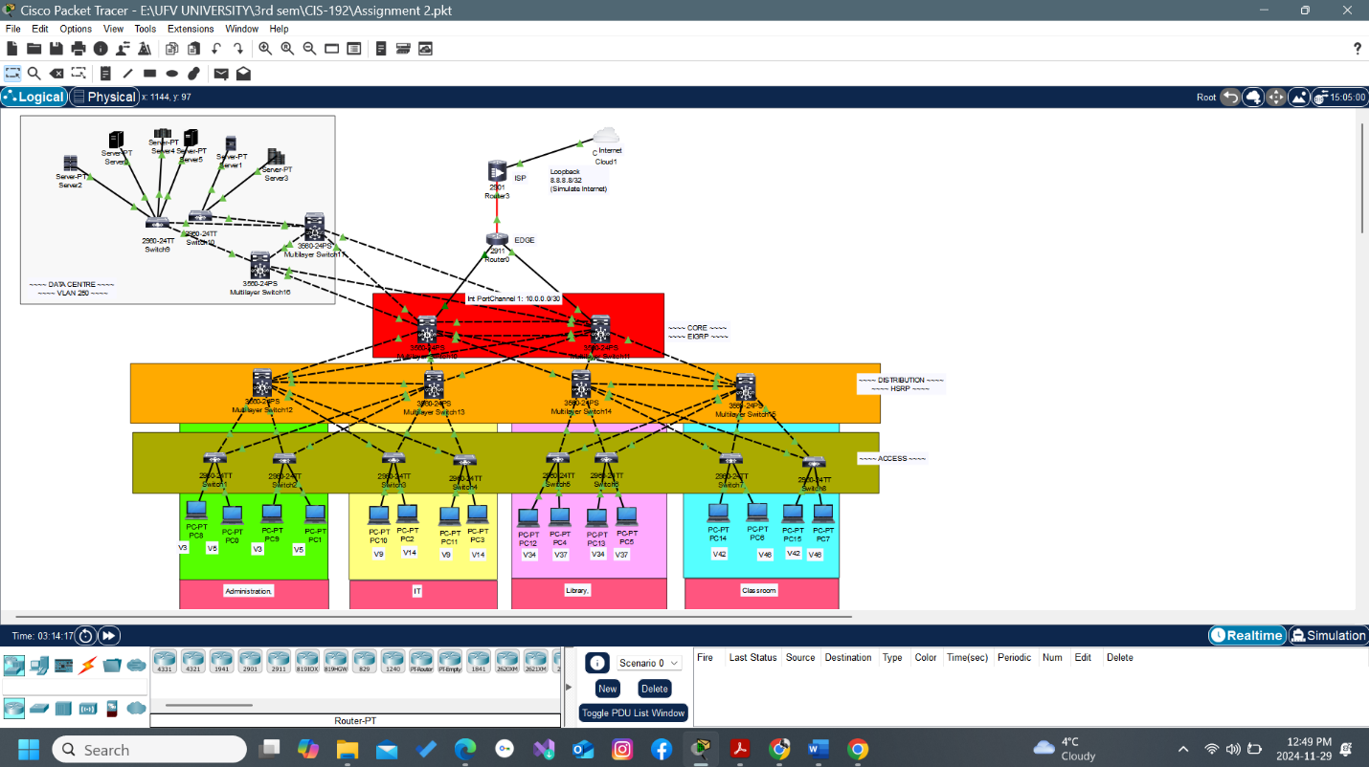

Network Features and Benefits
Redundant Links:
  - EtherChannel aggregates multiple links for increased bandwidth and reliability between layers.
VLAN Segmentation:
  - Departments are assigned specific VLANs (e.g., VLAN 3,5 for Administration, VLAN 9,14 for IT, VLAN 34,37 for Library, VLAN 42,46 for Classroom).
  - This improves security and reduces network congestion by isolating traffic.
Dynamic Routing:
  - Routing protocols like EIGRP or OSPF enable efficient data transfer and adapt to topology changes.
This design creates a secure, scalable, and resilient network that meets both current and future requirements.

    - Topology and IP Addressing Plan
IP Address for department:
Administration-192.168.3/5.0/24
IT-192.168.14/9.0/24
Library-192.168.34/37.0/24
Classroom-192.168.46/42.0/24
Router or device name/hostname | IP Addresses/subnet mask
- PC8 | 192.168.3.4 / 255.255.255.0
- PC8 | 192.168.5.4
- PC 9 | 192.168.3.5
- PC1 | 192.168.5.5
- PC10 | 192.168.9.4
- PC 2 | 192.168.14.4
- PC 11 | 192.168.9.5
- PC3 | 192.168.14.5
- PC12 | 192.168.34.4
- PC4 | 192.168.37.4
- PC5 | 192.168.37.5
- PC14 | 192.168.42.4
- PC6 | 192.168.46.5
- PC15 | 192.168.42.5
- PC7 | 192.168.46.4

VLAN are assigned for end device and recorded in switch for limiting access;
    - V3- PC8, PC9
    - V5-PC0, PC1
    - V9-PC10, PC11
    - V14-PC2, PC3
    - V34-PC12, PC13
    - V37-PC4, PC5
    - V42-PC14, PC15
    - V48- PC6, PC7
The code was used for assigning IP address and VLAN and save to corresponding switch with normal access and trunk. There is normal code which was used in corresponding to different switch:
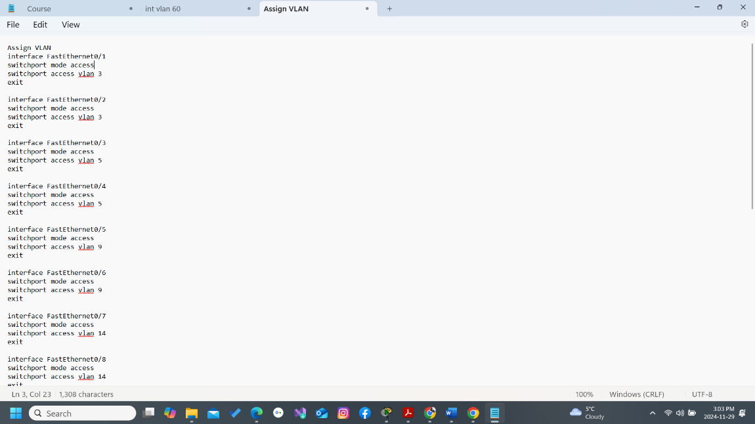
Code
interface FastEthernet0/1
switchport mode access
switchport access vlan 3
exit
Verify Configuration
Code which was used in Command Prompt:
show vlan brief
show ip interface brief
Ping Test
Run a ping test to ensure connectivity between devices within the same VLAN:
ping 192.168.3.5 - Test connectivity between PC8 and PC9

4. Core Layer Configuration
- EtherChannel Configuration:
  - EtherChannel is used to bundle multiple physical links into one logical link, providing redundancy and increased bandwidth.
  - Example configuration for LACP (Link Aggregation Control Protocol):
bash
Copy code
interface range GigabitEthernet1/0/1 - 2
channel-group 1 mode active
interface port-channel 1
switchport mode trunk
  - This ensures redundancy; if one link fails, the others continue to carry traffic.
- Dynamic Routing (EIGRP/OSPF):
  - EIGRP and OSPF are used for dynamic routing between routers.
  - EIGRP Configuration Example:
bash
Copy code
router eigrp 1
network 192.168.0.0 0.0.255.255
no auto-summary
  - OSPF Configuration Example:
bash
Copy code
router ospf 1
network 192.168.0.0 0.0.255.255 area 0
  - These protocols automatically adjust routes and provide fault tolerance, enabling efficient communication within the network.
- Verification:
  - Verify EtherChannel with:
bash
Copy code
show etherchannel summary
show interface port-channel 1
  - Verify Routing Protocols with:
bash
Copy code
show ip protocols
show ip route ospf (for OSPF)
The Core Layer configuration ensures high availability, redundancy, and efficient routing with EtherChannel and dynamic routing protocols like EIGRP and OSPF.

5. Distribution Layer Configuration & VLAN Setup for Access Layer Configuration
In the Distribution Layer, VLANs (Virtual Local Area Networks) are set up to logically segment the network into departments, improving performance and security.
VLAN are;
- V3- PC8, PC9
- V5-PC0, PC1
- V9-PC10, PC11
- V14-PC2, PC3
- V34-PC12, PC13
- V37-PC4, PC5
- V42-PC14, PC15
- V48- PC6, PC7
- Administration-V3, V5
- IT-V14, V9
- Library-V34, V37
- Classroom-V42, V46

VLAN Configuration Example:
Here’s how to configure a VLAN and assign it to a specific port:
- Creating a VLAN:
Switch(config)# vlan 3
Switch(config-vlan)# name Administration
- Assigning VLAN to a Port:
bash
Copy code
Switch(config)# interface g0/1
Switch(config-if)# switchport mode access
Switch(config-if)# switchport access vlan 10
Explanitation:
- vlan 3: Creates VLAN 3 for the Administration department.
- switchport mode access: Configures the port as an access port, meaning it will carry traffic for only one VLAN.
- switchport access vlan 3: Assigns VLAN 3 to the port.
Repeated the configuration for other VLANs (e.g., IT, Library, Classrooms) as required and shown in network topology.
The Distribution Layer uses VLANs to segment the network into departments, improving traffic management and security. The VLAN configuration assigns logical groups to physical ports, enabling communication within each department while isolating traffic between departments.
Port Security Example
Switch(config)# interface g0/1
Switch(config-if)# switchport port-security
Switch(config-if)# switchport port-security maximum 1
Switch(config-if)# switchport port-security violation restrict
Switch(config-if)# switchport port-security mac-address sticky

6. Security Implementations
Access Control Lists (ACLs)
ACLs are used to control network traffic by defining rules that permit or deny specific IP packets based on criteria such as source IP, destination IP, protocol type, or port.
Example ACL Rules:
- Allow traffic from a specific subnet (Administration VLAN):
Router(config)# access-list 100 permit ip 192.168.3.4 0.0.0.255 any
  - This rule allows any traffic from 192.168.3.0/24 to any destination.
- Deny all other traffic:
Router(config)# access-list 100 deny ip any any
  - This rule denies all other IP traffic.
- Apply the ACL to an interface (e.g., on the inbound direction):
Router(config)# interface g0/0
Router(config-if)# ip access-group 100 in
  - This applies ACL 100 to interface g0/0 to filter inbound traffic.
Explanation:
- access-list 100 permit: Defines an ACL rule to allow traffic.
- access-list 100 deny: Defines a rule to block all other traffic.
- ip access-group 100 in: Applies the ACL to incoming traffic on the specified interface.
The above mention code were utilize on all the route according to their connectivity and end device connection with access, distribution and core layer router.
Firewall Configuration
Firewall settings on edge routers help protect the network from unauthorized access by filtering incoming and outgoing traffic.
- Edge Router Firewall Settings typically involve:
  - Stateful Packet Inspection (SPI): Ensures only legitimate traffic is allowed through the firewall by tracking the state of active connections.
  - Default Deny Policy: Denying all traffic by default and explicitly allowing necessary traffic.
  - Access Control Lists (ACLs): Define specific rules to permit or deny traffic based on IP addresses, ports, and protocols.
  - NAT (Network Address Translation): Hides internal IP addresses from external networks by mapping them to a public IP.
Example Firewall Rule (Basic Inbound Filter):
Router(config)# access-list 101 permit tcp any host 192.168.10.10 eq 80
Router(config)# access-list 101 deny ip any any
Router(config)# interface g0/1
Router(config-if)# ip access-group 101 in
- This rule allows inbound HTTP traffic (port 80) to 192.168.10.10 and denies all other traffic which was used for core router.

7. Redundancy and Failover Mechanisms
EtherChannel for Redundancy
EtherChannel is a technology used to combine multiple physical links into one logical link, providing both increased bandwidth and redundancy.
- Role in Redundancy:
  - By bundling multiple links, EtherChannel allows for load balancing across links and ensures redundancy.
  - It prevents network outages caused by single link failures, making the network more resilient and reliable.
HSRP (Hot Standby Router Protocol) Configuration
HSRP is a Cisco protocol used to ensure router redundancy. It allows two or more routers to work together to present the illusion of a single router as the default gateway. If the active router fails, one of the standby routers takes over, providing failover protection.
HSRP Configuration Example:
- Configuring HSRP on a Router:
  - Step 1: Assigning the HSRP virtual IP address:
Router(config)# interface g0/0
Router(config-if)# standby 1 ip 192.168.3.5
    - standby 1 ip 192.168.3.5: This sets the virtual IP address that will be used as the default gateway for hosts on the network.
  - Step 2: priority to determine which router should be the active one:
Router(config-if)# standby 1 priority 110
    - priority 110: Increases the router's priority (default is 100), making this router more likely to be elected as the active router.
  - Step 3: Enable preemption, which will allow the router to take over as active if it has a higher priority than the current active router:
Router(config-if)# standby 1 preempt
    - preempt: If the router’s priority is higher than the current active router, it will take over as the active router.
Explanation of Commands:
- standby 1 ip: Specifies the virtual IP address for HSRP group 1.
- standby 1 priority: Sets the router's priority for the active role.
- standby 1 preempt: Enables preemption, allowing this router to become the active router if it has a higher priority.

8. Testing and Analysis
Packet Tracer was used to simulate the network, ensuring that configurations such as VLANs, EtherChannel, and HSRP were correctly implemented.
Performance metrics like latency, throughput, and failover success were measured using tools like ping, traceroute, and simulated failover scenarios.
- Findings: The network showed low latency, high throughput, and successful failover during redundancy testing, indicating the network’s efficiency and reliability.\

9. Conclusion and Recommendations
The network I built is strong in three key areas:
- Scalability: The design supports future growth, making it easy to add new devices or departments without major changes.
- Security: With tools like Access Control Lists (ACLs) and firewalls, the network is protected from unauthorized access and threats.
- Reliability: HSRP and EtherChannel provide backup systems that ensure the network stays online even if there’s a failure.
Future Improvements
To make the network even better, here are a few suggestions:
- Add Wireless Networks:
  - Adding Wi-Fi will give more flexibility and allow employees to work from different locations within the building.
- Use Intrusion Detection Systems (IDS):
  - An IDS will help spot any suspicious activity on the network and keep it safe from attacks before they happen.
- Move to IPv6:
  - IPv6 will help the network grow as more devices come online, offering more IP addresses and better efficiency.
Screenshots for process is included in another file:

