1. To create 500 samples (of 150 observations each) from the population using bootstrap, we will use the boot package in R. We will then find the average mean, standard deviation, and percentile for blood pressure for each sample and compare them with the statistics from the population using a histogram and a boxplot.

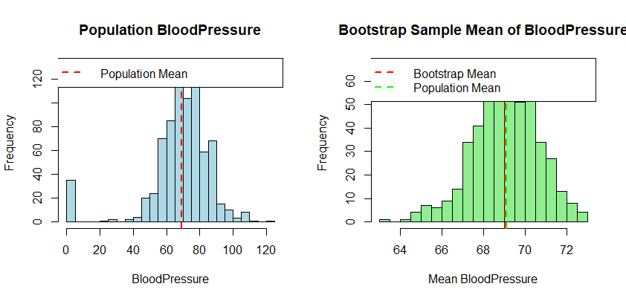

Mean: 69.02

Standard Deviation: 1.57

