FACULTY OF ENGINEERING AND TECHNOLOGY
Department of CSE – AI, ML and DS
PROJECT REPORT
AI-Assisted Web Application Project
Semester 3 – CSE (AI/ML)
CampusFlow: AI-Assisted Student Portal

Student Name: Ranjith Kumar
Enrollment No.: 92540118530
Division: [Enter your official division / GR number]

Contents
1. Introduction
2. Target User
3. Tools Used
4. Prompt Engineering Process
5. Application Design and Development
6. Final Application
7. Conclusion

1. Introduction
Students often manage class information, assignment deadlines, attendance estimates, course progress and study materials in different places. This can make it difficult to identify priorities quickly. CampusFlow is a simple student-portal prototype that brings common student tasks into one dashboard.
The project uses AI-assisted prompt engineering to plan the interface, generate a web prototype and improve usability. The prototype uses HTML, CSS and JavaScript. It demonstrates navigation between dashboard, assignments, attendance, courses and study resources. All information shown is sample data and is not connected to official university systems.

2. Target User
The primary users are college students who want a simple place to review assignment tasks, check illustrative attendance information, monitor course progress and organize study resources. A teacher or evaluator can also use the prototype to review how an AI-assisted workflow turns a real-world need into a web interface.
User needs include a clear view of upcoming tasks, a way to mark assignments complete and add tasks, navigation between sections, a responsive layout for laptop and mobile browsers, and clear labels distinguishing sample data from official records.

3. Tools Used
- HTML5 — page structure and interface components.
- CSS3 — layout, colors, responsive behavior and visual styling.
- JavaScript — navigation, assignment checklist interactions, adding tasks, reminder response and dynamic date display.
- ChatGPT or another AI assistant — planning, prompt drafting, code generation and review suggestions.
- Web browser — opening and testing the prototype.
- Word processor / PDF export — preparing the report.
The prototype is front-end only. It has no database, authentication, official attendance records or server. Changes to tasks and reminders are temporary and may reset when the page is refreshed. Update this section to match the tools you actually used.

4. Prompt Engineering Process
Use the following prompt-book entries while building and testing. The assignment specifically asks for screenshots of prompts: capture the prompts in the AI tool you actually use and insert those genuine screenshots below each matching entry. This text is not a substitute for screenshot evidence.
Prompt 1 — Idea/problem analysis:
“Act as a user-experience analyst. Define the problem, target users, objectives, constraints and useful features for a simple college student portal. Keep the scope realistic for a beginner web prototype and do not assume access to university systems.”
Prompt 2 — Requirements/features:
“Create a requirements list for a student portal with dashboard, assignment tracker, attendance overview, course progress and study resources. Separate essential features from optional features and identify all values that must be sample data.”
Prompt 3 — UI/layout design:
“Design a clean responsive student dashboard with left navigation, a welcome banner, summary cards, upcoming assignments and course progress. Use accessible contrast, clear labels and a mobile-friendly layout.”
Prompt 4 — Code generation:
“Generate a self-contained HTML file using HTML, CSS and vanilla JavaScript for this student portal. Include working navigation, an assignment checklist, add-assignment interaction, reminder form and sample attendance/course data. Keep it beginner-friendly and clearly label sample data.”
Prompt 5 — Testing:
“Create a manual test checklist for the student portal. Test every navigation item, assignment completion, adding an assignment, saving a reminder, responsive layout and the sample-data disclaimer. Give expected results.”
Prompt 6 — Debugging and improvement:
“Review this HTML, CSS and JavaScript for common errors, accessibility, small-screen layout and misleading claims. Suggest fixes and provide corrected code. Do not claim backend functionality.”
Improvement cycle: define the problem, refine requirements, generate the prototype, test every visible interaction, then use a debugging prompt to address issues. Add dated notes explaining which changes you actually made.
SCREENSHOT TO ADD: Insert genuine screenshot(s) of the actual prompt/application here before submission.

5. Application Design and Development
Page structure:
1. Dashboard — welcome message, sample attendance summary, pending assignment count, course cards and reminder input.
2. Assignments — checklist, status labels and option to add an assignment.
3. Attendance — sample attendance summary and course-by-course table.
4. My Courses — course progress and suggested next actions.
5. Study Resources — sample cards for Python, DBMS and Data Structures.
Navigation flow: the user opens the dashboard, chooses a section from the navigation menu, reviews the information and uses controls such as assignment checkboxes or the reminder form.
Development steps: define the problem; plan the sections and sample content; create the interface with HTML and CSS; add JavaScript behavior; open the file in a browser; test the interactions; fix issues found.
Add actual screenshots of the application after opening index.html in a browser. Suggested captions: “Figure 1. Dashboard overview”; “Figure 2. Assignment tracker”; “Figure 3. Attendance page with illustrative sample data”; “Figure 4. Study resources page”. Insert genuine screenshots of the prompts in Section 4. A design preview is not proof of a deployed application.
Dashboard design preview (illustrative only):
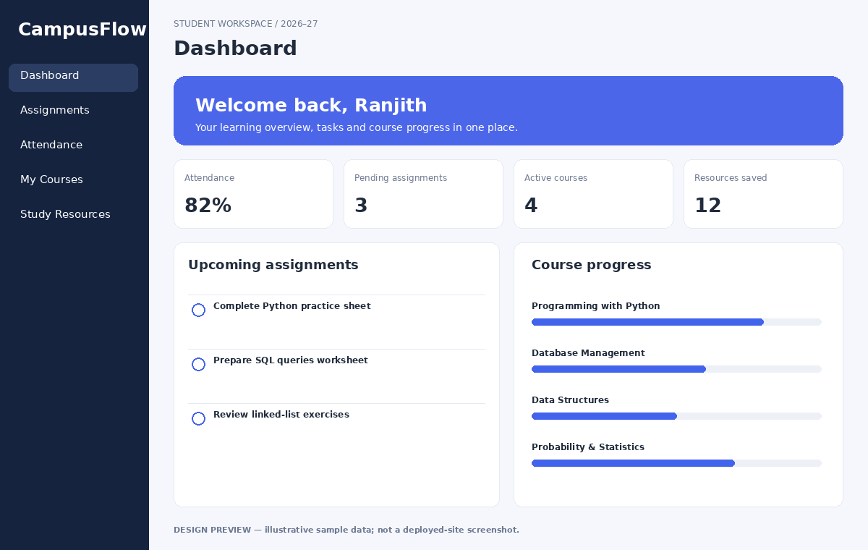
Figure 1. Dashboard design preview. Add screenshots of the actual application before submission.
SCREENSHOT TO ADD: Insert genuine screenshot(s) of the actual prompt/application here before submission.

6. Final Application
Application name: CampusFlow — AI-Assisted Student Portal.
Implemented prototype features: dashboard summary cards and course progress; navigation between five sections; assignment checkboxes that update completion status and pending count; add-assignment interaction; reminder form with a saved-message response; responsive layout; sample-data notice for attendance.
Application link: [Paste your real published website URL here after publishing and testing it.]
The supplied index.html is a locally runnable front-end prototype and is not yet hosted online. Do not submit a made-up URL. Publish it using a method allowed by your instructor, test the public URL, and then add it here. Submit the working link and final PDF through the Google Form attached to your class assignment, if that is the instructed process.

7. Conclusion
CampusFlow demonstrates how prompt engineering and AI-assisted development can help plan and create a simple web application for a student-focused problem. The prototype combines a dashboard, assignment tracking, illustrative attendance, course progress and study resources in one interface. Testing and prompt refinement help improve clarity and usability.
Future improvements could include secure sign-in, a database, real assignment deadlines, teacher-managed course data, official attendance integration, notifications and accessibility testing. These would require additional development and appropriate permission to use university data. The current prototype is a demonstration, not an official student information system.

