June 14, 2026
JOBTELLECT
An End-to-End Job Market Intelligence Analytics Project

Project Overview
By - Ranjith A R

Introduction
JOBTELLECT is an interactive Job Market Intelligence Dashboard designed to transform raw job posting data into actionable insights. The project analyzes hiring demand, required skills, salary trends, experience requirements, and geographic distribution of opportunities to provide a comprehensive view of the job market.
The dashboard enables users to explore market trends, identify in-demand skills, evaluate compensation patterns, and understand regional hiring dynamics through interactive visualizations and business intelligence techniques.

Project Objectives
• Analyze overall hiring trends and job market activity.
• Identify the most in-demand skills across industries.
• Understand salary patterns across experience levels and locations.
• Examine geographic distribution of employment opportunities.
• Support data-driven career planning and decision-making.
• Present complex job market data through intuitive visualizations.

Problem Statement
Job seekers often face challenges in understanding market demand, salary expectations, required skills, and regional opportunities. Large volumes of job posting data are available, but extracting meaningful insights from raw information can be difficult.
JOBTELLECT addresses this challenge by consolidating job market data into a unified analytics platform that enables users to quickly identify trends, opportunities, and key career insights.

Key Features
- Market Overview
- Skills Intelligence
- Salary Intelligence
- Location Intelligence
Tools and Technologies
- SQL
- Python
- Pandas
- NumPy
- Power BI
- Power Query
- DAX
- Data Visualization
- Business Intelligence

Analytics Workflow

- Data Acquisition
- Data Cleaning & Preprocessing using SQL and Python
- Exploratory Data Analysis
- KPI Identification
- Dashboard Design & Development
- Business Insight Generation
- Documentation & Presentation
Dataset Overview & Methodology
The dataset consists of job posting records containing information about companies, job roles, salary ranges, locations, work types, experience requirements, and skills. The data was analyzed to identify hiring trends, skill demand patterns, compensation insights, and geographic opportunity distribution.

Dataset Metrics
Total Job Postings: 123.85K+
Total Companies: 24.41K+
Total Locations: 8.5K+
Experience Levels: Multiple
Work Types: Multiple
Skills Categories: Multiple

Data Processing Workflow

Raw Dataset
↓
SQL Queries
↓
Python Processing
↓
Data Cleaning
↓
Exploratory Analysis
↓
Power BI Modelling
↓
Dashboard Development
Data Preparation Activities
• Cleaned missing and inconsistent values.
• Standardized categorical attributes.
• Processed location and salary information.
• Created calculated metrics and KPIs.
• Structured data for analytical reporting.

Dashboard Architecture
JOBTELLECT is organized into four analytical modules, each designed to address a specific aspect of the job market. Together, these modules provide a comprehensive view of hiring trends, skill requirements, salary patterns, and geographic opportunities.

Dashboard Modules
- Market Overview
Provides a high-level summary of hiring activity, job demand, work type distribution, and experience-level trends.

- Skills Intelligence
Analyzes the most demanded skills, skill relationships, and skill distribution across job opportunities.

- Salary Intelligence
Examines salary trends across locations, companies, and experience levels to identify compensation patterns.

- Location Intelligence
Explores geographic hiring demand, regional opportunity distribution, and location-based employment trends.

Key Dashboard Features
- Interactive Filters
- Dynamic KPIs
- Geospatial Analysis
- Skill Intelligence
- Salary Analytics
- Business Insights
- Cross-Page Navigation
- Responsive Visual Design

Market Overview Dashboard
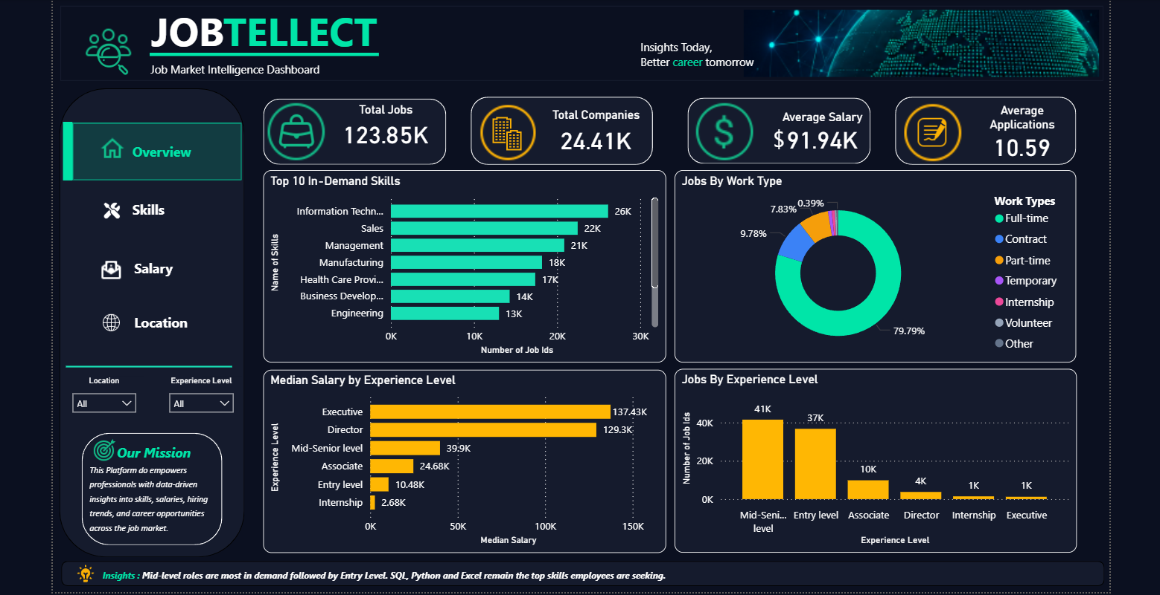
Content
The Market Overview dashboard provides a high-level summary of job market activity. It enables users to understand overall hiring demand, company participation, work-type distribution, experience-level requirements, and skill demand patterns through key performance indicators and interactive visualizations.

Key Performance Indicators (KPIs)
KPI | Description
Total Jobs | Total job opportunities available
Total Companies | Companies actively hiring
Most Demanded Skill | Highest requested skill
Most Demanded Experience Level | Most requested experience category

Major Visualizations
- Job Distribution by Work Type
Illustrates the proportion of Full-Time, Contract, Part-Time, Internship, and other employment categories.
- Experience Level Distribution
Shows hiring demand across Entry-Level, Associate, Mid-Senior, Director, and Executive roles.
- Top Skills Analysis
Highlights the most frequently requested skills in the job market.
- Market Trend Analysis
Provides a comparative view of hiring activity across key dimensions.

Key Insights
• Full-Time positions dominate the job market.
• Mid-Senior and Entry-Level roles account for a significant share of opportunities.
• Technical and analytical skills remain highly demanded.
• Hiring demand is distributed across a diverse range of industries and companies.

Business Value
The Overview dashboard serves as the entry point for users to quickly understand the overall employment landscape before exploring detailed skill, salary, and location insights.

Skills Intelligence Dashboard
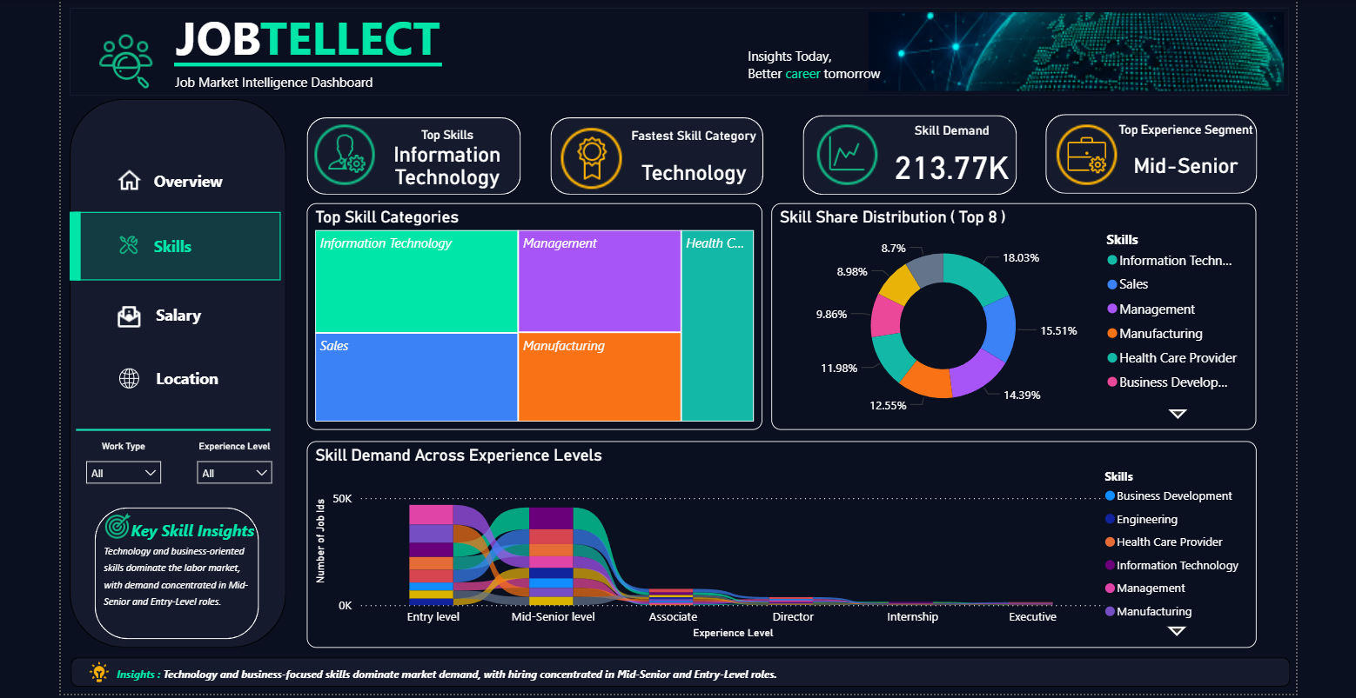
Content
The Skills Intelligence Dashboard focuses on identifying the most demanded skills, analyzing skill relationships, and understanding how skill requirements vary across job opportunities. The dashboard helps uncover market-driven skill trends and provides insights into the competencies most valued by employers.

Key Performance Indicators (KPIs)
KPI | Description
Total Skill | Unique skills identified
Top Skill | Most demanded skill
Skill Categories | Number of skill groups
Skill Demand | Total skill occurrences

Major Visualizations
- Top Skills Analysis
Highlights the most frequently requested skills across job postings and helps identify core competencies required by employers.
- Skill Distribution
Displays the relative contribution of different skills to overall hiring demand.
- Skill Relationship Analysis
Examines how skills are connected and frequently appear together within job requirements.
- Skill Category Insights
Provides a broader view of technical, analytical, and business-oriented skill demand.

Key Insights
• SQL and Python emerge as highly demanded skills across job opportunities.
• Technical and analytical competencies dominate hiring requirements.
• Certain skill combinations frequently appear together, indicating complementary expertise.
• Mid-Senior positions require a broader and more diverse skill set than Entry-Level roles.
• Employers increasingly seek candidates with a combination of technical, business-oriented capabilities.

Business Value
The Skills Intelligence Dashboard helps job seekers identify market-relevant competencies, prioritize learning paths, and align their skill development efforts with industry demand.

Salary Intelligence Dashboard
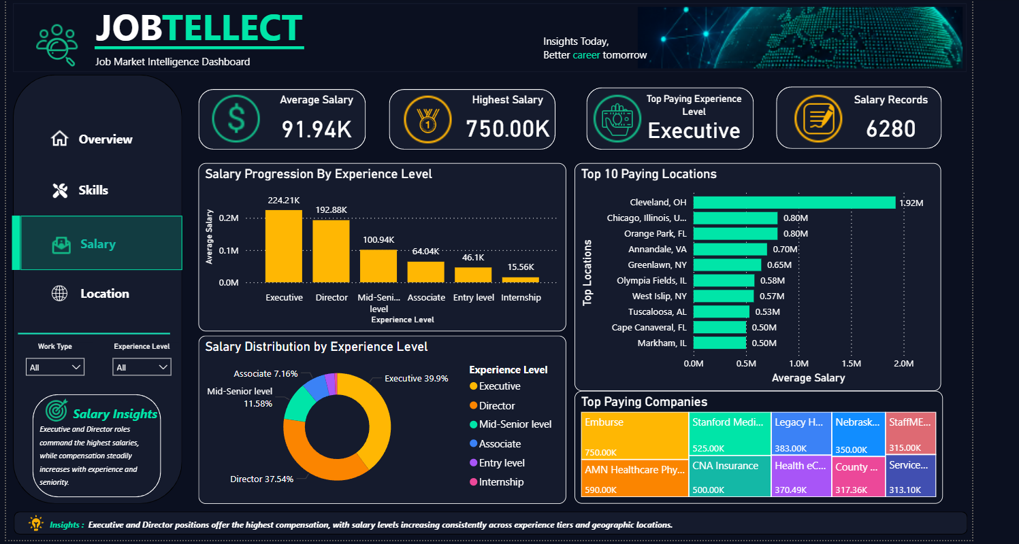
Content
The Salary Intelligence Dashboard analyzes compensation trends across experience levels, companies, and locations. It enables users to understand salary patterns, identify high-paying opportunities, and evaluate how compensation varies across different segments of the job market.

Key Performance Indicators (KPIs)
KPI | Description
Average Salary | Mean Compensation Level
Median Salary | Typical Compensation Value
Highest Paying Location | Location With Highest Salary
Highest Paying Company | Company Offering highest Compensation

Major Visualizations
- Salary Distribution Analysis
Provides an overview of salary variations across different job opportunities.
- Experience vs Salary Analysis
Examines how compensation changes with increasing experience levels.
- Location-Based Salary Analysis
Highlights salary differences across geographic regions.
- Company Compensation Analysis
Identifies organizations offering competitive salary packages.

Key Insights
• Executive and Director positions command the highest compensation levels.
• Salary generally increases with experience and responsibility.
• Significant salary variation exists across locations.
• Certain organizations consistently offer above-average compensation packages.
• Geographic location remains a major factor influencing salary outcomes.

Business Value
The Salary Intelligence Dashboard enables users to evaluate compensation trends, benchmark salary expectations, and identify high-value career opportunities based on market data.

Location Intelligence Dashboard
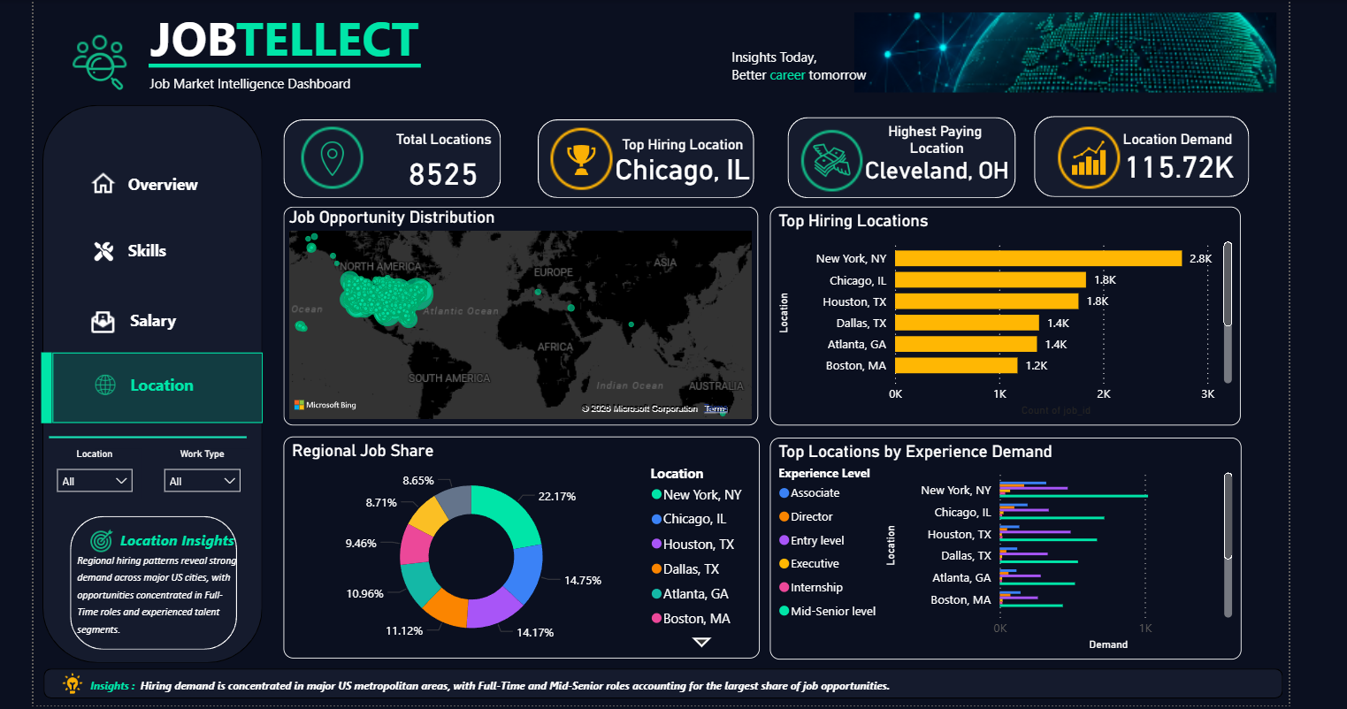
Content
The Location Intelligence Dashboard examines the geographic distribution of job opportunities and hiring demand. It provides insights into regional employment patterns, location-based opportunities, work-type distribution, and experience-level requirements across different areas.

Key Performance Indicators (KPIs)
KPI | Description
Total Locations | Unique Locations Identified
Top Hiring Location | Location with highest hiring demand
Highest Paying Location | Location offering highest compensation
Location Demand | Total job Opportunities across locations

Major Visualizations
- Geographic Opportunity Distribution
Visualizes the spatial distribution of job opportunities and hiring activity across locations.
- Top Hiring Locations
Highlights locations with the highest concentration of job opportunities.
- Regional Job Share Analysis
Shows the relative contribution of different locations to overall hiring demand.
- Experience Demand by Location
Examines how experience-level requirements vary across different regions.

Key Insights
• Hiring demand is concentrated in major metropolitan hubs.
• Regional differences significantly influence employment opportunities.
• Full-Time positions dominate hiring activity across most locations.
• Experience-level demand varies across regions and employment markets.
• Certain locations consistently demonstrate stronger hiring activity and salary potential.

Business Value
The Location Intelligence Dashboard helps users identify high-opportunity regions, understand geographic hiring trends, and make informed career decisions based on location-specific market conditions.

Challenges Faced
• Cleaning and transforming large datasets.
• Handling missing, blank, and inconsistent values.
• Designing meaningful KPIs aligned with business objectives.
• Selecting appropriate visualizations for different analytical requirements.
• Maintaining consistency across multiple dashboard pages.
• Optimizing dashboard layout, navigation, and user experience.
• Transforming raw data into actionable business insights.

Key Learnings
• Improved data analysis and business intelligence skills.
• Enhanced proficiency in SQL, Python, Power BI, Power Query, and DAX.
• Developed experience in KPI design and dashboard storytelling.
• Strengthened analytical thinking and problem-solving abilities.
• Learned to transform complex datasets into meaningful business insights.
• Improved project planning, documentation, and presentation skills.

Conclusion
JOBTELLECT successfully transforms raw job market data into meaningful insights through an end-to-end analytics approach. By integrating data analysis, visualization, and business intelligence techniques, the project provides a comprehensive understanding of hiring trends, skill demand, salary patterns, and geographic opportunities. The project demonstrates the practical application of analytics tools and methodologies to solve real-world problems and support data-driven decision making.

References
Dataset Source:
• Microsoft Power BI Documentation
• Python Documentation
• SQL Documentation

