
[Titre du document]
[Sous-titre du document]

[Date]
[Nom de la société]
[Adresse de la société]

Introduction

Hey ! I’m Ranjith APPASSAMY, a co-op student working as a Data Analyst.
As a student saving money is important. However with a less income it is sometimes difficult to manage money.
That’s why i created this projet in order to enter my daily expenses so that i can track them and have a analysis. This helped me to have a better understanding of my consumption. And suprisingly i tought i spend a lot on food, which is not the case at all !

This project is also a reflection of the skills i learnt over the years at college and companies.

Database model

The very first thing I did is to create a model for my future database which results to this :

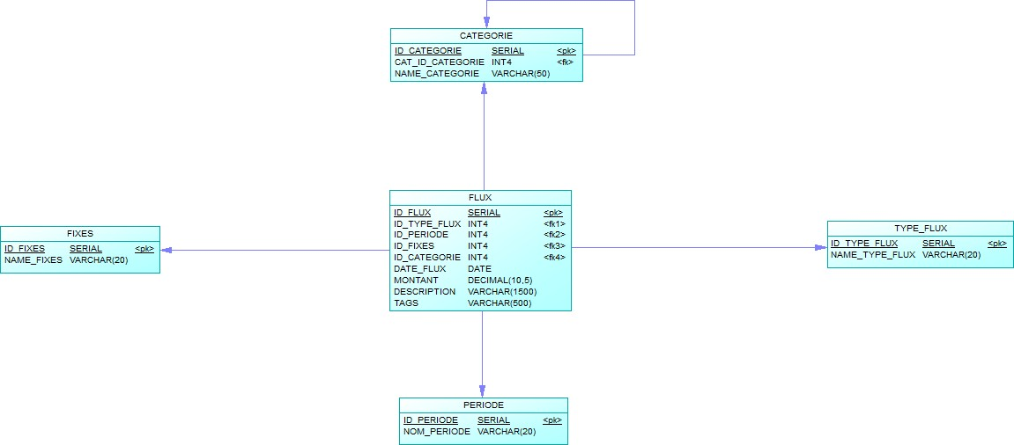

As you can see the model is quite simple. Let’s have a close look to every single table.

Table | Purpose | Example
Categorie | Let the expenses to have category. Related to it self, there are categories and sub categories | For instance, groceries is a category and meat is a sub category of it.
Fixes | Describe if the expense is fixed, variable or excepetionnal | For example groceries expenses often changes. However the house rent is usually fixed
Type_Flux | Describe wether it is a income, outcome or neutral | Salary is an income. Gas station expense is a outcome
Période | Describes the moment of the expenses | In my case college, work, holidays.
Flux | Main table related to the others, with additionnal information like the date, amount, description

Data

Identified data

I spent 2 months during summer, identifying things i often buy. Therefore i was able to give to each of them categories and sub categories.

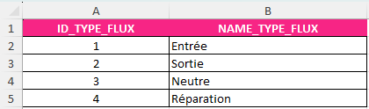
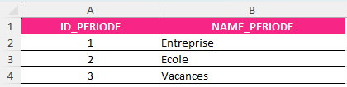
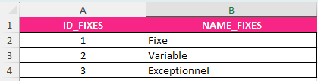
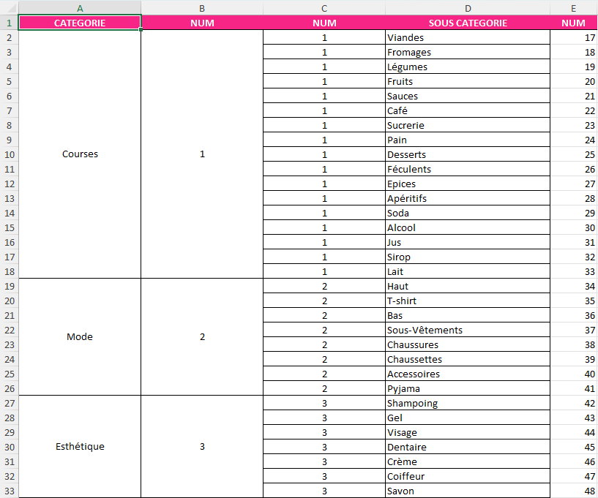

After, that i created manually data in an Excel file to give them and id. This are things that dont change often.
If in the future I identify a new information, I will fill this excel file and update the database.

Once satisified with the data, i created an SQL script that initialize the database and fill the database with the know data.
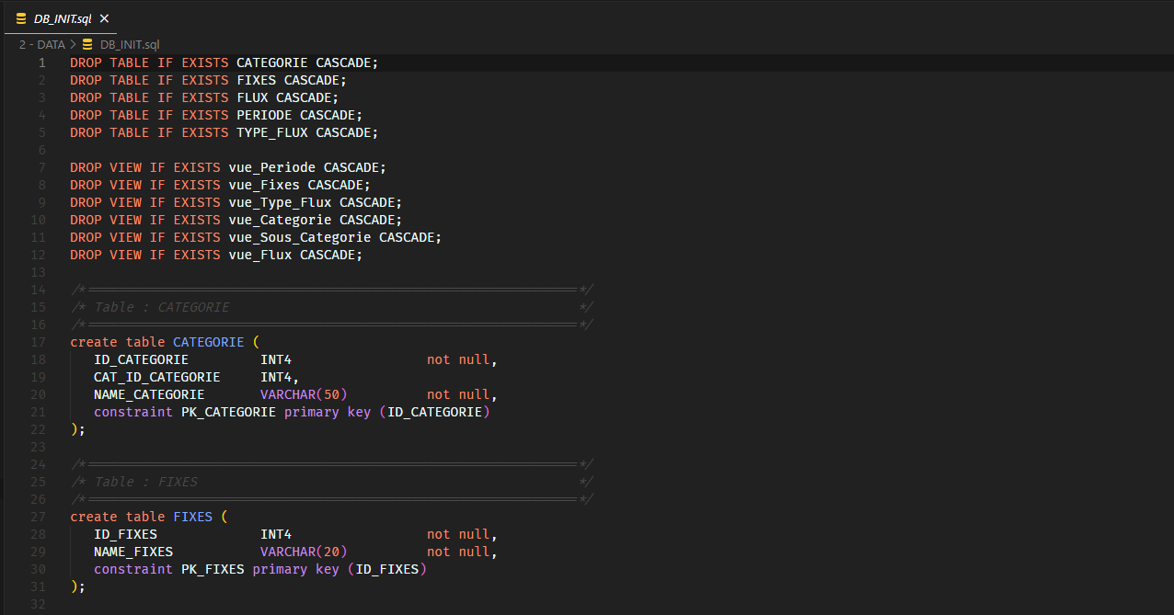
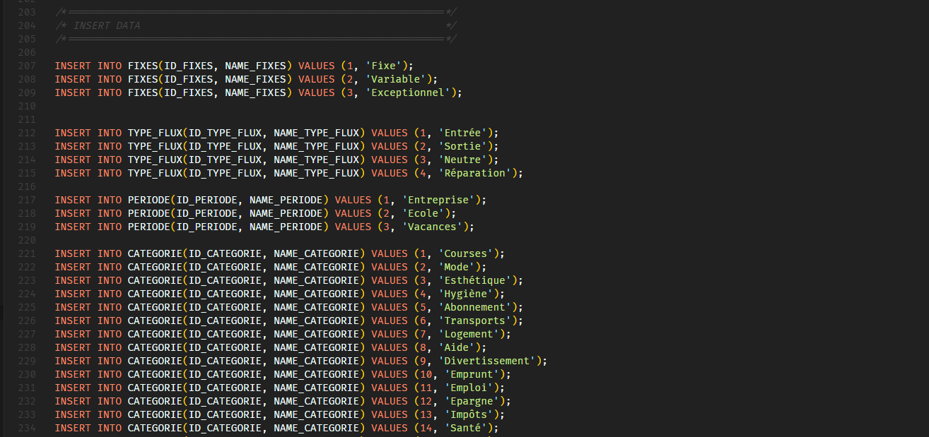

Daily data

Now coming to the core of the project : daily data. As i enter every single details, it is quite complicated to generate an SQL insert query. Therefore, I had to search an other way.

To solve this problem, i decide to create a simple Python GUI which is connected to the database.
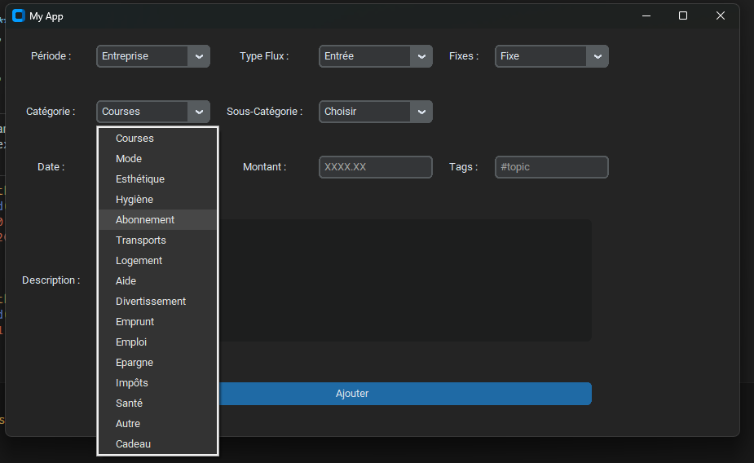

This GUI let me choose all the details. Once I click the blue button it automatically creates an SQL query an insert directly to the database.

Database

This let me insert the data in my database.
For the database, I went for local PostgreSQL database as it is free and open-source.

Create views

Now that I have the details, I can have a look to them by using queries. However using ID of each table is maybe efficient for storage but definetely not for the user.

So i created various views according to my needs.

View Name | Usage
Vue_Periode | Details about Periode table with custom field names
Vue_Fixes | Details about Fixes table with custom field names
Vue_Type_Flux | Details about Type_Flux table with custom field names
Vue_Categorie | To list all the parents categories with custom field names
Vue_Sous_Categorie | To list all the parents sub categories with custom field names
vue_Flux | To list all the expenses with custom field names. More readable thanks to the join with related tables
Vue_Flux_MAct | As the vue_flux but filtered on the current month

Raw data from the table FLUX :
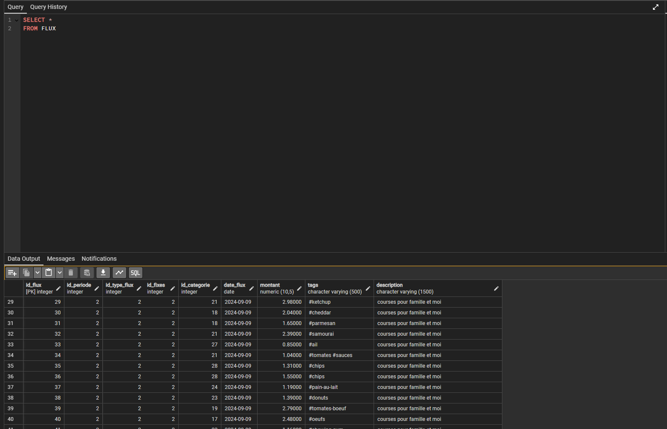

Same data in the view vue_Flux :
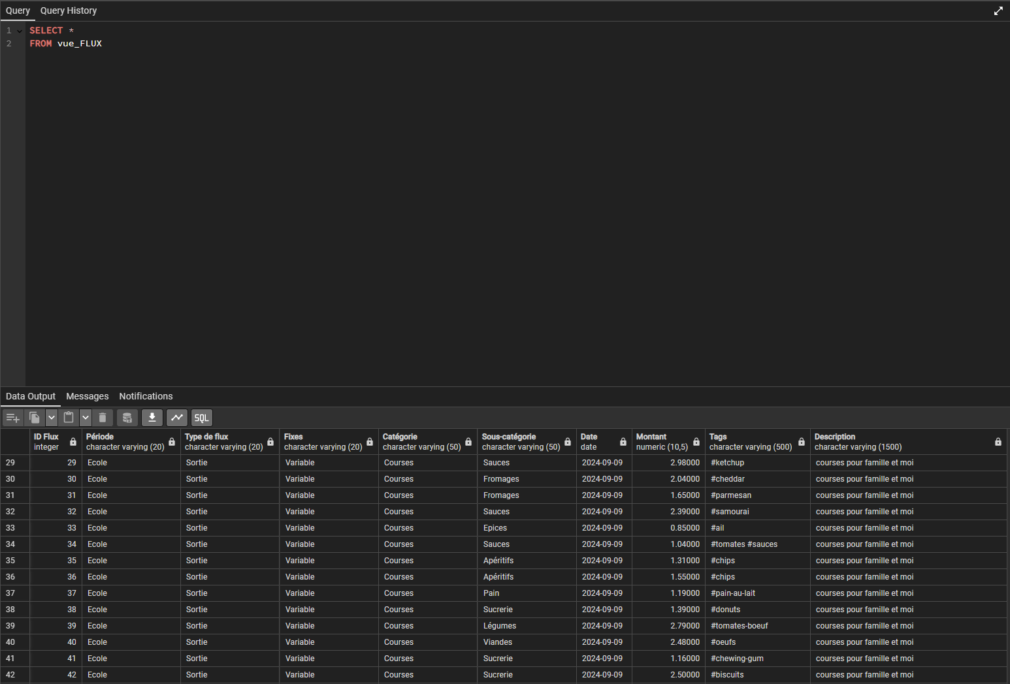

Procedures

It is always important to have a backup of your data. Imagine tomorrow PostgreSQL is not your SGBD and you need all the data from it.

Therefore i made a procedure that export all the data to csv files

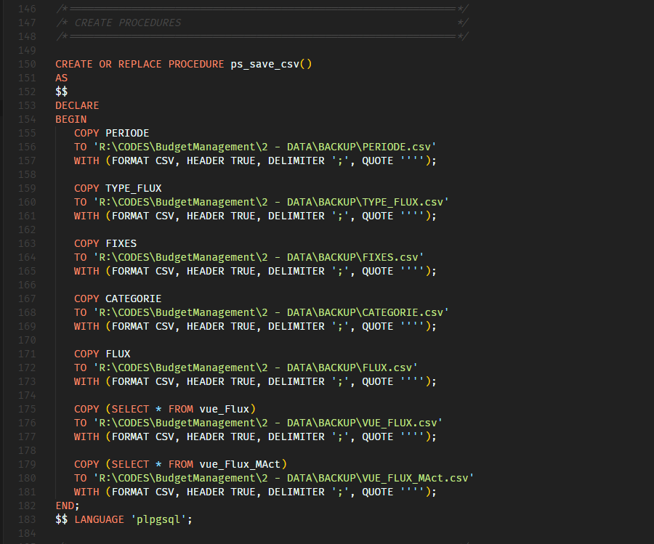

Functions

As i describe all the details, it is sometimes complicated to type the query for calculate the sum. Therefore i made a function that takes as paramters the date and a part of description.

Without the function :

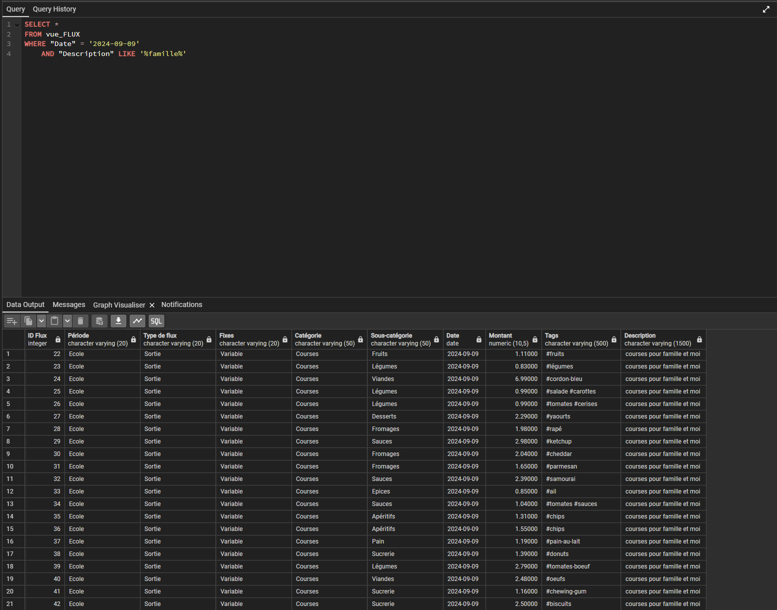
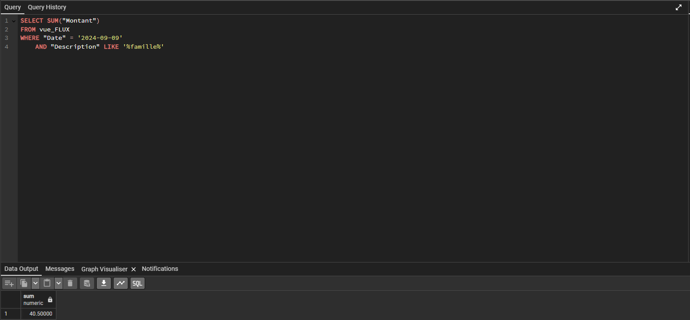

With the function :
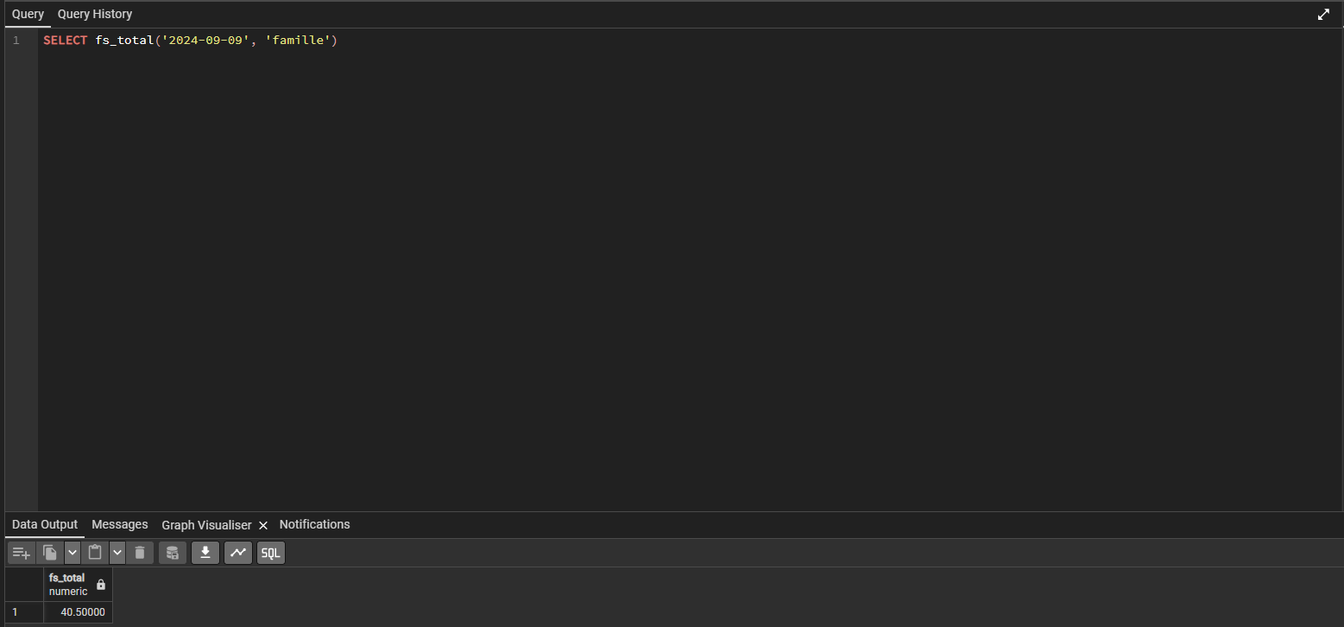
The output is the same, but the syntax is faster for daily use purpose.

Dashboard

