**1. Write code for a simple user registration form for an event.**

Step 1:

* Install Python from <http://python.org>
* Open powershell in windows
* Install Flask and MySQL with following commands
  + pip install flask
  + pip install flask-mysqldb

Step 2:

* Install xampp in windows
* Run xampp control panel then run apache and mysql
* Create database “mydb” in <http://localhost/phpmyadmin>
* Create a table

CREATE TABLE `user` (

`userid` int(11) NOT NULL,

`name` varchar(100) NOT NULL,

`email` varchar(100) NOT NULL,

`password` varchar(255) NOT NULL

) ENGINE=InnoDB DEFAULT CHARSET=utf8mb4;

ALTER TABLE `user`

ADD PRIMARY KEY (`userid`);

Step 3:

* Create a project (in powershell)

>md Register_Login

* Change to Project

>cd Register_Login

* Code . (it opens VS Code)

Step 4:

* Create app.py and write below code in the file
* Create templates folder under project
* Create register.html, login.html and user.html
* Write below code in respective fles
* Project Structure:

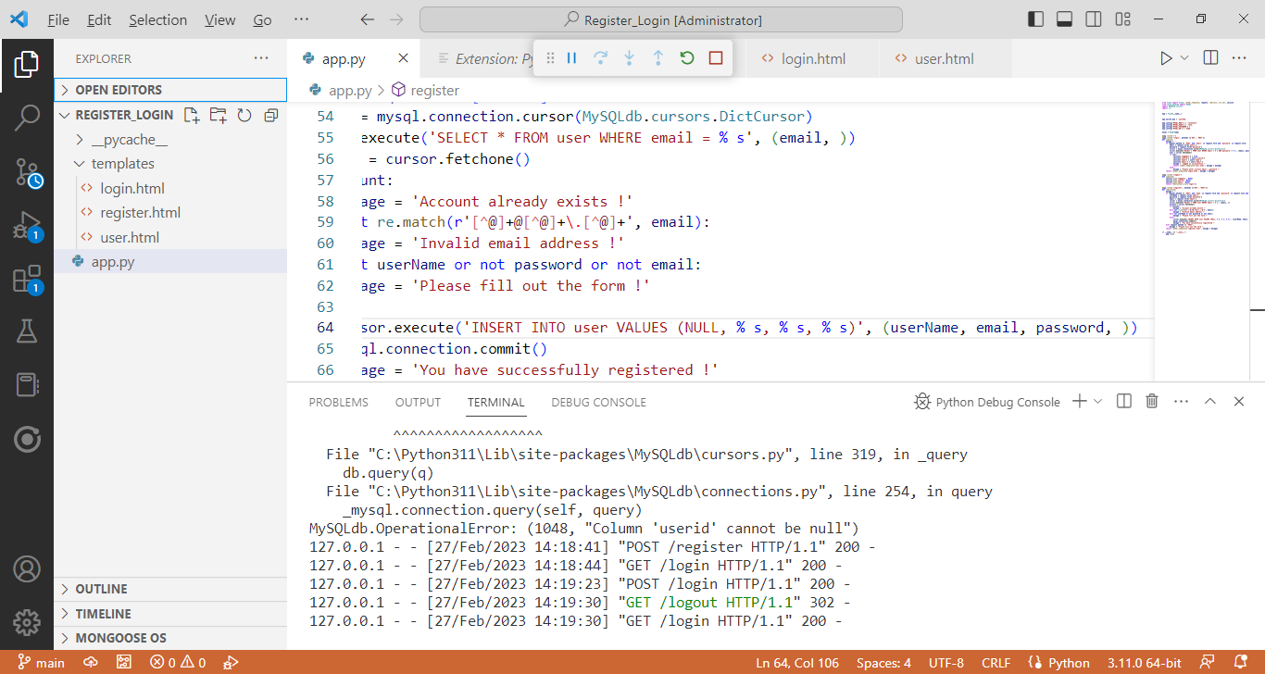

**app.py**

from flask import Flask, render_template, request, redirect, url_for, session

from flask_mysqldb import MySQL

import MySQLdb.cursors

import re

app = Flask(__name__)

app.secret_key = 'xyzsdfg'

app.config['MYSQL_HOST'] = 'localhost'

app.config['MYSQL_USER'] = 'root'

app.config['MYSQL_PASSWORD'] = ''

app.config['MYSQL_DB'] = 'mydb'

mysql = MySQL(app)

@app.route('/')

@app.route('/login', methods =['GET', 'POST'])

def login():

mesage = ''

if request.method == 'POST' and 'email' in request.form and 'password' in request.form:

email = request.form['email']

password = request.form['password']

cursor = mysql.connection.cursor(MySQLdb.cursors.DictCursor)

cursor.execute('SELECT * FROM user WHERE email = % s AND password = % s', (email, password, ))

user = cursor.fetchone()

if user:

session['loggedin'] = True

session['userid'] = user['userid']

session['name'] = user['name']

session['email'] = user['email']

mesage = 'Logged in successfully !'

return render_template('user.html', mesage = mesage)

else:

mesage = 'Please enter correct email / password !'

return render_template('login.html', mesage = mesage)

@app.route('/logout')

def logout():

session.pop('loggedin', None)

session.pop('userid', None)

session.pop('email', None)

return redirect(url_for('login'))

@app.route('/register', methods =['GET', 'POST'])

def register():

mesage = ''

if request.method == 'POST' and 'name' in request.form and 'password' in request.form and 'email' in request.form :

userName = request.form['name']

password = request.form['password']

email = request.form['email']

cursor = mysql.connection.cursor(MySQLdb.cursors.DictCursor)

cursor.execute('SELECT * FROM user WHERE email = % s', (email, ))

account = cursor.fetchone()

if account:

mesage = 'Account already exists !'

elif not re.match(r'[^@]+@[^@]+\.[^@]+', email):

mesage = 'Invalid email address !'

elif not userName or not password or not email:

mesage = 'Please fill out the form !'

else:

cursor.execute('INSERT INTO user VALUES (NULL, % s, % s, % s)', (userName, email, password, ))

mysql.connection.commit()

mesage = 'You have successfully registered !'

elif request.method == 'POST':

mesage = 'Please fill out the form !'

return render_template('register.html', mesage = mesage)

if __name__ == "__main__":

app.run()

**login.html:**

<html>

<head>

<meta charset="utf-8">

<meta name="viewport" content="width=device-width, initial-scale=1">

<title>User Login Form</title>

<link rel="stylesheet" href="https://cdn.jsdelivr.net/npm/bootstrap@4.6.1/dist/css/bootstrap.min.css">

</head>

<body>

<div class="container">

<h2>User Login</h2>

<form action="{{ url_for('login') }}" method="post">

{% if mesage is defined and mesage %}

<div class="alert alert-warning">{{ mesage }}</div>

{% endif %}

<div class="form-group">

<label for="email">Email:</label>

<input type="email" class="form-control" id="email" name="email" placeholder="Enter email" name="email">

</div>

<div class="form-group">

<label for="pwd">Password:</label>

<input type="password" class="form-control" id="password" name="password" placeholder="Enter password" name="pswd">

</div>

<button type="submit" class="btn btn-primary">Login</button>

<p class="bottom">Dont't have an account? <a class="bottom" href="{{url_for('register')}}"> Register here</a></p>

</form>

</div>

</body>

</html>

**rgister.html:**

<html>

<head>

<meta charset="utf-8">

<meta name="viewport" content="width=device-width, initial-scale=1">

<title>User Registeration Form</title>

<link rel="stylesheet" href="https://cdn.jsdelivr.net/npm/bootstrap@4.6.1/dist/css/bootstrap.min.css">

</head>

<body>

<div class="container">

<h2>User Registration</h2>

<form action="{{ url_for('register') }}" method="post">

{% if mesage is defined and mesage %}

<div class="alert alert-warning">{{ mesage }}</div>

{% endif %}

<div class="form-group">

<label for="name">Name:</label>

<input type="text" class="form-control" id="name" name="name" placeholder="Enter name" name="name">

</div>

<div class="form-group">

<label for="email">Email:</label>

<input type="email" class="form-control" id="email" name="email" placeholder="Enter email" name="email">

</div>

<div class="form-group">

<label for="pwd">Password:</label>

<input type="password" class="form-control" id="password" name="password" placeholder="Enter password" name="pswd">

</div>

<button type="submit" class="btn btn-primary">Register</button>

<p class="bottom">Already have an account? <a class="bottom" href="{{url_for('login')}}"> Login here</a></p>

</form>

</div>

</body>

</html>

**user.html:**

<html>

<head>

<meta charset="utf-8">

<meta name="viewport" content="width=device-width, initial-scale=1">

<title>User Account</title>

<link rel="stylesheet" href="https://cdn.jsdelivr.net/npm/bootstrap@4.6.1/dist/css/bootstrap.min.css">

</head>

<body>

<div class="container">

<div class="row">

<h1>User Profile</h1>

</div>

<br>

<div class="row">

Logged in : <strong>{{session.name}} | <a href="{{ url_for('logout') }}"> Logout</a>

</div>

<br><br>

<div class="row">

<h2>Welcome to the user profile page...</h2>

</div>

</div>

</body>

</html>

Step5:

* Select app.py then run it.
* Open <http://127.0.0.1:5000/> in browser

**Output:**

