Tensorflow

The core open source library to help you develop and train ML models.

TensorFlow is an end-to-end open source platform for machine learning. It has a comprehensive, flexible ecosystem of tools, libraries and community resources that lets researchers push the state-of-the-art in ML and developers easily build and deploy ML powered applications.

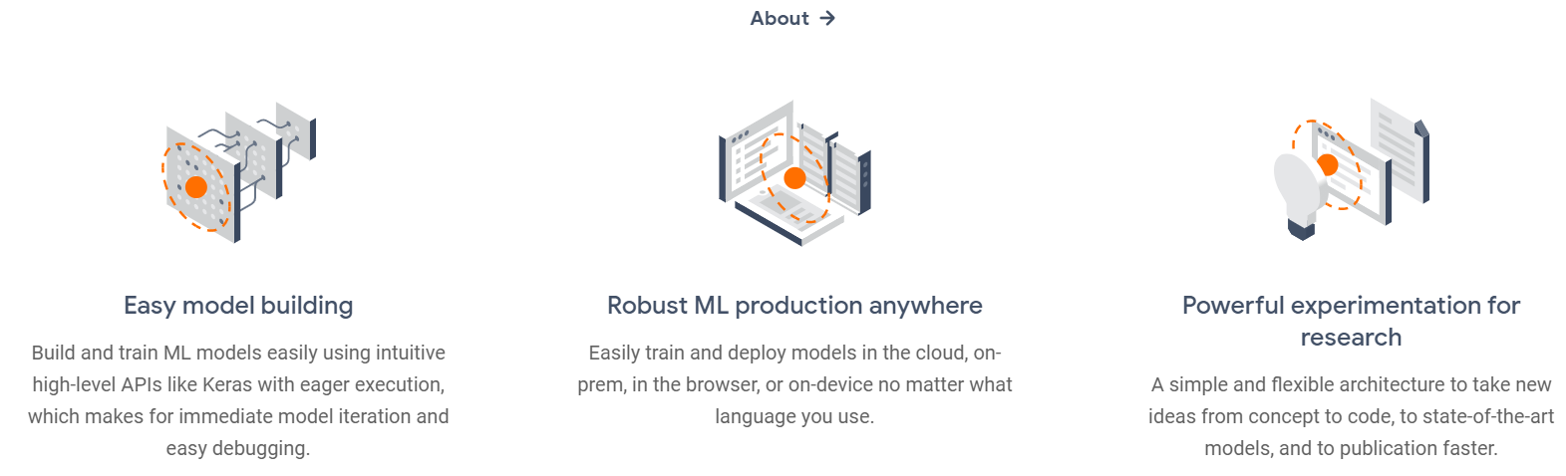

Deploy anywhere.

Take advantage of the full deployment capabilities of the TensorFlow platform. You can export Keras models to JavaScript to run directly in the browser, to TF Lite to run on iOS, Android, and embedded devices. It's also easy to serve Keras models as via a web API.

## When to use a Sequential model

A Sequential model is appropriate for **a plain stack of layers** where each layer has **exactly one input tensor and one output tensor**.

A Sequential model is **not appropriate** when:

* Your model has multiple inputs or multiple outputs
* Any of your layers has multiple inputs or multiple outputs
* You need to do layer sharing
* You want non-linear topology (e.g. a residual connection, a multi-branch model)

KERAS--Edureka

**Keras** is a neural network library while **TensorFlow** is the open-source library for a number of various tasks in machine learning. **TensorFlow** provides both high-level and low-level APIs while **Keras** provides only high-level APIs. ... Both frameworks thus provide high-level APIs for building and training models with ease.

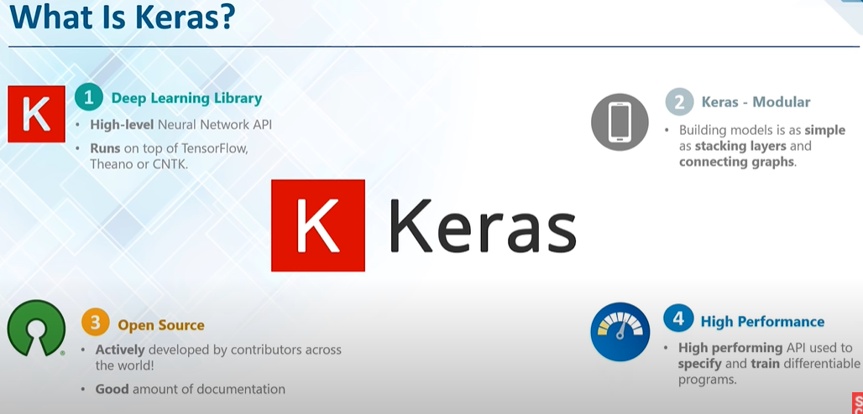

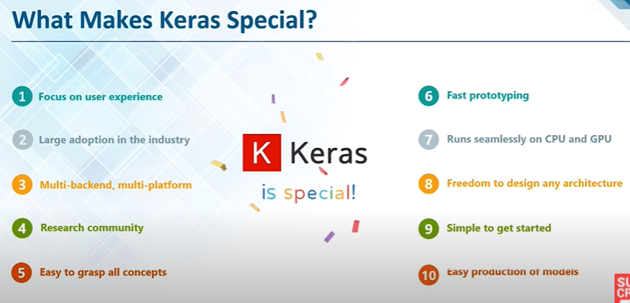

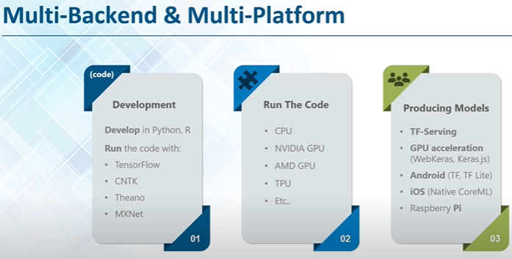

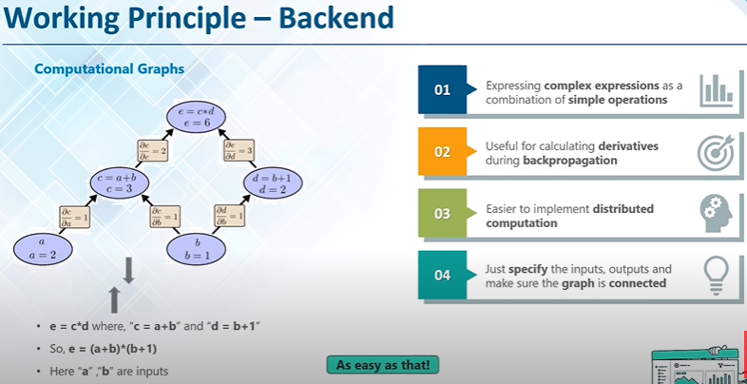

Model.fit() 🡪 to train the network built using sequential() function.

