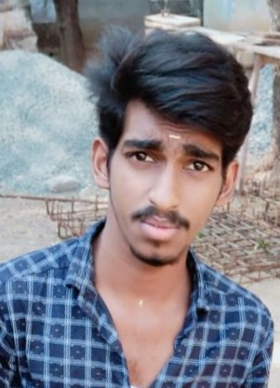

**Phone:**

+91 6380958311

**Email:**

[kumarranjith50677@gmail.com](mailto:kumarranjith50677@gmail.com)

**GitHub:** <https://github.com/ranjith50677>

**Linked in:**

**Address:**

290/30a Alangiyam Road - Metro City

Dharapuram Tirupur-638657

**Education**

**SSLC**

**NCP** municipality higher secondary school dharapuram.

* From 2016
* 62%

**B.SC computer science**

RVS College of Arts and Science - Coimbatore

* From 2018 to 2021
* 71%

**HSC**

**NCP** municipality higher secondary school dharapuram.

* From 2018
* 58%

I seek challenging opportunities where I can fully use my skills for the success of the organization

**Career Objective**

**Languages**

**English:**

R W S

**Tamil:**

R W S

**Declaration:**

I hereby declare that the information furnished above is true to the best of my knowledge.

RANJITHKUMAR K

**Skills:**

**RANJITHKUMAR K**