Machine learning classification
Task-1

Objective :
The objective of the project is to build and evaluate a Machine Learning Classification model using the iris dataset. The project aims to classify iris flowers into different species based on their features and compare the performance of classification algorithm.
Dataset Description:
The iris dataset is one of the most popular datasets used in machine learning. It contains 150 samples of iris flowers with four features: sepal length, sepal width, petal length and petal width. The dataset consists of three flower species: Setos, versicolor, and virginica.
Data preprocessing:
The dataset was loaded using the scikit-learn library. The input features and target variables were separated. The data was prepared for model training and testing. Proper preprocessing was performed to ensure the dataset was ready for classification.
Train-Test Split:
The dataset was divided into training and testing sets using an 80:20 ratio. The training data was used to train the
Machine learning models , while the testing data was used to evaluate their performance.
Algorithms used:
Logistic regression: logistic regression is a supervised machine learning algorithm used for classification tasks. It predicts the probability of a data sample belonging to a specific class.
Random forest Classifier: Random forest is an ensemble learning algorithm that combines multiple decision trees to improve prediction accuracy and reduce overfitting.
Model evaluation:
The models were evaluated using the following performance metrices:
- Accuracy
- Precision
- Recall
- F1 score
- Cross validation score
These metrices were used to compare the performance of the classification models.
Results:
The following screenshots shows the outputs and results obtained from the Machine Learning Classification project.
Dataset Loaded Successfully :
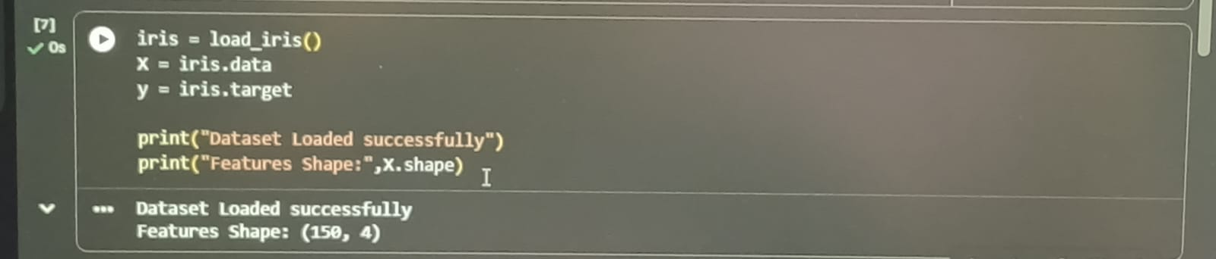
Accuracy comparison:
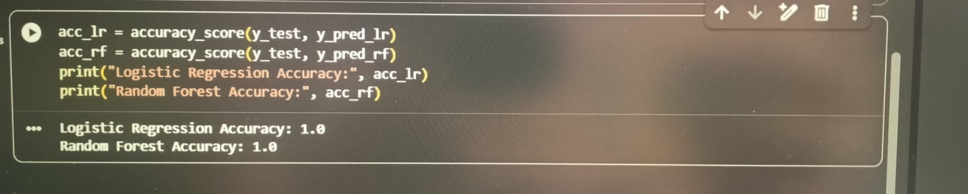
Precision, Recall and F1 Score: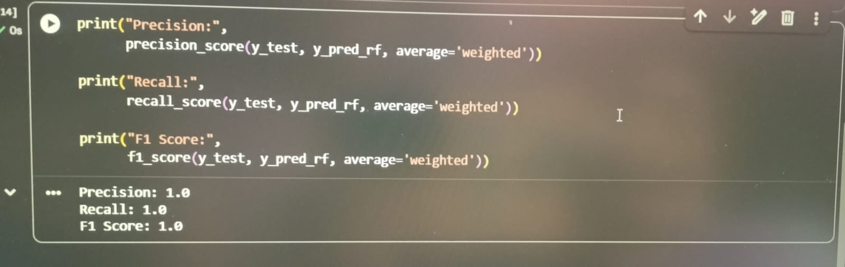
Cross validation score:


Model comparison Graph:
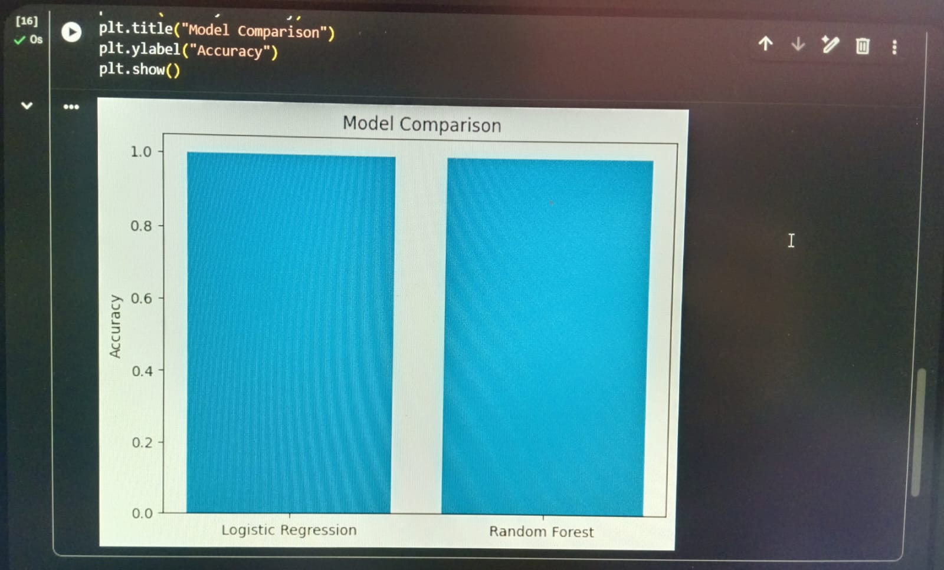
Conclusion:
The Machine Learning Classification project was successfully implemented using the Iris dataset. Logistic Regression and Random Forest algorithms were trained and evaluated. Based on the performance metrics, Random Forest achieved better classification accuracy and overall performance. The project demonstrates how machine learning algorithms can be used effectively for classification tasks.

