RANJITH B  JAVA BACKEND DEVELOPER | SPRING BOOT & SQL  +91 8148017881 | ranjithb2k06@gmail.com | Coimbatore, Tamil Nadu  LinkedIn: linkedin.com/in/ranjith-b-csbs | GitHub: github.com/ranjithbrs  Portfolio: ranjithbrs.github.io/portfolio | 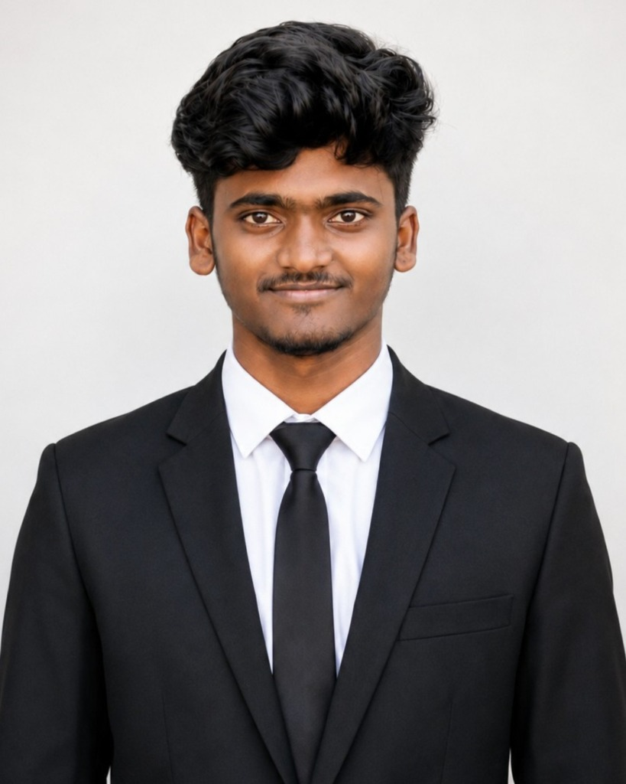
PROFESSIONAL SUMMARY
Aspiring Java Backend Developer and CSBS student with strong fundamentals in Core Java, Spring Boot, Spring Data JPA, and relational databases (MySQL). Hands-on experience developing RESTful APIs, database schemas, user authentication modules with BCrypt, and containerizing web services with Docker. Passionate about writing clean, maintainable, and reliable backend code.
TECHNICAL SKILLS
Core Java: Java 21 / 17, Object-Oriented Programming (OOP), Collections Framework, Exception Handling, File I/O
Backend Frameworks: Spring Boot 3, Spring Data JPA, Hibernate ORM, RESTful API Development, Spring Security (Basic)
Databases & SQL: MySQL, Relational Schema Design, SQL Queries (CRUD, JOINs, Indexing), Database Relationships (1:N, N:M)
Tools & Environment: Git, GitHub, Postman (API Testing), Maven, Docker (Basics), VS Code, Linux Basics
Core Concepts: Data Structures & Algorithms, MVC Architecture, REST API Design, BCrypt Password Encryption
WORK EXPERIENCE
Cybersecurity Intern (Network & Protocol Inspection) - NoviTech R&D Private Limited Coimbatore | 1 Month
Technologies & Tools: Wireshark, Packet Inspection, HTTP/TCP Analysis, Network Basics
- Monitored client-server network traffic using Wireshark, inspecting HTTP request headers and payload structures.
- Assisted in reviewing API endpoint security to understand protection against unauthorized requests and data tampering.
- Gained practical knowledge of transport layer security (TLS/SSL) and secure client-server communication.
FEATURED PROJECTS
Online Examination System - Web Assessment Backend - Java / Spring Boot Developer 2024
Tech Stack: Java 21, Spring Boot 3, Spring Data JPA, MySQL, Docker, HTML/CSS
- Developed a web-based examination platform using Spring Boot and MySQL for managing question banks, student attempts, and scoring.
- Implemented basic exam integrity monitoring that detects tab switching and browser blur events to notify administrators.
- Secured user credentials using BCrypt password hashing and containerized the backend application using Docker.
Centralized PHC Doctor Attendance Monitoring System - Backend Developer 2024
Tech Stack: Java, Spring Boot 3, MySQL (Railway), RESTful APIs
- Built a backend service to track medical officer check-in and attendance across Primary Health Centers (PHCs).
- Implemented GPS coordinate validation using the Haversine formula in Java to verify that doctors are near their assigned clinic during check-in.
- Created RESTful endpoints with Spring Data JPA for fetching attendance history and generating daily administrative reports.
Secure User Authentication & Session Module - Java Developer 2024
Tech Stack: Java, Servlets/JSP, JDBC, MySQL, HTML5/CSS3
- Engineered a complete user registration and login module using parameterized SQL queries to prevent SQL injection.
- Implemented session tracking and role-based page redirection (Admin vs Student/User).
- Tested all endpoints and response codes (200, 400, 401, 500) systematically using Postman.
EDUCATION
B.Tech in Computer Science & Business Systems (CSBS) - Nehru Institute of Engineering & Technology, Coimbatore 2023 - 2027 (Expected)
Anna University | Cumulative Grade Point Average (CGPA): 8.3 / 10.0
Higher Secondary Certificate (12th Grade - State Board) - Government Higher Secondary School, Marungapuri 2022 - 2023
Academic Score: 79.0%
Secondary School Leaving Certificate (10th Grade - State Board) - Government High School, T.Idaiyappatti 2020 - 2021
Status: Pass (First Class)
CERTIFICATIONS
- HackerRank Certified: Java (Basic)
- AWS Cloud Foundations - AWS Academy
- Introduction to Internet of Things (IoT) - IIT Bombay (NPTEL)
- Business Analyst Certification - Celonis
- AI & Machine Learning Certification - Google for Developers

