curecast
Strength prediction and low-clinker mix optimisation for concrete
Project overview
Ranjith Guggilla
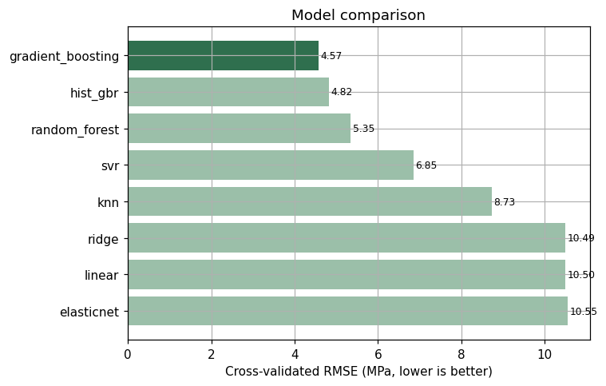

One-Line Summary
curecast predicts the compressive strength of a concrete mix from its recipe and then finds the lowest-carbon recipe that still meets a strength target, cutting embodied CO2 by roughly 61% on a worked 40 MPa example while holding within the range of mixes the model was actually trained on.

What the Project Is About
Concrete is the most-used building material on earth, and the cement inside it carries most of its carbon. Producing cement accounts for somewhere around 8% of global CO2 emissions, most of it from the clinker in ordinary Portland cement. Concrete producers can replace part of that cement with industrial by-products such as blast-furnace slag and fly ash, which cost less and carry a fraction of the carbon, but only up to the point where strength starts to suffer. curecast learns the strength-versus-recipe relationship from real laboratory data and turns it into a decision tool: type in a mix and get an instant strength estimate with reasons, or name a strength target and get the greenest mix that reaches it.

Problem Statement
Mix design today leans on codified tables, prior experience, and trial batches. Strength does not move linearly with any single ingredient, so finding the cheapest, lowest-carbon recipe that still clears a target by hand is slow and conservative. Producers over-specify cement to be safe, which wastes money on every load and locks in avoidable carbon. The core question is simple to state and hard to answer without data: for a given strength requirement and curing age, how little cement can I use, and how much of the binder can I swap for slag and fly ash, before the mix stops meeting spec?

Solution Overview
curecast has two halves that share one trained model. The first is a strength predictor: a gradient-boosting regression pipeline that estimates compressive strength in megapascals from the eight standard mix inputs and curing age, and explains each estimate in language a technologist recognises. The second is a carbon-aware optimiser that searches over binder content, the slag-and-fly-ash fraction of that binder, and the water-to-binder ratio, scoring every candidate with the trained model and returning the design with the least embodied carbon that clears the target. A small web app puts both in front of a non-technical user.

How the System Works, Step by Step
- Load 1,030 real laboratory mixes and validate every column against a physical envelope, failing loudly on anything implausible rather than training on it.
- Engineer six ratio features that materials engineers already use — water-to-binder, total binder, the slag-and-ash fraction of the binder, and others — each computed from a single row so nothing leaks across the train and test split.
- Compare eight candidate models with 5-fold cross-validation, from a plain linear baseline up to gradient boosting, and pick the winner on cross-validated error.
- Refit the winner on the full training split and measure it once on a held-out set of 206 mixes it never saw.
- For a strength target, search the recipe space, score each candidate with the trained model, discard anything outside the trained-data envelope, and keep the lowest-carbon design that meets the target.
- Report the chosen mix with its predicted strength, embodied carbon, cost, and the saving against a conventional high-clinker mix.

What Happens in the Background
The strength model is a single scikit-learn pipeline, so preprocessing is refit on every cross-validation fold and never sees held-out rows. Feature scaling lives inside the pipeline for the linear and distance-based models and is skipped for the tree ensembles that do not need it. Because the feature engineering is part of the pipeline, the exact same maths runs when the served model scores a recipe a user typed in, which removes a common source of train-serve drift. The optimiser wraps the model in a constrained grid search and enforces the training envelope on water, binder, and cement so it can never recommend a mix the model has only extrapolated to. Carbon and cost come from a single table of published, order-of-magnitude factors, so every money and CO2 figure traces back to one place a reviewer can audit.

Backend and Tools Used
The project is pure Python with a scikit-learn core. Data handling is pandas and numpy; the model zoo, pipelines, cross-validation, and permutation importance are scikit-learn; statistical correlations in the exploratory pass use pingouin; charts use matplotlib with yellowbrick for regression diagnostics; the trained pipeline is serialised with joblib; and the interface is Gradio. Quality is held by a pytest suite and ruff linting, both wired into a GitHub Actions workflow that also trains the model and uploads it as a build artifact on the main branch.

Business Insights
- Clinker is the lever. Cement and curing age dominate strength, so the biggest carbon savings come from replacing cement with slag and fly ash while giving the mix time to cure, not from tinkering with aggregates.
- On a worked 40 MPa target, the optimiser reaches 44.46 MPa with 60.8% less embodied carbon and 17.1% lower material cost than a conventional all-cement mix of the same target.
- That carbon gap is 276.3 kg CO2e per cubic metre. On a mid-size pour of 1,000 cubic metres it is about 276 tonnes of CO2e, comparable to taking roughly 60 petrol cars off the road for a year.
- The tool is conservative by design. It keeps a safety margin above the target and refuses to recommend recipes outside the data it learned from, so its suggestions are ones an engineer can take to a trial batch rather than a spreadsheet fantasy.

Tech Stack With Versions
Component | Library | Version
Language | Python | 3.10+
Data handling | pandas / numpy | 2.3.3 / 2.2.6
Modelling | scikit-learn | 1.7.2
Statistics | pingouin / scipy | 0.6.1 / 1.15.3
Visualisation | matplotlib / yellowbrick / seaborn | 3.10.9 / 1.5 / 0.13.2
Serialisation | joblib | 1.6.0
Interface | gradio | 6.26.0
Quality | pytest / ruff | 8.x / 0.9.x

My Role
I designed and built the project end to end: framing the decarbonisation problem, sourcing and validating the dataset, engineering the features, comparing and selecting the model, building the carbon-aware optimiser, writing the test suite and CI, and packaging the whole thing behind a usable interface with a documented, reproducible training run.

Core Contributions
- A leak-free scikit-learn pipeline with domain feature engineering that reaches an R2 of 0.933 on held-out data.
- An honest eight-model comparison that lets the simplest model compete and reports a naive baseline as the floor.
- A carbon-aware mix optimiser constrained to the training envelope, which is what makes its recommendations trustworthy.
- Plain-language reason codes so every strength estimate comes with a why, not just a number.
- A tested, linted, CI-backed codebase with a one-command training run and a Gradio front end.

Outputs Achieved
- A serialised strength model plus a metrics file that regenerates every figure quoted here.
- Six diagnostic charts covering the data, the model comparison, held-out accuracy, residuals, and feature importance.
- A two-tab web app: score a mix, or optimise for a target.
- A 27-test suite and clean lint, both green, with a publish script that stands up the public repository in one step.

Key Results and Impact
Every number below comes from a single held-out test split of 206 mixes that no model saw during training, regenerated automatically on each run.

Model Comparison
Model | CV R2 | CV RMSE (MPa) | CV MAE (MPa)
gradient_boosting | 0.926 | 4.57 | 3.08
hist_gbr | 0.918 | 4.82 | 2.99
random_forest | 0.899 | 5.35 | 3.69
svr | 0.835 | 6.85 | 4.81
knn | 0.732 | 8.73 | 6.32
ridge | 0.613 | 10.49 | 8.24
linear | 0.612 | 10.50 | 8.24
elasticnet | 0.608 | 10.55 | 8.31
Cross-validated RMSE by model. Gradient boosting leads; the linear baseline is kept in the race on purpose.

Held-Out Performance
Metric | Gradient boosting | Mean-only baseline
R2 | 0.933 | -0.000
RMSE (MPa) | 4.14 | 16.05
MAE (MPa) | 2.89 | 13.05
A typical prediction lands within about 2.9 MPa of the real value, across a strength range from 2.33 to 82.6 MPa. Predicting the average every time gives an RMSE of 16.1 MPa, so the model removes roughly three-quarters of the error a naive guess would carry.
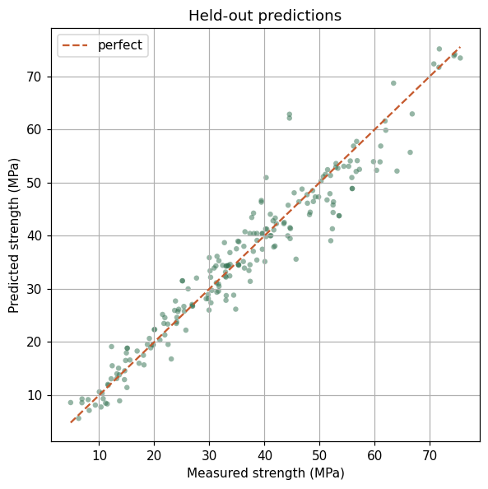
Held-out predictions against measured strength.

What Drives Strength
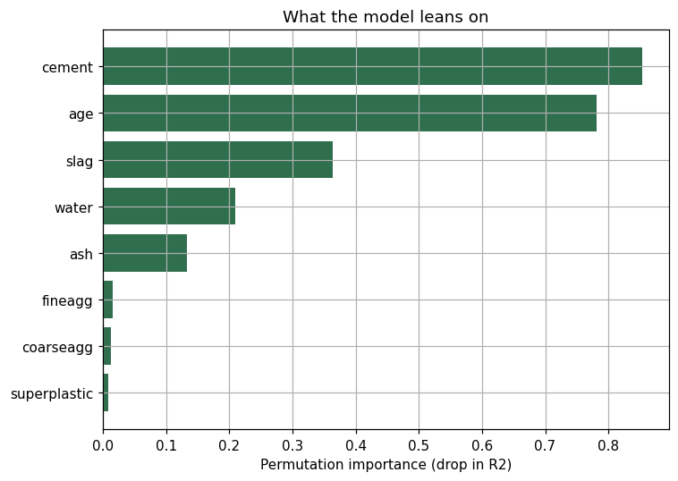
Permutation importance on the held-out split. Cement and curing age dominate.

The Carbon Case
 | High-clinker baseline | curecast mix
Cement (kg/m3) | 480 | 160
Slag + fly ash (kg/m3) | 0 | 240
Predicted strength (MPa) | — | 44.5
Embodied carbon (kg CO2e/m3) | 454.6 | 178.3
Material cost ($/m3) | 103.0 | 85.4
A 60.8% cut in embodied carbon and a 17.1% cut in material cost, on a mix predicted to clear the 40 MPa target with margin. The carbon and price factors behind these figures are published, order-of-magnitude industry values held in one configuration file, so the percentages are the headline and the absolute dollars are directional.

Closing Line
curecast turns a hard, conservative mix-design decision into a fast, defensible one, and in doing so points at real carbon and cost sitting inside every cubic metre of concrete poured.

