demoscout
Project overview: screening new music releases from their audio profile

One-line summary
A release screener that predicts how popular a new track will be, with an honest range and a hit probability, validated only on artists it has never seen.

What the project is about
Labels and playlist teams receive far more new releases than they can promote. demoscout takes what is known on release day, which is the audio profile, the genre and the release date, and turns it into an expected popularity score, an 80% range, the chance of reaching a hit threshold, the closest comparable tracks and a few plain-language reasons. It is built on 28,352 tracks by 10,692 artists from the public Spotify songs dataset.

Problem statement
A new track has no listening history, and often comes from an artist with none either. Any model that quietly uses artist history, or that is tested on random rows, will look much better than it will behave in that situation. The business question is narrower and harder: given only release-day information, which tracks deserve a promotion budget, and how sure can anyone be?

Solution overview
- Split by artist, so no artist appears in more than one of train, validation and test.
- Fit six range models and four hit models, and let the simplest one within one standard error of the best ship.
- Report intervals from whole-artist resampling, so the uncertainty reflects how tracks cluster by artist.
- Price the shortlist under stated cost assumptions and show how the answer moves when they change.
- Wrap the winning models in a scoring function and a small web app.

How the system works, step by step
- Download the csv and remove rows without an artist or a usable release date. Collapse repeat rows, since a track appears once per playlist it sits on (32,833 raw rows become 28,352 tracks).
- Hash each artist name into train (17,079 tracks), validation (5,346) or test (5,927).
- Fit every candidate on the training artists. Choose on validation by pinball loss for the range and log loss for the hit probability.
- Score the chosen models once on the test artists and resample artists to get intervals.
- Run the audits: four split protocols, an artist-history check, feature ablations, permutation importance and genre and era breakdowns.
- Benchmark nearest-neighbour indexes for the similar-track lookup and price the shortlist.
- Refit the winners on train plus validation and save the bundle the app loads.

What happens in the background
Scaling and one-hot genre encoding live inside each model, so nothing is learned from held-out rows. The spread of the Gaussian-style models is estimated from out-of-fold residuals on the training rows. The shipped range model is three boosted models trained with pinball loss at the 10th, 50th and 90th percentiles, sorted row by row so quantiles never cross. The hit probability comes from a separate boosted classifier. When a release is scored, one feature at a time is swapped to the typical value to see how far the median moves, and a kd-tree over the standardised audio features returns the five closest tracks in the catalogue.

Backend and tools used
Everything runs in Python as a command line pipeline (demoscout run) that writes metrics.json, ten tables and five charts, plus a saved bundle. A Gradio app reads the bundle. CI lints with ruff and runs pytest on every push, and on the main branch it also retrains and uploads the model and metrics as an artifact.

Business insights
- Audio alone is a weak signal (skill 0.071 over predicting the mean). Release year and genre add most of the rest, and part of the release-year effect is a data-collection snapshot, so the product has to be sold as a screen, not an oracle.
- A small shortlist is where it pays. At the assumed $2,500 cost and $10,000 value per hit, break-even precision is 25%, and the shortlist reaches 31.3% on unseen artists.
- Artist history is the easy way to look good and the wrong thing to rely on for debut releases. With it, a random split improves; on unseen artists it makes the model worse.
- The economics are fragile. At $7,500 per hit the screen loses money at the same cost, which is why the sensitivity grid ships with the results.

Tech stack with versions
component | version
Python | 3.13
pandas | 2.3.3
numpy | 2.5.3
SciPy | 1.18.1
scikit-learn | 1.9.1
NGBoost | 0.5.11
properscoring | 0.1
hnswlib | 0.8.0
pynndescent | 0.7.0
matplotlib | 3.11.2
joblib | 1.6.0
Gradio | 6.31.0
pytest / pytest-cov | 9.1.1 / 7.1.0
ruff | 0.17.3

My role
I designed, built, tested and documented the project on my own, from choosing the dataset and the validation scheme to the economics, the app and the CI setup.

Core contributions
- Artist-disjoint validation with artist-level bootstrap intervals throughout.
- A probabilistic model comparison on pinball loss, CRPS and interval score, with a pre-set one-standard-error rule.
- A leakage audit that quantifies what repeat rows and artist history add.
- A benchmark of exact and approximate nearest-neighbour search, written up honestly where brute force wins.
- A shortlist cost model with stated assumptions and a sensitivity grid.
- A tested scoring function behind the Gradio app, with plain-language reasons.

Outputs achieved
- A published-ready repository with 35 passing tests (96% coverage) and clean lint.
- A saved screener bundle and a web app that returns a range, a hit probability, reasons and comparable tracks.
- Ten result tables, a metrics file and five charts, all produced by one command in about 100 seconds.

Key results and impact
Range models on the test artists (pinball is averaged over the 10th, 50th and 90th percentiles; lower is better):
model | RMSE | pinball | 80% coverage | interval width
mean only | 23.4 | 5.877 | 0.746 | 61.1
genre mean | 22.9 | 5.721 | 0.754 | 59.8
ridge | 22.3 | 5.583 | 0.772 | 58.1
boosting, constant spread | 21.2 | 5.280 | 0.784 | 54.6
boosting, quantile models (shipped) | 21.6 | 5.133 | 0.774 | 56.9
NGBoost, Normal head | 21.3 | 5.241 | 0.754 | 51.7
The shipped model lowers pinball by 0.7442 against the mean (95% interval 0.6526 to 0.8297) and by 0.4507 against ridge (0.3704 to 0.5136).
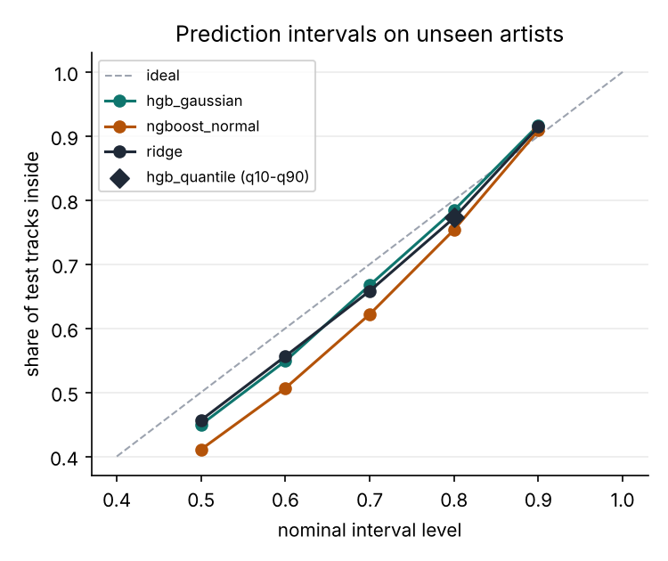
Hit screen on the test artists:
model | AUC | log loss | ECE
base rate | 0.500 | 0.4212 | 0.0076
genre only | 0.648 | 0.4005 | 0.0147
logistic | 0.722 | 0.3805 | 0.0121
boosted classifier (shipped) | 0.770 | 0.3603 | 0.0107
NGBoost tail | 0.766 | 0.3655 | 0.0288
The shipped classifier has AUC 0.7703 (95% interval 0.7488 to 0.7898).
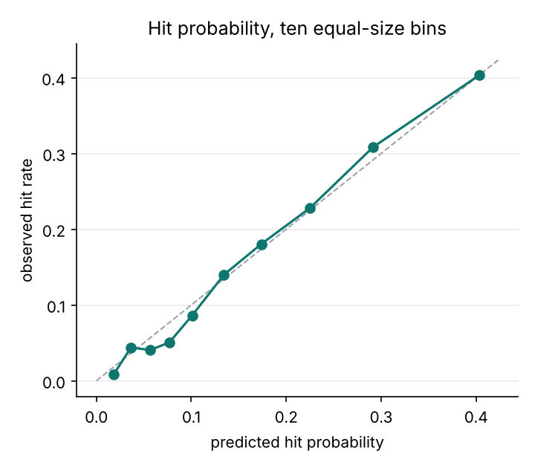
The same boosted model under four ways of cutting the data. Skill is the share of mean-only squared error removed:
protocol | test rows | RMSE | skill
random rows, repeats kept | 6,547 | 22.1 | 0.224
random rows, repeats removed | 5,662 | 21.5 | 0.184
artist-disjoint | 5,927 | 21.2 | 0.184
forward in time | 5,976 | 19.7 | 0.176
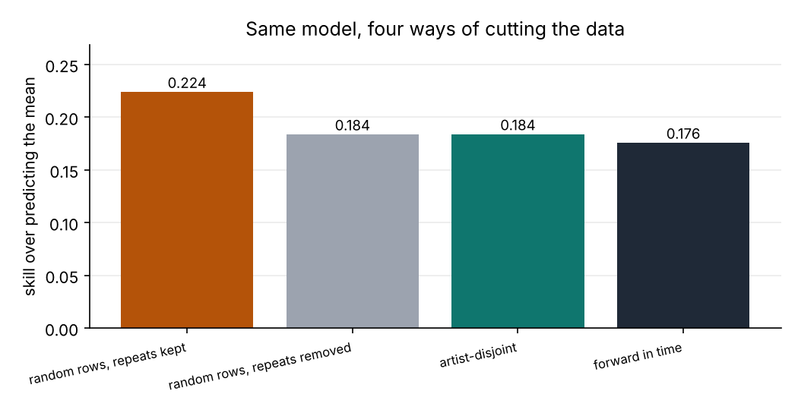
Value of a 30% shortlist per 1,000 releases, assuming $2,500 per promoted release and $10,000 per hit (both are assumptions, not data):
policy | hit share of list | net per 1,000 | 95% interval
shipped hit screen | 31.3% | $189,809 | $87,349 to $290,455
genre hit rate only | 23.1% | -$58,208 | -$170,214 to $50,035
random shortlist | 14.9% | -$302,851 | -$374,616 to -$236,679
hindsight | n/a | $739,835 | n/a
The model beats the genre-only rule by $248,018 per 1,000 releases ($167,168 to $325,745).
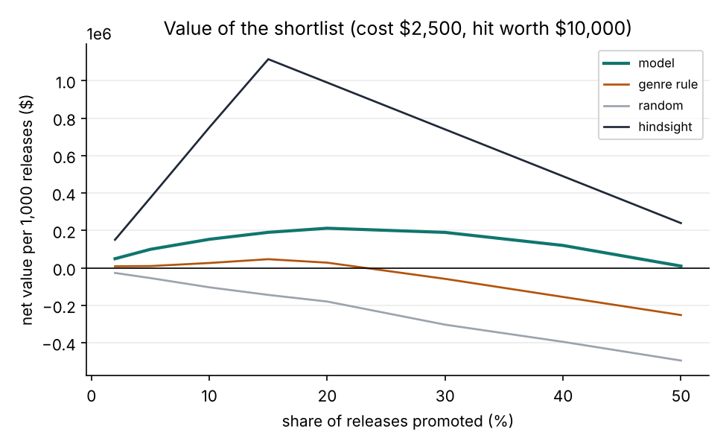
Similar-track search over 17,079 tracks and 3,000 queries. Brute force is exact and fast enough at this size; the approximate indexes only pay off at much larger catalogues. Timings come from a two-core machine.
index | build (s) | queries per second | recall@10
brute force | 0.001 | 29,289 | 1.0000
kd-tree | 0.024 | 9,642 | 0.9987
hnsw (ef=16) | 1.762 | 119,687 | 0.9882
hnsw (ef=64) | 1.712 | 31,209 | 0.9985
hnsw (ef=256) | 1.845 | 9,620 | 0.9987
nn-descent | 24.657 | 161,641 | 0.9397
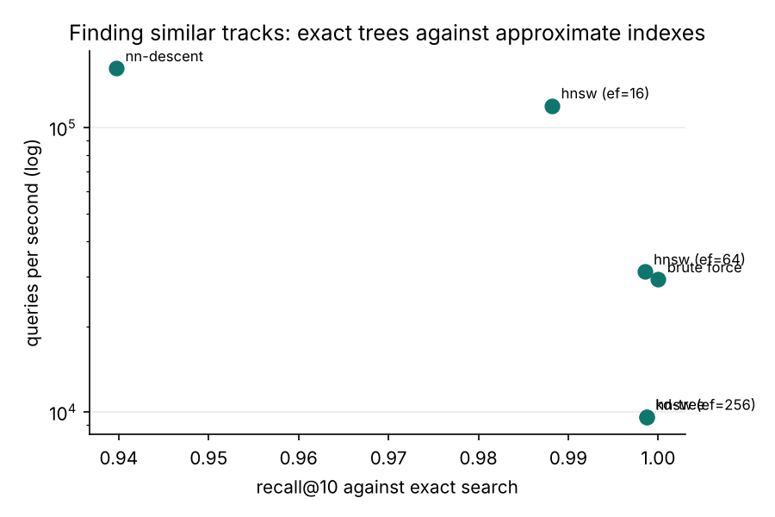

Closing line
The model is a modest but real screen, and the main thing the project demonstrates is how to measure it honestly for the case it is meant for: a release from an artist nobody has data on yet.

