dryspot
Project overview: ranking water points by the chance they are dry on the next visit
Ranjith Guggilla

One-line summary
A model that ranks 438,538 African water points by the chance they will have no water on the next visit, checked on map areas it never saw, so a field team that can visit one point in ten finds a dry one 70% of the time instead of 24%.

What the project is about
Water points such as boreholes, hand pumps and protected springs are surveyed and logged by governments and charities, and each record says whether water was available on the day of the visit. Roughly one in four was not. The records are an unusually large public view of how rural water infrastructure actually behaves, and they are rarely used to decide where a maintenance team should go next.
dryspot turns that record into a visit list. It learns from past surveys which kinds of water points tend to be found dry, scores every point on a list, and tells the team which ones to see first. Most of the work went into making sure the claimed accuracy is the accuracy a team would actually get in a new area.

Problem statement
A maintenance team has a fixed number of visits and a list of thousands of water points. Visiting at random finds a dry point about 24% of the time. Sending people to the countries and districts with the worst averages helps a little. The question is whether a point-level ranking can do clearly better, and how much better in places the model has not been trained on.
The second half of that question is where many such projects go wrong. Water points cluster in space and were often surveyed in campaigns, so a model scored on randomly held-out rows can look excellent while it mostly recognises neighbours of points it has already seen. That score says little about a new district.

Solution overview
The solution has four parts.
- A cleaning step that keeps only labelled visits, removes duplicates and impossible coordinates, and blanks impossible install years.
- A set of seven candidate models, from a country-average baseline to gradient boosting with location, compared under four different ways of holding data out: random rows, whole map blocks, whole countries and later survey years.
- A selection rule that picks the simplest model that cannot be told apart from the best on held-out map blocks, then checks calibration, conformal prediction sets and the cost per fault found.
- A scoring layer: a command line tool, a web app with a single-point checker, and a list ranker that draws a map and explains each score in plain language.

How the system works, step by step
- The Water Point Data Exchange extract is downloaded once (58 MB) and loaded.
- Rows with an unknown status are dropped, exact duplicates removed, implausible coordinates flagged against each country's typical location, and impossible install years blanked.
- Each point is assigned to an h3 hexagon about 60 km across (a map block) and a finer cell, used for splitting and for resampling.
- Features are built from the raw columns: country, water source, technology and a pump-family grouping, facility class, a free-or-fee reading of the payment text, a cleaned installer name, coordinates, install year and age at the time of the survey.
- Seven pipelines are trained and scored under each of the four hold-out regimes. Every preprocessing step sits inside the pipeline, so nothing is learned from held-out rows.
- The simplest model whose gap to the best is statistically indistinguishable from zero is chosen on the map-block results.
- Calibration, conformal prediction sets, a grouped importance measure and the visit-budget comparison are computed from held-out predictions.
- The chosen model is refit on all rows and saved with a background sample used to explain individual scores.
- A list of water points goes in; a ranked list with a risk, a band, a visit-first flag and plain-language reasons comes out.

What happens in the background
Several details matter more than they look.
- Whole-map-block splits use h3 cells as groups, so every point in a block is either entirely in training or entirely held out. A check in the tests confirms that random splits share cells between train and test while block splits almost never do.
- The neighbour dry-rate feature is computed with a k-d tree on unit-sphere coordinates. When the model is fitted, each training row is scored from its neighbours with itself removed, so the feature means the same thing at fit time and at prediction time.
- Confidence intervals resample map cells, not rows, because points in one cell are not independent. Model comparisons use the same resamples for both models, which is what makes small gaps measurable.
- The free-text status field is excluded. A text model on it alone reaches an AUC of 0.991 because it restates the visit result, which nobody has before a visit.
- The survey year and month are excluded from the shipped model. They help slightly on random splits, partly because they identify which team ran a campaign.

Backend and tools used
The code is a Python package with a command line entry point. Data handling uses pandas and pyarrow. Models are scikit-learn pipelines, with histogram gradient boosting for the main candidates. Spatial blocks come from h3, nearest-neighbour lookups from SciPy's k-d tree, conformal prediction sets from crepes, charts from matplotlib, maps from folium and the interface from Gradio. Tests run with pytest and linting with ruff, both wired into a GitHub Actions workflow that also trains a subsampled model on pushes to the main branch and uploads it as an artifact.

Business insights
- A ranked visit list is worth roughly double a country-average rule. At a 10% visit budget the model finds a dry point on 69.9% of visits, against 35.5% for the country average and 24.0% at random.
- At the stated cost of $35 a visit, finding one fault costs about $50 with the model, $98 with the country average and $146 at random. Per 1,000 faults found, that is $48,407 saved against the country average and $96,018 against random visits.
- Technician time follows the same pattern. At six visits a day, 100 faults take 23.8 technician-days with the ranking, 46.9 with the country average and 69.6 at random.
- The ranking is least reliable where it is needed for expansion. For a country absent from the training data the AUC falls to about 0.57 to 0.64. A new country needs local surveys before the scores can be trusted.
- Points where users pay are dry 13.2% of the time against 30.4% for free ones. That is a useful screening signal and a prompt to look at how maintenance is funded, though the data cannot show which causes which.
All cost figures are assumptions: $35 per visit and six visits per technician-day. They count the visit that confirms and logs a fault, not the repair. Both are settings in the configuration file.

Tech stack with versions
Component | Version | Used for
Python | 3.13 | language, 3.11 and later supported
pandas | 3.0.5 | data cleaning and tabular work
NumPy | 2.5.3 | arrays and bootstrap code
scikit-learn | 1.9.1 | pipelines, logistic regression, gradient boosting, metrics
SciPy | 1.18.1 | k-d tree for neighbour lookups
h3 | 4.5.0 | map blocks and cells for validation
crepes | 0.9.1 | Mondrian conformal classification
matplotlib | 3.11.2 | charts
folium | 0.20.0 | interactive risk map
Gradio | 6.30.0 | web app
pyarrow | 26.0.0 | parquet output
pytest and pytest-cov | 9.1.1, 7.1.0 | tests and coverage
ruff | 0.17.0 | linting and formatting

My role
I did the whole project on my own: choosing the problem, finding and checking the data, designing the validation, writing the code and tests, running the study, and writing the documentation and this overview.

Core contributions
- A validation design that reports the same models under random, spatial, country and forward-in-time hold-outs, with intervals that resample map cells.
- A neighbour-rate transformer that never sees a row's own label, plus the evidence that it overstates skill on random splits.
- A model selection rule based on paired cell-level bootstrap gaps, which led to dropping survey timing at almost no cost.
- A leakage audit of the free-text status field.
- Calibration and conformal checks fitted on held-out blocks, with the failures reported.
- A visit-budget comparison in dollars and technician-days with the assumptions stated.
- A command line tool and web app that rank any list of water points and explain each score.

Outputs achieved
- A trained, saved model and a metrics file holding every number quoted here.
- Six charts: validation regimes, country hold-out, importance, calibration, hit rate by visit budget and a map of dry shares.
- A command line (download, train, score, app) and a Gradio app with a single-point checker and a list ranker that draws a map and returns a downloadable csv.
- 75 tests at 95% line coverage, and a clean lint run.
- A GitHub Actions workflow that lints, tests on two Python versions, and trains a subsampled model on the main branch.

Key results and impact

The headline
On held-out map blocks the shipped model reaches a ROC AUC of 0.809 (95% interval 0.800 to 0.817). With a 10% visit budget:
Strategy | Visits that find a dry point | Cost per fault | Tech-days per 100 faults
Random visits | 24.0% | $146 | 69.6
Country average only | 35.5% (33.7% to 37.5%) | $98 | 46.9
dryspot ranking | 69.9% (67.6% to 72.5%) | $50 | 23.8
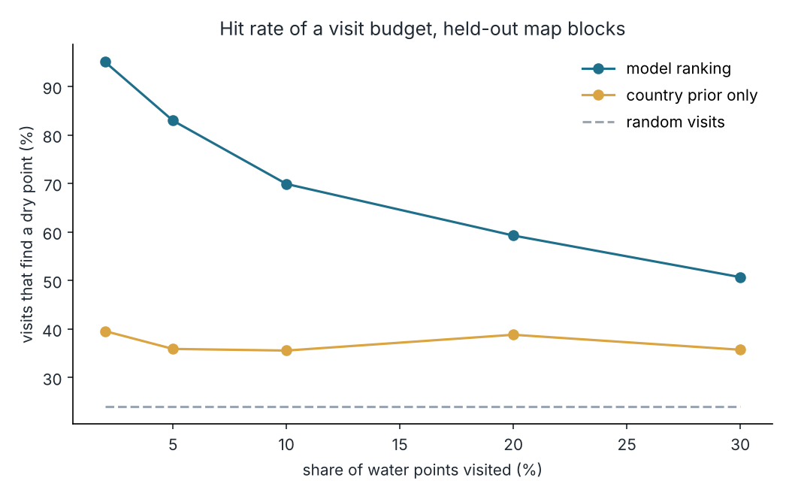
Hit rate of a visit budget on held-out map blocks.

The same models, four ways of testing them
Model (ROC AUC) | Random rows | Map blocks | Whole countries | Later surveys
Country average | 0.652 | 0.624 | 0.453 | 0.529
Logistic regression | 0.754 | 0.736 | 0.536 | 0.674
Boosted, attributes only | 0.837 | 0.790 | 0.641 | 0.639
Boosted, location, no survey timing (shipped) | 0.859 | 0.809 | 0.565 | 0.711
Boosted, location, no survey year | 0.860 | 0.807 | 0.566 | 0.718
Boosted, location and timing | 0.863 | 0.811 | 0.638 | 0.715
Boosted, location and neighbour dry rate | 0.876 | 0.788 | 0.605 | 0.668

Scoring on random rows flatters the neighbour-based model by about 0.09 AUC against what it achieves on unseen map blocks. Location helps inside surveyed regions and hurts across borders: with a whole country held out, the attributes-only model beats every model that uses coordinates.
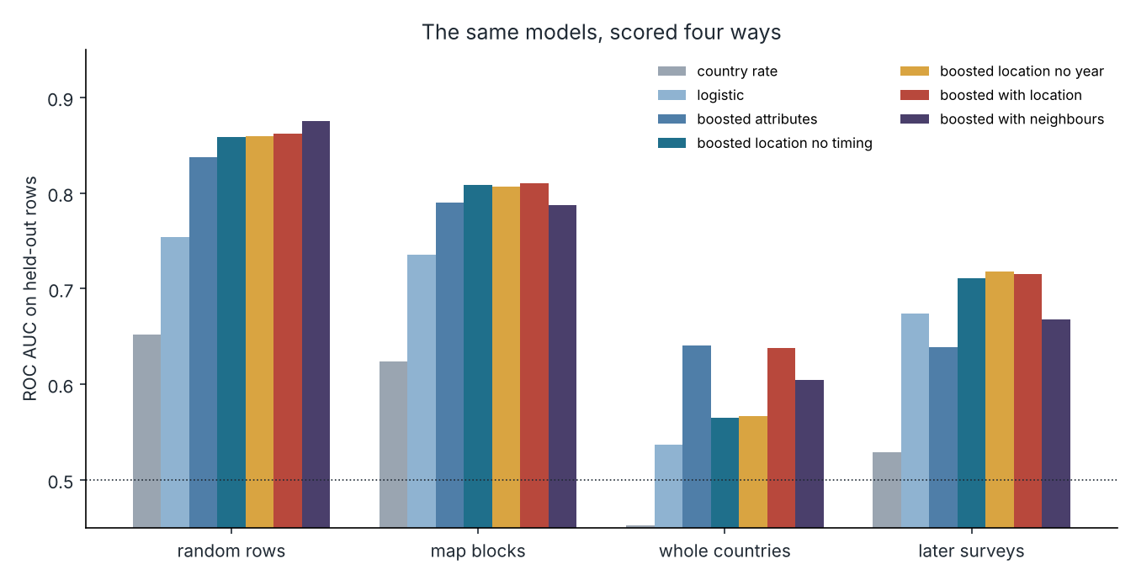
ROC AUC for each model under each hold-out regime.

Choosing the shipped model
The best model on map blocks uses location and survey timing (AUC 0.811). Dropping the timing costs 0.0016 AUC, with a paired interval of -0.0017 to 0.0041, so the two cannot be told apart. The simpler model, which does not depend on which team ran a campaign, is the one shipped.

What drives a score
Group of inputs | AUC lost when shuffled
payment arrangement | 0.105
country | 0.071
water source | 0.055
location | 0.048
installation year | 0.040
pump technology | 0.020
installer | 0.020
survey timing | 0.013
facility type | 0.000
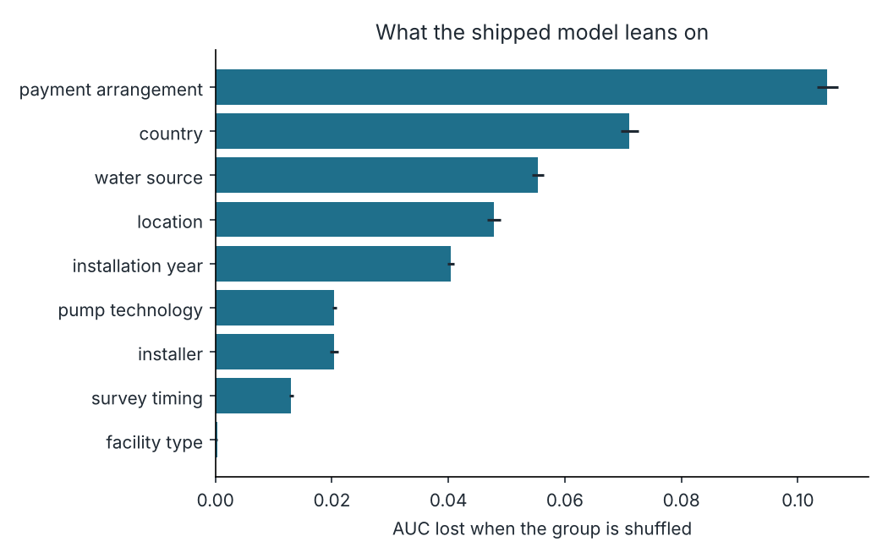
Grouped permutation importance on 40,000 held-out rows.

Calibration and uncertainty
The raw probabilities were already well calibrated on held-out blocks (expected calibration error 0.0154). An isotonic step made it slightly worse (0.0231), so none is applied. Conformal prediction sets, built per country and calibrated on half of the blocks, covered 89.1% at a nominal 90%. 74.1% of points received a single label and those were right 86.2% of the time. The median country covered 88.7%; Burkina Faso and Peru fell under 80%.
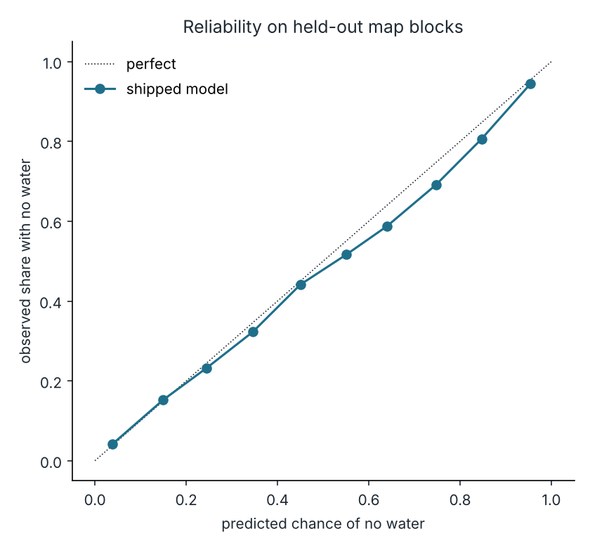
Reliability of the shipped model on held-out map blocks.

Where the dry points are
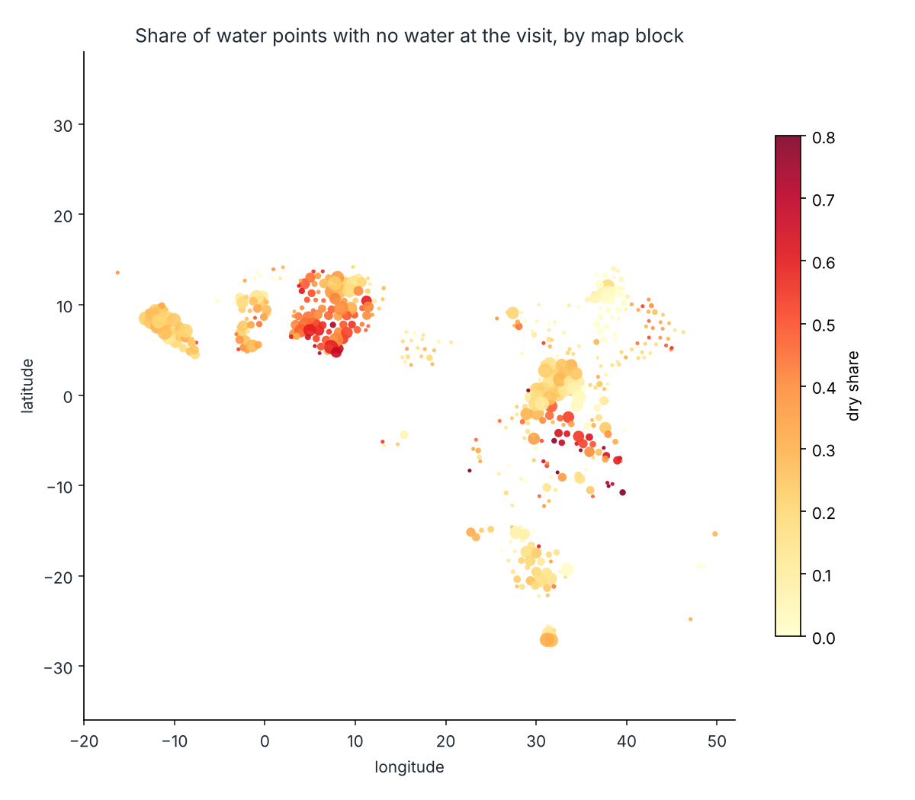
Share of water points with no water at the visit, by map block.

Limits worth knowing
- The label is one snapshot: dry on the day of the visit. Seasonal dry spells and broken pumps are mixed together.
- Surveys are not a random sample of water points, so the 24% dry rate describes this dataset, not Africa.
- For a country absent from training, the median per-country AUC was 0.624, and it ranged from 0.458 to 0.969.
- Costs are assumptions and exclude repair.

Closing line
A visit list built from past surveys finds a dry water point twice as often as the best simple rule, and the validation in this project is what makes that claim safe to repeat.

