gatecheck
Validity gates, inference and a shippable verdict for mobile game A/B tests
Ranjith Guggilla | github.com/ranjithguggilla/gatecheck

One line summary
gatecheck turns a 90,189 player A/B test into a defensible ship decision, and measures what the shortcuts around that decision actually cost: peeking ten times pushes the false positive rate from 5.0% to 19.5%, a targeting model that looks convincing fails its placebo test, and a fixed 50/50 split serves the worse build to three times more players than it needs to.

What the project is about
A mobile puzzle game placed its first progression gate at level 30. A gate is a forced wait: progress stops until the player waits out a timer, asks a friend, or pays. The team wanted to know whether moving that gate to level 40, giving players more uninterrupted play before the first wall, would keep more of them coming back. They shipped both builds to new installs at random and watched for two weeks.
What arrived afterwards was a file of 90,189 rows and a question nobody could answer from it directly. gatecheck is the layer between the two. It refuses to report a result until the randomisation has been checked, reports the effect three different ways so that agreement between them means something, and finishes with one of three words and the reasons attached to it.
The part I care most about is the second half. Most experiment tooling stops at a p value. This one goes on to ask what would have happened if the team had watched the dashboard daily, whether a targeting model could rescue a losing change, and whether the measurement itself could have been cheaper. All three answers are measured on the same data, and two of them are negative.

Problem statement
Experiment readouts fail in ways that do not look like failure.
- An uneven split gets waved through or, worse, sets off an alarm that burns a week of investigation on a healthy test. The line between the two is a threshold most teams never set deliberately.
- Somebody checks the dashboard every morning and stops the test the day it goes green. The reported error rate is still 5%. The real one is not.
- Three metrics get read off one experiment and the first to cross 0.05 becomes the headline, with no accounting for the fact that three chances at 5% is not a 5% chance.
- A change loses on average, so somebody proposes shipping it to the segment where it wins. The segment is found by a model, the model is never tested against the case where no such segment exists, and the segment is noise.
- A predictive model scores well on a feature that will not exist at the moment the prediction is needed, and nobody notices until it is in production.
- The whole measurement runs at a fixed 50/50 split, so half of every player who arrives during the test gets the build the team already suspects is worse.
Each of these is well known in principle and routinely ignored in practice, because ignoring them is free until it is not, and because nobody has the number in front of them.

Solution overview
gatecheck is a Python package with a command line entry point, a Streamlit review dashboard and a single JSON file that every downstream consumer reads. It runs in four passes.
- Validity first, and it can stop the run. Sample ratio mismatch, duplicate identifiers, players appearing in both arms, an audit of the engagement tail, and an explicit statement of which columns existed before assignment. If a gate fails, the verdict is a hold and no effect is reported at all.
- The effect, measured three ways. A pooled two proportion z test with a Newcombe hybrid score interval, a Beta-Binomial posterior with a highest density interval and an expected loss for each decision, and a bootstrap of the difference. Holm and Benjamini-Hochberg control the metric family.
- The practice around the effect, measured on the same data. The control arm is split against itself two thousand times to price peeking and calibrate a stopping boundary. Sixty thousand arrivals are replayed through four allocation policies. A targeting model is built and then put through a placebo test it fails.
- The decision. A pure function takes six numbers and a set of thresholds and returns ship, hold or roll back, with the reasons in plain language, and a revenue figure with every assumption written next to it.

How the system works, step by step
- The raw file is read, dtypes are normalised, the schema is enforced, and a parquet cache is written so repeat runs skip the parse.
- The two arms are separated. A third label or a missing arm raises rather than silently proceeding.
- Validity gates run. They produce a pass or fail plus a list of reasons phrased for a reader, not for a log file.
- Each binary metric gets a two proportion test with both an absolute and a relative interval. The skewed engagement metric gets a winsorised Welch test and a rank test on the raw values, because agreement between two tests that fail differently is worth more than either alone.
- The whole metric family goes through Holm and Benjamini-Hochberg together.
- The primary metric gets a bootstrap and a Beta-Binomial posterior, including the probability the change is worse than the tolerance the team set in advance.
- Power analysis reports the smallest effect this sample could have found, and the power it achieved against the effect it did find.
- The peeking study splits the control arm against itself, calibrates a stopping boundary on the first half of the replications and measures it on the second, then walks the real experiment forward look by look under both rules.
- The bandit replay runs uniform, epsilon greedy, UCB1 and Thompson sampling over sixty thousand arrivals and two hundred seeds each.
- The targeting section fits a two model uplift learner, measures the spread it produces, and compares that spread against thirty runs of the same procedure on data where no effect can exist.
- The decision function combines the evidence into a verdict, and the revenue model converts the retention move into an annual figure.
- Everything is written to a metrics file and eight charts. The dashboard reads that file; it never recomputes.

What happens in the background
A few pieces do more work than their line count suggests.
- The bootstrap does not resample rows. Drawing a column of zeros and ones with replacement and taking the mean has exactly the distribution of a binomial draw divided by n, so twenty thousand replicates over ninety thousand rows collapse into two vectorised draws. The continuous metric still gets a real resampling bootstrap, chunked so the index matrix stays small and trimmed so one player with 49,854 rounds cannot set the scale.
- The stopping boundary is not lifted from a table. A published Pocock constant assumes a look schedule that is probably not yours. This one bisects for the flat boundary whose family wise error rate over the calibration replications lands on the target, then reports how it behaves on replications it has never seen.
- The bandit replay is vectorised across seeds rather than across time. All two hundred seeds advance one step together, so Thompson sampling stays genuinely sequential while sixty thousand steps finish in seconds.
- Every scikit-learn estimator sits inside a pipeline with its scaler, so no preprocessing ever sees a validation fold. The uplift learner's folds are stratified on the treatment by outcome interaction so both arms and both outcomes appear in every one.
- The four allocation policies all start from the same seed, so the gaps between them are gaps in policy rather than in random streams. The sequential walk through the real experiment uses a seed of its own, kept apart from the one driving the A/A replications, so the trajectory and the boundary judging it are not the same draw.
- Degenerate inputs are handled rather than crashed on. A metric nobody hit produces a contingency table with an empty column, which the library underneath refuses; the code returns the correct answer instead.

Backend and tools used
No service, no database, no cloud dependency. A run is one process against a file that ships with the repository, and it finishes in about eleven seconds on a laptop. That is deliberate: a reviewer can clone the project and reproduce every number in this document before their coffee goes cold.
Layer | What it does
Data | pandas for the frame, pyarrow for a parquet cache, explicit schema enforcement on read
Inference | scipy and statsmodels for the tests and multiplicity control, arviz for highest density intervals
Simulation | numpy for the A/A replays, the bootstrap and the vectorised bandit replay
Modelling | scikit-learn pipelines for the leakage audit and the two model uplift learner
Interfaces | typer and rich for the command line, Streamlit for the review dashboard
Quality | pytest and Hypothesis for the suite, ruff for lint, GitHub Actions for both plus an artifact build

Business insights
Four things came out of this that a product review would act on.
The change costs money and should be reversed. Day-7 retention falls 0.82 percentage points, a 4.31% relative drop, with an interval that never touches zero. On the default assumptions that is roughly $264,000 a year, within a range of $100,000 to $427,000 implied by the interval alone.
Day-1 retention is the wrong metric to watch. It moves 0.59 points in the same direction and does not survive multiplicity control at p = 0.0744. A team watching only day 1 would have called this test a draw and kept a change that was quietly costing them.
Engagement did not move, and two tests disagree about that in a way worth understanding. The rank test lands at 0.0502, a hair outside the line, while Welch's t on winsorised values returns 0.883 and Cohen's d is -0.001. When two tests that fail in different ways disagree that sharply, the rank test is reading a tiny shift in a very large sample rather than anything a player would feel. The trimmed mean interval spans zero.
The measurement itself was more expensive than it needed to be. A fixed 50/50 split served the worse build to 30,000 of 60,000 arrivals. Thompson sampling would have served it to 9,126, sparing 20,874 players and ending with 164 more retained players, while still identifying the better arm 98.5% of the time.

Tech stack
Component | Version | Why it is here
Python | 3.10 and 3.12 | both are exercised in CI
pandas | 2.3.3 | the player frame and the arm split
numpy | 2.2.6 | every simulation in the project
scipy | 1.15.3 | distributions, chi-square, Welch, Mann-Whitney, trimmed means
statsmodels | 0.15.0 | Holm and Benjamini-Hochberg, and the z test the suite pins against
scikit-learn | 1.7.2 | leak-free pipelines for the leakage audit and the uplift learner
arviz | 0.23.4 | highest density intervals on the posterior difference
pyarrow | 25.0.1 | parquet cache between runs
matplotlib | 3.10.9 | the eight figures
typer and rich | 0.27.2, 15.0.0 | the command line and its output
Streamlit | 1.64.0 | the review dashboard
pytest and Hypothesis | 9.1.1, 6.168.3 | 119 tests, including property based checks on the statistics
ruff | 0.16.9 | lint, clean across the tree

My role
I built all of it: the problem framing, the data handling, every statistical routine, the simulations, the decision layer, the dashboard, the test suite and the continuous integration. There was no starting template and no borrowed analysis notebook.
The judgement calls are the part I would defend in a review. Setting the sample ratio alarm at 0.0005 instead of 0.05 is a decision about how a team spends its attention. Reporting that the targeting model found nothing, rather than quietly dropping the section, is a decision about what a portfolio piece is for. Letting the simplest honest model win is the same decision in a different costume.

Core contributions
- A validity layer that can stop a readout, including an explicit finding that this dataset has no pre-assignment covariates and therefore supports no causally interpretable subgroup at all.
- Three independent reads of the same effect, chosen so their failure modes differ: a Newcombe interval that holds its coverage near the boundaries, a conjugate posterior with an expected loss for each decision, and a bootstrap that is exact rather than approximate for a binary metric.
- A peeking study that prices the most common mistake in experimentation on this data, and a stopping boundary calibrated on held-out replications rather than taken from a table.
- A four policy allocation replay that turns a textbook regret curve into a count of players who got the worse build, and that reports the variance which makes epsilon greedy look better on averages than it deserves.
- A placebo test for the targeting model, which is the piece I would point at first. It is the difference between a model that found something and a procedure that always produces a number.
- A leakage audit that quantifies the trap rather than warning about it: 0.888 ROC-AUC against 0.709, a gap of 0.179 that is entirely a column spanning the outcome window.
- 119 tests, including Hypothesis properties that generate arm sizes and rates across five orders of magnitude and assert the invariants that hand-picked cases miss, plus a continuous integration check that deletes the committed results, regenerates them and compares every number key by key.

Outputs achieved
Artifact | What it is
results/metrics.json | every number in this document, keyed by section, and the contract the dashboard and CI both read
Eight figures | retention, bootstrap, posterior, peeking, bandits, power, engagement and the targeting placebo
Command line | validate, run and report, with validate exiting non-zero so it works as a pipeline guard
Dashboard | thresholds and business assumptions on sliders, verdict updating live
Test suite | 119 tests across 11 modules, green, in about three seconds
CI | lint and tests on two Python versions, plus a main-branch job that regenerates the analysis, checks every committed number still reproduces, and uploads the results

Key results and impact

Did randomisation do its job
Gate | Result
Arm sizes | 44,700 control against 45,489 treatment
Sample ratio mismatch | chi-square 6.90, p = 0.0086, above the 0.0005 alarm threshold
Assignment entropy | 0.99994 bits against a perfect 1.0
Duplicate player ids | 0 of 90,189
Ids in both arms | 0
Engagement outliers | max 49,854 rounds against a 99th percentile of 493, a ratio of 101
Pre-assignment covariates | none, so balance cannot be tested at all

The split is uneven enough to notice. At the 0.05 threshold people habitually reach for, it would be flagged, which is exactly why the threshold here is 0.0005: with tens of thousands of assignments a fair coin wanders, and a team alarming at 0.05 spends its week investigating healthy experiments. The read stands, and the imbalance is reported rather than buried.

What the experiment found
Metric | Control | Treatment | Absolute | 95% interval | p
Day-7 retention | 19.02% | 18.20% | -0.82pp | -1.33 to -0.31pp | 0.00155
Day-1 retention | 44.82% | 44.23% | -0.59pp | -1.24 to +0.06pp | 0.0744
Game rounds, 14 days | 52.46 mean | 51.30 mean | -0.28 trimmed | -1.41 to +0.91 | 0.0502 rank

After Holm, day-7 retention survives at p = 0.00466 and the other two do not. Benjamini-Hochberg agrees.
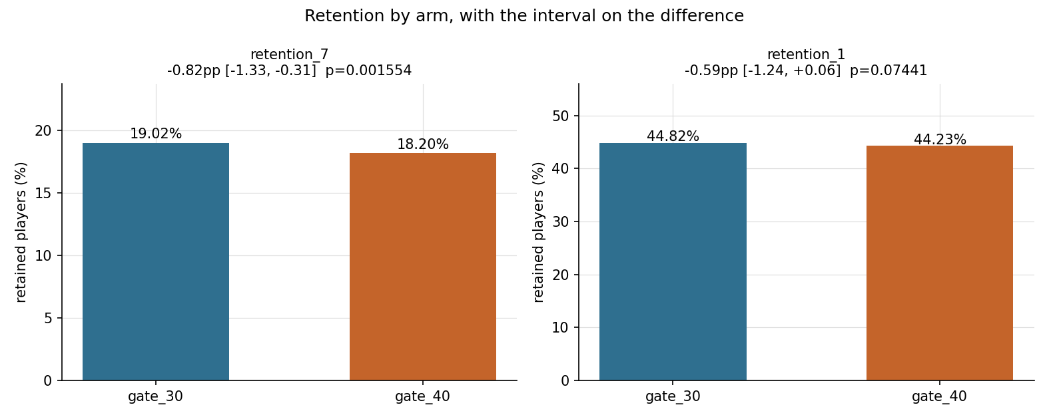
Both retention metrics, with the confidence interval on the difference rather than on each bar.
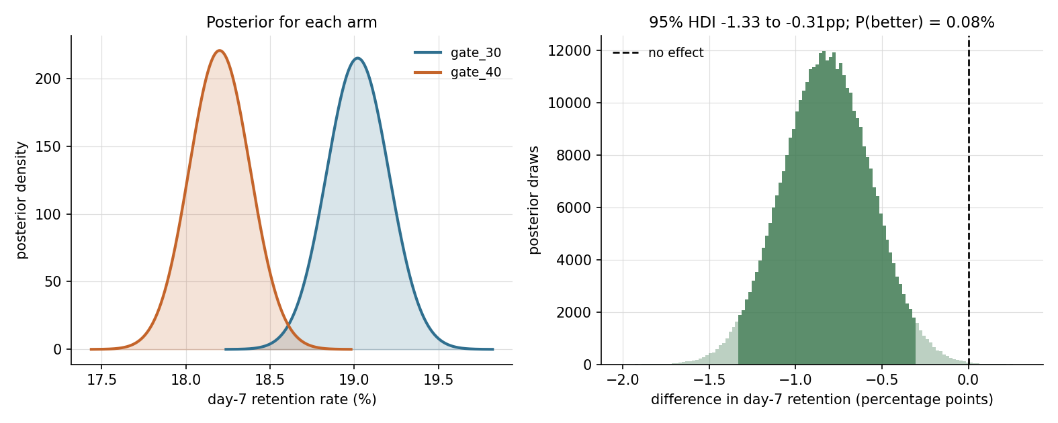
The posterior puts the chance the change is an improvement at 0.08%. Expected loss from shipping is 0.82pp of retention; from holding, 0.00005pp.

What the shortcuts would have cost
The control arm was split against itself two thousand times. Both halves are the same players under the same build, so every rejection is a false one. The first thousand splits calibrate the boundary and the second thousand measure it.
Stopping rule | False positives on 1,000 held-out A/A splits
One look at the end | 5.0%
Ten looks, no correction | 19.5%
Ten looks, Bonferroni | 2.8%
Ten looks, boundary calibrated to z = 2.53 | 5.7%

Peeking inflates the error rate 3.9 times over. Bonferroni fixes that and overshoots. The calibrated boundary lands on target, and the bill arrives as sample size: holding 80% power, moving the critical value from 1.96 to 2.53 needs 45% more players. That is larger than the 29% gap between the two thresholds suggests, because sample size scales with the square of the combined threshold. On the real experiment the uncorrected rule crosses at look 2 and the calibrated one at look 3, which stops 62,580 player exposures early.
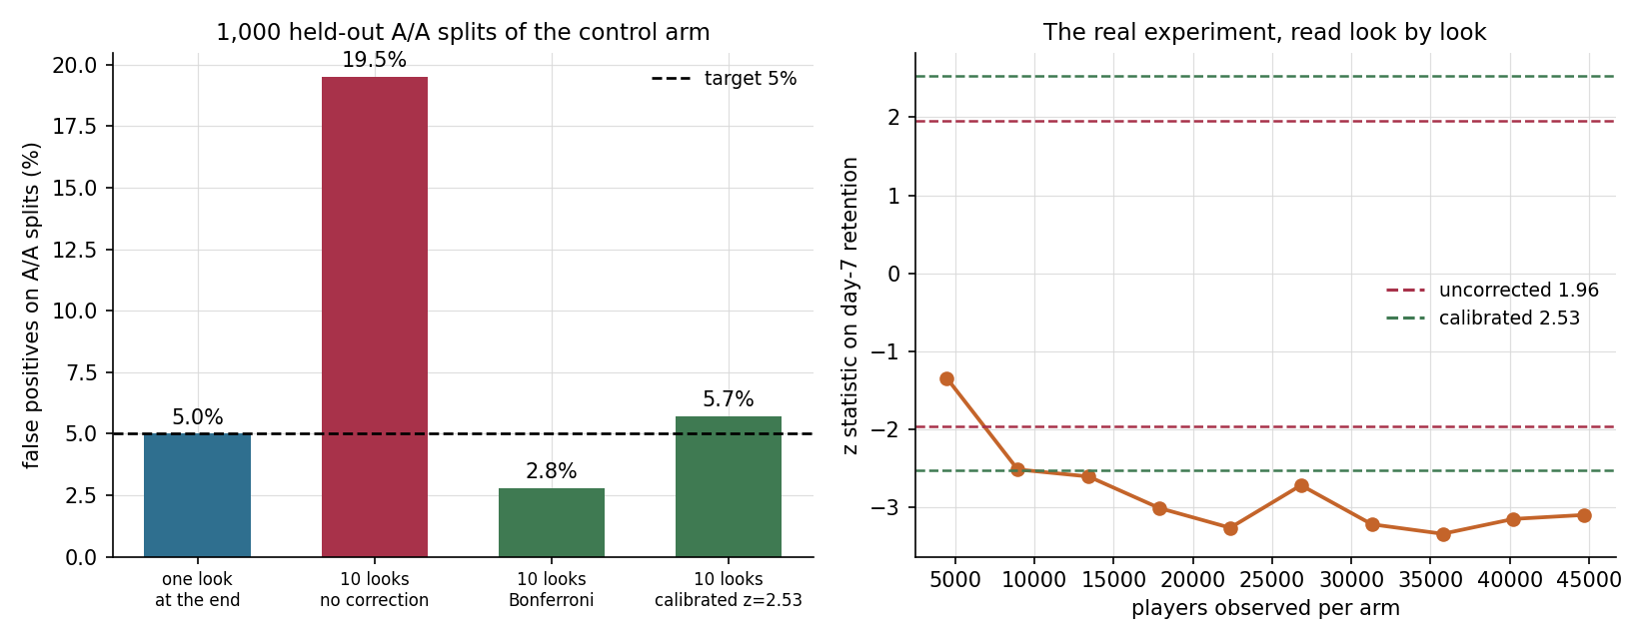
Left: what each stopping rule costs when there is nothing to find. Right: the real experiment, read look by look.

Adaptive allocation, replayed
Policy | Players served the worse build | Regret | Picked the better arm | Retained players
Uniform 50/50 | 30,000 | 246.0 | 100% | 11,176
Epsilon greedy (0.1) | 9,530 (sd 12,989) | 78.2 | 95.0% | 11,351
UCB1 | 21,368 (sd 2,928) | 175.2 | 99.5% | 11,247
Thompson sampling | 9,126 (sd 8,533) | 74.8 | 98.5% | 11,341

All four policies run from the same seed, so the gaps between them are not partly gaps between random streams. Thompson sampling spares 20,874 players the worse build and cuts regret 69.6%. Epsilon greedy lands close on the averages and should not be trusted on them: its standard deviation of 12,989 is larger than its mean, meaning it sometimes locks onto the wrong arm early and stays there, which is also why it identifies the better arm only 95.0% of the time. The averages alone would rank it first on exposure; the spread is what makes Thompson the one to run.
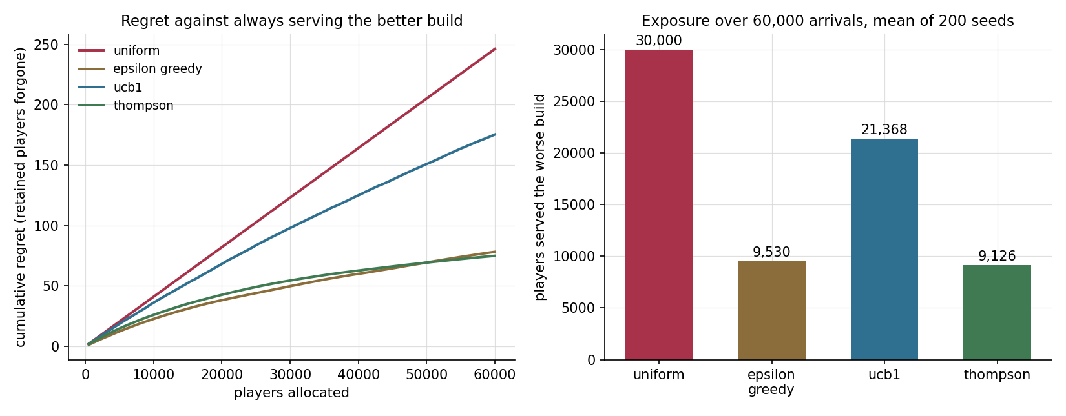
Regret against always serving the better build, and how many players each policy exposes to the worse one.

Two things this data cannot support
A targeting model. A two model uplift learner separates the top and bottom score deciles by 1.39pp, which looks like a finding. Splitting the control arm into two pseudo arms and running the identical procedure sixty times produces spreads averaging -0.13pp with a standard deviation of 1.95pp, reaching 5.41pp in absolute size at the extreme. The permutation p value is 0.48. The real number sits in the middle of the numbers the method invents when there is nothing there.
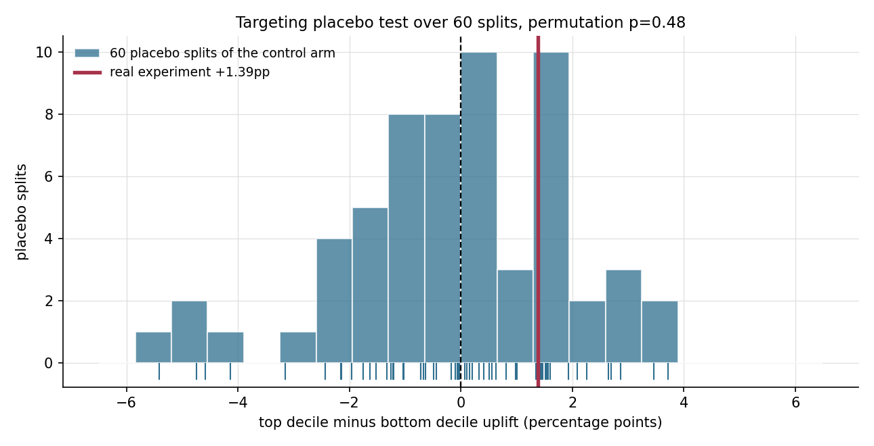
The real uplift spread against sixty placebo splits where no effect can exist.
A retention predictor. Predicting day-7 retention from day-1 retention plus log game rounds reaches 0.888 ROC-AUC. Dropping the game rounds column takes it to 0.709. That 0.179 gap is not skill: the engagement column spans the fourteen days after install and therefore contains the outcome window. At the moment a prediction would be useful, the number does not exist yet.
Feature set | ROC-AUC | Honest to use
Day-1 retention plus log game rounds | 0.888 (sd 0.002) | no, spans the outcome window
Day-1 retention only | 0.709 (sd 0.003) | yes
Majority class | 0.500 | yes, and it is the floor

What the experiment could have found
With 44,700 players per arm at a 19.02% baseline, the smallest effect detectable at 80% power is 0.74pp absolute, or 3.90% relative. The observed -0.82pp sits just past that, giving 88.3% achieved power. This test was adequately sized for the effect it found and would have been blind to anything much smaller. That is a useful thing to know before designing the next one.
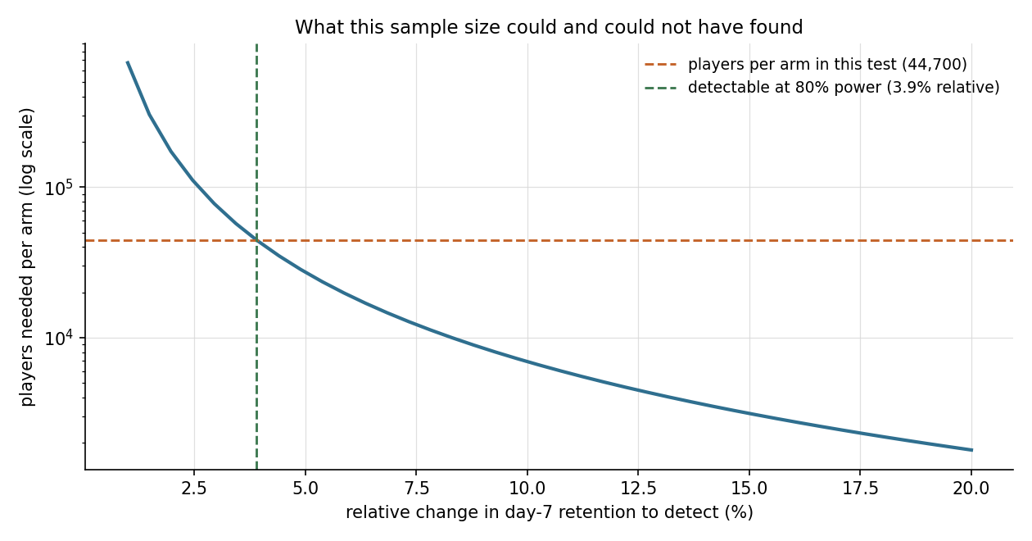
Required sample size against effect size, with this test's actual sample marked.

The verdict and what it is worth
Roll back, high confidence.
- Day-7 retention moves down 0.82pp, 95% interval -1.33 to -0.31pp, p = 0.00155.
- The posterior puts the chance the change is an improvement at 0.08%.
- The whole interval sits below the -0.20pp floor the team agreed to tolerate.
- The posterior chance the change is worse than that floor is 99.2%.
Figure | Value | Rests on
Retained players lost per year | 147,623 | 18,000,000 players a year reaching the gate at full rollout
Annual revenue effect | -$263,508 | $0.085 ARPDAU across 21 monetised days per retained player
Range from the interval alone | -$426,749 to -$100,287 | the same assumptions applied to each interval bound

Two further assumptions are stated openly because they are the ones a sceptic should attack: the retention gap is assumed to persist rather than close on its own, and no change to install volume, store ranking or acquisition cost is modelled. All of these live in one configuration file and move on sliders in the dashboard, so anyone who disagrees can point at the assumption they would change rather than at the model.

The number I would put on a slide is not the 0.82 point drop. It is the 19.5%: the false positive rate a team earns simply by checking the dashboard every morning, measured on their own data, on a test they would otherwise have trusted.

