gradeline
Ordinal quality grading and tasting-panel triage for wine lots

One-line summary
A grading model that predicts a lot's tasting-panel score from lab measurements, reports how sure it is, and decides which lots are worth a panel review, cutting expected cost per lot from $100.00 (review everything) to $76.79 under stated assumptions.

What the project is about
Wine lots are graded by a tasting panel on a 3 to 9 scale. The panel is slow and expensive, while the chemistry for a lot is already in the lab system. gradeline learns the relationship between measurements and panel grade from 5,320 distinct lots of vinho verde (red and white) and uses it two ways: to estimate the grade, and to flag lots that are probably low tier (grade 5 or below) so the panel time goes where it matters.

Problem statement
A winery that sends every lot to the panel spends money on lots that were never in doubt. A winery that sends none ships some low-tier lots as standard product. The question is which lots to review. The grade scale is ordered, so the model also has to respect that a lot predicted as 5 and graded 7 is a bigger miss than one graded 6, which plain classification accuracy does not capture.

Solution overview
I built an ordinal grader that outputs a probability for each of five grade classes, a rule that converts the probability of grade 5 or below into a review decision using explicit costs, and a short plain-language reason for each call. A Gradio app wraps the scoring function so a technician can type in a lot and see the result.

How the system works, step by step
- Load the red and white tables, flag colour, and remove 1,177 exact repeated rows.
- Collapse grades to five classes (4 or below, 5, 6, 7, 8 or above) and split 60/20/20, stratified on grade and colour.
- Cross-validate eight candidate models on the training fold with five folds repeated three times.
- Pick the simplest probabilistic model within one standard error of the best by kappa.
- Refit on training plus validation lots and score the test fold once.
- Turn the grade distribution into a decoded grade and a probability of grade 5 or below.
- Apply the cost-based cut-off to decide between review and release, and attach reasons.

What happens in the background
The shipped model is a set of four boosted classifiers, one per grade boundary, each estimating the chance that a lot grades above that boundary. Their outputs are forced to be consistent (the chance of grade above 6 cannot exceed the chance of grade above 5) and then differenced into a distribution over the five classes. The median of that distribution is reported as the grade, because the median minimises expected absolute error. For one lot, the reasons come from swapping each measurement for the typical lot's value and watching how the expected grade moves. Log transforms and scaling sit inside the model pipeline, so nothing is learned from the validation or test lots before they are scored.

Backend and tools used
- Python with scikit-learn for pipelines, boosting, logistic models and cross-validation
- SciPy for cutpoint search and the Friedman test; scikit-posthocs for the Nemenyi post-hoc comparison
- Krippendorff alpha for model-versus-panel agreement; mlxtend for McNemar's test
- matplotlib for charts, joblib for the model bundle, Gradio for the scoring app
- pytest and ruff for tests and lint, GitHub Actions for CI and a main-branch training job

Business insights
- The model sends 51.2% of lots to the panel and still catches 82.9% of the low-tier lots.
- Against reviewing everything it saves $23.21 per lot (bootstrap 95% interval $17.76 to $28.67), or $24,700 on the 1,064 test lots.
- A simple alcohol ranking reviewing the same share of lots costs $92.58 per lot, so most of the model's advantage comes from combining measurements, not from one strong signal.
- The model leaves a lot on the table: hindsight costs $37.31 per lot and low-tier lots are about 37% of production.
- The dollar inputs ($100 per review, $400 per missed low-tier lot) are assumptions, and the model beat both extremes at every cost ratio tested from 0.1 to 0.8.

Tech stack with versions
component | version
Python | 3.13
numpy | 2.5.3
pandas | 3.0.5
SciPy | 1.18.1
scikit-learn | 1.9.1
matplotlib | 3.11.2
krippendorff | 0.9.0
scikit-posthocs | 0.17.1
mlxtend | 0.25.0
Gradio | 6.30.0
pytest / pytest-cov | 9.1.1 / 7.1.0

My role
I owned the work from problem framing to delivery: choosing the dataset, designing the validation, writing the estimators, the economics and the app, and documenting the findings including the ones that cut against the model.

Core contributions
- Implemented the cumulative-binary ordinal classifier and a kappa-optimising cutpoint regressor from scratch on scikit-learn.
- Found and quantified duplicate-row leakage: random splits on the raw files overstate kappa by 0.064.
- Separated metric tuning from real quality: the cutpoint models win on kappa but not on absolute error, and the write-up says so.
- Built a probability-based triage rule with a transparent cost model and a sensitivity sweep.
- Added a scoring service with input validation, range warnings and what-if reasons, covered by 32 tests at 84% line coverage.

Outputs achieved
- Trained model bundle, metrics file, test predictions and six charts, all regenerated by one command.
- A Gradio scoring app and a documented Python function for batch use.
- A public repository with CI that lints, tests and retrains the model on every push to main.

Key results and impact
On 1,064 held-out lots the shipped model reaches quadratic weighted kappa 0.531 (95% interval 0.488 to 0.572), mean absolute grade error 0.462, exact grade 57.2% and within one grade 96.6%. The mode-only baseline reaches 43.7% exact with kappa 0, which is why kappa and within-one accuracy are the headline measures.
model | CV kappa | test kappa | test MAE | exact | within one
mode_only | 0.000 ± 0.000 | 0.000 | 0.635 | 0.437 | 0.928
alcohol_cutpoints | 0.447 ± 0.006 | 0.441 | 0.604 | 0.463 | 0.938
ordinal_logit | 0.460 ± 0.006 | 0.495 | 0.492 | 0.546 | 0.963
multinomial_logit | 0.462 ± 0.004 | 0.501 | 0.479 | 0.559 | 0.963
ridge_cutpoints | 0.539 ± 0.007 | 0.553 | 0.549 | 0.505 | 0.951
boosted_multiclass | 0.471 ± 0.007 | 0.536 | 0.465 | 0.572 | 0.962
boosted_cumulative (shipped) | 0.504 ± 0.005 | 0.531 | 0.462 | 0.572 | 0.966
boosted_cutpoints | 0.559 ± 0.004 | 0.612 | 0.507 | 0.534 | 0.962

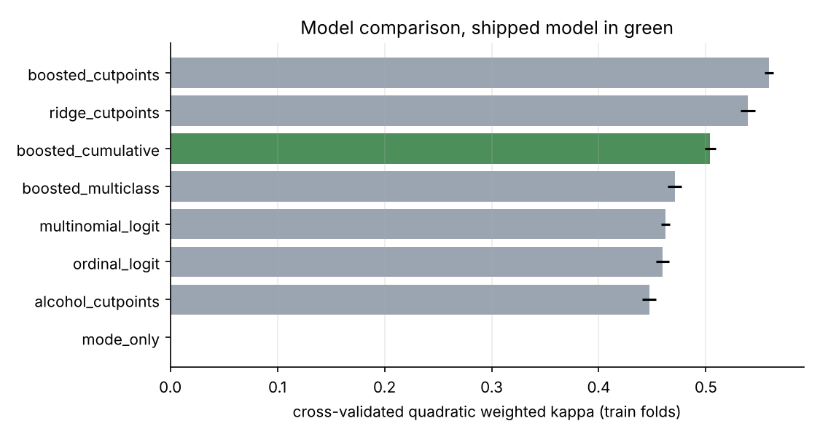
The cutpoint models score highest on kappa because their cutpoints are tuned for it. They return one score instead of a distribution, so they cannot drive the triage rule, and the shipped model comes from the probabilistic group.
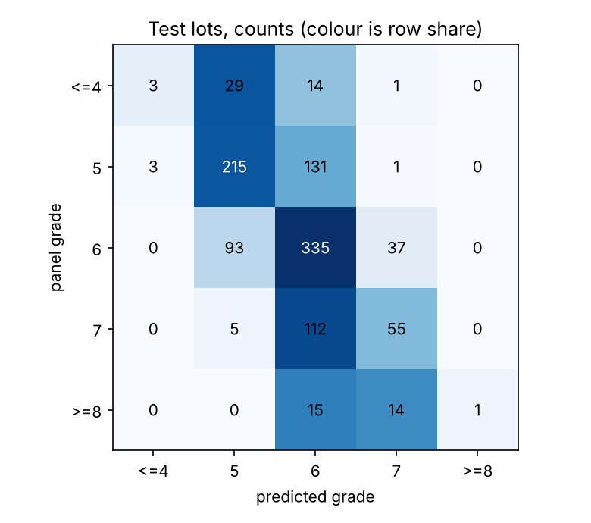

Triage economics
policy | cost per lot | total on test fold
review none | $149.25 | $158,800
review all | $100.00 | $106,400
model, break-even cut | $76.97 | $81,900
model, tuned cut (shipped) | $76.79 | $81,700
random, same share | $124.14 | $132,088
alcohol rank, same share | $92.58 | $98,500
hindsight | $37.31 | $39,700

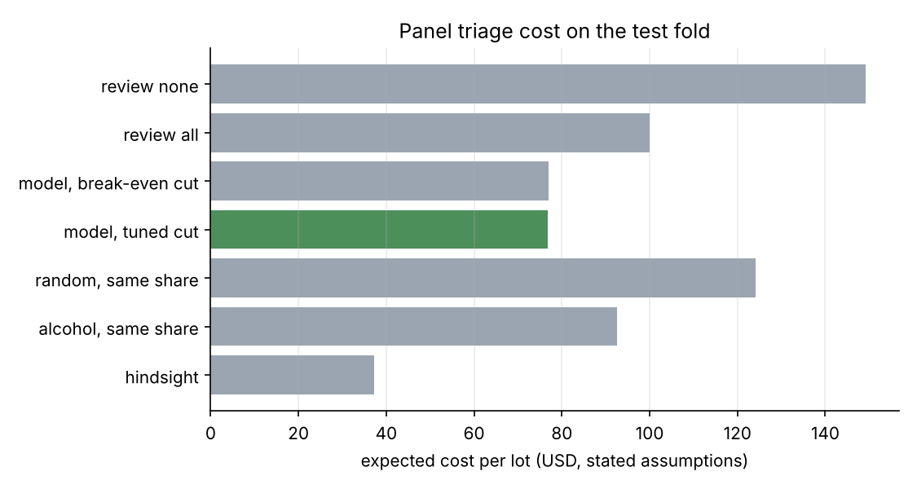

Validation findings
- Repeated rows: kappa 0.572 on a random split of the raw files against 0.508 once repeats are removed.
- Statistical comparison: the logistic models and the boosted multiclass model are indistinguishable (Nemenyi p above 0.99); shipped versus multinomial logit on exact grades gives McNemar p = 0.31.
- Calibration: the raw probability of grade 5 or below has error 0.020 on test; isotonic recalibration made it worse (0.030) and was not shipped.
- Colour: a white-only model applied to red lots scores kappa 0.153, so colour stays in the model.
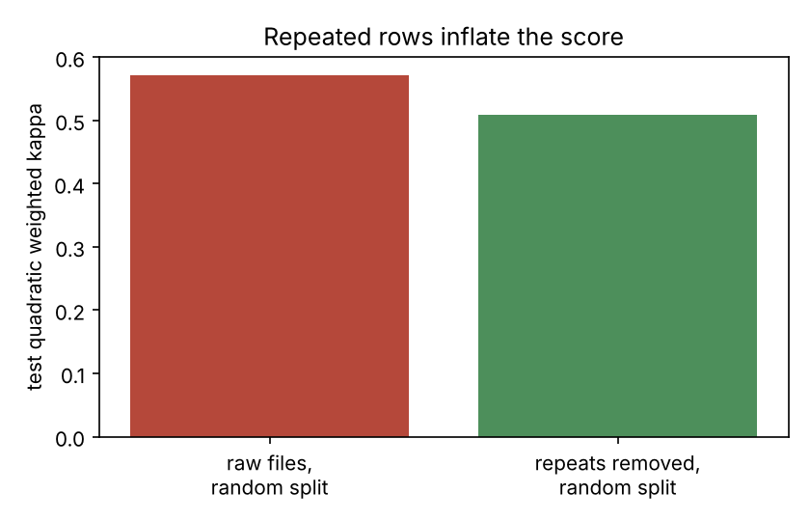
Alcohol is by far the largest driver (permutation importance 0.237 kappa), followed by volatile acidity (0.084) and free sulfur dioxide (0.064).

Closing line
gradeline treats wine grading as the ordered problem it is, says plainly where the numbers are weak, and turns the model's uncertainty into a review rule a quality manager can price and challenge.

