icefall
Booking-time summit odds and oxygen planning for Himalayan expeditions
Project overview | Ranjith Guggilla

One-line summary
icefall turns 60,521 Himalayan climber records into booking-time summit odds and a cheaper oxygen order, and shows that the oxygen statistic everyone quotes overstates what oxygen does.

What the project is about
The Himalayan Database is the long-running record of expeditions in Nepal: who went, to which peak, with what support, and how it ended. I used the 1950 to spring 2019 records for paying climbers, 60,521 people on 387 peaks across 10,276 expeditions, and asked what a careful analyst can and cannot say from them.
There are three threads. The first forecasts a climber's chance of reaching the summit using only what is known at booking. The second plans how much bottled oxygen an expedition should bring. The third asks what oxygen itself does to the odds, a question where the obvious number is badly wrong. Under all three sits the part I treated as the real product: a testing discipline built around forward-in-time validation, resampling by expedition, a leakage audit and cost assumptions that are written down.

Problem statement
Operators and clients mostly get odds from anecdotes and raw summit rates, and the rates move a lot. The summit rate was 27.5% in the training years and 41.9% in the test years, and inside the test window it ran from 15.4% in 2015 to 62.8% in 2019.
Oxygen ordering has lopsided costs. A surplus set is money wasted and a missing set can end an attempt, so following a peak's historical oxygen rate, the natural shortcut, leaves many expeditions short. The raw oxygen statistic is also quoted as if it were an effect: climbers who used oxygen summited 73.0% of the time against 14.1% for those who did not.
The data sets traps of its own. Teammates share a fate (intraclass correlation 0.47), the outcome is recorded in columns that sit beside the features, and the world changed over the decades. A model validated the usual way would look better than it is.

Solution overview
I built a reproducible pipeline and a small app around it. A booking-time model uses the peak's own history from earlier years only, is chosen on a validation window with the one-standard-error rule, and is scored once on 2014 to 2019. Audits then measure how much a careless split or a leaked column would have inflated the score. For oxygen, four estimators compare outcomes with and without it, and a separate newsvendor model decides how many sets to order, priced on the held-out years with the assumptions stated.
Everything lands in one metrics file, nine tables and seven charts. A Gradio app turns a booking into odds with plain-language reasons, and CI reruns the whole pipeline and compares it with the committed numbers.

How the system works, step by step
- Load the trimmed extract and keep paying (non-hired) climbers from 1950, joining peak height and the year of first ascent.
- Build point-in-time peak history: for each peak and year, success, death and oxygen rates from earlier years only, shrunk towards the all-peak rate so a thinly climbed peak does not report 0% or 100%.
- Split forward in time: training to 2008 (41,933 climbers), validation 2009 to 2013 (9,162), test 2014 to 2019 (9,426).
- Fit five candidates on the training years: a peak-history lookup, two logistic regressions and two gradient-boosted models. Score them on validation with standard errors that resample whole expeditions, and pick with the one-standard-error rule.
- Refit the chosen model on train plus validation and score it once on the test years, with intervals that resample expeditions, against the lookup baseline.
- Run the audits: the same model under random-row, random-expedition and forward splits; each outcome-side column added in turn; the intraclass correlation inside expeditions.
- Estimate what oxygen does on 8,000 m peaks since 1980 with the raw gap, g-computation, inverse probability weighting and a doubly robust estimator, then check with a shuffled-treatment placebo and dowhy.
- Plan oxygen orders: model each climber's oxygen use, sum it over each expedition, add a safety offset taken from validation residuals, and price every policy on the test years across a range of cost ratios.
- Write the metrics, tables and charts, and save a bundle that the app loads to score a booking and explain the score.

What happens in the background
The history features are the quiet guard rail. For a climber in a given year they use only outcomes from earlier years, and a unit test flips an outcome in one year and checks that nothing from that year or before moves. That test failed on my first version: the fallback for the earliest year used the dataset's overall rate, which looked forward. It now uses fixed constants.
Every interval in the project resamples whole expeditions, because the effective sample is smaller than the row count (3,222 independent rows' worth out of 9,426 on the test years). A second full run reproduces every number in the metrics file to the digit except dowhy's randomised refuter values, and a small comparison module checks a fresh run against the committed file.
CI lints and tests on every push. On the main branch it also reruns the full pipeline, compares the result with the committed metrics and uploads the run as an artifact.

Backend and tools used
Layer | Tool | What it does here
Data handling | pandas, numpy | Loading, filtering, point-in-time history, tables
Models | scikit-learn | Logistic regression and histogram gradient boosting in leak-free pipelines
Calibration | netcal | Temperature scaling check on validation years
Causal estimates | scikit-learn, dowhy | g-computation, weighting and doubly robust estimators; dowhy cross-check and refuters
Resampling | numpy | Expedition-level bootstrap and intraclass correlation
Charts | matplotlib | Seven README and report charts
Serving | joblib, Gradio | Model bundle and a booking-odds app
Quality | pytest, pytest-cov, ruff | 59 tests, lint, coverage
Automation | GitHub Actions | Lint, tests, full rerun, metrics comparison, artifact upload

Business insights
Re-anchor the level before tuning the model. The jump from 27.5% to 41.9% matters more than another point of AUC. The model is right on average over the test years (42.1% predicted, 41.9% observed) and wrong year by year, so its level should be reset on the current season.
The oxygen order pays for itself under stated costs. At $800 per unused set and $4,500 per missing one, ordering by the model plus a safety offset costs $358 per climber. That is $48 less than bringing a set for everyone and $597 less than following the peak's recent rate. Over the 5,840 held-out climbers the first saving is $280,600 (interval $56,690 to $500,193).
The saving depends on the cost ratio. If a missing set costs about ten times an unused one, ordering for everyone is as good as the model (the model is $800 behind at a ratio of 10). The first job with real invoices is to replace my two numbers.
Read the oxygen headline carefully. The raw +59.0 point gap is mostly a statement about who gets high enough to use a bottle. The expedition-level estimate, closer to a pre-trip decision, is +34.5 points (+31.7 to +36.4) and is still an upper bound.
Do not use the death model to decide anything. Its AUC is 0.580 (0.502 to 0.654) on 69 deaths. I kept it because a negative result is worth reporting.
A careless split would have cost real credibility. The same model scores AUC 0.809 with random rows and 0.650 going forward, a 0.16 gap that is teammates and time, not skill.

Tech stack with versions
Component | Version
Python | 3.13
numpy | 2.5.3
pandas | 3.0.5
scikit-learn | 1.9.1
scipy (pulled in by scikit-learn) | 1.18.1
matplotlib | 3.11.2
joblib | 1.6.0
netcal | 1.4.0
dowhy | 0.14
gradio | 6.30.0
pytest / pytest-cov | 9.1.1 / 7.1.0
ruff | 0.17.2

My role
I built this on my own, from choosing the questions to the CI workflow. That meant framing the problems and deciding what counts as known at booking, cleaning and joining the data, designing the validation, writing the models and the causal and ordering analyses, building the app, writing the tests and the documentation, and checking that a clean checkout reproduces the numbers.

Core contributions
- Point-in-time history features with a regression test that flips an outcome and checks that no earlier feature moves; the test caught a forward-looking fallback in my own first version.
- Expedition-level resampling and an intraclass correlation estimate behind every interval, so the reported uncertainty matches the real sample size.
- A split and leakage audit with measured costs: the random-row score overstates the forward score by 0.16 AUC, and a recorded highpoint lifts the AUC to 0.999.
- A causal comparison that separates a treatment decided on the mountain from one decided before leaving, and that reports a failed dowhy refuter next to the estimates that passed instead of dropping it.
- A newsvendor ordering model priced on held-out years, with a sweep over the cost ratio so the conclusion does not rest on one pair of numbers.
- A scoring function and Gradio app that explain each estimate by swapping one input at a time to a typical value.
- A metrics comparison module and a CI job that reruns the pipeline and checks it against the committed numbers.

Outputs achieved
- A packaged Python project with a one-command pipeline, a booking-odds app and a pinned environment.
- A metrics file holding every quoted number, nine result tables and seven charts.
- 59 tests at 98% coverage, with lint clean, passing from a fresh checkout.
- A CI workflow that lints, tests, reruns the full pipeline on the main branch and compares it with the committed metrics.
- A trimmed copy of the source extract with its data dictionary and credit, so the repo runs offline.
- A README with the results, the architecture, usage and the limits.

Key results and impact

Data and split
Split | Years | Climbers | Expeditions | Summit rate
train | 1950 to 2008 | 41,933 | 6,362 | 27.5%
valid | 2009 to 2013 | 9,162 | 2,057 | 39.0%
test | 2014 to 2019 | 9,426 | 1,857 | 41.9%

Summit odds at booking time
Validation scores for the five candidates. Gradient boosting with 15 leaves has the lowest log loss and is the first model inside one standard error of the best, so the rule selects it.
Model | Log loss | SE | AUC | ECE
Peak history lookup | 0.6439 | 0.0072 | 0.633 | 0.014
Logistic regression, C = 0.3 | 0.6439 | 0.0072 | 0.655 | 0.058
Logistic regression, C = 3 | 0.6472 | 0.0071 | 0.650 | 0.061
Gradient boosting, 15 leaves | 0.6170 | 0.0077 | 0.683 | 0.014
Gradient boosting, 40 leaves | 0.6238 | 0.0094 | 0.679 | 0.032

On the test years the shipped model reaches AUC 0.675 (0.654 to 0.699) and log loss 0.634 (0.617 to 0.651), against 0.506 and 0.704 for the peak-history lookup. The log loss gain is 0.0695 (0.0565 to 0.0841). The model is modest at ranking and honest about its level on average, which is the useful part.
Test year | Climbers | Observed | Model | Lookup
2014 | 1,624 | 28.3% | 39.4% | 40.8%
2015 | 1,528 | 15.4% | 41.0% | 38.6%
2016 | 1,748 | 43.9% | 39.9% | 34.4%
2017 | 1,782 | 52.7% | 42.6% | 32.8%
2018 | 1,847 | 53.2% | 41.6% | 37.1%
2019 | 897 | 62.8% | 53.1% | 39.1%
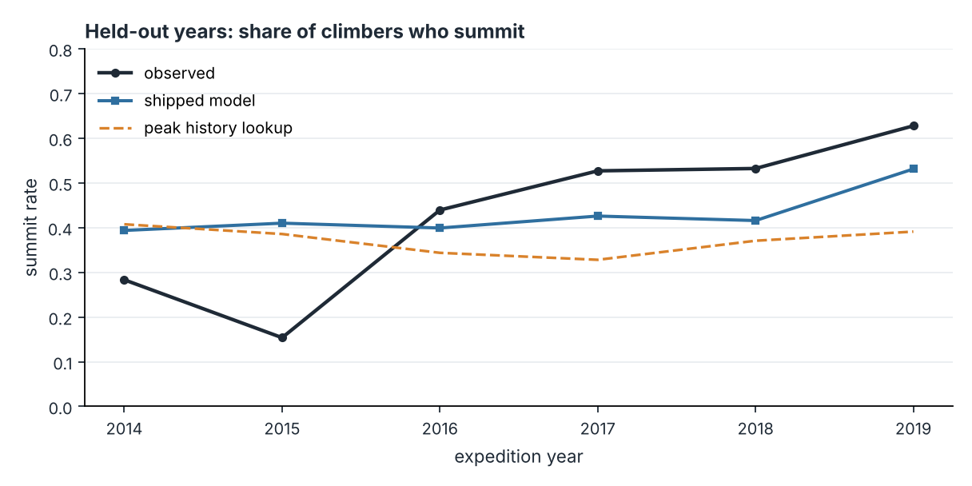
Observed and predicted summit rate in each held-out year.

Evaluation discipline
Hold-out | Train rows | Test rows | AUC | Log loss
random rows | 48,416 | 12,105 | 0.809 | 0.486
random expeditions | 48,283 | 12,238 | 0.753 | 0.540
forward in time | 41,933 | 9,426 | 0.650 | 0.651

Column added to the booking-time features | Test AUC
booking-time features only | 0.675
+ member used oxygen | 0.860
+ member highpoint (metres) | 0.999
+ expedition ended in success | 0.860
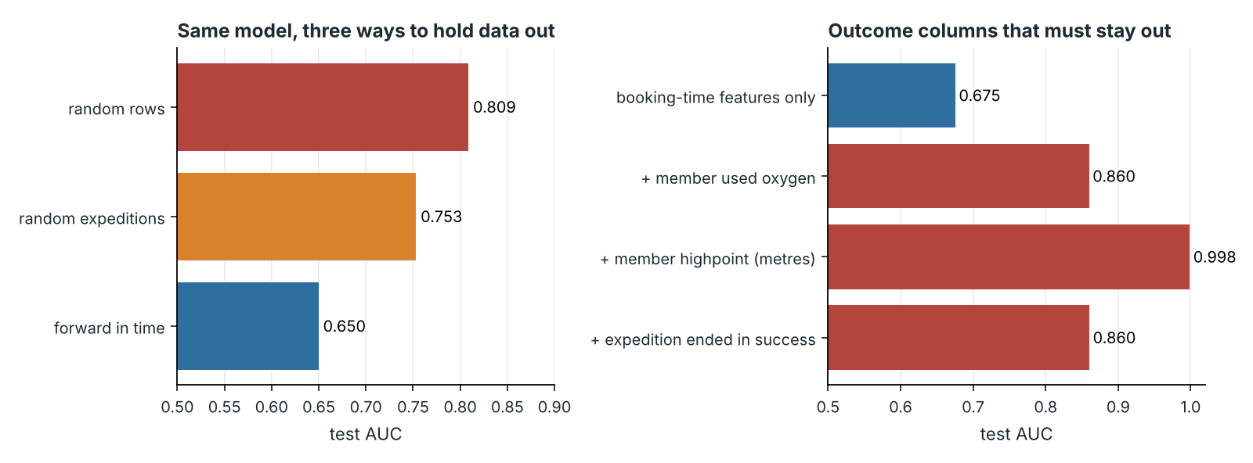
Left: the same model under three splits. Right: AUC when outcome-side columns are added one at a time.
Inside the test years the intraclass correlation is 0.472 with 5.1 climbers per expedition, a design effect of 2.93. A row-level bootstrap gives an AUC interval of 0.666 to 0.686; resampling expeditions gives 0.654 to 0.699, 2.25 times wider.

What oxygen does
33,087 climbers on 8,000 m peaks since 1980. Risk differences in percentage points.
Comparison | Naive | g-comp. | IPW | AIPW (95% interval)
Member used oxygen: summit | +59.0 | +61.3 | +54.0 | +56.0 (+53.5 to +57.8)
Member used oxygen: died | +0.2 | +1.0 | +1.3 | +1.3 (+0.7 to +2.0)
Expedition used oxygen: summit | +25.7 | +25.1 | +31.4 | +34.5 (+31.7 to +36.4)
Expedition used oxygen: died | -0.3 | +0.3 | +0.4 | +0.3 (-0.1 to +0.7)
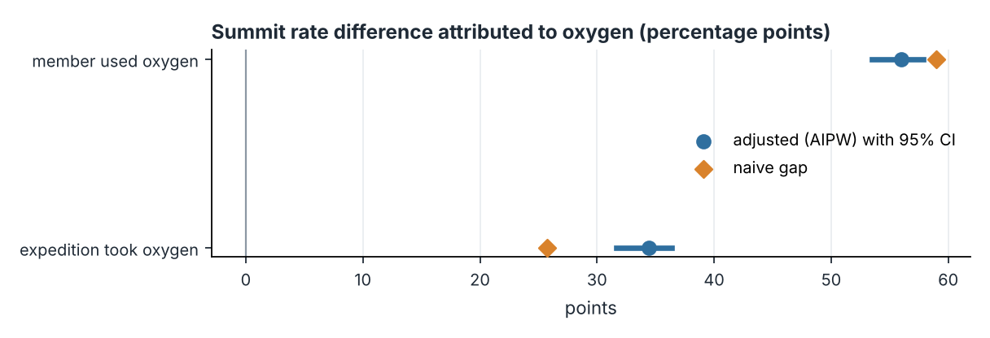
Naive gap against the adjusted estimate and its interval.
A member's own oxygen use is decided on the mountain, so the large gap mostly sorts climbers by how high they got. The expedition-level estimate is closer to a decision made before leaving and is still recorded afterwards, so I read it as an upper bound. A permutation placebo on my estimator gives +0.004 points on average; dowhy's linear-regression estimate agrees with the headline, and its weighting refuter fails its placebo in a way I could not explain, which I report as a flag.

Ordering oxygen
1,095 expeditions on 8,000 m peaks in the test years, 5,840 climbers, 2,878 sets used. Costs assume $800 per unused set and $4,500 per missing set.
Policy | Sets | Unused | Short | Total cost | Per climber
order for every member | 5,840 | 2,962 | 0 | $2,369,600 | $406
peak history rate | 2,950 | 1,113 | 1,041 | $5,574,900 | $955
model expected demand | 3,745 | 1,241 | 374 | $2,675,800 | $458
model plus safety offset | 4,310 | 1,610 | 178 | $2,089,000 | $358
hindsight (exact demand) | 2,878 | 0 | 0 | $0 | $0
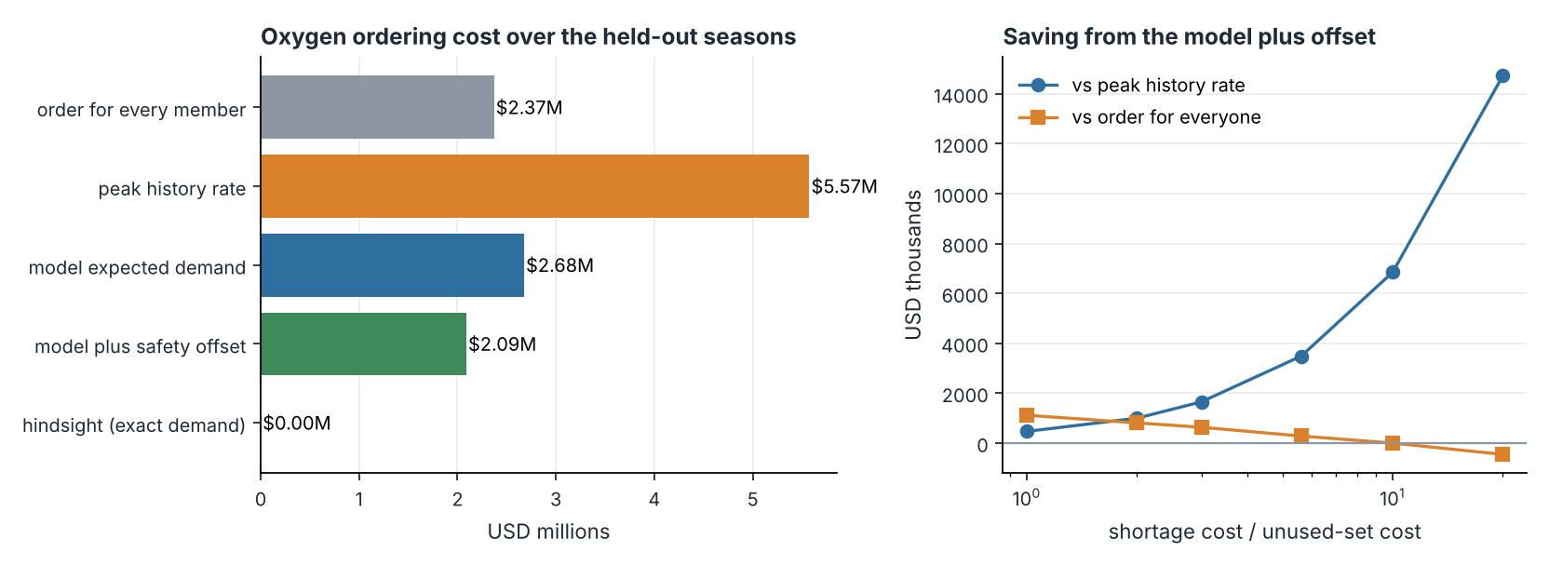
Left: cost of each ordering policy. Right: saving from the model as the shortage-to-waste cost ratio changes.
Cost ratio | Offset (sets) | Saving vs a set for everyone | Saving vs peak history rate
1.0 | -0.06 | $1,114,400 | $468,000
2.0 | +0.15 | $809,600 | $996,000
3.0 | +0.41 | $633,600 | $1,652,800
5.6 | +0.85 | $280,600 | $3,485,900
10.0 | +1.37 | -$800 | $6,848,000
20.0 | +1.98 | -$454,400 | $14,722,400

Death risk
Test AUC 0.580 (0.502 to 0.654) on 69 deaths. The top tenth of climbers by predicted risk holds 13.0% of the deaths. I do not recommend using it.

Closing line
The headline is not an AUC of 0.675. It is that every number in this project can be traced, rerun and, where it flattered the model, taken apart.

