patchrisk
Project overview: ranking code changes by the chance they introduce a bug

One-line summary
A commit-risk model trained on 12,278 commits from six open-source Python projects that ranks changes by the chance a later fix will blame them, validated forward in time and honest about how little of the signal comes from anything except change size.

What the project is about
Every team that reviews code has more changes than review time. patchrisk learns from a project's own history which kinds of changes were later blamed for bugs and uses that to suggest where a second reviewer is most likely to pay off. The training data is the complete git history of click, flask, httpx, jinja, requests and werkzeug.
Most commit-risk write-ups report a single impressive AUC. This project spends its effort on the questions that decide whether such a number can be trusted: whether labels are mature, whether the split leaks, whether the probabilities survive a drop in the bug rate, and whether the model beats the trivial rule of reading the smallest or the largest diff first.

Problem statement
Review capacity is fixed and the volume of changes is not. A team needs a defensible way to decide which commits get a deeper review. The obstacle is that the ground truth is delayed and noisy. A bug shows up months after the commit that caused it, and the link between the two has to be inferred by blaming the lines a later fix touched. A model evaluated carelessly on that data can look strong while telling the team nothing it did not already know from the size of the diff.

Solution overview
The system walks each repository oldest commit first, computes features that use only earlier history, finds bug-introducing commits with a blame pass over bug-fix commits, and splits the result by time into training, validation and test periods. Three models compete under a one-standard-error rule that favours the simplest one inside the noise. The winner is calibrated, explained in plain sentences, and wrapped in a small web app and a scoring function. Around it sit a set of audits that stress the labelling and the validation protocol, and a review-budget calculation with every cost assumption written down.

How the system works, step by step
- Clone each repository at a pinned revision so a rerun sees identical history.
- Walk the non-merge commits oldest first. For each commit that touches Python, record size, spread over files and directories, change entropy, author experience, how often and how recently the touched files changed, complexity change, and message and timing flags.
- Flag bug-fix commits from their messages, skip those touching more than 20 files, and blame the removed or changed lines. Any commit that last touched those lines is linked to the fix.
- Label each commit as buggy if a fix blamed it. Validation and test commits are labelled with all fixes known today because they are over a year old. Training labels use only fixes known at the training cutoff, with the final year dropped because it is not yet mature.
- Fit logistic regression, gradient boosting and a random forest on the training period and choose among them on validation log loss.
- Fit an isotonic calibrator on validation after checking that it helps on a held-out half of validation.
- Score the untouched test period, attach intervals that resample whole repository-months, and run the audits and the budget analysis.
- Refit on training plus validation, save the bundle, and serve it through the scoring function and the app.

What happens in the background
History features are computed from state that is updated only after a commit is processed, so nothing about a commit's own future leaks into its row. The blame pass ignores whitespace-only edits and skips fix commits that look like refactors. Right-skewed columns are put through a signed log before scaling for the linear model. Uncertainty comes from a cluster bootstrap over repository-months, not row-level resampling, since neighbouring commits are correlated. The explanation shown to a user comes from occlusion: each feature is swapped for its background median in turn and the three biggest movements in log-odds are turned into sentences. The whole study is deterministic and reruns in about ten seconds on the committed data.

Backend and tools used
Python 3.13 with PyDriller for the git walk and the blame pass, radon for cyclomatic complexity, pandas and NumPy for the tables, scikit-learn for the models and metrics, SciPy for numerics, matplotlib for charts, joblib for the model bundle and Gradio for the interface. pytest with a coverage plugin and ruff run in a GitHub Actions workflow, and a second job on the main branch retrains the model and uploads the metrics, tables and charts as a build artifact.

Business insights
Change size is the main driver of risk. A logistic model on size features alone reaches a test AUC of 0.784, and the full 24-feature model reaches 0.795. Author experience, file history and complexity add almost nothing in these projects, which is a useful result in itself because it says not to build an expensive pipeline around them for libraries of this kind.
The practical lever is therefore review policy, not prediction. The top 20% of commits by predicted probability hold 56.6% of the bug-introducing commits, against 47.3% for simply reading the largest diffs first and 19.4% for a random pick. That is a gain of 9.3 points over the size rule, with an interval of 4.0 to 15.6. When review time is counted in lines instead of commits, reading the smallest commits first does almost as well as the model, so the recommendation for a line-limited team is to split large changes before review.
Two cautions matter for anyone deploying this. The share of commits later blamed for a bug fell from 28.9% in the training years to 13.2% in the test period, so uncalibrated probabilities were about twice too high until the calibrator was applied. And the labels are a proxy: a hand check of 40 flagged fix messages found 24 that read as real bug fixes.

Tech stack with versions
Component | Version | Used for
Python | 3.13 | runtime
PyDriller | 2.12 | git traversal and blame-based SZZ
radon | 6.0.1 | cyclomatic complexity
GitPython | 3.2.1 | git access for PyDriller
pandas / NumPy | 3.0.5 / 2.5.3 | data handling
scikit-learn | 1.9.1 | models, calibration, metrics
SciPy | 1.18.1 | numerics
matplotlib | 3.11.2 | charts
Gradio | 6.31.0 | web interface
pytest / ruff | 9.1.1 / 0.16.9 | tests and lint

My role
I designed, built, tested and documented the whole project on my own: the data mining, the labelling rules, the evaluation design, the models, the economics, the app, the test suite and the CI workflow. I also did the hand audit of the fix-message rule and wrote up the results, including the ones that did not favour the model.

Core contributions
- A leak-aware mining pipeline whose history features use only earlier commits, verified by a test that builds a throwaway git repository and checks the blame link.
- A label-maturity study showing that commits from the final year before the cutoff look half as buggy as they turn out to be (13.7% against 28.2%), and a comparison of three ways to handle it.
- A validation study comparing random rows, forward-in-time and repository-held-out splits, which found the ranking stable across them.
- A clustered bootstrap that treats repository-months as the unit of resampling.
- Honest baselines, including a size-only model and the smallest-first rule, so the model is credited only for what it adds.
- A review-budget calculator with every assumption exposed, plus a sensitivity grid over defect cost and catch rate.

Outputs achieved
A trained and calibrated scoring bundle, a Gradio app with a scoring form and a review queue, a command line with mine, run and app commands, 42 passing tests at 95% line coverage, a lint-clean codebase, a CI workflow with a training job, seven charts, a metrics file that backs every number in the README, and a hand-audited sample of the labelling rule.

Key results and impact
The test period covers 977 commits and 74,193 changed lines from mid-2022 to late 2025, all at least a year old so their labels are mature. Intervals are 95% cluster bootstrap intervals.
Ranking | Test AUC | Average precision
Logistic regression, 24 features (shipped) | 0.795 | 0.426
Random forest | 0.785 | 0.341
Logistic regression, size features only | 0.784 | 0.417
Gradient boosting | 0.777 | 0.342
Bigger diff first | 0.764 | 0.377
Random order | 0.524 | 0.136
The shipped model's AUC has an interval of 0.756 to 0.833. Its lead over the size rule is 0.031, with an interval of 0.008 to 0.050.
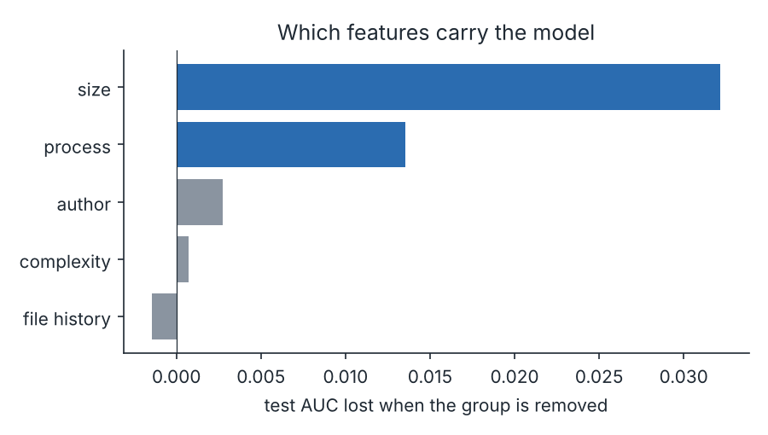
Test AUC lost when each feature group is removed
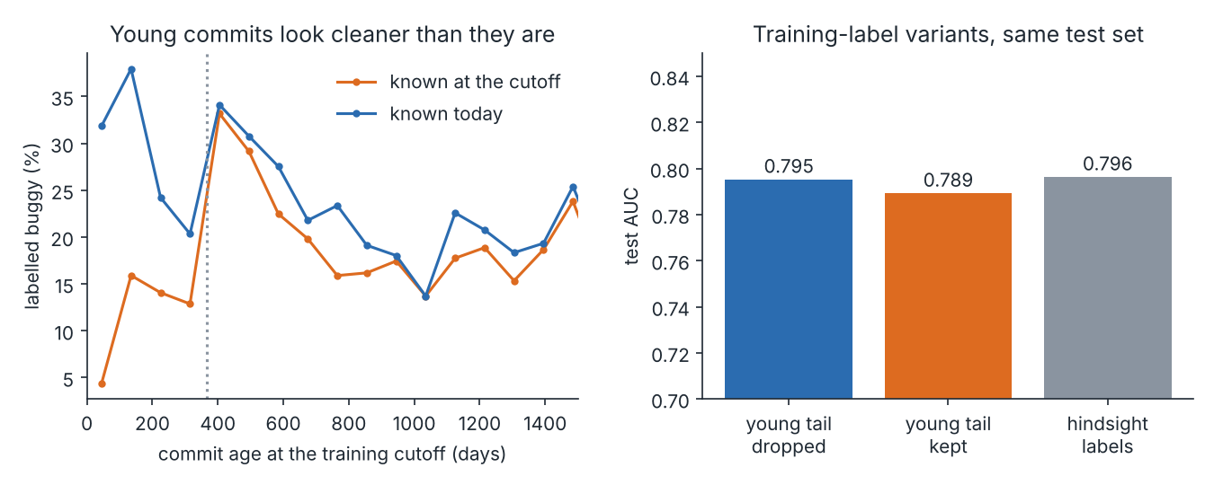
Young commits look cleaner at the cutoff, but the ranking barely changes
Training labels | Test AUC | Test log loss
Known at cutoff, final year dropped (shipped) | 0.795 | 0.3845
Known at cutoff, final year kept | 0.789 | 0.3587
Every fix ever mined | 0.796 | 0.3915

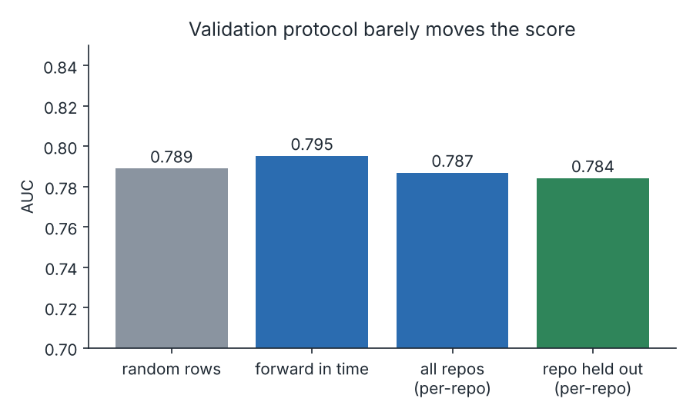
AUC under three validation protocols
A random split gives 0.789, forward in time 0.795, and holding a whole repository out gives a mean of 0.784 against 0.787 when the model has seen it.
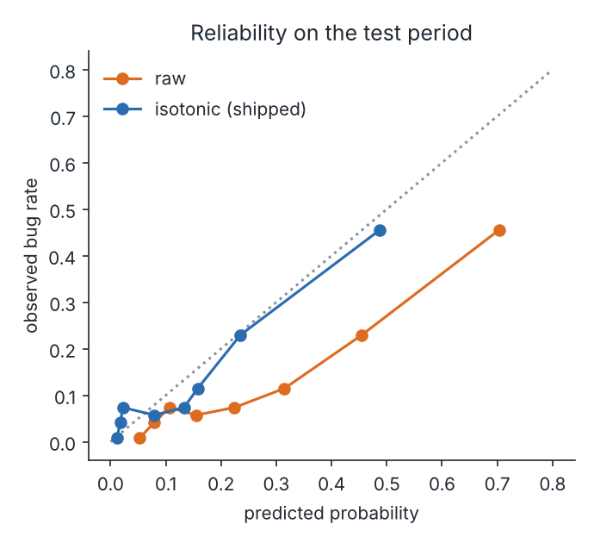
Raw and isotonic-calibrated probabilities on the test period
The model predicted 26.2% on average for the test commits against 13.2% observed. Isotonic calibration cut the expected calibration error from 0.130 to 0.033.
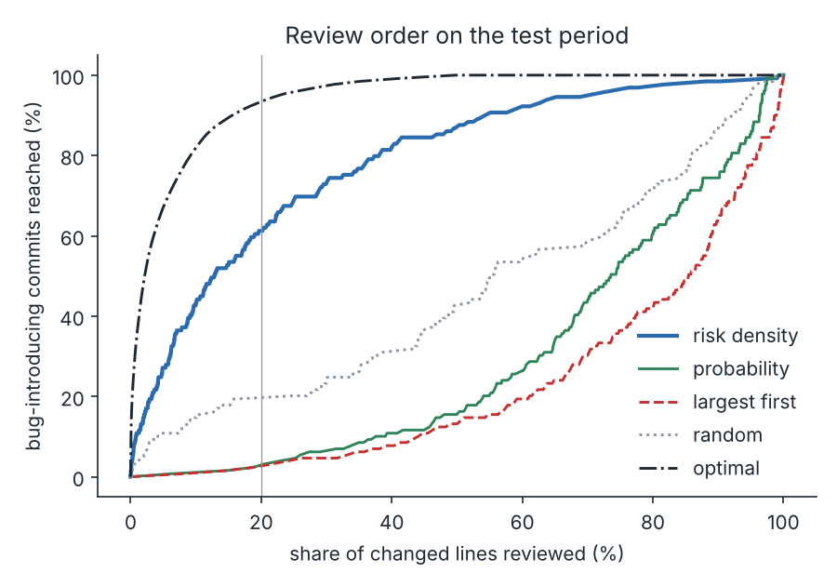
Share of bug-introducing commits reached as review effort grows
With 20% of changed lines reviewed, ranking by probability per line reaches 61.2% of bug-introducing commits and the smallest-first rule reaches 58.1%. The 3.1 point difference has an interval of -1.7 to +8.5 and includes zero.
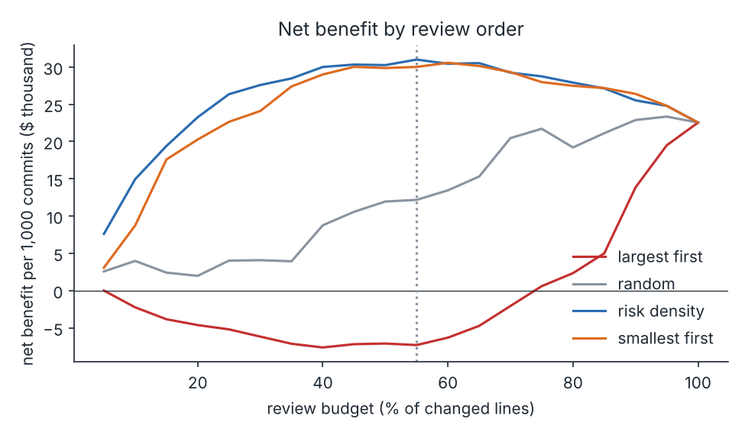
Net benefit per 1,000 commits by review order, under stated assumptions
Review order | Commits read | Bugs in list | Net per 1,000 commits
Probability per changed line | 943 | 116 | $31,001
Smallest first | 955 | 115 | $30,018
Random | 469 | 68 | $12,175
Largest first | 39 | 20 | -$7,312
Review everything | 977 | 129 | $22,549
The money figures rest on assumptions I chose and list openly: a reviewer reads 200 changed lines an hour, each commit adds 15 minutes of overhead, an hour costs $90, an escaped defect costs $2,000, and deep review prevents 30% of defects. Against largest-first the model order is ahead by $38,313 per 1,000 commits (interval $21,906 to $54,181). Against smallest-first it is ahead by $984, with an interval of -$966 to +$2,191. The break-even cost of an escaped defect is $1,130.

Closing line
patchrisk is a small model with a careful evaluation, and the most valuable thing it shows is how much of a commit-risk score is just the size of the diff.

