ratecraft
A motor insurance tariff, built and audited end to end
Ranjith Guggilla | github.com/ranjithguggilla/ratecraft

One-line summary
ratecraft prices third-party liability cover for 677,991 French motor policies with exposure-offset GLMs and gradient-boosted challengers, picks the model with a rule fixed in advance, and shows in a simulated market that a flat-rate competitor facing it keeps about a third of the customers at a 137% loss ratio.

What the project is about
Every motor insurer has to answer one question for every customer: how much will this driver cost us over the next year? The answer becomes a tariff, a table of rating factors and multipliers that a regulator can read and an underwriter can defend. Get it wrong in either direction and the market punishes you: overcharge and the good risks leave, undercharge and you collect the bad ones.
ratecraft builds that tariff from public data the way a pricing team would, then checks it the way their model reviewer would. It models how often each policyholder claims and how much each claim costs, compares classical GLMs against gradient boosting under a fair rule, and turns the difference between models into money with a two-insurer market simulation. A Gradio screen quotes any customer and explains the price in plain words.

Problem statement
Insurance data breaks the assumptions most machine learning tutorials make. Policies are on cover for different lengths of time, so the target is a rate, not a count. 96% of policies have no claim at all, and among the claims, the largest 1% carry 38% of the total cost. The same customer can appear several times in the table, so a random train and test split can grade a model on people it has already seen.
On top of that, a better score is not automatically a better tariff. The model has to be calibrated across the whole price range, explainable factor by factor, and worth its extra complexity in euros. The question I set was therefore practical: which model should actually price this book, how sure can we be that it is better, and what is the difference worth?

Solution overview
The system fetches the French motor third-party liability tables from a pinned commit of the CASdatasets package, checks them against SHA-256 digests, and audits them before any model sees them. Exposure is capped at one year, individual claims are capped at EUR 50,000 with the excess charged back as a flat loading, and the data is split 60/20/20 by risk profile so no customer straddles two folds.
Six pure-premium models compete: a flat rate, a Poisson frequency GLM times a gamma severity GLM, a Tweedie GLM, the GLM with interaction terms found by a greedy search, a boosted frequency times boosted severity model, and a Tweedie GBM. A rule fixed before the test fold was opened ships the simplest model unless the next tier buys at least 5% more improvement on validation. Everything is then scored once on held-out profiles with deviance, Gini, a Murphy decomposition, actual-over-expected tables, a double-lift chart and a profile-level bootstrap.

How the system works, step by step
- Fetch and verify. A sparse, blobless git fetch pulls only the two data files from a pinned commit; their digests must match before anything is parsed. A pure-Python reader handles the R file format, so no R install is needed.
- Audit. Claim counts are reconciled against claim rows, exposure and claim-size problems are counted, and repeated risk profiles are measured. Nothing is silently fixed.
- Prepare. Exposure is capped at one policy-year, claims at EUR 50,000, rating factors are banded at fixed edges with a base level for each, and density enters as a logarithm.
- Split. Identical risk profiles are grouped and whole groups are dealt into train, validation and test.
- Fit. Frequency GLMs carry log-exposure as an offset; boosted frequency models get it as an init score. Severity models are weighted by claim count. Ridge strength, Tweedie power, interaction terms and tree shapes are all chosen on validation.
- Select. Within a complexity tier the better validation score wins; moving up a tier has to buy 5% more improvement.
- Evaluate. The test fold is scored once, with a bootstrap over whole risk profiles for the uncertainty.
- Price and explain. Pure premium plus the large-loss loading, divided by a 70% target loss ratio, gives the office premium. Each quote lists the factors that moved it most against an average policy.
- Simulate the market. Two insurers quote every test policy; customers choose by price; each insurer pays the claims of the customers it won.

What happens in the background
The pipeline runs in five cached stages (frequency GLM, frequency booster, severity, direct Tweedie models, and the side studies) followed by a report stage that writes every number to one metrics file, every table to CSV and every chart to PNG. Each stage can be rerun on its own, and a full run takes a little over two minutes on four CPU cores. A from-scratch rerun on the same machine reproduced every digit.
The side studies test assumptions instead of taking them on trust. One fits the frequency model three ways to see how exposure handling changes calibration by policy duration. Another repeats the GLM and booster fits over five seeds with grouped and row-level splits to measure whether the repeated profiles leak. A third refits severity at four claim caps to see what the large-loss treatment does to ranking and balance.
On the main branch, continuous integration downloads the pinned data, reruns everything from scratch, fails if any committed result moves by more than 1%, and uploads the fitted pricer with the charts as a build artifact.

Backend and tools used
The GLMs are fitted with glum, written as formulas through formulaic and backed by tabmat's categorical matrices, which keeps a 61-coefficient Poisson fit on 400,000 policies under a second. The challengers are LightGBM boosters with a monotone constraint on bonus-malus. Calibration tests by rating factor come from model-diagnostics, the raw R files are read with rdata, the evaluation and bootstrap code is my own on NumPy and scikit-learn, charts are drawn with matplotlib, and the quoting screen is Gradio. Ruff and pytest guard the code in GitHub Actions on Python 3.10 and 3.12.

Business insights
- Nearly all the predictable signal is in claim frequency. The best severity model removes 0.43% of the flat mean's deviance, and the severity GLM only beat the plain average once its ridge penalty reached 0.01. Almost 30% of claims are for exactly EUR 1,204 or EUR 1,128.12, which looks like fixed-rate settlements rather than assessed damage.
- Bonus-malus carries most of the risk. Drivers in the 100 to 125 band, where new drivers start, claim at 5.57 times the rate of the best band, which is why driver age 18 to 20 adds only 18% once bonus-malus is known.
- The textbook treatment of exposure fails on this data. Policies on cover for under a month claim three times as often per year as full-year policies; the offset model under-predicts them by 42% and over-predicts full-year policies by 18%. The common shortcut of fitting annualised claims without weights overstates the whole book by 58%.
- Pricing sophistication pays off against a cruder competitor and then shows diminishing returns. A GLM wipes out a flat-rate rival; a booster against a good GLM wins on margin but not by much, because the winner's curse also hands it the customers it underprices.

Tech stack with versions
component | library | version
language | Python | 3.10 and 3.12 in CI
GLMs | glum / tabmat / formulaic | 3.4.1 / 4.2.1 / 1.2.2
boosted models | LightGBM | 4.7.0
calibration tests | model-diagnostics | 1.4.2
R data reader | rdata | 0.11.2
data frames | pandas / NumPy / pyarrow | 2.3.3 / 2.2.6 / 25.0.1
isotonic fits, metrics | scikit-learn / SciPy | 1.7.2 / 1.15.3
interface | Gradio | 6.28.0
charts | matplotlib | 3.10.9
reference checks | statsmodels | 0.15.0
quality | pytest / ruff | 9.1.1 / 0.16.9

My role
I designed and built the whole project on my own: the problem framing, the data pipeline and audit, the banding and the split, every model and the selection rule, the evaluation and bootstrap code, the exposure, split and large-loss studies, the market simulation, the pricing and explanation layer, the Gradio screen, the test suite and the CI pipeline that re-derives every reported number.

Core contributions
- A reproducible data path: pinned commit, digest check, sparse fetch and a pure-Python reader, with the GPL data kept out of the MIT repository.
- A profile-grouped split, and a five-seed study that measured whether it mattered (here it did not, and the write-up says so).
- Exposure-correct GLMs and boosters, plus a greedy interaction search that kept two terms and rejected a third that fell 4% short of the bar.
- A pre-registered selection rule and a profile-level bootstrap that puts an honest interval on the winner's lead.
- Calibration evidence beyond a single score: Murphy decomposition, double lift and bias tests across 52 rating-factor levels.
- A pricing layer that explains every quote against an average policy, with the effects multiplying back to the exact price.
- A two-insurer market simulation that converts model differences into loss ratios and euros under stated assumptions.

Outputs achieved
- A Python package (src/ratecraft) of 16 modules, including the Gradio quoting screen installed as ratecraft-app.
- 99 tests at 93% line coverage, all on synthetic data, with ruff clean.
- A metrics file holding every quoted number, 13 CSV result tables, nine charts and the fitted pricer.
- A CI workflow that lints and tests on two Python versions and, on the main branch, rebuilds and checks every committed result before uploading the pricer as an artifact.

Key results and impact

Pure-premium models on held-out risk profiles
Test fold: 135,633 policies, 71,617 policy-years and 5,248 claims. Improvement is the share of the flat rate's Tweedie deviance (power 1.5, claims capped at EUR 50,000) that a model removes.
model | validation improvement | test improvement | Gini
flat rate | 0 | 0 | 0
GLM tariff (Poisson x gamma) | 4.65% | 5.65% | 0.341
Tweedie GLM | 4.50% | 5.50% | 0.339
GLM with two interactions | 4.93% | 6.16% | 0.352
boosted frequency x severity (shipped) | 5.42% | 6.37% | 0.360
Tweedie GBM | 5.37% | 6.06% | 0.349

The interaction terms bought 6.0% more validation improvement than the plain GLM and the booster bought 9.8% more than that, so both cleared the 5% bar. The booster's test lead over the GLM with interactions is 0.21 points, with a 95% bootstrap interval of -0.15 to +0.55 points; it comes out ahead in 88.5% of 200 resamples.
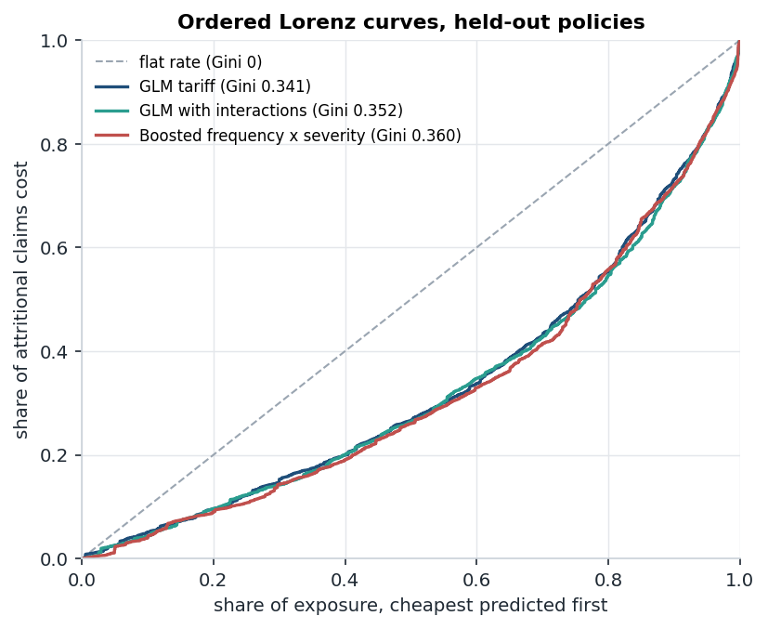
Ordered Lorenz curves on the held-out policies.

Calibration
model | discrimination | miscalibration
GLM tariff | 4.87 | 0.58
GLM with interactions | 5.20 | 0.51
boosted frequency x severity | 5.72 | 0.87
Tweedie GBM | 5.40 | 0.79

The booster ranks risks best and is also the least well calibrated, which leaves an isotonic recalibration as the cheapest improvement still available. On the double-lift chart its line is closer to actual cost in 8 of 10 deciles, and both the booster and the GLM with interactions show exactly one biased level out of 52 at p < 0.01.
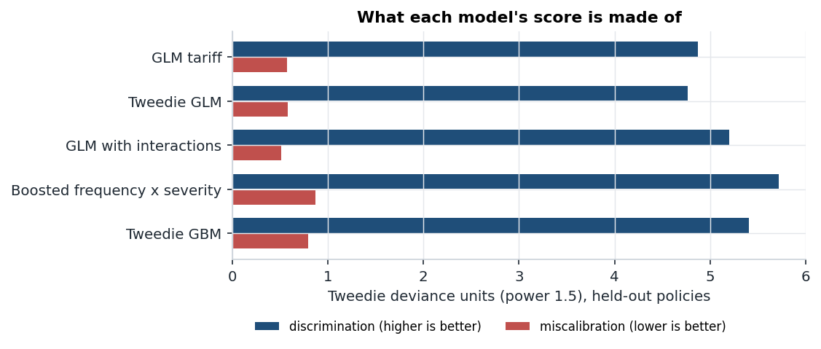
Discrimination and miscalibration from the Murphy decomposition.

The exposure finding
actual / expected | under 1 month | 1-3 months | full year | book balance
log-exposure offset | 1.72 | 1.43 | 0.85 | 1.019
annualised, unweighted | 1.20 | 0.95 | 0.52 | 1.585
offset plus duration factor | 0.90 | 0.93 | 1.03 | 1.020

The duration factor fixes calibration but implies a full-year claim rate 24% lower than the offset model's. Because the data cannot say whether short policies are short because of claims or because they are new business, and the two explanations call for opposite corrections, I ship the offset model, which stays balanced under both.
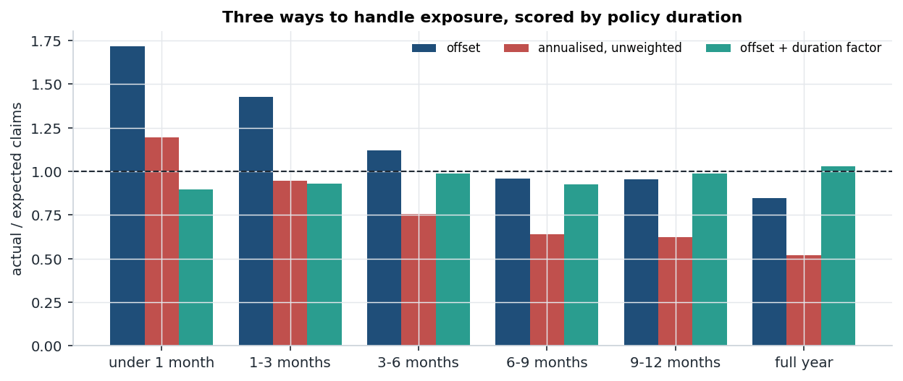
Actual over expected claims by policy duration for three exposure treatments.

What the differences are worth
Assumptions: both insurers divide their technical price by a 70% target loss ratio, expenses are 25% of premium, and customers either take the cheaper quote or follow a logit demand curve with elasticity 4. Results are per 100,000 policy-years each insurer writes.
market and demand | insurer | customers | loss ratio | result
flat vs GLM, cheapest wins | flat rate | 35.2% | 136.7% | -EUR 11.49M
 | GLM with interactions | 64.8% | 64.9% | +EUR 1.26M
flat vs GLM, logit | flat rate | 41.5% | 111.6% | -EUR 6.81M
 | GLM with interactions | 58.5% | 67.1% | +EUR 1.04M
GLM vs booster, cheapest wins | GLM with interactions | 48.3% | 81.7% | -EUR 1.19M
 | booster | 51.7% | 74.7% | +EUR 0.04M
GLM vs booster, logit | GLM with interactions | 49.5% | 75.6% | -EUR 0.10M
 | booster | 50.5% | 73.5% | +EUR 0.26M
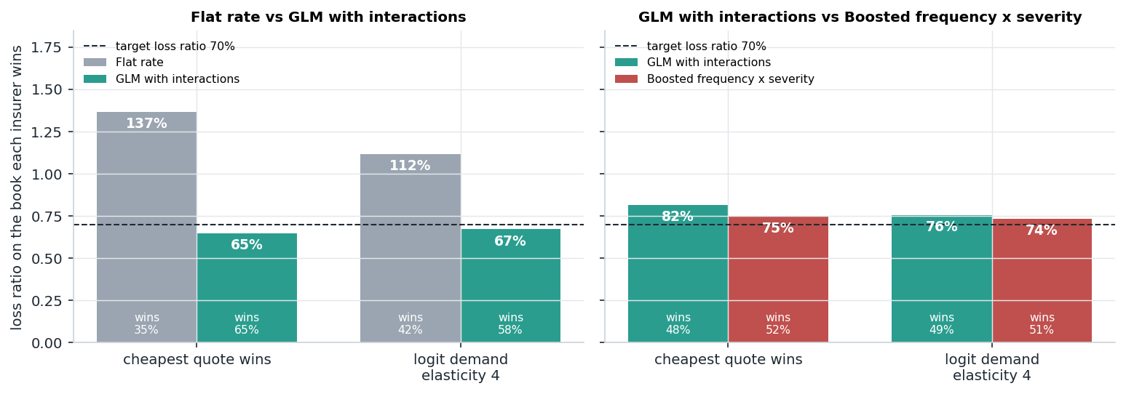
Loss ratio on the book each insurer wins.

Quotes with reasons
The pricer's own output for three example customers. The new driver is where the models disagree most: EUR 679 from the booster against EUR 963 from the GLM with interactions.
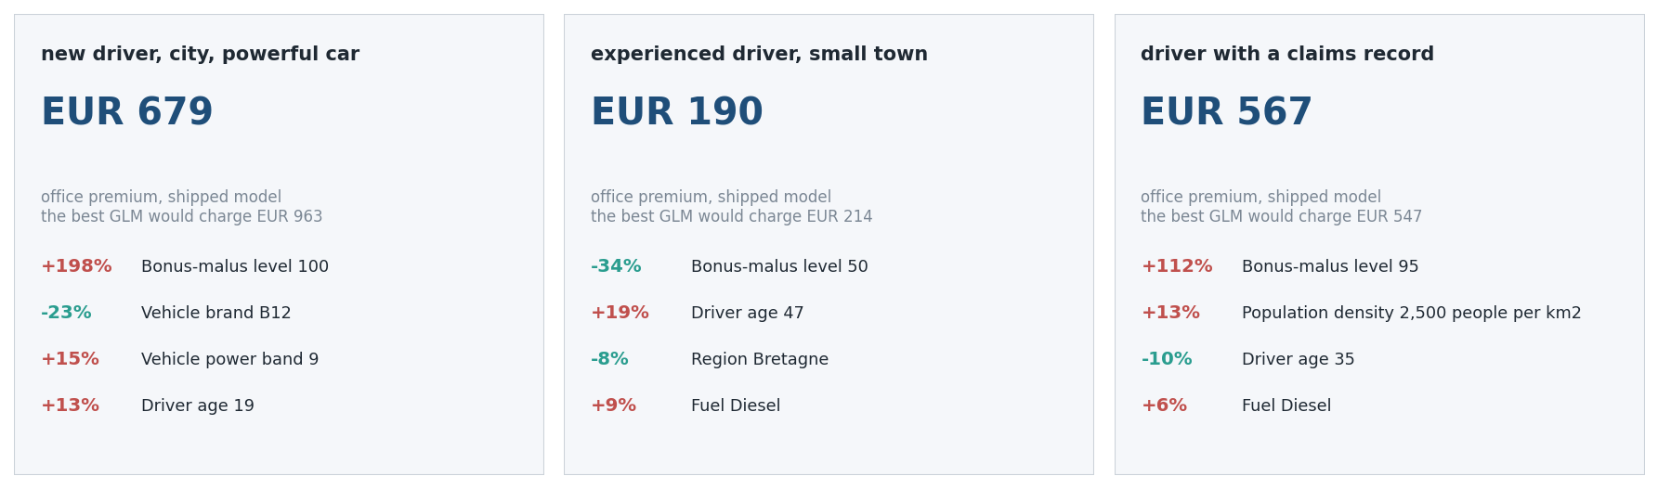
Office premiums and the four factors that moved each one most.

Closing line
A pricing model earns its place by being calibrated, explainable and worth more than the simpler one in money, and ratecraft measures all three on public data instead of assuming them.

