shiftcast
Project overview: from a week-ahead demand forecast to a cost-minimal driver schedule

One-line summary
shiftcast forecasts a week of New York taxi demand, converts it into the number of cabs needed in every half hour, and uses a constraint solver to build the cheapest set of driver shifts that covers it, then prices the result against what actually happened.

What the project is about
Fleet operators commit to a driver schedule days before the demand arrives. The forecast is only useful if it changes what gets scheduled, and the schedule is only useful if it is cheap. I built the whole chain on 10,320 half-hourly trip counts (1 July 2014 to 31 January 2015) so that I could measure how much each link in it matters, rather than assume the forecast is the important part.

Problem statement
A taxi fleet has to decide how many cabs to put on the road in each of the 336 half-hours of the coming week, and in what shift patterns, without knowing demand. Too few cabs and trips go unserved. Too many and drivers sit idle on the clock. The week used for evaluation contains Christmas, New Year, a public holiday and the January 2015 blizzard, which is where a plan built from history is most likely to fail.

Solution overview
The system has four stages. Four candidate forecasters produce a demand forecast one week ahead. The best one on validation weeks is chosen by a written rule. Residuals from validation weeks turn the point forecast into a sized demand at a chosen safety level. An integer program then picks how many cabs start each kind of shift at each half-hour so every slot is covered at minimum cost. A cost model scores the plan against realised demand.

How the system works, step by step
- Load the trip counts and check they form one regular 30 minute grid with no gaps, duplicates or negative values.
- Cut the series into whole-week blocks: nine for validation, eight for testing, aligned so the last block ends on the final observation.
- For each block, forecast all 336 slots using only history that ends before the block starts. Four forecasters run: seasonal naive, a four-week window median, MSTL with daily and weekly seasonality, and gradient boosting on a log ratio.
- Rank the models by validation WAPE and apply the selection rule: lowest error wins, unless a simpler model is within 0.003 WAPE.
- Fit residual quantiles by part of the day on the validation weeks, then size demand at each of six safety levels.
- Solve a weekly shift-cover problem for every block and level, pick the safety level that minimises validation cost, and fix it before looking at the test weeks.
- Score the chosen plan and five alternatives on the test weeks: perfect foresight, a point forecast with no margin, seasonal naive, a greedy scheduler and a flat fleet.
- Repeat the level choice under four unmet-trip cost assumptions to see how fragile the conclusion is.
- Plan the week after the data ends, and publish the metrics, charts and a small web planner.

What happens in the background
Each forecaster is a function of the history and the future timestamps only, and a test confirms that changing anything inside the forecast block leaves the forecast unchanged. The boosting model predicts the log ratio of a slot to the mean of the same slot over the previous four weeks, so it learns time-of-day and weekday shape while the level comes from recent weeks. Holiday flags use the US and New York calendars with half weight on a holiday eve.
The scheduler treats the week as a cycle of 336 slots. It has one integer variable per shift length and start slot, a coverage constraint per slot, and an objective in cents. Short four-hour shifts carry a 15% premium per slot, so the solver uses them only for narrow peaks. Every weekly problem solved to proven optimality in a median of 0.30 seconds. Because costs depend on the number of cabs, the evaluation caches each solved schedule and reprices it under different assumptions without re-solving.

Backend and tools used
- Python for the full pipeline, with a single entry point that writes metrics, forecasts, a next-week plan and charts.
- statsforecast for the MSTL model, LightGBM for boosting, NumPy, pandas and SciPy for the numerical work.
- Google OR-Tools CP-SAT for the shift-cover integer program.
- The holidays package for the New York calendar, matplotlib for charts, and Gradio for the planner interface.
- pytest with coverage, ruff for lint and formatting, and a GitHub Actions workflow that lints, tests and, on the main branch, runs the full study and uploads the results.

Business insights
The scheduling method is worth far more than the forecast model. Replacing a greedy scheduler with the solver cuts total cost by $47.7M (10.6%) over the eight test weeks, and a flat fleet sized to last week's peak costs $262.8M more. Choosing between forecast models moves cost by about 0.1%.
At the base cost assumptions the forecasting model did not pay for itself: the shipped plan cost $0.5M more than simply repeating last week. It starts to win once an unmet trip is expensive. At $40 per unmet trip it saves $15.7M, and at $25 it saves $3.8M. A fleet should measure its real cost of a missed trip before investing in forecasting.
Most of the remaining gap to perfect foresight (13.3%) is three weeks: the two holiday weeks and the storm week ran 31.8%, 27.1% and 20.7% above the lower bound. The cheapest improvement is an event override that lets a planner mark a known holiday or a storm warning, not a better model for ordinary weeks.

Tech stack with versions
Component | Version | Used for
Python | 3.13 | Pipeline and tests
statsforecast | 2.1.1 | MSTL forecaster
LightGBM | 4.7.0 | Boosting on log ratio
OR-Tools | 9.15.6755 | CP-SAT shift scheduling
pandas | 2.3.3 | Time series handling
NumPy | 2.5.3 | Array maths
SciPy | 1.18.1 | Numerical support
holidays | 0.106 | New York holiday calendar
matplotlib | 3.11.2 | Charts
Gradio | 6.30.0 | Planner interface
pytest / ruff | current | Tests and lint

My role
I designed, built, tested and documented the project on my own: choosing the question, finding and validating the data, writing every module, setting the evaluation rules before looking at the test weeks, and writing up the results including the ones that did not go the way I expected.

Core contributions
- A week-ahead evaluation that respects the real planning horizon, so no forecaster can use yesterday.
- A written model selection rule that prefers the simpler model when the difference is inside a stated tolerance, applied before the test weeks were scored.
- A cost-aware safety level chosen on validation, with the sensitivity to the unmet-trip cost shown rather than hidden.
- A cyclic shift-cover integer program with mixed shift lengths, compared against a greedy scheduler and a flat fleet.
- A planner interface backed by a unit-tested scoring function, and a CI workflow that rebuilds the full study on every push to main.

Outputs achieved
- A tested Python package with 37 passing tests and 93% line coverage, lint clean.
- A metrics file holding every number reported here, plus backtest and test forecasts at slot level.
- Seven charts, most of them used in the README and this document.
- A next-week plan with forecast, sized demand and cabs to schedule for every half hour.
- A Gradio planner for any of the eight test weeks or the week after the data ends.

Key results and impact
Forecast accuracy, measured as week-ahead WAPE (lower is better). The shipped model won validation and is the simplest serious candidate.
Model | Validation (9 weeks) | Test (8 weeks)
Window median, 4 weeks (shipped) | 5.99% | 16.58%
Gradient boosting on log ratio | 7.38% | 15.57%
Seasonal naive | 8.19% | 16.31%
MSTL | 8.25% | 18.13%

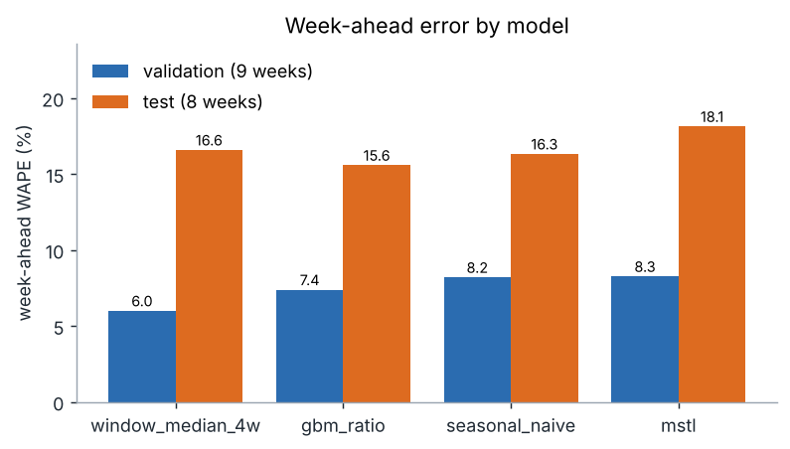
Boosting scored better on the test weeks. The paired bootstrap over test weeks puts the shipped model's gap to boosting at 1.0 points with a 95% interval of -0.3 to 2.5, which includes zero, so the four models cannot be separated on eight weeks.
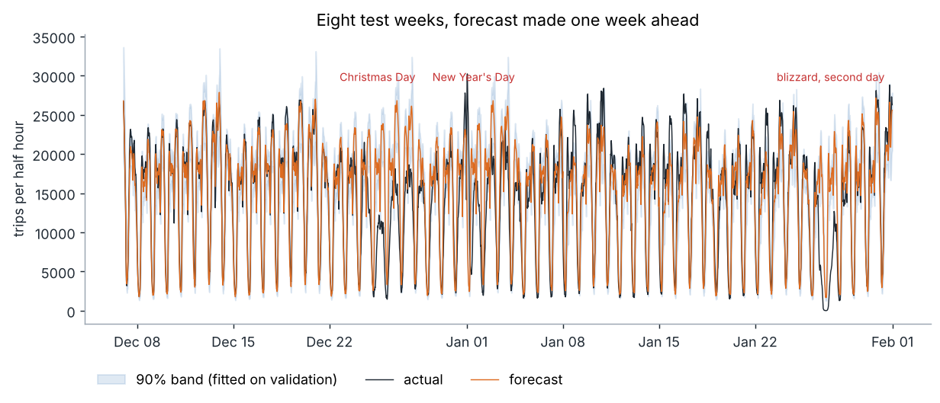
Daily-total error on the days the history could not have anticipated:
Day | Signed error | Note
Christmas Eve (2014-12-24) | +22.7% | forecast too high
Christmas Day (2014-12-25) | +102.3% | forecast too high
New Year's Eve (2014-12-31) | +3.7% | forecast too high
New Year's Day (2015-01-01) | +10.8% | forecast too high
MLK Day (2015-01-19) | +8.9% | forecast too high
blizzard, first day (2015-01-26) | +59.8% | forecast too high
blizzard, second day (2015-01-27) | +190.2% | forecast too high

On ordinary days the median daily error is 6.5%. The nominal 90% prediction interval, fitted on validation weeks, covered 60.5% of test slots (65.1% on ordinary days, 28.0% on the event days). The calibration window was calmer than the test period, which is why I treat the safety margin as a tunable cost choice rather than a guaranteed coverage level.
Cost of each planning approach over the eight test weeks (38.9 million trips):
Plan | Labour | Unmet trips | Total | Service level
Perfect foresight (lower bound) | $355.7M | $0.0M | $355.7M | 100.0%
Shipped: window median + solver | $368.7M | $34.2M | $402.9M | 94.1%
Point forecast + solver | $369.5M | $33.5M | $403.0M | 94.3%
Seasonal naive + solver | $363.7M | $38.7M | $402.4M | 93.4%
Greedy scheduler | $425.5M | $25.2M | $450.6M | 95.7%
Flat fleet at last week's peak | $665.3M | $0.4M | $665.7M | 99.9%

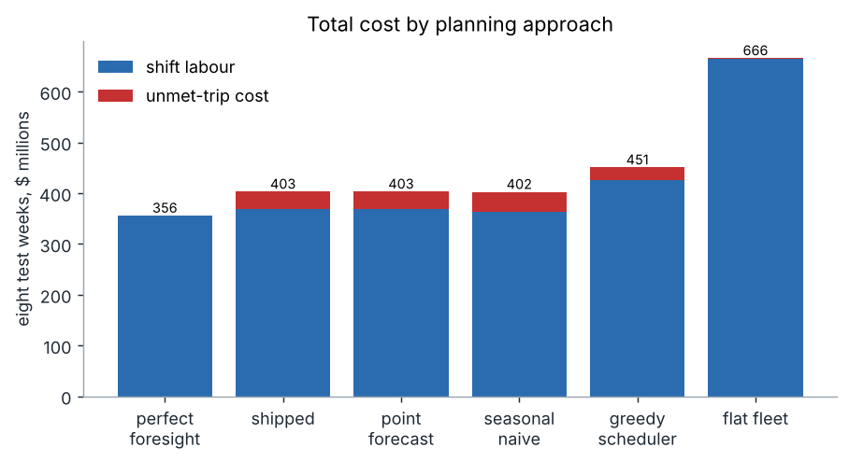
How the conclusion changes with the cost of an unmet trip (safety level re-chosen on validation each time):
Unmet-trip cost | Level | Shipped | Seasonal naive | Difference
$8 | 0.50 | $386.9M | $384.3M | -$2.6M
$15 | 0.50 | $402.9M | $402.4M | -$0.5M
$25 | 0.60 | $424.3M | $428.2M | +$3.8M
$40 | 0.70 | $451.2M | $466.8M | +$15.7M

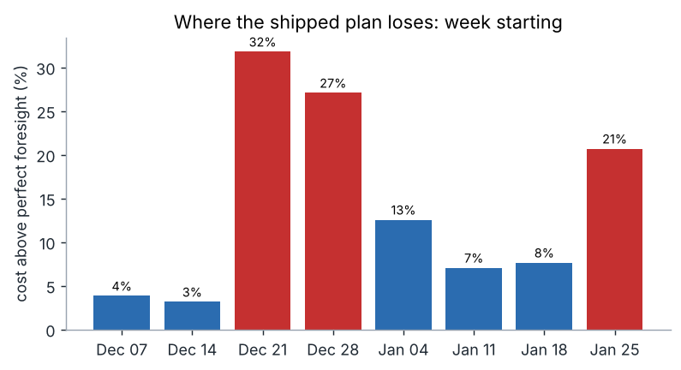
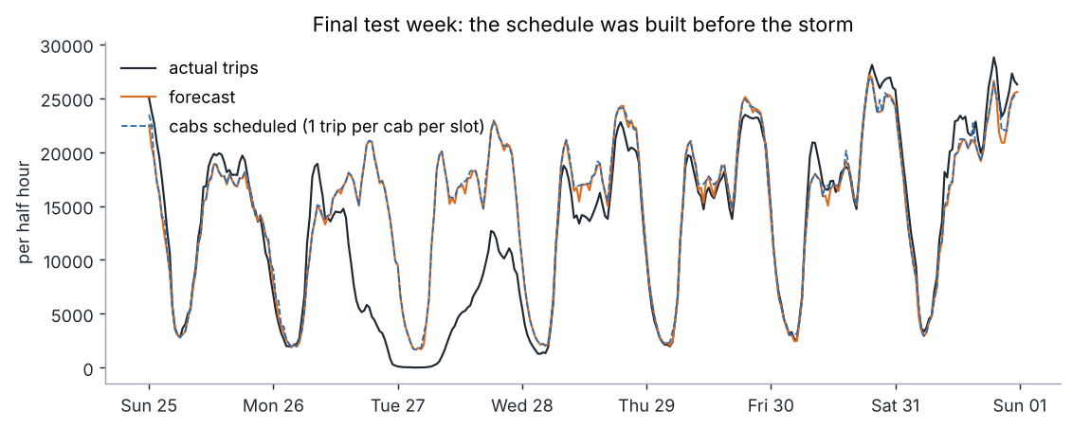
Impact in plain terms: the solver-built schedule is 11% cheaper than a sensible greedy rule and 39% cheaper than a flat fleet, and it serves 94% of trips at the base costs. The remaining distance to perfect foresight, 13.3%, is concentrated in weeks with events, so that is where a planner override or an event feed would pay back first. All dollar figures rest on assumed unit costs and a fleet scale implied by the aggregate counts, so they show relative size, not a forecast of real profit.

Closing line
A week-ahead forecast only matters as far as it changes the schedule, and on this data the schedule optimiser, not the forecast model, was where the money was.

