**Electronic control unit**

An electronic control unit (ECU), also known as an electronic control module (ECM), is an [embedded system](https://en.wikipedia.org/wiki/Embedded_system) in [automotive electronics](https://en.wikipedia.org/wiki/Automotive_electronics) that controls one or more of the [electrical systems](https://en.wikipedia.org/wiki/Automotive_electronics#Types) or subsystems in a car or other [motor vehicle](https://en.wikipedia.org/wiki/Motor_vehicle).

Modern vehicles have many ECUs, and these can include some or all of the following: [engine control module](https://en.wikipedia.org/wiki/Engine_control_unit) (ECM), [powertrain control module](https://en.wikipedia.org/wiki/Powertrain_control_module) (PCM), transmission control module (TCM), brake control module (BCM or EBCM), central control module (CCM), central timing module (CTM), general electronic module (GEM), [body control module](https://en.wikipedia.org/wiki/Body_control_module) (BCM), and suspension control module (SCM). These ECUs together are sometimes referred to collectively as the car's computer though technically they are all separate computers, not a single one. Sometimes an assembly incorporates several individual control modules (a PCM often controls both the engine and the transmission).

Some modern motor vehicles have up to 150 ECUs. [Embedded software](https://en.wikipedia.org/wiki/Embedded_software) in ECUs continues to increase in line count, complexity, and sophistication. Managing the increasing complexity and number of ECUs in a vehicle has become a key challenge for [original equipment manufacturers](https://en.wikipedia.org/wiki/Original_equipment_manufacturer#Automotive_parts) (OEMs).

**Engine control unit (ECU)**

An engine control unit (ECU), also commonly called an engine control module (ECM), is a type of [electronic control unit](https://en.wikipedia.org/wiki/Electronic_control_unit) that controls a series of [actuators](https://en.wikipedia.org/wiki/Actuators) on an [internal combustion engine](https://en.wikipedia.org/wiki/Internal_combustion_engine) to ensure optimal engine performance. It does this by reading values from a multitude of [sensors](https://en.wikipedia.org/wiki/Sensor) within the engine bay, interpreting the data using multidimensional performance maps (called [lookup tables](https://en.wikipedia.org/wiki/Lookup_table)), and adjusting the engine actuators. Before ECUs, air–fuel mixture, ignition timing, and idle speed were mechanically set and dynamically controlled by [mechanical](https://en.wikipedia.org/wiki/Machine) and [pneumatic](https://en.wikipedia.org/wiki/Pneumatics) means.

If the ECU has control over the [fuel](https://en.wikipedia.org/wiki/Fuel) lines, then it is referred to as an electronic engine management system (EEMS). The [fuel injection](https://en.wikipedia.org/wiki/Fuel_injection) system has the major role of controlling the engine's fuel supply. The whole mechanism of the EEMS is controlled by a stack of sensors and actuators.

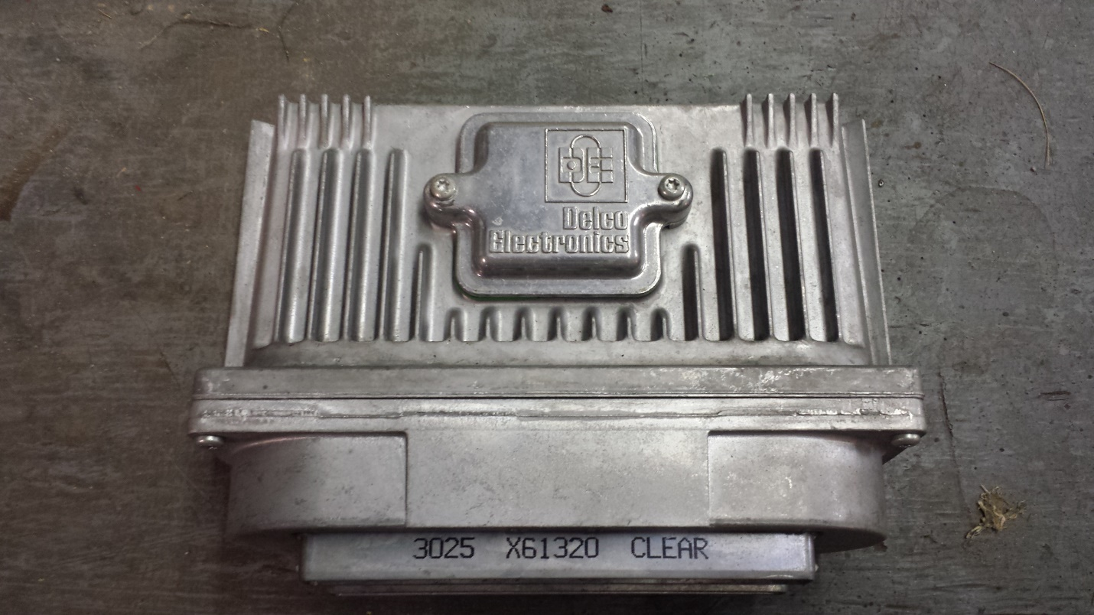

**Workings**

### Control of air–fuel ratio

Most modern engines use some type of fuel injection to deliver fuel to the cylinders. The ECU determines the amount of fuel to inject based on a number of sensor readings. [Oxygen sensors](https://en.wikipedia.org/wiki/Oxygen_sensor) tell the ECU whether the engine is running rich (too much fuel or too little oxygen) or running lean (too much oxygen or too little fuel) as compared to ideal conditions (known as stoichiometric). The [throttle position sensor](https://en.wikipedia.org/wiki/Throttle_position_sensor) tells the ECU how far the throttle plate is opened when the accelerator ([gas pedal](https://en.wikipedia.org/wiki/Car_controls)) is pressed down. The mass [air flow sensor](https://en.wikipedia.org/wiki/Air_flow_meter) measures the amount of air flowing into the engine through the throttle plate. The [engine coolant temperature sensor](https://en.wikipedia.org/wiki/Engine_coolant_temperature_sensor) measures whether the engine is warmed up or cool. If the engine is still cool, additional fuel will be injected.

Air–fuel mixture control of carburettors with computers is designed with a similar principle, but a mixture control solenoid or stepper motor is incorporated in the float bowl of the carburettor.

### Control of idle speed

Most engine systems have [idle speed](https://en.wikipedia.org/wiki/Idle_speed) control built into the ECU. The engine [RPM](https://en.wikipedia.org/wiki/Revolutions_per_minute) is monitored by the [crankshaft position sensor](https://en.wikipedia.org/wiki/Crankshaft_position_sensor), which plays a primary role in the engine timing functions for fuel injection, spark events, and valve timing. Idle speed is controlled by a programmable throttle stop or an idle air bypass control stepper motor. Early carburettor-based systems used a programmable throttle stop using a bidirectional [DC motor](https://en.wikipedia.org/wiki/DC_motor). Early [throttle body injection](https://en.wikipedia.org/wiki/Fuel_injection#Throttle_body_injection) (TBI) systems used an idle air control [stepper motor](https://en.wikipedia.org/wiki/Stepper_motor). Effective idle speed control must anticipate the engine load at idle.

A full authority throttle control system may be used to control idle speed and provide cruise control functions and top-speed limitation. It also monitors the ECU section for reliability.

### Control of variable valve timing

Some engines have [variable valve timing](https://en.wikipedia.org/wiki/Variable_valve_timing). In such an engine, the ECU controls the time in the engine cycle at which the valves open. The valves are usually opened sooner at higher speed than at lower speed. This can increase the flow of air into the cylinder, increasing power and fuel economy.

### Electronic valve control

Experimental engines have been made and tested that [have no camshaft](https://en.wikipedia.org/wiki/Camless), but have full electronic control of the intake and exhaust valve opening, valve closing, and area of the valve opening. Such engines can be started and run without a starter motor for certain multi-cylinder engines equipped with precision-timed electronic ignition and fuel injection. Such a *static-start* engine would provide the efficiency and pollution-reduction improvements of a [mild hybrid-electric drive](https://en.wikipedia.org/wiki/Hybrid_vehicle_drivetrain#Mild_Hybrids), but without the expense and complexity of an oversized starter motor.

The first production engine of this type was invented (in 2002) and introduced (in 2009) by Italian automaker [Fiat](https://en.wikipedia.org/wiki/Fiat) in the [Alfa Romeo](https://en.wikipedia.org/wiki/Alfa_Romeo) MiTo. Their [Multiair](https://en.wikipedia.org/wiki/Multiair" \o "Multiair) engines use electronic valve control, which dramatically improves torque and horsepower while reducing fuel consumption as much as 15%. Basically, the valves are opened by hydraulic pumps, which are operated by the ECU. The valves can open several times per intake stroke, based on engine load. The ECU then decides how much fuel should be injected to optimize combustion.

At steady load conditions, the valve opens, fuel is injected, and the valve closes. Under a sudden increase in throttle, the valve opens in the same intake stroke and a greater amount of fuel is injected. This allows immediate acceleration. For the next stroke, the ECU calculates the engine load at the new, higher RPM and decides how to open the valve: early or late, wide-open, or half-open. The optimal opening and timing are always reached and combustion is as precise as possible. This is impossible with a normal camshaft, of course, which opens the valve for the whole intake period and always to full lift.

The elimination of cams, lifters, rockers, and timing set reduces not only weight and bulk, but also friction. A significant portion of the power that an engine actually produces is used up just driving the valve train, compressing all those valve springs thousands of times a minute.

Once more fully developed, electronic valve operation will yield even more benefits. Cylinder deactivation, for instance, could be made much more fuel efficient if the intake valve could be opened on every downstroke and the exhaust valve opened on every upstroke of the deactivated cylinder or "dead hole". Another even more significant advancement will be the elimination of the conventional throttle. When a car is run at part throttle, this interruption in the airflow causes excess vacuum, which causes the engine to use up valuable energy acting as a vacuum pump. BMW attempted to get around this on their V-10 powered M5, which had individual throttle butterflies for each cylinder, placed just before the intake valves. With electronic valve operation, it will be possible to control engine speed by regulating valve lift. At part throttle, when less air and gas are needed, the valve lift would not be as great. Full throttle is achieved when the gas pedal is depressed, sending an electronic signal to the ECU, which in turn regulates the lift of each valve event, and opens it all the way up.

**Powertrain control module**

A power-train control module, abbreviated PCM, is an [automotive](https://en.wikipedia.org/wiki/Automotive_industry) component, a control unit, used on [motor vehicles](https://en.wikipedia.org/wiki/Motor_vehicle). It is generally a combined controller consisting of the [engine control unit](https://en.wikipedia.org/wiki/Engine_control_unit) (ECU) and the [transmission control unit](https://en.wikipedia.org/wiki/Transmission_control_unit) (TCU). On some cars, such as many Chryslers, there are multiple computers: the PCM, the TCU, and the Body Control Module (BCM), for a total of three separate computers. These automotive computers are generally very reliable. The PCM commonly controls more than 100 factors in a car or truck. There are many hundreds of error codes that can occur, which indicates that some subsection of the car is experiencing a problem. When one of these errors occurs, usually it will turn on the "check engine" light on the dashboard. The PCM is one of potentially several on-board computers, or essentially the "brain" of the engine control system.

The primary inputs to the PCM come from many sensors, of different types, that are spread around the car. Most of them are oriented toward engine management and performance. These sensors fail at a much higher rate than any of the computers do.

Early use of the powertrain control module dates back to the late 1970s- official phasing inof the PCM occurred during the early 1980s when used in conjunction with electronic controlled [carburetors](https://en.wikipedia.org/wiki/Carburetor) and [lockup torque converters](https://en.wikipedia.org/wiki/Lockup_torque_converter) (at the time conventional 3-speed automatics received lockup converters at the same time overdrives were introduced.

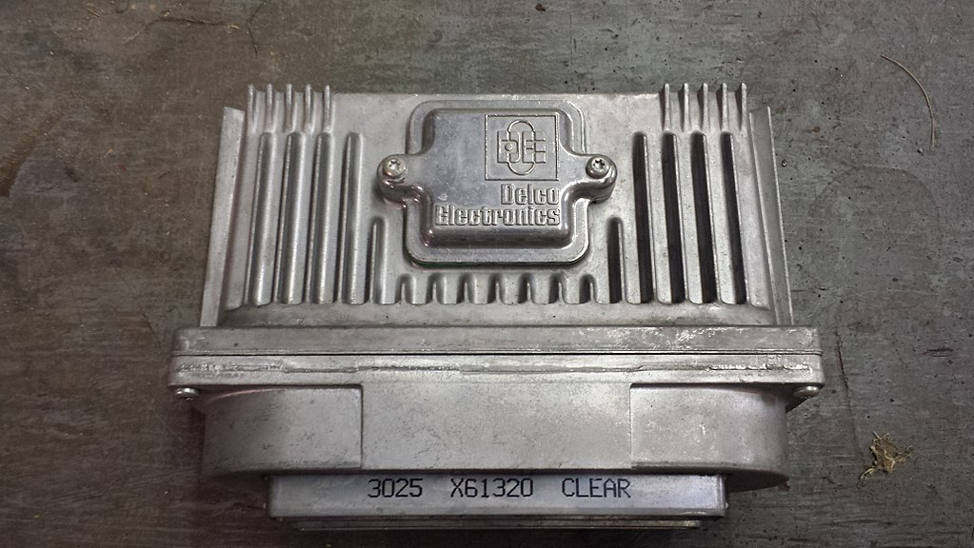

**Transmission control unit**

A transmission control unit (TCU), also known as a transmission control module (TCM), or a gearbox control unit (GCU), is a type of [automotive](https://en.wikipedia.org/wiki/Automotive) [ECU](https://en.wikipedia.org/wiki/Electronic_control_unit) that is used to control electronic [automatic transmissions](https://en.wikipedia.org/wiki/Automatic_transmission). Similar systems are used in conjunction with various [semi-automatic transmissions](https://en.wikipedia.org/wiki/Semi-automatic_transmission), purely for [clutch](https://en.wikipedia.org/wiki/Clutch) [automation](https://en.wikipedia.org/wiki/Automation) and actuation. A TCU in a modern automatic transmission generally uses [sensors](https://en.wikipedia.org/wiki/Sensor) from the vehicle, as well as [data](https://en.wikipedia.org/wiki/Data) provided by the [engine control unit](https://en.wikipedia.org/wiki/Engine_control_unit) (ECU), to calculate how and when to change [gears](https://en.wikipedia.org/wiki/Gear) in the vehicle for optimum performance, [fuel economy](https://en.wikipedia.org/wiki/Fuel_efficiency) and shift quality.

**Body control module**

In automotive electronics, body control module or 'body computer' is a generic term for an [electronic control unit](https://en.wikipedia.org/wiki/Electronic_control_unit) responsible for monitoring and controlling various electronic accessories in a vehicle's body. Typically in a car the BCM controls the [power windows](https://en.wikipedia.org/wiki/Power_windows), [power mirrors](https://en.wikipedia.org/wiki/Power_mirrors), [air conditioning](https://en.wikipedia.org/wiki/Air_conditioning), [immobilizer](https://en.wikipedia.org/wiki/Immobilizer) system, [central locking](https://en.wikipedia.org/wiki/Central_locking), etc. The BCM communicates with other on-board computers via the car's [vehicle bus](https://en.wikipedia.org/wiki/Vehicle_bus), and its main application is controlling load drivers – actuating [relays](https://en.wikipedia.org/wiki/Relay) that in turn perform actions in the vehicle such as locking the doors, flashing the [turn signals](https://en.wikipedia.org/wiki/Turn_signals) (in older cars), or dimming the interior lighting.