What is JDBC ?

It’s a J2AEE API , which is used to connect to any data base from the java code

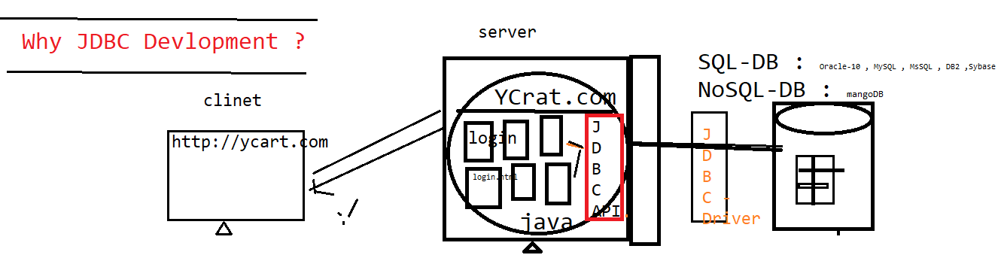



JDBC helps java program to store / retrieve data from the physical database

JDBC WorkFlow ?

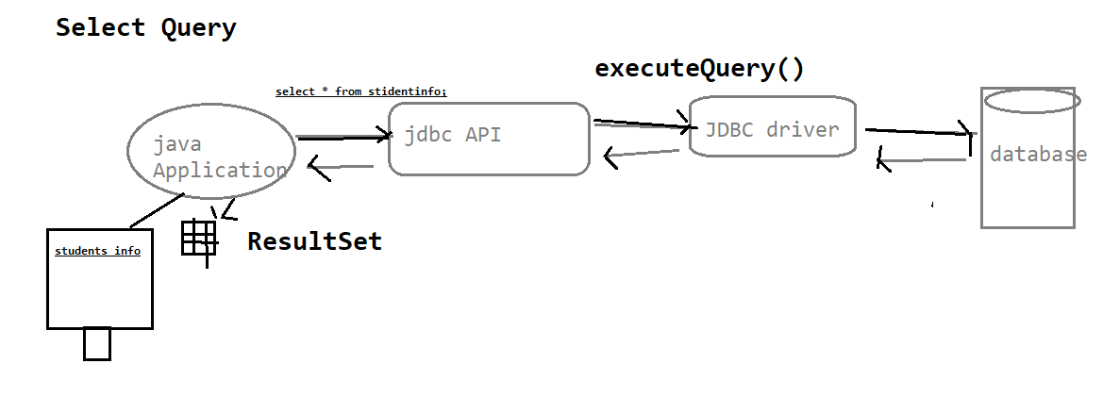

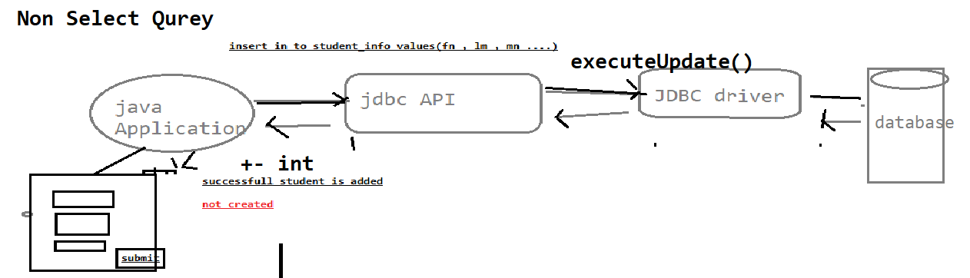

What is JDBC Drivers & JDBC API ?

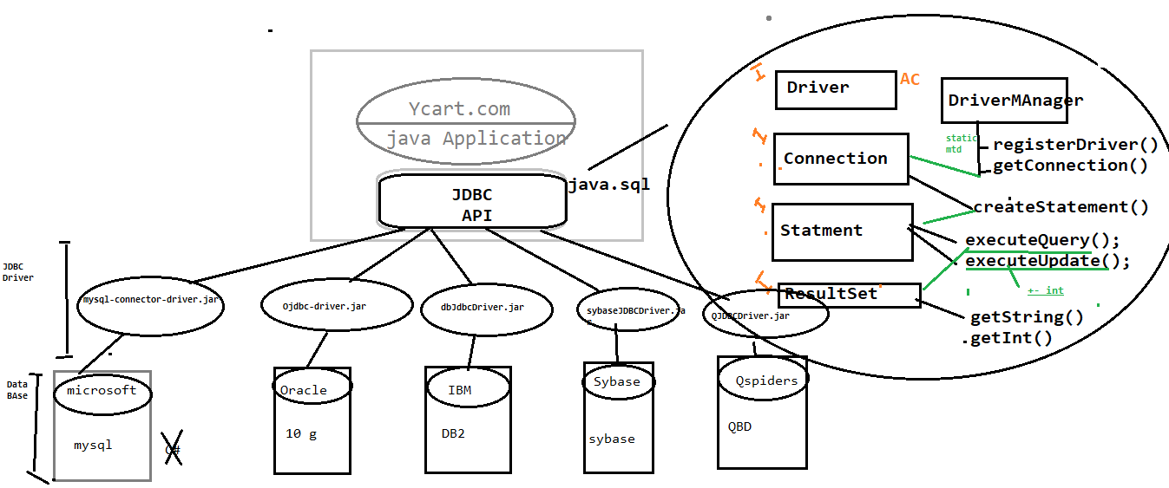

JDBC API : its an API’s available in java.sql package , which is collection interfaces with abstract method & class , & it’s database independent

JDBC Driver : its implementation class of JDBC API provided by data base vender . it’s a db dependent

Why JDBC in Automation ?

In Automation also required JDBC Connection , Most of the test case Preconditions , required few set of data in Database & also validation GUI WRT Database

