Computer Networks Lab Report
Submitted By
V RANJITH KUMAR
RA2411030050052
Under the guidance of
Dr. Mallika
(Assistant Professor, School of Computing)
in partial fulfilment for the award of the degree
of
BACHELOR OF TECHNOLOGY
in
DEPARTMENT OF COMPUTER SCIENCE AND ENGINEERING WITH CYBER SECURITY
of
FACULTY OF ENGINEERING AND TECHNOLOGY

SRM INSTITUTE OF SCIENCE AND TECHNOLOGY,
TIRUCHIRAPPALLI
Academic Year: 2026–2027

COMPUTER NETWORKS LABORATORY
Lab Record: Experiments 1 and 4 (Cisco Packet Tracer)

Lab 1: Introduction to Packet Tracer, Peer-to-Peer Communication, Study of Cables and its Color Codes

Aim
To create a simple peer-to-peer network in Cisco Packet Tracer, assign IP addresses to two PCs, verify connectivity using the ping command, and study network cables and their colour codes.

Procedure
1. Open Packet Tracer
- Launch Cisco Packet Tracer on your computer.
- Familiarize yourself with the interface, including the workspace, device selection, and tools.
2. Create a Simple Network
- Drag two computers (PC-PT) onto the workspace.
- Drag a switch (Switch-PT) onto the workspace.
- Connect each computer to the switch using straight-through Ethernet cables.
3. Configure IP Addresses
- Click on the first computer, go to the Desktop tab, and select IP Configuration.
- Assign an IP address (192.168.1.1) and a subnet mask (255.255.255.0).
- Click on the second computer, go to the Desktop tab, and select IP Configuration.
- Assign an IP address (192.168.1.2) and a subnet mask (255.255.255.0).
4. Test Peer-to-Peer Communication
- On the first computer, open the Command Prompt from the Desktop tab.
- Use the ping command to test connectivity to the second computer (ping 192.168.1.2).
- Observe the response to ensure the computers can communicate.
5. Study Cables and Color Codes
- Examine different types of network cables provided (Ethernet, crossover).
- Note the color codes for each wire in the cables:
  - Straight-through cable (used to connect different devices like a computer to a switch).
  - Crossover cable (used to connect similar devices like computer to computer).

Screenshots
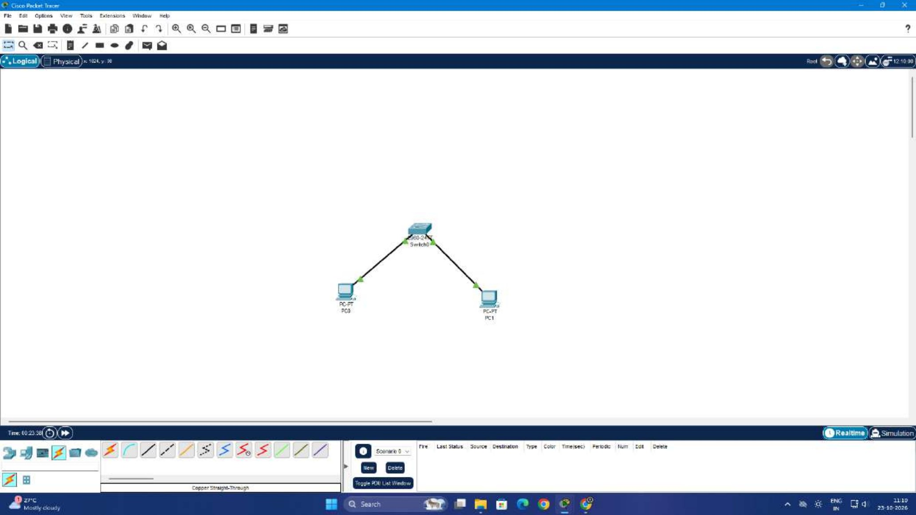
Fig 1.1: Network topology (PC0 and PC1 connected to Switch0)
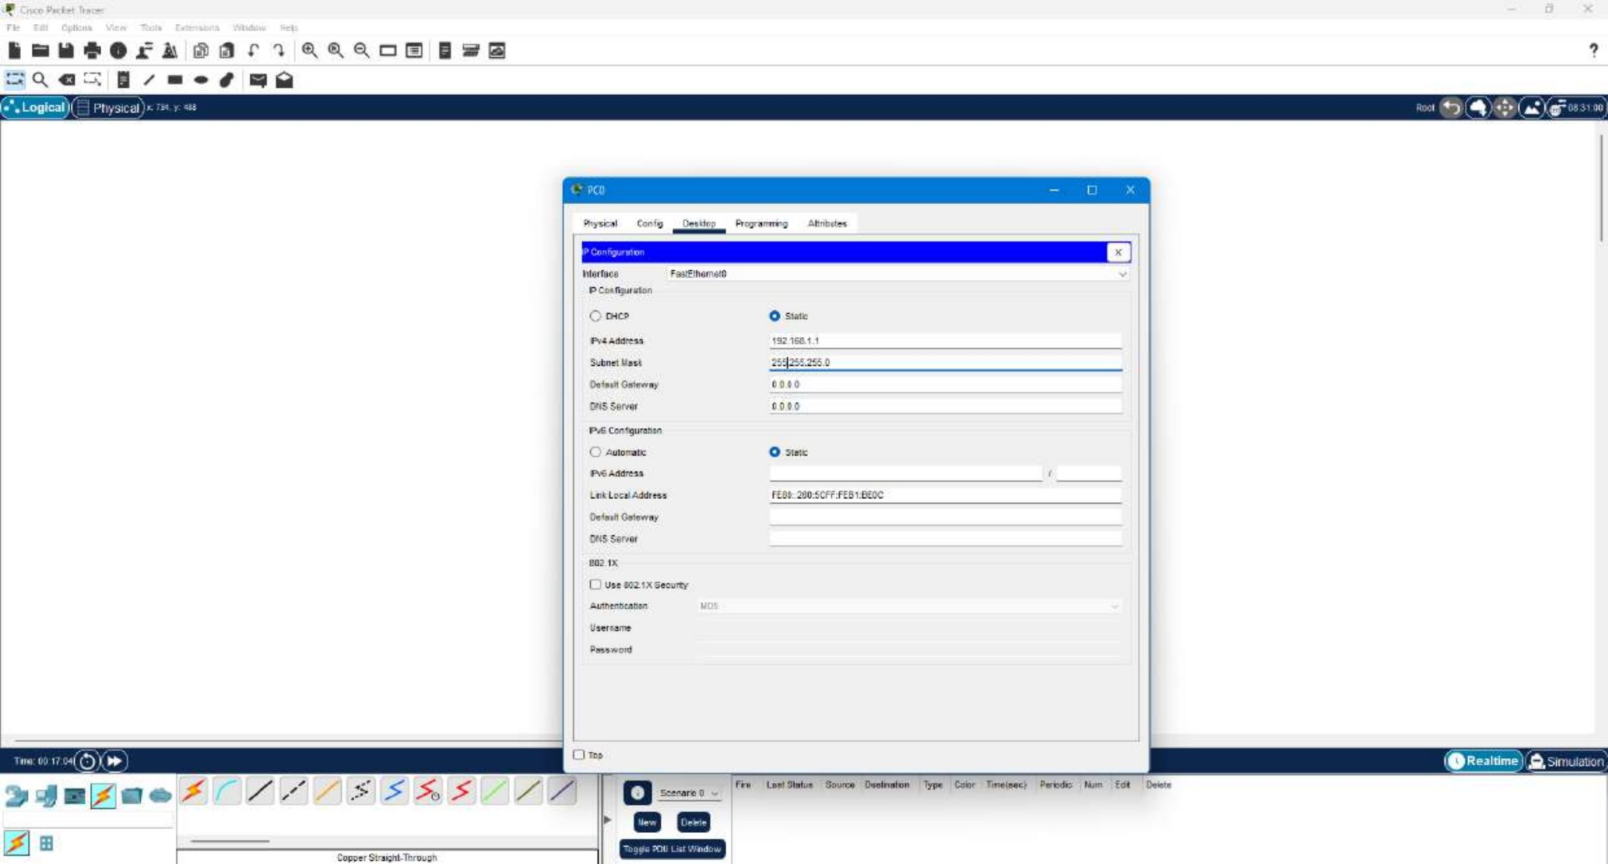
Fig 1.2: IP configuration of PC0 (192.168.1.1 / 255.255.255.0)
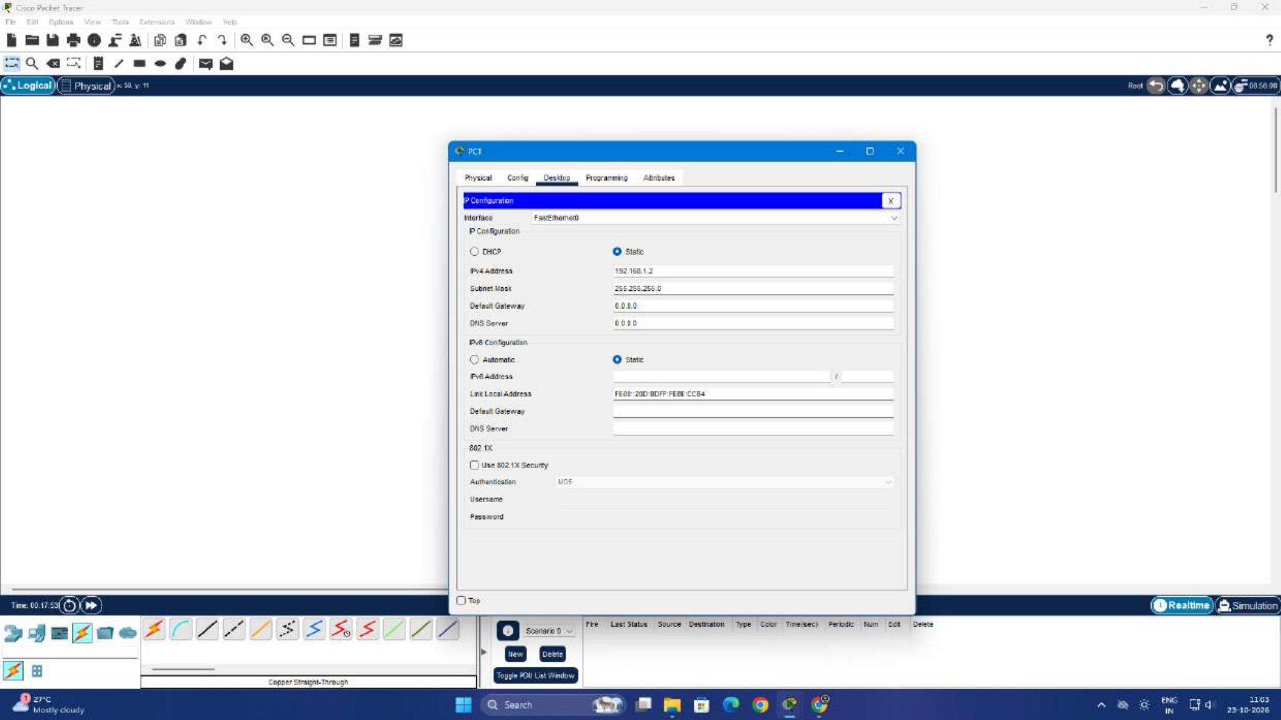
Fig 1.3: IP configuration of PC1 (192.168.1.2 / 255.255.255.0)
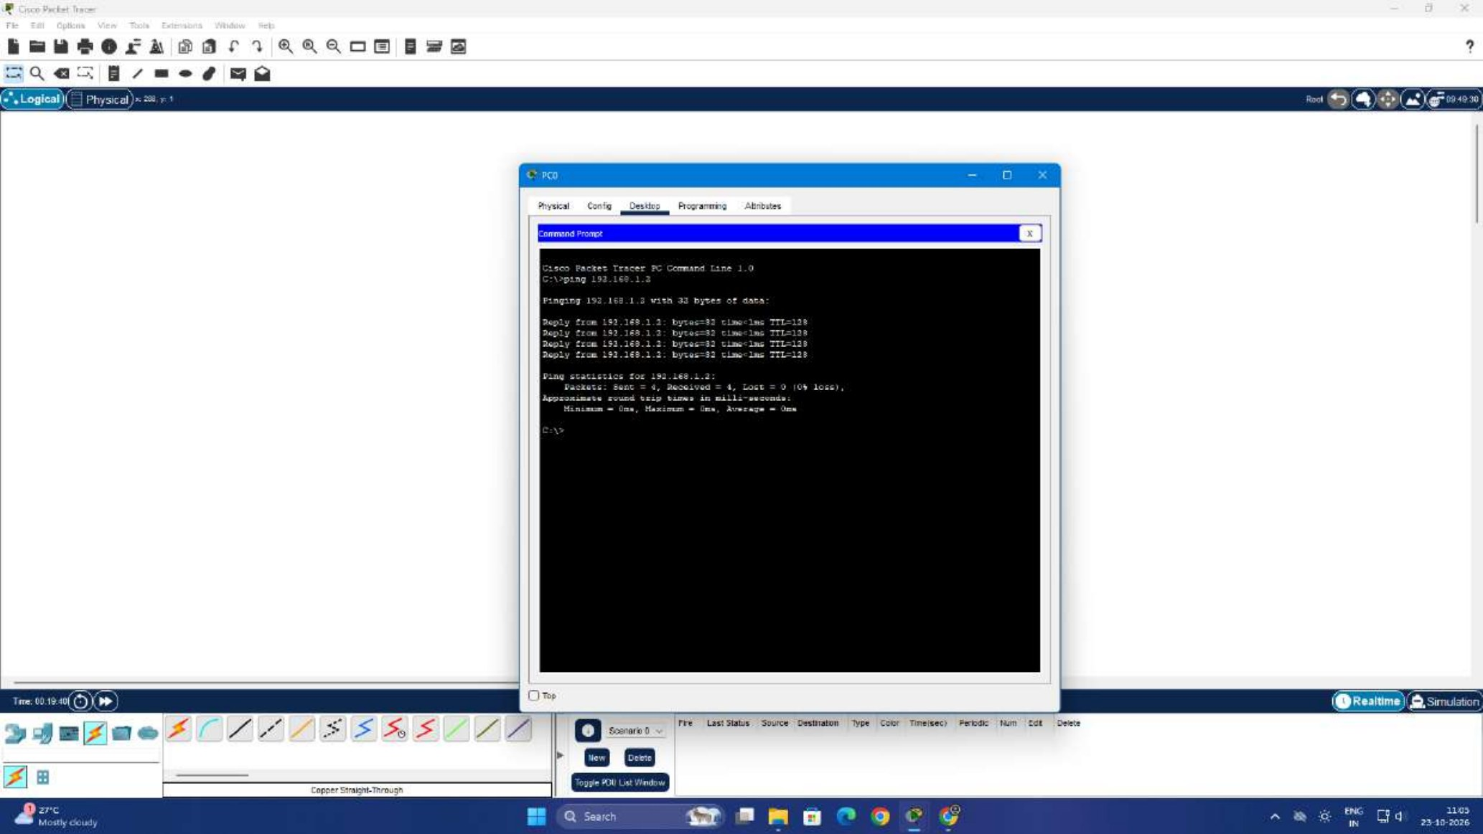
Fig 1.4: Ping from PC0 to PC1 (192.168.1.2), 4 packets sent, 4 received, 0% loss
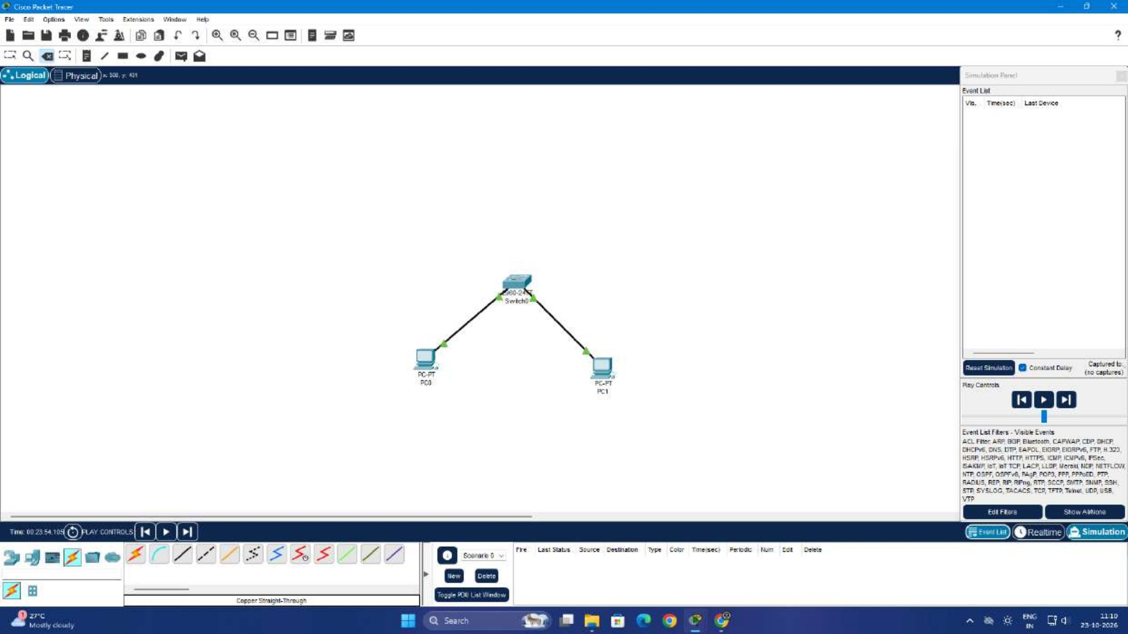
Fig 1.5: Simulation mode, before sending the packet
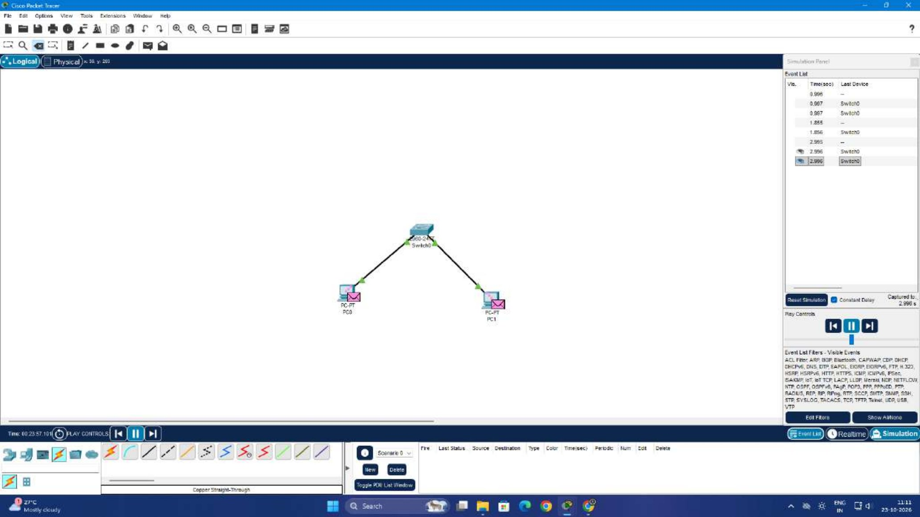
Fig 1.6: Simulation mode, packet captured in the event list

Result
Two PCs were connected through a switch using straight-through cables and configured with 192.168.1.1 and 192.168.1.2. The ping from PC0 to PC1 was successful with no packet loss, confirming peer-to-peer communication.

Lab 4: IP Addressing and Subnetting (VLSM)

Aim
To design a network of three routers connected in a triangle, divide the address space into /30 subnets using VLSM, configure the router interfaces, and verify connectivity between the routers.

Procedure
1. Open Packet Tracer
- Launch Cisco Packet Tracer on your computer.
2. Design Network Topology
- Create a network with three routers connected in a triangular fashion.
3. Calculate Subnets Using VLSM
- Determine the number of required subnets and host addresses.
- Divide the network into subnets using VLSM. Each point-to-point link needs only 2 usable hosts, so a /30 mask (255.255.255.252) is used.
4. Assign IP Addresses
- Configure the interfaces of each router with the calculated IP addresses.
- Addressing used in this experiment:

Link | Subnet | Interface IPs | Mask
Router0 to Router1 | 192.168.1.0/30 | .1 (R0), .2 (R1) | 255.255.255.252
Router0 to Router2 | 192.168.1.4/30 | .5 (R0), .6 (R2) | 255.255.255.252
Router1 to Router2 | 192.168.1.8/30 | .9 (R1), .10 (R2) | 255.255.255.252

5. Configure Interfaces
- Access the CLI of each router.
- Configure the IP addresses on each interface, for example:
Router> enable
Router# configure terminal
Router(config)# interface gigabitethernet 0/0/0
Router(config-if)# ip address 192.168.1.1 255.255.255.252
Router(config-if)# no shutdown
Router(config-if)# exit
Router(config)# end
Router# show ip interface brief
6. Test Connectivity
- Use the ping command to test connectivity between the routers.

Screenshots
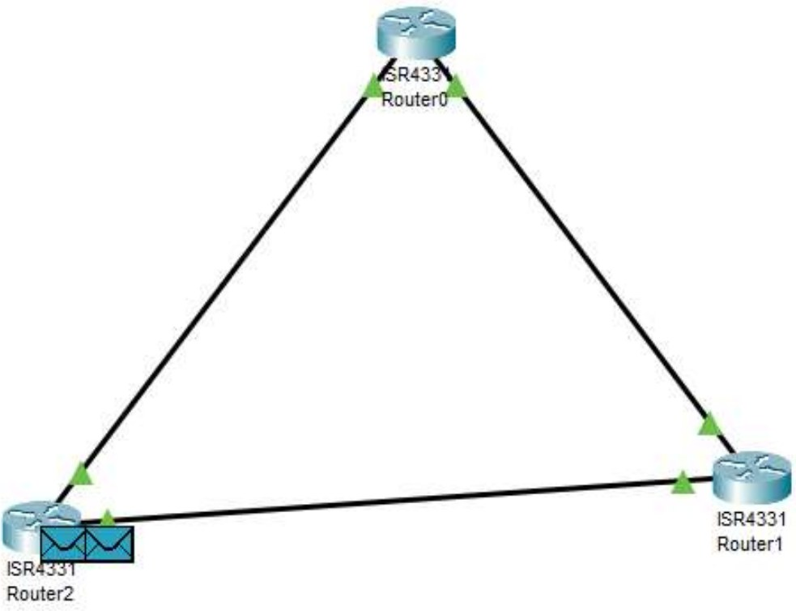
Fig 4.1: Triangular topology of Router0, Router1 and Router2
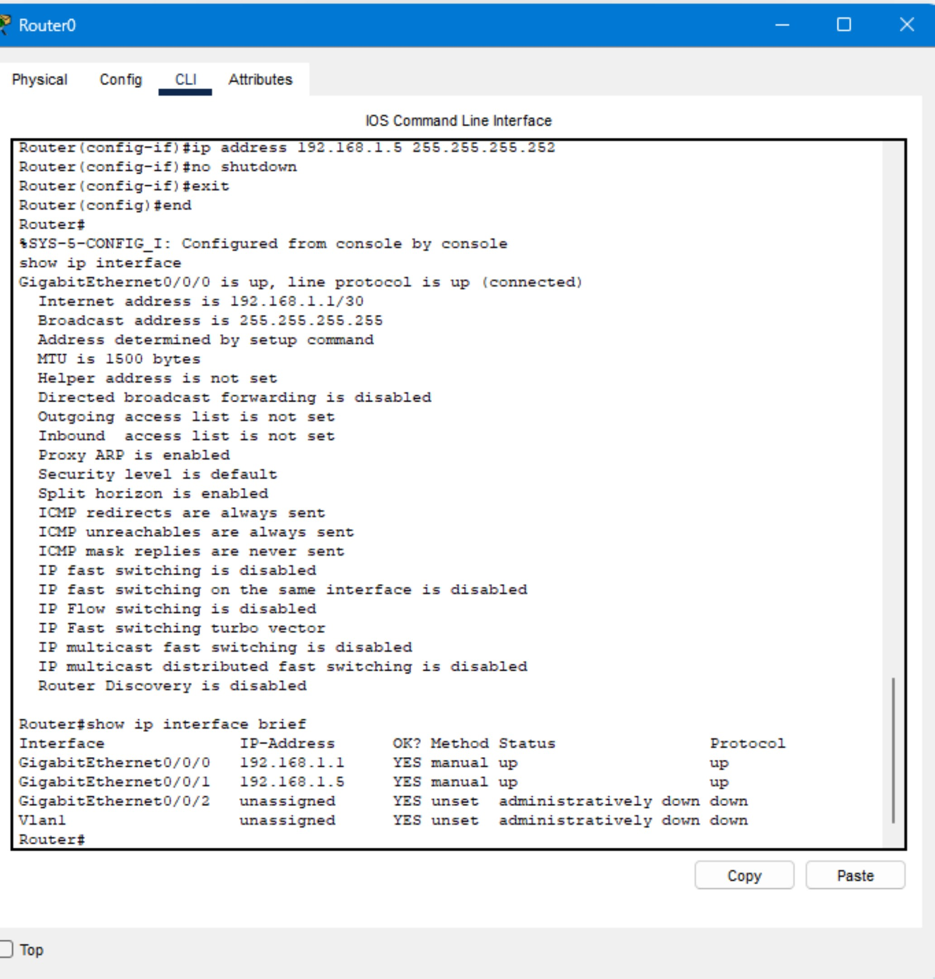
Fig 4.2: Router0 configuration (Gig0/0/0 = 192.168.1.1, Gig0/0/1 = 192.168.1.5)
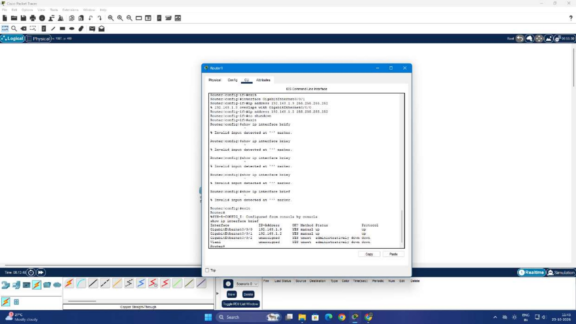
Fig 4.3: Router1 configuration (Gig0/0/0 = 192.168.1.9, Gig0/0/1 = 192.168.1.2)
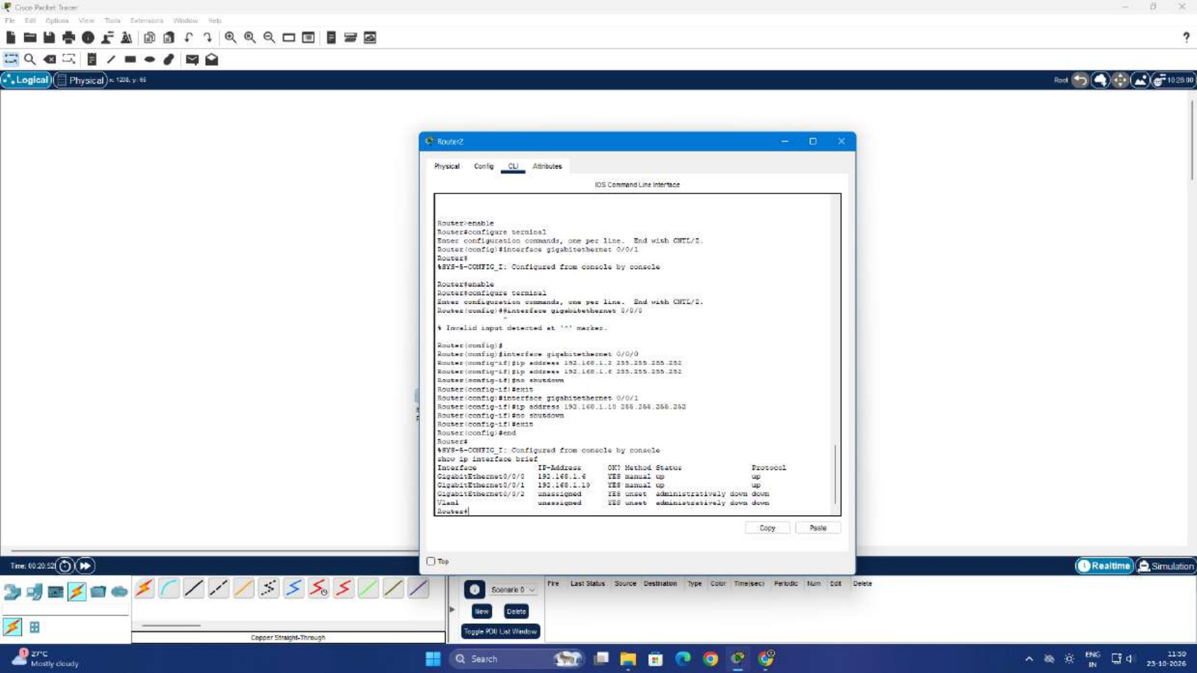
Fig 4.4: Router2 configuration (Gig0/0/0 = 192.168.1.6, Gig0/0/1 = 192.168.1.10)
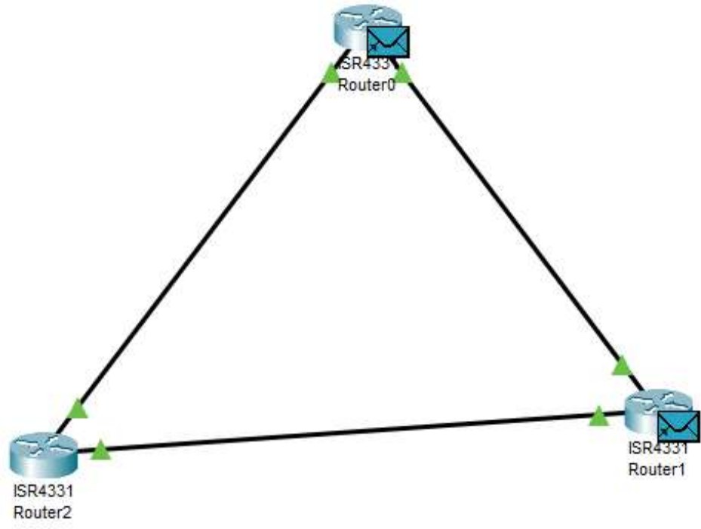
Fig 4.5: Packet transfer between the routers (simulation)

Result
The three routers were connected in a triangular topology and addressed with /30 subnets using VLSM. All configured interfaces show status up and protocol up in the show ip interface brief output, and connectivity between the routers was tested.

