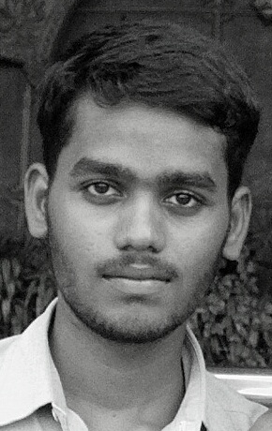
 | Personal Information
 | Full Name | Ranjithkumar Ganapathi
 | Date of Birth | 15-11-1996
 | Gender | Male
 | Nationality | Indian
RANJITHKUMAR G | Address | Plot No: 15, Kavinjar Kanadasan Street, Villianur, Puducherry - 605110
 | Phone | +91 8124835183
 | E-mail | ranjithkuruveli@gmail.com
 | Website | https://ranjithkuru.github.io
 | Academic Details
Course | Institution | Year | Percentage
B.Tech (CSE) | Sri Venkateshwara College of Engineering and Technology - Ariyur | 2014-18 | 73%
HSC | Achariya Siksha Mandir, Puducherry | 2013-14 | 79%
SSLC | SRV High School, Puducherry | 2011-12 | 89%

 | Skills and Competences
 | Languages Known | Tamil (Mother Tongue), English
 | Technical Knowledge
 | Area of Interest | - Automobile  - Manufacturing Process
 | Mini Projet | - Tittle: Semi Automatic Side Stand  - Description: Take off the side stand automatically by using crank drives and  sprocket
 | Design Softwares Worked | AutoCAD, Pro E, Photoshop
 | Operating Systems Worked | Ubuntu Linux, Windows
 | Accreditations | - Had an experience of witnessing Leo Fasteners Pvt Ltd in the year of 2016  - Witnessed the power plant maintained by Neyveli Lignite Corporation in the  year of 2017  - Attended workshop conducted at Sri Venkateshwaraa College of Engineering  and Technology on the topic of Computational Fluid Dynamics, Automobiles  and Nanotechnology in the year of 2016  - Worked as an apprenticeship at G M Pens International pvt Ltd for one week  during February 2016
 | Achievements | - State level trophies twice on elocution and once on Drawing Competition  (Conducted by Govt. of Puducherry)
 | Personal Skills & Hobbies
 | Personal Skills | - DIY Enthusiast  - Undergone soft skills training
 | Hobbies | Creating designs using AutoCAD and Pro E, Photography

