EASYMENU-NG
System Architecture Description

Version 01

Version

Version | Date | Description | Author
00 | 18/12/11 | Draft | Gianrico D'Angelis
01
02
03
04

Indice
1. Scope 5
2. Description 5
2.1 Prerequisites and dependencies 5
3. Architecture Overview 6
3.1 Tablet 6
3.1.1 UserInterface 6
3.1.2 Core Controller 8
3.1.3 Rest Methods 8
4. Server 9

Definitions, acronyms e abbreviations

Definitions
Tablet | A tablet PC is a wireless, portable personal computer with a touch screen interface.

Acronyms
REST | Representation State Transfer

Abbreviations

Reference Documents
System Requirements Specifications v.01

Scope
This document defines the System Requirements Specifications (SRS) for the Easymenu-NG project.

Description
The Easymenu-NG (Next Generation) project is about the design and implementation of an Electronic Restaurant Menu for Android Tablets (to start). In a next stage the same might be ported to other platforms.
At a glance Easymenu-NG system should be :
- fully functional
- easy to use
- open to integrations, customizations and upgrades
The next sections inlcude all the collected System Requirements to design the Easymenu-NG architecture.

Prerequisites and dependencies
Easymenu-NG system is intended to operate in a networked/wifi environment.

Architecture Overview
Easymenu-NG Architecture Overview is shown in Figure 1.

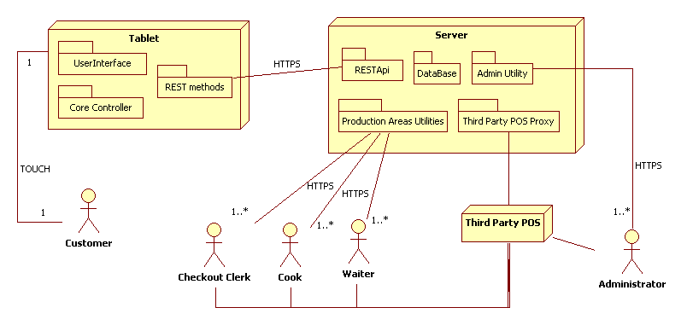
Figure 1-- Architecture Overview

Tablet

The Tablet App permits the interaction of the Customer with the system. The Tablet App communicates with the Server through a RESTful API over HTTPS.
The Tablet App includes the following packages.

UserInterface
Must be easy to use and interact with, have the minimum screen switches as possible.
A few sketches are available in the following figures.
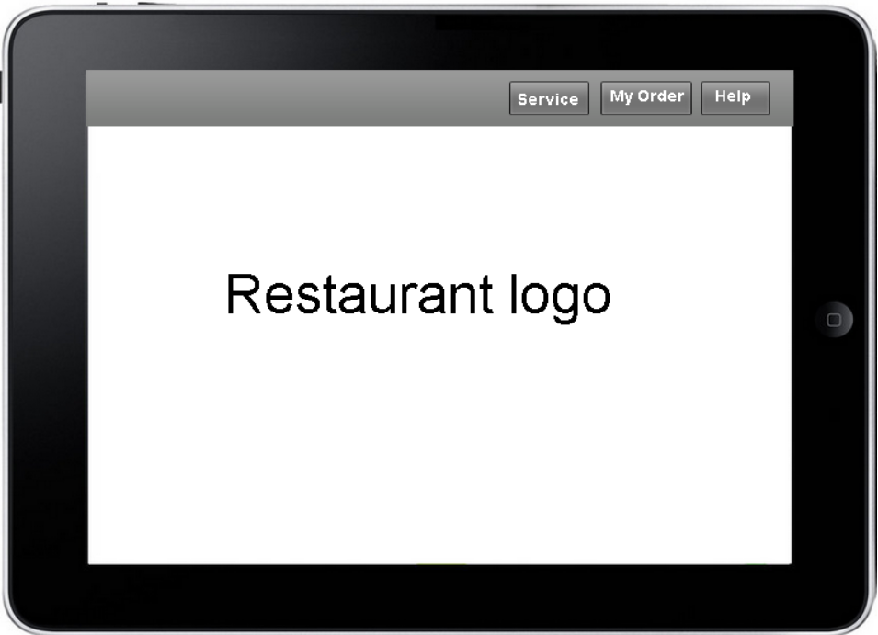

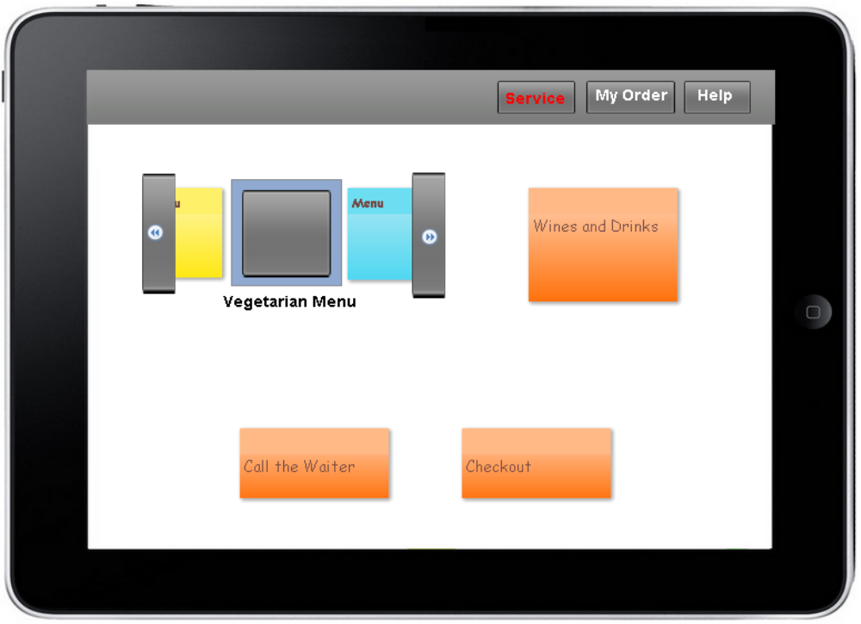
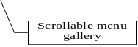
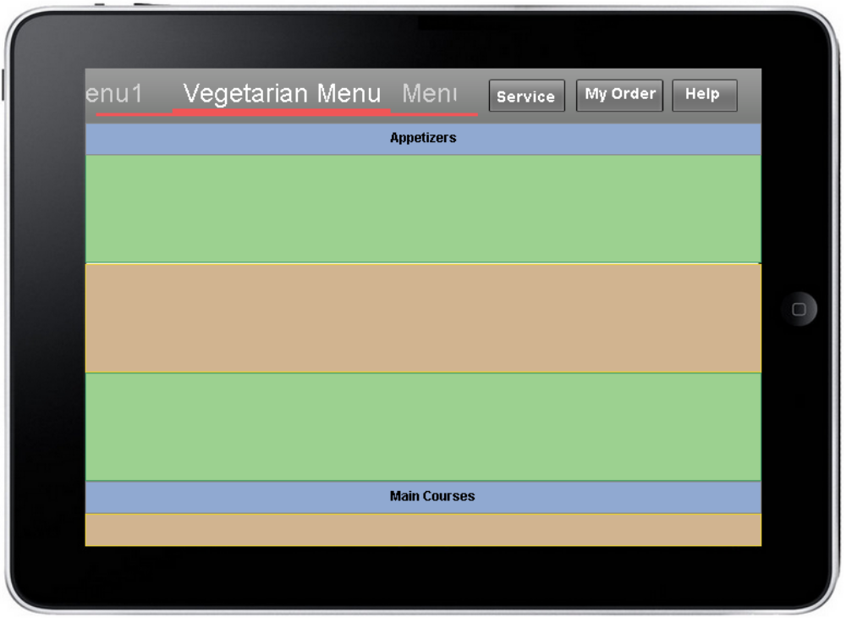
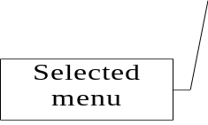
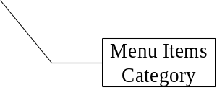


Core Controller
Implements the Core functionalities of the tablet App in order to provide the User Interface with the content retrieved through the REST Api. It also implements caching engine.

Rest Methods
Implements the REST methods to communicate with the server.

Server
The server is the entity that includes all the back-office components.
A database (based on MySQL) will store all the data for the system to operate.

