**1.TARGET LINES:**

**Steps:**

1. Load your dataset into Power Bl.

2. Create a visual (ex: Column Chart or Line Chart) showing Sales by Category/Month/etc.

3. Go to Analytics Pane (select the chart → right side, magnifying glass icon).

4. Click + Add under Constant Line.

5. Set the Target Value (e.g. 50000 sales)

6. Customize color, style, and label (rename as "Target Line").

7. Now the chart shows your actual sales compared with the target.

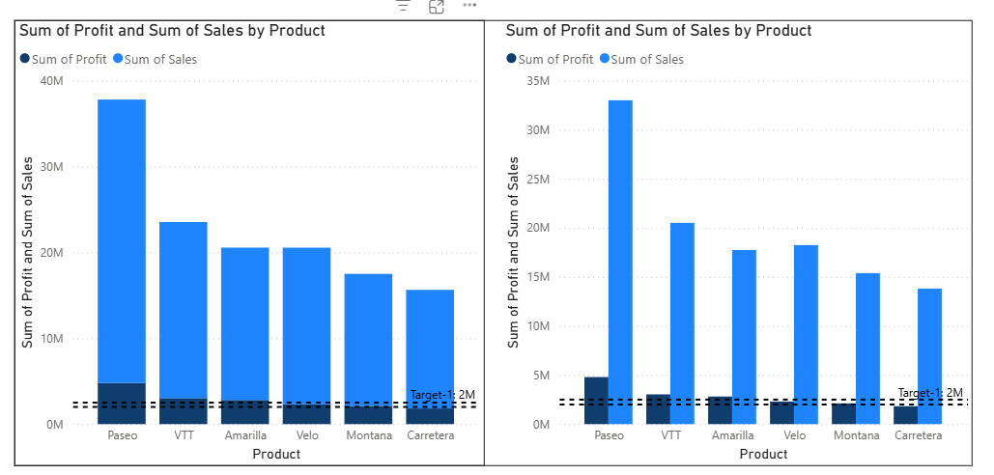

**2.DRILL DOWN & DRILL THROUGH:**

**Drill Down (Pie Chart with Hierarchy):**

1. Create a Pie Chart with Sales.

2. Drag Category to Legend and Sales to Values.

3. Drag another field (e.g. Sub-Category) under Category in the Legend (this creates hierarchy.)

4. Enable the Drill Down button (down arrow icon on the top-right of chart)

5. Click on a slice (Category) → it drills down to Sub-Category.

**Drill Through (Go to Detail Page):**

1. Create a new page in Power Bl.

2. On that page, add a table/visual vith detailed information (e.g. Product, Region, Sales)

3. In the new page, drag Category (or any field you want to drill through) into the Drill Through filters well.

4. Now, go back to the main Pie Chart → right-click on any Category slice → choose Drill Through → [Detail Page Name]

5. It takes you to the detailed view of that selected category.

Sales by Category

**THESE ARE THE DRILL DOWN AND DRILL THROUGH (BUTTONS):**



**DASHBOARD :** 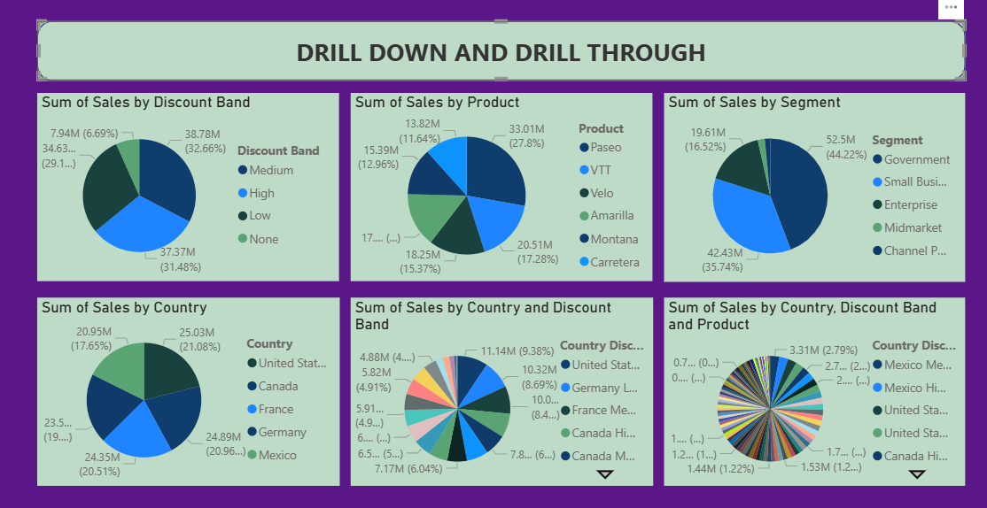

**3. SLICERS AND DATE:**

**(Steps):**

1. Insert a **Slicer visual** from the Visualizations pane.
2. Drag the **Date column** into the slicer.
3. By default, it shows a **date range slider** (you can filter by time period).
4. Change slicer type: Click dropdown → choose *Between*, *Before*, *After*, *List*, *Dropdown*, or *Relative Date*.
   * Example: Relative Date → show “Last 7 days / Last 30 days / This Year”.
5. Use slicers to control all visuals (Sales, Profit, etc.) on the report page.

