Reinforcement Learning — Week 1
Icy Robot Maze (Grid-World): Value Iteration & Policy Iteration

1. The Big Picture
This submission implements a 10×10 grid-world (100 states) representing an icy floor. The robot starts anywhere on the grid and must reach the Goal tile (bottom-right, state 99) while avoiding the Trap tile (center, state 55). Every normal step costs -0.1 reward, reaching the Goal gives +10, and landing on the Trap gives -10.
The floor is slippery (stochastic transition dynamics): a chosen action succeeds with 85% probability. The remaining 15% is split evenly (5% each) across the three unintended directions. Two classic Dynamic Programming algorithms were implemented to solve for the optimal Value Map and Action Map: Value Iteration and Policy Iteration.

2. Milestone 1 — Flattening the Grid
Coordinates (row, col) are converted to a single flattened state ID using row × width + col, and back using floor division / modulo. This was verified against the expected test case:
def coords_to_state(row, col, width=10):
# Formula: Multiply row by width, then add the column
return row * width + col

def state_to_coords(state, width=10):
# Formula: Use floor division for row, modulo for column
row = state // width
col = state % width
return row, col

# Test:
print(coords_to_state(1, 2)) # 12
print(state_to_coords(12)) # (1, 2)
Output: 12 and (1, 2) — matches the expected values exactly.

3. Milestone 2 — The Slippery Floor Table (P)
build_world() constructs the transition tensor P of shape (100, 4, 100) and the reward table R of shape (100, 4). Terminal states (Goal, Trap) are absorbing — once entered, every action loops back with probability 1.0. For normal tiles, wall-bumps keep the robot on its current tile, the intended direction gets 0.85 probability, and each of the other three directions gets 0.05 probability (0.15 / 3), exactly reproducing the ice physics described in the brief.
def build_world(self):
for s in range(self.num_states):
if s == self.goal or s == self.trap:
for a in range(self.num_actions):
self.P[s, a, s] = 1.0
continue

r, c = s // 10, s % 10
neighbors = {
0: (max(r - 1, 0), c), # Up
1: (min(r + 1, 9), c), # Down
2: (r, max(c - 1, 0)), # Left
3: (r, min(c + 1, 9)) # Right
}

for a in range(self.num_actions):
intended_state = neighbors[a][0] * 10 + neighbors[a][1]
self.P[s, a, intended_state] += 0.85

for slip_action in range(self.num_actions):
if slip_action != a:
slip_state = neighbors[slip_action][0]*10 + neighbors[slip_action][1]
self.P[s, a, slip_state] += 0.05

for s_next in range(self.num_states):
prob = self.P[s, a, s_next]
if prob > 0:
if s_next == self.goal:
self.R[s, a] += prob * 10.0
elif s_next == self.trap:
self.R[s, a] += prob * -10.0
else:
self.R[s, a] += prob * -0.1

4. Milestone 3 — Vectorized Value Iteration
Instead of looping over states, the Bellman update is computed for all 100 states and 4 actions at once using a tensor dot product between P and the current value estimate V, avoiding any nested for-loops inside the update step:
def solve_value_iteration(self, gamma=0.99, theta=1e-8, max_iters=1000):
V = np.zeros(self.num_states)
for i in range(max_iters):
# Q[s, a] = R[s, a] + gamma * sum_s' P[s, a, s'] * V[s']
Q = self.R + gamma * np.tensordot(self.P, V, axes=(2, 0))

# Best achievable value at each state
V_new = np.max(Q, axis=1)

delta = np.max(np.abs(V_new - V))
V = V_new
if delta < theta:
print(f"Value Iteration converged in {i+1} iterations!")
break

final_Q = self.R + gamma * np.tensordot(self.P, V, axes=(2, 0))
optimal_policy = np.argmax(final_Q, axis=1)
return V, optimal_policy
Value Iteration converged in 61 iterations (θ = 1e-8, γ = 0.99).

5. Milestone 4 — Vectorized Policy Iteration
Policy Iteration alternates between exact Policy Evaluation — solving the linear system (I − γP_π)V = R_π directly with scipy.linalg.solve — and Policy Improvement, which greedily updates the policy using the freshly solved values. This repeats until the policy map stops changing:
def solve_policy_iteration(self, gamma=0.99, max_iters=100):
policy = np.zeros(self.num_states, dtype=int)
V = np.zeros(self.num_states)
state_indices = np.arange(self.num_states)

for i in range(max_iters):
# 1. Exact Policy Evaluation: (I - gamma*P_pi) V = R_pi
P_pi = self.P[state_indices, policy, :]
R_pi = self.R[state_indices, policy]

A = np.eye(self.num_states) - gamma * P_pi
V = scipy.linalg.solve(A, R_pi)

# 2. Policy Improvement
Q = self.R + gamma * np.tensordot(self.P, V, axes=(2, 0))
new_policy = np.argmax(Q, axis=1)

if np.array_equal(new_policy, policy):
print(f"Policy Iteration converged in {i+1} steps!")
break
policy = new_policy

return V, policy
Policy Iteration converged in 4 steps.

6. Results
Both algorithms were run with γ = 0.99. As expected, they converge to (numerically) the same value function — the value of the starting corner (state 0) was 6.195 under both methods. The resulting optimal policies agree on 97 of 100 tiles; the 3 remaining tiles are states where two actions are exactly tied in value, so either arrow is equally optimal (a common, expected occurrence when a symmetric grid has more than one shortest path).

Value Iteration — Value Map & Optimal Policy
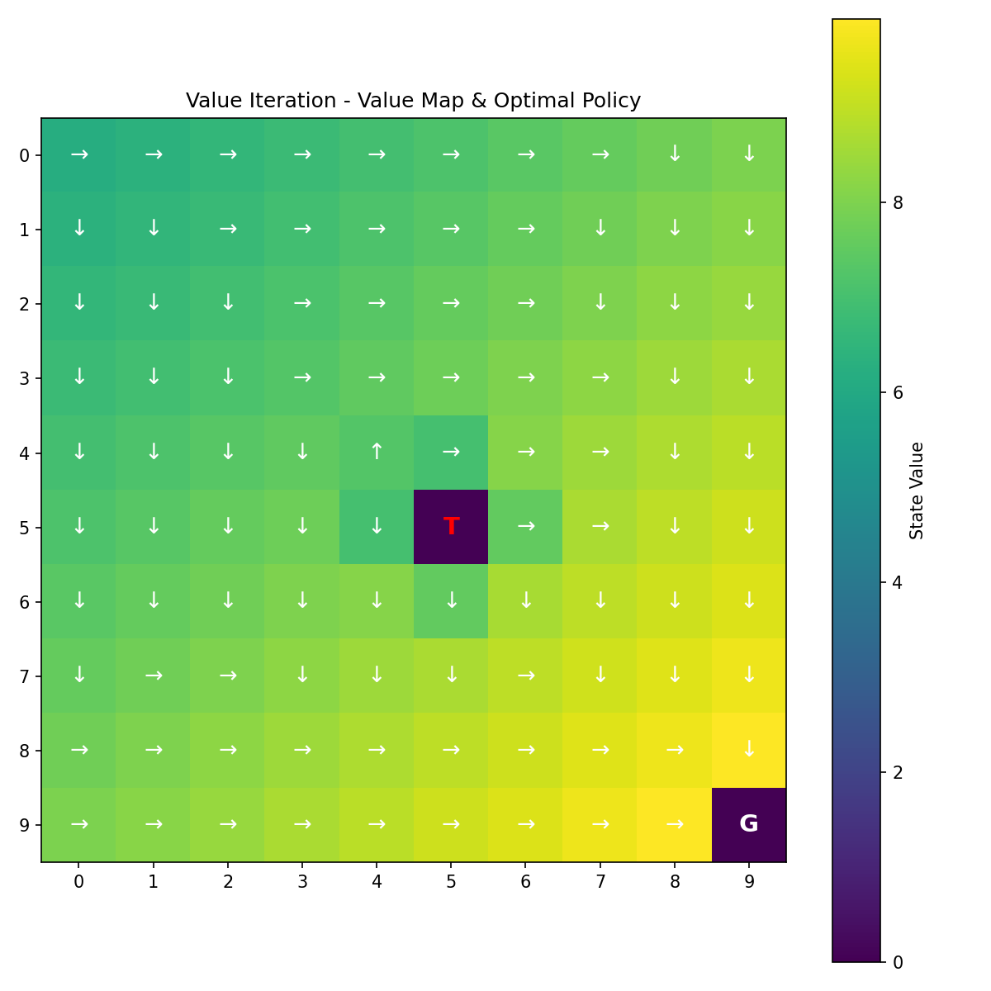

Policy Iteration — Value Map & Optimal Policy
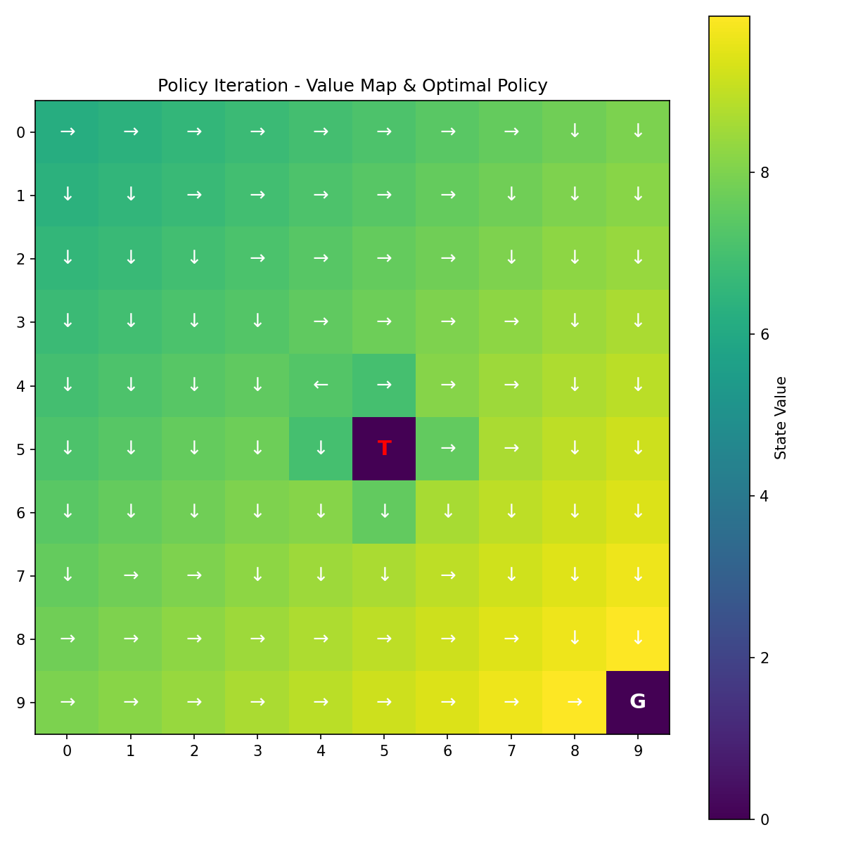
G = Goal tile, T = Trap tile. Arrows show the safest, fastest direction to move from each tile; brighter tiles have higher expected value (closer to the Goal / farther from the Trap).

7. Weekly Self-Check
- ✓ No nested for-loops inside the Value Iteration state-update block — np.tensordot is used inside solve_value_iteration.
- ✓ solve_policy_iteration is fully implemented and uses scipy.linalg.solve to compute exact state value updates in a single step.
- ✓ Grid plots with directional arrows pointing toward the goal are exported for both solved value maps (see Section 6).

8. Full Source Code
The complete, runnable implementation (gridworld.py) is attached separately alongside this document.

