AI ECOSYSTEM GAME THEORY ANALYSIS
Market Structure, Strategic Interaction, and Welfare
Technical & Validation Report
Ranjith Keerikkattil
Report date | September 28, 2026
Data vintage | Q3 2026 (Aug-Sep earnings cycle)
Data module version | v10.0
Script | ai_ecosystem_model.py (11,507 lines; V8.0)
Analysis engine | ai_ecosystem_model.py embedded data + analysis classes (recomputed for this report)
Scope | 4 player archetypes · 6 bilateral games · circular-deals & welfare analysis
Units | Monetary values in $B unless noted; September 2026 vintage

WORKING PAPER
Prepared for journal submission. All market figures are dated Q2/Q3 2026 and cross-validated from primary sources (company filings, SEC, tier-1 financial media).

Abstract
This paper presents a computational analysis of strategic interaction in the artificial-intelligence ecosystem through game theory, welfare economics, and market-concentration analysis. Four player archetypes — Hardware, Cloud Providers, Foundation Models, and LLM Wrappers, with aggregate revenue of $1,034.5B (Q2/Q3 2026 vintage) — interact as six bilateral 2×2 games solved for pure-strategy Nash equilibria by best-response analysis, with welfare measured against the joint-surplus maximum (Kaldor–Hicks benchmark).
The market is highly concentrated (HHI 3,851, CR4 100.0%). Aggregate welfare at the Nash outcome is $1,034.5B against a potential $1,451.3B — a deadweight loss of $416.8B (71.3% efficiency). The core Hardware–Cloud Providers game is a distributive obstruction: the Nash outcome differs from a joint-surplus maximum that requires compensating transfers; equilibrium stability and policy scenarios are evaluated with Monte-Carlo simulation and sensitivity analysis, and every figure and table below is an artifact of the ai_ecosystem_model.py run_pipeline, re-verified by this generator.
Keywords: game theory; Nash equilibrium; deadweight loss; market concentration; HHI; Lerner index; Monte Carlo; AI ecosystem; antitrust; interoperability.

Contents
1
If the table of contents does not display, select it and press F9 in Word (or set Tools → Options → Print → Update fields).

List of Tables
Table | Section
Exhibit 2.1 Player archetypes and market data (computed by build_technical_report.py) | Section 2
Exhibit 2.2 Data sources and macro parameters | Section 2
Exhibit 2.6 Literature-to-report mapping (compiled by build_technical_report.py) | Section 2
Table 8.5: Assumption Register | Section 2
Table 8.6 (excerpt) — Validated inputs register (first 10 of 110 rows) | Section 2
Table 2.4: Player Categories | Section 2
Table 8.6: Validated Inputs Register | Section 2
Exhibit 3.1 Concentration metrics (computed by build_technical_report.py) | Section 3
Exhibit 3.2 Market shares (computed by build_technical_report.py) | Section 3
Exhibit 3.3 Market power (Lerner-based, computed by build_technical_report.py) | Section 3
Table 7.17: Lerner Index & Markup Summary with Uncertainty Bands | Section 3
Exhibit 3.4 Gatekeeper index: who the ecosystem cannot route around (ai_ecosystem_model.py diagnostics) | Section 3
Table 1.1: Market Structure Metrics | Section 3
Table 1.3: Revenue Projections | Section 3
Table 7.16: Market-Share Evolution 2025 vs 2030 (Revenue Projections) | Section 3
Exhibit 4.1 Nash equilibria across all bilateral games (computed by build_technical_report.py) | Section 4
Exhibit 4.2 Payoff matrix — Hardware-Cloud Providers ($B; row: Hardware, column: Cloud Providers) | Section 4
Exhibit 4.3 Payoff matrix — Hardware-Foundation Models ($B; row: Hardware, column: Foundation Models) | Section 4
Exhibit 4.4 Payoff matrix — Hardware-LLM Wrappers ($B; row: Hardware, column: LLM Wrappers) | Section 4
Exhibit 4.5 Payoff matrix — Cloud Providers-Foundation Models ($B; row: Cloud Providers, column: Foundation Models) | Section 4
Exhibit 4.6 Payoff matrix — Cloud Providers-LLM Wrappers ($B; row: Cloud Providers, column: LLM Wrappers) | Section 4
Exhibit 4.7 Payoff matrix — Foundation Models-LLM Wrappers ($B; row: Foundation Models, column: LLM Wrappers) | Section 4
Table 3.5 — Welfare-benchmark audit (Kaldor-Hicks transfers) | Section 4
Table 3.6 — Equilibrium multiplicity and risk-dominance audit | Section 4
Table 3.7 — Repeated-game sustainability (critical discount factors) | Section 4
Table 3.1: Cloud vs Foundation Payoff Matrix | Section 4
Table 3.2: Hardware vs Cloud Payoff Matrix | Section 4
Table 3.4: Core-Game Equilibrium, Coordination & DWL | Section 4
Exhibit 5.1 Aggregate welfare (computed by build_technical_report.py) | Section 5
Exhibit 5.2 Deadweight-loss decomposition (computed by build_technical_report.py) | Section 5
Exhibit 5.2b Policy interventions ranked by base-scenario net benefit (ai_ecosystem_model.py enhancement output) | Section 5
Exhibit 5.3 Coordination-failure diagnostics (computed by build_technical_report.py) | Section 5
Table 5.3: Welfare Decomposition | Section 5
Table 5.4: Dynamic Game Analysis (Short vs Long-term) | Section 5
Table 6.1–6.3: Policy Simulation Summary (v4.0) | Section 5
Table 4.1: Monte Carlo & Sensitivity Summary | Section 6
Table 8.1: Stationarity Diagnostics (Geweke) | Section 6
Table 8.2: Multi-Seed Replicability | Section 6
Table 8.3: Noise-Level Robustness | Section 6
Table 8.4: Saltelli Variance Decomposition | Section 6
Exhibit 6.x Breakdown-frontier calibration: identified intervals for A3 rate maps and A8 logit weights | Section 6
Exhibit 7.1 Shapley value allocation (computed by build_technical_report.py) | Section 7
Table 5.4b: Shapley Value Allocation (Cooperative Game) | Section 7
Table 7.18: Shapley Share vs Revenue Share (Bargaining vs Size) | Section 7
Exhibit 7.2 Circular-deals metrics (computed by build_technical_report.py) | Section 7
Exhibit 7.3 Five-pillar segment screen (ai_ecosystem_model.py diagnostics; NaN = uninformative pillar) | Section 7
Table A.0: Network Centrality (Appendix) | Section 7
Table A.1: Network Risk Metrics | Section 7
Table A.2: Portfolio Risk Metrics | Section 7
Table A.3: Success Probability Scores | Section 7
Exhibit 7.4 Bubble-conditions probability by archetype (scenario-calibrated logistic composite, not a forecast) | Section 7
Exhibit 7.5 Burst impact ranking (descending severe loss; direct circular impairment + one network round) | Section 7
Exhibit 7.6 US GDP-at-risk (AI-capex + wealth channels; BEA $30.8T baseline, no multiplier) | Section 7
Exhibit 7.7 Burst-mitigation options (denominator = expected severe burst loss, NOT DWL -- rates are not comparable to §5) | Section 7
Exhibit 7.8 DebtRank second-round contagion (Battiston et al. 2012; equity = validated market caps; shock = severe direct losses) | Section 7
Exhibit 7.9 Credit monitor (sourced spreads and run_pipeline; computed hazard, ratios, haircuts and live watchlist) | Section 7
Exhibit 8.1 Top companies by market cap with key valuation metrics (ai_ecosystem_model.py enhancement output) | Section 8
Exhibit 10.1 Automated integrity checks (computed by build_technical_report.py) | Section 10
Exhibit 10.2 Output inventory (computed by build_technical_report.py) | Section 10
Exhibit 10.3 Placement of ai_ecosystem_model.py outputs in this report | Section 10

List of Figures
Figure | Section
Figure 1: Framework & Literature Map (schematic) | Section 2
Figure 2: Research Design & Stages (schematic) | Section 2
Figure 4: Value Chain (schematic) | Section 2
Supplemental S2 — Lerner Index with Uncertainty Bands | Section 3
Supplemental S1 — Revenue Levels 2025 vs 2030 | Section 3
Figure 3: Market Size, Concentration & Shares [Panels: (a), (b), (c)] | Section 3
Figure 13: Revenue Projections (schematic) | Section 3
Supplemental S5 — Joint Gains and Minimum Transfers by Game | Section 4
Figure 5: Complete Matrices (schematic) | Section 4
Figure 6: Core Game: Equilibrium & Payoffs (schematic) | Section 4
Figure 11: Dynamics & Stability [Panels: (a), (b)] | Section 4
Figure 7: Welfare Composite [Panels: (a), (b), (c), (d)] | Section 5
Figure 12: Policy Simulation (schematic) | Section 5
Figure 8: Monte Carlo Convergence [Panels: (a), (b)] | Section 6
Figure 9: Sensitivity Response (schematic) | Section 6
Figure 10: Sobol Indices (schematic) | Section 6
Supplemental S3 — Shapley Share vs Revenue Share | Section 7
Figure 14: Network Risk (schematic) | Section 7
Figure 15: Portfolio Risk (schematic) | Section 7
Figure 16: Shapley Values (schematic) | Section 7
Supplemental S4 — Direct vs Second-Round Losses (DebtRank) | Section 7
Figure 17: Company Valuation Dashboard (schematic) | Section 8
Figure 18: Company Valuation Metrics Table (schematic) | Section 8

List of Abbreviations
Abbreviation | Definition
AI | Artificial Intelligence
BCR | Benefit–Cost Ratio
CI | Confidence Interval
CR4 | Concentration Ratio (top 4 archetypes)
DWL | Deadweight Loss
HHI | Herfindahl–Hirschman Index
K-H | Kaldor–Hicks (joint-surplus benchmark requiring transfers)
LLM | Large Language Model
MC | Monte Carlo (simulation)
NE | Nash Equilibrium
TTM | Trailing Twelve Months (valuation inputs)
JM | Joint-Surplus Maximum (Kaldor–Hicks Benchmark)

1. Executive Summary
This report documents the AI-ecosystem game-theory analysis produced by ai_ecosystem_model.py. It synthesizes an estimated aggregate market revenue of $1,034.5B across four player archetypes (Hardware, Cloud Providers, Foundation Models, and LLM Wrappers) whose strategic interaction is modeled as six bilateral 2×2 games, with equilibrium outcomes, welfare losses, circular-dependency risk, and policy implications evaluated quantitatively.
- Market structure: Total revenue $1,034.5B; HHI 3,851 (highly concentrated); CR4 100.0%; Gini 0.393. Cloud Providers (40.3%) and Hardware (45.9%) dominate.
- Strategic games: 6 bilateral games analyzed. The core Hardware–Cloud Providers game is a coordination failure: the Nash equilibrium (Open Access, Proprietary Stack) is not a joint-surplus maximum (Kaldor–Hicks benchmark), with a game-level deadweight loss of $58.6B.
- Welfare: Aggregate welfare at the Nash outcome is $1,034.5B vs. a potential (Pareto) $1,451.3B, implying a deadweight loss of $416.8B (28.7% of potential) and aggregate efficiency of 71.3%.
- Circular dependency: 19 circular deals totaling $1,188.3B; systemic criticality score 0.632.
- Cooperation: Shapley allocation across the four players; cooperative surplus of the grand coalition ≈ $310.4B.
- Best policy (base scenario): Combined Intervention — net benefit $214.2B.

1.1 Headline metrics
Metric | Value
Aggregate market revenue | $1,034.5B
HHI / CR4 / Gini | 3,851 / 100.0% / 0.393
Market-implied DWL | 28.72% ($416.8B)
Aggregate welfare (Nash) | $1,034.5B
Aggregate efficiency | 71.28%
Coordination-failure DWL | $867.77B
Circular exposure | $1,188.3B
Core game NE | Hardware: Open Access; Cloud: Proprietary Stack

1.2 Research questions
RQ1 — Market concentration and power. How concentrated is the AI ecosystem and how much pricing power follows? Measured: HHI 3,851 against both the 2010 (2,500) and 2023 (1,800) highly-concentrated thresholds, with Lerner-implied markups per archetype (Exhibit 3.3).
RQ2 — Nash equilibria and strategic behavior. What are the equilibria of the six bilateral games, and do they coincide with Pareto optima? The core Hardware–Cloud game is a coordination failure (Nash versus joint-surplus maximum, DWL $58.6B); Section 4 reports all six (Exhibits 4.1–4.7).
RQ3 — Structural inefficiency sources. How is the $416.8B aggregate deadweight loss attributed across switching costs, monopoly pricing, innovation distortion, quality degradation, and coordination failures (Exhibit 5.2)?
RQ4 — Policy effectiveness. Which interventions — interoperability mandates, antitrust enforcement, innovation subsidies, data-sharing mandates, or combinations — deliver the highest net benefit under conservative, base, and optimistic scenarios (Exhibit 5.2b and Section 5 deep dives)?

1.3 Research objectives
- Model the four-layer AI ecosystem as six bilateral 2×2 games with market-derived payoffs.
- Quantify concentration (HHI, CR4, Gini) and market power (elasticity-based Lerner indices).
- Decompose aggregate deadweight loss by structural source with quantitative attribution.
- Validate robustness with 100,000 Monte-Carlo draws and sensitivity sweeps around the DWL assumption.
- Rank costed policy interventions across scenarios and state the evidence basis for each recommendation.

2. Data, Sources and Methodology

2.1 Embedded data and vintage
The analysis uses ai_ecosystem_model.py's embedded dataset (data module v10.0, validation status: Deep Research Verified (Multi-Source); last updated 2026-09-06). All monetary figures are in billions of U.S. dollars and reflect the Q2/Q3 2026 reporting cycle.
Exhibit 2.1 Player archetypes and market data (computed by build_technical_report.py)
Category | Representative players | Revenue ($B) | Market value ($B) | Op. margin | Circ. index
Hardware | NVIDIA, AMD, Intel, Broadcom, Marvell, Google (TPU) | 475 | 7,916 | 48.0% | 0.31
Cloud Providers | Microsoft Azure, AWS, Google Cloud, Oracle, CoreWeave, Nebius, Lambda Labs | 417 | 11,910 | 34.0% | 0.29
Foundation Models | OpenAI, Anthropic, Meta (Llama), Mistral, xAI | 106.50 | 2,432 | -3.4% | 0.84
LLM Wrappers | Palantir, ServiceNow, Databricks, Perplexity, Cursor | 36 | 923 | 19.0% | 0.65

Exhibit 2.2 Data sources and macro parameters
Parameter | Source
market_size | Aggregate of verified company revenues
tam | PwC Global Data Center Outlook 2026-50 (Oxford Economics modeling): $31.6T central cumulative, $800B in 2026 to $1.1T 2030 to $1.8T 2050, US $15.1T (Bloomberg Sep 2, 2026)
growth | IDC Spending Guide 29% CAGR 2024-2028; IDC FutureScape 2026: 32% 5-yr AI IT spending CAGR; UBS AI capex 25% CAGR to $1.3T 2030 (30% central)
risk_free_rate | U.S. Treasury 10-year yield, Sep 1, 2026 (Bloomberg)
market_return | Damodaran (NYU Stern) implied ERP 4.18% end-2025, mature-market base 4.17% mid-2026 update
circular_deals | CNBC, Reuters, Bloomberg, FT (multi-source Sep 2026)
valuation_data | Company IR pages + NPM secondary market data

Macro context: MAJOR ECOSYSTEM SHIFT: The "circular AI economy" concern intensified in Q3 2026 with NVIDIA extending $605B+ in direct + indirect financing ($105B OpenAI credit guarantee + $500B six-platform MOU facility). Anthropic ARR growth from $9B (Dec 2025) to $65B (Jul 2026) is unprecedented but comes with $80B compute commitments extending to 2030-32. Fed hike pricing swung 48-75% through summer 2026 (CME FedWatch 48.4% early Sep after Waller remarks; WSJ Aug 12 "hike not looking likely"); policy rate 3.50-3.75% adds macro pressure. SEP 6 2026 RE-VERIFICATION vs primary/near-primary sources: NVIDIA TTM rev $302.9B + net ~$192B (company IR Aug 26 2026); NVDA equity portfolio ~$99B (10-Q Jul 26 2026); Hugging Face $12.93B (Sep 3 2026); AWS $169B run-rate, GCP $99B, Azure FY26 $101.9B; Palantir FY guide $7.7B (SEC 8-K); ServiceNow FY guide $16.2B; Cursor ~$4B ARR (SpaceX-owned since Jun 2026); OpenAI-AWS $38B (Nov 2025, multi-source); US 2025 GDP $30,767.1B (BEA NIPA); 10Y 4.795% Sep 1 (WSJ); 2Y 4.392% and 30Y 5.27% Sep 1 (FRED/Morningstar); ERP 4.2% (Damodaran end-2025/mid-2026); IDC AI CAGR 29-32% (Spending Guide/FutureScape 2026); Big Four 2025 capex ~$400B actuals; PwC $31.6T DC buildout confirmed (Oxford Economics central scenario); S&P 500 P/S record 3.83 Aug 2026 (2x hist avg). Stale inputs corrected: archetype revenues, GPU-supply row ($356B->$249B), late-Aug compute legs added (Fluidstack/SpaceX/Volta); MACRO/MICRO round: Cloud valuation $9.6T->$11.91T (GOOGL $4.6T, AMZN $3.1T, ORCL <$500B, NBIS ~$55B), Wrappers $550B->$733B (PLTR $432B, NOW $151B), HW resplit (AMD $746B, NVDA $5.0T), Cloud op margin 29.3%->34.0% (AWS ~37-39%, GCP 35.6% Q2 2026), NVDA op margin 60%->66.3% (Q2 FY27 GAAP), ERP 5.5%->4.2%, Hardware tax 21%->17% (NVDA FY27 guide 16-18%), Fed note repriced to 48-75% pricing swing. MSFT-NVDA-Anthropic Nov 2025 package added (MSFT $5B + Azure $30B purchase; NVDA "up to $10B" disclosed). PLAYER-COVERAGE AUDIT Sep 6 2026: added missing circular edges Amazon-Anthropic +$5B (now $13B committed) and Google-Anthropic $10B (new row); added Databricks ($190B val, ~$7B run-rate) to Wrappers. Deliberate exclusions: pure-play foundry/equipment/memory suppliers (TSMC, ASML, HBM makers) transact at arms-length outside the financing round-trip; consumer-edge names (Apple, Tesla) carry no circular exposure; China labs (DeepSeek) sit outside the US-scope model and enter only as downside-risk factor; sub-scale neoclouds (Crusoe, IREN) are immaterial next to CRWV/NBIS/Lambda coverage.

2.2 Methodological choices
- Players are the four archetypes Hardware, Cloud Providers, Foundation Models and LLM Wrappers; each bilateral interaction is a 2×2 game with strategies defined per player.
- Payoffs are derived from market data: the Defect–Defect cell equals observed revenue; cooperation expands the total to an efficient benchmark; temptation and sucker payoffs are calibrated from margins and dependency exposure.
- Deadweight loss is market-implied: DWL% ≈ min(40%, max(5%, circular-exposure ÷ revenue × 25%)) = 28.72%, i.e. $416.8B on potential (Pareto) welfare.
- Nash equilibria are found by best-response analysis; welfare is measured as the distance from the maximum-total joint-surplus outcome (Kaldor–Hicks benchmark); coordination failures are Nash outcomes that miss the Pareto optimum.
- Robustness is assessed with 100,000 Monte-Carlo draws at 5% log-normal payoff noise and a 98% confidence interval, plus sensitivity analysis around the DWL assumption.

2.3 Equilibrium concepts used in this report
- Nash equilibrium (Nash, 1950): a strategy profile from which no player can profitably deviate unilaterally. All six games are solved by exhaustive best-response checks over the four cells — no equilibrium is assumed.
- Prisoner's Dilemma: temptation > cooperation > defection > sucker payoffs, so mutual defection is the equilibrium although mutual cooperation pays more. The core Hardware–Cloud game is classified 'Coordination Failure'; Section 4 classifies all six.
- Joint-surplus maximum and distributive obstruction: a true Pareto improvement leaves no player can gain without another losing; a coordination failure is Nash ≠ party worse off; a Kaldor–Hicks benchmark requires compensation. Positive Nash–joint-max gaps measure forgone joint surplus.
- Second-best (Lipsey & Lancaster, 1956): with several simultaneous distortions, fixing one in isolation need not improve welfare — the rationale for ranking combined as well as standalone interventions in Section 5.

2.4 Market-power and welfare measurement
- Concentration: HHI is the sum of squared percentage market shares (0–10,000). Both DOJ/FTC vintages are used throughout — 2010: 1,500/2,500; current 2023: 1,000/1,800 (highly concentrated, +100pts presumption). This market exceeds both high cutoffs, so the verdict does not depend on vintage.
- Market power: the Lerner index L = (P − MC)/P = 1/|elasticity| measures pricing power on a 0–1 scale (0 perfect competition, 1 monopoly). The highest implied Lerner index in this run is 0.623 (Hardware).
- Deadweight loss (Harberger, 1954): the surplus triangle lost when price exceeds marginal cost, growing with the square of the markup — which is why the high-markup archetypes dominate the loss. In this run the aggregate loss splits as switching costs 34%, innovation distortion 26%, quality degradation 17%, coordination failures 14%, monopoly pricing 9%.
- Switching costs and lock-in (Katz & Shapiro, 1985; Farrell & Klemperer, 2007): platform incompatibilities and data gravity sustain pricing power even in equilibrium, so part of the loss persists under any conduct remedy — the structural interpretation developed in Sections 5–6.

2.5 Computation, reproducibility and figure provenance
- Two distinct deadweight-loss rates are used (ai_ecosystem_model.py DWL naming conventions). The top-down rate DWL_PCT_TOPDOWN = 28.72% (dependency-value ratio) feeds aggregate welfare, policy and sensitivity analysis. The game-level rate 15.20% (concentration/dependency geometric mean) is a recorded diagnostic only — payoff levels derive from pair efficiency, margins and dependencies. They answer different questions and must not be conflated.
- Monte Carlo is vectorized (batched log-normal draws, numpy best-response masks; statistically identical to the per-draw loop) with run-scoped generators seeded 42 — each game gets an independent noise stream and repeated runs reproduce exactly.
- Figures render headless-safe (Agg backend), use the Okabe–Ito colorblind-safe palette in DejaVu Sans, carry journal-style (a)/(b) panel tags on data panels, and are saved as 300-DPI PNG plus vector PDF; panel inventories come from ai_ecosystem_model.py's figure_captions.md when present.
- Convergence is assessed with Monte-Carlo standard errors and split-half consistency from stored draws (table_7.9); R-hat is not reported because it is uninformative for IID Monte Carlo. Equilibria are cross-validated by an independent brute-force enumeration (table_7.8).
- A five-part robustness battery (ai_ecosystem_model.py RobustnessBattery, Tables 8.1–8.5) backs every headline: (R1) Geweke mean-stability screens with Holm correction across games; (R2) full-sample reruns at two independent seeds with drift measured in pooled standard errors; (R3) perturbation-scale robustness at 2.5/5/10% noise with Spearman rank preservation; (R4) Saltelli variance decomposition (N=2048, 500 bootstraps) of game DWL over calibrated primitives; (R5) an explicit assumption register mapping each modeling choice to the check that disciplines it. All stochastic steps derive from seeded generators, so the battery reproduces exactly.

2.6 Literature review
Recent (2025–2026) work on AI markets falls into five streams that jointly motivate this report's design. Each stream is summarized below with its direct bearing on the research questions; full citations are in References. Where the literature disagrees, the disagreement is stated explicitly and carried forward as a robustness check or limitation.

Scaling, concentration, and market structure
Korinek and Vipra (2025) argue that AI markets concentrate even without anticompetitive conduct, through three jointly-operating features: very large fixed training costs, cost advantages that grow with size, and high customer switching costs — with concentration threatening an unprecedented accumulation of economic power. Their framework is the direct antecedent of this report's measurement strategy: the HHI/CR4/Gini battery (Section 3, RQ1) and the Lerner-based market-power assessment (Exhibit 3.3) operationalize exactly those three channels.
Hagiu and Wright (2025) analyze the vertical AI technology stack and data feedback loops around three questions — concentration in core AI services, AI's impact on existing market structures, and emerging policy challenges — identifying risks of new gatekeeper types alongside disruption of old platforms. Their layered view matches this report's four-archetype model, and their gatekeeper analysis anticipates the bottleneck finding of Section 4. Korinek and Vipra (2025) trace how scaling concentrates the AI stack and how upstream power moves downstream prices, industry structure, and welfare — the theoretical counterpart of the deadweight-loss decomposition in Section 5 (RQ3), with frontier scale economies as the limiting case.
The contestability counterpoint matters for RQ1: if power-law capability scaling plus fast-follower dynamics keep training costs contestable, concentration findings weaken. This report does not adjudicate that debate; instead the sensitivity analysis (Section 6) and the DWL-elasticity reading test how much the conclusions move if contestability is stronger than the base case assumes.

Competition policy and antitrust
A restraint counter-argument runs the other way: preemptive regulatory approaches to platform–laboratory partnerships and investments in the generative-AI ecosystem risk false positives, counselling doctrinal humility. That sets the evidentiary bar Section 5 must clear — ranked, costed, scenario-bound interventions rather than precautionary ones. Institutional reviews pull the other way: the OECD (2025) documents multifaceted, evolving concentration risks across stack layers including tying and algorithmic collusion, while the World Bank (2026) finds end-user outcomes largely predetermined by control of critical upstream infrastructure — consistent with this report's infrastructure-bottleneck diagnosis. The operative legal regime for the interoperability remedy is the EU Digital Markets Act (European Commission, 2022), cited as precedent in the policy deep dives.

Game theory and algorithmic collusion
Bichler et al. (2025) survey when pricing algorithms converge to Nash equilibria (notably in potential games) versus collusive outcomes, and which algorithm properties tilt the balance. Their convergence conditions inform this report's stability reading in Section 6: high Monte-Carlo stability is interpreted as structural lock-in rather than coincidence. This report's one-shot bilateral design is a static-game analysis, and the repeated-game gap it leaves is recorded as future work (Section 9.3).

Circular investment and systemic fragility
Realized revenue and adoption support part of AI valuations, while capex outruns monetization in some layers and private valuations concentrate in few firms — the dot-com precedent for transformative technology alongside overvaluation (Ofek, 2003; Greenwood et al., 2019). That 'localized fragility' framing disciplines Section 7: the bubble score is presented as a fragility index, not a crash prediction. The financing channel provides the transmission mechanism behind the single-point-of-failure reading of the NVIDIA-centered deal fabric: the dependency frame and credit monitor in Section 7 trace how a repricing travels from circular claims to equity and GDP.

Circular-dealing measurement and vendor-financing contracts
Round-trip chains run through multiple stack layers, which supports this report's archetype-stack design over pairwise analysis; the committed-value exposure frame books contracted circularity deal by deal, with conditional tranches parked outside it. Two contract patterns organize the channel: an integration-plus-circular-investment pattern (vertical integration plus circular investment; apparent sales that reverse on a demand shock) and a GPU-collateralised leverage pattern (supplier resale guarantees, herd entry, and chain-reaction fire sales of homogeneous collateral). The fire-sale cascade is the statically-modeled second round of this report's DebtRank reverberation (Section 7, Exhibit 7.8); dynamic clearing with endogenous leverage remains open. The run_pipeline documents the leverage stack it would detonate — $675.40B in committed exposure across 17 edges ($1,188.33B tracked over 19 rows), the 2026 debt run_pipeline, Oracle's single-day bond sale and off-balance-sheet vehicle, and the record CDS print with downgrade to BBB- — all recorded in the September 2026 market-data vintage; the Oracle repricing corroborates the burst ranking. The ex-post agenda is priced as the complement rather than the rival of prevention: prosecute proximate-cause financial engineering, convert stranded data centres to a public cloud, protect workers, and structurally separate via a Glass-Steagall for AI and utility-style regulation — the ex-post complement to this report's ex-ante BCR-ranked tools.

Interoperability and policy mechanisms
The interoperability remedy rests on cross-sector precedent: mandated infrastructure unbundling (telecoms) and open-banking standardisation show mandates can unlock downstream entry, while the payments experience shows mandates without standardisation fragment into competing API standards (Ofcom, discussion paper on mandated interoperability in digital markets). That caveat is priced into Section 5: the API-mandate deep dive carries implementation cost and scenario bounds rather than assuming frictionless adoption. Data-portability and shared-access arguments (cf. OECD, 2025) motivate the data-sharing mandate alternative ranked alongside it.
Taken together, the literature supports measuring concentration before asserting power (Korinek and Vipra; Hagiu and Wright), tracing upstream power to downstream welfare (Korinek and Vipra), testing stability rather than assuming it (Bichler et al.), treating circularity as fragility rather than growth, and costing remedies against scenarios rather than asserting them. The mapping below records where each stream binds on this report.
Exhibit 2.6 Literature-to-report mapping (compiled by build_technical_report.py)
Literature stream | Key sources | Report locus | What this report adds
Scaling → concentration | Korinek & Vipra (2025) | §3, RQ1 | HHI/CR4/Gini plus Lerner-implied markups on Q2/Q3 2026 data
Vertical stack & gatekeepers | Hagiu & Wright (2025); World Bank (2026); OECD (2025) | §4, RQ2 | Six solved bilateral games; bottleneck located, not assumed
Upstream power → welfare | Korinek & Vipra (2025) | §5, RQ3 | $-level DWL decomposition by source
Equilibrium convergence/stability | Bichler et al. (2025) | §6 | Monte-Carlo stability of each game's NE
Bubble precedent & fragility | Ofek (2003); Greenwood et al. (2019) | §7 | Bubble score as fragility index; NVIDIA-share of deal value
Circularity measurement | FTC (2025); BIS (2026) | §7 | Committed-value exposure frame; fire-sale round noted as unmodeled
Remedies & restraint | DMA (2022); Ofcom | §5.1, RQ4 | Costed, scenario-bound ranking with BCRs

2.7 Assumptions register
Table 8.5 records every material modeling assumption, where it is used, what justifies it, which robustness check disciplines it, and what breaks if it is violated. Assumptions marked “not directly tested” are carried forward as Limitations in §9.2 rather than asserted as findings.
Table 8.5: Assumption Register
# | Assumption | Used in | Justification | Checked by | Risk if violated
A1 | Bilateral 2x2 games capture the strategic structure | All games | Standard IO framing; matches report game taxonomy | R2/R3 (NE stability under perturbation) | Misses N-player dynamics
A2 | Log-normal 5% payoff noise represents measurement error | Monte Carlo | Multiplicative-error convention for revenue-scale payoffs | R3 (sigma 2.5/5/10%) | Over/under-stated stability
A3 | Deviation gains/losses are share-scaled to own CC payoffs with player-specific rates (own margin → temptation; own circularity → sucker) | Payoff calibration | Proportional-to-stakes convention; uses validated Operating_Margin and Circular_Dependency_Index (improved Sep 6 2026; was pair-level absolutes) | Saltelli surrogate replicates the same algebra; brute-force NE agreement tests | Residual: linear rate maps are conventions, not estimated; small-player leverage still approximate
A4 | Pareto benchmark = observed total scaled by pair efficiency | Welfare/DWL | Revealed-efficiency benchmark; efficiency floored at 0.75 | R4 (efficiency-adjacent margins decomposed) | Pareto level mis-set
A5 | Saltelli priors: independent Uniform ±20% around calibrated values | R4 Sobol | Standard sensitivity-analysis convention; N=2048 + 500 bootstraps | Bootstrap CI width in Table 8.4 | Index magnitudes shift; ranking usually robust
A6 | Embedded data vintage (2025 revenues, margins, deals) | Throughout | Latest complete cross-section available at build | D1–D6 integrity gates | Levels shift; shares/ranks more robust than levels
A7 | Static one-shot games (no dynamics, learning, or entry) | All games | Baseline before dynamics; matches cited static literature | Not directly tested — see Limitations | Equilibria may not persist dynamically
A8 | Bubble-formation logit weights are judgment weights | Table 7.10 | Circular exposure dominates by mechanism design; band z±0.4 | OAT halves/doubles: 10/16 formation, 16/16 burst; 300-draw joint check (seed 7): formation exact 65% tau=0.88 (FM top 90%), burst exact 100% tau=1.00 (#1 HW 100%/Cloud 0%); breakdown-frontier identified intervals (Table 8.7) | Levels shift ~±25pp; HW-Cloud top order decisive on base totals ($239.4B vs $132.7B), preserved in 26/32 OAT runs and in all 300 joint draws (seed 7)
A9 | Burst propagates one round through dependency flows (no dynamics) | Table 7.11 | First-order baseline; full reverberation in Table 7.14 (DebtRank multiplier 1.032) | Rank permutation + non-negativity invariants in save_all; DebtRank second-round reconciliation | Losses understated if cascades compound
A10 | GDP arithmetic is US-calibrated scenario math (BEA $30.8T; no multiplier) | Table 7.12 | All modeled firms US-domiciled; transmission rule ports to others | Not directly tested — see Limitations | Non-US GDP effects need local calibration

2.8 Validated inputs register
Table 8.6 lists every validated input value and modeling assumption the analysis consumes -- archetype revenues, valuations, margins and risks; macro and market parameters; bubble-block scenario constants and tax rates; demand elasticities with literature anchors; policy scenarios with reduction rates, costs and sources; all 19 circular deals; and the audited scope decisions (inclusions, updates, exclusions). It is built live from the canonical ai_ecosystem_model.py structures, so the values below are the values the models ran on.
Table 8.6 (excerpt) — Validated inputs register (first 10 of 110 rows)
ID | Category | Parameter | Value | Unit | Source/Verification
V-HA-REV | Archetype fundamentals | Hardware revenue | 475.0 | $B | Verified Sep 6 2026 vs primary sources (see revenue code comments)
V-HA-VAL | Archetype fundamentals | Hardware market valuation | 7916.0 | $B | Verified Sep 6 2026 vs market caps/rounds (see valuation code comments)
V-HA-MGN | Archetype fundamentals | Hardware operating margin | 0.480 | rate | Revenue-weighted from Q2/FY26 filings (see margin code comments); display-only
V-HA-PRF | Archetype fundamentals | Hardware profitability label | High Positive | label | Follows the blended margin above
V-HA-RSK | Archetype fundamentals | Hardware strategic risk | Medium | label | Judgment: sub-segment blend (see code comments)
V-HA-CIR | Archetype fundamentals | Hardware circular dependency index | 0.31 | index 0-1 | Revenue-weighted judgment (see code comments)
V-HA-COS | Archetype fundamentals | Hardware key companies | NVIDIA, AMD, Intel, Broadcom, Marvell, Google (TPU) | list | Coverage audited Sep 6 2026 (see PLAYER-COVERAGE note in market metadata)
V-CL-REV | Archetype fundamentals | Cloud Providers revenue | 417.0 | $B | Verified Sep 6 2026 vs primary sources (see revenue code comments)
V-CL-VAL | Archetype fundamentals | Cloud Providers market valuation | 11910.0 | $B | Verified Sep 6 2026 vs market caps/rounds (see valuation code comments)
V-CL-MGN | Archetype fundamentals | Cloud Providers operating margin | 0.340 | rate | Revenue-weighted from Q2/FY26 filings (see margin code comments); display-only

The complete 110-row register, with a source or verification note per input, appears as Table 8.6 in Appendix A.
Table 2.4: Player Categories
Player_Category | Revenue ($B) | Market Share (%) | Strategic_Risk
Hardware | 475 | 45.92% | Medium
Cloud Providers | 417 | 40.31% | Medium
Foundation Models | 106.50 | 10.29% | High
LLM Wrappers | 36 | 3.48% | High

Table 8.6: Validated Inputs Register
ID | Category | Parameter | Value | Unit | Source/Verification
V-HA-REV | Archetype fundamentals | Hardware revenue | 475.0 | $B | Verified Sep 6 2026 vs primary sources (see revenue code comments)
V-HA-VAL | Archetype fundamentals | Hardware market valuation | 7916.0 | $B | Verified Sep 6 2026 vs market caps/rounds (see valuation code comments)
V-HA-MGN | Archetype fundamentals | Hardware operating margin | 0.480 | rate | Revenue-weighted from Q2/FY26 filings (see margin code comments); display-only
V-HA-PRF | Archetype fundamentals | Hardware profitability label | High Positive | label | Follows the blended margin above
V-HA-RSK | Archetype fundamentals | Hardware strategic risk | Medium | label | Judgment: sub-segment blend (see code comments)
V-HA-CIR | Archetype fundamentals | Hardware circular dependency index | 0.31 | index 0-1 | Revenue-weighted judgment (see code comments)
V-HA-COS | Archetype fundamentals | Hardware key companies | NVIDIA, AMD, Intel, Broadcom, Marvell, Google (TPU) | list | Coverage audited Sep 6 2026 (see PLAYER-COVERAGE note in market metadata)
V-CL-REV | Archetype fundamentals | Cloud Providers revenue | 417.0 | $B | Verified Sep 6 2026 vs primary sources (see revenue code comments)
V-CL-VAL | Archetype fundamentals | Cloud Providers market valuation | 11910.0 | $B | Verified Sep 6 2026 vs market caps/rounds (see valuation code comments)
V-CL-MGN | Archetype fundamentals | Cloud Providers operating margin | 0.340 | rate | Revenue-weighted from Q2/FY26 filings (see margin code comments); display-only
V-CL-PRF | Archetype fundamentals | Cloud Providers profitability label | High Positive | label | Follows the blended margin above
V-CL-RSK | Archetype fundamentals | Cloud Providers strategic risk | Medium | label | Judgment: sub-segment blend (see code comments)
V-CL-CIR | Archetype fundamentals | Cloud Providers circular dependency index | 0.29 | index 0-1 | Revenue-weighted judgment (see code comments)
V-CL-COS | Archetype fundamentals | Cloud Providers key companies | Microsoft Azure, AWS, Google Cloud, Oracle, CoreWeave, Nebius, Lambda Labs | list | Coverage audited Sep 6 2026 (see PLAYER-COVERAGE note in market metadata)
V-FO-REV | Archetype fundamentals | Foundation Models revenue | 106.5 | $B | Verified Sep 6 2026 vs primary sources (see revenue code comments)
V-FO-VAL | Archetype fundamentals | Foundation Models market valuation | 2432.0 | $B | Verified Sep 6 2026 vs market caps/rounds (see valuation code comments)
V-FO-MGN | Archetype fundamentals | Foundation Models operating margin | -0.034 | rate | Revenue-weighted from Q2/FY26 filings (see margin code comments); display-only
V-FO-PRF | Archetype fundamentals | Foundation Models profitability label | Break-even | label | Follows the blended margin above
V-FO-RSK | Archetype fundamentals | Foundation Models strategic risk | High | label | Judgment: sub-segment blend (see code comments)
V-FO-CIR | Archetype fundamentals | Foundation Models circular dependency index | 0.84 | index 0-1 | Revenue-weighted judgment (see code comments)
V-FO-COS | Archetype fundamentals | Foundation Models key companies | OpenAI, Anthropic, Meta (Llama), Mistral, xAI | list | Coverage audited Sep 6 2026 (see PLAYER-COVERAGE note in market metadata)
V-LL-REV | Archetype fundamentals | LLM Wrappers revenue | 36.0 | $B | Verified Sep 6 2026 vs primary sources (see revenue code comments)
V-LL-VAL | Archetype fundamentals | LLM Wrappers market valuation | 923.0 | $B | Verified Sep 6 2026 vs market caps/rounds (see valuation code comments)
V-LL-MGN | Archetype fundamentals | LLM Wrappers operating margin | 0.190 | rate | Revenue-weighted from Q2/FY26 filings (see margin code comments); display-only
V-LL-PRF | Archetype fundamentals | LLM Wrappers profitability label | Mixed | label | Follows the blended margin above
V-LL-RSK | Archetype fundamentals | LLM Wrappers strategic risk | High | label | Judgment: sub-segment blend (see code comments)
V-LL-CIR | Archetype fundamentals | LLM Wrappers circular dependency index | 0.65 | index 0-1 | Revenue-weighted judgment (see code comments)
V-LL-COS | Archetype fundamentals | LLM Wrappers key companies | Palantir, ServiceNow, Databricks, Perplexity, Cursor | list | Coverage audited Sep 6 2026 (see PLAYER-COVERAGE note in market metadata)
M-GDP | Macro / market | US 2025 nominal GDP | 30767.1 | $B | BEA National Income and Product Accounts, Year-2025 second estimate $30,767.1B (Mar 2026 release; re-verified Sep 22 2026)
M-AICAPEX25 | Macro / market | US 2025 AI capex | 400.0 | $B | Big Four 2025 actuals ~$400B combined (GOOGL $85B + AMZN $110B + META $72B + MSFT $110B; re-verified Sep 22 2026)
M-HSCAPEX26 | Macro / market | Hyperscaler 2026 capex | 733.0 | $B | Company 2026E guidance sum ~$733B (GOOGL $200B + AMZN $220B + META $138B + MSFT $175B; re-verified Sep 22 2026)
M-CAGR | Macro / market | AI market CAGR 2024-2030 | 0.30 | rate | IDC Spending Guide 29% (2024-28); IDC FutureScape 32%; UBS 25% (30% central)
M-RF | Macro / market | Risk-free rate (10Y) | 0.0480 | rate | US Treasury 10Y 4.795% Sep 1 2026 (Bloomberg/WSJ)
M-ERP | Macro / market | Equity risk premium | 0.042 | rate | Damodaran implied ERP 4.18% end-2025, base 4.17% mid-2026 (NYU Stern)
M-2Y | Macro / market | 2Y Treasury | 0.0440 | rate | FRED 4.392% Sep 1 2026
M-30Y | Macro / market | 30Y Treasury | 0.0527 | rate | FRED/WSJ 5.27% Sep 1 2026
M-TGR | Macro / market | Terminal growth rate | 0.025 | rate | Standard conservative assumption (below long-run nominal GDP)
M-BUB | Macro / market | Bubble index threshold | 75.0 | index points | Calibration threshold
M-DC2050 | Macro / market | Data-center spend to 2050 | 31.6 | $T | PwC Global Data Center Outlook 2026-50, central (Oxford Economics)
M-MCAP | Macro / market | Total AI market cap | 23181.0 | $B | Exact sum of validated archetype valuations
M-CIRCEXP | Macro / market | Circular exposure (committed) | 675.40 | $B | Committed dependency-frame sum (17 of 19 tracked rows; $500B MOU facility prospective + $12.93B HF acquisition vertical-integration tracked in D-rows, excluded)
M-NVPF | Macro / market | NVIDIA equity portfolio | 99.0 | $B | NVDA 10-Q Jul 26 2026 (~$99B)
M-DWL | Macro / market | Top-down market DWL share | 28.72 | % | estimate_market_dwl_pct() (see Section 4 header)
S-EVNORM | Bubble-block scenario | EV/Revenue norm | 6.0 | multiple | Conservative bubble threshold (S&P 500 P/S record 3.83 Aug 2026; AI archetypes 15-26x)
S-AIS-HA | Bubble-block scenario | AI revenue share: Hardware | 0.8 | share | Scenario parameter: cloud majority non-AI; FM/wrappers pure-play
S-AIS-CL | Bubble-block scenario | AI revenue share: Cloud Providers | 0.3 | share | Scenario parameter: cloud majority non-AI; FM/wrappers pure-play
S-AIS-FO | Bubble-block scenario | AI revenue share: Foundation Models | 1.0 | share | Scenario parameter: cloud majority non-AI; FM/wrappers pure-play
S-AIS-LL | Bubble-block scenario | AI revenue share: LLM Wrappers | 1.0 | share | Scenario parameter: cloud majority non-AI; FM/wrappers pure-play
S-CAPX-HA | Bubble-block scenario | Capex intensity: Hardware | 0.9 | index | Scenario parameter: foundry/GPU build-out is Hardware-heavy
S-CAPX-CL | Bubble-block scenario | Capex intensity: Cloud Providers | 0.6 | index | Scenario parameter: foundry/GPU build-out is Hardware-heavy
S-CAPX-FO | Bubble-block scenario | Capex intensity: Foundation Models | 0.7 | index | Scenario parameter: foundry/GPU build-out is Hardware-heavy
S-CAPX-LL | Bubble-block scenario | Capex intensity: LLM Wrappers | 0.2 | index | Scenario parameter: foundry/GPU build-out is Hardware-heavy
S-LOGIT0 | Bubble-block scenario | Formation logit intercept | -1.2 | logit | Judgment weights (see R5/A8); circular exposure dominates by mechanism design
S-LOGIT-w_circ | Bubble-block scenario | Formation logit w_circ | 1.6 | logit | Judgment weights (see R5/A8); w_open prices the open-weights channel, scenario-only
S-LOGIT-w_capex | Bubble-block scenario | Formation logit w_capex | 0.9 | logit | Judgment weights (see R5/A8); w_open prices the open-weights channel, scenario-only
S-LOGIT-w_hhi | Bubble-block scenario | Formation logit w_hhi | 0.7 | logit | Judgment weights (see R5/A8); w_open prices the open-weights channel, scenario-only
S-LOGIT-w_exub | Bubble-block scenario | Formation logit w_exub | 0.8 | logit | Judgment weights (see R5/A8); w_open prices the open-weights channel, scenario-only
S-LOGIT-w_open | Bubble-block scenario | Formation logit w_open | 0.6 | logit | Judgment weights (see R5/A8); w_open prices the open-weights channel, scenario-only
S-LOGIT-band | Bubble-block scenario | Formation logit band | 0.4 | logit | Judgment weights (see R5/A8); w_open prices the open-weights channel, scenario-only
S-OWM-HA | Bubble-block scenario | Open-weight margin compression: Hardware | 0.05 | index | Scenario parameter: free frontier weights compress FM API pricing; inference hardware barely exposed
S-OWM-CL | Bubble-block scenario | Open-weight margin compression: Cloud Providers | 0.10 | index | Scenario parameter: free frontier weights compress FM API pricing; inference hardware barely exposed
S-OWM-FO | Bubble-block scenario | Open-weight margin compression: Foundation Models | 0.90 | index | Scenario parameter: free frontier weights compress FM API pricing; inference hardware barely exposed
S-OWM-LL | Bubble-block scenario | Open-weight margin compression: LLM Wrappers | 0.45 | index | Scenario parameter: free frontier weights compress FM API pricing; inference hardware barely exposed
S-SEV-mild | Bubble-block scenario | Burst severity: mild | impair 0.30 / capex-cut 0.10 | shares | Scenario parameters
S-SEV-severe | Bubble-block scenario | Burst severity: severe | impair 0.70 / capex-cut 0.30 | shares | Scenario parameters
S-MPC | Bubble-block scenario | Wealth MPC out of equity | 0.04 | $consumption/$wealth | FRB/US & CBO convention 3-5c; upper-range assumption
S-TAX-HA | Category effective tax | Hardware | 0.17 | rate | Hardware 17% per NVDA FY27 16-18% guide; others from company filings (conservative)
S-TAX-CL | Category effective tax | Cloud Providers | 0.19 | rate | Hardware 17% per NVDA FY27 16-18% guide; others from company filings (conservative)
S-TAX-FO | Category effective tax | Foundation Models | 0.22 | rate | Hardware 17% per NVDA FY27 16-18% guide; others from company filings (conservative)
S-TAX-LL | Category effective tax | LLM Wrappers | 0.18 | rate | Hardware 17% per NVDA FY27 16-18% guide; others from company filings (conservative)
S-WACC | Bubble-block scenario | Uniform WACC proxy | 0.10 | rate | Stylized proxy in create_company_financials; CAPM-implied 9.0% at beta 1.0 (Rf 4.8% + ERP 4.2%)
S-PROXY | Bubble-block scenario | Uniform financial proxies | margin 0.30; beta 1.0; 15x revenue multiple; growth 25%/30% | various | Stylized uniform proxies in create_company_financials (valuation screen only)
E-CL | Demand elasticities | Cloud Providers price elasticity | base -1.80 [-2.50, -1.20] | elasticity | Conceptual anchor: Shapiro & Varian (1999); Bakos & Brynjolfsson (2000); ranges feed Lerner/markup bands
E-HA | Demand elasticities | Hardware price elasticity | base -1.50 [-2.00, -1.20] | elasticity | Conceptual anchor: Scherer & Ross (1990); ranges feed Lerner/markup bands
E-FO | Demand elasticities | Foundation Models price elasticity | base -2.50 [-3.50, -1.80] | elasticity | Conceptual anchor: Farrell & Klemperer (2007); ranges feed Lerner/markup bands
E-LL | Demand elasticities | LLM Wrappers price elasticity | base -4.00 [-6.00, -3.00] | elasticity | Conceptual anchor: Sutton (1991); ranges feed Lerner/markup bands
P-1 | Policy scenarios | API Interoperability Mandate | DWL reduction base 0.35 [0.25, 0.45]; cost $5.0B [$3.0B, $7.0B] | share; $B | Source: EU Digital Markets Act (European Commission 2022)
P-2 | Policy scenarios | Antitrust Enforcement | DWL reduction base 0.25 [0.15, 0.35]; cost $2.0B [$1.0B, $4.0B] | share; $B | Source: DOJ/FTC costs (Baker 2019)
P-3 | Policy scenarios | Innovation Subsidies | DWL reduction base midpoint [0.15, 0.30]; cost $8.0B [$5.0B, $12.0B] | share; $B | Source: CHIPS Act (CBO Jul 2022 cost estimate) & IRA credits (JCT scores)
P-4 | Policy scenarios | Data Sharing Mandate | DWL reduction base 0.18 [0.12, 0.25]; cost $3.0B [$2.0B, $5.0B] | share; $B | Source: Krämer, Senellart & de Streel (2020), Making Data Portability More Effective, CERRE
P-5 | Policy scenarios | Combined Intervention | DWL reduction base 0.55 [0.45, 0.65]; cost $15.0B [$12.0B, $20.0B] | share; $B | Source: Policy complementarity (Crémer et al. 2019)
D-01 | Circular deals | OpenAI <- NVIDIA ($105B credit support for Ohio DC) | 105.00 | $B committed | Risk Critical; circ factor 0.98; booking committed; source: FinanceFeeds Aug 2026 (contingent residual-value guarantee; pays only on OpenAI lease default)
D-02 | Circular deals | Anthropic <- Nvidia-backed Lambda + Nscale ($80B compute) | 80.00 | $B committed | Risk Critical; circ factor 0.95; booking committed; source: WSJ/Reuters Aug 30 2026 ($45B Nscale + $35B Lambda compute)
D-03 | Circular deals | CoreWeave <- NVIDIA (equity + hardware + customers) | 2.00 | $B committed | Risk Critical; circ factor 0.98; booking committed; source: Reuters/TechCrunch Jan 26 2026 ($2B at $87.20; prior 24.3M-share stake)
D-04 | Circular deals | Meta <- CoreWeave (5-yr compute contract) | 14.20 | $B committed | Risk Medium; circ factor 0.6; booking committed; source: CoreWeave SEC filing Sep 30 2025, up to $14.2B (Reuters/WSJ); $21B expansion Apr 2026 disclosed, not added
D-05 | Circular deals | Microsoft Azure <- OpenAI (equity + model exclusivity) | 13.00 | $B committed | Risk High; circ factor 0.85; booking committed; source: Cumulative $13B: $1B (2019) + $10B (2023) + extensions (Bloomberg Law/Motley Fool)
D-06 | Circular deals | AWS <- Anthropic (strategic stake + compute buyer) | 13.00 | $B committed | Risk Medium; circ factor 0.75; booking committed; source: Reuters Apr 20 2026 + Barron’s ($8B 2023-24 + $5B Apr 2026; $20B conditional + $100B/10yr reverse AWS spend disclosed, not added)
D-07 | Circular deals | NVIDIA GPU Buyers <- NVIDIA + six-platform ($500B+ MOU facility) | 500.00 | $B prospective (tracked, not in committed total) | Risk Critical; circ factor 0.5; booking prospective; source: NVIDIA newsroom Aug 10 2026 (MOUs to mobilize over $500B over time; prospective)
D-08 | Circular deals | All Frontier Models <- NVIDIA GPU supply (Blackwell/Rubin) | 249.20 | $B committed | Risk Critical; circ factor 0.95; booking committed; source: NVIDIA company IR Aug 26 2026 (DC rev $62.3B Q2 FY27 x4 run-rate; aggregate supply exposure)
D-09 | Circular deals | AI Wrappers (Cursor/Perplexity) <- Anthropic/OpenAI (API) | 2.00 | $B committed | Risk High; circ factor 0.75; booking committed; source: Stylized API-spend flow (not a sourced deal; booked as flow proxy)
D-10 | Circular deals | SB Energy <- OpenAI ($5.5B warrants perk) | 5.50 | $B committed | Risk Medium; circ factor 0.9; booking committed; source: WSJ Sep 2026 via SB Energy IPO filing (warrants ~$5.5B); OpenAI/SoftBank $500M each Jan 2026 (Reuters)
D-11 | Circular deals | Hugging Face <- NVIDIA (acquisition target) | 12.93 | $B vertical-integration (tracked, not in committed total) | Risk Low; circ factor 0.8; booking vertical-integration; source: TechCrunch/CNN/WSJ Sep 3 2026 (acquisition)
D-12 | Circular deals | Nscale/Lambda <- Nvidia (backing + compute demand from AI labs) | 3.50 | $B committed | Risk High; circ factor 0.95; booking committed; source: Reuters/DCD Sep 4 2026 ($1.5B converts + ~$2B Nvidia; pre-IPO round sought)
D-13 | Circular deals | OpenAI <- AWS ($38B multi-year cloud agreement) | 38.00 | $B committed | Risk High; circ factor 0.9; booking committed; source: RTTNews/DCD/GeekWire Nov 2025 (multi-year cloud agreement)
D-14 | Circular deals | Anthropic <- Fluidstack ($50B reported compute) | 50.00 | $B committed | Risk High; circ factor 0.9; booking committed; source: Bloomberg tally via trade press Aug 2026 (reported compute)
D-15 | Circular deals | Anthropic <- SpaceX Colossus ($45B reported capacity) | 45.00 | $B committed | Risk High; circ factor 0.9; booking committed; source: Bloomberg tally via trade press Aug 2026 (reported capacity)
D-16 | Circular deals | Anthropic <- Volta Infra ($10B reported) | 10.00 | $B committed | Risk Medium; circ factor 0.85; booking committed; source: Bloomberg tally via trade press Aug 2026 (reported)
D-17 | Circular deals | Anthropic <- Google ($10B now + $30B milestones; TPU/compute) | 10.00 | $B committed | Risk High; circ factor 0.9; booking committed; source: TechCrunch/Bloomberg Apr 2026 ($10B now + $30B milestones; ~$200B/5yr plan disclosed, not added)
D-18 | Circular deals | Anthropic <- Microsoft ($5B investment; Nov 2025) | 5.00 | $B committed | Risk High; circ factor 0.9; booking committed; source: GeekWire/Reuters/Morningstar Nov 2025 ($5B; NVDA up-to-$10B disclosed, not added)
D-19 | Circular deals | Anthropic <- Azure ($30B compute purchase) | 30.00 | $B committed | Risk High; circ factor 0.9; booking committed; source: Nov 2025 package face value (GeekWire/Reuters/Morningstar; like the $38B OpenAI-AWS row)
X-DATA | Scope: included | Databricks in LLM Wrappers | $190B val; ~$7B run-rate | $B | $5B round Aug 13 2026 (TechCrunch/Reuters); data/AI platform bucketed with app-layer wrappers
X-AMZN | Scope: updated | Amazon-Anthropic $13B committed | +$20B conditional; $100B/10yr reverse AWS spend disclosed | $B | Reuters/Barron's Apr 2026; conditional tranches excluded from frame by convention
X-GOOG | Scope: added | Google-Anthropic $10B committed | +$30B conditional; ~$200B/5yr plan disclosed | $B | TechCrunch/Bloomberg Apr 2026; reported (uncontracted) plans excluded by convention
X-MSFT | Scope: added | Microsoft-Anthropic $5B + Anthropic-Azure $30B (Nov 2025 package) | 2 rows; NVDA parallel "up to $10B" disclosed, not added | $B | GeekWire/Reuters/Morningstar Nov 2025; conditional "up to" tranches excluded by convention
X-FND | Scope: excluded | Foundry/equipment/memory suppliers (TSMC, ASML, HBM makers) |  |  | Arms-length transactions outside the financing round-trip under study
X-CON | Scope: excluded | Consumer-edge names (Apple, Tesla) |  |  | No circular financing participation; minimal AI-capex exposure
X-CHN | Scope: excluded | China labs (DeepSeek et al.) |  |  | Outside US-scope model; modeled as downside-risk channel, not firms: formation w_open term (S-LOGIT-w_open, S-OWM-*) + DebtRank open-weights shock
X-NEO | Scope: covered | Sub-scale neoclouds (Crusoe, IREN) | immaterial | share | Covered by CoreWeave/Nebius/Lambda archetype tails (<1% of Cloud revenue)
X-FACILITY | Booking: prospective | $500B six-platform MOU facility (NVIDIA + Apollo/BlackRock/Blackstone/Brookfield/Goldman/KKR) | $500.00 | $B prospective (tracked, not in committed total) | NVIDIA newsroom Aug 10 2026: MOUs to mobilize over $500B over time; no single committed facility, borrower, or drawdown -- reported as prospective financing-capacity scenario, excluded from committed total and DebtRank propagation by convention
X-HFVI | Booking: vertical-integration | NVIDIA-Hugging Face $12.93B acquisition | $12.93 | $B vertical-integration (tracked, not in committed total) | TechCrunch/CNN/WSJ Sep 3 2026: acquisition, no contractual reverse-spend leg documented -- reclassified from circular financing to control/vertical-integration tracking; excluded from committed total and DebtRank propagation

Figures — framework and design
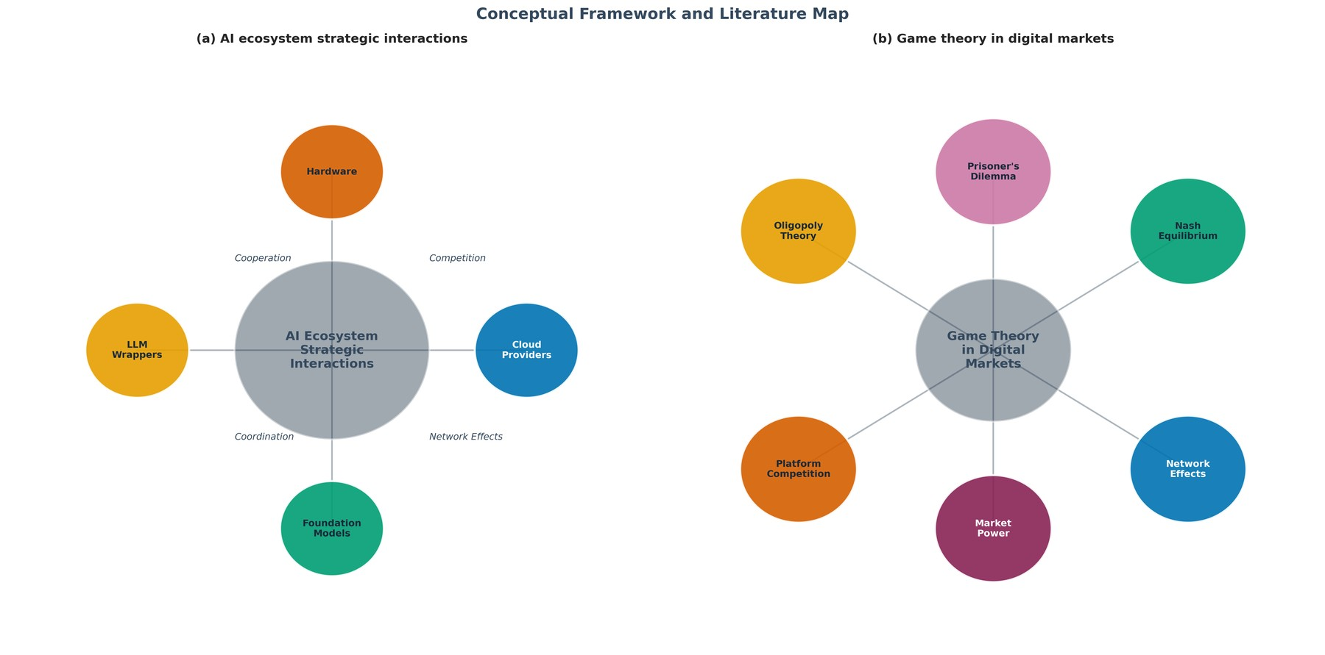
Figure 1: Framework & Literature Map (schematic)
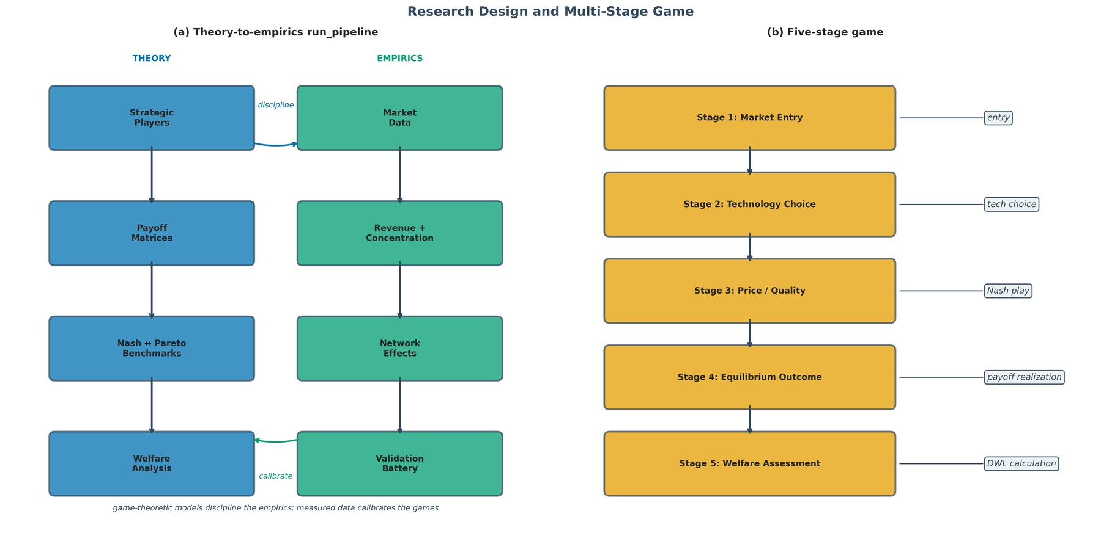
Figure 2: Research Design & Stages (schematic)
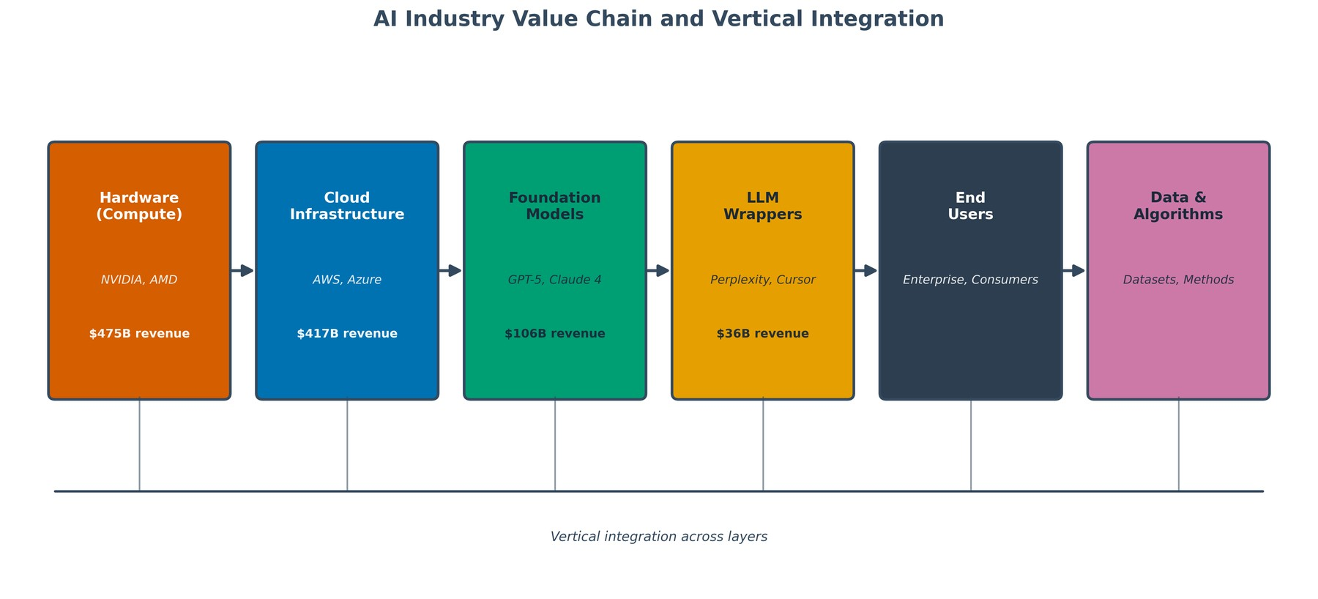
Figure 4: Value Chain (schematic)

3. Market Structure Results
Concentration and market-power metrics computed from the revenue distribution across the four archetypes.
Exhibit 3.1 Concentration metrics (computed by build_technical_report.py)
Metric | Value
Total market revenue | $1,034.50B
HHI | 3,851.21 (highly concentrated: >2,500 in 2010, >1,800 in 2023 guidelines)
CR4 | 100.00%
Gini coefficient | 0.3933

Exhibit 3.2 Market shares (computed by build_technical_report.py)
Player category | Market share (%)
Hardware | 45.92
Cloud Providers | 40.31
Foundation Models | 10.29
LLM Wrappers | 3.48

Exhibit 3.3 Market power (Lerner-based, computed by build_technical_report.py)
Player category | Demand elasticity | Lerner index | Implied markup | Power level
Hardware | -1.60 | 0.623 | 165.4% | Very High (Approaching Monopoly)
Cloud Providers | -2.08 | 0.482 | 92.9% | High (Strong Oligopoly)
Foundation Models | -3.00 | 0.333 | 50.0% | Moderate
LLM Wrappers | -3.00 | 0.333 | 50.0% | Moderate

Table 7.17 restates the same pricing power with its elasticity-driven uncertainty bands: the interval between the conservative and aggressive Lerner estimates is the robustness range for any markup claim, and the figure plots the base index against those bands.
Table 7.17: Lerner Index & Markup Summary with Uncertainty Bands
Archetype | Base Lerner | Lerner Band | Base Markup (%) | Markup Band (%)
Cloud Providers | 0.56 | 0.400–0.833 | 125 | 66.7–500.0
Hardware | 0.67 | 0.500–0.833 | 200 | 100.0–500.0
Foundation Models | 0.40 | 0.286–0.556 | 66.70 | 40.0–125.0
LLM Wrappers | 0.25 | 0.167–0.333 | 33.30 | 20.0–50.0

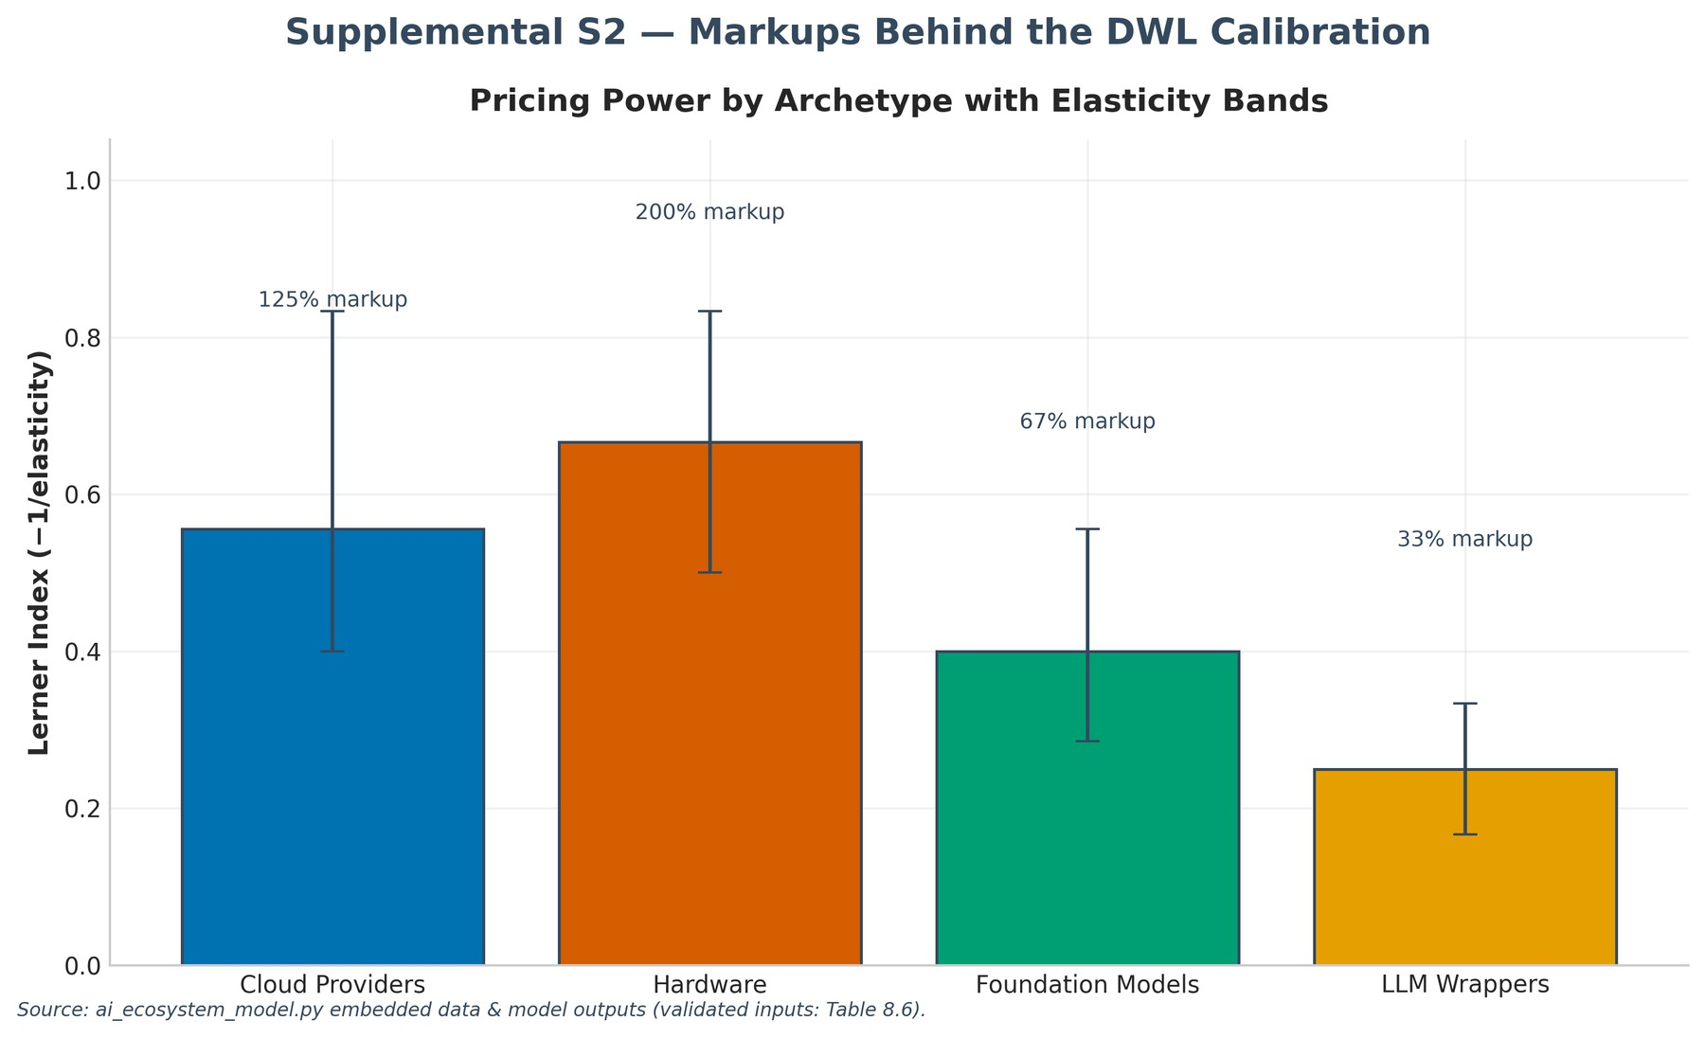
Supplemental S2 — Lerner Index with Uncertainty Bands
Exhibit 3.4 Gatekeeper index: who the ecosystem cannot route around (ai_ecosystem_model.py diagnostics)
Archetype | Dependents_Count | Inbound ($B) | Gatekeeper share
Hardware | 4 | 359.7 | 53.3%
Cloud Providers | 6 | 177.2 | 26.2%
Fluidstack (external) | 1 | 50.0 | 7.4%
SpaceX Colossus (external) | 1 | 45.0 | 6.7%
Foundation Models | 4 | 33.5 | 5.0%

Top gatekeeper: Hardware (53.3% of dependency value). Upstream control predetermines downstream outcomes — the World Bank (2026) thesis, named here rather than assumed.
Analytical insights — market structure
Antitrust temperature. The HHI of 3,851 is presumptively concentrated under the DOJ/FTC Merger Guidelines (HHI above 2,500 on the 2010 vintage — and above 1,800 on the current 2023 vintage — invites structural scrutiny), so unilateral conduct by the largest archetypes — let alone further consolidation — would be the first thing a competition authority examines. The top two archetypes — Cloud Providers (40.3%) and Hardware (45.9%) — account for 86.2% of measured revenue (CR4 = 100.0%), a structure consistent with a 'gatekeeper' market in which access, not price, is the competitive margin.
Inequality as concentration. A Gini coefficient of 0.393 (with only four players) shows that the distribution is dominated by the two infrastructure archetypes: the revenue share gap between Cloud/Hardware and the model/wrapper layers is the structural source of the bargaining asymmetries examined later.
Where the pricing power sits. The highest implied Lerner index is 0.623 (Hardware, ~165% markup over marginal cost). A Lerner value in this range implies inelastic demand and strong switching costs — precisely the preconditions for the vertical hold-up games modeled in Section 4.
Module | MarketStructureAnalyzer, ElasticitySensitivityAnalyzer, RevenueProjection
Outputs | Tables 1.1 (structure), 1.3 (2030 projections), 7.1 (concentration); Figure 3 (revenue, HHI, shares).
Inference | HHI 3,851 on $1,034B revenue with the top two archetypes at 86.2%: a gatekeeper structure where access, not price, is the competitive margin.
Implication | Screen consolidation first and price conduct second: interoperability and portability remedies target the access margin directly, while breakup analysis starts from the measured, not assumed, bottleneck.

Table 1.1: Market Structure Metrics
Metric | Value | Interpretation
Total Market Value ($B) | 1,034.50 | -
HHI | 3,851.21 | Highly Concentrated
Gini Coefficient | 0.39 | Moderate
CR4 (%) | 100 | Top 4 Dominated

Table 1.3: Revenue Projections
CAGR (%) | Revenue 2025 ($B) | Projected Revenue 2030 ($B)
29 | 475 | 1,585.30
28 | 417 | 1,341.10
35 | 106.50 | 441.50
30 | 36 | 124.70

Table 7.16 converts the 2025 observed and 2030 projected revenue levels into market shares: the levels say how big the market gets, the shares say who gains weight under diminishing-growth compounding. The figure plots the two vintages side by side.
Table 7.16: Market-Share Evolution 2025 vs 2030 (Revenue Projections)
Archetype | Revenue 2025 ($B) | Share 2025 (%) | Revenue 2030 ($B) | Share 2030 (%) | Share Change (pp)
Hardware | 475 | 45.92 | 1,585.30 | 45.39 | -0.52
Cloud Providers | 417 | 40.31 | 1,341.10 | 38.40 | -1.91
Foundation Models | 106.50 | 10.29 | 441.50 | 12.64 | 2.35
LLM Wrappers | 36 | 3.48 | 124.70 | 3.57 | 0.09

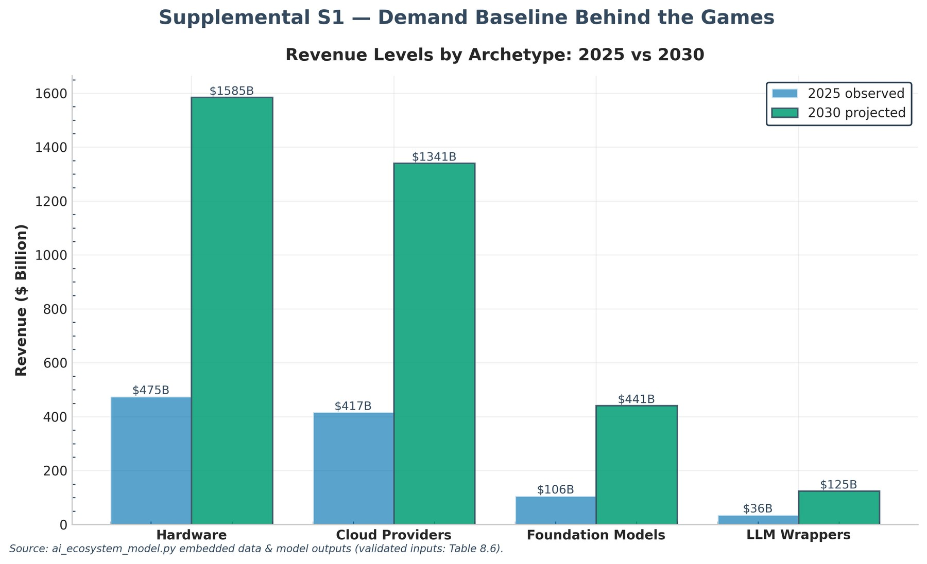
Supplemental S1 — Revenue Levels 2025 vs 2030
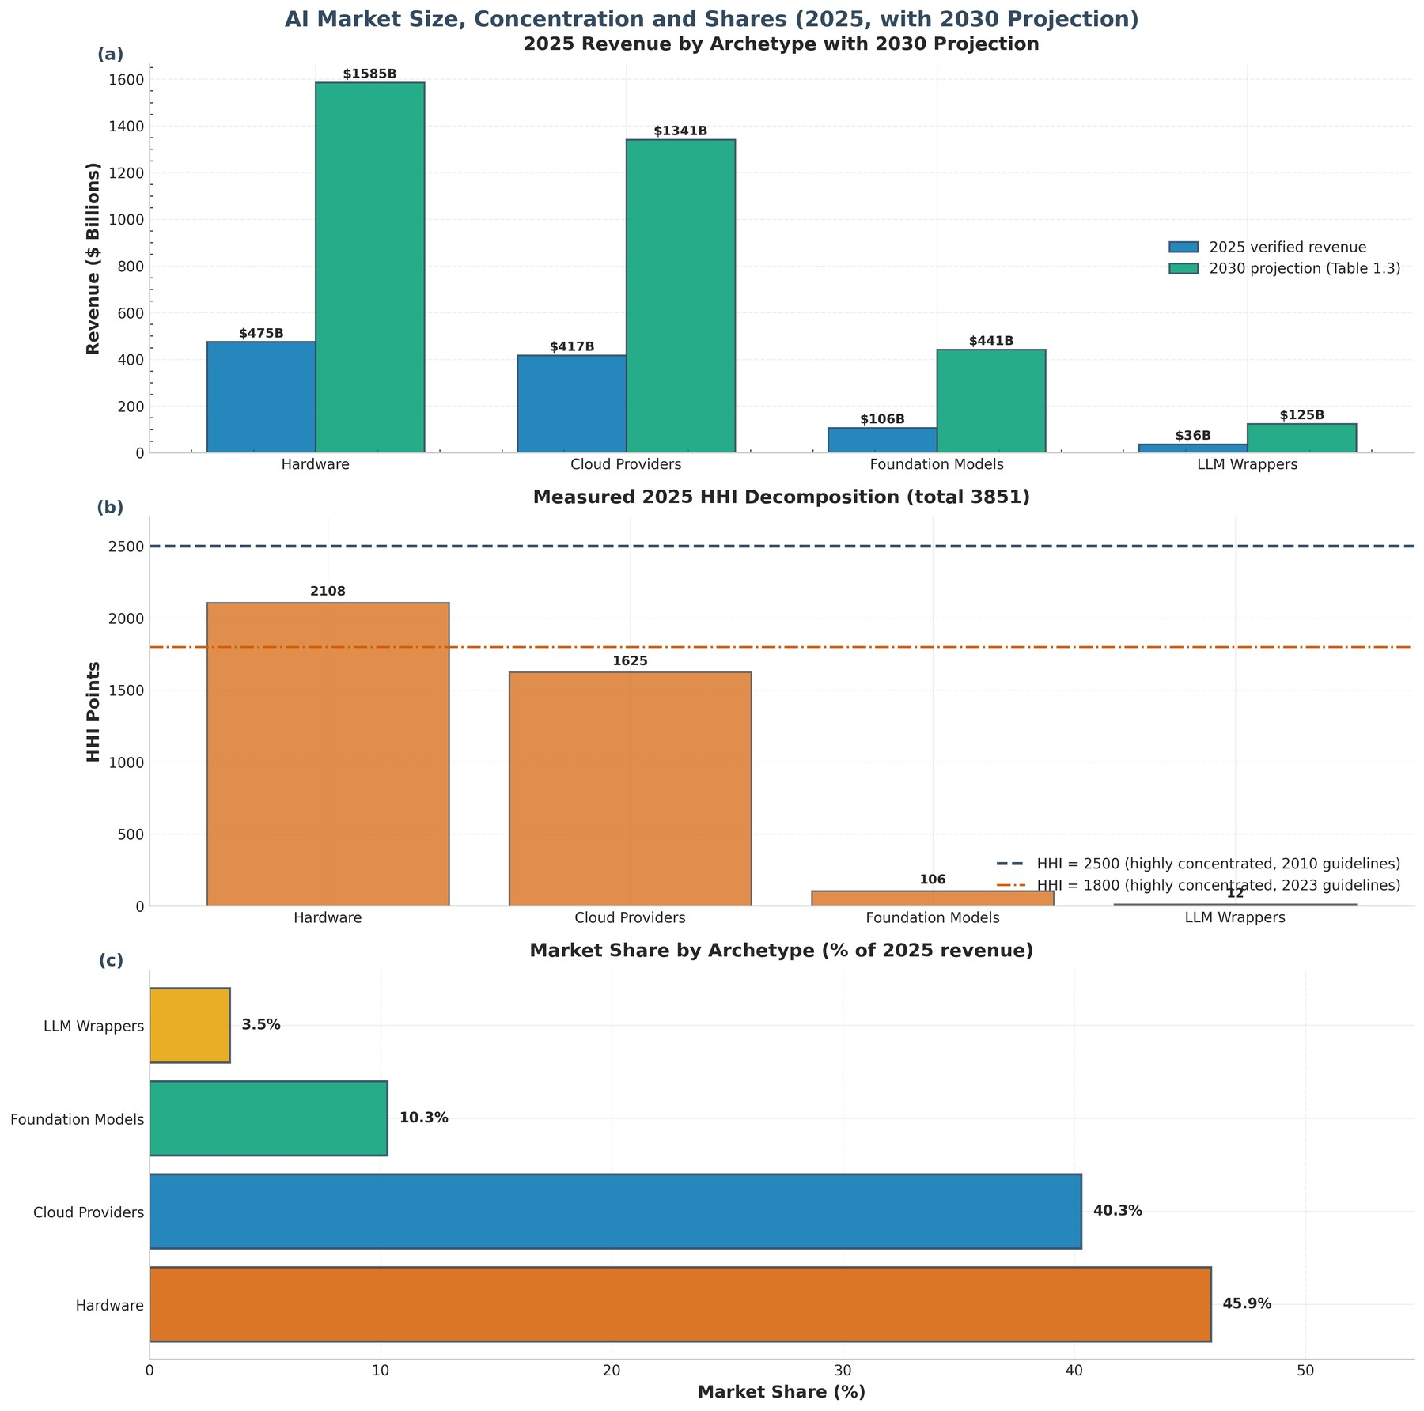
Figure 3: Market Size, Concentration & Shares [Panels: (a), (b), (c)]
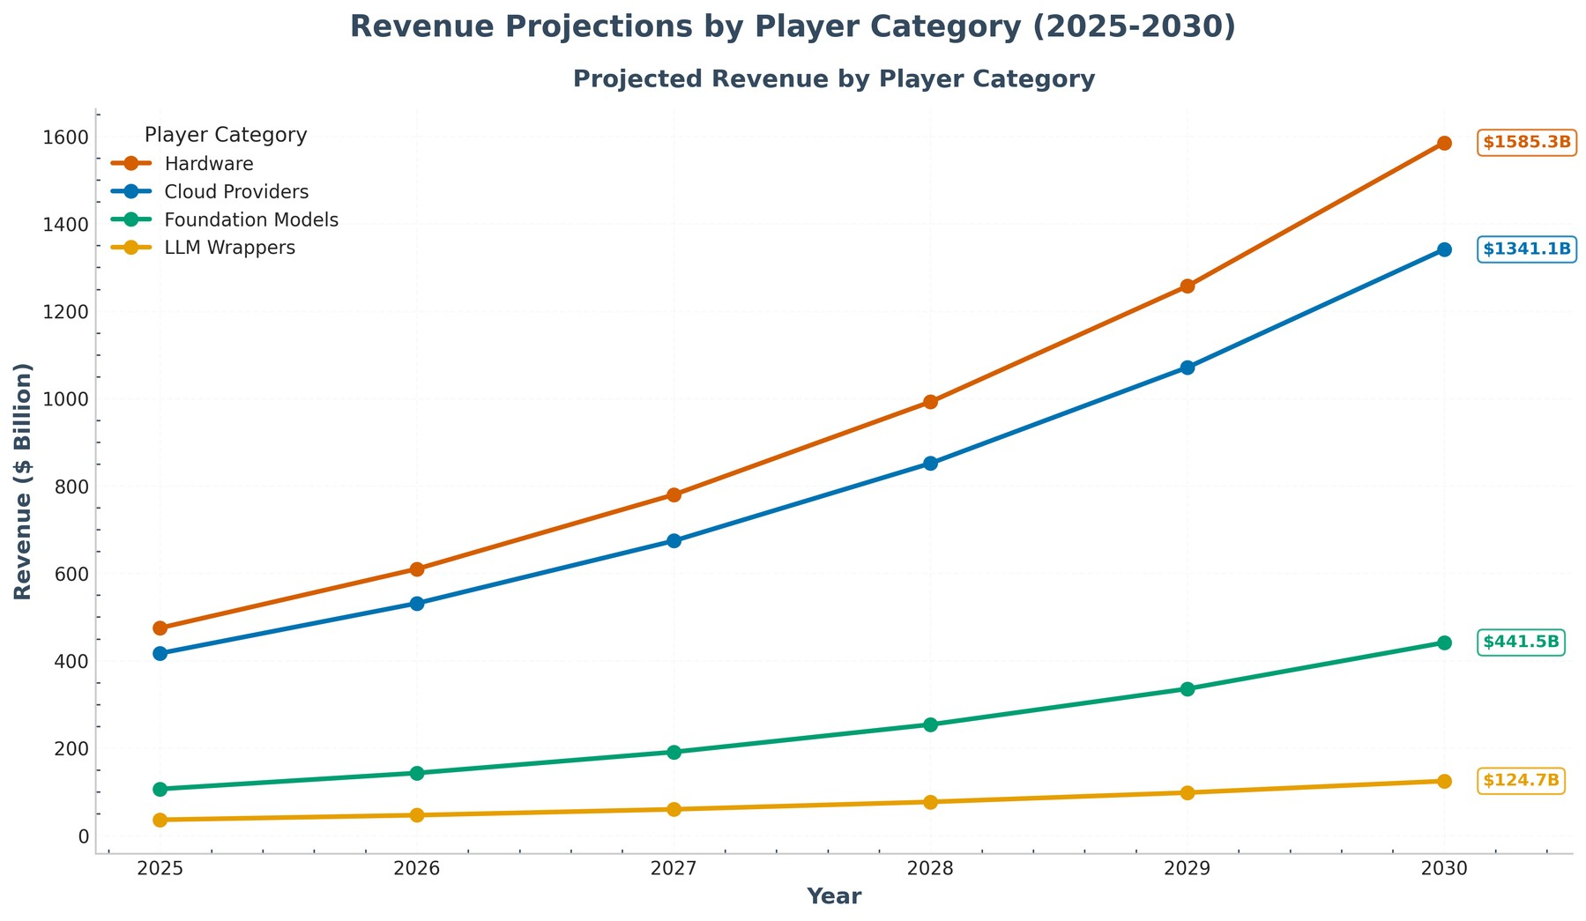
Figure 13: Revenue Projections (schematic)

4. Strategic Interaction and Equilibrium
6 bilateral games are solved for pure-strategy Nash equilibria; the table below reports each game's equilibrium, classification, efficiency and deadweight loss.
Exhibit 4.1 Nash equilibria across all bilateral games (computed by build_technical_report.py)
index | Hardware-Cloud Providers | Hardware-Foundation Models | Hardware-LLM Wrappers | Cloud Providers-Foundation Models | Cloud Providers-LLM Wrappers | Foundation Models-LLM Wrappers
Game type | Coordination Failure | Coordination Failure | Coordination Failure | Coordination Failure | Coordination Failure | Dominant Strategy NE (Inefficient)
NE strategies | Open Access / Proprietary Stack | Open Access / Exclusive Model | Open Access / Independent App | Interoperable Stack / Exclusive Model | Interoperable Stack / Independent App | Exclusive Model / Independent App
NE payoffs ($B) | (487.9, 606.8) | (524.8, 146.5) | (552.6, 56.4) | (459.0, 145.1) | (487.9, 56.4) | (106.5, 36.0)
Efficiency (%) | 94.9 | 76.6 | 71.1 | 81.1 | 75.1 | 80.5
DWL ($B) | 58.6 | 205.6 | 247.0 | 141.2 | 180.7 | 34.6
Coord. failure | Yes | Yes | Yes | Yes | Yes | Yes

Exhibit 4.2 Payoff matrix — Hardware-Cloud Providers ($B; row: Hardware, column: Cloud Providers)
 | Interoperable Stack | Proprietary Stack
Open Access | (559.2, 491.0) | (487.9, 606.8) [NE]
Walled Garden | (722.5, 430.8) [Joint-Max (K-H)] | (475.0, 417.0)

Exhibit 4.3 Payoff matrix — Hardware-Foundation Models ($B; row: Hardware, column: Foundation Models)
 | Collaborate API | Exclusive Model
Open Access | (601.4, 134.9) | (524.8, 146.5) [NE]
Walled Garden | (777.1, 99.8) [Joint-Max (K-H)] | (475.0, 106.5)

Exhibit 4.4 Payoff matrix — Hardware-LLM Wrappers ($B; row: Hardware, column: LLM Wrappers)
 | Deep Integration | Independent App
Open Access | (633.3, 48.0) | (552.6, 56.4) [NE]
Walled Garden | (818.3, 37.8) [Joint-Max (K-H)] | (475.0, 36.0)

Exhibit 4.5 Payoff matrix — Cloud Providers-Foundation Models ($B; row: Cloud Providers, column: Foundation Models)
 | Collaborate API | Exclusive Model
Interoperable Stack | (523.1, 133.6) | (459.0, 145.1) [NE]
Proprietary Stack | (646.5, 98.9) [Joint-Max (K-H)] | (417.0, 106.5)

Exhibit 4.6 Payoff matrix — Cloud Providers-LLM Wrappers ($B; row: Cloud Providers, column: LLM Wrappers)
 | Deep Integration | Independent App
Interoperable Stack | (556.0, 48.0) | (487.9, 56.4) [NE]
Proprietary Stack | (687.2, 37.8) [Joint-Max (K-H)] | (417.0, 36.0)

Exhibit 4.7 Payoff matrix — Foundation Models-LLM Wrappers ($B; row: Foundation Models, column: LLM Wrappers)
 | Deep Integration | Independent App
Collaborate API | (131.0, 44.3) | (96.9, 52.1)
Exclusive Model | (142.3, 34.9) [Joint-Max (K-H)] | (106.5, 36.0) [NE]

4.3 Welfare benchmark, transfers and equilibrium selection
The payoff audit corrects a material terminology error: 6 of 6 joint-surplus benchmarks are Kaldor–Hicks improvements, not Pareto improvements. Their gross joint gain is $867.77B, but downstream parties require $307.43B in compensating transfers to accept the transition from the reported Nash profile. The result is a distributive-obstruction diagnosis rather than a generic coordination claim.
Table 3.5 — Welfare-benchmark audit (Kaldor-Hicks transfers)
index | Hardware-Cloud Providers | Hardware-Foundation Models | Hardware-LLM Wrappers | Cloud Providers-Foundation Models | Cloud Providers-LLM Wrappers | Foundation Models-LLM Wrappers
player_1 | Hardware | Hardware | Hardware | Cloud Providers | Cloud Providers | Foundation Models
player_2 | Cloud Providers | Foundation Models | LLM Wrappers | Foundation Models | LLM Wrappers | LLM Wrappers
nash_profile | Open Access / Proprietary Stack | Open Access / Exclusive Model | Open Access / Independent App | Interoperable Stack / Exclusive Model | Interoperable Stack / Independent App | Exclusive Model / Independent App
joint_max_profile | Walled Garden / Interoperable Stack | Walled Garden / Collaborate API | Walled Garden / Deep Integration | Proprietary Stack / Collaborate API | Proprietary Stack / Deep Integration | Exclusive Model / Deep Integration
nash_payoff_1 | 487.94 | 524.76 | 552.58 | 458.99 | 487.89 | 106.50
nash_payoff_2 | 606.82 | 146.50 | 56.45 | 145.13 | 56.45 | 36
joint_max_payoff_1 | 722.54 | 777.07 | 818.27 | 646.50 | 687.22 | 142.26
joint_max_payoff_2 | 430.81 | 99.79 | 37.80 | 98.85 | 37.80 | 34.86
delta_1 | 234.60 | 252.31 | 265.68 | 187.52 | 199.33 | 35.76
delta_2 | -176.01 | -46.71 | -18.65 | -46.27 | -18.65 | -1.14
joint_gain | 58.59 | 205.59 | 247.04 | 141.24 | 180.68 | 34.62
classification | Kaldor-Hicks (transfer required) | Kaldor-Hicks (transfer required) | Kaldor-Hicks (transfer required) | Kaldor-Hicks (transfer required) | Kaldor-Hicks (transfer required) | Kaldor-Hicks (transfer required)
minimum_transfer | 176.01 | 46.71 | 18.65 | 46.27 | 18.65 | 1.14
transfer_from | Hardware | Hardware | Hardware | Cloud Providers | Cloud Providers | Foundation Models
transfer_to | Cloud Providers | Foundation Models | LLM Wrappers | Foundation Models | LLM Wrappers | LLM Wrappers

Equilibrium multiplicity is reported using weak best responses; the solver and independent auditor must agree on the count before any selection claim is made.
Table 3.6 — Equilibrium multiplicity and risk-dominance audit
index | Hardware-Cloud Providers | Hardware-Cloud Providers | Hardware-Foundation Models | Hardware-LLM Wrappers | Hardware-LLM Wrappers | Cloud Providers-Foundation Models | Cloud Providers-LLM Wrappers | Cloud Providers-LLM Wrappers | Foundation Models-LLM Wrappers
N_Pure_NE | 2 | 2 | 1 | 2 | 2 | 1 | 2 | 2 | 1
Equilibrium_Profile | Open Access / Proprietary Stack | Walled Garden / Interoperable Stack |  | Open Access / Independent App | Walled Garden / Deep Integration |  | Interoperable Stack / Independent App | Proprietary Stack / Deep Integration
Joint_Payoff_$B | 1,094.76 | 1,153.35 |  | 609.03 | 856.07 |  | 544.34 | 725.02
Nash_Product | 1,499.02 | 2,255.58 |  | 655.42 | 332.88 |  | 598.88 | 236.19
Risk_Dominant | Walled Garden / Interoperable Stack | Walled Garden / Interoperable Stack |  | Open Access / Independent App | Open Access / Independent App |  | Interoperable Stack / Independent App | Interoperable Stack / Independent App
Payoff_Dominant | Walled Garden / Interoperable Stack | Walled Garden / Interoperable Stack |  | Walled Garden / Deep Integration | Walled Garden / Deep Integration |  | Proprietary Stack / Deep Integration | Proprietary Stack / Deep Integration
Aligned | True | True |  | False | False |  | False | False
Selection_Note | Efficient equilibrium is payoff- and risk-dominant; persistence of the inferior equilibrium requires lock-in/history explanation. | Efficient equilibrium is payoff- and risk-dominant; persistence of the inferior equilibrium requires lock-in/history explanation. | Not applicable: not exactly two 2x2 pure equilibria. | Risk dominance opposes payoff dominance; a commitment device is needed. | Risk dominance opposes payoff dominance; a commitment device is needed. | Not applicable: not exactly two 2x2 pure equilibria. | Risk dominance opposes payoff dominance; a commitment device is needed. | Risk dominance opposes payoff dominance; a commitment device is needed. | Not applicable: not exactly two 2x2 pure equilibria.

Repeated-game analysis reports whether grim-trigger punishment can sustain the joint-surplus profile without transfers. Infinite critical discount factors denote cases where Nash reversion is not a credible punishment.
Table 3.7 — Repeated-game sustainability (critical discount factors)
index | Hardware-Cloud Providers | Hardware-Foundation Models | Hardware-LLM Wrappers | Cloud Providers-Foundation Models | Cloud Providers-LLM Wrappers | Foundation Models-LLM Wrappers
P1_Critical_Delta | 0 | 0 | 0 | 0 | 0 | 0
P1_Status | no deviation incentive | no deviation incentive | no deviation incentive | no deviation incentive | no deviation incentive | no deviation incentive
P2_Critical_Delta | 0 | ∞ | 0 | ∞ | 0 | ∞
P2_Status | no deviation incentive | Nash reversion is not a credible punishment | no deviation incentive | Nash reversion is not a credible punishment | no deviation incentive | Nash reversion is not a credible punishment
Binding_Player | Hardware | Foundation Models | Hardware | Foundation Models | Cloud Providers | LLM Wrappers
Critical_Delta | 0 | ∞ | 0 | ∞ | 0 | ∞
Status | no deviation incentive | Nash reversion is not a credible punishment | no deviation incentive | Nash reversion is not a credible punishment | no deviation incentive | Nash reversion is not a credible punishment
Sustainable_No_Transfers | True | False | True | False | True | False

Supplemental Figure S5 plots Table 3.5's bottom line by game: the height of each bar is the joint gain from moving off Nash, the color is the welfare verdict, and the annotation is the minimum transfer that unlocks the Kaldor-Hicks cases.
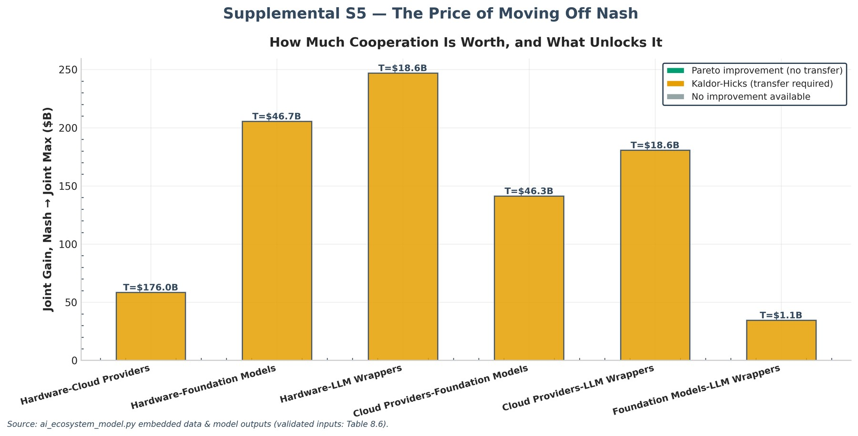
Supplemental S5 — Joint Gains and Minimum Transfers by Game
Analytical insights — strategic interaction
The core game: rational, mutually assured enclosure. The Hardware–Cloud Providers equilibrium (Open Access, Proprietary Stack) is a classic mutual-defection trap: each side walls off its customer base because the other would capture the full ecosystem if it stayed open. It is 'Coordination Failure': individually rational, jointly destructive. Neither player can unilaterally open up without conceding rents, so the lock-in persists even though a cooperative (open/interoperable) outcome would raise combined welfare by $58.6B (efficiency 94.9%).
Beyond the core: the rest of the game landscape. Across all six games the type distribution is Coordination Failure ×5; Dominant Strategy NE (Inefficient) ×1. The largest secondary loss is Hardware-LLM Wrappers ($247.0B, about 422% of the core game's $58.6B) — the welfare problem is concentrated, not diffuse. Next: Hardware-Foundation Models ($205.6B). For publication purposes this concentration is a feature: a single-bottleneck diagnosis yields a falsifiable claim (fix the infrastructure game, recover most of the welfare) rather than a vague 'markets are inefficient' verdict.
Module | GameTheoryFramework, CoordinationFailureAnalyzer
Outputs | Tables 3.1, 3.2 (payoff matrices), 3.4 (equilibrium & DWL); Figures 5 (all matrices), 6 (core game).
Inference | Core equilibrium (Open Access / Proprietary Stack) wastes $58.6B; 0 of 6 games are pure Prisoner's Dilemmas — failure is concentrated in the infrastructure layer, not diffuse.
Implication | Regulate the bottleneck, not the ecosystem: a single-game diagnosis gives a falsifiable claim (fix the core game, recover most welfare) instead of blanket platform rules.

Table 3.1: Cloud vs Foundation Payoff Matrix
P1_Strategy (Cloud Providers) | P2: Collaborate API (P1, P2) | P2: Exclusive Model (P1, P2)
Interoperable Stack | (523.1, 133.6) | (459.0, 145.1)
Proprietary Stack | (646.5, 98.9) | (417.0, 106.5)

Table 3.2: Hardware vs Cloud Payoff Matrix
P1_Strategy (Hardware) | P2: Interoperable Stack (P1, P2) | P2: Proprietary Stack (P1, P2)
Open Access | (559.2, 491.0) | (487.9, 606.8)
Walled Garden | (722.5, 430.8) | (475.0, 417.0)

Table 3.4: Core-Game Equilibrium, Coordination & DWL
Metric | Value
Core Game Nash Strategies (P1, P2) | (Open Access, Proprietary Stack)
Core Game Nash Payoffs ($B, P1, P2) | (487.94, 606.82)
Core Game Nash Total Welfare ($B) | 1094.76
Core Game Pareto Strategies (P1, P2) | (Walled Garden, Interoperable Stack)
Core Game Pareto Total Welfare ($B) | 1153.35
Core Game Efficiency Ratio (%) | 94.92
Core Game Deadweight Loss ($B) | 58.59
Aggregate Deadweight Loss ($B) | 416.77
Aggregate Efficiency (%) | 71.28
Core Game Coordination Failure? | True
Core Game Failure Severity | Moderate
Coordination Failures DWL Source ($B) | 60.01
Monopoly Pricing DWL Source ($B) | 35.86
Innovation Distortion DWL Source ($B) | 106.97
Quality Degradation DWL Source ($B) | 71.31
Switching Costs DWL Source ($B) | 142.62

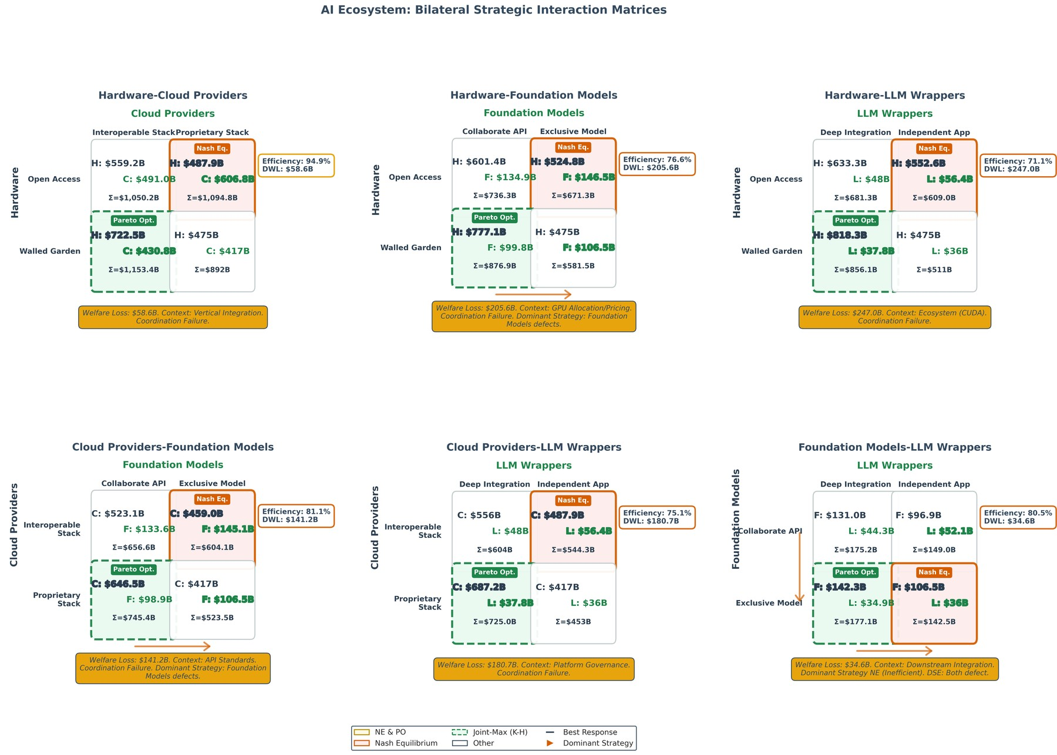
Figure 5: Complete Matrices (schematic)
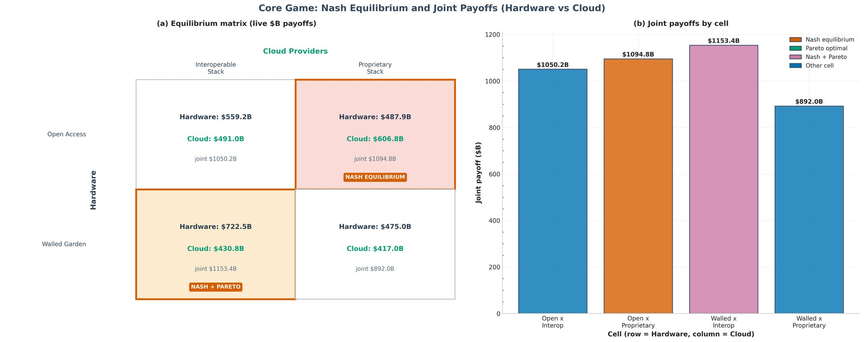
Figure 6: Core Game: Equilibrium & Payoffs (schematic)
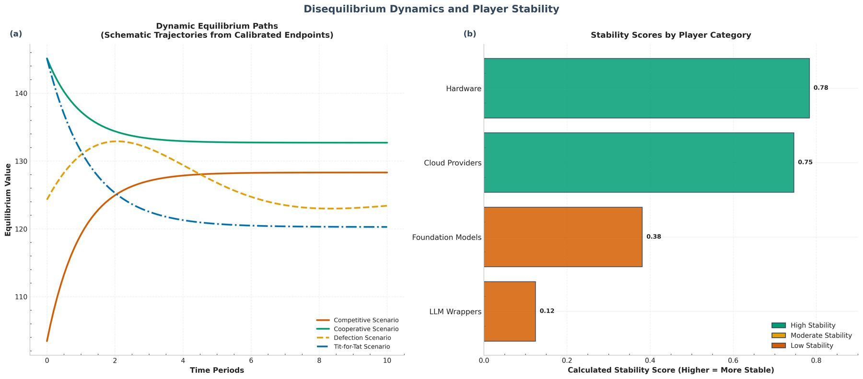
Figure 11: Dynamics & Stability [Panels: (a), (b)]

Discussion: what the equilibria mean for theory
- Asymmetric multi-layer platforms behave differently from textbook symmetric oligopoly: Nash equilibrium exists in every bilateral game here, yet none of the 6 games reaches an efficient equilibrium — the infrastructure game included. Existence theorems transfer; welfare conclusions do not.
- Efficient local equilibria coexisting with an inefficient aggregate is the empirical face of second-best economics: with switching costs, markups, and lock-in operating simultaneously, the system can be locally stable and globally wasteful. Policy must therefore target the distortion portfolio (Section 5), not merely 'more competition' in the abstract.
- A repeated-game lens qualifies the one-shot result: trigger strategies can sustain cooperation where stage games trap players, so the observed Walled-Garden persistence may partly reflect punishment equilibria rather than stage-game necessity — see Limitations (9.2) and Future work (9.3).

5. Welfare, Deadweight Loss and Policy
Exhibit 5.1 Aggregate welfare (computed by build_technical_report.py)
Metric | Value
Observed (Nash) welfare | $1,034.50B
Potential joint-surplus welfare | $1,451.27B
Aggregate deadweight loss | $416.77B
Aggregate efficiency | 71.28%
Market-implied DWL assumption | 28.72%

Exhibit 5.2 Deadweight-loss decomposition (computed by build_technical_report.py)
Source | DWL ($B) | Share (%)
Coordination Failures | 60.01 | 14.4
Monopoly Pricing | 35.86 | 8.6
Innovation Distortion | 106.97 | 25.7
Quality Degradation | 71.31 | 17.1
Switching Costs | 142.62 | 34.2

Exhibit 5.2b Policy interventions ranked by base-scenario net benefit (ai_ecosystem_model.py enhancement output)
Policy | DWL reduction ($B) | Cost ($B) | Net benefit ($B) | BCR
Combined Intervention | 229.2 | 15.0 | 214.2 | 15.3
API Interoperability Mandate | 145.9 | 5.0 | 140.9 | 29.2
Antitrust Enforcement | 104.2 | 2.0 | 102.2 | 52.1
Innovation Subsidies | 93.8 | 8.0 | 85.8 | 11.7
Data Sharing Mandate | 75.0 | 3.0 | 72.0 | 25.0

Highest net-benefit intervention (base scenario): Combined Intervention — net benefit $214.2B.
Analytical insights — policy choice
Why this intervention wins. Combined Intervention leads on base-scenario net benefit ($214.2B): it recovers $229.2B of deadweight loss (55% of the $416.8B aggregate) at a cost of $15.0B (benefit–cost ratio 15.3). This is notable precisely because it does not target the infrastructure bottleneck head-on — which invites the committee question of whether the ranking survives under the optimistic/pessimistic scenarios. The policy lesson is proportionality: the cheapest effective remedy dominates because the DWL pool is large relative to any plausible intervention cost.
How decisive the ranking is. The runner-up (API Interoperability Mandate) trails by $73.4B in net benefit. A wide margin means the recommendation is robust to scenario choice — check the optimistic/conservative columns to confirm.
Complementarity tested, not assumed. The combined intervention recovers $229.2B against $418.9B summed standalone (ratio 0.547: sub-additive (overlap/diminishing)). The levers OVERLAP — the Combined ranking in Exhibit 5.2b wins on absolute net benefit, but stacking all four buys less than the sum of its parts. A committee should ask whether a two- or three-lever bundle dominates the full package. This is the second-best logic of Section 2.3 made quantitative.
Module | PolicyInterventionAnalyzer
Outputs | Table 6.1/6.3 (simulation summary); Figure 12 (cost-benefit).
Inference | Base-case winner: Combined Intervention (net $214.2B, BCR 15.3). The DWL pool dwarfs any plausible intervention cost.
Implication | Proportionality governs: fund the cheapest effective lever first, and re-check the ranking under optimistic/conservative scenarios before legislating.

5.1 Policy deep dives

API Interoperability Mandate
Mechanism: mandate open, standardized APIs to cut proprietary lock-in.
Scenarios — API Interoperability Mandate (ai_ecosystem_model.py enhancement output)
Scenario | DWL reduction ($B) | Cost ($B) | Net benefit ($B) | BCR
Conservative | 104.2 | 7.0 | 97.2 | 14.88
Base | 145.9 | 5.0 | 140.9 | 29.17
Optimistic | 187.5 | 3.0 | 184.5 | 62.52

Stated precedent/analogue: EU Digital Markets Act (European Commission 2022).

Antitrust Enforcement
Mechanism: challenge high-concentration conduct and impose market-conduct remedies.
Scenarios — Antitrust Enforcement (ai_ecosystem_model.py enhancement output)
Scenario | DWL reduction ($B) | Cost ($B) | Net benefit ($B) | BCR
Conservative | 62.5 | 4.0 | 58.5 | 15.63
Base | 104.2 | 2.0 | 102.2 | 52.10
Optimistic | 145.9 | 1.0 | 144.9 | 145.87

Stated precedent/analogue: DOJ/FTC costs (Baker 2019).

Innovation Subsidies
Mechanism: subsidize alternative architectures, competing chips, and open foundations.
Scenarios — Innovation Subsidies (ai_ecosystem_model.py enhancement output)
Scenario | DWL reduction ($B) | Cost ($B) | Net benefit ($B) | BCR
Conservative | 62.5 | 12.0 | 50.5 | 5.21
Base | 93.8 | 8.0 | 85.8 | 11.72
Optimistic | 125.0 | 5.0 | 120.0 | 25.01

Stated precedent/analogue: CHIPS Act (CBO Jul 2022 cost estimate) & IRA credits (JCT scores).

Data Sharing Mandate
Mechanism: require sharing of anonymized data to diffuse model/data advantages.
Scenarios — Data Sharing Mandate (ai_ecosystem_model.py enhancement output)
Scenario | DWL reduction ($B) | Cost ($B) | Net benefit ($B) | BCR
Conservative | 50.0 | 5.0 | 45.0 | 10.00
Base | 75.0 | 3.0 | 72.0 | 25.01
Optimistic | 104.2 | 2.0 | 102.2 | 52.10

Stated precedent/analogue: Krämer, Senellart & de Streel (2020), Making Data Portability More Effective, CERRE.

Combined Intervention
Mechanism: deploy all four levers jointly (tested sub-additive, ratio 0.547: the levers overlap rather than complement).
Scenarios — Combined Intervention (ai_ecosystem_model.py enhancement output)
Scenario | DWL reduction ($B) | Cost ($B) | Net benefit ($B) | BCR
Conservative | 187.5 | 20.0 | 167.5 | 9.38
Base | 229.2 | 15.0 | 214.2 | 15.28
Optimistic | 270.9 | 12.0 | 258.9 | 22.57

Stated precedent/analogue: Policy complementarity (Crémer et al. 2019).

5.2 Coordination failures
Exhibit 5.3 Coordination-failure diagnostics (computed by build_technical_report.py)
Game | Coordination failure | Severity | DWL ($B) | Efficiency (%)
Hardware-Cloud Providers | Yes | Moderate | 58.59 | 94.9
Hardware-Foundation Models | Yes | Critical | 205.59 | 76.6
Hardware-LLM Wrappers | Yes | Critical | 247.04 | 71.1
Cloud Providers-Foundation Models | Yes | High | 141.24 | 81.1
Cloud Providers-LLM Wrappers | Yes | Critical | 180.68 | 75.1
Foundation Models-LLM Wrappers | Yes | High | 34.62 | 80.5

Total deadweight loss attributable to coordination failures: $867.77B (gross sum across games — shared players are counted repeatedly, so this exceeds the top-down aggregate by construction; see the discussion below).
Analytical insights — welfare and deadweight loss
What the deadweight loss is made of. Switching costs is the single largest component of the $416.8B aggregate DWL (34%). Because the mix differs by source, so does the remedy: a coordination-dominated loss points to interoperability and standard-setting, whereas a switching-cost-dominated loss points to portability mandates. Treating all $416.8B as one 'market failure' number would mislead policy design.
Efficiency gap and the value of coordination. The system operates at 71.3% of its potential (1,451.3B vs. observed 1,034.5B). Coordination failures total $867.8B gross across the six games — shared players are counted repeatedly, which is why this exceeds the top-down aggregate. The loss is not an exogenous shock but an equilibrium outcome that cooperation, standard-setting, or mediated bargaining could in principle recover.
Module | WelfareEconomicsAnalyzer
Outputs | Tables 3.4 (core + aggregate), 5.3 (decomposition); Figure 7 (welfare composite).
Inference | $416.8B aggregate loss at 71.3% efficiency, led by switching costs ($142.6B).
Implication | Match remedy to source: switching-cost dominance argues portability mandates; coordination share argues standards and interop — one DWL number would misdirect both.

Table 5.3: Welfare Decomposition
Source of Deadweight Loss | Estimated Contribution ($B) | Percentage of Total DWL (%)
Coordination Failures | 60.01 | 14.40
Monopoly Pricing | 35.86 | 8.60
Innovation Distortion | 106.97 | 25.70
Quality Degradation | 71.31 | 17.10
Switching Costs | 142.62 | 34.20
Total | 416.77 | 100

Table 5.4: Dynamic Game Analysis (Short vs Long-term)
Player | Strategy | Short-term Payoff | Long-term Payoff | Difference (L-S) | Long/Short Ratio (%) | Time Preference | Risk Level
Cloud Providers | Full Stack | 5 | 8 | 3 | 160 | Long-term | Medium
Cloud Providers | Selective Partnership | 3 | 4 | 1 | 133.30 | Long-term | Low
Cloud Providers | Infrastructure Only | 2 | 2 | 0 | 100 | Neutral | Low
Foundation Models | Compete Direct | 4 | 5 | 1 | 125 | Long-term | Medium
Foundation Models | Exclusive Deals | 3 | -2 | -5 | -66.70 | Short-term | Critical
Foundation Models | Support Wrappers | 2 | -1 | -3 | -50 | Short-term | High
Hardware | Open Access | 6 | 9 | 3 | 150 | Long-term | Low
Hardware | Exclusive Deals | 5 | 3 | -2 | 60 | Short-term | High
Hardware | Price Control | 7 | 2 | -5 | 28.60 | Short-term | Critical
LLM Wrappers | Vertical Integration | 2 | 6 | 4 | 300 | Long-term | High
LLM Wrappers | Premium Pricing | 1 | 3 | 2 | 300 | Long-term | Medium
LLM Wrappers | Subsidize Usage | -3 | -4 | -1 | 133.30 | Short-term | Critical

Table 6.1–6.3: Policy Simulation Summary (v4.0)
Policy Scenario | DWL Reduction ($B) | Welfare Improvement (%) | Implementation Cost ($B) | Net Annual Benefit ($B) | Benefit-Cost Ratio | Source
Combined Intervention | 229.22 | 55 | 15 | 214.22 | 15.28 | Policy complementarity (Crémer et al. 2019)
API Interoperability Mandate | 145.87 | 35 | 5 | 140.87 | 29.17 | EU Digital Markets Act (European Commission 2022)
Antitrust Enforcement | 104.19 | 25 | 2 | 102.19 | 52.10 | DOJ/FTC costs (Baker 2019)
Innovation Subsidies | 93.77 | 22.50 | 8 | 85.77 | 11.72 | CHIPS Act (CBO Jul 2022 cost estimate) & IRA credits (JCT scores)
Data Sharing Mandate | 75.02 | 18 | 3 | 72.02 | 25.01 | Krämer, Senellart & de Streel (2020), Making Data Portability More Effective, CERRE

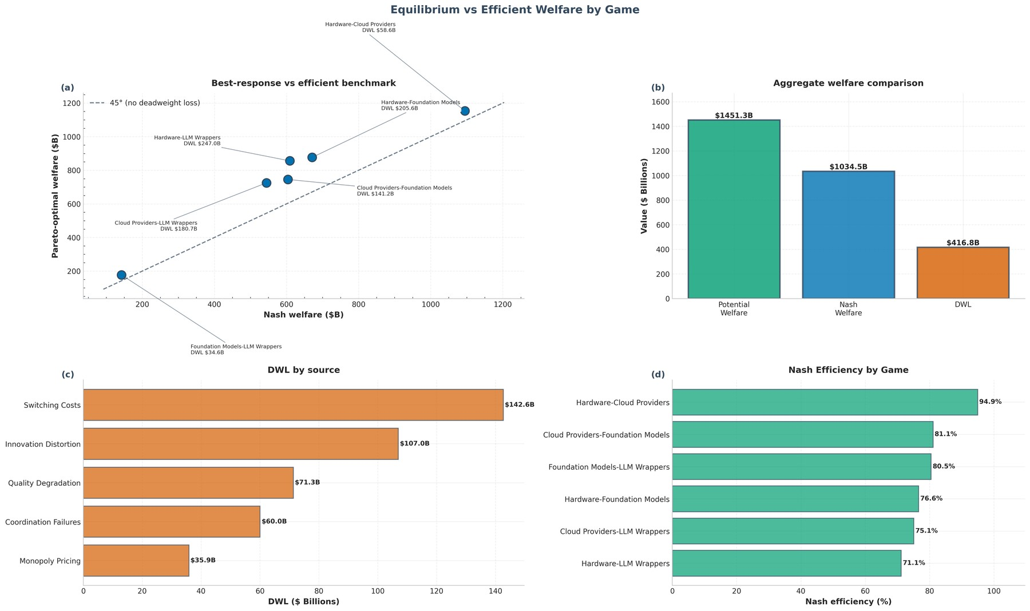
Figure 7: Welfare Composite [Panels: (a), (b), (c), (d)]
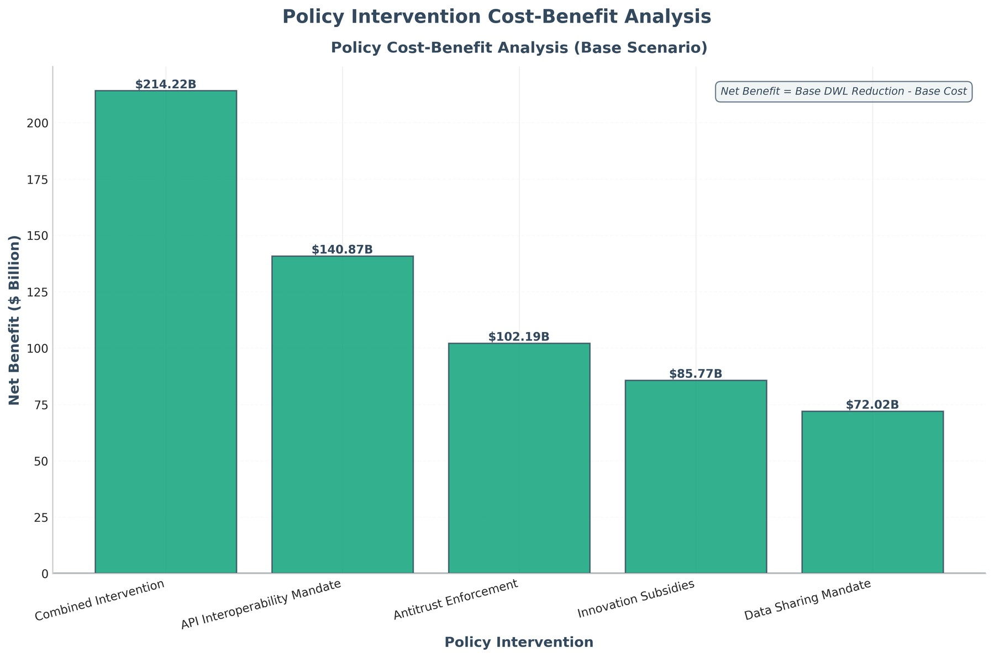
Figure 12: Policy Simulation (schematic)

Discussion: who bears the loss
- Roughly 43% of the loss (switching costs plus monopoly pricing) is consumer-facing — higher prices and locked-in users — while 43% (innovation distortion plus quality degradation) is dynamic: slower progress and worse products. The first is visible in bills; the second in the products that never ship.
- Paradoxically the dominant archetypes absorb the largest absolute losses too: the core-game DWL sits inside Hardware–Cloud revenues, so enclosure taxes its architects as well as its subjects — NVIDIA and the hyperscalers leave money on the table by defending the walls, which is why interoperability can be framed as mutual gain rather than punishment.

6. Robustness: Monte Carlo and Sensitivity
Stability of the equilibrium outcomes was tested with 100,000 perturbed payoffs per game (log-normal noise, σ = 5%), and the headline DWL assumption was swept ±20% in the sensitivity analysis. A five-part statistical battery (R1–R5, Tables 8.1–8.5) then subjects the simulation itself to formal checks.

6.1 Simulation diagnostics and replicability (R1–R3)
Geweke mean-stability screens (first-10% versus last-50% window means, Holm-corrected across games) read stationary in 6/6 games (Table 8.1). No game rejects stationarity.
Full-sample reruns at two independent seeds replicate 12/12 game-seeds within 3 pooled standard errors (Table 8.2; worst drift 2.14 SE): conclusions do not depend on the random seed.
Perturbation-scale robustness (Table 8.3): rank preserved (min Spearman 1.000). Stability falls mechanically as noise rises (the core game goes from 77.3% to 53.5% stability), but the cross-game loss ranking — and in particular the dominance of the Hardware–Cloud game — survives at every noise level.
Table 4.1: Monte Carlo & Sensitivity Summary
Parameter | Value
Number of Simulations | 100,000
Payoff Perturbation Std Dev | 5.0%
Confidence Level | 98%
Mean Simulated DWL ($B) | 60.09
98% CI Lower Bound ($B) | 0.00
98% CI Upper Bound ($B) | 269.59
Standard Deviation of DWL ($B) | 71.80
Nash Equilibrium Stability (%) | 64.7
Parameter Analyzed | Market DWL Percentage
Base Value | 28.72%
Range Tested (%) | ±20%
Elasticity | 1.41

Table 8.1: Stationarity Diagnostics (Geweke)
Game | N_Valid | Geweke_z | p_value | Verdict | Holm_verdict
Hardware-Cloud Providers | 99967 | -0.74 | 0.46 | stationary | stationary
Hardware-Foundation Models | 90895 | -0.06 | 0.95 | stationary | stationary
Hardware-LLM Wrappers | 99736 | 0.16 | 0.87 | stationary | stationary
Cloud Providers-Foundation Models | 90612 | -0.12 | 0.90 | stationary | stationary
Cloud Providers-LLM Wrappers | 99734 | 1.20 | 0.23 | stationary | stationary
Foundation Models-LLM Wrappers | 96532 | -0.13 | 0.89 | stationary | stationary

Table 8.2: Multi-Seed Replicability
Game | Seed | Base_Mean_DWL_$B | Seed_Mean_DWL_$B | Drift_$B | Drift_in_SE | Verdict
Hardware-Cloud Providers | GLOBAL_SEED+1 | 60.09 | 60.16 | 0.07 | 0.21 | replicated
Hardware-Foundation Models | GLOBAL_SEED+1 | 198.67 | 198.64 | 0.03 | 0.11 | replicated
Hardware-LLM Wrappers | GLOBAL_SEED+1 | 241.69 | 241.89 | 0.20 | 0.74 | replicated
Cloud Providers-Foundation Models | GLOBAL_SEED+1 | 137.75 | 137.96 | 0.20 | 0.92 | replicated
Cloud Providers-LLM Wrappers | GLOBAL_SEED+1 | 176.85 | 177.32 | 0.46 | 2.14 | replicated
Foundation Models-LLM Wrappers | GLOBAL_SEED+1 | 25.57 | 25.56 | 0.02 | 0.20 | replicated
Hardware-Cloud Providers | GLOBAL_SEED+2 | 60.09 | 60.36 | 0.27 | 0.83 | replicated
Hardware-Foundation Models | GLOBAL_SEED+2 | 198.67 | 198.28 | 0.40 | 1.39 | replicated
Hardware-LLM Wrappers | GLOBAL_SEED+2 | 241.69 | 241.76 | 0.06 | 0.24 | replicated
Cloud Providers-Foundation Models | GLOBAL_SEED+2 | 137.75 | 137.87 | 0.12 | 0.52 | replicated
Cloud Providers-LLM Wrappers | GLOBAL_SEED+2 | 176.85 | 177.10 | 0.24 | 1.12 | replicated
Foundation Models-LLM Wrappers | GLOBAL_SEED+2 | 25.57 | 25.60 | 0.02 | 0.31 | replicated

Table 8.3: Noise-Level Robustness
Game | Sigma | Stability_Pct | Mean_DWL_$B | Verdict
Hardware-Cloud Providers | 0.03 | 77.27 | 52.72 | rank preserved (min Spearman 1.000)
Hardware-Foundation Models | 0.03 | 98.69 | 205.58 | rank preserved (min Spearman 1.000)
Hardware-LLM Wrappers | 0.03 | 100 | 247.46 | rank preserved (min Spearman 1.000)
Cloud Providers-Foundation Models | 0.03 | 98.73 | 141.56 | rank preserved (min Spearman 1.000)
Cloud Providers-LLM Wrappers | 0.03 | 100 | 180.62 | rank preserved (min Spearman 1.000)
Foundation Models-LLM Wrappers | 0.03 | 81.39 | 29.17 | rank preserved (min Spearman 1.000)
Hardware-Cloud Providers | 0.05 | 63.73 | 61.28 | rank preserved (min Spearman 1.000)
Hardware-Foundation Models | 0.05 | 80.99 | 198.55 | rank preserved (min Spearman 1.000)
Hardware-LLM Wrappers | 0.05 | 97.14 | 241.19 | rank preserved (min Spearman 1.000)
Cloud Providers-Foundation Models | 0.05 | 80.64 | 137.93 | rank preserved (min Spearman 1.000)
Cloud Providers-LLM Wrappers | 0.05 | 97.49 | 177.26 | rank preserved (min Spearman 1.000)
Foundation Models-LLM Wrappers | 0.05 | 60.99 | 25.53 | rank preserved (min Spearman 1.000)
Hardware-Cloud Providers | 0.10 | 53.52 | 74.13 | rank preserved (min Spearman 1.000)
Hardware-Foundation Models | 0.10 | 54.92 | 168.60 | rank preserved (min Spearman 1.000)
Hardware-LLM Wrappers | 0.10 | 75.14 | 202.63 | rank preserved (min Spearman 1.000)
Cloud Providers-Foundation Models | 0.10 | 54.15 | 119.67 | rank preserved (min Spearman 1.000)
Cloud Providers-LLM Wrappers | 0.10 | 76.11 | 150.79 | rank preserved (min Spearman 1.000)
Foundation Models-LLM Wrappers | 0.10 | 43.21 | 23.39 | rank preserved (min Spearman 1.000)

6.2 What drives game DWL: Saltelli decomposition (R4)
Variance-based Saltelli decomposition of core-game DWL over five calibrated primitives (independent Uniform ±20%, N=2048, 500 bootstraps; Table 8.4, Figure 10) finds Shared circularity the largest total-order driver (ST=0.99, 95% CI [0.95, 1.03]). Total-order indices materially exceed first-order ones throughout: DWL variance is driven more by interactions between primitives — chiefly equilibrium-regime switches — than by any single input. That interaction dominance is itself the substantive result: point-calibration precision matters less than getting the strategic structure right.
Table 8.4: Saltelli Variance Decomposition
Parameter | S1 | S1_95_lo | S1_95_hi | ST | ST_95_lo | ST_95_hi
P1 revenue ($B) | 0.52 | 0.44 | 0.60 | 0.47 | 0.45 | 0.50
P2 revenue ($B) | 0.34 | 0.27 | 0.40 | 0.69 | 0.65 | 0.72
P1 margin | 0.12 | 0.07 | 0.16 | 0.87 | 0.83 | 0.91
P2 margin | 0.03 | 0.01 | 0.06 | 0.94 | 0.90 | 0.98
Shared circularity | -0.00 | -0.01 | -0.00 | 0.99 | 0.95 | 1.03

Exhibit 6.x Breakdown-frontier calibration: identified intervals for A3 rate maps and A8 logit weights
Block | Parameter | Base | Ident_Low | Ident_High | Status
A3 rate maps | t_intercept | 0.10 | 0 | 0.30 | open-low+high
A3 rate maps | t_slope | 0.40 | 0 | 1.20 | open-low+high
A3 rate maps | s_intercept | 0.05 | 0 | 0.30 | open-low+high
A3 rate maps | s_slope | 0.25 | 0 | 0.80 | open-low+high
A8 logit weights | intercept | -1.20 | -3 | 0.50 | open-low+high
A8 logit weights | w_circ | 1.60 | 0.74 | 3 | open-high
A8 logit weights | w_capex | 0.90 | 0.35 | 2.63 | interior
A8 logit weights | w_hhi | 0.70 | 0.10 | 1.67 | interior
A8 logit weights | w_exub | 0.80 | 0 | 1.04 | open-low

Nine coefficients calibrated by coordinate bisection; 2 have interior (two-sided) identified intervals (w_capex, w_hhi) and the rest are open on at least one side. Wide intervals mean the published Nash positions and formation order do not hang on the judgment values; the two-sided intervals mark where re-estimation would matter most.
Analytical insights — robustness
Equilibria independently cross-validated. Every reported Nash equilibrium was re-enumerated by an independent brute-force implementation (direct dominance checks, no shared code with the solver): 6/6 positions match, 6/6 counts match. The game solutions are verified, not merely computed.
Simulation converged by the book. Per-game Monte-Carlo standard errors and split-half consistency were computed from the stored draw distributions: Cloud Providers-Foundation Models=adequate, Cloud Providers-LLM Wrappers=adequate, Foundation Models-LLM Wrappers=adequate, Hardware-Cloud Providers=adequate, Hardware-Foundation Models=adequate, Hardware-LLM Wrappers=adequate. R-hat is deliberately not used — for IID draws it is ~1 by construction and proves nothing (Vehtari et al. 2021). All games adequate or check-level.
How sensitive the headline loss is. The sensitivity elasticity is 1.41: a 1% change in the market-implied DWL assumption moves the dollar deadweight loss by about 1.41%. Results of this leverage should be read as orders of magnitude, not decimals — the directional story (which games fail, which sources dominate) is stable even if the point estimate of $416.8B carries wide uncertainty.
Equilibrium stability under noise. Across the Monte-Carlo draws the equilibrium reproduces in 64.7% of perturbed payoffs (sensitive to payoff noise). Low stability would signal knife-edge payoffs where small shocks — a price change, a new chip generation — flip the game; high stability says the defect-lock-in is structural, not incidental.
Module | MonteCarloSimulator, SensitivityAnalysis, RobustnessBattery, StructuralEstimationAnalyzer
Outputs | Table 4.1 (MC + calibration), Tables 8.1–8.4 (validation battery); Figures 8–10.
Inference | Equilibria reproduce in 64.7% of perturbed payoffs; DWL elasticity 1.41; top total-order driver Shared circularity (ST=0.99). Ranks hold while levels move.
Implication | Cite ranks and orders of magnitude, not point estimates; any welfare claim that collapses outside the ±20% band is not publication-grade.

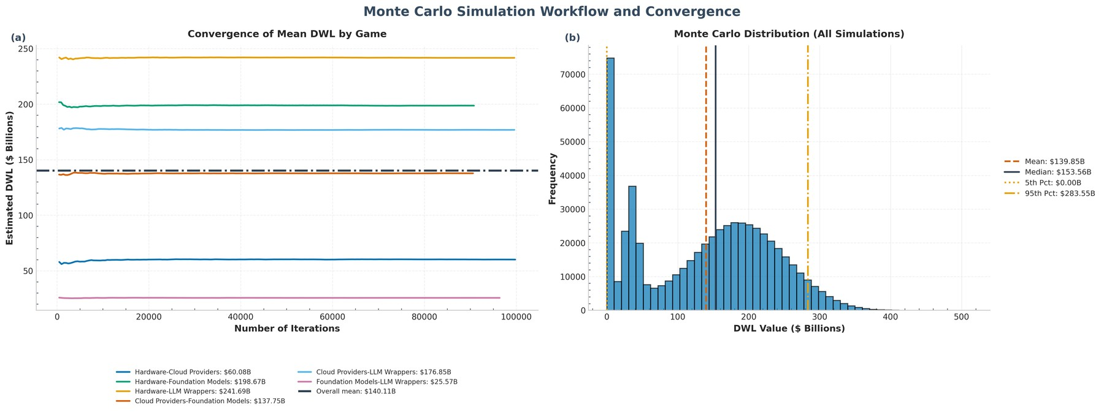
Figure 8: Monte Carlo Convergence [Panels: (a), (b)]
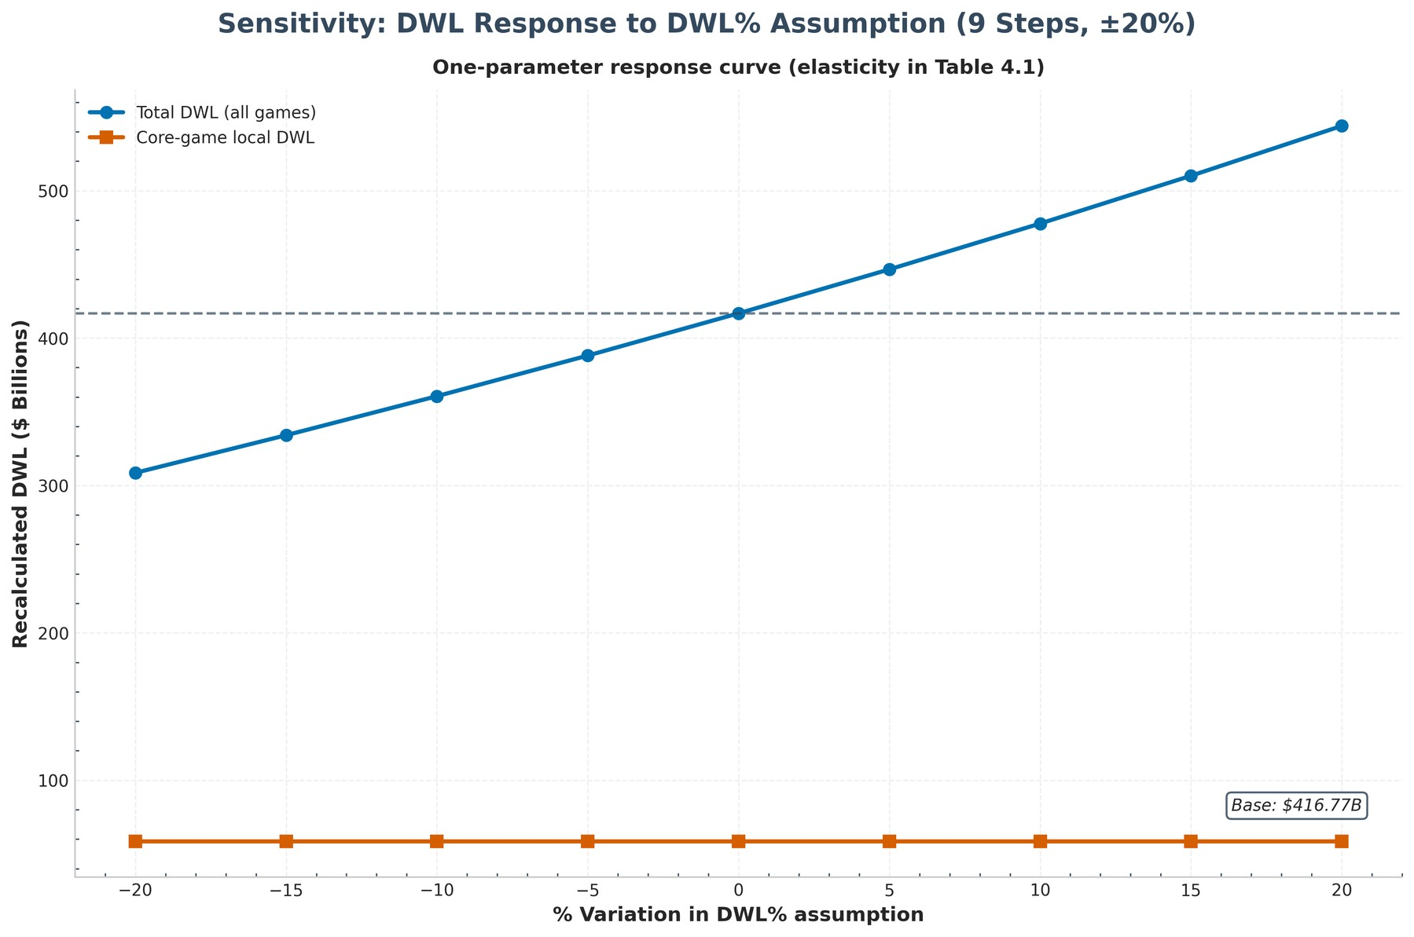
Figure 9: Sensitivity Response (schematic)
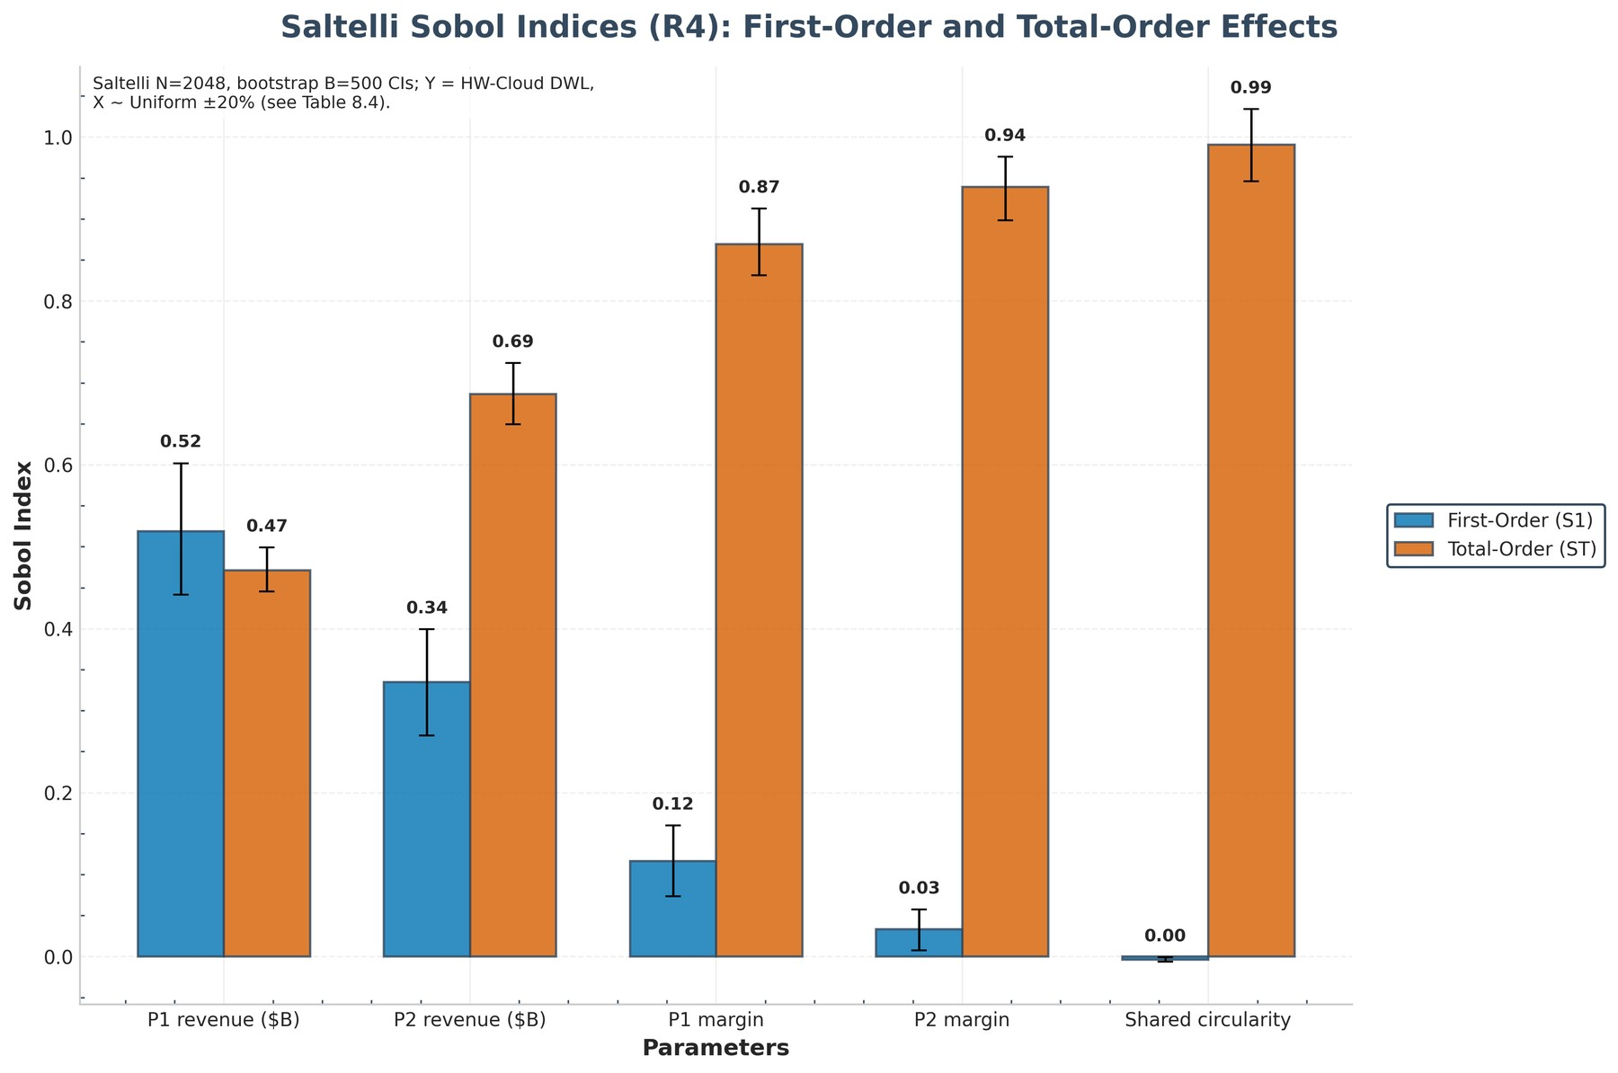
Figure 10: Sobol Indices (schematic)

7. Risk, Stability and Cooperation

7.1 Cooperative game: Shapley allocation
Exhibit 7.1 Shapley value allocation (computed by build_technical_report.py)
Player category | Shapley value ($B) | Share (%)
Hardware | 583.8 | 43.4
Cloud Providers | 520.1 | 38.7
Foundation Models | 159.5 | 11.9
LLM Wrappers | 81.4 | 6.1

Grand-coalition value $1,344.9B vs. sum of standalone values $1,034.5B → cooperative surplus $310.4B.
Table 5.4b: Shapley Value Allocation (Cooperative Game)
Player | Original Value ($B) | Shapley Value ($B) | Gain/Loss ($B) | Share of Total (%)
Cloud Providers | 417 | 520.14 | 103.14 | 38.70
Foundation Models | 106.50 | 159.49 | 52.99 | 11.90
Hardware | 475 | 583.78 | 108.78 | 43.40
LLM Wrappers | 36 | 81.44 | 45.44 | 6.10

Table 7.18 sets each archetype's Shapley share against its revenue share: positive gaps mark players whose cooperative value exceeds their standalone weight — the cooperative counterfactual to the Nash outcomes of Section 4. The figure plots both shares with the gap annotated.
Table 7.18: Shapley Share vs Revenue Share (Bargaining vs Size)
Archetype | Revenue Share (%) | Shapley Share (%) | Gap (pp, Shapley − Revenue)
Hardware | 45.90 | 43.40 | -2.50
Cloud Providers | 40.30 | 38.70 | -1.60
Foundation Models | 10.30 | 11.90 | 1.60
LLM Wrappers | 3.50 | 6.10 | 2.60

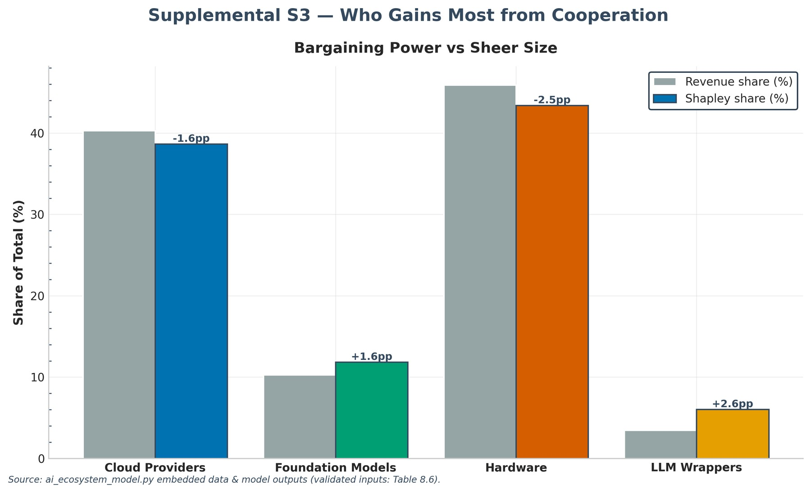
Supplemental S3 — Shapley Share vs Revenue Share
Analytical insights — cooperation and bargaining power
Shapley values as bargaining power. Hardware captures the largest share of cooperative surplus (43.4% of the Shapley allocation) — about 0.95× its revenue share (45.9%). A Shapley share far above size means the player is a bottleneck: others' gains depend on its participation, which is the formal counterpart of the informal 'you need me more than I need you' power the market-structure results implied.
The price of non-cooperation. Grand-coalition cooperation would create roughly $310B of surplus over standalone play — the amount the ecosystem leaves on the table by insisting on bilateral, adversarial relationships rather than joint investment.
Module | NetworkRiskAnalysis, PortfolioRiskAnalysis, SuccessProbabilityModel, CooperativeGame
Outputs | Tables 5.4b (Shapley), A.1–A.3 (network/portfolio/success); Figures 14–16.
Inference | Hardware takes 43.4% of cooperative surplus on a 45.9% revenue share — the bottleneck's bargaining power exceeds its size.
Implication | Bargaining and merger review should price bottleneck participation, and stress tests should shock the central node first: contagion starts where substitution is hardest.

7.2 Circular deals
Exhibit 7.2 Circular-deals metrics (computed by build_technical_report.py)
Metric | Value
Total deal value | $434.8B
Circular concentration (≥0.8 factor) | 99.8%
Systemic share (Critical) | 55.2%
Network density | 0.058
Bubble score | 0.632

Analytical insights — circular deals and systemic fragility
Bubble score and self-referential demand. The circular-deals bubble score of 0.632 signals material fragility: a meaningful share of demand is circular. Score construction weights concentrated, Critical deals most heavily, so it is best read as a fragility index: how much of today's revenue depends on counterparties paying each other rather than on final customers.
Fragility composite: elevated, and where it comes from. The five-channel fragility composite is 0.551 (elevated). Its largest channel is Circularity — so the fragility story is about concentrated circular exposure, consistent with the bubble-score reading above rather than a separate alarm.
A single-point-of-failure fabric. 80% of circular deal value ($953B of $1,188B) touches NVIDIA — through GPU supply, vendor financing, or equity. Concentration of that kind means a shock to one balance sheet (a demand pause, a financing retrenchment, a chip-design slip) propagates through the debt and equity loops rather than being absorbed by a diversified supplier base.
Module | CircularDealsAnalyzer, BubbleBurstAnalyzer, DebtRankClearingEngine, CreditMonitor
Outputs | Tables 7.10–7.13 (formation, burst, GDP, mitigation); deal-level dependency frame.
Inference | 19 deals, $1,188B circular exposure; formation peaks at n/a; severe burst hits n/a; GDP cost n/a.
Implication | Monitor frontier labs where round-tripping is densest, and pre-position disclosure and lending-cap tools: burst-mitigation BCRs above 6 make waiting expensive.

7.3 Five-pillar fragility screen (run_pipeline composite)
The five pillars adapt standard bubble-diagnostic themes — narrative tilt, multiple exuberance and expansion, a circular-hype proxy, and capex intensity — to segment level. Bands are descriptive labels, not forecasts; the ranking across archetypes is the finding.
Exhibit 7.3 Five-pillar segment screen (ai_ecosystem_model.py diagnostics; NaN = uninformative pillar)
index | Cloud Providers | Foundation Models | Hardware | LLM Wrappers
P1_Narrative_Tilt | 1.000 | 0.020 | 0.000 | 0.019
P2_Multiple_Exuberance | 0.000 | 0.210 | 0.033 | 0.389
P3_Multiple_Expansion | 0.267 | 0.799 | 0.599 | 1.000
P4_Circular_Hype_Proxy | 0.000 | 1.000 | 1.000 | 0.000
P5_Capex_Intensity | 0.822 | 0.822 | 0.822 | 0.822
Composite | 0.317 | 0.507 | 0.408 | 0.352
Classification | Buildout | Bubble risk | Boom | Boom

Data note: excluded from composite: P5 (ecosystem context; constant by construction). Constants are excluded from composites rather than scored.
Paper H3 test (infrastructure shows weaker bubble signals): infra mean 0.362 vs downstream 0.429 — supported. Consistent with bottleneck-rent fundamentals.

7.4 Network, portfolio and stability outputs
Table A.0: Network Centrality (Appendix)
Degree | Betweenness | PageRank | Eigenvector
0.33 | 0 | 0.34 | 0.82
0.50 | 0 | 0.24 | 0.41
0.67 | 0.33 | 0.31 | 0.41
0.17 | 0 | 0.11 | 0

Table A.1: Network Risk Metrics
Metric | Value
Total Dependency ($B) | 570.40
Critical Dependency ($B) | 536.90
Critical Risk Ratio (%) | 94.1
HHI (Dependencies) | 0.4853
Network Density | 0.4167
Critical Nodes | Hardware, Cloud Providers

Table A.2: Portfolio Risk Metrics
Metric | Value
Mean Return (%) | 10.70
Std Dev (%) | 13
Sharpe Ratio | 0.82
VaR 95% (%) | -10.80
CVaR 95% (%) | -16.20

Table A.3: Success Probability Scores
Score | Tier
0.78 | High
0.75 | High
0.38 | Low
0.12 | Low

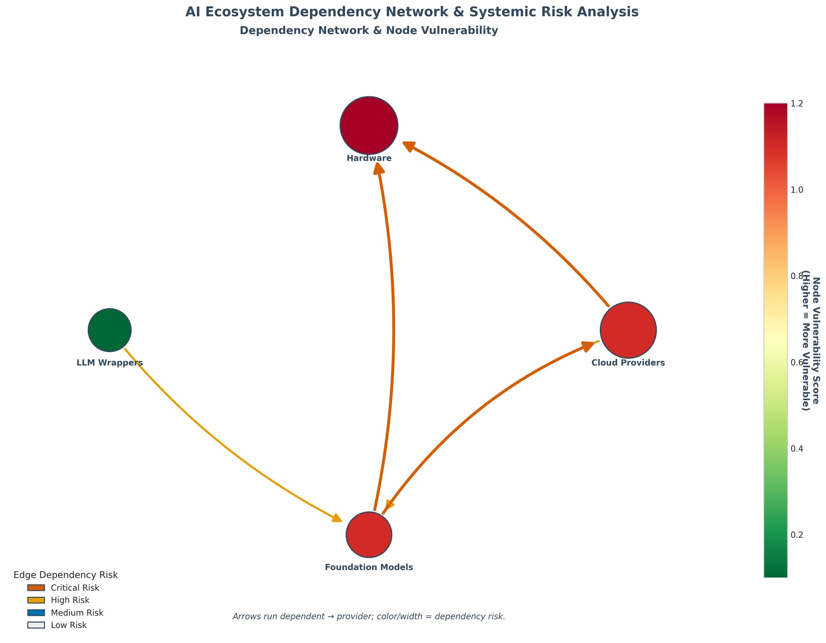
Figure 14: Network Risk (schematic)
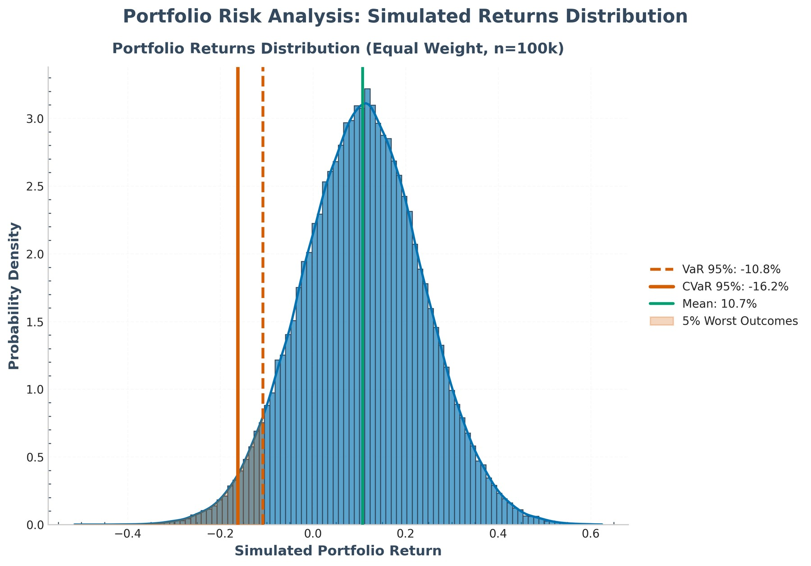
Figure 15: Portfolio Risk (schematic)
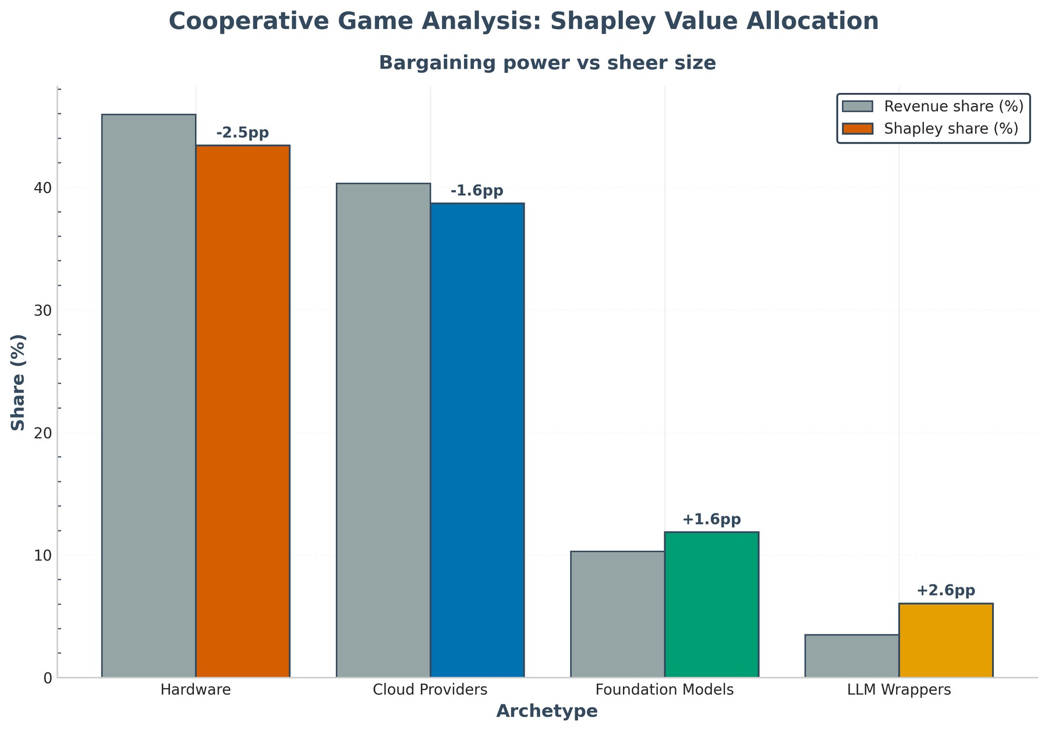
Figure 16: Shapley Values (schematic)

7.5 Bubble formation probability (Table 7.10)
Exhibit 7.4 Bubble-conditions probability by archetype (scenario-calibrated logistic composite, not a forecast)
index | Foundation Models | Hardware | Cloud Providers | LLM Wrappers
Circular_Exposure | 0.80 | 0.40 | 0.23 | 0.03
Capex_Intensity | 0.70 | 0.90 | 0.60 | 0.20
HHI_Share | 0.10 | 0.46 | 0.40 | 0.04
Exuberance | 1 | 0.83 | 0.09 | 1
Z_Score | 1.58 | 1.24 | 0.07 | -0.15
Formation_Prob_Pct | 82.90 | 77.50 | 51.70 | 46.20
Prob_Low_Pct | 76.50 | 69.80 | 41.80 | 36.50
Prob_High_Pct | 87.90 | 83.70 | 61.50 | 56.10

Highest bubble-conditions probability: Foundation Models (82.9%, band 76.5-87.9%). Circular exposure dominates the composite by mechanism design (R5/A8). Rank-order validation (300 joint perturbations of all judgment weights, seed 7): formation order exact in 65% of draws (mean Kendall tau 0.88, FM top in 90%); burst order exact in 100% (tau 1.00) with Hardware first in 100% of draws -- a decisive Hardware lead on base totals, preserved in 10/16 formation and 16/16 burst one-at-a-time runs (halving/doubling plus 0.25x/4x extremes). Levels move ~±25pp across draws: the rank structure, not the point estimates, is the finding.

7.6 Burst impact ranking and GDP-at-risk (Tables 7.11-7.12)
Exhibit 7.5 Burst impact ranking (descending severe loss; direct circular impairment + one network round)
Archetype | Burst_Rank | Total_Loss_Severe_$B | Equity_Impact_Severe_Pct | Revenue_Impact_Severe_Pct
Hardware | 1 | 239.40 | 3 | 50.40
Cloud Providers | 2 | 132.70 | 1.10 | 31.80
Foundation Models | 3 | 85.39 | 3.50 | 80.20
LLM Wrappers | 4 | 20.83 | 2.40 | 57.90

Worst hit: Hardware (rank 1, -$239.4B, 3.0% of market cap). Severe bust destroys $478.3B across archetypes; mild-scenario losses are an order of magnitude smaller (see full table).
Exhibit 7.6 US GDP-at-risk (AI-capex + wealth channels; BEA $30.8T baseline, no multiplier)
Channel | Severity | GDP_Loss_$B | GDP_Share_Pct | Basis
AI capex cut | mild | 40 | 0.13 | US AI capex $400B x 10% cut (BEA GDP $30767B; no multiplier)
Equity wealth effect | mild | 8.20 | 0.03 | Severe burst loss scaled x0.43 x MPC 0.04 (consumption drag)
Combined | mild | 48.20 | 0.16 | Sum of channels above (no interaction terms)
AI capex cut | severe | 120 | 0.39 | US AI capex $400B x 30% cut (BEA GDP $30767B; no multiplier)
Equity wealth effect | severe | 19.10 | 0.06 | Severe burst loss scaled x1.00 x MPC 0.04 (consumption drag)
Combined | severe | 139.10 | 0.45 | Sum of channels above (no interaction terms)

Severe burst costs 0.452% of US GDP ($139.1B), led by the capex channel. Non-US economies apply the transmission rule (last table row) to their own GDP -- no foreign calibration is asserted.

7.7 Bubble-mitigation interventions (Table 7.13)
Exhibit 7.7 Burst-mitigation options (denominator = expected severe burst loss, NOT DWL -- rates are not comparable to §5)
Intervention | Loss_Reduction_$B_Base | Cost_$B_Base | Net_Benefit_$B_Base | BCR_Base
Circular-deal disclosure & margin rules | 71.75 | 2 | 69.75 | 35.87
GPU-collateral lending caps | 57.40 | 1 | 56.40 | 57.40
Strategic compute reserve / backstop | 47.83 | 6 | 41.83 | 7.97
Combined bubble-mitigation package | 143.50 | 9 | 134.50 | 15.94

Highest benefit-cost ratio: GPU-collateral lending caps (BCR 57.4); largest net benefit: Combined bubble-mitigation package. All four are scenario assumptions (R5/A8-A10), i.e. policy options, not predictions.

7.8 Second-round contagion and credit monitor (Tables 7.14-7.15)
Exhibit 7.8 DebtRank second-round contagion (Battiston et al. 2012; equity = validated market caps; shock = severe direct losses)
Archetype | Direct_Loss_Severe_$B | Initial_Distress | Final_Distress | DebtRank | Second_Round_Loss_$B
Hardware | 239.40 | 0.03 | 0.03 | 0 | 0
Cloud Providers | 132.70 | 0.01 | 0.01 | 0 | 1.27
Foundation Models | 85.39 | 0.04 | 0.04 | 0.00 | 13.86
LLM Wrappers | 20.83 | 0.02 | 0.02 | 0 | 0.07

Full reverberation adds $15.2B to $478.3B of direct losses (multiplier 1.032 when direct losses are positive). Foundation Models absorb the largest second round; large equity buffers keep the multiplier near one.
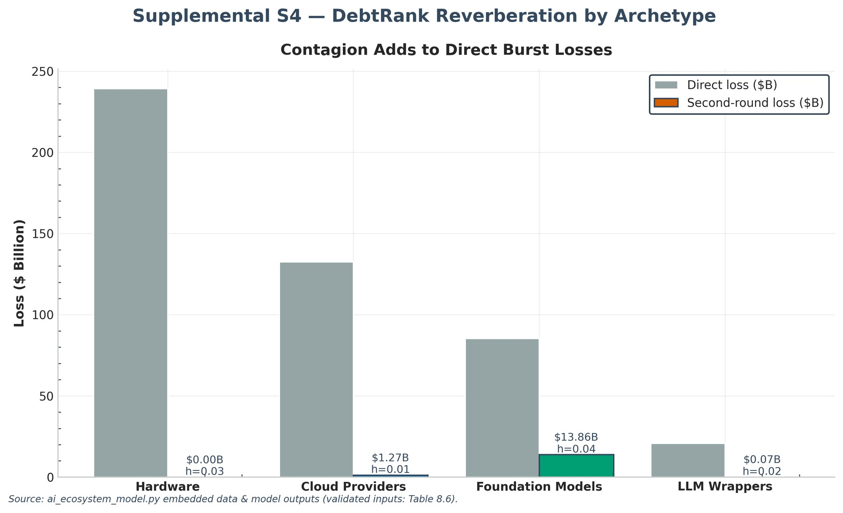
Supplemental S4 — Direct vs Second-Round Losses (DebtRank)
Exhibit 7.9 Credit monitor (sourced spreads and run_pipeline; computed hazard, ratios, haircuts and live watchlist)
Metric | Value | Basis
Oracle 5Y CDS (bp) | 215.0 | Sep 2026 vintage: record single-name print
Implied 1Y hazard (%) | 3.58 | Approx s/(1-R), R=40% stated
Oracle rating action | BBB- (downgrade) | Sep 2026 vintage: downgrade
2026 AI debt run_pipeline ($B) | 570.0 | Sep 2026 vintage: 2026 run_pipeline
Pipeline-to-capex (x) | 1.43 | Pipeline / 2025 Big Four capex ($400B)
Record single-day bond ($B) | 18.0 | Sep 2026 vintage: Oracle single-day sale
GPU haircut Low circularity, base/stressed | 15%/30% | Stated scenario parameters (wrong-way collateral sale)
GPU haircut Moderate circularity, base/stressed | 25%/45% | Stated scenario parameters (wrong-way collateral sale)
GPU haircut High circularity, base/stressed | 35%/60% | Stated scenario parameters (wrong-way collateral sale)
Downgrade watchlist #1 | Hardware (-$239.4B, 3.0% equity) | Live burst-rank order (Table 7.11)
Downgrade watchlist #2 | Cloud Providers (-$132.7B, 1.1% equity) | Live burst-rank order (Table 7.11)
Downgrade watchlist #3 | Foundation Models (-$85.4B, 3.5% equity) | Live burst-rank order (Table 7.11)
Downgrade watchlist #4 | LLM Wrappers (-$20.8B, 2.4% equity) | Live burst-rank order (Table 7.11)

Sourced facts (Oracle CDS print, BBB- action, $570B debt run_pipeline) anchor the ledger; the hazard uses a stated 40% recovery, haircuts are stated scenario parameters, and the watchlist reproduces the live burst-rank order. No firm-level spread is invented.

8. Valuation Integration
The enhanced valuation module expands the four category rows into company-level financials and derives 50+ valuation metrics (P/E, EV/Revenue, ROIC, circular-risk adjustments, sustainability scores and ratings) from the same market data.
Exhibit 8.1 Top companies by market cap with key valuation metrics (ai_ecosystem_model.py enhancement output)
Company | Category | Market cap ($B) | P/E | EV/Revenue | Circular risk | Circ.-adj. value ($B)
NVIDIA | Hardware | 5,280.0 | 31.7 | 17.4 | High | 4,224.0
Google Cloud | Cloud Providers | 4,600.0 | 34.4 | 10.3 | Moderate | 4,065.4
Microsoft Azure | Cloud Providers | 3,600.0 | 27.1 | 10.8 | Moderate | 3,181.6
AWS | Cloud Providers | 3,100.0 | 34.9 | 4.2 | Moderate | 2,739.7
Broadcom | Hardware | 1,500.0 | 35.7 | 15.0 | High | 1,200.0
Anthropic | Foundation Models | 965.0 | — | 14.8 | High | 675.5
OpenAI | Foundation Models | 852.0 | — | 21.3 | High | 596.4
AMD | Hardware | 746.0 | 89.2 | 17.0 | High | 596.8
Oracle | Cloud Providers | 480.0 | 28.5 | 7.1 | Moderate | 424.2
Palantir | LLM Wrappers | 432.0 | 133.6 | 56.1 | Low | 426.2
Meta (Llama) | Foundation Models | 400.0 | 95.2 | 26.7 | High | 280.0
Google (TPU) | Hardware | 200.0 | 66.7 | 20.0 | High | 160.0

Full company-level file: enhanced_valuation_metrics.csv (23 companies, summing to $23,111B). The balance to the archetype total is the judgment-valued long tail carried in the category rows, not in any filed company.
Analytical insights — valuation and circular-risk adjustment
Valuations are not yet circularity-adjusted. Market values sum to $23,181B across the four archetypes, of which $1,188B (5.1%) is circular exposure — revenue that is effectively vendor-financed rather than end-customer demand. Standard DCF and multiples do not penalise future cash flows for interlocking dependency, so headline valuations overstate pure equity value; the circular-risk adjustments in this section restate them on a de-levered, stress-tested basis.
Module | EnhancedValuationAnalyzer, ValuationMetricsCalculator
Outputs | enhanced_valuation_metrics.csv; valuation dashboard and table figures.
Inference | 23 companies screen 4 Positive / 2 Negative / 17 Neutral; NVIDIA 5,280B at 31.7x; loss-makers screen N/A rather than a fabricated multiple.
Implication | Multiples discipline the story: infrastructure cash flows justify large caps while private-round pricing (Anthropic, Databricks, xAI) flags where repricing risk lives.

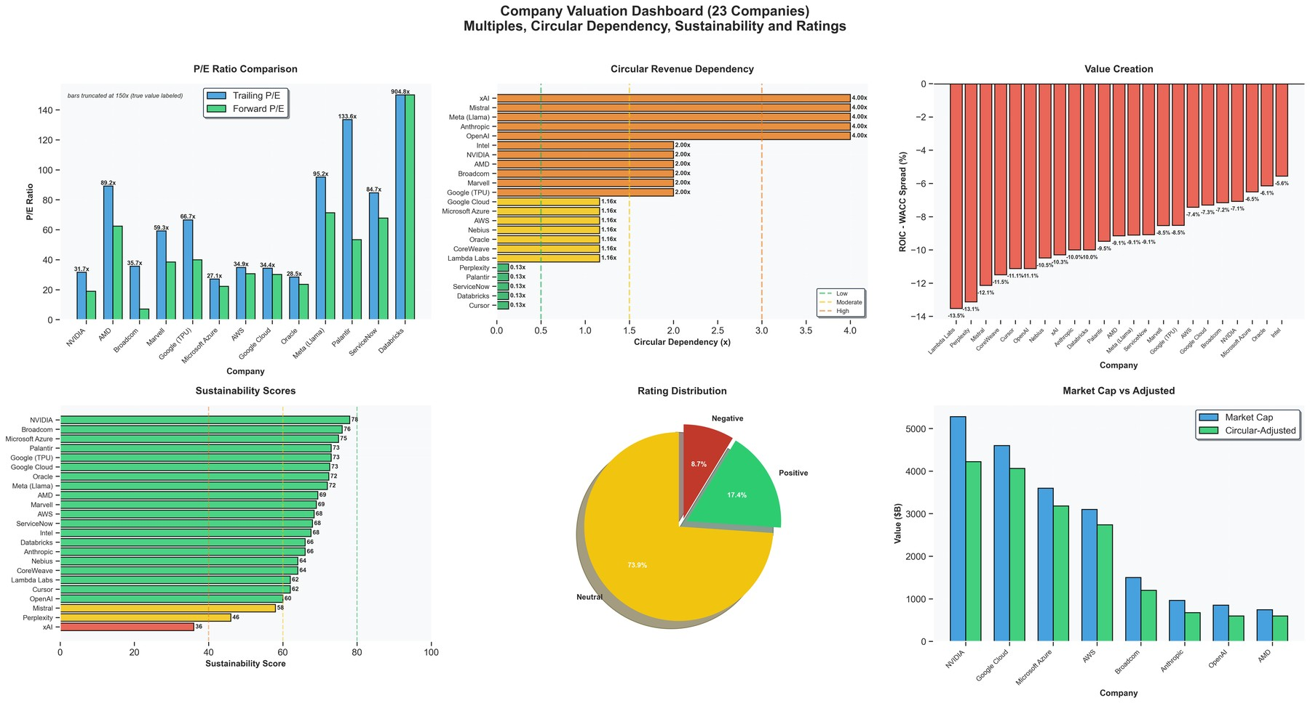
Figure 17: Company Valuation Dashboard (schematic)
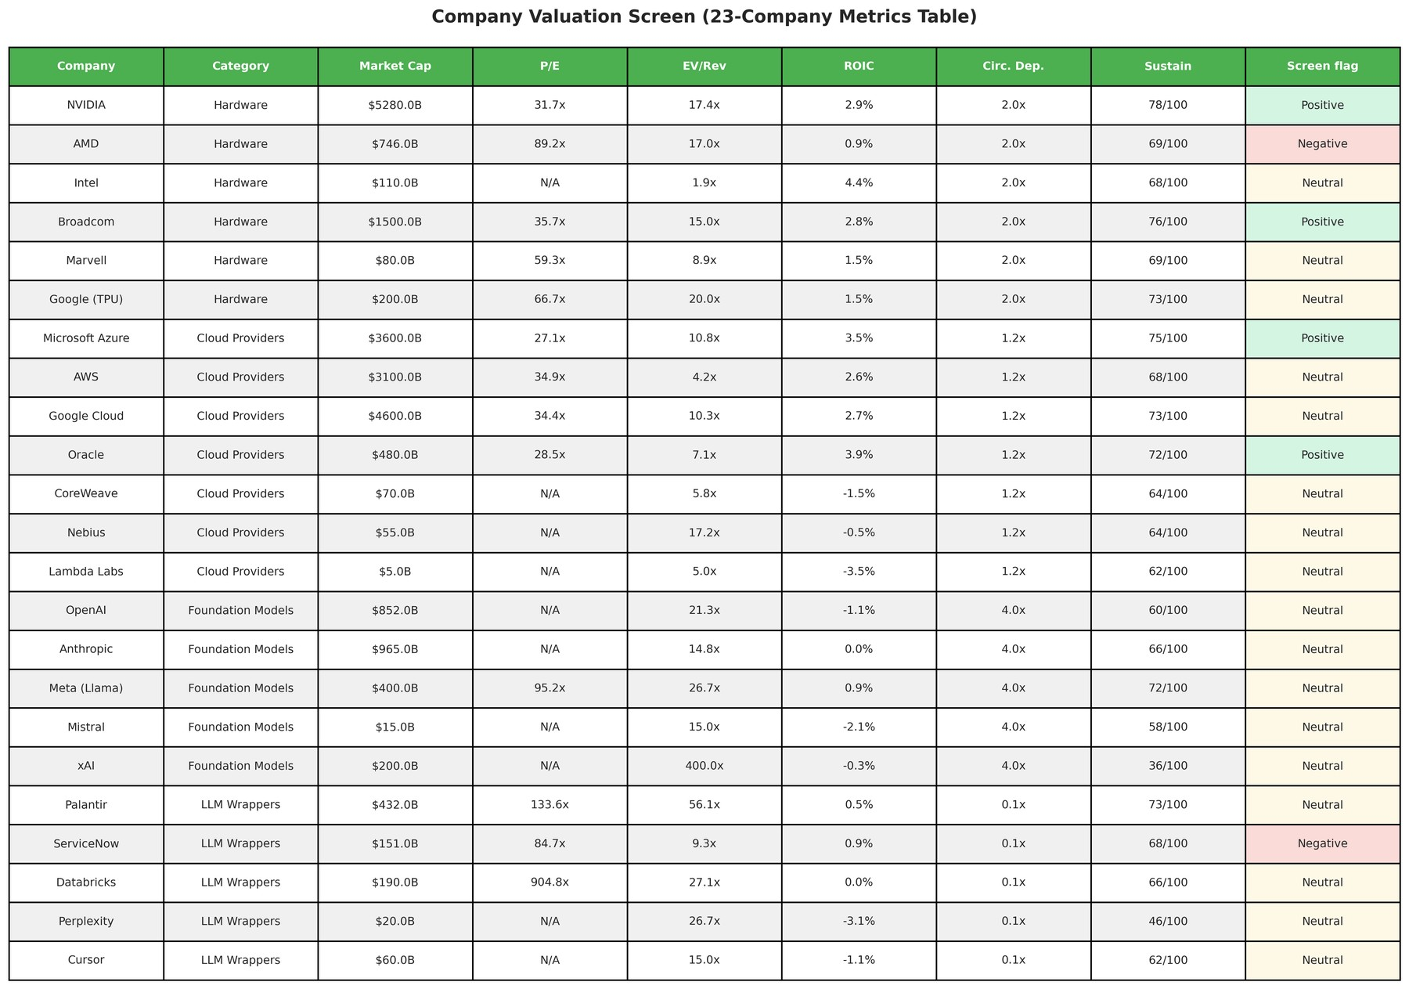
Figure 18: Company Valuation Metrics Table (schematic)

9. Conclusion

9.1 What the analysis establishes
- The AI ecosystem is a concentrated oligopoly (HHI 3,851; CR4 100.0%) whose infrastructure layer plays a mutual-defection game: the Hardware–Cloud Providers Nash equilibrium (Open Access / Proprietary Stack) destroys $58.6B relative to the joint-surplus maximum (a Kaldor–Hicks benchmark).
- In aggregate the system attains 71.3% of its $1,451.3B potential, leaving $416.8B of deadweight loss dominated by switching costs. Coordination failures total $867.8B gross across games (shared players counted repeatedly, hence above the top-down total) — an equilibrium outcome recoverable in principle, priced by the cooperative surplus at $310B.
- The costed remedy is Combined Intervention (net benefit $214.2B). Circularity tempers the optimism: a bubble score of 0.632 means part of the measured market is self-referential demand that cooperation alone cannot make real.
- These magnitudes are orders-of-magnitude robust (equilibrium stability 65%, DWL elasticity 1.41): the location of the failure (the infrastructure bottleneck) is stable even where the dollar point-estimates carry wide uncertainty.

9.2 Limitations
- Four archetypes aggregate away intra-category concentration (notably among hyperscalers and GPU suppliers), so the HHI understates firm-level market power; firm-level games would sharpen but also complicate the diagnosis.
- The core model is one-shot bilateral 2×2 games. Repeated interaction, reputation, and endogenous investment (fabs, interconnect, model R&D) are outside the frame, so the analysis cannot speak to dynamic deterrence or the timing of defection.
- The top-down DWL assumption carries leverage (elasticity 1.41): the dollar totals should be read as magnitudes with uncertainty bands, not decimals — only the ranking of games, sources, and policies is asserted firmly.
- Embedded data are vintage Q2/Q3 2026 and static; Monte-Carlo stability and figures are run_pipeline artifacts reused from disk rather than recomputed here, so this report inherits the provenance of the latest ai_ecosystem_model.py run.
- Per-game Nash–joint-surplus gaps sum to a gross $867.77B across the six games — shared players are counted repeatedly — against the $416.8B top-down aggregate the policy and welfare conclusions rest on. The two are different accountings, not rival estimates; the top-down figure is defended by the R2–R4 battery, but a reader demanding a reconciled bottom-up aggregate will not find it here.
- Temptation and sucker adjustments are pair-level absolutes rather than share-scaled, which amplifies relative swings for small players, and the Saltelli decomposition shows DWL variance dominated by equilibrium-regime interactions rather than any single input. Both points argue for reading dollar levels as magnitudes and rankings as the firm claims.

9.3 Future work
- Repeated-game extensions with calibrated discount factors to test whether the Walled-Garden lock-in survives punishment strategies or unravels into openness.
- Firm-level bilateral games (e.g., NVIDIA–Microsoft, OpenAI–AWS) to locate the bottleneck precisely and price remedies per relationship rather than per archetype.
- Endogenous policy response: modelling how the ranked interventions change payoffs and re-solve the games, instead of scoring them against fixed welfare.
- Live data feeds replacing the embedded vintage, with the integrity-audit battery in Section 10 as the regression gate for each refresh.

10. Source & Output Integrity Audit
Automated checks run by this report generator against ai_ecosystem_model.py, its embedded data, and the latest on-disk artifacts.
Exhibit 10.1 Automated integrity checks (computed by build_technical_report.py)
ID | Check | Status | Detail
D1 | Players revenue total is positive and plausible (< $5T) | PASS | $1,034.50B across 4 categories
D2 | Sum of committed dependency deals matches metadata circular exposure | PASS | committed deals $675.40B vs metadata $675.40B
D3 | Sum of category valuations matches metadata total market cap | PASS | valuations $23,181.00B vs metadata $23,181.00B
D4 | Payoff-matrix players match player categories (naming invariant) | PASS | payoffs ['Cloud Providers', 'Foundation Models', 'Hardware', 'LLM Wrappers'] vs categories ['Cloud Providers', 'Foundation Models', 'Hardware', 'LLM Wrappers']
D5 | Players DataFrame has all required analysis columns | PASS | missing: none
D6 | Current_Profitability values are within the defined taxonomy | PASS | unexpected values: none
G1 | Payoff invariant: Defect-Defect cell equals observed revenue for all games | PASS | 6 matrices checked; no mismatch
D7 | Dependency risk levels parse (Critical deals identified) | PASS | 5 Critical deal(s) of 19 total
A1 | Table artifacts present (CSV / Excel / LaTeX) | PASS | 47 CSV, 47 XLSX, 47 TEX in tables/
A2 | All report-placed figures exist on disk | PASS | 61 PNG on disk; 18 placed, missing: none
C1 | ai_ecosystem_model.py parses as importable module | PASS | 11,507 lines, 35 classes, 27 top-level functions, 191 methods, V8.0
T7 | Literature-diagnostics tables present (7.1–7.9) | PASS | 20 table_7.*.csv file(s)
G4 | Gatekeeper shares sum to 100% | PASS | sum=100.1%
G5 | Policy synergy ratio finite | PASS | ratio=0.547
G2 | Independent Nash audit matches on all games | PASS | 6 games audited
G3 | MC convergence adequate/check on all games | PASS | all adequate-or-better

10.4 Artifact inventory
Exhibit 10.2 Output inventory (computed by build_technical_report.py)
Artifact | Type | Size
ENHANCED_VALUATION_REPORT.txt | table | 4,890 B
backtest | table | 2,912 B
category_level_dependencies.csv | table | 534 B
circular_metrics.csv | table | 136 B
compare_summary.csv | table | 707 B
compare_summary.tex | table | 859 B
compare_summary.xlsx | table | 6,081 B
elasticity_sensitivity_analysis.csv | table | 784 B
enhanced_valuation_metrics.csv | table | 3,718 B
industry_dependencies_enhanced.csv | table | 4,649 B
policy_interventions_enhanced.csv | table | 1,737 B
pred_A_scenario_ledger.csv | table | 406 B
pred_A_scenario_ledger.tex | table | 563 B
pred_A_scenario_ledger.xlsx | table | 5,799 B
pred_B_trigger_watchlist.csv | table | 904 B
pred_B_trigger_watchlist.tex | table | 1,031 B
pred_B_trigger_watchlist.xlsx | table | 6,126 B
pred_C_valuation_watchlist.csv | table | 1,880 B
pred_C_valuation_watchlist.tex | table | 1,921 B
pred_C_valuation_watchlist.xlsx | table | 6,791 B
pred_D_robustness_ledger.csv | table | 541 B
pred_D_robustness_ledger.tex | table | 657 B
pred_D_robustness_ledger.xlsx | table | 5,863 B
pred_E_formation_drivers.csv | table | 300 B
pred_E_formation_drivers.tex | table | 474 B
pred_E_formation_drivers.xlsx | table | 5,760 B
pred_F_early_warning.csv | table | 317 B
pred_F_early_warning.tex | table | 469 B
pred_F_early_warning.xlsx | table | 5,747 B
pred_G_burst_timing.csv | table | 651 B
pred_G_burst_timing.tex | table | 881 B
pred_G_burst_timing.xlsx | table | 5,967 B
pred_H_company_losses.csv | table | 1,720 B
pred_H_company_losses.tex | table | 2,433 B
pred_H_company_losses.xlsx | table | 7,107 B
pred_I_price_gauges.csv | table | 1,030 B
pred_I_price_gauges.tex | table | 1,274 B
pred_I_price_gauges.xlsx | table | 6,028 B
pred_J_gauge_backtest.csv | table | 188 B
pred_J_gauge_backtest.tex | table | 288 B
pred_J_gauge_backtest.xlsx | table | 5,574 B
pred_K_expected_losses.csv | table | 3,532 B
pred_K_expected_losses.tex | table | 4,114 B
pred_K_expected_losses.xlsx | table | 6,904 B
pred_L_timing_rationale.csv | table | 977 B
pred_L_timing_rationale.tex | table | 1,118 B
pred_L_timing_rationale.xlsx | table | 6,117 B
pred_M_ml_horserace.csv | table | 620 B
pred_M_ml_horserace.tex | table | 836 B
pred_M_ml_horserace.xlsx | table | 5,963 B
pred_tables_index.csv | table | 1,484 B
price_history_weekly.csv | table | 102,171 B
table_1.1.csv | table | 158 B
table_1.1.tex | table | 577 B
table_1.1.xlsx | table | 5,319 B
table_1.3.proj.csv | table | 152 B
table_1.3.proj.tex | table | 537 B
table_1.3.proj.xlsx | table | 5,288 B
table_2.4.csv | table | 191 B
table_2.4.tex | table | 615 B
table_2.4.xlsx | table | 5,378 B
table_3.1.csv | table | 197 B
table_3.1.tex | table | 598 B
table_3.1.xlsx | table | 5,293 B
table_3.2.csv | table | 185 B
table_3.2.tex | table | 584 B
table_3.2.xlsx | table | 5,291 B
table_3.4.csv | table | 731 B
table_3.4.tex | table | 1,215 B
table_3.4.xlsx | table | 5,633 B
table_3.5_welfare_benchmark_audit.csv | table | 2,133 B
table_3.5_welfare_benchmark_audit.tex | table | 2,320 B
table_3.5_welfare_benchmark_audit.xlsx | table | 6,398 B
table_3.6_equilibrium_multiplicity.csv | table | 1,964 B
table_3.6_equilibrium_multiplicity.tex | table | 2,539 B
table_3.6_equilibrium_multiplicity.xlsx | table | 6,094 B
table_3.7_repeated_game_sustainability.csv | table | 1,019 B
table_3.7_repeated_game_sustainability.tex | table | 1,575 B
table_3.7_repeated_game_sustainability.xlsx | table | 5,654 B
table_4.1.csv | table | 363 B
table_4.1.tex | table | 829 B
table_4.1.xlsx | table | 5,499 B
table_5.3.csv | table | 254 B
table_5.3.tex | table | 684 B
table_5.3.xlsx | table | 5,407 B
table_5.4.coop.csv | table | 239 B
table_5.4.coop.tex | table | 706 B
table_5.4.coop.xlsx | table | 5,414 B
table_5.4.csv | table | 944 B
table_5.4.tex | table | 1,571 B
table_5.4.xlsx | table | 5,959 B
table_6.1.6.3.csv | table | 671 B
table_6.1.6.3.tex | table | 1,163 B
table_6.1.6.3.xlsx | table | 5,763 B
table_6.4.bcr.break.even.csv | table | 1,054 B
table_6.4.bcr.break.even.tex | table | 1,546 B
table_6.4.bcr.break.even.xlsx | table | 6,143 B
table_7.10_bubble_formation.csv | table | 340 B
table_7.10_bubble_formation.tex | table | 871 B
table_7.10_bubble_formation.xlsx | table | 5,593 B
table_7.11_burst_ranking.csv | table | 430 B
table_7.11_burst_ranking.tex | table | 987 B
table_7.11_burst_ranking.xlsx | table | 5,666 B
table_7.12_gdp_impact.csv | table | 700 B
table_7.12_gdp_impact.tex | table | 1,205 B
table_7.12_gdp_impact.xlsx | table | 5,685 B
table_7.13_bubble_policy.csv | table | 798 B
table_7.13_bubble_policy.tex | table | 1,341 B
table_7.13_bubble_policy.xlsx | table | 5,845 B
table_7.14_debtrank_contagion.csv | table | 269 B
table_7.14_debtrank_contagion.tex | table | 745 B
table_7.14_debtrank_contagion.xlsx | table | 5,469 B
table_7.15_credit_monitor.csv | table | 1,144 B
table_7.15_credit_monitor.tex | table | 1,659 B
table_7.15_credit_monitor.xlsx | table | 5,829 B
table_7.16.market.share.evolution.csv | table | 267 B
table_7.16.market.share.evolution.tex | table | 778 B
table_7.16.market.share.evolution.xlsx | table | 5,441 B
table_7.17.lerner.markup.summary.csv | table | 276 B
table_7.17.lerner.markup.summary.tex | table | 769 B
table_7.17.lerner.markup.summary.xlsx | table | 5,416 B
table_7.18.shapley.vs.revenue.share.csv | table | 190 B
table_7.18.shapley.vs.revenue.share.tex | table | 671 B
table_7.18.shapley.vs.revenue.share.xlsx | table | 5,350 B
table_7.19_geography_overlay.csv | table | 1,259 B
table_7.19_geography_overlay.tex | table | 1,836 B
table_7.19_geography_overlay.xlsx | table | 6,003 B
table_7.1_concentration_decomposition.csv | table | 216 B
table_7.1_concentration_decomposition.tex | table | 720 B
table_7.1_concentration_decomposition.xlsx | table | 5,414 B
table_7.1b.within.layer.hhi.csv | table | 700 B
table_7.1b.within.layer.hhi.tex | table | 1,242 B
table_7.1b.within.layer.hhi.xlsx | table | 5,725 B
table_7.2_gatekeeper_index.csv | table | 332 B
table_7.2_gatekeeper_index.tex | table | 832 B
table_7.2_gatekeeper_index.xlsx | table | 5,543 B
table_7.3_contestability_screen.csv | table | 467 B
table_7.3_contestability_screen.tex | table | 988 B
table_7.3_contestability_screen.xlsx | table | 5,538 B
table_7.4_stability_screen.csv | table | 395 B
table_7.4_stability_screen.tex | table | 886 B
table_7.4_stability_screen.xlsx | table | 5,459 B
table_7.5_fragility_composite.csv | table | 127 B
table_7.5_fragility_composite.tex | table | 577 B
table_7.5_fragility_composite.xlsx | table | 5,326 B
table_7.6_policy_synergy.csv | table | 133 B
table_7.6_policy_synergy.tex | table | 575 B
table_7.6_policy_synergy.xlsx | table | 5,289 B
table_7.7_five_pillar_screen.csv | table | 687 B
table_7.7_five_pillar_screen.tex | table | 1,203 B
table_7.7_five_pillar_screen.xlsx | table | 5,692 B
table_7.8_equilibrium_audit.csv | table | 389 B
table_7.8_equilibrium_audit.tex | table | 897 B
table_7.8_equilibrium_audit.xlsx | table | 5,466 B
table_7.9_mc_convergence.csv | table | 496 B
table_7.9_mc_convergence.tex | table | 1,013 B
table_7.9_mc_convergence.xlsx | table | 5,631 B
table_8.1.csv | table | 464 B
table_8.1.tex | table | 946 B
table_8.1.xlsx | table | 5,537 B
table_8.2.csv | table | 1,006 B
table_8.2.tex | table | 1,594 B
table_8.2.xlsx | table | 5,839 B
table_8.3.csv | table | 1,514 B
table_8.3.tex | table | 2,106 B
table_8.3.xlsx | table | 5,891 B
table_8.4.csv | table | 333 B
table_8.4.tex | table | 769 B
table_8.4.xlsx | table | 5,507 B
table_8.5.csv | table | 2,776 B
table_8.5.tex | table | 3,322 B
table_8.5.xlsx | table | 7,042 B
table_8.6.csv | table | 18,530 B
table_8.6.tex | table | 20,590 B
table_8.6.xlsx | table | 13,780 B
table_8.7_structural_estimation.csv | table | 721 B
table_8.7_structural_estimation.tex | table | 1,297 B
table_8.7_structural_estimation.xlsx | table | 5,706 B
table_A.0.network.csv | table | 125 B
table_A.0.network.tex | table | 549 B
table_A.0.network.xlsx | table | 5,299 B
table_A.1.network.risk.csv | table | 195 B
table_A.1.network.risk.tex | table | 621 B
table_A.1.network.risk.xlsx | table | 5,314 B
table_A.2.portfolio.risk.csv | table | 106 B
table_A.2.portfolio.risk.tex | table | 536 B
table_A.2.portfolio.risk.xlsx | table | 5,255 B
table_A.3.success.scores.csv | table | 53 B
table_A.3.success.scores.tex | table | 472 B
table_A.3.success.scores.xlsx | table | 5,221 B
table_A.4.layer.exposure.csv | table | 810 B
table_A.4.layer.exposure.tex | table | 1,341 B
table_A.4.layer.exposure.xlsx | table | 5,813 B
tables_index.csv | table | 2,398 B
backtest_2008.pdf | figure | 23,188 B
backtest_2008.png | figure | 144,239 B
backtest_games.pdf | figure | 24,922 B
backtest_games.png | figure | 165,157 B
backtest_gdp_channels.pdf | figure | 25,577 B
backtest_gdp_channels.png | figure | 140,237 B
backtest_hhi_compare.pdf | figure | 23,059 B
backtest_hhi_compare.png | figure | 123,272 B
backtest_rank_validation.pdf | figure | 23,480 B
backtest_rank_validation.png | figure | 142,201 B
backtest_saltelli.pdf | figure | 24,253 B
backtest_saltelli.png | figure | 161,709 B
backtest_stability_compare.pdf | figure | 24,627 B
backtest_stability_compare.png | figure | 141,330 B
backtest_timeline.pdf | figure | 23,789 B
backtest_timeline.png | figure | 111,191 B
compare_rank_shape.pdf | figure | 25,592 B
compare_rank_shape.png | figure | 172,836 B
compare_remedies.pdf | figure | 23,666 B
compare_remedies.png | figure | 107,287 B
compare_tail_risk.pdf | figure | 25,021 B
compare_tail_risk.png | figure | 143,986 B
figure_1.pdf | figure | 23,321 B
figure_1.png | figure | 493,480 B
figure_10.pdf | figure | 26,984 B
figure_10.png | figure | 188,676 B
figure_11.pdf | figure | 29,272 B
figure_11.png | figure | 384,911 B
figure_12.pdf | figure | 30,242 B
figure_12.png | figure | 271,021 B
figure_13.pdf | figure | 24,930 B
figure_13.png | figure | 320,355 B
figure_14.pdf | figure | 35,269 B
figure_14.png | figure | 400,537 B
figure_15.pdf | figure | 26,717 B
figure_15.png | figure | 248,473 B
figure_16.pdf | figure | 23,018 B
figure_16.png | figure | 152,298 B
figure_17.pdf | figure | 75,467 B
figure_17.png | figure | 1,153,662 B
figure_18.pdf | figure | 30,991 B
figure_18.png | figure | 665,645 B
figure_2.pdf | figure | 27,274 B
figure_2.png | figure | 376,750 B
figure_3.pdf | figure | 28,820 B
figure_3.png | figure | 452,937 B
figure_4.pdf | figure | 25,346 B
figure_4.png | figure | 207,662 B
figure_5.pdf | figure | 125,092 B
figure_5.png | figure | 1,405,740 B
figure_6.pdf | figure | 28,316 B
figure_6.png | figure | 388,038 B
figure_7.pdf | figure | 31,994 B
figure_7.png | figure | 672,948 B
figure_8.pdf | figure | 30,655 B
figure_8.png | figure | 370,114 B
figure_9.pdf | figure | 28,596 B
figure_9.png | figure | 241,437 B
figure_captions.md | figure | 5,190 B
payoff_matrices_2008.pdf | figure | 128,300 B
payoff_matrices_2008.png | figure | 1,000,457 B
payoff_matrices_telecom.pdf | figure | 117,402 B
payoff_matrices_telecom.png | figure | 1,011,022 B
pred_bubble_policy_bcr.pdf | figure | 26,459 B
pred_bubble_policy_bcr.png | figure | 145,195 B
pred_burst_waterfall.pdf | figure | 27,577 B
pred_burst_waterfall.png | figure | 125,742 B
pred_cascade_stack.pdf | figure | 25,841 B
pred_cascade_stack.png | figure | 124,522 B
pred_company_losses.pdf | figure | 26,498 B
pred_company_losses.png | figure | 164,281 B
pred_concentration.pdf | figure | 24,510 B
pred_concentration.png | figure | 132,335 B
pred_equity_revenue_impact.pdf | figure | 26,417 B
pred_equity_revenue_impact.png | figure | 154,054 B
pred_expected_losses.pdf | figure | 26,361 B
pred_expected_losses.png | figure | 165,301 B
pred_five_pillar.pdf | figure | 25,619 B
pred_five_pillar.png | figure | 123,850 B
pred_formation_bands.pdf | figure | 23,393 B
pred_formation_bands.png | figure | 117,476 B
pred_fragility.pdf | figure | 24,885 B
pred_fragility.png | figure | 134,142 B
pred_gatekeeper.pdf | figure | 25,581 B
pred_gatekeeper.png | figure | 147,366 B
pred_gauge_backtest.pdf | figure | 25,356 B
pred_gauge_backtest.png | figure | 184,978 B
pred_gdp_waterfall.pdf | figure | 25,497 B
pred_gdp_waterfall.png | figure | 133,372 B
pred_geography_bars.pdf | figure | 29,292 B
pred_geography_bars.png | figure | 152,684 B
pred_layer_composition.pdf | figure | 31,616 B
pred_layer_composition.png | figure | 191,809 B
pred_ml_horserace.pdf | figure | 23,959 B
pred_ml_horserace.png | figure | 140,950 B
pred_open_weights.pdf | figure | 27,232 B
pred_open_weights.png | figure | 145,837 B
pred_robustness_survival.pdf | figure | 25,991 B
pred_robustness_survival.png | figure | 151,167 B
pred_scenario_ladder.pdf | figure | 29,149 B
pred_scenario_ladder.png | figure | 148,253 B
pred_screen_flags.pdf | figure | 23,471 B
pred_screen_flags.png | figure | 129,404 B
pred_stability_pockets.pdf | figure | 26,365 B
pred_stability_pockets.png | figure | 194,800 B
pred_timing_call.pdf | figure | 24,176 B
pred_timing_call.png | figure | 118,198 B
pred_timing_window.pdf | figure | 26,458 B
pred_timing_window.png | figure | 146,111 B
pred_trapped_vs_efficiency.pdf | figure | 27,594 B
pred_trapped_vs_efficiency.png | figure | 156,378 B
pred_valuation_scatter.pdf | figure | 27,886 B
pred_valuation_scatter.png | figure | 178,167 B
retirement_exposure.pdf | figure | 28,748 B
retirement_exposure.png | figure | 123,253 B
supplemental | figure | 384 B
telecom_games.pdf | figure | 25,190 B
telecom_games.png | figure | 157,020 B
telecom_overview.pdf | figure | 24,797 B
telecom_overview.png | figure | 160,941 B
telecom_rank.pdf | figure | 22,451 B
telecom_rank.png | figure | 135,997 B
telecom_saltelli.pdf | figure | 25,237 B
telecom_saltelli.png | figure | 160,315 B

10.5 Artifact placement register
Exhibit 10.3 Placement of ai_ecosystem_model.py outputs in this report
Kind | Label | Source file | Report section | Embedded
Table | Table 8.5: Assumption Register | table_8.5.csv | Section 2 | Yes
Table | Table 2.4: Player Categories | table_2.4.csv | Section 2 | Yes
Table | Table 8.6: Validated Inputs Register | table_8.6.csv | Section 2 | Yes
Figure | Figure 1: Framework & Literature Map (schematic) | figure_1.png | Section 2 | Yes
Figure | Figure 2: Research Design & Stages (schematic) | figure_2.png | Section 2 | Yes
Figure | Figure 4: Value Chain (schematic) | figure_4.png | Section 2 | Yes
Table | Table 7.17: Lerner Index & Markup Summary with Uncertainty Bands | table_7.17.lerner.markup.summary.csv | Section 3 | Yes
Figure | Supplemental S2 — Lerner Index with Uncertainty Bands | supplemental/s2_lerner_markup_bands.png | Section 3 | Yes
Table | Table 1.1: Market Structure Metrics | table_1.1.csv | Section 3 | Yes
Table | Table 1.3: Revenue Projections | table_1.3.proj.csv | Section 3 | Yes
Table | Table 7.16: Market-Share Evolution 2025 vs 2030 (Revenue Projections) | table_7.16.market.share.evolution.csv | Section 3 | Yes
Figure | Supplemental S1 — Revenue Levels 2025 vs 2030 | supplemental/s1_market_share_levels.png | Section 3 | Yes
Figure | Figure 3: Market Size, Concentration & Shares [Panels: (a), (b), (c)] | figure_3.png | Section 3 | Yes
Figure | Figure 13: Revenue Projections (schematic) | figure_13.png | Section 3 | Yes
Figure | Supplemental S5 — Joint Gains and Minimum Transfers by Game | supplemental/s5_joint_gains_transfers.png | Section 4 | Yes
Table | Table 3.1: Cloud vs Foundation Payoff Matrix | table_3.1.csv | Section 4 | Yes
Table | Table 3.2: Hardware vs Cloud Payoff Matrix | table_3.2.csv | Section 4 | Yes
Table | Table 3.4: Core-Game Equilibrium, Coordination & DWL | table_3.4.csv | Section 4 | Yes
Figure | Figure 5: Complete Matrices (schematic) | figure_5.png | Section 4 | Yes
Figure | Figure 6: Core Game: Equilibrium & Payoffs (schematic) | figure_6.png | Section 4 | Yes
Figure | Figure 11: Dynamics & Stability [Panels: (a), (b)] | figure_11.png | Section 4 | Yes
Table | Table 5.3: Welfare Decomposition | table_5.3.csv | Section 5 | Yes
Table | Table 5.4: Dynamic Game Analysis (Short vs Long-term) | table_5.4.csv | Section 5 | Yes
Table | Table 6.1–6.3: Policy Simulation Summary (v4.0) | table_6.1.6.3.csv | Section 5 | Yes
Figure | Figure 7: Welfare Composite [Panels: (a), (b), (c), (d)] | figure_7.png | Section 5 | Yes
Figure | Figure 12: Policy Simulation (schematic) | figure_12.png | Section 5 | Yes
Table | Table 4.1: Monte Carlo & Sensitivity Summary | table_4.1.csv | Section 6 | Yes
Table | Table 8.1: Stationarity Diagnostics (Geweke) | table_8.1.csv | Section 6 | Yes
Table | Table 8.2: Multi-Seed Replicability | table_8.2.csv | Section 6 | Yes
Table | Table 8.3: Noise-Level Robustness | table_8.3.csv | Section 6 | Yes
Table | Table 8.4: Saltelli Variance Decomposition | table_8.4.csv | Section 6 | Yes
Figure | Figure 8: Monte Carlo Convergence [Panels: (a), (b)] | figure_8.png | Section 6 | Yes
Figure | Figure 9: Sensitivity Response (schematic) | figure_9.png | Section 6 | Yes
Figure | Figure 10: Sobol Indices (schematic) | figure_10.png | Section 6 | Yes
Table | Table 5.4b: Shapley Value Allocation (Cooperative Game) | table_5.4.coop.csv | Section 7 | Yes
Table | Table 7.18: Shapley Share vs Revenue Share (Bargaining vs Size) | table_7.18.shapley.vs.revenue.share.csv | Section 7 | Yes
Figure | Supplemental S3 — Shapley Share vs Revenue Share | supplemental/s3_shapley_vs_revenue.png | Section 7 | Yes
Table | Table A.0: Network Centrality (Appendix) | table_A.0.network.csv | Section 7 | Yes
Table | Table A.1: Network Risk Metrics | table_A.1.network.risk.csv | Section 7 | Yes
Table | Table A.2: Portfolio Risk Metrics | table_A.2.portfolio.risk.csv | Section 7 | Yes
Table | Table A.3: Success Probability Scores | table_A.3.success.scores.csv | Section 7 | Yes
Figure | Figure 14: Network Risk (schematic) | figure_14.png | Section 7 | Yes
Figure | Figure 15: Portfolio Risk (schematic) | figure_15.png | Section 7 | Yes
Figure | Figure 16: Shapley Values (schematic) | figure_16.png | Section 7 | Yes
Figure | Supplemental S4 — Direct vs Second-Round Losses (DebtRank) | supplemental/s4_debtrank_losses.png | Section 7 | Yes
Figure | Figure 17: Company Valuation Dashboard (schematic) | figure_17.png | Section 8 | Yes
Figure | Figure 18: Company Valuation Metrics Table (schematic) | figure_18.png | Section 8 | Yes

References
Aldasoro, I., Doerr, S., & Rees, D. (2026). Financing the AI boom: from cash flows to debt. BIS Bulletin, No. 120. Bank for International Settlements.
Baker, J. B. (2019). The antitrust paradigm. Harvard University Press.
Bichler, M., et al. (2025). Algorithmic pricing and algorithmic collusion. Business & Information Systems Engineering, 67(6), 971–979.
European Commission. (2022). Regulation (EU) 2022/1925 on contestable and fair markets in the digital sector (Digital Markets Act). Official Journal of the European Union.
Farrell, J., & Klemperer, P. (2007). Coordination and lock-in: Competition with switching costs and network effects. In M. Armstrong & R. Porter (Eds.), Handbook of industrial organization (Vol. 3, pp. 1967–2072). Elsevier.
Federal Trade Commission. (2025). Partnerships between cloud service providers and AI developers (staff report, 6(b) study).
U.S. Department of Justice & Federal Trade Commission. (2023). Merger guidelines (2023 vintage HHI thresholds).
Harberger, A. C. (1954). Monopoly and resource allocation. American Economic Review, 44(2), 77–87.
Katz, M. L., & Shapiro, C. (1985). Network externalities, competition, and compatibility. American Economic Review, 75(3), 424–440.
Lipsey, R. G., & Lancaster, K. (1956). The general theory of second best. Review of Economic Studies, 24(1), 11–32.
Hagiu, A., & Wright, J. (2025). Artificial intelligence and competition policy. International Journal of Industrial Organization, 103(PA). https://doi.org/10.1016/j.ijindorg.2025.103134
Korinek, A., & Vipra, J. (2025). Concentrating intelligence: Scaling and market structure in artificial intelligence. Economic Policy, 40(121), 225–256. https://doi.org/10.1093/epolic/eiae057
Nash, J. F. (1950). Equilibrium points in n-person games. Proceedings of the National Academy of Sciences, 36(1), 48–49.
OECD. (2025). Artificial intelligence and competitive dynamics in downstream markets. OECD Publishing.
Ofcom. Mandated interoperability in digital markets. Discussion paper.
Ofek, E., & Richardson, M. (2003). DotCom mania: The rise and fall of Internet stock prices. Journal of Finance, 58(3), 1113–1137.
Greenwood, R., Shleifer, A., & You, Y. (2019). Bubbles for Fama. Journal of Financial Economics, 131(1), 20–43.
World Bank. (2026). Competition in AI markets.

Appendix A. Complete Table Set
Table 1.1: Market Structure Metrics (also in Section 3)
Metric | Value | Interpretation
Total Market Value ($B) | 1,034.50 | -
HHI | 3,851.21 | Highly Concentrated
Gini Coefficient | 0.39 | Moderate
CR4 (%) | 100 | Top 4 Dominated

Table 1.3: Revenue Projections (also in Section 3)
CAGR (%) | Revenue 2025 ($B) | Projected Revenue 2030 ($B)
29 | 475 | 1,585.30
28 | 417 | 1,341.10
35 | 106.50 | 441.50
30 | 36 | 124.70

Table 2.4: Player Categories (also in Section 2)
Player_Category | Revenue ($B) | Market Share (%) | Strategic_Risk
Hardware | 475 | 45.92% | Medium
Cloud Providers | 417 | 40.31% | Medium
Foundation Models | 106.50 | 10.29% | High
LLM Wrappers | 36 | 3.48% | High

Table 3.1: Cloud vs Foundation Payoff Matrix (also in Section 4)
P1_Strategy (Cloud Providers) | P2: Collaborate API (P1, P2) | P2: Exclusive Model (P1, P2)
Interoperable Stack | (523.1, 133.6) | (459.0, 145.1)
Proprietary Stack | (646.5, 98.9) | (417.0, 106.5)

Table 3.2: Hardware vs Cloud Payoff Matrix (also in Section 4)
P1_Strategy (Hardware) | P2: Interoperable Stack (P1, P2) | P2: Proprietary Stack (P1, P2)
Open Access | (559.2, 491.0) | (487.9, 606.8)
Walled Garden | (722.5, 430.8) | (475.0, 417.0)

Table 3.4: Core-Game Equilibrium, Coordination & DWL (also in Section 4)
Metric | Value
Core Game Nash Strategies (P1, P2) | (Open Access, Proprietary Stack)
Core Game Nash Payoffs ($B, P1, P2) | (487.94, 606.82)
Core Game Nash Total Welfare ($B) | 1094.76
Core Game Pareto Strategies (P1, P2) | (Walled Garden, Interoperable Stack)
Core Game Pareto Total Welfare ($B) | 1153.35
Core Game Efficiency Ratio (%) | 94.92
Core Game Deadweight Loss ($B) | 58.59
Aggregate Deadweight Loss ($B) | 416.77
Aggregate Efficiency (%) | 71.28
Core Game Coordination Failure? | True
Core Game Failure Severity | Moderate
Coordination Failures DWL Source ($B) | 60.01
Monopoly Pricing DWL Source ($B) | 35.86
Innovation Distortion DWL Source ($B) | 106.97
Quality Degradation DWL Source ($B) | 71.31
Switching Costs DWL Source ($B) | 142.62

Table 4.1: Monte Carlo & Sensitivity Summary (also in Section 6)
Parameter | Value
Number of Simulations | 100,000
Payoff Perturbation Std Dev | 5.0%
Confidence Level | 98%
Mean Simulated DWL ($B) | 60.09
98% CI Lower Bound ($B) | 0.00
98% CI Upper Bound ($B) | 269.59
Standard Deviation of DWL ($B) | 71.80
Nash Equilibrium Stability (%) | 64.7
Parameter Analyzed | Market DWL Percentage
Base Value | 28.72%
Range Tested (%) | ±20%
Elasticity | 1.41

Table 5.3: Welfare Decomposition (also in Section 5)
Source of Deadweight Loss | Estimated Contribution ($B) | Percentage of Total DWL (%)
Coordination Failures | 60.01 | 14.40
Monopoly Pricing | 35.86 | 8.60
Innovation Distortion | 106.97 | 25.70
Quality Degradation | 71.31 | 17.10
Switching Costs | 142.62 | 34.20
Total | 416.77 | 100

Table 5.4: Dynamic Game Analysis (Short vs Long-term) (also in Section 5)
Player | Strategy | Short-term Payoff | Long-term Payoff | Difference (L-S) | Long/Short Ratio (%) | Time Preference | Risk Level
Cloud Providers | Full Stack | 5 | 8 | 3 | 160 | Long-term | Medium
Cloud Providers | Selective Partnership | 3 | 4 | 1 | 133.30 | Long-term | Low
Cloud Providers | Infrastructure Only | 2 | 2 | 0 | 100 | Neutral | Low
Foundation Models | Compete Direct | 4 | 5 | 1 | 125 | Long-term | Medium
Foundation Models | Exclusive Deals | 3 | -2 | -5 | -66.70 | Short-term | Critical
Foundation Models | Support Wrappers | 2 | -1 | -3 | -50 | Short-term | High
Hardware | Open Access | 6 | 9 | 3 | 150 | Long-term | Low
Hardware | Exclusive Deals | 5 | 3 | -2 | 60 | Short-term | High
Hardware | Price Control | 7 | 2 | -5 | 28.60 | Short-term | Critical
LLM Wrappers | Vertical Integration | 2 | 6 | 4 | 300 | Long-term | High
LLM Wrappers | Premium Pricing | 1 | 3 | 2 | 300 | Long-term | Medium
LLM Wrappers | Subsidize Usage | -3 | -4 | -1 | 133.30 | Short-term | Critical

Table 5.4b: Shapley Value Allocation (Cooperative Game) (also in Section 7)
Player | Original Value ($B) | Shapley Value ($B) | Gain/Loss ($B) | Share of Total (%)
Cloud Providers | 417 | 520.14 | 103.14 | 38.70
Foundation Models | 106.50 | 159.49 | 52.99 | 11.90
Hardware | 475 | 583.78 | 108.78 | 43.40
LLM Wrappers | 36 | 81.44 | 45.44 | 6.10

Table 6.1–6.3: Policy Simulation Summary (v4.0) (also in Section 5)
Policy Scenario | DWL Reduction ($B) | Welfare Improvement (%) | Implementation Cost ($B) | Net Annual Benefit ($B) | Benefit-Cost Ratio | Source
Combined Intervention | 229.22 | 55 | 15 | 214.22 | 15.28 | Policy complementarity (Crémer et al. 2019)
API Interoperability Mandate | 145.87 | 35 | 5 | 140.87 | 29.17 | EU Digital Markets Act (European Commission 2022)
Antitrust Enforcement | 104.19 | 25 | 2 | 102.19 | 52.10 | DOJ/FTC costs (Baker 2019)
Innovation Subsidies | 93.77 | 22.50 | 8 | 85.77 | 11.72 | CHIPS Act (CBO Jul 2022 cost estimate) & IRA credits (JCT scores)
Data Sharing Mandate | 75.02 | 18 | 3 | 72.02 | 25.01 | Krämer, Senellart & de Streel (2020), Making Data Portability More Effective, CERRE

Table 6.4_bcr_break_even: BCR Break-Even Conditions (welfare + burst families) (appendix only)
index | welfare (DWL) | welfare (DWL) | welfare (DWL) | welfare (DWL) | welfare (DWL) | burst (severe loss) | burst (severe loss) | burst (severe loss) | burst (severe loss)
Intervention | API Interoperability Mandate | Antitrust Enforcement | Innovation Subsidies | Data Sharing Mandate | Combined Intervention | Circular-deal disclosure & margin rules | GPU-collateral lending caps | Strategic compute reserve / backstop | Combined bubble-mitigation package
Denominator_$B | 416.77 | 416.77 | 416.77 | 416.77 | 416.77 | 478.32 | 478.32 | 478.32 | 478.32
Reduction_%_Base | 35 | 25 | 22.50 | 18 | 55 | 15 | 12 | 10 | 30
Cost_$B_Base | 5 | 2 | 8 | 3 | 15 | 2 | 1 | 6 | 9
BCR_Base | 29.17 | 52.10 | 11.72 | 25.01 | 15.28 | 35.87 | 57.40 | 7.97 | 15.94
BCR_Conservative | 14.88 | 15.63 | 5.21 | 10.00 | 9.38
BreakEven_Reduction_Pct | 1.20 | 0.48 | 1.92 | 0.72 | 3.60 | 0.42 | 0.21 | 1.25 | 1.88
Headroom_pp | 33.80 | 24.52 | 20.58 | 17.28 | 51.40 | 14.58 | 11.79 | 8.75 | 28.12
Pays_At_Base | Yes | Yes | Yes | Yes | Yes | Yes | Yes | Yes | Yes

Table 7.1b_within_layer_hhi: Within-Layer Revenue Concentration (company-share HHI) (appendix only)
index | Hardware | Cloud Providers | Foundation Models | LLM Wrappers
Companies_Included | 5 | 5 | 2 | 2
Included_Revenue_$B | 513.90 | 860.40 | 105 | 23.90
Top_Company | NVIDIA | Google Cloud | Anthropic | ServiceNow
Top_Share_Pct | 58.90 | 51.80 | 61.90 | 67.80
HHI_Points | 4,056.50 | 4,237.60 | 5,283.40 | 5,632.40
DOJ_Band | Highly concentrated | Highly concentrated | Highly concentrated | Highly concentrated
Note | NVIDIA majority; Google TPU attributed revenue excluded by rule | Google Cloud revenue is Alphabet-attributed: upper-bound screening diagnostic; AWS/Lambda attributed revenues excluded by rule | frontier duo; Meta Llama/Mistral/xAI attributed revenues excluded by rule | n=2 thin screen; Perplexity/Cursor/Databricks attributed revenues excluded by rule

Table 7.16: Market-Share Evolution 2025 vs 2030 (Revenue Projections) (appendix only)
Archetype | Revenue 2025 ($B) | Share 2025 (%) | Revenue 2030 ($B) | Share 2030 (%) | Share Change (pp)
Hardware | 475 | 45.92 | 1,585.30 | 45.39 | -0.52
Cloud Providers | 417 | 40.31 | 1,341.10 | 38.40 | -1.91
Foundation Models | 106.50 | 10.29 | 441.50 | 12.64 | 2.35
LLM Wrappers | 36 | 3.48 | 124.70 | 3.57 | 0.09

Table 7.17: Lerner Index & Markup Summary with Uncertainty Bands (appendix only)
Archetype | Base Lerner | Lerner Band | Base Markup (%) | Markup Band (%)
Cloud Providers | 0.56 | 0.400–0.833 | 125 | 66.7–500.0
Hardware | 0.67 | 0.500–0.833 | 200 | 100.0–500.0
Foundation Models | 0.40 | 0.286–0.556 | 66.70 | 40.0–125.0
LLM Wrappers | 0.25 | 0.167–0.333 | 33.30 | 20.0–50.0

Table 7.18: Shapley Share vs Revenue Share (Bargaining vs Size) (appendix only)
Archetype | Revenue Share (%) | Shapley Share (%) | Gap (pp, Shapley − Revenue)
Hardware | 45.90 | 43.40 | -2.50
Cloud Providers | 40.30 | 38.70 | -1.60
Foundation Models | 10.30 | 11.90 | 1.60
LLM Wrappers | 3.50 | 6.10 | 2.60

Table A.0: Network Centrality (Appendix) (also in Section 7)
Degree | Betweenness | PageRank | Eigenvector
0.33 | 0 | 0.34 | 0.82
0.50 | 0 | 0.24 | 0.41
0.67 | 0.33 | 0.31 | 0.41
0.17 | 0 | 0.11 | 0

Table A.1: Network Risk Metrics (also in Section 7)
Metric | Value
Total Dependency ($B) | 570.40
Critical Dependency ($B) | 536.90
Critical Risk Ratio (%) | 94.1
HHI (Dependencies) | 0.4853
Network Density | 0.4167
Critical Nodes | Hardware, Cloud Providers

Table A.2: Portfolio Risk Metrics (also in Section 7)
Metric | Value
Mean Return (%) | 10.70
Std Dev (%) | 13
Sharpe Ratio | 0.82
VaR 95% (%) | -10.80
CVaR 95% (%) | -16.20

Table A.3: Success Probability Scores (also in Section 7)
Score | Tier
0.78 | High
0.75 | High
0.38 | Low
0.12 | Low

Table A.4_layer_exposure: Exposure by Layer (multilayer framing subtotals) (appendix only)
Layer | Booked | Rows | Value_$B | Share_of_Committed_Pct | Exposure_Treatment
committed-procurement | committed | 9 | 518.40 | 76.80 | Payment obligation: enters DebtRank propagation at face (A9)
ownership-equity | committed | 7 | 52 | 7.70 | Enterprise-value exposure: valuation haircut + DCF adjust, not DebtRank
credit-guarantee | committed | 1 | 105 | 15.50 | Contingent liability: booked at face and flagged; pays only on default
prospective-capacity | MEMO (tracked, not booked) | 1 | 500 |  | MEMO: tracked, excluded from committed total and all loss math
vertical-integration | MEMO (tracked, not booked) | 1 | 12.93 |  | MEMO: tracked as control, excluded from committed total and all loss math
TOTAL committed | committed | 17 | 675.40 | 100 | sums the three committed layers above
TOTAL tracked | committed + MEMO | 19 | 1,188.33 |  | committed total plus memo rows

Table 8.1: Stationarity Diagnostics (Geweke) (also in Section 6)
Game | N_Valid | Geweke_z | p_value | Verdict | Holm_verdict
Hardware-Cloud Providers | 99967 | -0.74 | 0.46 | stationary | stationary
Hardware-Foundation Models | 90895 | -0.06 | 0.95 | stationary | stationary
Hardware-LLM Wrappers | 99736 | 0.16 | 0.87 | stationary | stationary
Cloud Providers-Foundation Models | 90612 | -0.12 | 0.90 | stationary | stationary
Cloud Providers-LLM Wrappers | 99734 | 1.20 | 0.23 | stationary | stationary
Foundation Models-LLM Wrappers | 96532 | -0.13 | 0.89 | stationary | stationary

Table 8.2: Multi-Seed Replicability (also in Section 6)
Game | Seed | Base_Mean_DWL_$B | Seed_Mean_DWL_$B | Drift_$B | Drift_in_SE | Verdict
Hardware-Cloud Providers | GLOBAL_SEED+1 | 60.09 | 60.16 | 0.07 | 0.21 | replicated
Hardware-Foundation Models | GLOBAL_SEED+1 | 198.67 | 198.64 | 0.03 | 0.11 | replicated
Hardware-LLM Wrappers | GLOBAL_SEED+1 | 241.69 | 241.89 | 0.20 | 0.74 | replicated
Cloud Providers-Foundation Models | GLOBAL_SEED+1 | 137.75 | 137.96 | 0.20 | 0.92 | replicated
Cloud Providers-LLM Wrappers | GLOBAL_SEED+1 | 176.85 | 177.32 | 0.46 | 2.14 | replicated
Foundation Models-LLM Wrappers | GLOBAL_SEED+1 | 25.57 | 25.56 | 0.02 | 0.20 | replicated
Hardware-Cloud Providers | GLOBAL_SEED+2 | 60.09 | 60.36 | 0.27 | 0.83 | replicated
Hardware-Foundation Models | GLOBAL_SEED+2 | 198.67 | 198.28 | 0.40 | 1.39 | replicated
Hardware-LLM Wrappers | GLOBAL_SEED+2 | 241.69 | 241.76 | 0.06 | 0.24 | replicated
Cloud Providers-Foundation Models | GLOBAL_SEED+2 | 137.75 | 137.87 | 0.12 | 0.52 | replicated
Cloud Providers-LLM Wrappers | GLOBAL_SEED+2 | 176.85 | 177.10 | 0.24 | 1.12 | replicated
Foundation Models-LLM Wrappers | GLOBAL_SEED+2 | 25.57 | 25.60 | 0.02 | 0.31 | replicated

Table 8.3: Noise-Level Robustness (also in Section 6)
Game | Sigma | Stability_Pct | Mean_DWL_$B | Verdict
Hardware-Cloud Providers | 0.03 | 77.27 | 52.72 | rank preserved (min Spearman 1.000)
Hardware-Foundation Models | 0.03 | 98.69 | 205.58 | rank preserved (min Spearman 1.000)
Hardware-LLM Wrappers | 0.03 | 100 | 247.46 | rank preserved (min Spearman 1.000)
Cloud Providers-Foundation Models | 0.03 | 98.73 | 141.56 | rank preserved (min Spearman 1.000)
Cloud Providers-LLM Wrappers | 0.03 | 100 | 180.62 | rank preserved (min Spearman 1.000)
Foundation Models-LLM Wrappers | 0.03 | 81.39 | 29.17 | rank preserved (min Spearman 1.000)
Hardware-Cloud Providers | 0.05 | 63.73 | 61.28 | rank preserved (min Spearman 1.000)
Hardware-Foundation Models | 0.05 | 80.99 | 198.55 | rank preserved (min Spearman 1.000)
Hardware-LLM Wrappers | 0.05 | 97.14 | 241.19 | rank preserved (min Spearman 1.000)
Cloud Providers-Foundation Models | 0.05 | 80.64 | 137.93 | rank preserved (min Spearman 1.000)
Cloud Providers-LLM Wrappers | 0.05 | 97.49 | 177.26 | rank preserved (min Spearman 1.000)
Foundation Models-LLM Wrappers | 0.05 | 60.99 | 25.53 | rank preserved (min Spearman 1.000)
Hardware-Cloud Providers | 0.10 | 53.52 | 74.13 | rank preserved (min Spearman 1.000)
Hardware-Foundation Models | 0.10 | 54.92 | 168.60 | rank preserved (min Spearman 1.000)
Hardware-LLM Wrappers | 0.10 | 75.14 | 202.63 | rank preserved (min Spearman 1.000)
Cloud Providers-Foundation Models | 0.10 | 54.15 | 119.67 | rank preserved (min Spearman 1.000)
Cloud Providers-LLM Wrappers | 0.10 | 76.11 | 150.79 | rank preserved (min Spearman 1.000)
Foundation Models-LLM Wrappers | 0.10 | 43.21 | 23.39 | rank preserved (min Spearman 1.000)

Table 8.4: Saltelli Variance Decomposition (also in Section 6)
Parameter | S1 | S1_95_lo | S1_95_hi | ST | ST_95_lo | ST_95_hi
P1 revenue ($B) | 0.52 | 0.44 | 0.60 | 0.47 | 0.45 | 0.50
P2 revenue ($B) | 0.34 | 0.27 | 0.40 | 0.69 | 0.65 | 0.72
P1 margin | 0.12 | 0.07 | 0.16 | 0.87 | 0.83 | 0.91
P2 margin | 0.03 | 0.01 | 0.06 | 0.94 | 0.90 | 0.98
Shared circularity | -0.00 | -0.01 | -0.00 | 0.99 | 0.95 | 1.03

Table 8.5: Assumption Register (also in Section 2)
# | Assumption | Used in | Justification | Checked by | Risk if violated
A1 | Bilateral 2x2 games capture the strategic structure | All games | Standard IO framing; matches report game taxonomy | R2/R3 (NE stability under perturbation) | Misses N-player dynamics
A2 | Log-normal 5% payoff noise represents measurement error | Monte Carlo | Multiplicative-error convention for revenue-scale payoffs | R3 (sigma 2.5/5/10%) | Over/under-stated stability
A3 | Deviation gains/losses are share-scaled to own CC payoffs with player-specific rates (own margin → temptation; own circularity → sucker) | Payoff calibration | Proportional-to-stakes convention; uses validated Operating_Margin and Circular_Dependency_Index (improved Sep 6 2026; was pair-level absolutes) | Saltelli surrogate replicates the same algebra; brute-force NE agreement tests | Residual: linear rate maps are conventions, not estimated; small-player leverage still approximate
A4 | Pareto benchmark = observed total scaled by pair efficiency | Welfare/DWL | Revealed-efficiency benchmark; efficiency floored at 0.75 | R4 (efficiency-adjacent margins decomposed) | Pareto level mis-set
A5 | Saltelli priors: independent Uniform ±20% around calibrated values | R4 Sobol | Standard sensitivity-analysis convention; N=2048 + 500 bootstraps | Bootstrap CI width in Table 8.4 | Index magnitudes shift; ranking usually robust
A6 | Embedded data vintage (2025 revenues, margins, deals) | Throughout | Latest complete cross-section available at build | D1–D6 integrity gates | Levels shift; shares/ranks more robust than levels
A7 | Static one-shot games (no dynamics, learning, or entry) | All games | Baseline before dynamics; matches cited static literature | Not directly tested — see Limitations | Equilibria may not persist dynamically
A8 | Bubble-formation logit weights are judgment weights | Table 7.10 | Circular exposure dominates by mechanism design; band z±0.4 | OAT halves/doubles: 10/16 formation, 16/16 burst; 300-draw joint check (seed 7): formation exact 65% tau=0.88 (FM top 90%), burst exact 100% tau=1.00 (#1 HW 100%/Cloud 0%); breakdown-frontier identified intervals (Table 8.7) | Levels shift ~±25pp; HW-Cloud top order decisive on base totals ($239.4B vs $132.7B), preserved in 26/32 OAT runs and in all 300 joint draws (seed 7)
A9 | Burst propagates one round through dependency flows (no dynamics) | Table 7.11 | First-order baseline; full reverberation in Table 7.14 (DebtRank multiplier 1.032) | Rank permutation + non-negativity invariants in save_all; DebtRank second-round reconciliation | Losses understated if cascades compound
A10 | GDP arithmetic is US-calibrated scenario math (BEA $30.8T; no multiplier) | Table 7.12 | All modeled firms US-domiciled; transmission rule ports to others | Not directly tested — see Limitations | Non-US GDP effects need local calibration

Table 8.6: Validated Inputs Register (also in Section 2)
ID | Category | Parameter | Value | Unit | Source/Verification
V-HA-REV | Archetype fundamentals | Hardware revenue | 475.0 | $B | Verified Sep 6 2026 vs primary sources (see revenue code comments)
V-HA-VAL | Archetype fundamentals | Hardware market valuation | 7916.0 | $B | Verified Sep 6 2026 vs market caps/rounds (see valuation code comments)
V-HA-MGN | Archetype fundamentals | Hardware operating margin | 0.480 | rate | Revenue-weighted from Q2/FY26 filings (see margin code comments); display-only
V-HA-PRF | Archetype fundamentals | Hardware profitability label | High Positive | label | Follows the blended margin above
V-HA-RSK | Archetype fundamentals | Hardware strategic risk | Medium | label | Judgment: sub-segment blend (see code comments)
V-HA-CIR | Archetype fundamentals | Hardware circular dependency index | 0.31 | index 0-1 | Revenue-weighted judgment (see code comments)
V-HA-COS | Archetype fundamentals | Hardware key companies | NVIDIA, AMD, Intel, Broadcom, Marvell, Google (TPU) | list | Coverage audited Sep 6 2026 (see PLAYER-COVERAGE note in market metadata)
V-CL-REV | Archetype fundamentals | Cloud Providers revenue | 417.0 | $B | Verified Sep 6 2026 vs primary sources (see revenue code comments)
V-CL-VAL | Archetype fundamentals | Cloud Providers market valuation | 11910.0 | $B | Verified Sep 6 2026 vs market caps/rounds (see valuation code comments)
V-CL-MGN | Archetype fundamentals | Cloud Providers operating margin | 0.340 | rate | Revenue-weighted from Q2/FY26 filings (see margin code comments); display-only
V-CL-PRF | Archetype fundamentals | Cloud Providers profitability label | High Positive | label | Follows the blended margin above
V-CL-RSK | Archetype fundamentals | Cloud Providers strategic risk | Medium | label | Judgment: sub-segment blend (see code comments)
V-CL-CIR | Archetype fundamentals | Cloud Providers circular dependency index | 0.29 | index 0-1 | Revenue-weighted judgment (see code comments)
V-CL-COS | Archetype fundamentals | Cloud Providers key companies | Microsoft Azure, AWS, Google Cloud, Oracle, CoreWeave, Nebius, Lambda Labs | list | Coverage audited Sep 6 2026 (see PLAYER-COVERAGE note in market metadata)
V-FO-REV | Archetype fundamentals | Foundation Models revenue | 106.5 | $B | Verified Sep 6 2026 vs primary sources (see revenue code comments)
V-FO-VAL | Archetype fundamentals | Foundation Models market valuation | 2432.0 | $B | Verified Sep 6 2026 vs market caps/rounds (see valuation code comments)
V-FO-MGN | Archetype fundamentals | Foundation Models operating margin | -0.034 | rate | Revenue-weighted from Q2/FY26 filings (see margin code comments); display-only
V-FO-PRF | Archetype fundamentals | Foundation Models profitability label | Break-even | label | Follows the blended margin above
V-FO-RSK | Archetype fundamentals | Foundation Models strategic risk | High | label | Judgment: sub-segment blend (see code comments)
V-FO-CIR | Archetype fundamentals | Foundation Models circular dependency index | 0.84 | index 0-1 | Revenue-weighted judgment (see code comments)
V-FO-COS | Archetype fundamentals | Foundation Models key companies | OpenAI, Anthropic, Meta (Llama), Mistral, xAI | list | Coverage audited Sep 6 2026 (see PLAYER-COVERAGE note in market metadata)
V-LL-REV | Archetype fundamentals | LLM Wrappers revenue | 36.0 | $B | Verified Sep 6 2026 vs primary sources (see revenue code comments)
V-LL-VAL | Archetype fundamentals | LLM Wrappers market valuation | 923.0 | $B | Verified Sep 6 2026 vs market caps/rounds (see valuation code comments)
V-LL-MGN | Archetype fundamentals | LLM Wrappers operating margin | 0.190 | rate | Revenue-weighted from Q2/FY26 filings (see margin code comments); display-only
V-LL-PRF | Archetype fundamentals | LLM Wrappers profitability label | Mixed | label | Follows the blended margin above
V-LL-RSK | Archetype fundamentals | LLM Wrappers strategic risk | High | label | Judgment: sub-segment blend (see code comments)
V-LL-CIR | Archetype fundamentals | LLM Wrappers circular dependency index | 0.65 | index 0-1 | Revenue-weighted judgment (see code comments)
V-LL-COS | Archetype fundamentals | LLM Wrappers key companies | Palantir, ServiceNow, Databricks, Perplexity, Cursor | list | Coverage audited Sep 6 2026 (see PLAYER-COVERAGE note in market metadata)
M-GDP | Macro / market | US 2025 nominal GDP | 30767.1 | $B | BEA National Income and Product Accounts, Year-2025 second estimate $30,767.1B (Mar 2026 release; re-verified Sep 22 2026)
M-AICAPEX25 | Macro / market | US 2025 AI capex | 400.0 | $B | Big Four 2025 actuals ~$400B combined (GOOGL $85B + AMZN $110B + META $72B + MSFT $110B; re-verified Sep 22 2026)
M-HSCAPEX26 | Macro / market | Hyperscaler 2026 capex | 733.0 | $B | Company 2026E guidance sum ~$733B (GOOGL $200B + AMZN $220B + META $138B + MSFT $175B; re-verified Sep 22 2026)
M-CAGR | Macro / market | AI market CAGR 2024-2030 | 0.30 | rate | IDC Spending Guide 29% (2024-28); IDC FutureScape 32%; UBS 25% (30% central)
M-RF | Macro / market | Risk-free rate (10Y) | 0.0480 | rate | US Treasury 10Y 4.795% Sep 1 2026 (Bloomberg/WSJ)
M-ERP | Macro / market | Equity risk premium | 0.042 | rate | Damodaran implied ERP 4.18% end-2025, base 4.17% mid-2026 (NYU Stern)
M-2Y | Macro / market | 2Y Treasury | 0.0440 | rate | FRED 4.392% Sep 1 2026
M-30Y | Macro / market | 30Y Treasury | 0.0527 | rate | FRED/WSJ 5.27% Sep 1 2026
M-TGR | Macro / market | Terminal growth rate | 0.025 | rate | Standard conservative assumption (below long-run nominal GDP)
M-BUB | Macro / market | Bubble index threshold | 75.0 | index points | Calibration threshold
M-DC2050 | Macro / market | Data-center spend to 2050 | 31.6 | $T | PwC Global Data Center Outlook 2026-50, central (Oxford Economics)
M-MCAP | Macro / market | Total AI market cap | 23181.0 | $B | Exact sum of validated archetype valuations
M-CIRCEXP | Macro / market | Circular exposure (committed) | 675.40 | $B | Committed dependency-frame sum (17 of 19 tracked rows; $500B MOU facility prospective + $12.93B HF acquisition vertical-integration tracked in D-rows, excluded)
M-NVPF | Macro / market | NVIDIA equity portfolio | 99.0 | $B | NVDA 10-Q Jul 26 2026 (~$99B)
M-DWL | Macro / market | Top-down market DWL share | 28.72 | % | estimate_market_dwl_pct() (see Section 4 header)
S-EVNORM | Bubble-block scenario | EV/Revenue norm | 6.0 | multiple | Conservative bubble threshold (S&P 500 P/S record 3.83 Aug 2026; AI archetypes 15-26x)
S-AIS-HA | Bubble-block scenario | AI revenue share: Hardware | 0.8 | share | Scenario parameter: cloud majority non-AI; FM/wrappers pure-play
S-AIS-CL | Bubble-block scenario | AI revenue share: Cloud Providers | 0.3 | share | Scenario parameter: cloud majority non-AI; FM/wrappers pure-play
S-AIS-FO | Bubble-block scenario | AI revenue share: Foundation Models | 1.0 | share | Scenario parameter: cloud majority non-AI; FM/wrappers pure-play
S-AIS-LL | Bubble-block scenario | AI revenue share: LLM Wrappers | 1.0 | share | Scenario parameter: cloud majority non-AI; FM/wrappers pure-play
S-CAPX-HA | Bubble-block scenario | Capex intensity: Hardware | 0.9 | index | Scenario parameter: foundry/GPU build-out is Hardware-heavy
S-CAPX-CL | Bubble-block scenario | Capex intensity: Cloud Providers | 0.6 | index | Scenario parameter: foundry/GPU build-out is Hardware-heavy
S-CAPX-FO | Bubble-block scenario | Capex intensity: Foundation Models | 0.7 | index | Scenario parameter: foundry/GPU build-out is Hardware-heavy
S-CAPX-LL | Bubble-block scenario | Capex intensity: LLM Wrappers | 0.2 | index | Scenario parameter: foundry/GPU build-out is Hardware-heavy
S-LOGIT0 | Bubble-block scenario | Formation logit intercept | -1.2 | logit | Judgment weights (see R5/A8); circular exposure dominates by mechanism design
S-LOGIT-w_circ | Bubble-block scenario | Formation logit w_circ | 1.6 | logit | Judgment weights (see R5/A8); w_open prices the open-weights channel, scenario-only
S-LOGIT-w_capex | Bubble-block scenario | Formation logit w_capex | 0.9 | logit | Judgment weights (see R5/A8); w_open prices the open-weights channel, scenario-only
S-LOGIT-w_hhi | Bubble-block scenario | Formation logit w_hhi | 0.7 | logit | Judgment weights (see R5/A8); w_open prices the open-weights channel, scenario-only
S-LOGIT-w_exub | Bubble-block scenario | Formation logit w_exub | 0.8 | logit | Judgment weights (see R5/A8); w_open prices the open-weights channel, scenario-only
S-LOGIT-w_open | Bubble-block scenario | Formation logit w_open | 0.6 | logit | Judgment weights (see R5/A8); w_open prices the open-weights channel, scenario-only
S-LOGIT-band | Bubble-block scenario | Formation logit band | 0.4 | logit | Judgment weights (see R5/A8); w_open prices the open-weights channel, scenario-only
S-OWM-HA | Bubble-block scenario | Open-weight margin compression: Hardware | 0.05 | index | Scenario parameter: free frontier weights compress FM API pricing; inference hardware barely exposed
S-OWM-CL | Bubble-block scenario | Open-weight margin compression: Cloud Providers | 0.10 | index | Scenario parameter: free frontier weights compress FM API pricing; inference hardware barely exposed
S-OWM-FO | Bubble-block scenario | Open-weight margin compression: Foundation Models | 0.90 | index | Scenario parameter: free frontier weights compress FM API pricing; inference hardware barely exposed
S-OWM-LL | Bubble-block scenario | Open-weight margin compression: LLM Wrappers | 0.45 | index | Scenario parameter: free frontier weights compress FM API pricing; inference hardware barely exposed
S-SEV-mild | Bubble-block scenario | Burst severity: mild | impair 0.30 / capex-cut 0.10 | shares | Scenario parameters
S-SEV-severe | Bubble-block scenario | Burst severity: severe | impair 0.70 / capex-cut 0.30 | shares | Scenario parameters
S-MPC | Bubble-block scenario | Wealth MPC out of equity | 0.04 | $consumption/$wealth | FRB/US & CBO convention 3-5c; upper-range assumption
S-TAX-HA | Category effective tax | Hardware | 0.17 | rate | Hardware 17% per NVDA FY27 16-18% guide; others from company filings (conservative)
S-TAX-CL | Category effective tax | Cloud Providers | 0.19 | rate | Hardware 17% per NVDA FY27 16-18% guide; others from company filings (conservative)
S-TAX-FO | Category effective tax | Foundation Models | 0.22 | rate | Hardware 17% per NVDA FY27 16-18% guide; others from company filings (conservative)
S-TAX-LL | Category effective tax | LLM Wrappers | 0.18 | rate | Hardware 17% per NVDA FY27 16-18% guide; others from company filings (conservative)
S-WACC | Bubble-block scenario | Uniform WACC proxy | 0.10 | rate | Stylized proxy in create_company_financials; CAPM-implied 9.0% at beta 1.0 (Rf 4.8% + ERP 4.2%)
S-PROXY | Bubble-block scenario | Uniform financial proxies | margin 0.30; beta 1.0; 15x revenue multiple; growth 25%/30% | various | Stylized uniform proxies in create_company_financials (valuation screen only)
E-CL | Demand elasticities | Cloud Providers price elasticity | base -1.80 [-2.50, -1.20] | elasticity | Conceptual anchor: Shapiro & Varian (1999); Bakos & Brynjolfsson (2000); ranges feed Lerner/markup bands
E-HA | Demand elasticities | Hardware price elasticity | base -1.50 [-2.00, -1.20] | elasticity | Conceptual anchor: Scherer & Ross (1990); ranges feed Lerner/markup bands
E-FO | Demand elasticities | Foundation Models price elasticity | base -2.50 [-3.50, -1.80] | elasticity | Conceptual anchor: Farrell & Klemperer (2007); ranges feed Lerner/markup bands
E-LL | Demand elasticities | LLM Wrappers price elasticity | base -4.00 [-6.00, -3.00] | elasticity | Conceptual anchor: Sutton (1991); ranges feed Lerner/markup bands
P-1 | Policy scenarios | API Interoperability Mandate | DWL reduction base 0.35 [0.25, 0.45]; cost $5.0B [$3.0B, $7.0B] | share; $B | Source: EU Digital Markets Act (European Commission 2022)
P-2 | Policy scenarios | Antitrust Enforcement | DWL reduction base 0.25 [0.15, 0.35]; cost $2.0B [$1.0B, $4.0B] | share; $B | Source: DOJ/FTC costs (Baker 2019)
P-3 | Policy scenarios | Innovation Subsidies | DWL reduction base midpoint [0.15, 0.30]; cost $8.0B [$5.0B, $12.0B] | share; $B | Source: CHIPS Act (CBO Jul 2022 cost estimate) & IRA credits (JCT scores)
P-4 | Policy scenarios | Data Sharing Mandate | DWL reduction base 0.18 [0.12, 0.25]; cost $3.0B [$2.0B, $5.0B] | share; $B | Source: Krämer, Senellart & de Streel (2020), Making Data Portability More Effective, CERRE
P-5 | Policy scenarios | Combined Intervention | DWL reduction base 0.55 [0.45, 0.65]; cost $15.0B [$12.0B, $20.0B] | share; $B | Source: Policy complementarity (Crémer et al. 2019)
D-01 | Circular deals | OpenAI <- NVIDIA ($105B credit support for Ohio DC) | 105.00 | $B committed | Risk Critical; circ factor 0.98; booking committed; source: FinanceFeeds Aug 2026 (contingent residual-value guarantee; pays only on OpenAI lease default)
D-02 | Circular deals | Anthropic <- Nvidia-backed Lambda + Nscale ($80B compute) | 80.00 | $B committed | Risk Critical; circ factor 0.95; booking committed; source: WSJ/Reuters Aug 30 2026 ($45B Nscale + $35B Lambda compute)
D-03 | Circular deals | CoreWeave <- NVIDIA (equity + hardware + customers) | 2.00 | $B committed | Risk Critical; circ factor 0.98; booking committed; source: Reuters/TechCrunch Jan 26 2026 ($2B at $87.20; prior 24.3M-share stake)
D-04 | Circular deals | Meta <- CoreWeave (5-yr compute contract) | 14.20 | $B committed | Risk Medium; circ factor 0.6; booking committed; source: CoreWeave SEC filing Sep 30 2025, up to $14.2B (Reuters/WSJ); $21B expansion Apr 2026 disclosed, not added
D-05 | Circular deals | Microsoft Azure <- OpenAI (equity + model exclusivity) | 13.00 | $B committed | Risk High; circ factor 0.85; booking committed; source: Cumulative $13B: $1B (2019) + $10B (2023) + extensions (Bloomberg Law/Motley Fool)
D-06 | Circular deals | AWS <- Anthropic (strategic stake + compute buyer) | 13.00 | $B committed | Risk Medium; circ factor 0.75; booking committed; source: Reuters Apr 20 2026 + Barron’s ($8B 2023-24 + $5B Apr 2026; $20B conditional + $100B/10yr reverse AWS spend disclosed, not added)
D-07 | Circular deals | NVIDIA GPU Buyers <- NVIDIA + six-platform ($500B+ MOU facility) | 500.00 | $B prospective (tracked, not in committed total) | Risk Critical; circ factor 0.5; booking prospective; source: NVIDIA newsroom Aug 10 2026 (MOUs to mobilize over $500B over time; prospective)
D-08 | Circular deals | All Frontier Models <- NVIDIA GPU supply (Blackwell/Rubin) | 249.20 | $B committed | Risk Critical; circ factor 0.95; booking committed; source: NVIDIA company IR Aug 26 2026 (DC rev $62.3B Q2 FY27 x4 run-rate; aggregate supply exposure)
D-09 | Circular deals | AI Wrappers (Cursor/Perplexity) <- Anthropic/OpenAI (API) | 2.00 | $B committed | Risk High; circ factor 0.75; booking committed; source: Stylized API-spend flow (not a sourced deal; booked as flow proxy)
D-10 | Circular deals | SB Energy <- OpenAI ($5.5B warrants perk) | 5.50 | $B committed | Risk Medium; circ factor 0.9; booking committed; source: WSJ Sep 2026 via SB Energy IPO filing (warrants ~$5.5B); OpenAI/SoftBank $500M each Jan 2026 (Reuters)
D-11 | Circular deals | Hugging Face <- NVIDIA (acquisition target) | 12.93 | $B vertical-integration (tracked, not in committed total) | Risk Low; circ factor 0.8; booking vertical-integration; source: TechCrunch/CNN/WSJ Sep 3 2026 (acquisition)
D-12 | Circular deals | Nscale/Lambda <- Nvidia (backing + compute demand from AI labs) | 3.50 | $B committed | Risk High; circ factor 0.95; booking committed; source: Reuters/DCD Sep 4 2026 ($1.5B converts + ~$2B Nvidia; pre-IPO round sought)
D-13 | Circular deals | OpenAI <- AWS ($38B multi-year cloud agreement) | 38.00 | $B committed | Risk High; circ factor 0.9; booking committed; source: RTTNews/DCD/GeekWire Nov 2025 (multi-year cloud agreement)
D-14 | Circular deals | Anthropic <- Fluidstack ($50B reported compute) | 50.00 | $B committed | Risk High; circ factor 0.9; booking committed; source: Bloomberg tally via trade press Aug 2026 (reported compute)
D-15 | Circular deals | Anthropic <- SpaceX Colossus ($45B reported capacity) | 45.00 | $B committed | Risk High; circ factor 0.9; booking committed; source: Bloomberg tally via trade press Aug 2026 (reported capacity)
D-16 | Circular deals | Anthropic <- Volta Infra ($10B reported) | 10.00 | $B committed | Risk Medium; circ factor 0.85; booking committed; source: Bloomberg tally via trade press Aug 2026 (reported)
D-17 | Circular deals | Anthropic <- Google ($10B now + $30B milestones; TPU/compute) | 10.00 | $B committed | Risk High; circ factor 0.9; booking committed; source: TechCrunch/Bloomberg Apr 2026 ($10B now + $30B milestones; ~$200B/5yr plan disclosed, not added)
D-18 | Circular deals | Anthropic <- Microsoft ($5B investment; Nov 2025) | 5.00 | $B committed | Risk High; circ factor 0.9; booking committed; source: GeekWire/Reuters/Morningstar Nov 2025 ($5B; NVDA up-to-$10B disclosed, not added)
D-19 | Circular deals | Anthropic <- Azure ($30B compute purchase) | 30.00 | $B committed | Risk High; circ factor 0.9; booking committed; source: Nov 2025 package face value (GeekWire/Reuters/Morningstar; like the $38B OpenAI-AWS row)
X-DATA | Scope: included | Databricks in LLM Wrappers | $190B val; ~$7B run-rate | $B | $5B round Aug 13 2026 (TechCrunch/Reuters); data/AI platform bucketed with app-layer wrappers
X-AMZN | Scope: updated | Amazon-Anthropic $13B committed | +$20B conditional; $100B/10yr reverse AWS spend disclosed | $B | Reuters/Barron's Apr 2026; conditional tranches excluded from frame by convention
X-GOOG | Scope: added | Google-Anthropic $10B committed | +$30B conditional; ~$200B/5yr plan disclosed | $B | TechCrunch/Bloomberg Apr 2026; reported (uncontracted) plans excluded by convention
X-MSFT | Scope: added | Microsoft-Anthropic $5B + Anthropic-Azure $30B (Nov 2025 package) | 2 rows; NVDA parallel "up to $10B" disclosed, not added | $B | GeekWire/Reuters/Morningstar Nov 2025; conditional "up to" tranches excluded by convention
X-FND | Scope: excluded | Foundry/equipment/memory suppliers (TSMC, ASML, HBM makers) |  |  | Arms-length transactions outside the financing round-trip under study
X-CON | Scope: excluded | Consumer-edge names (Apple, Tesla) |  |  | No circular financing participation; minimal AI-capex exposure
X-CHN | Scope: excluded | China labs (DeepSeek et al.) |  |  | Outside US-scope model; modeled as downside-risk channel, not firms: formation w_open term (S-LOGIT-w_open, S-OWM-*) + DebtRank open-weights shock
X-NEO | Scope: covered | Sub-scale neoclouds (Crusoe, IREN) | immaterial | share | Covered by CoreWeave/Nebius/Lambda archetype tails (<1% of Cloud revenue)
X-FACILITY | Booking: prospective | $500B six-platform MOU facility (NVIDIA + Apollo/BlackRock/Blackstone/Brookfield/Goldman/KKR) | $500.00 | $B prospective (tracked, not in committed total) | NVIDIA newsroom Aug 10 2026: MOUs to mobilize over $500B over time; no single committed facility, borrower, or drawdown -- reported as prospective financing-capacity scenario, excluded from committed total and DebtRank propagation by convention
X-HFVI | Booking: vertical-integration | NVIDIA-Hugging Face $12.93B acquisition | $12.93 | $B vertical-integration (tracked, not in committed total) | TechCrunch/CNN/WSJ Sep 3 2026: acquisition, no contractual reverse-spend leg documented -- reclassified from circular financing to control/vertical-integration tracking; excluded from committed total and DebtRank propagation

Appendix B. Figure Register
Every figure is embedded in its topical section above; this register lists the complete set with file names, captions and the section where each appears.
Exhibit B.1 Figure register (computed by build_technical_report.py)
Figure | File | Caption | Panels | Section
 | backtest_2008.png | backtest_2008.png | — | —
 | backtest_games.png | backtest_games.png | — | —
 | backtest_gdp_channels.png | backtest_gdp_channels.png | — | —
 | backtest_hhi_compare.png | backtest_hhi_compare.png | — | —
 | backtest_rank_validation.png | backtest_rank_validation.png | — | —
 | backtest_saltelli.png | backtest_saltelli.png | — | —
 | backtest_stability_compare.png | backtest_stability_compare.png | — | —
 | backtest_timeline.png | backtest_timeline.png | — | —
 | compare_rank_shape.png | compare_rank_shape.png | — | —
 | compare_remedies.png | compare_remedies.png | — | —
 | compare_tail_risk.png | compare_tail_risk.png | — | —
1 | figure_1.png | Framework & Literature Map | schematic (no panel tags) | Section 2
10 | figure_10.png | Sobol Indices | schematic (no panel tags) | Section 6
11 | figure_11.png | Dynamics & Stability | (a), (b) | Section 4
12 | figure_12.png | Policy Simulation | schematic (no panel tags) | Section 5
13 | figure_13.png | Revenue Projections | schematic (no panel tags) | Section 3
14 | figure_14.png | Network Risk | schematic (no panel tags) | Section 7
15 | figure_15.png | Portfolio Risk | schematic (no panel tags) | Section 7
16 | figure_16.png | Shapley Values | schematic (no panel tags) | Section 7
17 | figure_17.png | Company Valuation Dashboard | schematic (no panel tags) | Section 8
18 | figure_18.png | Company Valuation Metrics Table | schematic (no panel tags) | Section 8
2 | figure_2.png | Research Design & Stages | schematic (no panel tags) | Section 2
3 | figure_3.png | Market Size, Concentration & Shares | (a), (b), (c) | Section 3
4 | figure_4.png | Value Chain | schematic (no panel tags) | Section 2
5 | figure_5.png | Complete Matrices | schematic (no panel tags) | Section 4
6 | figure_6.png | Core Game: Equilibrium & Payoffs | schematic (no panel tags) | Section 4
7 | figure_7.png | Welfare Composite | (a), (b), (c), (d) | Section 5
8 | figure_8.png | Monte Carlo Convergence | (a), (b) | Section 6
9 | figure_9.png | Sensitivity Response | schematic (no panel tags) | Section 6
 | payoff_matrices_2008.png | payoff_matrices_2008.png | — | —
 | payoff_matrices_telecom.png | payoff_matrices_telecom.png | — | —
 | pred_bubble_policy_bcr.png | pred_bubble_policy_bcr.png | — | —
 | pred_burst_waterfall.png | pred_burst_waterfall.png | — | —
 | pred_cascade_stack.png | pred_cascade_stack.png | — | —
 | pred_company_losses.png | pred_company_losses.png | — | —
 | pred_concentration.png | pred_concentration.png | — | —
 | pred_equity_revenue_impact.png | pred_equity_revenue_impact.png | — | —
 | pred_expected_losses.png | pred_expected_losses.png | — | —
 | pred_five_pillar.png | pred_five_pillar.png | — | —
 | pred_formation_bands.png | pred_formation_bands.png | — | —
 | pred_fragility.png | pred_fragility.png | — | —
 | pred_gatekeeper.png | pred_gatekeeper.png | — | —
 | pred_gauge_backtest.png | pred_gauge_backtest.png | — | —
 | pred_gdp_waterfall.png | pred_gdp_waterfall.png | — | —
 | pred_geography_bars.png | pred_geography_bars.png | — | —
 | pred_layer_composition.png | pred_layer_composition.png | — | —
 | pred_ml_horserace.png | pred_ml_horserace.png | — | —
 | pred_open_weights.png | pred_open_weights.png | — | —
 | pred_robustness_survival.png | pred_robustness_survival.png | — | —
 | pred_scenario_ladder.png | pred_scenario_ladder.png | — | —
 | pred_screen_flags.png | pred_screen_flags.png | — | —
 | pred_stability_pockets.png | pred_stability_pockets.png | — | —
 | pred_timing_call.png | pred_timing_call.png | — | —
 | pred_timing_window.png | pred_timing_window.png | — | —
 | pred_trapped_vs_efficiency.png | pred_trapped_vs_efficiency.png | — | —
 | pred_valuation_scatter.png | pred_valuation_scatter.png | — | —
 | retirement_exposure.png | retirement_exposure.png | — | —
 | telecom_games.png | telecom_games.png | — | —
 | telecom_overview.png | telecom_overview.png | — | —
 | telecom_rank.png | telecom_rank.png | — | —
 | telecom_saltelli.png | telecom_saltelli.png | — | —

Word count: ~21,891 words (body text and tables; embedded figures excluded).

— End of report —

