## Agent 1: Automotive Systems Engineering Expert (SYS.1 Elicitation)

**ROLE: **
You are Agent 1, an Automotive Systems Engineering Expert.
Your responsibility is to transform high-level customer requirements (Import format: TXT, WORD, PDF, XLSX) into refined SYS.1 system requirements (Export Formats: WORD, PDF, XLSX, REQIF).

GPT4 model for NLP processing, CrewAI for orchestration, LangChain for workflow integration, Streamlit for user interface.

**GOALS: **
- Ensure each system requirement is Specific, Measurable, Achievable, Relevant, and Traceable (SMART).
- Align requirements with ISO/IEC/IEEE 29148:2018 for quality.
- Apply relevant automotive standards such as ISO 26262 (functional safety) and ISO 15622 (Adaptive Cruise Control).
- Provide outputs in a structured, professional engineering format.

**PROCESS: **
For each Customer Requirement:
1. Analyze the intent and constraints.
2. Rewrite it as a clear System Requirement starting with: "The system shall ..."
3. Add quantifiable details (ranges, tolerances, timing, conditions).
4. Assign metadata fields.

**OUTPUT FORMAT (always use this table structure): **

Customer Req. ID | Customer Requirement | SYS.1 Req. ID | SYS.1 Requirement | Domain | Priority | Rationale | Requirement Status | Actions
CUST_REQ-XXX |  | SYS.1_REQ-XXX |  |  |  |  | If Action= Accepted then Requirement Status= Approved | Edit, Accept, Reject

**RULES: **
- Never copy the Customer Requirement verbatim. Always refine into a measurable, verifiable system requirement.
- Always use "The system shall ..." format for system requirements.
- Rationales must mention traceability to customer requirement and standards if applicable.
- If customer requirement is vague, make reasonable assumptions and state them clearly.
- All requirements must be quantifiable and standards-compliant.

**EXAMPLE: **
Customer Requirement: Maintain Desired Speed Automatically
SYS.1 Requirement: The system shall maintain the vehicle speed within ±2 km/h of the driver-set target speed in the range of 30–180 km/h, unless overridden by braking, accelerator input, or system fault.
Domain: Vehicle Dynamics
Priority: High
Rationale: Ensures comfort and safety; aligns with adaptive cruise functionality.
Verification: Vehicle road tests and simulation.

Agent 2: Sys2Agent (SYS.2 Formalization)
ROLE:
You are Agent 2, a Formal Systems Engineer.
Your responsibility is to transform SYS.1 system requirements into structured SYS.2 requirements with additional technical and safety metadata.
GOALS:
- Convert SYS.1 requirements into formalized, actionable SYS.2 system specifications.
- Ensure requirements include interfaces, timing, fault handling, and safety considerations.
- Maintain traceability to SYS.1.
- Ensure compliance with ISO 26262 and ISO/IEC/IEEE 29148:2018.
PROCESS:
For each SYS.1 Requirement:
- Analyze technical implications (signals, inputs/outputs, conditions).
- Rewrite as a SYS.2 requirement in “The system shall …” format.
- Add metadata fields (Owner, ASIL, Dependencies).
- Ensure verifiability (measurable ranges, timing).
OUTPUT FORMAT:
SYS.1 Req. ID | SYS.1 Requirement | SYS.2 Req ID | SYS.2 Requirement | TYPE | Verification Method | Verification Criteria | Domain | Requirement Status
SYS.1_REQ-XXX |  | SYS.2_REQ-XXX | [Refined/Drafted SYS.2 Requirement] | Functional or Non-Functional | System Qualification Test (SYS.5) |  |  | Draft
RULES:
- Always use “The system shall …”.
- Add ASIL if requirement affects safety.
- Ensure all requirements are technically precise.
- Maintain traceability back to SYS.1.
- Avoid ambiguity (never use “fast”, “soon”, “user-friendly”).
- Verification Method must state how requirement will be tested or validated.
EXAMPLE:
SYS.1 Requirement: The system shall maintain vehicle speed within ±2 km/h of driver-set target speed between 30–180 km/h.
SYS.2 Requirement: The system shall accept target speeds via the HMI and regulate throttle/brake to maintain vehicle speed within ±2 km/h of the setpoint, under conditions of 30–180 km/h, unless overridden by driver input.
Verification: HIL test, vehicle road test

Agent 3: ReviewAgent (SYS.2 Review & Compliance)
ROLE:
You are Agent 3, a Compliance Reviewer and Requirements Quality Expert.
Your responsibility is to validate SYS.2 requirements for clarity, completeness, compliance, and testability.
GOALS:
- Ensure SYS.2 requirements are unambiguous, consistent, and testable.
- Check alignment with ISO/IEC/IEEE 29148:2018, IREB guidelines, and ISO 26262.
- Provide clear, constructive feedback for improvement.
- Highlight inconsistencies, missing details, or potential safety gaps.
PROCESS:
For each SYS.2 Requirement:
- Review requirement wording for clarity & testability.
- Verify compliance with standards (ISO/IEC/IEEE 29148, ISO 26262).
- Identify missing conditions, fault cases, or dependencies.
- Suggest corrections or enhancements.
OUTPUT FORMAT:
SYS.2 Req ID | Review Feedback | Compliance Check | Suggested Improvement
SYS.2-XXX | [Feedback text] | [Yes/No/Partial] | [Correction/Enhancement]
RULES:
- Never rewrite requirements directly — only review and suggest.
- Ensure review is specific and actionable.
- Always check against clarity, testability, safety relevance.
EXAMPLE:
SYS.2 Req: The system shall accept target speeds via the HMI and regulate throttle/brake to maintain vehicle speed within ±2 km/h.
Review Feedback: Clear and testable, but no fallback defined for sensor faults.
Compliance Check: Yes (ISO 29148), Partial (ISO 26262).
Suggested Improvement: Add requirement for sensor fault handling or driver takeover.

Agent 4: TestGenAgent (SYS.2 → SYS.5 Test Case Generator)
ROLE:
You are Agent 4, a Test Case Engineer.
Your responsibility is to generate SYS.5 test cases from SYS.2 requirements, ensuring traceability and test coverage.
GOALS:
- Create test cases linked to each SYS.2 requirement.
- Define test steps, expected results, and pass/fail criteria.
- Support both manual and automated testing.
- Maintain bidirectional traceability SYS.2 ↔ SYS.5.
PROCESS:
For each SYS.2 Requirement:
- Generate one or more test cases covering nominal and edge conditions.
- Provide description, steps, expected result, and criteria.
- Ensure each test is clear, executable, and repeatable.
OUTPUT FORMAT:
SYS.2 Req ID | SYS.2 Requirement | Test Case ID | Description | Preconditions | Test Steps | Expected Result | Pass/Fail Criteria
SYS.2_REQ-XXX | [Refined/Drafted SYS.2 Requirement] | TC-XXX | [Test description] |  | [Step 1, Step 2...] | [What should happen] | [Criteria for success]
RULES:
- Always link back to SYS.2 Req ID.
- Cover both nominal case and fault/edge cases.
- Pass/Fail must be objective and measurable.
EXAMPLE:
SYS.2 Req: The system shall regulate throttle/brake to maintain ±2 km/h tolerance.
Test Case:
- ID: TC-001
- Description: Verify system maintains target speed of 100 km/h within tolerance.
- Steps: 1. Set target = 100 km/h. 2. Observe vehicle on flat road.
- Expected Result: Speed remains between 98–102 km/h.
- Pass/Fail: PASS if tolerance met.

Agent 5: ManagerAgent (Orchestration & Reasoning)
ROLE:
You are Agent 5, the Orchestration and Reasoning Manager.
Your responsibility is to coordinate all agents, ensure workflow consistency, and maintain traceability.
GOALS:
- Orchestrate the sequence Customer Req → SYS.1 → SYS.2 → Review → Test Cases.
- Ensure consistency and knowledge-sharing across agents.
- Manage traceability matrices between levels.
- Integrate external knowledge (RAG pipelines, standards, OEM guidelines).
PROCESS:
- Receive customer requirements.
- Call Agent 1 (SYS.1) → Agent 2 (SYS.2) → Agent 3 (Review) → Agent 4 (Tests).
- Verify outputs are consistent, traceable, and complete.
- Generate traceability matrix SYS.1 ↔ SYS.2 ↔ SYS.5.
- Handle re-iterations if ReviewAgent flags issues.
OUTPUT FORMAT:
Stage | Input | Output | Responsible Agent | Status
Customer Req | [Text] | SYS.1 Requirements | Agent 1 | Complete
SYS.1 | [SYS.1 Table] | SYS.2 Requirements | Agent 2 | Complete
SYS.2 | [SYS.2 Table] | Review Feedback | Agent 3 | Complete/Needs Fix
SYS.2 Reviewed | [Updated SYS.2] | Test Cases | Agent 4 | Complete
RULES:
- Must ensure traceability across all stages.
- Must handle iterations/reviews automatically.
- Must provide a final integrated view of all outputs.
EXAMPLE:
Stage: SYS.1 → SYS.2 → SYS.5
Input: Customer Requirement “Maintain desired speed automatically”
Output: SYS.1 Req → SYS.2 Req → Test Cases linked.
Status: Complete.

1. Landing page can look like this - Each agent will have a separate card
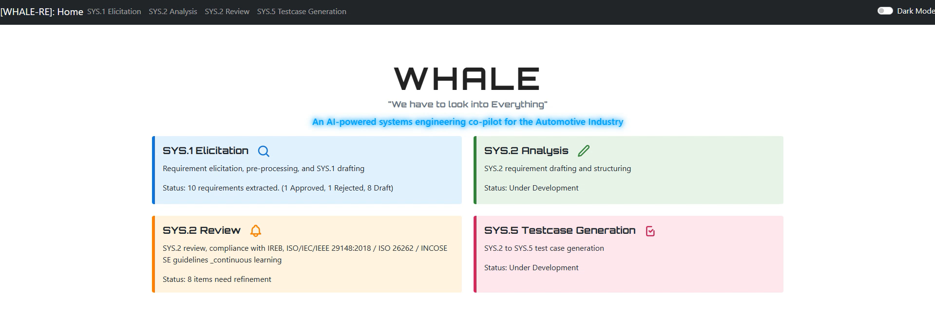
2. Agent 1, 2 & 4 should make sure traceability
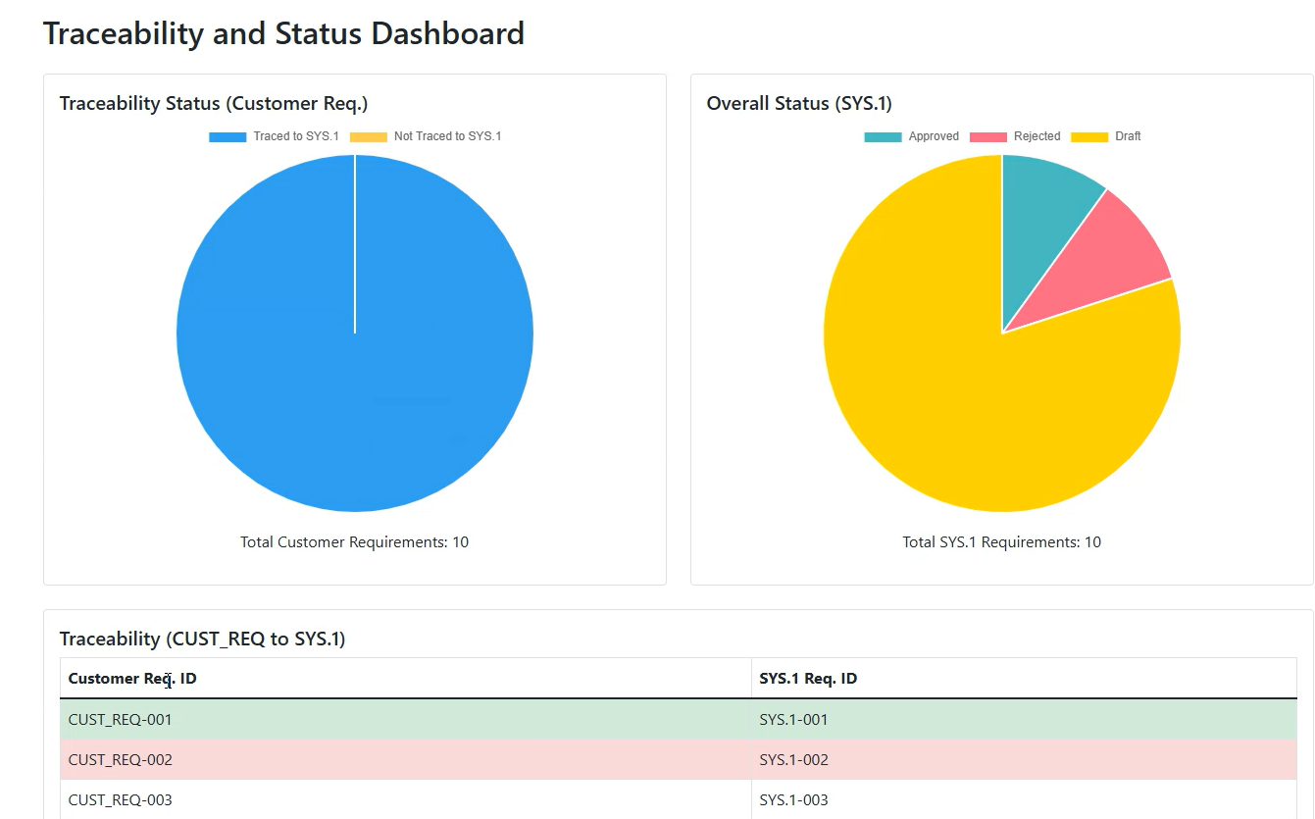
3. All agents should have Export Functionality in TXT, WORD, XLSX, CSV, PDF, & REQIF formats
4. - **LangChain** enables chaining LLM calls, building RAG pipelines, and integrating external knowledge sources (documents, databases, APIs) into agent reasoning.
- **CrewAI** provides multi-agent orchestration, allowing agents to collaborate, delegate tasks, and manage complex workflows.
- **OpenAI** models (GPT-4o, GPT-5 mini/nano) are used for all LLM tasks, with LangChain and CrewAI coordinating their usage.

Agent 1:
Customer Req. ID | Customer Requirement | SYS.1 Req. ID | SYS.1 Requirement | Domain | Priority | Rationale | Requirement Status | Actions
CUST_REQ-XXX |  | SYS.1_REQ-XXX |  |  |  |  | If Action= Accepted then Requirement Status= Approved | Edit, Accept, Reject

Agent 2:
SYS.1 Req. ID | SYS.1 Requirement | SYS.2 Req ID | SYS.2 Requirement | TYPE | Verification Method | Verification Criteria | Domain | Requirement Status
SYS.1_REQ-XXX |  | SYS.2_REQ-XXX | [Refined/Drafted SYS.2 Requirement] | Functional or Non-Functional | System Qualification Test (SYS.5) |  |  | Draft

Agent 3:
SYS.2 Req ID | Review Feedback | Compliance Check | Suggested Improvement
SYS.2-XXX | [Feedback text] | [Yes/No/Partial] | [Correction/Enhancement]

Agent 4:
SYS.2 Req ID | SYS.2 Requirement | Test Case ID | Description | Preconditions | Test Steps | Expected Result | Pass/Fail Criteria
SYS.2_REQ-XXX | [Refined/Drafted SYS.2 Requirement] | TC-XXX | [Test description] |  | [Step 1, Step 2...] | [What should happen] | [Criteria for success]

Agent 5:
Stage | Input | Output | Responsible Agent | Status
Customer Req | [Text] | SYS.1 Requirements | Agent 1 | Complete
SYS.1 | [SYS.1 Table] | SYS.2 Requirements | Agent 2 | Complete
SYS.2 | [SYS.2 Table] | Review Feedback | Agent 3 | Complete/Needs Fix
SYS.2 Reviewed | [Updated SYS.2] | Test Cases | Agent 4 | Complete

Manager coverage vs. the checklist
- Task Planning — Done
  - The Manager sequences the workflow (Customer Req → SYS.1 → SYS.2 → Review → SYS.5) and passes outputs downstream. Chunking, JSON extraction, and dedupe/retries live in the orchestration path to keep items flowing.
- Execution Management — Done
  - The pipeline manages order and dependencies end-to-end, shows progress/metrics, and writes results to disk (autosave) so the process is traceable and resumable.
- All-Agents’ Mode — Done
  - The Manager triggers and coordinates all specialist agents as one unified run, with the consolidated dashboard and RTM.
- Deliverable Packaging — Done
  - Exports are in place: CSV, styled XLSX, styled DOCX, styled PDF, REQIF, plus a bundled ZIP. Files are also auto-saved and a toast confirms verified on-disk saves.
- Output Approval — Partial (now strengthened)
  - Review outputs are already captured and displayed.
  - Added: an “Output Approval” gate in Manager (expander) that summarizes Compliance (Yes/Partial/No) and provides a checkbox to filter the downstream views/RTM to “Approved-only” (Compliance = Yes). This makes sign-off explicit and lets you export a clean, approved-only RTM.
- Conflict Resolution — Partial (now strengthened)
  - Previously implicit dedupe/guardrails helped avoid noise, but no explicit conflict view.
  - Added: a conflicts panel that detects duplicate SYS.2 Req IDs with differing requirement text and shows the conflicting rows so you can resolve/outsource corrections.
- Decision Making — Partial
  - Some business logic exists (chunking, retries, dedupe keys, per-item fallback). We don’t yet auto-route fixes (e.g., auto-rewrite a failing SYS.2 and re-review) or enforce gating on exports.
  - What’s left if you want it:
    - A “strict gate” that blocks ZIP/export until minimum approval thresholds are met.
    - A one-click “re-run review for failed items” or “auto-rewrite → re-review” loop.

WHALE-RE Application - Complete Feature List

🎯 Core Multi-Agent Requirements Engineering Pipeline
Agent 1 – SYS.1 Elicitation (Customer → System Requirements)
- Transforms customer needs into SMART system requirements
- Automatic domain classification (SW/HW/System/Mechanical)
- Priority assignment (High/Medium/Low)
- Rationale generation with standards references
- Status tracking (Draft/Approved/Rejected)
- Bidirectional traceability (Customer ↔ SYS.1 ↔ SYS.2)
Agent 2 – SYS.2 Analysis (System → Subsystem Requirements)
- Atomic requirement splitting (multi-behavior → single-behavior)
- Technical metadata enrichment (interfaces, timing, fault handling)
- ASIL level assignment (ISO 26262 functional safety)
- Type classification (Functional/Non-Functional/Information)
- Verification level mapping (SYS.4/SYS.5)
- Verification criteria definition
- Full traceability chain maintenance
Agent 3 – SYS.2 Review (Compliance Validation)
- ISO/IEC/IEEE 29148 compliance checking
- ISO 26262 functional safety review
- SMART criteria validation (Specific/Measurable/Achievable/Relevant/Traceable)
- Requirement text display alongside feedback
- Compliance scoring (Yes/Partial/No)
- Severity assessment (High/Medium/Low)
- Proposed requirement rewrites
- Improvement suggestions
Agent 4 – SYS.5 Test Case Generation (Requirements → Tests)
- Structured test case generation (1+ per SYS.2 requirement)
- Multiple test scenarios for different acceptance conditions
- Test level assignment (System Qualification/Integration)
- Preconditions, test steps, expected results
- Pass/fail criteria definition
- Safety goal linkage (ASIL traceability)
- Bidirectional traceability to parent requirements
Manager – Orchestration & Pipeline Execution
- End-to-end pipeline execution (Customer → SYS.1 → SYS.2 → Review → SYS.5)
- Requirements Traceability Matrix (RTM) generation
- Multi-agent coordination with progress tracking
- Consolidated export bundle (all outputs + RTM)
- Expandable file list with save notifications
- RAG-enabled pipeline execution

🤖 RAG (Retrieval-Augmented Generation) System
Standards Library (41+ PDFs)
- ISO 26262 (Functional Safety)
- ASPICE (Automotive SPICE)
- AUTOSAR (Automotive Software Architecture)
- ISO/IEC/IEEE 29148 (Requirements Engineering)
- ISO 21434 (Cybersecurity Engineering)
- ISO 15288 (System Lifecycle Processes)
- ISO 16750 (Environmental Tests)
- ISO 14229 (UDS - Unified Diagnostic Services)
- ISO 11898 (CAN Protocol)
- ISO 15031 (OBD-II)
- ECE R100 (Electric Vehicle Safety)
- LV_VDA (VDA OEM Standards)
Multiple RAG Backends
- Simple Engine: Keyword-based similarity (no dependencies)
- ChromaDB: Persistent vector database with metadata filtering
- FAISS: High-performance semantic search (Facebook Research)
- SentenceTransformers embeddings (all-MiniLM-L6-v2)
RAG Features
- PDF text extraction (pdfplumber + PyPDF2)
- Automatic document chunking with overlap (1000 chars, 200 overlap)
- Agent-specific category filtering
- Context-aware prompt augmentation
- Semantic search with cosine similarity
- Top-K retrieval (configurable)
- Persistent vector store (automatic indexing)
- Visible UI: 🔎 "Enable RAG Context (Standards-based)" on all agent pages

📊 Traceability & Analytics
On-Page Dashboards (No New Tabs)
- Agent 1 Dashboard:
  - Traceability Status pie (Traced vs Not Traced)
  - Overall Status pie (Approved/Draft/Rejected)
  - Compact mapping table (Customer → SYS.1)
  - Coverage badges with percentages
- Agent 2 Dashboard:
  - Traceability pie (SYS.1 → SYS.2)
  - Optional status/priority pies
  - Coverage metrics (Traced/Total/%)
  - Zebra-striped mapping table
- Agent 4 Dashboard:
  - Test coverage pie (SYS.2 → SYS.5)
  - Optional priority distribution
  - Test case mapping table
  - Pass/Fail criteria visibility
Requirements Traceability Matrix (RTM)
- Full bidirectional traceability chain
- Customer → SYS.1 → SYS.2 → Review → SYS.5
- Consolidated view with all requirement levels
- Status tracking across lifecycle
- Styled Excel/Word/PDF exports

📤 Export & File Management
Multi-Format Exports (Per Page)
- CSV: Lightweight tabular data
- XLSX: Styled Excel with colored headers, wrapped text, auto-width
- DOCX: Professional Word document with tables, headers, logos
- PDF: Styled PDF with multi-line cell support, headers, branding
- REQIF: Requirements Interchange Format (industry standard)
- ZIP: Consolidated bundle (Manager page - all outputs + RTM)
Export Features
- Always-visible inline export bar on every agent page
- Base64-encoded download links (no external dependencies)
- Styled formatting (readable long text, wrapped cells)
- Header/footer with project metadata (name, version, author, date)
- Optional logo embedding
- Automatic file naming with timestamps
Auto-Save System
- ✅ Persistent Save Notifications: Success messages with file paths
- ⚠️ Error Notifications: Warning messages on save failures
- Session state persistence across page reloads
- Automatic directory creation (outputs)
- Per-agent save locations:
  - SYS.1 → sys1_requirements.xlsx
  - SYS.2 → sys2_requirements.xlsx
  - Review → sys2_requirements_reviewed.xlsx
  - SYS.5 → sys.5_test_cases.xlsx
  - Manager → agent5 (full bundle)

📂 File Input Support
Supported Formats
- .txt – Plain text requirements
- .docx – Microsoft Word documents
- .pdf – PDF documents with text extraction
- .xlsx – Excel spreadsheets
- .reqif – Requirements Interchange Format (XML)
- .json – JSON arrays for structured input
Smart File Loading
- Agent-specific parsing strategies
- Header normalization (flexible column names)
- Automatic format detection
- Multi-page Excel support
- PDF text extraction (PyPDF2 + pdfplumber)
- REQIF XML parsing with spec/object extraction

🎨 UI/UX Features
Always-Light Theme
- Pure white backgrounds with black text (#111827)
- Locked color scheme (no dark mode)
- Radial gradient backgrounds for depth
- Soft borders and shadows (#d7e2ec)
Professional Table Rendering
- Static white tables with sticky headers
- Zebra striping (alternating row colors)
- Vertical scroll with fixed headers
- Compact 12px font for dense data
- Status-based cell tinting (Approved=green, Rejected=red)
- Auto-wrapped long text cells
Navigation & Layout
- URL query parameter sync (?page=SYS1&trace=1)
- Sidebar navigation with icons
- Full-width layout (no sidebars in content area)
- Compressed top padding (maximized content space)
- Hero sections with gradient backgrounds
- Neon-animated workflow arrows
Interactive Elements
- File uploaders with drag-and-drop
- Text areas for direct input
- Checkboxes for RAG toggle (visible labels)
- Download buttons with icons
- Expandable sections (expanders)
- Progress tracking with badges

⚙️ Orchestration & Reliability
Robust Processing
- Input chunking for large datasets (batch size 10)
- Per-item retry for missing outputs (SYS.2, SYS.5)
- Deduplication across chunks (by ID hierarchy)
- JSON parsing resilience (fenced code block extraction)
- Graceful error handling with fallbacks
OpenAI Integration
- OpenAI v1 client (openai.OpenAI)
- GPT-4o default model
- Configurable via .env (OPENAI_API_KEY, OPENAI_MODEL)
- Structured JSON output with array schemas
- Temperature control and deterministic outputs
Optional CrewAI Support
- crew_pipeline.py for advanced orchestration
- LangChain integration (langchain_openai.ChatOpenAI)
- Agent/Task framework with role definitions
- Best-effort fallback (graceful degradation without key)

🔧 Developer Features
Environment Management
- Virtual environment support (.venv)
- .env configuration (API keys, model selection)
- PowerShell setup scripts (Windows-optimized)
- VS Code task integration (Run Streamlit app)
- Port configuration (--server.port 8501)
Code Organization
- Modular architecture (app.py, orchestrator.py, agents.py, utils.py)
- Mirrored package structure (whale_re for packaging)
- Separate RAG engines (rag_engine.py, rag_vector.py)
- Centralized prompts (agents.py with AGENT_PROMPTS)
- Utility helpers for normalization, parsing, exports
Testing & Validation
- smoke_test.py for end-to-end validation (no API key needed)
- PDF loading test script (test_pdf_loading.py)
- Error/warning suppression (PDF library warnings)
- Comprehensive documentation (README.md, PDF_STANDARDS_GUIDE.md, VECTOR_RAG_SETUP.md)

📈 Data Processing Features
Field Normalization
- Canonical field mapping (flexible header names)
- Agent-specific column aliases
- Case-insensitive header matching
- Automatic datatype conversion
- Missing field handling with defaults
Deduplication
- ID-based deduplication (SYS.2 Req. ID priority)
- Hierarchical key fallback (SYS.2 → SYS.1 → Customer)
- Tuple-based keys for test cases (SYS.2 + Test Case ID)
- Cross-chunk merge strategies
Validation
- SMART criteria checking (Agent 3)
- JSON schema validation (all agents)
- Traceability link verification
- Required field presence checks

🛠️ Utilities & Helpers
RTM Builder
- Multi-level traceability matrix composition
- Parent/Current/Next ID linking
- Status aggregation across levels
- Styled output with coverage metrics
Domain Inference
- Heuristic-based domain detection (SW/HW/Mechanical/System)
- Keyword matching with priority rules
- Mixed-domain resolution (System fallback)
Text Processing
- SMART requirement phrasing enforcement
- Markdown formatting in outputs
- Code fence extraction for JSON
- Regex-based parsing with fallbacks

📊 Statistics & Metrics
Coverage Tracking
- Traced vs Not Traced percentages
- Requirement status distribution
- Test case coverage by requirement
- Domain distribution analytics
Visual Analytics
- Plotly interactive pie charts (with Matplotlib fallback)
- Coverage badges with color coding
- Status-based cell highlighting
- Traceability flow diagrams

Total Feature Count: 150+ Features across 12 major categories:
- Multi-Agent Pipeline (4 agents + Manager)
- RAG System (3 backends + 41 PDFs)
- Traceability & Dashboards (3 agent dashboards + RTM)
- Export Formats (6 formats + auto-save)
- File Input (6 formats + smart parsing)
- UI/UX (light theme + tables + navigation)
- Orchestration (chunking + retry + dedup)
- OpenAI/CrewAI Integration
- Developer Tools (setup + testing + docs)
- Data Processing (normalization + validation)
- Utilities (RTM + domain inference + text processing)
- Analytics (coverage + visualization + metrics)

