**NFS: Network File System (2049)**

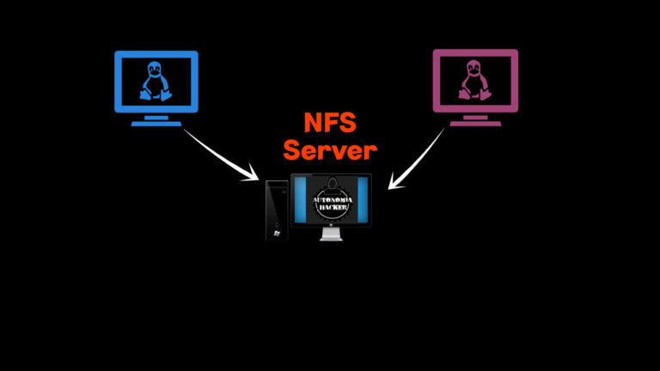

* NFS is a network protocol that allows computers to share and access files over a network.
* Port no:2049



**Server: 192.168.10.6**

* Steps
* # **yum install nfs-utils -y**
* # **mkdir share**
* # **chmod 777 share**
* # **vi /etc/exports**

/share 192.168.10.8(rw,sync)

:wq

* # **systemctl start nfs-server**
* # **systemctl start rpcbind**
* # **systemctl stop firewalld.service**
* # **exportfs -rv**



**Client: 192.168.10.8**

* Steps
* # **yum install nfs-utils -y**
* # **mkdir datashare**
* # **chmod 777 datashare**
* # **systemctl start nfs-server**
* # **systemctl start rpcbind**
* # **systemctl stop firewalld.service**
* # **showmount -e 192.168.10.6 [server ip]**

->/share(everyone)

* # **mount 192.168.10.6:/share / datashare**
* # cd /datashare



**Server: 192.168.10.6**

#cd /share

[root@server share]# touch demo.txt



**Client: 192.168.10.8**

[root@client datashare]# ls

->demo.txt

***In this way you can access files and directories from a shared location on the network***

* ***Nfs-utils is a package allows remote systems to mount file systems over a network and access files as if they were local.***
* ***Rpcbind is a service used to find and communicate with each other across a network***
* ***Firewalld.service if there is communication issue with server then it means the firewall is blocking the necessary NFS-related ports***
* ***exportfs -rv When you run exportfs -rv, it re-reads the /etc/exports file and applies any changes to the NFS server's export list***

***-v view***

***-r refresh***

* ***/share 192.168.10.6 (rw,sync) rw means IP address has both read and write access to the shared directory***

***Sync means data is immediately written to the server's disk***