* Networking

1. OSI -open system interconnection

***Que. Explain 7 layers of osi model ?***

The OSI Model is a framework for how networking systems communicate and transmit data between sender and receiver.

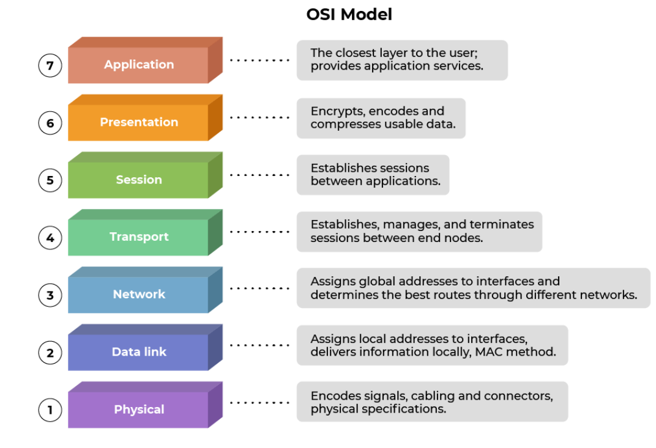

[2]TCP/IP

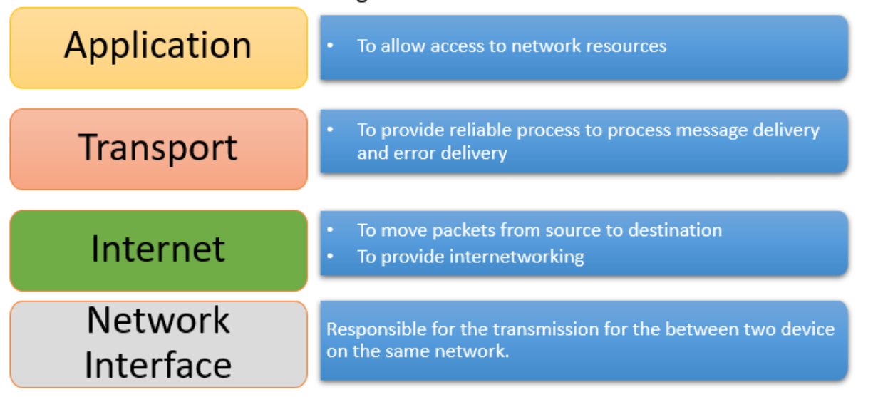

#Networking Devices:

Hub, bridge, switch, and router are all networking devices used to connect and manage network traffic

1. Hub

- A hub is a basic networking device that operates at the physical layer (Layer 1) of the OSI model.

- It is essentially a multi-port repeater, which means it takes incoming data on one port and broadcasts it to all other ports.

2. Bridge

- A bridge is a device that operates at the data link layer (Layer 2) of the OSI model.

- It is used to filter and forward network traffic based on MAC (Media Access Control) addresses.

3. Switch

- operates at the data link layer (Layer 2).

- It is similar to a bridge but is typically more intelligent and has a larger number of ports.

- Switches use MAC address tables to make forwarding decisions, allowing them to selectively forward traffic only to the appropriate port rather than

broadcasting it to all ports.

4. Router

- A router operates at the network layer (Layer 3) of the OSI model.

- It is a more complex networking device that is used to connect different networks (e.g., local area networks or LANs) and make decisions about where to

forward data based on IP (Internet Protocol) addresses.

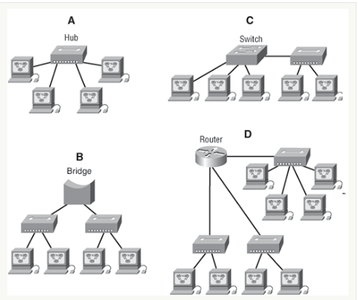

In networking, a topology refers to the physical or logical layout of devices and the connections between them within a network.

1. Bus Topology

- In a bus topology, all devices are connected to a single central cable (the bus).

2. Star Topology

- In a star topology, each device is connected directly to a central hub or switch

- Star topologies are common in Ethernet LANs and are easy to manage.

3. Ring Topology

- In a ring topology, devices are connected in a circular fashion, with each device connecting to exactly two other devices.

- Data travels around the ring in one direction until it reaches its destination.

4. Mesh Topology

- In a mesh topology, every device is connected to every other device in the network.

- Mesh topologies provide redundancy and fault tolerance because multiple paths exist for data to travel.

5. Point-to-Point Topology

- Point-to-point topology involves connecting each device to a single, dedicated link or channel.

- This type of topology is commonly used for direct communication between two devices, such as in a WAN (Wide Area Network) link.

6. Hybrid Topology

- Hybrid topologies combine two or more different topologies.

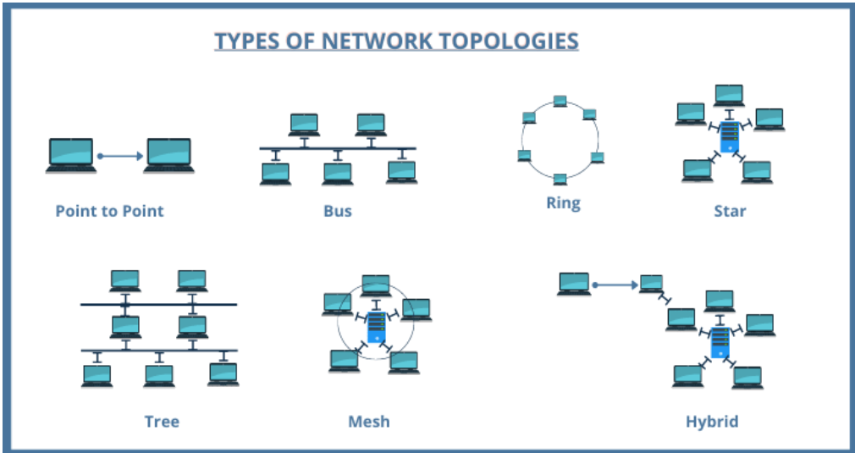

Types of computer networks:

1. LAN (Local Area Network)

- A LAN is a network that covers a small geographical area, such as a single building, office, or campus.

- Common LAN technologies include Ethernet and Wi-Fi (Wireless LAN), and they are used to connect computers, servers, printers, and other devices within

a localized environment.

2. MAN (Metropolitan Area Network)

- A MAN is a network that covers a larger geographical area than a LAN but is still confined to a specific city.

- MANs are used to connect multiple LANs within a city

3. WAN (Wide Area Network)

- A WAN covers a much larger geographical area like cities, countries

- The internet is a prime example of a global WAN, but private WANs are also used by organizations to connect their branch offices, data centers, and

remote locations.

eg. VPNs (Virtual Private Networks)

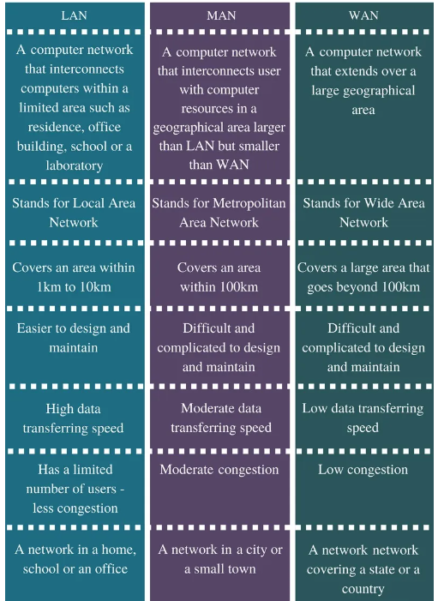

ADDRESSING

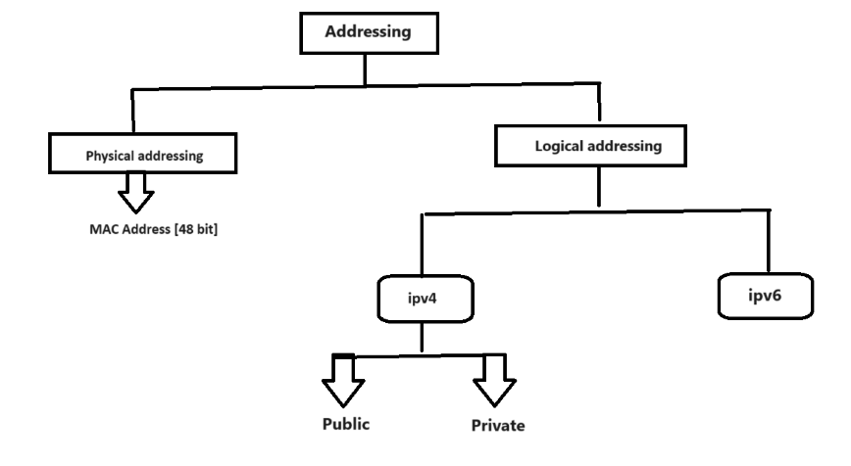

***Que. Difference between ipv4 and ipv6***

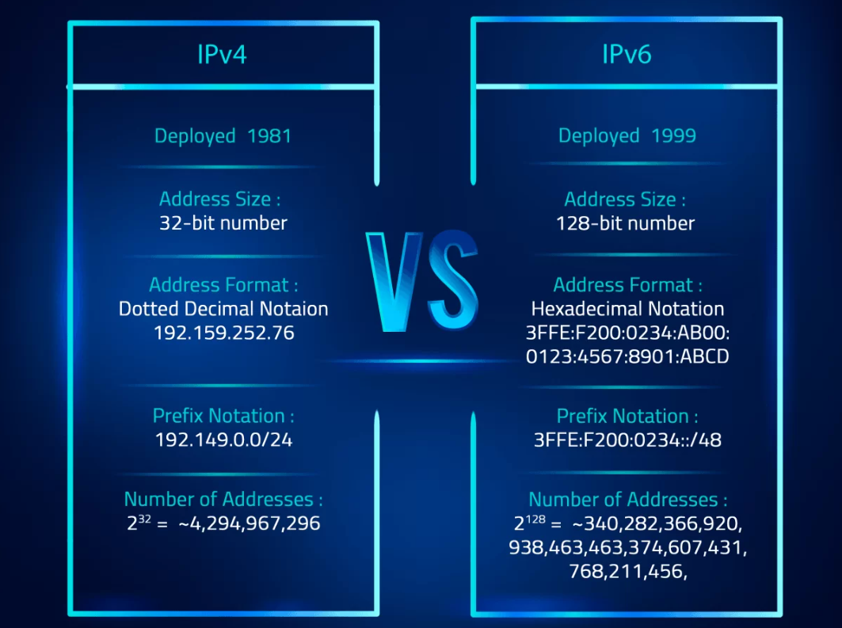

***Que. Difference between public and private ip***

**Public IP Address**

1 Public IP Address is used to communicate outside the network.

2.Except private IP Addresses, rest IP addresses are public.

3.dynamic

**Private IP Address**

1. Private IP Address is used to communicate within the network.

|  |
| --- |
| 2. Private IP Address range:  10.0.0.0 – 10.255.255.255,  172.16.0.0 – 172.31.255.255,  192.168.0.0 – 192.168.255.255 |
| 1. static |

**Classful**

***Que. Explain Ipv4-Classes:***

Class A 1.0.0.0.0 - 126.0.0.0

Class B 128.0..0.0 - 191.255.0.0

Class C 192.0.0.0 - 223.255.255.0

Class D 224-239 -----research

Class E 240-255 ------research

Note: IP range 127.0.0.0 is reserved for loopback address[trouble shooting] which means an address that sends outgoing signals back to the same computer for testing

Network id ->It is a STARTING addressing of an IP [the first address is the network identification]

Broadcast id ->It is a LAST address of an IP [to transmit data to all of the hosts on the local subnet.]

Note:Both n/w id and bro. id are reserved by network [-2]

Subnet mask ->A subnet mask is for only internal usage within a network. Routers use subnet masks to route data packets to the right place

Ex. 192.168.1.0

Network id-192.168.1.0 ----host bit zero ----identify /represents network

Broadcast id-192.168.1.255 ----host bit 255 ----resvered to send msg to all

Subnet mask -255.255.255.0 ----network bits 255