KPMG Calypso
RTC Source Control

Document Control
The following table identifies to whom this document has been distributed for review
Table 1: Document Reviewers List
Name | Role | Responsibility
Table 2: Document Change History
Date | Version | Document Status (Description of changes) | Author
27 April 2016 | 0.1 | Draft | Rajdip Roy
Table 3: Document Acceptance and Signoff
Name | Signature | Date

The principles of source control in RTC are:
1. Streams (very much similar with CVS and SVN branches)
2. Attached to the streams there are components. A component is a container dedicated to a subset of artifacts. For instance, there can be a component for source code, one for documentation, one for test assets, etc. Or, if the system architecture is really complex, there can be several components for source control, one for each major component of the architecture.
3. Developers access the source control via workspaces. Basically, a workspace is a read/write view into the repository that give the developer the possibility to perform checkouts, check-ins, merges, and so on
Workspaces can be individual or they can be shared. In case a small team will need to work in a very integrated way. Communication between developers via source control happens by delivering change sets from their workspaces into the stream and then accepting other developers' changes from the stream into their workspace. There is an RTC Client application, either stand alone or as an Eclipse plugin, which needs to be integrated with the development IDE , in order to make this interaction with RTC source control work.
Setup
Get your own Jazz login userid and password, by creating an account.
- Rational Team Concert 5.0.2 and later requires Eclipse 4.3.2 or later.
- As mentioned in the developers setup document install
- Installing the plug-in
In Eclipse, click Help > Install New Software.
In the Install window, complete these steps:
In the Work with field, enter https://jazz.net/downloads/rational-team-concert/5.0.2/5.0.2/p2.
Press Enter to load the contents of the update site.
Select the Rational Team Concert Client feature check box.
Select the Group items by category check box.
Click Next and click Next again.
Accept the license terms and click Finish to install the plug-in.

Creating a repository connection
In eclipse Jazz Administration perspective, click on Create a Repository connection on the left menu. Refer to the screenshot below.
For URI put https://rtc-app.softlayer.com:9443/ccm
For User ID / Password, put your credentials for Jazz. When you will OK this window, RTC will ask you if you want to accept the server's certificate or not. Accept it permanently

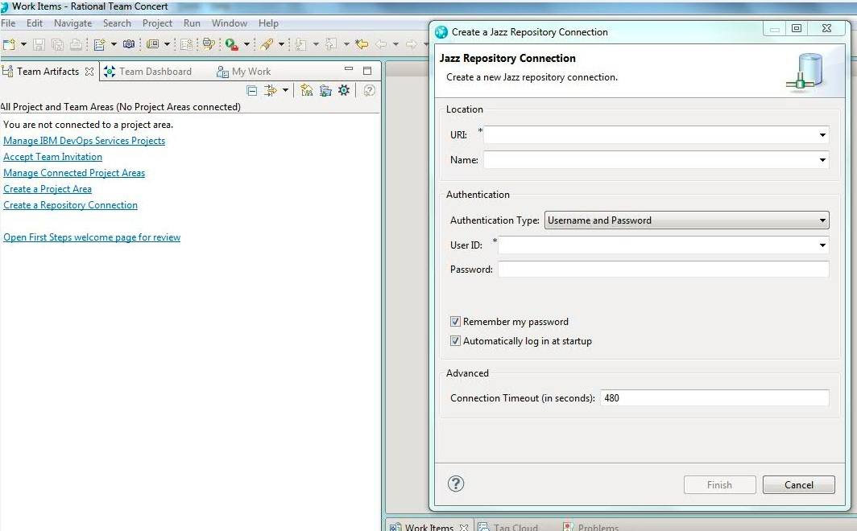

Creating a repository workspace
In the Eclipse Workbench, click Window > Show View > Other > Team > Team Artifacts.
Expand your project area to show the Source Control folder.
Right-click the Source Control folder, and click New > Repository Workspace.
Select the stream to flow to (Calypso Portal Development) and click Next.
Specify a new name for your repository workspace and click Finish.
Complete the wizard.

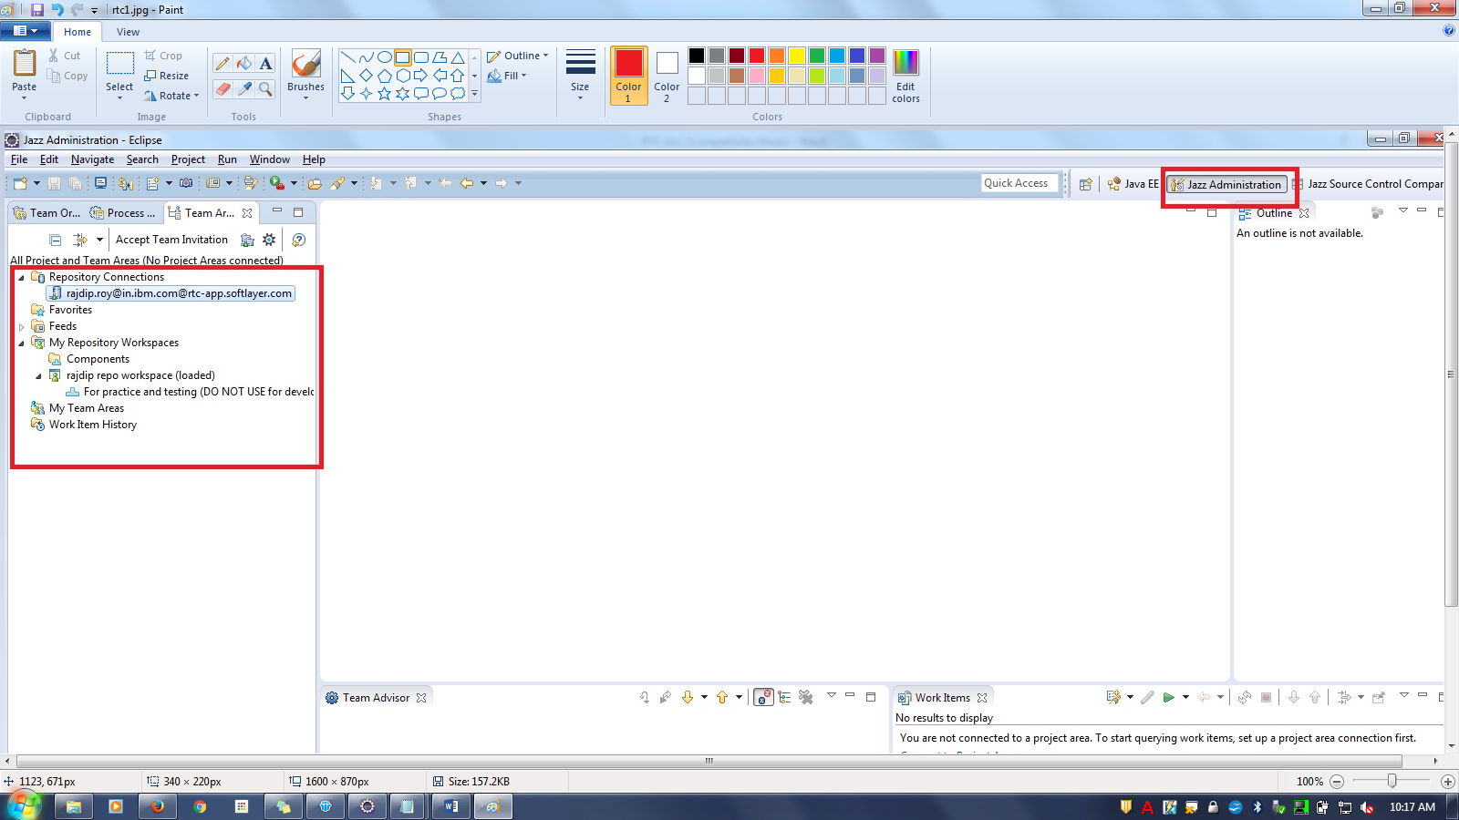

To accept or checkout new project
Switch to the Java Perspective
Then, from right click on the project Team and "Show Pending Changes"
The application will open a view which looks like this

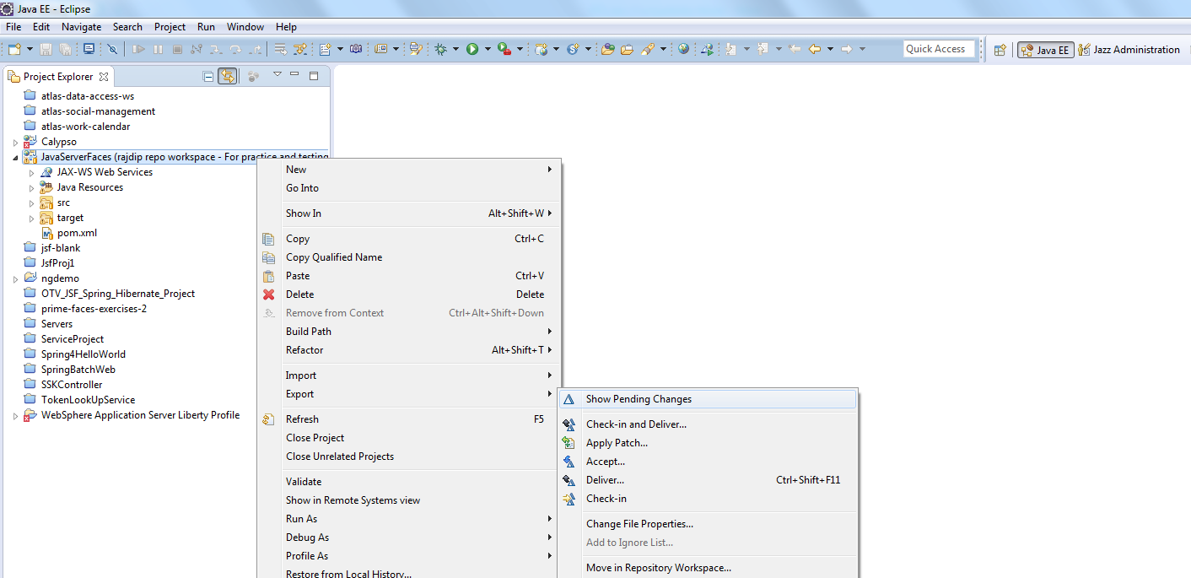

To deliver your changes to the Stream,
Select your project in Java EE perspective and right click. From the context menu, select Team → Check-in and Deliver.
The transfer of data between a developer's workspace and a stream is a 2 step operation. If we are talking about a file which is already in source control, you need to perform a Check-out command on it because without it, the file is read only and the user does not have the right to modify it and create a new version. Check-out tells RTC that the user executing the command takes ownership of the file if the file is modified, when Check-In is executed, a new version of the element is created in its container (the component) and control is returned to RTC.
Now, the developer has the chance to execute unit testing and make sure that his / her code changes are sound. All this is done in the user's repository workspace. So, the new file version is located only in the repository workspace now, the new version needs to reach the stream. This is done by executing the command Deliver which will compare the repository workspace and the stream and where differences are detected, RTC will try to do automatic merge. if the automatic merge works, then a new version of the element is created in the stream if the automatic merge fails, then manual merge is required, i.e., the developer must decide how to combine his changes with what is available in the stream once the manual merge is done, a new version of the element is created in the stream. Now, the cycle repeats, so that in the source control repository, a file has attached to it a string of successive versions that show how it evolved since creation until present state. This evolution information tells who did, what changes, when. You cannot do a deliver without checking in the files first
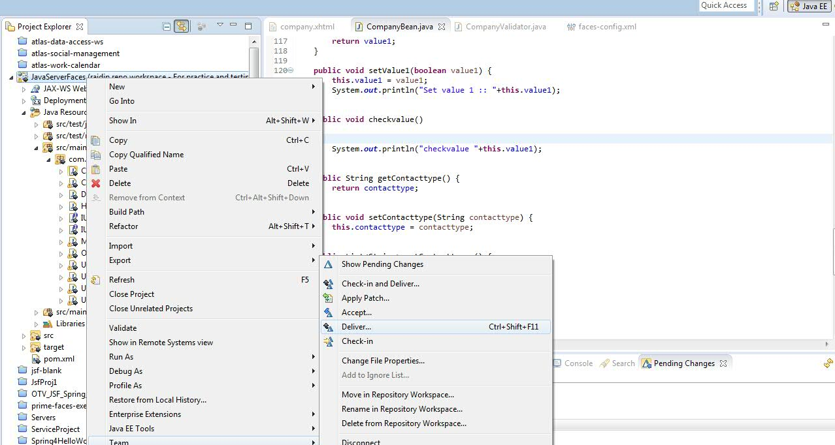

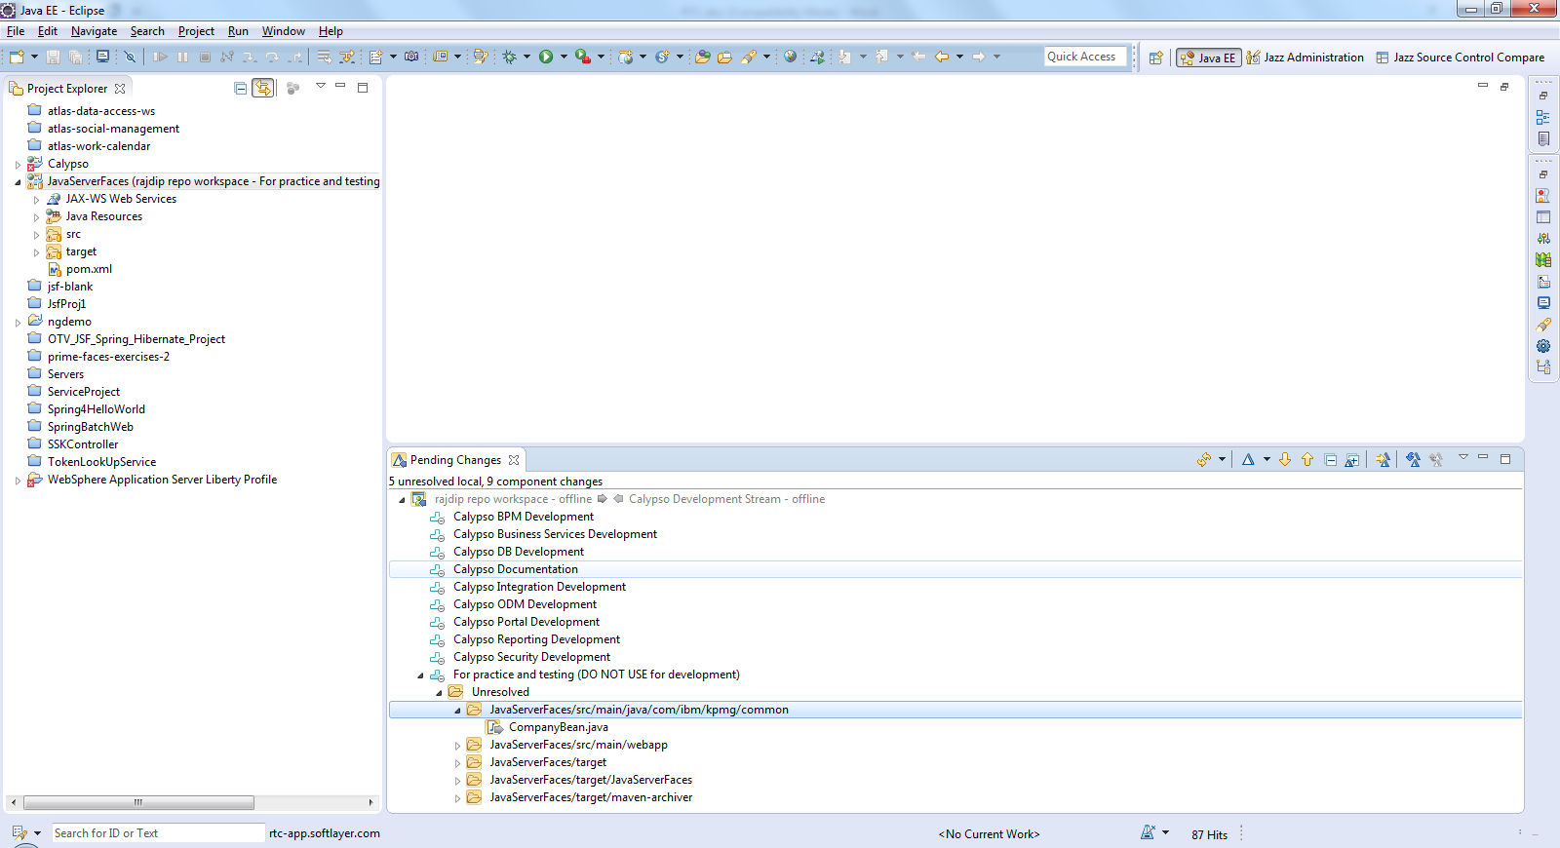

Right click on the Pending changes view on a project component, will show Accept if there are Incoming changes from the Stream to your project workspace. Incoming or outgoing will be shown by arrows in the Pending changes view. Double clicking on any file will show the diffrenece between the local workspace and the one in the stream, in 2 separate panes.

